Prevalence and histopathological study of Clarias magur (Clariidae) (Hamilton, 1822) gut, infected by Cestode parasite Lytocestus indicus (Lytocestidae) (Moghe, 1925) Woodland, 1926

Abstract: In the present study, histopathological damage in the gut of Clarias magur caused by the parasite Lytocestus indicus has been investigated. This finding reveals that the infection induces pathological changes in the host’s gut wall. Histopathological examination of both infected and non-infected gut of Clarias magur revealed that the non-infected tissues exhibited intact villi and epithelial layers. In contrast, the infected tissues showed extensive damage, including destruction of the villi and epithelium. The parasite was noticed to remain attached to the wall of the stomach. The cestode was found to have dorsoventrally flattened, elongated body with digitiform scolex. The intestinal lumen and villi, of the host fish was observed to be anchored by the parasite, leading to blockage of the intestinal passage and rupture of the mucosal and submucosal layers. Vacuolation within the gastrointestinal layers were also noted. Seasonal fluctuations were recorded (premonsoon, monsoon, and postmonsoon) during this investigation. The findings revealed seasonal variations in prevalence, mean intensity, and relative abundance, with higher values observed during the summer. This is the first report documenting the intestinal pathology in the fish Clarias magur caused by the cestode parasite Lytocestus indicus from North Bengal, West Bengal, India.

Keywords: Cestode; Lytocestus indicus; Clarias magur; gut; histopathology; prevalence.

Introduction:
Aquaculture plays a vital role in ensuring food security in India and contributes significantly to export earnings. Fish provide vital proteins, essential micronutrients, and polyunsaturated fatty acids that play a crucial role in supporting healthy development and overall well-being. However, in both capture and culture fisheries, fish are frequently exposed to parasitic infections that can impact their health and productivity. Cestodes (tapeworms) constitute a highly diverse group of exclusively parasitic flatworms (Platyhelminthes: Neodermata) that infect fishes. The cestodes are characterized by their unique morphology, medical and veterinary importance, and their complex life cycles (Caira and Littlewood, 2001; Roberts and Janovy, 2005). Among the cestodes, the order Caryophyllidea (Platyhelminthes, Eucestoda) comprises a widely distributed group of monozoic intestinal parasites characterized by the presence of a single set of reproductive organs. This group comprises four families- Balanotaeniidae, Capingentidae, Caryophyllaeidae, and Lytocestidae, which primarily infects cypriniform and siluriform fishes (Biswas et al., 2024). Despite their wide distribution, information on these parasites from tropical Asia—particularly the Indomalayan (Oriental) zoogeographic region, including the Indian subcontinent, is limited. Only a few quality studies have been conducted to date (Mackiewicz, 1963, 1981; Mackiewicz and Murhar,1972). This investigation was carried out on the freshwater catfish species Clarias magur (Hamilton, 1822). During this investigation, it was observed that the fish was found to be infected with certain internal parasites. The present study reports a species of Lytocestus, parasitizing the catfish Clarias magur (Hamilton, 1822). This is a freshwater fish that belongs to the family Clariidae and order Siluriformes. This fish was collected from North Bengal, West Bengal, for this investigation. Clarias magur, widely known as ‘magur’, is a moderately sized catfish species that has considerable economic importance in Indian aquaculture and markets. The fish is valued due to its medicinal or therapeutic importance. It has high demand in the market of the northeastern region of India for its unique flavour and rich nutritional value (Borah, 2020). Knudsen et al. (2002) demonstrated that parasitic infections in fish can reduce their market value and negatively impact fish production in both capture and culture fisheries by potentially leading to fish mortality. Moreover, the intensity of infection was found to vary with seasons. Lytocestus indicus was previously reported in Clarius batracus, Channa punctatus, Channa striatus and Lytocetsus clariasae was found in Clarius batracus (Ash et al., 2011; Reddy and Benarjee, 2014; Hiware et al., 2008. In West Bengal this parasite was also reported from Clarias batracus by Biswas et al., 2024. The cestode is a gut-inhabiting parasite. The parasite anchors itself to the wall of the gastrointestinal lining of fish hosts using its scolex to feed on the host fish by invading the intestinal wall. The cestode adheres deeply to the mucosal, submucosal, and muscularis mucosa of the gut, causing progressive tissue damage to the host tissues. The infection ruptures the sub-mucosal, mucosa layers of the gut of the host fish. In cases of heavy infection, a large number of parasites may block the intestinal passage. Thus, the effects of this parasite can lead to significant changes, which ultimately reduce nutrient absorption and disrupt other metabolic functions. Considering the importance of this parasite, this present paper aims to represent the histopathological changes caused by this cestode parasite in its host’s gut and to study the seasonal occurrence of this parasite. The observed damage could have serious physiological consequences for the fish and may cause death of the host fish due to malabsorption of nutrients.

Materials and methods:

Collection of parasites and infected gut:

The freshwater fish Clarius magur were collected from the freshwater body of North Bengal, West Bengal, India, for the investigation of parasites (Fig. 1). A total 72 fish were studied during this investigation, conducted between March, 2023-February 2024.The skin, gills, fins, intestine, kidney, muscle, liver, and body cavity were precisely examined for the detection of ectoparasites and endoparasites. The gut of some fish was found to be infected with endoparasites. The fish were dissected, and the worms were collected from the infected stomach and intestine region. The worms were then washed in saline solution, flattened, preserved in 70% alcohol, and later processed for taxonomical studies. The parasites adhering to the gut wall were left intact, and tissue samples from both the infected areas and unaffected gut regions were preserved in formal-buffered solution.

Calculation of Parasitic Occurrence:

The determination of the seasonal occurrence of L. indicus in C. magur followed the Margolis et al., 1982.

Prevalence:
The Prevalence was determined by calculating the percentage of host individuals infected by a specific parasite species compared to the total number of hosts examined in the area under investigation. This method provides a clear and quantifiable measure of parasite prevalence.

Total number of infected fish
Prevalence (%) = X 100
Total number of host fish studied

Mean intensity:
The mean intensity was determined by taking the total number of individuals of a particular parasite species in a sample of host fishes against the number of infected host fish in that sample.

Total number of a specific parasite
within a sample of host fish
Mean intensity =
Total number of infected host fish
in the sample

Relative density /Abundance: The relative density or abundance was determined by calculating the total number of individuals of a particular parasite species in a sample fish host to the total number of host fish examined in that sample.

Total number of a particular parasite
in a sample of host fish
Abundance =
Total number of host fish
in that sample

Histopathological study:

The fixed tissues and worms were dehydrated in an ascending ethanol series and cleared in xylene. After that, the samples were embedded in paraffin and sectioned. The sections were then stained with haematoxylin-eosin and mounted in DPX for histological analysis. Photomicrographs were captured using an Olympus BX43 compound microscope.

Results:
A total of seventy-two medium-sized Clarias magur specimens (18–24 cm in length) were examined for parasitic infection during this study. Out of these, 33 individuals were found to be infected with Lytocestus indicus. The prevalence of infection was found to be higher during the pre-monsoon period compared to the monsoon and post-monsoon seasons (Table 1, Graph 1).
During the investigation, it was observed that the parasite-infected fish specimens exhibited mucous-laden stomach and intestines upon dissection. In cases of heavy infection, visible lumps were observed on the outer surface of the gut wall. Upon detailed observation, the cestode parasites were identified as Lytocestus indicus. The isolated parasite was elongated, with a dorsoventrally flattened body with traces of external segmentation. The scolex was robust, lanceolate or digitiform (Fig. 2). Body of the worm slightly tapers towards the anterior and posterior ends. This species was different from other caryophyllideans reported in Asian catfishes by several distinct morphological features. Notable characteristics include a large, robust body; a dumbbell- or butterfly-shaped ovary with short, broad lateral arms; a simple, sturdy scolex that is lanceolate to digitiform in shape with a rounded terminal end; and a short neck region devoid of vitelline follicles and testes. Additionally, it exhibits an almost complete absence of vitelline follicles in the preovarian region. The present study examined the histopathology of the cestode Lytocestus indicus in the gut of Clarius magur by comparing the healthy gut and parasite-infected gut of the fish.
The comparative examination between the normal and parasite-infected gut of the freshwater fish C. indicus showed that the epithelial lining and associated layers—serosa, muscularis mucosa, submucosa, and mucosa were remained structurally intact in the healthy specimens. (Fig. 3A, B). In contrast, in fish infected with cestodes, the parasitic worm L. indicus (Lytocestidae) occupied the interior of the gut of the Clarius magur. The parasites anchored themselves to the intestinal and stomach walls using their scolex, which caused noticeable protrusions or swellings at the attachment sites that were visible from the outside of the gut wall. After dissection, several white coloured Lytocestus indicus were coming out from the dissected portion. High mucus secretion was observed from the infected area. Histopathological examination of the fish gut infected by cestode parasites showed that the cestode remains attached to the mucosal, submucosal, and muscularis mucosa layers and slowly damages the host gastrointestinal tissue; it destroys the intestinal epithelium of the host fish. The worm deeply adhere through the intestinal lumen and villi to obtain nourishment from the host and thus damages the epithelium, plasma cells. The infection ruptures the submucosal, mucosal layers of the infected tissues of the host fish. Parasitic infection leads to the formation of vacuoles within those tissue layers. The attachment of the cestode's scolex caused localized pressure necrosis, with infiltration of inflammatory cells and congestion in the underlying submucosal tissue. Presence of a large number of cestode Lytocestus indicus inside the gut can block the intestinal passage. Thus, the effects of this parasite can lead to serious change, which ultimately reduces the absorption rate and interrupts other metabolic processes (Fig 4 A, B).



Fig. 1: Photograph showing a site of host fish collection.

Table 1 Prevalence, mean intensity, and abundance of L. indicus in C. magur in different seasons from March 2023 to February 2024

Season | Total no of fish examined | Infected | Noninfected | Prevalence (%) | Total no. of parasites recovered | Mean intensity | Relative density /Abundance
Premonsoon  (March-June) | 22 | 12 | 10 | 54.5 | 51 | 4.25 | 2.3
Monsoon  (July- Oct) | 30 | 13 | 17 | 43.3 | 42 | 3.2 | 1.4
Postmonsoon  (Nov-Feb) | 20 | 08 | 12 | 40 | 10 | 1.25 | 0.5

Graph 1 Seasonal occurrence of L. indicus in C. magur in different seasons from March 2023 to February 2024

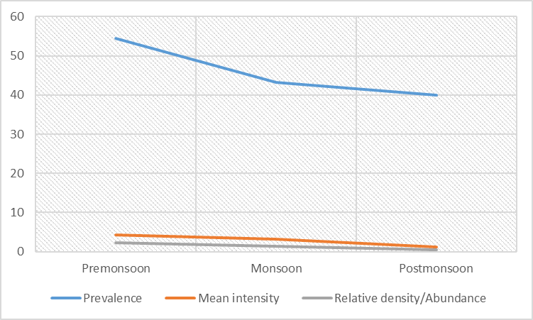
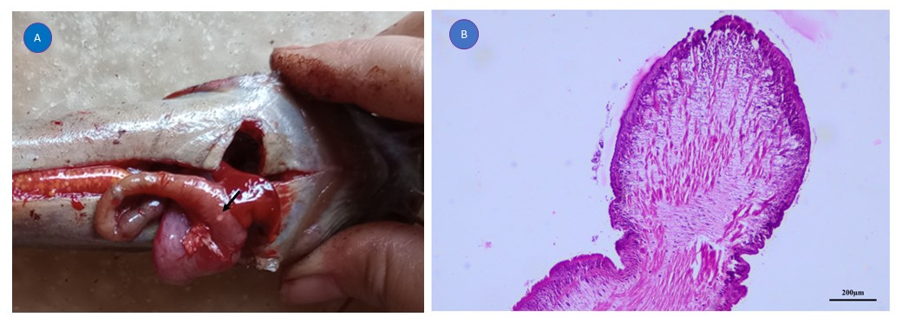

Fig. 2 Photograph showing the Lytocestus indicus (A) in the gut of C. magur, forming a nodule visible from the outer surface of the gut (B) histological section of the scolex region.
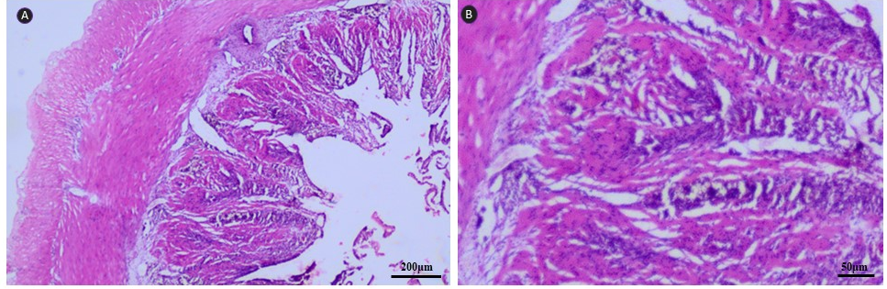
Fig 3: Histological section of healthy uninfected gut of C. magur (A) showing healthy villi and normal intestinal structures (B) healthy villi in higher magnification.

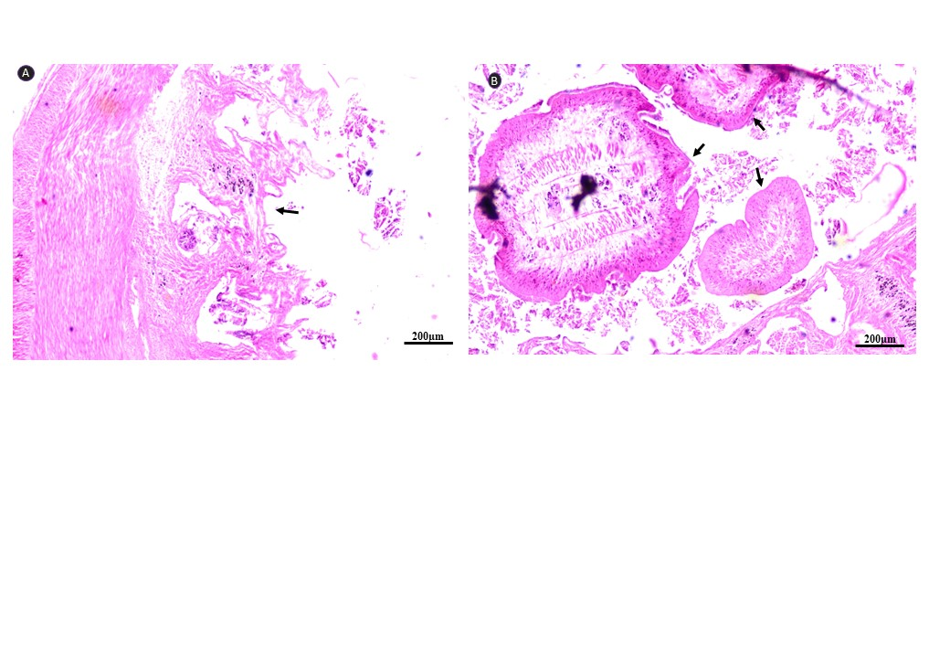

Fig 4: Histological section of gut of C. magur infected with Lytocestus indicus worms (A) showing damaged villi (B) showing the parasites in the intestinal lumen(arrow).

Discussion: During the study, the catfish Clarias magur was found to be infected with the cestode parasite, Lytocestus indicus (Moghe, 1925; family Lytocestidae). The parasite mainly infects and resides in the gastrointestinal tract of its host. The present study revealed seasonal variations in prevalence, mean abundance, and relative density, with a higher trend observed during summer and a lower trend during winter (Table 1, Graph 1). These findings are consistent with previous reports indicating increased parasitic activity in summer, which may be due to favorable environmental conditions and the availability of intermediate hosts during this season (Zhang, 1993; Vincent and Font, 2003)
This present study illustrates that the parasite is pathogenic to its host by causing mechanical damage to the host tissue. The parasite has having penetrative scolex by which it invades the host tissue and utilizes the nutritive materials from the host tissue for its nourishment and growth, which ultimately affects the growth of the host.
Intestinal parasites in vertebrates can provoke inflammation in the host’s digestive tract, leading to disruptions in normal gastrointestinal functions, including increased secretory activity and accelerated gut motility (Raipalli, 2018). The histopathological alterations caused by the cestode parasite were previously observed by Hiware et al., 2008; Reddy and Benarjee, 2014; Raipalli and Deshmukh, 2018; Pardeshi, 2019; Khodke, 2020; Vajidkhan, 2019a, b; and Hassan et al., 2019. All these studies showed that the cestodes are present in the gastrointestinal lumen of the host fish, attaching the scolex to the stomach and intestinal wall for nutrients. The attachment sites exhibit ruptured serosa layer, inflammatory infiltration in the infected area, and shortened, irregularly shaped villi. Heavy infestation by the cestodes leads to breakage, hemorrhaging, and detachment of the villous structures. These studies found necrosis in gut epithelial layers. The severity of tissue damage was directly correlated with the intensity of cestode infection. The severe damage to the infected region of the host fish showed that Lytocestus indicus is pathogenic. The damages might cause digestive disturbance in the infected fish and lead to physiological problems.

Conclusion: The present study indicates that the attachment and nutrition uptake mechanism of the cestode plays a key role in causing significant damage to the gut of host fish. Although a single Lytocestus indicus worm causes minimal harm, heavy infections lead to extensive tissue damage, including atrophy of the villi. Seasonal variation was also observed, which showed infection rates peaking during summer and declining in winter.

References:
- Ahmed, A.T.A., & Sanaullah, M. (1975). Pathological observation of the intestinal lesions induced by caryophyllaeid cestodes in Clarias batrachus (Linnaeus) (Siluriformes: Clariidae). Fish Path, 14, 1-7.
- Ash, A., Scholz, T., Oros, M., & Kar, P.K. (2011). Tapeworms (Cestoda: Caryophyllidea), Parasites of Clarias Batrachus (Pisces: Siluriformes) In the Indomalayan Region. J. Parasitol., 97(3), 435–459. https://doi.org/10.1645/GE-2625.1
- Borah, B.C. (2020). Asian Catfish Clarias magur (Ham), a Wonder Fish for Health and Nutrition. Acta Scientific Nutritional Health, 4(2). https://doi.org/10.31080/ASNH.2020.04.0624
- Biswas, R., Barcak, D., Oros, M., Patra, B.K., & Marick, J. (2024). Taxonomic inflation or hidden diversity: unveiling the fact surrounds Lytocestus indicus (Cestoda: Caryophyllidea). Parasitol Res, 123(9), 331. https://doi.org/10.1007/s00436-024-08336-5
- Caira, J. N., & Littlewood, D. T. J. (2001). Worms, Platyhelminthes. Encyclopedia of Biodiversity. Academic Press, San Diego, California, 5, 863–899.
- Krishnan, G.V. (1968). Diseases and parasites of fishes in warm water ponds in Asia and the far East, fisheries. Report. FAO-UN, 445, 319-343.
- Hamilton, F. (1822). An account of the fishes found in the river Ganges and its branches. Edinburg and London, Viii+405.
- Hassan, M., Hadi, M.S.I.A., Aziz, M.F.H., Wahab, W., Abdullah, F., & Deraman, S., et al., (2019). IOP Conf. Ser. Earth Environ. Sci., 370. https://doi.org/10.1088/1755-1315/370/1/012055
- Hayunga, E.G. (1977). Comparative histology of the scolices of three caryophyllaeid tapeworms: Relationship to pathology and site selection in host intestine. Diss. Abs. Int., 38.
- Hiware, C.J., Pawar, R.T., & Wongsawad, C. (2008). Studies on Histopathology of Clarias batrachus (Linnaeus) Intestine Parasited by Cestode, Lytocesus clariasae Jadhav and Gahvane, 1991. Journal of Yala Rajabhat University, 3 (2).
- Khodke, A.B. (2020). Histopathological studies on cestode parasites in marine fishes. Bioscience Discovery, 11(4),249-251.
- Knudsen, R., Amundsen, P.A., & Klemetsen, A. (2002). Parasite- induced host mortality: Indirect evidence from a long-term study. Environmental Biology of Fishes, 64, 257-265.
- Mackiewicz, J. S. (1963). Subfamily status of Bovieninae Fuhrmann, 1931 (Cestoidea: Caryophyllaeidae). Zeitschrift fu¨ r Parasitenkunde 23, 92–98.
- Mackiewicz, J.S. (1972). Relationship of pathology of scolex morphology among caryophyllid cestodes. F. Parasitkde, 39(3), 232-246.
- Mackiewicz, J.S. (1981). Synoptic review of the Caryophyllidea (Cestoidea) of India, Pakistan and Nepal. Himalayan Journal of Science, 1(1), 1-14.
- Margolis, L, Esch, G.W., Holmes, J.C., Kuris, A.M., & Schad, G.A. (1982). The use of ecological terms in parasitology. American Society of Parasitologists, 68(1), 131-133.
- Moghe, M.A. (1925). Caryophyllaeus indicus n. sp. (Trematoda) from the catfish Clarias batrachus (L.). Parasitol, 17,232–235.
- Niyogi, A., & Agrawal, S.M. (1989). Intestinal pathology due to caryophyllaeids parasitizing Clarias batrachus (Linn.) at Raipur. Indian J. Helminth, 41,112-119.
- Pardeshi, P.R. (2019). Histopathological Studies on Infection of Cestode Parasite, Senga Sp. In Intestine of Freshwater Fish, Channa Striatus (Bloch, 1793). Journal of Emerging Technologies and Innovative Research, 6,6
- Reddy, B.L., & Benarjee, G. (2014). Mode of attachment and Pathogenicity of Lytocestus indicus in fresh water Murrels. International Journal of Current Microbiology and Applied Sciences, 3(4), 507-511.
- Raipalli, A.S., & Deshmukh, A. L. (2018). Histopathological Study on Lytocestus Indicus (Moghe, 1925) Infecting Fresh Water Fish Clarias Batrachus from Ujani Reservoir Dist. Solapur (M.S) India. IJSRST, 4 (10), 344-347
- Roberts, L. S., & Janovy JR. (2009). Foundations of parasitology (8th ed.). McGraw Hill Companies, Inc., Boston, Massachusetts.
- Vajidkhan, P.A. (2019a). Histopathological Effects of Cestode Parasite, Circumoncobothrium Sp. In Intestine of Fresh Water Fish, Mastacembelus Armatus. J. Exp. Zool. India, 22(1), 529-531.
- Vajidkhan, P.A. (2019b). Histopathological Effects of Cestode Parasite, Gangesia Sp. In Intestine of Fresh Water Fish, Wallago Attu. Biochem. Cell. Arch. 19(1), 329-331.
- Vincent, A.G., & Font, W.F. (2003). Seasonal and yearly population dynamics of two exotic helminths, Camallanus cotti (Nematoda) and Bothriocephalus acheilognathi (Cestoda), parasitizing exotic fishes in Waianu Stream, O’ahu, Hawaii. J Parasitol., 89,756–760.
- Woodland, W. N. F. (1926). On the genera and possible affinities of the Caryophyllaeidae: A reply to Drs. Fuhrmann and J. G. Baer. Proceedings of the Zoological Society of London, 49–69.
- Zhang, Q.Z. (1993). Studies on the ecology of parasitic Camallanus cotti Fujita in the host Mystus Macropterus Bleeker. Journal of Southwest China Teachers University (Natural Science), 18, 85–89.

