Monocled Cobra, Naja kaouthia Lesson,1931 (Squamata: Elapidae) Breeding Biology in Dibrugarh City, Assam (India): Notes on 100 percent hatching success in a semi-natural condition and colouration with markings in juveniles.

.
ABSTRACT

Observation on breeding microenvironment of Monocled Cobra, Naja kaouthia Lesson,1931, one of the four species of the genus Naja found in India was done in Bongalgaon, Dibrugarh City, Assam (India). An egg cluster with 24 numbers of empty egg shells showing 100 percent hatching was recovered from a network of rat holes under a cemented earthen floor of a room used as living room by a family. Measurements of the empty shells were done in terms of length, breadth and ratio of the average values. Seven hatchlings could be recorded, four of which could be rescued, photographed and released in natural habitat with the help of persons from the Govt. Forest Department of Assam. Body colouration and markings of in 4 juveniles were noted. The case study is communicated with a review of the related aspects of breeding biology of this species in natural captive conditions.

Keywords: Naja kaouthia, breeding, microenvironment, Dibrugarh, egg-cluster, juvenile, colouration

1. INTRODUCTION

Monocled Cobra, Naja kaouthia Lesson,1931 (Order- Squamata: Family-Elapidae) is one of the four species of the genus Naja found in Indian limits. The other three species are Naja naja (Linnaeus,1758), Naja oxiana (Eichwald,1831) and Naja sagittifera Wall, 1913 [1]. Naja kaouthia is among the medically important venomous snakes of Southeastern Asia and is distributed in the countries of India, Nepal, Bhutan, Bangladesh, Myanmar, South and SW China, Thailand, North and West Malaysia, Cambodia, S. Laos and Vietnam [2,3]. This species is distributed in North and Eastern India in the plains of Ganga and Brahmaputra in the states of Arunachal Pradesh, Assam, Bihar, Haryana, Manipur, Meghalaya, Mizoram, Nagaland, Orissa, Sikkim, Tripura, Uttar Pradesh, and West Bengal [3, 4, 5] (Fig.1.). Naja kaouthia is seen to occupy certain areas of its distribution in India sympatrically with it’s sister species Naja naja (Linnaeus 1758). Monocled Cobra is a terrestrial species that prefers damp areas and sometimes found near water bodies. A mostly nocturnal snake showing activities in dusk and dawn feeding on fishes, small snakes, frogs and rats [4]. Individuals of Naja kaoutha handled by the present author during rescue in Dibrugarh City nearby areas exhibited venom spitting behavior that supports similar findings of earlier workers in this region of India [6].

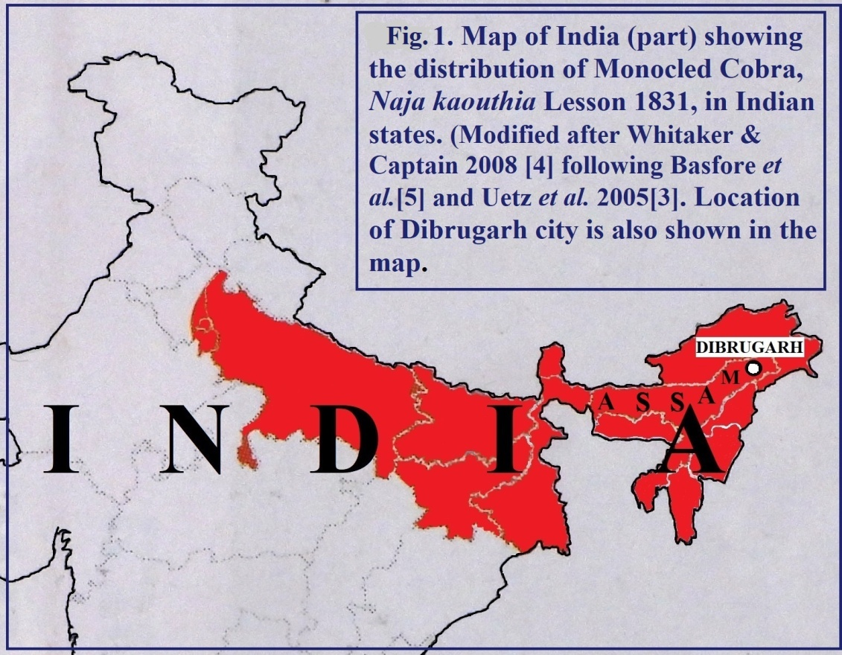

Fig.1. Map of India (part) showing the distribution of Monocled Cobra, Naja kaouthia Lesson 1831, in Indian states and location of Dibrugarh city, Assam .

Naja kaouthia assumed to be capable in reproducing most of the year depending upon geographical area. It exhibits dissociated type of reproductive pattern in which males mate at a time when their gonads are quiescent and the level of sex steroids are low in blood [7]. Mating of this oviparous species takes place during winter to summer months [8, 13]. Southern population normally has a reproductive period from January to March and in some cases up to the month of July [9, 10]. Mating in captive Naja kaouthia observed in Poland from late autumn to early winter (11th October to 29th December). Periods of egg deposition vary [12]. Females lay clusters of eggs from October to March [2,9,10,14,20,21,22,23]. Egg laying in Plock Zoo took place after the last day of mating in December to 19th March [11]. The time period from mating to egg laying was recorded as 76 (61-111) days [11].
Naja kaouthia lays eggs in root holes, rodent holes, dry mounds, caves etc. [9,13,14]. A female laid eggs in a ‘nest’ measuring 20 cm. diameter, 55 cm. circumference and 62 cm depth formed in a decaying root hole [15]. However it is also noted that eggs may be laid anywhere [19].
Number of eggs in a clutch of this species may be 8 to 43 [9,10,11,13,14, 15,16,18,19]. However the number of eggs laid by a female in one brood is up to 45 in Indian Cobra (Naja naja), the sympatric sister species of Monocled Cobra [17]. There is also a record of 7 clutches in 7/8 years from the first year of egg laying by Naja kaouthia with an average number of 30 eggs per clutch [11].
Measurement of 9 eggs of Naja kaouthia of a clutch had the average length of 47.45 mm (range 42.74mm to 51.27mm, n= 9) and width 24.86 mm ( range 20.8mm to 28.30mm, n =9) [ 15].The measurement shows a length breadth ratio of 1.90 of the the average values.
Females of Monocled Cobra generally stay with eggs and guard the eggs until they hatch [4,9,10,21,22,23,24]. There was a report of a female found guarding a nest inside a hole of a decaying root [15]. Captive females were also seen to remain with the clutch [11]. However, some collaboration between males and females has also been reported in the hybrid of Naja naja and Naja kaouthia [20]. It is reported that in natural condition snakes abandon the nest before hatching of the eggs [9].
In Monocled Cobra there are records of incubation period of 50 to 73days [10, 16, 22, 25]. At 28⁰C temperature incubation period of captive Naja kaouthia was recorded to be 61-69 days [18]. There are also records of incubation period of 51-69 days in 33⁰C. (approximately) [26,27]. In captivity hatchings occurred in 50-60 days when eggs were kept in 84-86⁰C.with 70-80% humidity and sometimes it took 4-5 day for an entire clutch to hatch [19]. New born snakes are seen from summer to most of the monsoon period [13].In Assam, hatchlings were observed in August [20] and in a case in Mizoram it was recorded to be 3rd September [15]. There was another case where young found hatched after an average of 51 days (48 - 54 ) with a hatching success rate of 39. 5 (n= 476)[11]. Further there were instances of hatching 57% eggs of Monocled Cobra in captivity under monitored environmental condition [25].
Naja kaouthia has comparatively thin and fragile egg membranes. In captive condition damage to the outer cover of eggs was done by cockroaches [11]. Fungal infection was commonly seen in captivity. Hatching percentage may also be reduced by unfertilized eggs or damage of eggs by fungal infection [15].
Length of newborn snakes were measured from 20 to 35 cm.[13]. Both dark coloured and bright coloured hatchlings were seen to hatch [11].Cannibalistic behavior is also reported in juveniles of Naja kaouthia [11,15].
There are records of four observations by the author similar to the case presented in this communication on breeding biology of Monocled Cobra related to breeding microhabitat, clusters of eggs, juveniles and two concerned adults in Dibrugarh City and nearby areas. Of the 4 cases the 1st one was at Maijan Road (‘Rail line’) Paltanbazar area of the City on 2nd the Aug. 2017, the 2nd one was from Bongalmora area of the city, in the last part of October, 2023 which is reported in the present communication, 3rd one was from Bonpitha of Mohmari, a place towards the south of the City on July 30, 2024 and the 4th one was from Lekai, a nearby area of Dibrugarh City. Measurements of an egg of the egg cluster of the 4th case gives the approximate values of length 4.64 cm, breadth, 2.66 cm. length breadth ratio 1.74 and weight 22 gram (unpublished). It was a egg detached during collection of the cluster. Measured with care and least handling and movement of the egg. No attempt was made to clean the sand soil particles attached to it to avoid any probable adverse effect to the developing embryo. Observations in all four cases were made possible by calls for rescue of the snakes from rat hole networks of earthen floor of the houses of the residents. The present communication is related to the 2nd case of the observations from Bongalgaon area of Dibrugarh city in the last part of October, 2023. It is expected that the findings will help in our understanding the breeding biology of Monocled Cobra in Assam.

2.material and methods

2.1.Dibrugarh City: Dibrugarh City, headquarters of the administrative district of Dibrugarh, Assam in the North Eastern region of India is located on the south bank of the Brahmaputra [28]. The coordinate of geographical location at Chowkidingi Chariali, a central place of the city is 27⁰28’North latitude and 95⁰30’East longitude. The city is at 104.24 meters above the mean sea level (MSL).The master plan area of Dibrugarh cirty is 66.14 sq. km. and its population is 1,86,214 persons in 2014 [29]. However, the land area and total population of the present Dibrugarh city were 15.5 sq.km. and 1,46,122 persons ( as per 2011 census) respectively [31].
Dibrugarh city experiences subtropical monsoon climate with mild winter, warm and humid summer and high rainfall. Average rainfall and rainy days in Dibrugarh City for 30 years (1981-2010) were 260.9 mm and 128. 5 Days respectively.Average annual minimum and maximum temperature (Degree centigrade) in Dibrugarh City for 30 years (1981-2010) are 18.8 and 28.1 respectively[30a].. Temperature history in 2023 at Dibrugarh Airport is represented in Figure 2. [30b].

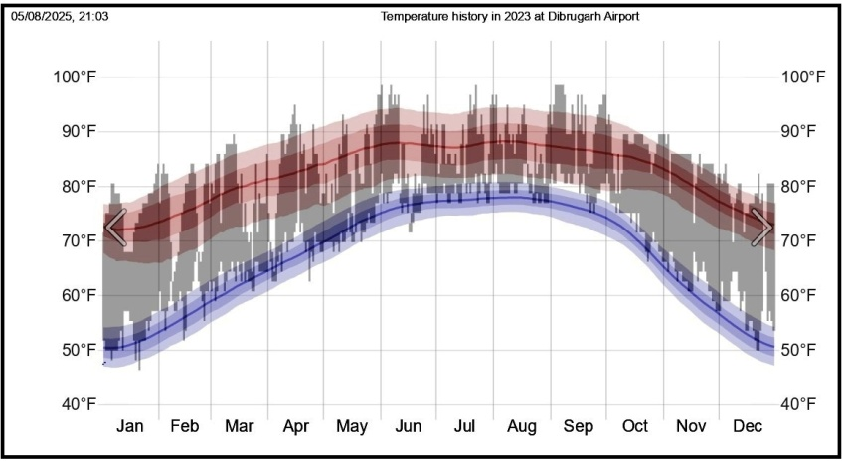

Figure 2. Figure showing the Temperature history in 2023 at Dibrugarh Airport (Source: Indian Meterology Department [30b]

Relative humidity during rainy season is about 88%. The climatic condition of Dibrugarh City can be devided into 4 seasons viz. winter, pre-monsoon, monsoon and retreating monsoon [31]. The humid subtropical climate of Dibrugarh city with extremely wet summers and relatively dry winter can be referred to as Cwa in Koppen climate classification [32]. The City and the district as a whole situated on the alluvial flood plains of the mighty Brahmaputra river. Residential areas including the vegetation of residential gardens and road side vegetation of the City are interspersed by small forest pockets and tea garden vegetation with bamboo plantation besides a few vanishing wetlands. Peripheral regions of the city are dominated by human habitation, forest areas, tea gardens and some riverside low lands vegetations. Jokai Reserve Forest with an area of 800 hectors (approx.) is 10.2 Km. away in the South direction of Dibrugarh city.

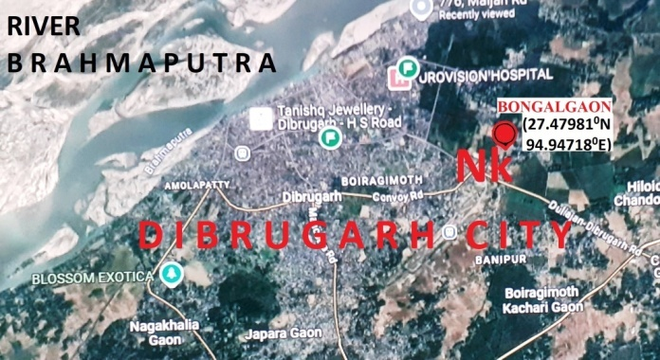

Fig.3.. Google Map of the Dibrugarh city (part), Assam, showing the location of the site of Naja kaouthia (Nk) at Bongalgaon.

2.2.Monocled Cobra in Dibrugarh City :
Dibrugarh city and nearby places can be called the home of Monocled Cobra (Naja kaouthia). There are nearly 50 records of Naja kaouthia individuals in this area from more than 45 (forty) localities. The records include personal observation, rescue records and information received with photographic evidences by the present author, snakes rescued by the Forest Range Office persons and other persons in the city and some nearby places in the district.
The present author observed cluster of empty egg shells and hatchlings of Naja kaouthia on 22th and 23rd Aug. 2023 at the residence of Rajib Jaiswal (27.47981⁰N,94.94718⁰E in Bongalgaon area of Dibrugarh City, Dist. Dibrugarh, Assam (India). The microhabitat was network of rat holes under the cemented earthen floor in two rooms of the house with bamboo walls used by the family as living room. (Fig.3,4) The surroundings of the house include grass covered low land in the North, half constructed R.C.C.house and an open area in the south, the road and a residential house in the East and a forest pocket with bamboo plants in the west side.

2.3.Field Observation:
The present author was informed on the 6th October, 2023 that a Cobra snake is seen in the residence Rajib Jaiswal coming out of and entering through an opening of the floor of their living room. It was reported that, n the 22nd October, Cobra hatchlings were seen and the adult Cobra spitted poison on the hand of the house wife. On the same day afternoon a Cobra hatchling was captured by a member of the family. The present author, on request visited the house for rescue of the snakes and saw the openings of the rat holes in the broken floor used by the adult snake for entering and coming out. A 2nd hatchling was also rescued. Shaded skin of an adult snake was also found at the corner of a room. In the morning of the 23 rd. Oct.2023 the present author visited the site and was informed that three other Cobra hatchlings (3rd, 4th and 5th) escaped to the surroundings from the house. The family decided to break the cemented earthen floor to expose the rat holes for rescue of the adult snake and hatchlings (if any) and to repair the floor for safety. The present author advised the family to contact Forest Range Office, Dibrugarh, Assam for cooperation.

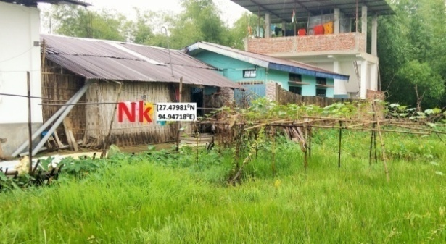

Fig.4.. Picture showing the location of the site (house) of Monocled Cobra, Naja kaouthia (Nk) and its environment at Bongalgaon in Dibrugarh city, Assam.

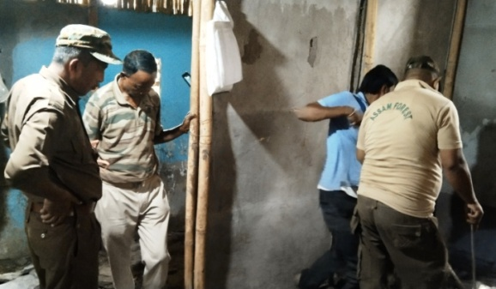

Fig. 5.. Picture showing persons from the State Forest Department and the owner of the house at the time of breaking the floor to expose the network of rat holes, the shelter of Monocled Cobra Naja kaouthia in the house (Nk) at Bongalgaon.

On the 25th Oct.’23 the cemented earthen floor of one room was broken and all the inter connected rat holes were exposed in presence of the forest dept. persons viz. Mr.Jitu Hazarika, Ms.Minati Deori, Mr.Ranjan Kumar Gogoi, Ms.Lipika Das and Mr.Sunil Sonowal (Fig. 5).

2.4.Egg shells and Juveniles :
A cluster of 24 empty eggshells was un recovered (Fig. 6). In the afternoon of the day two more Cobra hatchlings (6th and 7th) were rescued. The floor of the 2nd room was also broken on the 26th Oct. but neither adult nor juvenile cobra could be rescued and no more egg shell cluster recovered. Altogether 7 (seven) hatchlings could be recorded out of which three escaped to the surroundings and four were rescued and released through the forest department. The linear measurement and weight of the 24 egg shells were recorded (Fig. 7).
The four Monocled Cobra juveniles were photographed and colouration and markings of the head and neck were noted before release. The juveniles were released in the wild under the supervision of the authorized persons of Forest Range office, Dibrugarh (State Forest Department, Govt. of Assam) in the Jokai Reserved Forest at a point (27.3918, 94.9322) adjacent of the Jokai Forest Beat Office.

3. results and discussion
3.1 Egg Shells :
All 24 egg shells attached in the cluster were examined. Egg shells were empty with similar and characteristic opening indicating 100% hatching of eggs. They were irregularly inflated. Length and breadth of all irregularly inflated egg shells were measured using vernier calipers. Although the length, breadth of the irregularly inflated egg shells cannot be considered to be the actual size the eggs. However the measurement and ratio of the average values can give an idea of the relative size of the eggs of the egg cluster. The average values of the length and breadth and the ratio of the 24 irregularly inflated eggs are given in the Table1.

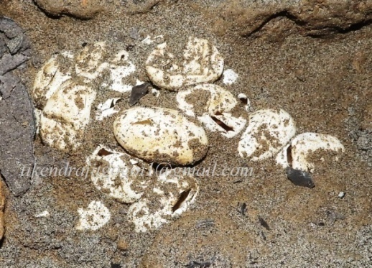

Fig. 6.. Picture of the cluster of empty egg shells of Monocled Cobra, Naja kaouthia in soil of the rat hole network under the floor of the house at Bongalgaon, Dibrugarh city, Assam.

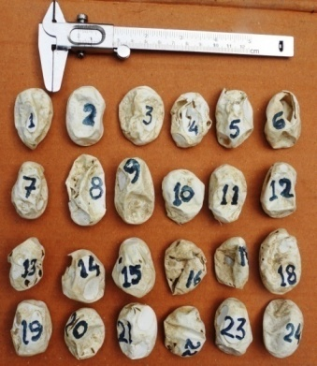
Fig. 7. Picture of the 24 empty egg shells of Monocled Cobra, Naja kaouthia recovered from the rat hole network.

The average values of the length and breadth of the 24 irregularly inflated eggs were- Mean length 4.21 (range 3. 60 to. 5.15 ), width 2.84 ( range 2.22 to 3.30) and average wt. 0.58 gram. This shows a length breadth ratio of 1.48. (Table 1.) The measurement can be compared with that of 9 eggs of Naja kaouthia of a clutch with average length of 4.74 cm ( range 4.27 cm to 5.12 cm.), width 2.48 cm ( range 2.08 cm to 2.83 cm.) and the average length breadth ratio of 1.90 following Lalmuansanga et al., 2020 [15]. There was a recent finding from an egg by the present author (unpublished) gives the length 4.64 cm, breadth, 2.66 cm. length breadth ratio 1.74 and weight 22 gram (Chapter 1.2).

Table.1.
Table showing the length and breadth of 24 empty, open and deformed egg shells of the cluster of eggs of the Naja kaouthia recovered from rat hole of the earthen floor of a house in Bongalgaon, Dibrugarh City, Assam (India).

N. | L. | B. | N. | L. | B. | N. | L. | B. | N. | L. | B. | A.L. | A.B. | L.B. ratio | A.W.
1 | 4.45 | 2.70 | 7 | 4.10 | 2.50 | 13 | 4.10 | 2.50 | 19 | 4.20 | 2.60 | 04.21 | 02.84 | 1.48 | 0.58
2 | 4.25 | 2.80 | 8 | 5.15 | 2.75 | 14 | 3.75 | 3.15 | 20 | 3.90 | 2.80
3 | 4.20 | 3.30 | 9 | 4.85 | 2.85 | 15 | 4.25 | 3.20 | 21 | 4.05 | 3.00
4 | 4.10 | 3.00 | 10 | 4.00 | 3.00 | 16 | 4.05 | 3.10 | 22 | 3.60 | 3.20
5 | 4.45 | 2.80 | 11 | 4.20 | 2.40 | 17 | 3.90 | 2.90 | 23 | 4.35 | 2.70
6 | 4.00 | 2.70 | 12 | 4.20 | 2.22 | 18 | 4.75 | 3.20 | 24 | 4.20 | 2.90

(Notes : L=.Length (cm), B= Breadth (cm.), W=Weight (gm.), A=Average, N =Serial Number. (n= 24).

3.2. Juvenile colouration and markings: The 4 juveniles observed had bright colouration with characterstic hood markings and throat markings. Dorsum of all 4 juveniles 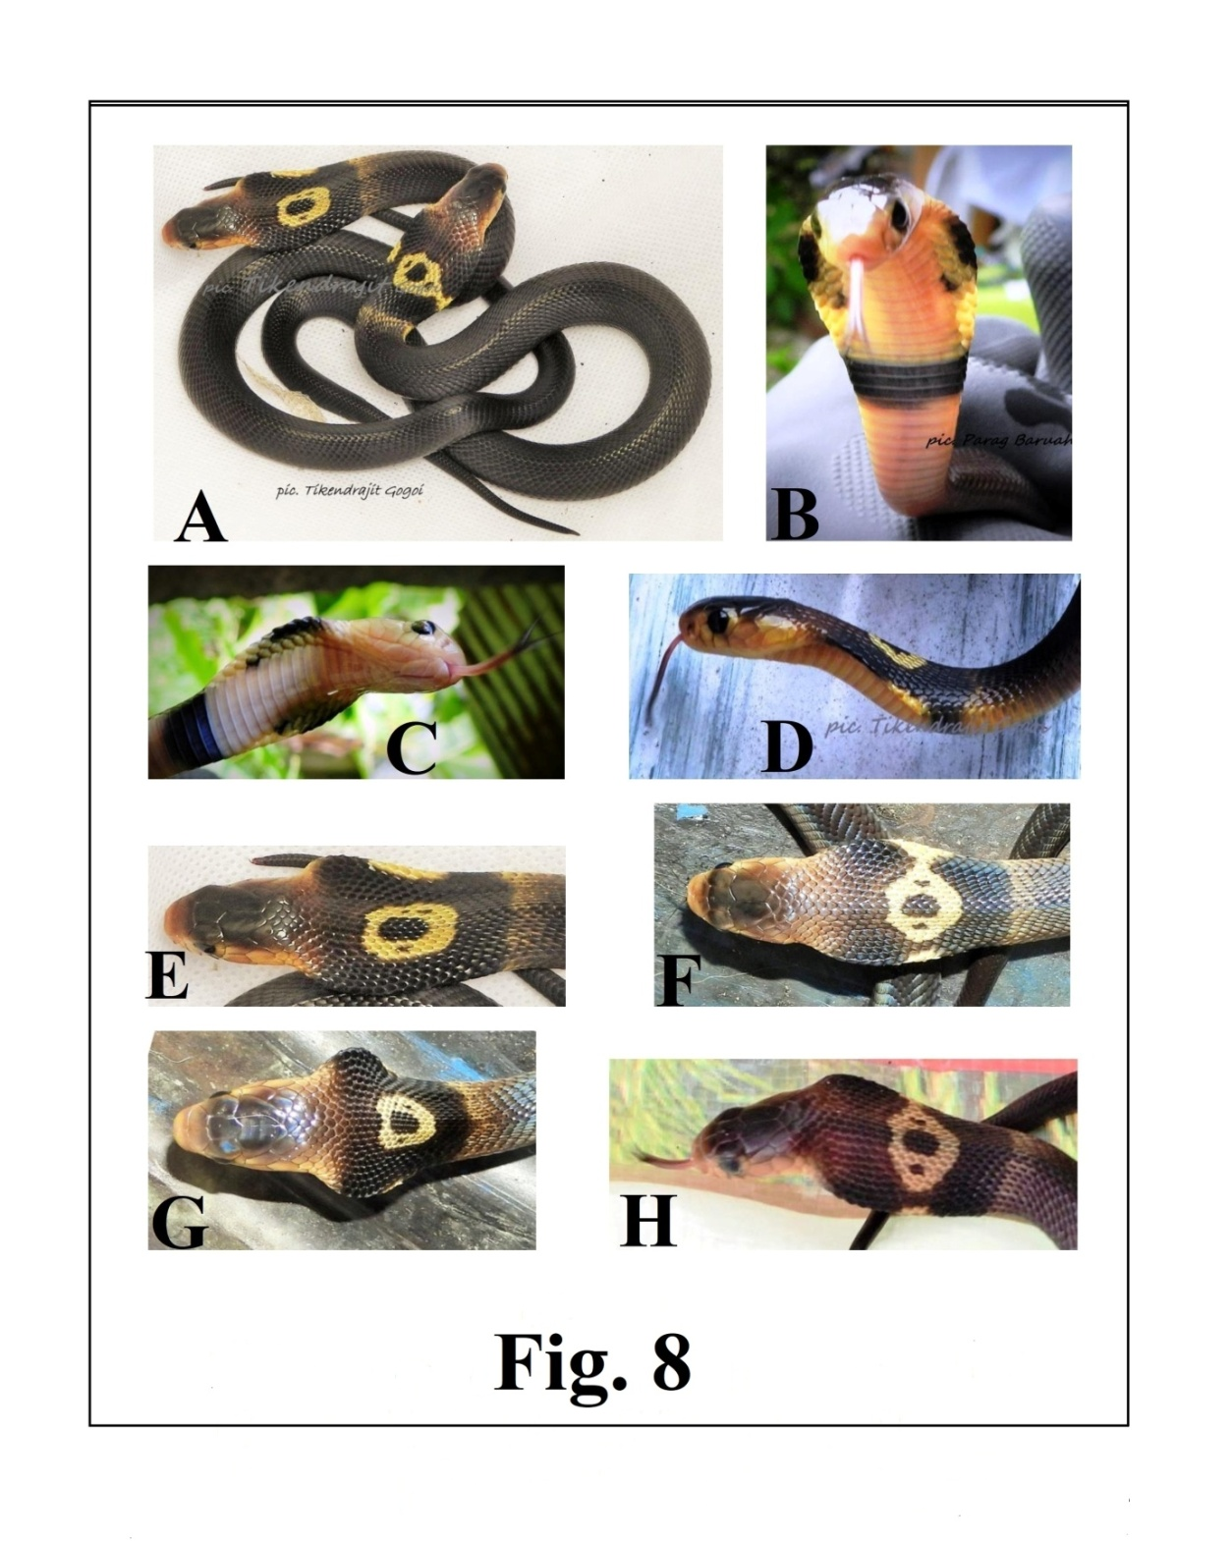
Fig. 8 (A,B,C,D,E,F,G,H) Pictures of the juveniles of Monocled Cobra, Naja kaouthia showing colouration and markings.

were uniformly black (Fig. 8A). The colouration of the juvaniles are brighter than the colours of the adults with similar colour observed earlier by the present author. The adult Monocled Cobras observed earlier in Assam by the present author had yellowish, brownish, olivaceous, grey or black dorsum sometimes with ragged bands.
Common distinct markings in the head and neck region of the juveniles include (a) typical central hood marking in the neck, (b) lateral yellow marks in both sides of the hood mark, (c) Transverse light band in the neck behind the hood mark, (d) Black ventral band in the neck region and (d) black paired spots in the ventral side of the neck (hood).
Typical central hood marks are with yellow peripheral part, a black central area and two black spots in the yellow part in both sides of the black area. The black spots in the yellow part may be broken into two smaller spots. (Plat 1. A, E). Lateral yellow marks in the sides of the hood mark may be merged with the central yellow part. (Fig. 8 A, F ). Ventral side of the hood is pinkish white with yellow colour in both sides (Fig. 8 B, C).. In the widest part of the hood there are marginal black elongated region in both sides. (Fig. 8 B,C ). Towards the inner and lower part of these two lateral black regions there are two black spots on each side (Fig. 8 B,C). There is a black ventral band in the throat at the lower part of the hood (Fig. 8 B,C).
The yellow periphery of the hood mark extend anterior posterior between 8th to10th and 17th to 21st transverse row of dorsal scales and transversely covering 12 to 20 longitudinal rows. Almost oval, anterior posterior elongated central black mark extends from 11th to 16th transverse rows covering 4 to 6 rows longitudinally. Lateral yellow area in both sides of the hood mark covering up to 7 transverse rows of dorsal scales correspond 11th to 13th dorsal rows of such scales. The faint transverse band in the neck region behind the hood mark extends from 21st to 23rd transverse rows of dorsal scales. The black ventral band in the neck region covers 16th to 19th ventral scales and corresponds to 23rd to 25th transverse rows of dorsal scales.

4.CONCLUSION

The microhabitat of the breeding of Monocled cobra in the present case of field observation is considered to be a semi wild condition where the snake breed naturally in rat holes under a human house cover. This was the 2nd of the 4 similar case of egg lying by Naja kaouthi in Dibrugarh City and nearby areas documented by the present author. Adverse biotic and abiotic conditions including microbial infections, predators, desiccation, submergence under water etc. were absent in this microhabitat. Under the circumstances in this semi natural environmental condition and absence of any spoilage of eggs during development, there was a 100% success of hatching of the 24 eggs of Monocled Cobra could be possible. All 4 normal juveniles are with bright colouration, and typical markings in the head and neck region. Selection of such microenvironment for breeding has an adaptive value for the species in rural environment.

DISCLAIMER

The author hereby declares that no any kind of assistance of AI technique was used during the preparation of this manuscript.

ETHICAL ISSUE

No experiment was conducted with the animals. To avoid the risk of physical injury and to minimize their stress no attempts were made to handle the rescued juveniles for measurements, scale count and sex determination. The four Monocled Cobra juveniles were rescued, photographed and released in the wild under the supervision of the authorized persons of Forest Range office, Dibrugarh.The shells of 24 empty eggs were deposited to the State Forest Department being the custodian of wildlife resources.

REFERENCES

1.Mohapatra,P.P., Ray, S., Sarkar, S., Deuti, K., Palot, M.J., Sethy, P.G.S. & Bahuguna, A. (2024).
Fauna of India Checklist Chordata : Reptilia, Online Version 1.0. Zoological Survey of India,
1-41.

https://zsi.gov.in › english › 119_REPTILIA /04/08/25.
2.Wallach, V., Williams, K.L. & Boundy, J. (2017). Snakes of the World A Catalogue of Living and
Extinct Species (1st ed.). CRC Press.
3.Uetz, P., Hallermann, J. & Hosek, J. (2025). The Reptile Database.
https://reptile- database.reptarium.cz/species?genus=Naja&species=kaouthia
/03/8/25.
4.Whitaker, R. & Captain, A. (2008). Snakes of India The Field Guide (1st ed.). Draco Books,
Chennai.
5.Basfore, B. Kalita, M. J., Sharma, N. & Boro, A. R. (2024). An updated checklist of snakes
(Reptlia: Squamata) in northeastern India derived from a review of recent literature. Journal
of Threatened Taxa 16(11), 26131–26149.
6.Shi, S.-Chao, Vogel, G., Ding L., Rao, D.-Qi, Liu, S, Zhang, L. et al. ( 2022). Description of a
New Cobra (Naja Laurenti, 1768;Squamata, Elapidae) from China with Designation of a
Neotype for Naja Atra. Animals 12(3481),1-31.
7.Tumkiratiwong, P., Meesuk, W, Chanhome, L. & Aowphol, A.(2012). Reproductive Patterns of
Captive Male and Female Monocled Cobra, Naja kaouthia (Lesson, 1831). Zoological
Studies 51(5), 692-700.
8.Csurhes, S. & Fisher, P.(2016). Cobra (all species) Invasive animal risk assessment. Queensland
Government, Australia. chrome-extension://efaidnbmnnnibpcajpcglclefindmkaj/https://www.daf.qld.gov.au/__data/assets/pdf_file/0003/51996/IPA-Cobra-Risk-Assessment.pdf /03/8/25
9.Ratnarathorn, N.( 2019). Regional Variation of the Monocled Cobra Naja kaouthia Lesson, 1831
(Squamata:Elapidae), in Thailand: Development, Temperature Effects, Environment, and
Phylogeny. Final Ph.D.Thesis. University College London. https://www.researchgate.net/publication/331430490_Regional_Variation_of_the_Monocled_Cobra_Naja_kaouthia_Lesson_1831_Squamata_Elapidae_ in_Thailand_Development_Temperature_Effects_Environment_and_Phylog
eny /03/8/25)
10.Anonymous 1.(2025). Monocled Cobra, Mating Habits. Online Animal Encyclopedia. https://animalia.bio/monocled-cobra#google_vignette/3/8/25.
11.Kopczynski, J.( 1993). Breeding and exhibiting the Monocellate cobra Naja kaouthia at Plock
Zoo. International Zoo Yearbook 32(1),197 – 204. DOI:10.1111/j.1748-1090.1993.tb03535.x
/3/8/25).
12.Das, S. & Biswas, A.(2017). Notes on the breeding ecology of monocled
cobras (Naja kaouthia) from areas adjacent to Sundarban, India. The
Herpetological Bulletin 140, 33-34.
13. Purkayastha, Jayaditya (2025). India Biodiversity Portal Naja kaouthia Lesson, 1831, Species.https://indiabiodiversity.org/species/show/227801 /03/08/25.
14. Cox, M. J. (1991). The Snakes of Thailand and Their Husbandry.(1st.ed) Krieger Public Company
Limited. Florida, U.S.A.
15. Lalmuansanga, Lalbiaкzuala, Lalrinsanga, Vanlalchhuana M., Hmar G.Z., Vanlalhrima,
Romalsawma et al.( 2020). Naja kaouthia (Monocled Cobra) Diet and Reproduction.
Herpetological Review.Natural History Notes 356.
https://www.researchgate.net/profile/Ht-Lalremsanga/publication/341987210_Naja_kaouthia-_Diet_and_Reproduction/links/5edc8e32299bf1c67d4ad849/Naja-kaouthia-Diet-and-Reproduction./03/08/25.
16.Das, I. & Das, A. (2025). A Naturalist’s Guide to the Reptiles of India, Bangladesh, Bhutan,
Nepal, Pakistan and Sri Lanka, Prakash Books India Pvt.Ltd. New Delhi, India.
17.Palot, M. J. and Santhosh, K. (2021). Record Clutch Size for an Indian Cobra, Naja naja (Linnaeus
1758). Reptiles and Amphibians, 28(3),494.
18.Strimple, P. (1992). Incubation and Hatching of Monocled Cobra Eggs. Litteratura Serpentium 12
(4).100 chrome-extension://efaidnbmnnnibpcajpcglclefindmkaj/https://www.snakesociety.nl/jaargangen/1992e/Litteratura%20Serpentium%2012-4%20100%20Strimple,%20Incubation%20and%20hatching%20of%20Naja%20naja%20kaouthia%20eggs.pdf/03/8/25.
19. Beard,W.(2011). Captive Care and Breeding of the Monocle Cobra Naja naja kaouthia. 1-5.
www.venomous reptiles.org/articles/449. /03/8/25.
20.Wüster, W. (1998). The Cobras of the Genus Naja in India. Hamadryad. 23 (1), 15-32.
21.Ahmed, M.F., Das, A. & Dutta, S. K.(2009). Amphibians and Reptiles of
Northeast India A Photographic Guide. (1st ed.) Aaranyak, Guwahati, India.
22.Das, I.(2008). A Photographic Guide to Snakes and other Reptiles of India (2nd
ed.) New Holland Publishers (U.K.) Ltd.
23.Whitaker, R.(2010). Common Indian Snakes A Field Guide (2nd ed.). Macmillan Publishers India. 24. Mattison, C.(2007). The New Encyclopedia of Snakes. Princeton, N.J : Princeton University
Press New York, United States of America.
25. Chanhome, L., Jintakune, P., Wilde, H. & Cox, M.J.( 2001). Venomous snake husbandry in
Thailand. Wilderness and Environmental Medicine,12,17-23. 26.Jackson, K.( 2002). Post-
ovipositional development of the monocled cobra, Naja kaouthia (Serpentes: Elapidae). Zoology, 105, 203-214. https://www.researchgate.net/publication/7417855_Post-
ovipositional_development_of_the_Monocled_cobra_Naja_kaouthia_Serpen
tes_Elapidae. /03/8/25.
27.Jitakune, P. (2004). งูพิษในประเทศไทย 2 (Venomous Snakes in Thailand 2).Bangkok, Thailand:
Matichon Book Publishing. (in Thai).
28.Das, S., Mili,U. & Bora, P. (2020). An overview of Urban Flooding in
Dibrugarh Town, Assam. PJAEE, 17(9), 7825-7836.
29. Anonymous (2025). Dibrugarh University. https://dibru.ac.in/about- dibrugarh /04/8/25.
30a. Anonymous (2025). Indian Metrological Department. "Dibrugarh Climatological Table 1971– 2000". https://city.imd.gov.in/citywx/extreme/JAN/dibrugarh2.htm
30b. Anonymous (2025). Indian Metrological Department https://weatherspark.com/h/y/149049/2023/Historical-Weather-during- 2023-at-Dibrugarh-Airport-Assam-India#Figures-Temperature
31.Anonymous (2025). City Disaster Management Plan (Dibrugarh), District Disaster Information &
Response Center, D.C’s.Office, Dibrugarh. https://www.asdma.gov.in>pdf>Dibrugarh
City/04/8/25.
31. Peel, M. C., Finlayson, B. L. & McMahon, T. A. (2007). Updated World map of Koppen-Geiger
climate classification. Hydrology and Earth System Sciences. 11 (5), 1633-1644)
.DOI:10.5194/hess-11-1633-2007/04/8/25.

