Original Research Article
Assessing Public Interest in Biodiversity and Wildlife Conservation through Google Search Trends in India

.
ABSTRACT
This research article aims to analyze long term Google search behaviour by the public which can be taken as a proxy for public interest in various biodiversity and conservation related topics over a ten-year period across India and globally.
In the current study, a set of 20 relevant keywords or search terms in English relating to Biodiversity and Conservation were selected and Google search volumes were extracted for a period of 10 years, from January 2015 to December 2024 (i.e., 120 months) for both India and the world for comparison. The Google search volume was analysed using non-parametric Mann-Kendall test for detecting the trend and Sen’s slope for detecting the magnitude of the trend. Additive Decomposition model was employed to decompose a time series and breakpoints were identified.
From January 2015 to December, 2024, most Biodiversity and Wildlife Conservation related terms showed an overall rising trend in India and globally. However, In India, ‘environment’, ‘endangered species’, and ‘wildlife trafficking’ lacked significant trends. A decline in search interest for the terms ‘deforestation’ and ‘extinction’ were also found in Indian scenario. Peak Relative search volume in India clustered around and immediately after the COVID-19 pandemic. 18 terms showed significant structural breakpoints in their temporal trend. A phase wise temporal analysis revealed post-pandemic declines in search interest in India for eight terms. However, globally, only ‘biodiversity hotspot’ showed a similar decline in trend.

Keywords: Google Trends, Search term, Biodiversity, Conservation, Temporal trend

1. INTRODUCTION
Conservation effort largely depends on the public awareness and engagement which is often largely affected by various policies and awareness programs (Khatibi et al., 2021). On the other hand, support and engagement from the public end is also a prerequisite of the effectiveness of any biodiversity conservation program (Sarkar, 2005). Public engagement is traditionally being monitored through ‘questionnaire survey’ based method. However, conducting quality surveys over long time and throughout huge geographical region is difficult (Kelley, 2003). Moreover, internet searches have proven to be more effective than traditional survey methods for tracking the public’s interest (Ripberger, 2011)
“Google Trends” is a web based service by Google Inc. that tracks the popularity of terms entered in its search engine. The site delivers readily available normalised real time data from the inception of the service (year 2004) as the frequencies of search terms (Nuti et al., 2014). The report can be generated by different geographical locations and timeframe. The system gives the data by normalizing the search count against the total search volume for a specific term in the specified region at the specified time (Gamma et al., 2016). Online search pattern data from Google Trends is already being used as a probable method as the real time surveillance of disease outbreaks (Carneiro and Mylonakis, 2009; Chu et al., 2025; Wang et al., 2024); crime prediction (Gamma et al., 2016); Issue Salience (Mellon, 2014) and also public interest in conservation (Mccallum and Bury, 2013; Phillips et al., 2022; Souza et al., 2021).
With the introduction of mobile 4G internet services in India in 2012 and subsequent diffusion of network infrastructure, the usage of internet has grown rapidly in both urban and rural India. At the end of year 2024, as per the “Internet in India Report 2024," jointly published by the Internet and Mobile Association of India (IAMAI) and Kantar, India had a count of 397 million urban and 488 million rural internet users which is predicted to cross a total of 900 million in 2025. This rapid expansion of internet presents an opportunity to assess the public interest through aggregated digital data from online sources like Google. A person’s online search result relating to biodiversity (e.g. conservation or extinction) may indicate individual concern, interest and the percolation of awareness through News media or Government awareness programs. India, recognised as one of the 17 megadiverse countries, presents a unique opportunity to assess the evolving interests of the citizen of India regarding biodiversity and conservation topics throughout the decade.
Previously, Google search pattern data relating to Biodiversity showed negative trend for search terms like- ‘Conservation’, ‘Biodiversity’, ‘Environment’, ‘Ecology’, ‘Extinction, ‘Habitat Fragmentation’ and ‘Wildlife’ from 2004 to 2009 for worldwide set (Mccallum and Bury, 2013). However, ‘Conservation’ showed positive trend when back-adjusted to show the trend in total volume of searches (Burivalova et al., 2018). It is commonly viewed by the conservationists that general interest in conservation is declining, possibly due to the fatigue from constant appeals and overwhelming number of biodiversity and conservation projects and the mammoth amount of financial and voluntary support it demands. Public support is important for biodiversity conservation, and any observed decline in public interest is of major concern as policy changes and NGO-led efforts depend heavily on it (Ladle et al., 2016; Sarkar, 2005). In this context, conservation culturomics which is the use of large-scale digital data to understand public interest (Ladle et al., 2016) has emerged as a promising approach for identifying future trend. However, such study is lacking in Indian context. The current study focuses on 20 search terms related to biodiversity and conservation using Google Trend data to gauge online interest in these topics over the past decade years in India and worldwide. It further explores the temporal variation to identify any trend that may have future implication for conservation efforts.
The period under study includes COVID-19 pandemic outbreak in India, i.e from March 2020-the First wave to March 2022, the end of 3rd Wave. With the introduction of countrywide lockdown from March, 2020 (Ghosh et al., 2020) extending to the third wave which lasted from January 2022 till March 2022; a surge in digitalization and use of internet was experienced throughout the country due to social distancing norms, lockdowns, work from home and distance learning (De’ et al., 2020). The present study also aims to find any potential rising or declining trend of the search items during that period.

2. methodology
The search volume in Google was used as a proxy for examining the changes in public engagement for a period of 10 years (January 2015 to December 2024). Twenty specific words or phrases were selected and care was taken so that selected words or phrases represents major research areas of conservation biology and do not make any overlap or confusion with ‘non-conservation’ search keywords (Nghiem et al., 2016). The 20 keywords selected were: "biodiversity", "biodiversity hotspot", "biosphere reserve", "community reserve", "conservation", "deforestation", "ecology", "ecosystem", "endangered species", "environment", "extinction", "habitat fragmentation", "habitat loss", "national park", "protected area", "vulnerable species", "wildlife protection act", "wildlife sanctuary", "wildlife trafficking" and "wildlife". However, the limitations of search terms are they do not reflect the intend or motivation behind the search by the user (Burivalova et al., 2018).
Google Trends provides ‘adjusted’ search volume for a specific term and specific time window by calculating the proportion (p_{i}) of total searches for each month (i). The proportion (p_{i}) is calculated by dividing the total number of Google searches (a_{i}) for the specific term for the month (i) by the total number of all the searches for the same month (S_{i}). The proportion is thus calculated by: p_{i} = (a_{i}/S_{i}). The highest (p_{i}) of all the months in the search window is considered as (p_{max}) and all the rest of the months are scaled relative to the p_{max} by: g_{i}= (p_{i} /p_{max}) × 100. The popularity of a term is thus given in the Google Trends output by the (g_{i}) and scores between 0 (no search) to 100 (highest relative interest).
Google Trends relative search volume (RSV) data was extracted from Google Trends using Pytrends, a Python based unofficial interface for the Google Trends API (Application Programming Interface). Data was extracted for the timeframe of January 2015 to December 2024, for a total of 120 months. The Google search volume was analysed using non-parametric Mann-Kendall test using both R-package ‘Kendall’ and Python package pyMannKendall (Hussain and Mahmud, 2019) as the data in the time series were not normally distributed and not considering serial correlation or seasonal effects. Both package give the estimate of Tau statistics (τ) and 2-sided P value for significance. Theil-Sen's slope estimator, also known as Sen's slope estimator was used for the same data with pyMannKendall package to estimate the magnitude of the monotonic trend. The analysis was done for the whole time series (i.e 120 months) to get the overall picture and also performed for the immediate pre-pandemic period (25 months: Month 38-Month 62), Pandemic period (25 months: Month 63-Month 87) and immediate post pandemic period (25 months: Month 88-Month 112) separately. Plotting of trend was done using Exponential moving average (EMA) to smoothen variations in time series data and give more weightage to recent changes than long-term changes.

To identify statistically significant breakpoints in the time series of each search interest for topics, an Additive Decomposition model was applied with the help of R and the time series was decomposed into Trend, Seasonal and Residual components using a moving average with symmetric window. Ordinary least square (OLS) residuals-based MOving SUm (MOSUM) test were used to statistically substantiate the presence of one or more than one breakpoints. The breakpoints() function of ‘strucchange’ package was utilised on trend component after decomposition. These breakpoints are selected using minimum Bayesian information Criterion (BIC). 95% confidence interval was calculated around each breakpoint (Vijay et al., 2021; Zeileis et al., 2002).

3. results and discussion
The current data implies mostly clear pattern of increment in most biodiversity and conservation related search terms between January 2015 to December 2024 (120 months) both for India and the whole world. However, from the result of Mann-Kendall test it was found that the trend for the terms ‘environment’ (Tau=0.113, P=0.068, Slope =0.025) and ‘endangered species’ (Tau=0.088, P=0.446, Slope =0.025) were statistically not significant for any particular trend in India. The term 'wildlife trafficking' showed insignificant Sen’s slope (Slope =0), implying no significant trend.
Significant downward trends or decrease in search interest were found for ‘deforestation’ and ‘extinction’ in both India and world (all negative Tau and P<0.05). However, the number of Google searches for all the rest of Biodiversity and Wildlife Conservation related terms under the present study were found to be increasing in case of India. 16 search terms namely: 'biodiversity', 'biodiversity hotspot', 'biosphere reserve', 'community reserve', 'conservation', 'ecology', 'ecosystem’, ‘habitat fragmentation', 'habitat loss', 'national park', 'protected area', 'vulnerable species', 'wildlife protection act', 'wildlife sanctuary', and 'wildlife' exhibited statistically significant upward trend (positive Tau and positive Sen’s Slope, all P<0.05) (Fig 1.) and also evident from the smoothed temporal trend of 18 search terms (Fig 2.).The search interest for the whole world showed statistically significant increase for search terms namely 'biodiversity', 'biodiversity hotspot', 'biosphere reserve', 'vulnerable species', 'wildlife protection act', 'wildlife sanctuary', 'ecosystem', 'community reserve', 'habitat loss', 'protected area', 'wildlife trafficking', ‘habitat fragmentation’, ‘national park','environment', and 'conservation'. However, no statistically significant trend was found for the term: 'wildlife'. A decline in search interest were found for the whole world for the search terms: ‘deforestation’, ‘ecology’, ‘endangered species’ and ‘extinction’. The result of Mann-Kendall trend test (Tau value and with 2-sided P value) and Sen’s slope (s) is summarised in Fig 1. The trend of the search term in India mostly agrees with the trend of similar search terms in whole world. However, starkly opposite trend result was found for the term ‘ecology’ (Tau=0.319 in India vs. -0.233 World). Moreover, the term ‘environment’ showed increasing search trend worldwide (Tau=0.328, P=1.05E-07) whereas no significant trend was observed in India (Tau=0.113, P=0.068).

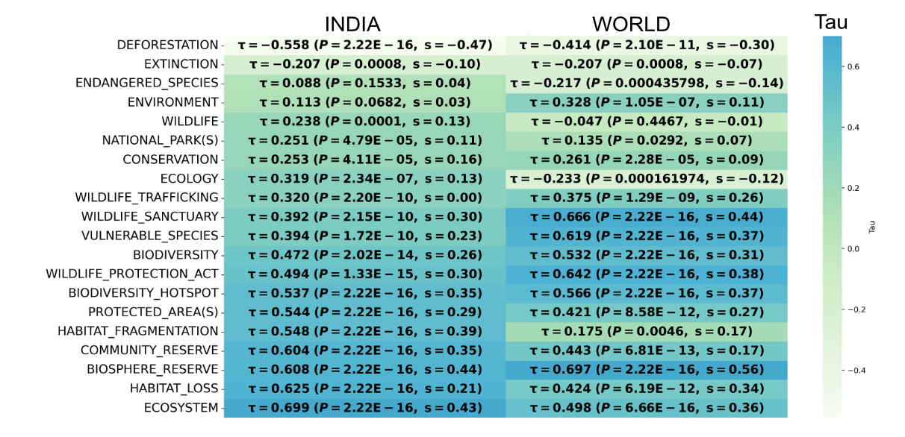

Fig. 1. Result of Mann-Kendall trend test on the 120-month search volume in Google using different keywords for both India and the world. The color of respective cells represents the value of Kendall’s Tau statistics (τ) which is also shown in brackets along with 2-sided P value and Sen’s slope (s). Darker blue shade represents stronger positive trend (high τ) and lighter green represents weaker or negative trend.

Months where the peak search volume (RSV=100) were attained for each term was identified for India in the exponential moving average (EMA) smoothed curves and it was observed that majority of trend peaks are concentrated around and after the period of COVID-19 pandemic (Month 63-Month 87) in India (Fig 2.).
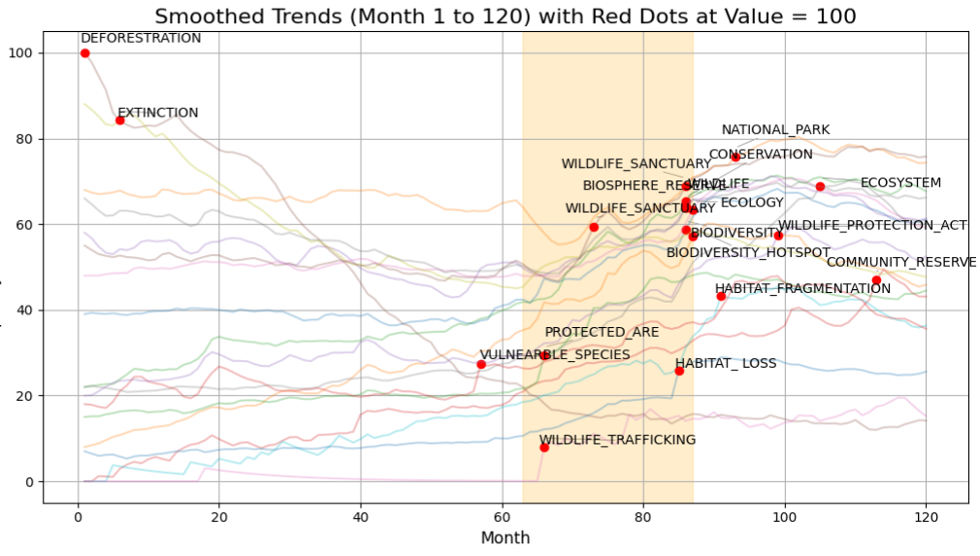
Fig. 2. Smoothed temporal trend of 18 search terms on which the red dots mark the peak raw RSV value (i.e 100). The orange-shaded region corresponds the COVID 19 Pandemic period in India.

To identify any breakpoint or changes present in the time series of each search term, Ordinary least square (OLS) residuals-based MOving SUm (MOSUM) test were performed. 18 search terms showed statistically significant MOSUM (value >2.00, P=0.02) indicating that there are significant structural breaks in the time series. It was found that 'biodiversity', 'biodiversity hotspot', 'biosphere reserve', 'community reserve', 'conservation', 'deforestation', 'ecology', 'ecosystem', 'habitat fragmentation', 'habitat loss', 'national park', 'protected area', 'vulnerable species', 'wildlife protection act', 'wildlife trafficking' and 'wildlife' one or two breakpoints within the pandemic period indicating a probable effect of pandemic period in overall search trends. Terms namely: 'community reserve', 'ecosystem', 'protected area', 'wildlife protection act' showed breakpoints after the pandemic period. The breakpoints of the time series for all the selected search terms are shown in Figure 3.
When the time series is divided into immediate pre-pandemic period (25 months: Month 38-Month 62), Pandemic period (25 months: Month 63-Month 87) and immediate post pandemic period (25 months: Month 88-Month 112), the result of Mann-Kendall trend test indicates a post-pandemic reduction in search interest for multiple search terms (Table 1.). None of the terms show a statistically significant decreasing trend during the Pandemic period (25 months: Month 63-Month 87). However, in India, topics namely: 'biodiversity', 'biodiversity hotspot', 'conservation', 'ecology', 'extinction', 'habitat fragmentation', 'habitat loss' and 'vulnerable species' started to show decrease in trend after pandemic period (Fig 2A, 2B, 2E, 2G, 2I, 2J, 2K, 2M and Table 1.). However, when compared, no such post-pandemic trend was identified in the world scenario, except the term ‘biodiversity Hotspot’ which showed significant downward trend (Table 1.). The current study indicated a change in public interest which happened mostly during and around the pandemic period. However, whether this emerging interest among the public is persistent or not is uncertain and can only be understood in future studies. The immediate decline in search interest after pandemic suggests that the surge may have been temporary.

Table 1. Result of Mann-Kendall trend test of Pandemic period (25 months: Month 63-Month 87) and Post Pandemic period (25 months: Month 88-Month 112) in India for the selected search terms. (●)=No trend, (↑) Increasing trend, (↓) Decreasing Trend

 | Pandemic period (INDIA)  (25 months: Month 63-Month 87) |  |  |  | Pandemic period (WORLD)  (25 months: Month 63-Month 87)
Search Term | Trend | p-value | Tau | Slope | Trend | p-value | Tau | Slope
Biodiversity | ● | 0.079 | 0.253 | 0.912 | ● | 0.454 | 0.11 | 0.273
Biodiversity Hotspot | ● | 0.282 | 0.157 | 0.667 | ● | 0.16 | 0.203 | 0.556
Biosphere Reserve | ↑ | 0.009 | 0.377 | 1.444 | ↑ | 0.002 | 0.447 | 1.613
Community Reserve | ● | 0.111 | 0.230 | 0.354 | ↑ | 0.022 | 0.33 | 0.364
Conservation | ↑ | 0.000 | 0.540 | 1.555 | ● | 0.497 | 0.1 | 0.118
Deforestation | ↑ | 0.006 | 0.387 | 0.500 | ↑ | 0.001 | 0.46 | 1.348
Ecology | ↑ | 0.000 | 0.527 | 1.000 | ● | 0.815 | 0.037 | 0.023
Ecosystem | ↑ | 0.000 | 0.563 | 1.268 | ● | 0.224 | 0.177 | 0.667
Extinction | ● | 0.981 | -0.007 | 0.000 | ● | 0.221 | -0.177 | -0.182
Habitat Fragmentation | ● | 0.083 | 0.250 | 0.583 | ● | 0.963 | 0.01 | 0.023
Habitat Loss | ↑ | 0.010 | 0.367 | 0.500 | ● | 0.315 | 0.147 | 0.397
National Park | ↑ | 0.000 | 0.557 | 2.130 | ↓ | 0.012 | -0.363 | -0.809
Protected Area | ↑ | 0.049 | 0.283 | 0.857 | ↑ | 0.013 | 0.357 | 0.69
Vulnerable Species | ● | 0.106 | 0.233 | 0.455 | ↑ | 0.035 | 0.303 | 0.536
Wildlife Protection act | ↑ | 0.042 | 0.293 | 0.945 | ↑ | 0.007 | 0.387 | 1.15
Wildlife Sanctuary | ↑ | 0.001 | 0.463 | 1.921 | ↑ | 0.001 | 0.48 | 1.388
Wildlife Trafficking | ● | 0.560 | 0.080 | 0.000 | ● | 0.59 | -0.08 | -0.121
Wildlife | ↑ | 0.003 | 0.430 | 1.417 | ● | 0.362 | -0.133 | -0.2
Search Term | Post Pandemic period (INDIA)  (25 months: Month 88-Month 112) |  |  |  | Post Pandemic period (WORLD)  (25 months: Month 88-Month 112)
Biodiversity | ↓ | 0.017 | -0.343 | -0.634 | ● | 0.815 | -0.037 | -0.028
Biodiversity Hotspot | ↓ | 0.018 | -0.340 | -0.857 | ↓ | 0.023 | -0.327 | -0.721
Biosphere Reserve | ● | 0.251 | -0.167 | -0.265 | ● | 0.425 | -0.117 | -0.2
Community Reserve | ● | 0.262 | 0.163 | 0.500 | ● | 0.482 | 0.103 | 0.172
Conservation | ↓ | 0.003 | -0.433 | -0.750 | ● | 0.888 | -0.023 | 0
Deforestation | ● | 0.480 | -0.103 | -0.065 | ● | 0.526 | 0.093 | 0.125
Ecology | ↓ | 0.001 | -0.490 | -0.913 | ● | 0.497 | -0.1 | -0.167
Ecosystem | ● | 0.215 | 0.180 | 0.500 | ● | 0.215 | 0.18 | 0.538
Extinction | ↓ | 0.000 | -0.547 | -0.425 | ● | 0.796 | -0.04 | 0
Habitat Fragmentation | ↓ | 0.035 | -0.303 | -0.707 | ● | 0.761 | 0.047 | 0.314
Habitat Loss | ↓ | 0.021 | -0.330 | -0.268 | ● | 0.207 | 0.183 | 0.764
National Park | ● | 0.106 | -0.233 | -0.437 | ● | 0.167 | -0.2 | -0.29
Protected Area | ● | 0.054 | -0.277 | -0.279 | ● | 0.303 | 0.15 | 0.5
Vulnerable Species | ↓ | 0.006 | -0.397 | -1.104 | ● | 0.146 | -0.21 | -0.38
Wildlife Protection act | ● | 0.708 | -0.057 | -0.162 | ● | 0.128 | -0.22 | -0.425
Wildlife Sanctuary | ● | 0.542 | -0.090 | -0.092 | ● | 0.888 | -0.023 | 0
Wildlife Trafficking | ● | 0.163 | 0.200 | 0.276 | ↑ | 0.000 | 0.563 | 1.586
Wildlife | ● | 0.205 | -0.183 | -0.293 | ● | 0.439 | -0.113 | -0.101
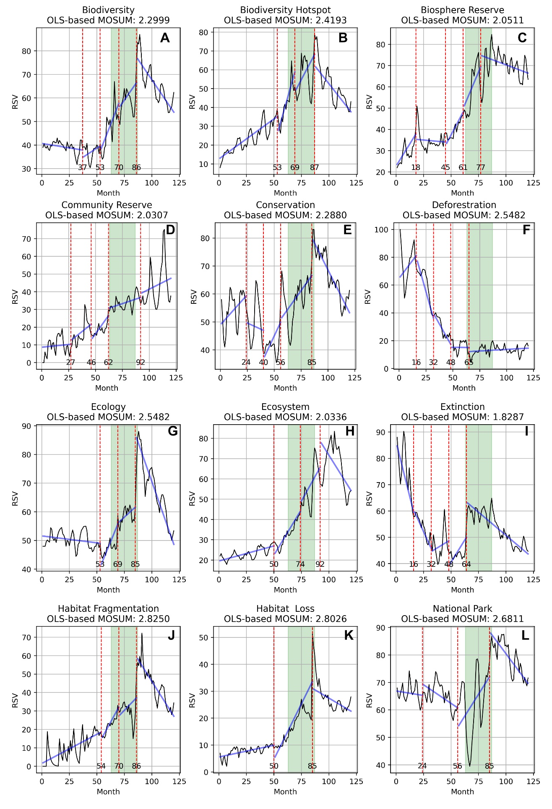
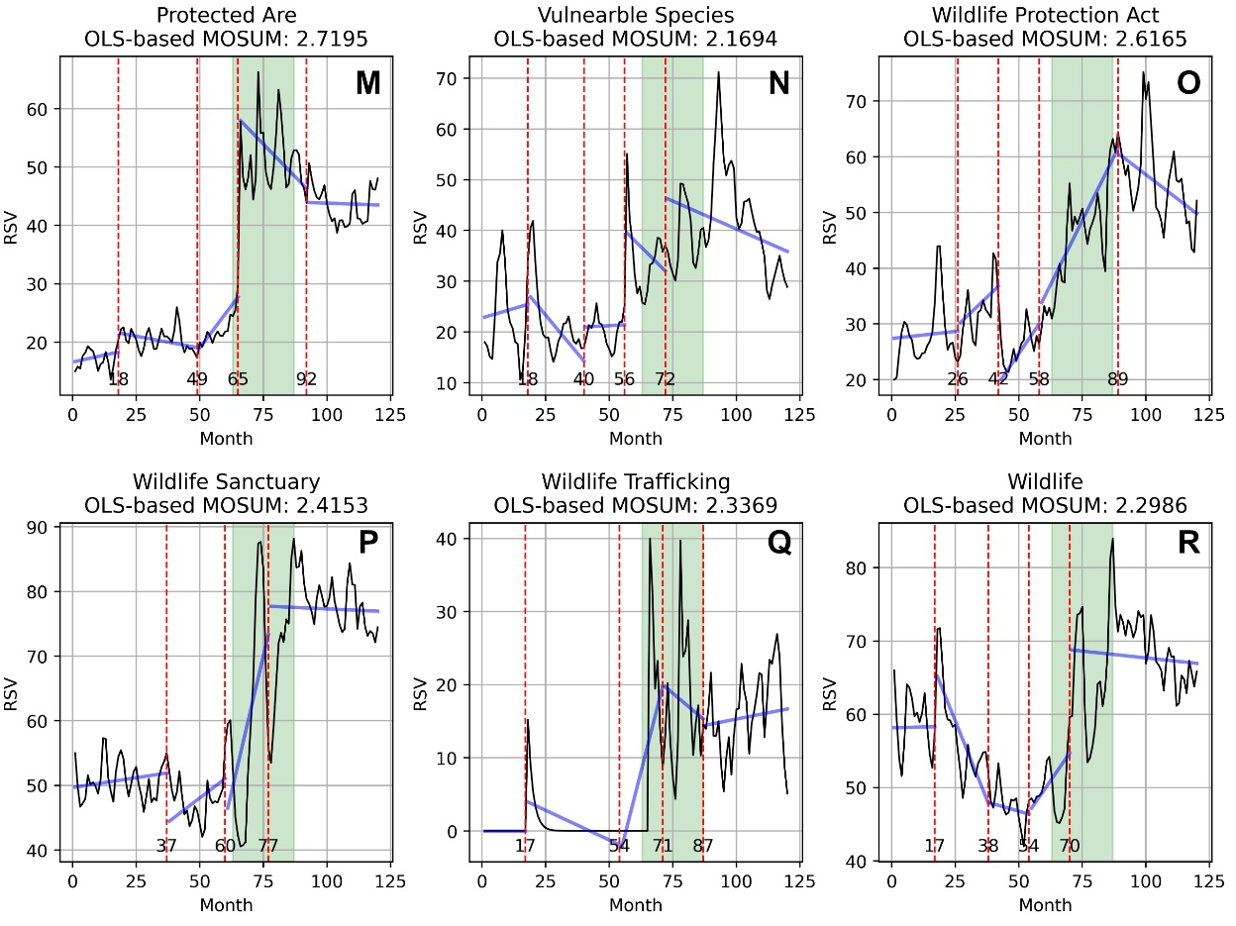
Fig. 3. Temporal trend of search terms and identification of significant breakpoints. The RSV for each search term is depicted by thin black lines, which are smoothed using Exponential Moving Average (EMA) to highlight underlying trend. Thick blue lines represent linear regression (Ordinary least squares Linear Regression) based on the actual RSV data. All the trends are significant for OLS-based MOSUM test, indicating presence of significant breakpoints in the trend. Breakpoints in the time series are denoted by red dotted lines with corresponding time (in months). The period corresponding to COVID-19 pandemic is represented by the time segment shaded in light green.

4. Conclusion

Analyzing Google Trends offers valuable insights into public interest and help to find thrust areas which need prioritization and popularization. The present study revealed a predominantly upward trend in public interest toward biodiversity and conservation-related topics over the past decade (January 2015 to December 2024), as reflected in Google search volumes for both India and worldwide. The current study also found a crisis driven rise in RSV of several biodiversity and conservation-related topics during pandemic in India and also identified sudden post-pandemic decline which needs monitoring in the coming years.

DISCLAIMER (ARTIFICIAL INTELLIGENCE)

Authors hereby declare that NO generative AI technologies such as Large Language Models (ChatGPT, COPILOT, etc.) and text-to-image generators have been used during the writing or editing of this manuscript.

Competing interests

Authors have declared that no competing interests exist.

References

Burivalova, Z., Butler, R. A., & Wilcove, D. S. (2018). Analyzing Google search data to debunk myths about the public’s interest in conservation. Frontiers in Ecology and the Environment, 16(9), 509–514. https://doi.org/10.1002/fee.1962
Carneiro, H. A., & Mylonakis, E. (2009). Google Trends: A Web‐Based Tool for Real‐Time Surveillance of Disease Outbreaks. Clinical Infectious Diseases, 49(10), 1557–1564. https://doi.org/10.1086/630200
Chu, A. M. Y., Tsang, J. T. Y., Chan, S. S. C., Chan, L. S. H., & So, M. K. P. (2025). Utilizing Google Trends data to enhance forecasts and monitor long COVID prevalence. Communications Medicine, 5(1). https://doi.org/10.1038/s43856-025-00896-6
De’, R., Pandey, N., & Pal, A. (2020). Impact of digital surge during Covid-19 pandemic: A viewpoint on research and practice. International Journal of Information Management, 55, 102171. https://doi.org/10.1016/j.ijinfomgt.2020.102171
Gamma, A., Schleifer, R., Weinmann, W., Buadze, A., & Liebrenz, M. (2016). Could Google Trends Be Used to Predict Methamphetamine-Related Crime? An Analysis of Search Volume Data in Switzerland, Germany, and Austria. PLOS ONE, 11(11), e0166566. https://doi.org/10.1371/journal.pone.0166566
Ghosh, P., Ghosh, R., & Chakraborty, B. (2020). COVID-19 in India: Statewise Analysis and Prediction. JMIR Public Health and Surveillance, 6(3), e20341. https://doi.org/10.2196/20341
Hussain, Md., & Mahmud, I. (2019). pyMannKendall: A python package for non parametric Mann Kendall family of trend tests. Journal of Open Source Software, 4(39), 1556. https://doi.org/10.21105/joss.01556
Kelley, K. (2003). Good practice in the conduct and reporting of survey research. International Journal for Quality in Health Care, 15(3), 261–266. https://doi.org/10.1093/intqhc/mzg031
Khatibi, F. S., Dedekorkut-Howes, A., Howes, M., & Torabi, E. (2021). Can public awareness, knowledge and engagement improve climate change adaptation policies? Discover Sustainability, 2(1). https://doi.org/10.1007/s43621-021-00024-z
Ladle, R. J., Correia, R. A., Do, Y., Joo, G., Malhado, A. C., Proulx, R., Roberge, J., & Jepson, P. (2016). Conservation culturomics. Frontiers in Ecology and the Environment, 14(5), 269–275. https://doi.org/10.1002/fee.1260
Mccallum, M. L., & Bury, G. W. (2013). Google search patterns suggest declining interest in the environment. Biodiversity and Conservation, 22(6–7), 1355–1367. https://doi.org/10.1007/s10531-013-0476-6
Mellon, J. (2014). Internet Search Data and Issue Salience: The Properties of Google Trends as a Measure of Issue Salience. Journal of Elections, Public Opinion and Parties, 24(1), 45–72. https://doi.org/10.1080/17457289.2013.846346
Nghiem, L. T. P., Papworth, S. K., Lim, F. K. S., & Carrasco, L. R. (2016). Analysis of the Capacity of Google Trends to Measure Interest in Conservation Topics and the Role of Online News. PLOS ONE, 11(3), e0152802. https://doi.org/10.1371/journal.pone.0152802
Nuti, S. V., Wayda, B., Ranasinghe, I., Wang, S., Dreyer, R. P., Chen, S. I., & Murugiah, K. (2014). The Use of Google Trends in Health Care Research: A Systematic Review. PLoS ONE, 9(10), e109583. https://doi.org/10.1371/journal.pone.0109583

Phillips, B. B., Burgess, K., Willis, C., & Gaston, K. J. (2022). Monitoring public engagement with nature using Google Trends. People and Nature, 4(5), 1216–1232. https://doi.org/10.1002/pan3.10381
Ripberger, J. T. (2011). Capturing Curiosity: Using Internet Search Trends to Measure Public Attentiveness. Policy Studies Journal, 39(2), 239–259. https://doi.org/10.1111/j.1541-0072.2011.00406.x
Sarkar, S. (2005). Biodiversity and environmental philosophy: An introduction. Cambridge University Press.
Sen, P. K. (1968). Estimates of the Regression Coefficient Based on Kendall’s Tau. Journal of the American Statistical Association, 63(324), 1379–1389. https://doi.org/10.1080/01621459.1968.10480934
Souza, C. N., Rodrigues, A. C., Correia, R. A., Normande, I. C., Costa, H. C. M., Guedes-Santos, J., Malhado, A. C. M., Carvalho, A. R., & Ladle, R. J. (2021). No visit, no interest: How COVID-19 has affected public interest in world’s national parks. Biological Conservation, 256, 109015. https://doi.org/10.1016/j.biocon.2021.109015
Theil, H. (1950). A Rank Invariant Method of Linear and Polynomial Regression Analysis, i, ii, iii. Proceedings of the Koninklijke Nederlandse Akademie Wetenschappen, Series A Mathematical Sciences, 53, 386–392, 521–525, 1397-1412.
Vijay, V., Field, C. R., Gollnow, F., & Jones, K. K. (2021). Using internet search data to understand information seeking behavior for health and conservation topics during the COVID-19 pandemic. Biological Conservation, 257, 109078. https://doi.org/10.1016/j.biocon.2021.109078
Wang, D., Lang, J. C., & Chen, Y.-H. (2024). Assessment of using Google Trends for real-time monitoring of infectious disease outbreaks: A measles case study. Scientific Reports, 14(1). https://doi.org/10.1038/s41598-024-60120-8
Zeileis, A., Leisch, F., Hornik, K., & Kleiber, C. (2002). strucchange: An RPackage for Testing for Structural Change in Linear Regression Models. Journal of Statistical Software, 7(2). https://doi.org/10.18637/jss.v007.i02

Nuti, S. V., Wayda, B., Ranasinghe, I., Wang, S., Dreyer, R. P., Chen, S. I., & Murugiah, K. (2014). The Use of Google Trends in Health Care Research: A Systematic Review. PLoS ONE, 9(10), e109583. https://doi.org/10.1371/journal.pone.0109583

