COMPARATIVE STUDY OF SAGITTAL OTOLITH MORPHOMETRY WITH FISH SIZE BETWEEN 4 SPECIES OF GENUS Puntius (HAMILTON, 1822) OF FAMILY CYPRINIDAE FROM GANGA RIVER, INDIA

ABSTRACT: This study was conducted to determine inter- generic and intra- specific relationship with otolith morphometry of Genus Puntius i.e. Puntius ticto, Puntius sophore, Puntius muzaffarpurensis and Puntius conchonius. Linear regression model was applied to correlate the otolith morphometry with fish morphometry and it showed strong and positive relationship between total fish length with otolith length, otolith breadth and fish weight with otolith weight. NIS Element D5.10.00 64-bit imaging software was used to measure the length and breadth of otolith of each species studied (Puntius ticto, Puntius sophore, Puntius muzaffarpurensis and Puntius conchonius). To find the discrimation if any between left and right sagittal otolith t-test (p>0.05) was used and it showed no significant difference. Results showed that otolith morphometry is an important index to predict the fish size and weight from otoliths, which is applicable in various dimension of ichthyology, fishery management, fish biology and paleontological studies.
Key words: Puntius, Otolith morphometry, linear regression, sagittal otolith, ichthyology, NIS Element D5.10.00 64-bit imaging software.
INTRODUCTION: The Genus Puntius (family Cyprinidae) (Fig. 1) are usually silver coloured ornamental, aquarium, edible and economically important small sized beautiful and attractive fresh water fishes which are commonly known as “Barb or Pothi”. During breeding season bright colour pattern is visible, mostly on fins. Characteristic feature is presence of identical blotches (1 or 2) at peculiar spot on fish body (Jayaram, 1981). This feature is used as an identification key to discriminate between Puntius species viz. a black blotch at the base of caudal fin and another one is on center of dorsal fin represents Puntius sophore (fig 1-a), a black blotch on above the pectoral fin and second one is on caudal peduncle represents Puntius ticto (fig1 –b), an identical blotch on lateral line represents Puntius muzaffarpurensis (fig 1-c) and a black blotch on caudal peduncle at edges of caudal fin represents Puntius conchonius (fig 1-d). These are omnivorous fishes, feeds on plant matter, insects, worms, planktons and small fishes. Breeding season is between March- August at moderate temperature like 25-26° C. Usually Genus Puntius is distributed throughout India, Nepal, Bangladesh, Pakistan, Burma, Sri Lanka and Thailand (Day, 1878).
In the inner ear cavity of Teleost fishes three paired acellular and calcareous structures are present, which are called as “Ear stones or Otoliths” namely Sagitta, Lapillus and Asteriscus. Out of these three, Sagitta is usually used for the systematic study (Akkiran, 1985). According to a study (Platt and Popper, 1981) there are variability of sagitta between different species, these are species- specific and have particular shape, size and features. For this reason, otoliths can be used as a taxonomic tool to estimate the fish growth and age. A slight and limited information about otolith morphometry is available for these species of Genus Puntius.
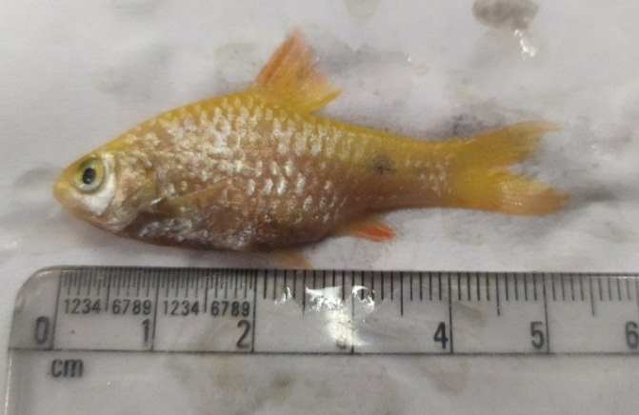
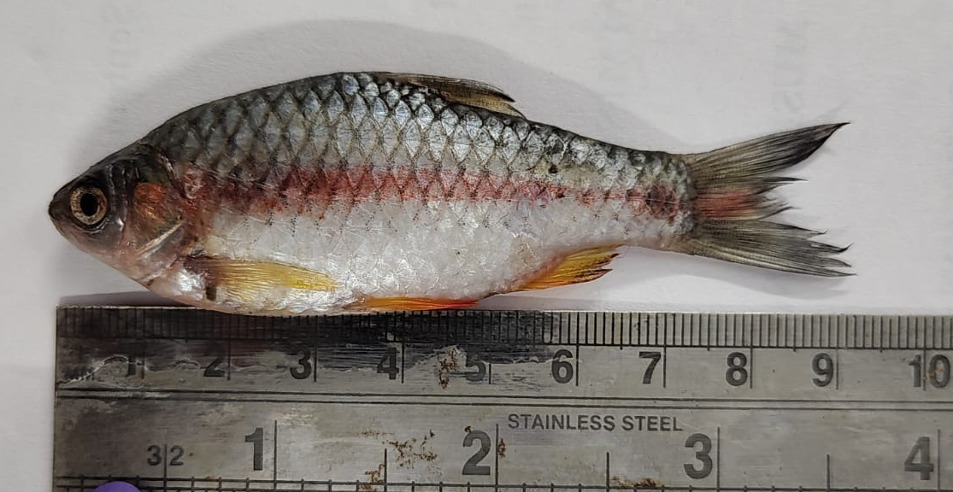 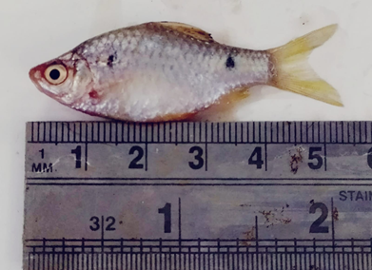 a b
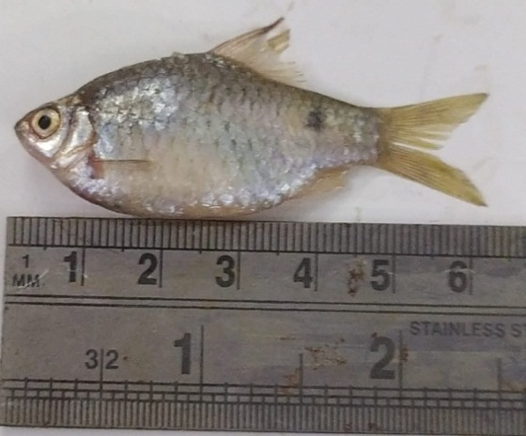
c d
Figure 1.- Puntius sophore (a), Puntius ticto (b), Puntius muzaffarpurensis (c) and Puntius conchonius (d).
MATERIALS AND METHODS: Study material for the study of these 4 species viz. Puntius ticto (30), Puntius sophore (30), Puntius muzaffarpurensis (30) and Puntius conchonius (30) were obtained during the period of March 2022- July 2024 from Ganga river water near and around Meerut region. Fish samples were caught by local fisherman and carried to the laboratory on an ice layer. Each species of Puntius were identified with the help of Day’s fauna (1878) and Jayaram (1981).
Morphometric measurements: After identification, morphometry of each fish sample was done, total length and weight were measured. Otoliths of each sample were removed by making a horizontal cut in the cranium at dorsal side between both eyes. Left and right otoliths were kept separately. Cleaning was done with 10% KOH solution followed by washing with distilled water. Washed otoliths were air dried and stored in transparent plastic vials, labeled with identification no., date of collection, generic and specific name.
Otolith morphometry was done with the help of NIS Element D5.10.00 64-bit imaging software as length and width of each otolith were measured and same is used for light microscopic photographs of otoliths. Weights of each otolith were taken (Figure 2 a-d).

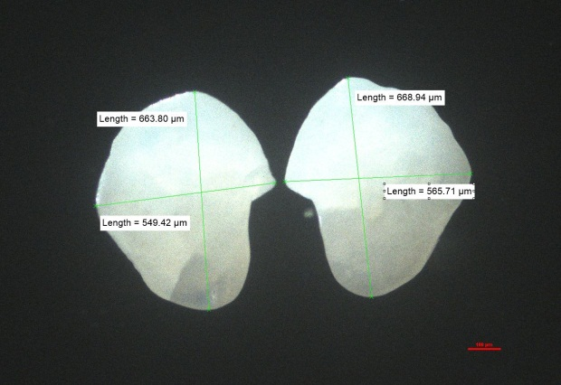
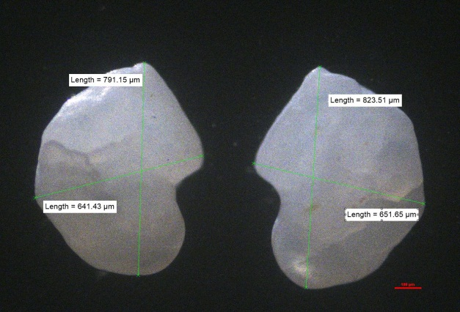 a- Puntius ticto b- Puntius sophore
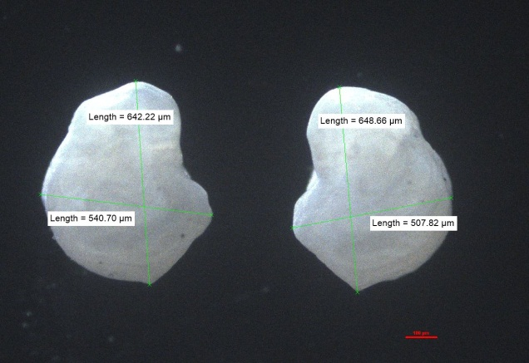 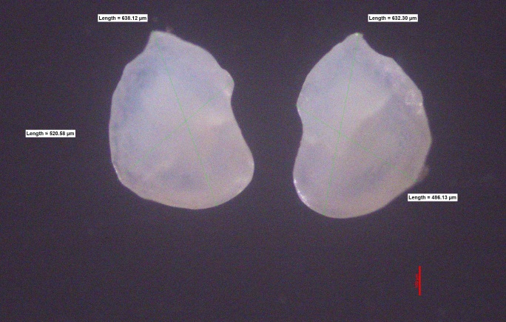 c- Puntius muzaffarpurensis d- Puntius conchonius
Figure 2- Morphometric measurements (length and width) of left and right otolith of Puntius ticto (a), Puntius sophore (b), Puntius muzaffarpurensis (c) and Puntius conchonius (d) using NIS Element D5.10.00 64-bit imaging software.
Statistical Analysis: Standard statistical methods were used to recognize the relationship among various measured parameters of otolith morphometry with fish morphometry. Discrimination between left and right otolith were checked by independent t-test and it showed no substantial difference, so any one of them can be choosen randmomly. Otolith length and width were compared with fish length as well as otolith weight was compared with fish weight. Linear regression model was applied to examine the relationship between fish length with otolith length and width also fish weight with otolith weight.
RESULTS: Standard statistical methods were used to analyze the data statistically. No significant difference was found between left and right otolith in 4 species of genus Puntius studied, hence only right otolith was selected for study of each fish sample.
To show the inter-generic variations among Puntius species studied, analysis of variance (ANOVA) was done between measured parameters and fish types viz. Puntius ticto, Puntius sophore, Puntius muzaffarpurensis and Puntius conchonius and results are represented by mean plot (Fig. 3 a-e).
Remarkable differences can be observed clearly among the 4 species studied in otolith morphometry and structures (Table- 1 and 2).

Table 1 and 2: showing inter- generic variations between measured parameters and fish types of genus Puntius using ANOVA

a
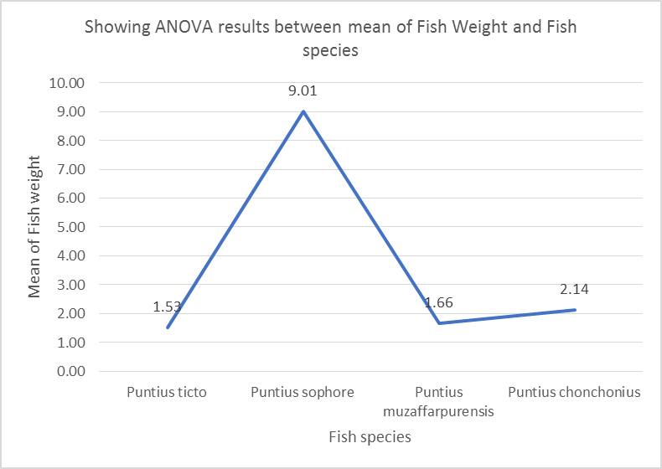
b

c

d

e
Figure 3- Mean plot showing inter- generic variations between mean of measured parameters and fish types of genus Puntius (a-e).
In Puntius ticto, otolith length is 0.13% and otolith width is 0.10% of the total fish length. In Puntius sophore, otolith length is 0.10% and otolith width is 0.08% of the total fish length. In Puntius muzaffarpurensis, otolith length is 0.12% and otolith width is 0.09% of the total fish length. In Puntius conchonius, otolith length is 0.12% and otolith width is 0.10% of the total fish length. The above statistics state that Puntius ticto show largest otolith and Puntius sophore shows smallest otolith.
DISCUSSION: In the present study, otolith morphometry of 4 native species of genus Puntius (family Cyprinidae) i.e. Puntius ticto, Puntius sophore, Puntius muzaffarpurensis and Puntius conchonius was done.Comparison was done among various morphometrical parameters of left and right otolith for each species to find out intra-specific variations as well as to find out inter- generic variations, comparison was done among measured parameters and fish types.This is the first study which is centered on these groups of Puntius fishes for otolith morphometry in India. A few such kind of studies have been done in India via Kumar et al, 2012; Mathur et al, 2014; Singh N, 2015; Aneesh- Kumar et al, 2017; Nimesh and Jain, 2018; Nimesh N, 2019; Nazir and Khan, 2019; Borah et al, 2019, Nimesh et al, 2021; Nimesh N, 2024.
Lack of significant difference between left and right otolith of each species studied of genus Puntius viz. Puntius ticto, Puntius sophore, Puntius muzaffarpurensis and Puntius conchonius, is compatiable with the observation that paired otoliths are specular images of each other as supported by many other studies (Hunt, 1979; Jawad and Al Mamry, 2012; Felix et al, 2013; Zengin et al, 2015; Dehghani et al, 2016; Saygin et al, 2017; Nimesh et al, 2021; Nimesh N, 2024).A comparative study with special reference to its taxonomic importance of otolith morphometry was done by Mathur (2014), Singh (2015) and Nimesh (2019) in native species of genus Channa (Gronovirus), Labeo and Rasborine respectively.
According to this study otolith length and width can be a best tool to estimate fish length because of its strong and positive relationship via linear regression model. This study is supported by many other studies like in 2018, Basusta and Basusta also reported positive relationship between otolith length and width with total fish length in Hoplostethus Mediterranean. According to Zengin et al, 2015; Bostanci et al, 2015; Kumar et al, 2017; Zengin et al, 2017, for estimation of fish size, otolith length, width and weight were considered as important taxonomic tool.
CONCLUSION: We can conclude that due to having strong positive linear correlation between otolith length and otolith width with fish length, in 4 native species studied of genus Puntius, otolith morphometry is a good indicator for calculation of fish size, growth, age, fish stock identification and fishery management. It was also concluded that intra-specific and inter- generic variations are clearly established by ANOVA among parameters studied and fish types in Puntius fishes.
COMPETING INTERESTS: Authors have declared that no competing interests exist.
REFERENCES:
- Akkiran N. (1985) A systematic study on Carangidae (Pisces) Employing the otolith characters in the Eastern Mediterranean. Biljeske-Notes 63:1-9.
- Aneesh Kumar K V, Nikki R, Oxona K, Hashim M and Sudhakar M. (2018) Relationship between fish and otolith size of nine deep sea fishes from the Andaman and Nicobar waters, North Indian Ocean. J. Appl. Icthol. 33(6), 1187-1195.
- Basusta A, Bal H and Aslan E (2013) Otolith Biometry- Total length relationships in the population of Hazar Bleak, Alburnus heckeli (Battalgil, 1943) inhabiting Lake Hazar, Elazig, Turkey. Pak. J.Zool. 45(4), 1180-1182
- Borah S, Vaisakh G, Jaiswar A K, Bhattacharjya B K, Sahoo A K, Deshmukhe G, Behera B K, Meena D K, Raman R K and Das B K (2019) Association patterns between dimensions of fish and otolith to expedite morphometric variations of three geographically isolated stocks of Tenualosa ilisha (Hamilton, 1822) from diverse ecosystems. Indian J.Fish. 66(3), 48-52.
- Bostanci D, Polat N, kurucu G, Yedier S, Kontas S and Darcin M (2015) Using otolith shape and morphometry to identify four Alburnus species (A. chalcoides, A. escherichii, A. mossulensis and A. tarichi) in Turkish inland waters. J. App. Ichthyol. 31 (6), 1013-1022.
- Day F. (1878) The Fishes of India; Being a Natural History of the Fishes Known to inhabit the Seas and Fresh Waters of India, Burma, and Ceylon. Parts1-4 William Dawson & Sons Ltd., London. 77p.
- Dehghani M, Kamrani E, Salarpouri A and Sharifian S (2016) Otolith dimensions (length, width),Otolith weight and fish length of Sardinella sindensis (Day, 1878), as index for Environmental studies, Persian gulf, Iran. Marine Biodiversity Records 9, 44.
- Harvey J T, Loughlin T R, Perez M A and Oxman D S. (2000) Relationship between fish size and otolith length for 63 species of fishes from the Eastern North Pacific Ocean. U. S. Dept. of Commerce NOAA. Technical Report NMFS 150.
- Hunt J J (1979) Back-calculation of length-at-age from otoliths for silver hake of the Scotian Shelf. ICNAF Sel. Pap. 5, 11-17.
- Jawad L, Al-Mamry J, Al-Busaidi H. (2011) Relationship between fish length and otolith length and width in the lutjanid fish, Lutjanus bengalensis (Lutjanidae) collected from Muscat City coast on the Sea of Oman, Journal of the Black Sea/Mediterranean Environment 17(2):116-126.
- Jawad LA, Al-Mamry JM, Al -Mamari HM, Al-Yarubi MM and AL-Busaidi HK. (2012) Relationship between fish length and otolith length, width and weight of Rhynchorhamphus georgi (Valenciennes, 1846) (Family: Hemiramphidae) collected from Oman Sea. Rom J Biol. 56:189–200.
- Jayaram K C. (1981) The Freshwater Fishes of India- A Handbook. Zoological Survey of India (Edition 1994).
- Kumar P, Chakraborty S K and Jaiswar A K. (2012) Comparative otolith morphology of sciaenids occuring along the North – West coast of India. Indian J.Fish. 59(4), 19-27.
- Kumar K V A, Deepa K P, Hashim M, Vasu C and Sudhakar M (2017) Relationships between fish size and otolith size of four bathydemersal fish species from the south eastern Arabian Sea, India. J. Appl. Ichthyol. 33, 102-107.
- Mathur S. (2014) Comparative study of otolith in native species of Genus Channa (Gronovirus) with reference to taxonomic importance. Ph. D. Thesis, Ch. Charan Singh University, Meerut, India.
- Mathur S, Jain S, Varma M. (2014) Fish otoliths and their significance in Taxonomy. Journal of Exp. Zool. India. 17(2):407- 410.
- Nazir A and Khan M A. (2019) Relationship between fish length, otolith size and otolith weight in Sperata aor (Bagridae) and Labeo bata (Cyprinidae) from the Ganga River India. Zoology and Ecology 29(2), 90-95.
- Nimesh N and Jain S. (2018) Otolith morphometry and fish length relation of Amblypharyngodon mola (Ham.) from middle Ganga region (India). Int. J. Fish. Aquacult. 10(10), 122-128.
- Nimesh N. (2019) Studies on Microstructure and Microchemistry of sagittal otolith of Rasborine fishes. Ph.D. Thesis, Ch. Charan Singh University, Meerut (Uttar Pradesh, India).
- Nimesh N, Jain S, Kang R and Nimesh M. (2021) Otolith morphometry- Total fish length relationship in the population of Rasbora daniconius (Hamilton, 1822) (Cyprinidae). Uttar Pradesh J. Zool. 42(24), 958-964.
- Nimesh N and Jain S. (2024) Otolith morphometry and body size relationship of Raborine fishes in Ganga River water. J. Exp.Zool. India 27, 635-641.
- Platt C and Popper A N. (1981) Fine structure and function of the ear. In: Hearing and Sound Communication in Fishes. (eds. Tavolga W N, Popper A N and Fay R R). New York: Springer-Verlag, pp. 3-38.
- Saygin S, Ozpicak M, ELP. M, Polat N, Atici A A and Odun N A. (2017) Comparative analysis of otolith features of Tarek, Alburnus tarichi (Guldenstadt, 1814) from different lakes across Van Basin (Van Ercek, Nazik, Aygir)( Turkey) Limnofish. J. Limnology and Freshwater Fisheries Res. 3(2), 91-99.
- Singh N. (2015) Comparative studies of otolith in native species of Genus: Labeo with special reference to its taxonomic importance. Ph. D. Thesis. C.C.S. University, Meerut.
- Zengin M, Saygin S and Polat N (2015) Otolith shape analysis and dimensions of Anchovy, Engraulis encrasicolus L. in the Black and Marmara Seas. Sains Malaysiana 44(5), 657-662.
- Zengin M, Saygin S and Polat N. (2017) Relationships between otolith size and total length of bluefish, Pomatomus saltatrix (Linnaeus, 1766) in Black Sea (Turkey). North-Western J. Zool. 13(1), 169- 171.

