Case report
Central Vestibular Disease in a Pug Dog Secondary to Ehrlichia canis Infection

Abstract
Canine ehrlichiosis, caused predominantly by Ehrlichia canis and transmitted by Rhipicephalus sanguineus, is a globally distributed tick-borne disease with diverse clinical manifestations ranging from acute to chronic systemic illness. While hematological abnormalities such as anemia, thrombocytopenia, and leukopenia are well-recognized hallmarks, neurological involvement is less common but increasingly reported. This case report describes a 9-year-old male pug presenting with central vestibular signs including head tilt, circling, ataxia, nystagmus, and vomiting. Clinical evaluation revealed pyrexia, dullness, and tick infestation. Otoscopic examination ruled out otitis media/interna. Hematological analysis showed anemia, leukopenia, and marked thrombocytopenia, while biochemical parameters remained within normal limits. Peripheral blood smear was negative for hemoparasites. A presumptive diagnosis of CME was confirmed by quantitative PCR, which detected Ehrlichia canis DNA. Treatment comprised doxycycline (5 mg/kg BID for 4 weeks), prednisolone (1 mg/kg BID tapered over 3 weeks), and meclizine (1 mg/kg SID) along with supportive therapy. Hematological parameters normalized post-treatment, and vestibular signs resolved completely. The case highlights the neurotropic potential of E. canis, which likely induces central vestibular signs via immune-mediated inflammation and vascular injury.
Keywords: Canine ehrlichiosis, Central vestibular disease, Doxycycline, Ehrlichia canis.

- INTRODUCTION
Canine Ehrlichiosis is a globally distributed, emerging zoonotic disease caused by rickettsial organisms transmitted by vectors. Typically, three species—Ehrlichia canis, E. ewingii, and E. chaffeensis—are known to infect dogs. Of these, E. canis is the most prominent pathogen, targeting platelets, monocytes and granulocytes. Dogs serve as reservoir hosts, while Rhipicephalus sanguineus (the brown dog tick) is the primary vector facilitating transmission [1]. The acute phase lasts 3–5 weeks and is marked by fever, lymphadenopathy, bleeding tendencies, and neurological signs. Subclinical infections can persist for years without visible symptoms, with dogs acting as carriers. Chronic cases involve severe anemia, pancytopenia, multi-organ dysfunction, ocular and neurological signs, and immune-mediated disorders [2,3]. Neurological signs are reported in up to 20% of infected dogs with ehrlichiosis, often presenting as vestibular signs such as head tilt, ataxia, and nystagmus indicative of central nervous system involvement [4]. Differentiation between central and peripheral vestibular signs is based on clinical patterns; vertical nystagmus, altered mentation, and proprioceptive deficits are linked to central vestibular signs, while horizontal or rotatory nystagmus, normal proprioception and isolated cranial nerve VII deficits suggest peripheral origin [5]. Histopathological findings in dogs with chronic E. canis infection show lymphoplasmacytic meningitis, perivascular cuffing, and occasional brain hemorrhages, particularly in the brainstem and cortex, reflecting immune-mediated CNS damage [6]. Similarly, in humans infected with E. chaffeensis, neurological signs such as encephalopathy, seizures, cranial nerve palsy, and stroke-like deficits are predominantly seen in immunocompromised or older individuals, likely driven by systemic inflammation and immune-mediated pathology. These parallels underscore the neurotropic potential and multisystemic impact of ehrlichial infections across species.
- CASE HISTORY AND OBSERVATIONS
A 9-year-old male pug weighing 10.5 kg was presented to Teaching Veterinary Clinical Complex, F/o Veterinary and Animal Sciences, Banaras Hindu University with history of head tilt, circling, leaning, occasional vomiting and ataxia for past 5 days. The general clinical examination revealed, dullness, pyrexia (103.5⁰ F), increased heart rate (100/min). The physical examination revealed, right sided head tilt, ataxia, nystagmus and tick infestation (Fig. 1).
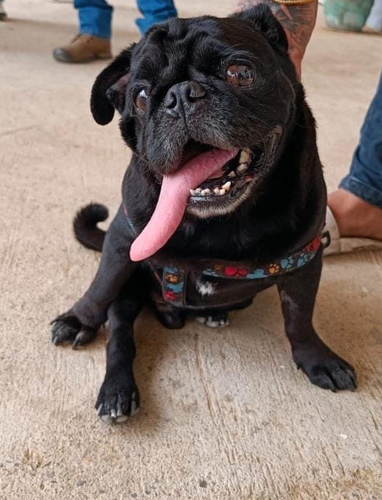
Fig 1: Prolonged head tilting of towards right side.
The otoscopic examination showed no abnormalities in ear canal and tympanic membrane. Following clinical examination, peripheral blood smear was prepared and whole blood sample was taken for complete blood count and biochemical analysis. The blood smear examination was negative for any hemo-protozoan infection. The complete blood count was performed on automated hemo-analyzer and revealed anaemia, leukopenia and thrombocytopenia (Table 1) while biochemical parameters were normal (Table 2). Based on clinical, laboratory findings & ruling out other causes, the animal was suspected for canine ehrlichiosis which was subsequently confirmed after molecular testing. The quantitative PCR analysis was positive for Ehrlichia canis.
Table 1. Before and after treatment haematological parameters of a dog suffering from central vestibular disease.
Parameter | Before treatment | After treatment
Hb (g/dl) | 10.1 | 16.6
PCV (%) | 28.5 | 46.7
TEC (x10⁶/µL) | 3.97 | 6.75
TLC (x10³/µL) | 6.8 | 11.7
PLT (x10³/µL) | 14 | 267
Table 2. Before and after treatment biochemical parameters of a dog suffering from central vestibular disease.
Parameter | Before treatment | After treatment
Albumin (g/dl) | 2.57 | 3.0
Total protein (g/dl) | 6.18 | 6.42
Direct bilirubin (mg/dl) | 0.24 | 0.10
Indirect bilirubin (mg/dl) | 0.13 | 0.15
Total bilirubin (mg/dl) | 0.37 | 0.25
AST (IU/L) | 34.2 | 24.3
ALT (IU/L) | 42.5 | 71.6
GGT (IU/L) | 2.3 | 2.5
ALP (IU/L) | 45 | 54
Blood urea (mg/dl) | 63.4 | 57.7
Blood urea nitrogen (mg/dl) | 29.6 | 26.9
Creatinine (mg/dl) | 0.97 | 0.84

- TREATMENT AND DISCUSSION
The dog was treated with Tab. Doxycycline™ @ 5 mg/kg BID orally for 4 weeks, Tab. Prednisolone™ @ 1 mg/kg BID orally for 2 weeks followed by tapering dose for 1 week. Along with this, Tab. Meclizine™ @ 1 mg/kg SID orally until the reduction of vestibular signs was administered. The supportive medication included Tab. Neurokind™ @ ½ SID orally for 4 weeks, hematinic syrup Feritas™ @ 3 ml BID orally for 4 weeks & syrup Advaplat™ @ 10 ml BID for 4 weeks. The haematological parameters were assessed after 4 weeks of therapy (Table 1). After 4 weeks of treatment, uneventful recovery was seen with abolishment of vestibular signs and hematological parameters returned to normalcy (fig 2).
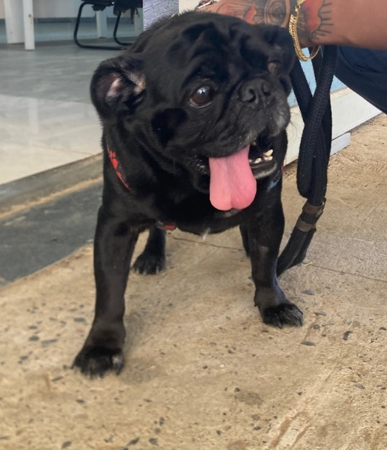
Fig 2: Correction of clinical signs like head tilting after treatment.
Vestibular disease in dogs can arise from various peripheral or central causes. Peripheral causes include idiopathic vestibular disease, otitis media/interna, hypothyroidism, congenital defects, aural neoplasia, ototoxicity, and inflammatory polyps. Central causes include neoplasia, cerebrovascular accidents, metronidazole toxicosis, hypothyroidism-related infarctions, and inflammatory or infectious meningoencephalitis. Ehrlichia canis along with other vector-borne infections like Rocky Mountain spotted fever, bartonellosis, and toxoplasmosis, is a less common but recognized infectious cause of central vestibular disease [7]. Clinical signs manifested are head tilt, asymmetrical ataxia, circling, vomiting, and nystagmus [8]. Ehrlichia canis causes neurological signs indirectly through vascular injury, immune-mediated inflammation, and hyperviscosity [9]. In the present case, the observed signs—head tilt, ataxia, nystagmus, circling, and vomiting—were consistent with central vestibular disease. Alternative causes such as metronidazole toxicity, ototoxicity, and trauma were excluded through detailed history-taking. The diagnosis of Ehrlichia canis infection was confirmed via PCR analysis of the blood sample. Doxycycline, a tetracycline antibiotic, acts by inhibiting bacterial protein synthesis through binding to the 30S ribosomal subunit and is the first-line drug for treating canine ehrlichiosis due to Ehrlichia canis [10]. Prednisolone is a cornerstone immunosuppressive treatment for various immune-mediated conditions in dogs, including immune-mediated hemolytic anemia (IMHA) and immune-mediated thrombocytopenia (IMTP). It suppresses the immune system’s attack on blood components by reducing antibody production and inflammation. In IMHA, it helps control hemolysis of red blood cells, and in IMTP, it limits platelet destruction [11]. Meclizine is an antihistamine used primarily to treat motion sickness and vestibular disorders such as vertigo in both human and veterinary medicine [12]. In the present case, the dog presented with vestibular signs secondary to ehrlichiosis, and the combination of doxycycline, prednisolone, and meclizine with other supportive treatment facilitated successful clinical recovery.
REFERENCES
- Aziz MU, Hussain S, Song B, Ghauri HN, Zeb J, Sparagano OA. Ehrlichiosis in dogs: a comprehensive review about the pathogen and its vectors with emphasis on south and east asian countries. Veterinary Sciences. 2023; 10(1): 1. https://doi.org/10.3390/vetsci10010021.
- Kumar R, Verma R, Diwakar RP. Canine ehrlichiosis: A review. Journal of Entomology & Zoology Studies.2020. 8(2): 1849-1852.
- Sahoo KK, Gupta D, Roy K, Tiwari A, Raikwar A, Pradhan S, Namdeo S, Choudhary GP, Sawhney A, Bhatt S, Singh M. Canine ehrlichiosis: A review. The Pharma Innovation Journal, 2022; SP-11(2): 474-480.
- Thomas WB. Vestibular dysfunction. Veterinary Clinics of North America: Small Animal Practice, 2000; 30(1): 227–249. https://doi.org/10.1016/s0195-5616(00)50011-4
- Bongartz U, Nessler J, Maiolini A, Stein VM, Tipold A, Bathen‐Nöthen A. Vestibular disease in dogs: Association between neurological examination, MRI lesion localisation and outcome. Journal of Small Animal Practice. 2020; 61(1): 57–63. https://doi.org/10.1111/jsap.13070.
- Waner T, Harrus S. Canine monocytic ehrlichiosis—from pathology to clinical manifestations. Israel Journal of Veterinary Medicine. 2013; 68(1): 12-18.
- Rossmeisl JH. Vestibular disease in dogs and cats. Veterinary clinics of north america: Small Animal Practice. 2010;40(1): 81–100. https://doi.org/10.1016/j.cvsm.2009.09.007
- Turbat RM, Fernoag C, Tudor N, Vlagioiu C. Vestibular syndrome in dogs and cats - clinical approach to diagnosis and a retrospective case series report. Scientific Works Series C. Veterinary Medicine, 2021; LXVII(1): 133-138.
- Silva I. Complex clinical presentations of tick-borne diseases in dogs in Sri Lanka. Sri Lanka Veterinary Journal. 2016; 63(2): 1. https://doi.org/10.4038/slvj.v63i2.9.
- Rao LN, Shobhamani B, Rao VV, Subramanyam KV. Comparative efficacy of doxycycline and imidocarb diprionate in treatment of ehrlichiosis in dogs. The Pharma Innovation Journal. 2022; SP-11(4): 1304-1309.
- Swann JW, Garden OA, Fellman CL, Glanemann B, Goggs R, LeVine DN, Mackin AJ, Whitley NT. ACVIM consensus statement on the treatment of immune‐mediated hemolytic anemia in dogs. Journal of Veterinary Internal Medicine. 2019; 33(3): 1141–1172. https://doi.org/10.1111/jvim.15463
- Barritt L. Meniere’s Disease. In S. J. Enna & D. B. Bylund (Eds.), xPharm: The Comprehensive Pharmacology Reference. 2008;1–6. Elsevier. https://doi.org/10.1016/B978-008055232-3.63820-6.

