Qualitative and Molecular Characterization of Rugda Mushroom: A Comprehensive Analysis

Abstract
Rugda mushrooms are valued for their nutritional and therapeutic properties, yet detailed compositional and taxonomic studies remain scarce. In this work, we present an integrated quantitative analysis of phytochemicals and molecular characterization of Rugda fruiting bodies, employing Gas Chromatography–Mass Spectrometry (GC-MS), Fourier-Transform Infrared Spectroscopy (FTIR), Scanning Electron Microscopy (SEM), and DNA-based phylogenetic analysis. GC-MS analysis revealed nine compounds. FTIR spectra exhibited characteristic peaks at O–H stretching, N-H bend, C–O strech, indicating phenol, amine & ester. SEM images showed a compact hyphal network with ellipsoid spores bearing reticulate ornamentation. ITS sequencing confirmed Rugda as belonging to the Astraeus asiaticus. The combined GC-MS, FTIR, and SEM data elucidate the chemical and morphological attributes of Rugda mushroom, while ITS-based molecular analysis provides accurate taxonomic placement. This multidisciplinary profiling lays a foundation for future exploration of Rugda’s bioactive compounds and supports its authentication for nutritional, pharmaceutical, and industrial applications.
Keywords- Rugda, Mushroom, Astraeus asiaticus, GC-MS, phylogenetic, FTIR.
INTRODUCTION
Mushrooms, due to their medicinal and culinary benefits, have historically been seen as an agreeable member of human civilisation, and have occasionally supplanted plant and animal-derived items. Mushrooms are now recognised as functional foods with nutritional value, structural quality, and acceptability (Mwangi et al., 2022). Furthermore, mushrooms undergo extraordinary changes in the coming days to adapt as smooth-running medicinal meals. Mushroom consumption is rapidly expanding in Asia, particularly in India and Japan. According to Research and Markets (2021), the mushroom cultivation industry was valued at 16.7 billion USD in 2020 and is expected to grow to 20.4 billion USD by 2025 (Landínez-Torres et al., 2021). Palatable mushrooms are low-calorie, low-fat food supplements that include modest levels of protein, carbs, vitamins, minerals, amino acids, and dietary fibre (Pandey and Ghosh, 2023). Mushrooms have antibacterial, antifungal, antiviral, antiparasitic, antioxidant, anti-inflammatory, antiproliferative, anticancer, anti-HIV, hypocholesterolemic, antidiabetic, and anticoagulant properties (Ghosh et al., 2020a; Manimaran et al., 2021). In this study, we chose to focus on the fungus Astraeus sp. because of its nutritional value and its widespread usage as a restorative medication due to its antidiabetic, anticancer, hepatoprotective, anti-inflammatory, and cardioprotective properties (Phadannok et al., 2020). The primary goal of this study was to discover the biodiversity of Astraeus asiaticus by morphological, biochemical, and molecular research in various woodlands or forests of the Bankura district, a red lateritic zone in West Bengal. Mycorrhizae transport nutrients between the host plant's roots and soil-dwelling fungi. Biodiversity is extremely valuable "natural capital." Different kinds, species, and genera, as well as their intricate relationships, enable a functioning ecosystem and productive economies (World Bank, 2022). Although wild mushrooms and fungi are an important part of any ecosystem, there has been little research into their diversity and types, particularly in tropical nations like India. As a result, an information gap exists. Wild edible mushrooms serve as a natural resource for rural communities, providing nutrition (Meena et al., 2020). As a result, research into the biodiversity of wild edible mushrooms, as well as their use, is critical to the economy. Astraeus species are economically significant because people harvest them for consumption and sale in commercial markets (Pandey and Ghosh, 2023). Porahat forest division is known for its abundance, and inhabitants can make money by selling wild edible mushrooms. As a result, this mushroom has a significant socioeconomic impact on rural Jharkhand, India. A. asiaticus is a promising eating fungus, but its therapeutic potential has not been investigated. Therefore, in this work, the molecular features, biodiversity, mycochemistry, antioxidant content, and antioxidant activity of this mushroom were identified to enable further research on its therapeutic relevance.
MATERIALS AND METHODS
Sample Collection
A mushroom survey was conducted in Jharkhand's Porahat Forest Division. From mid-July to August 2023, a periodic survey was undertaken in the optimal location for A. asiaticus gathering during the rainy season.
Identification of the Species
Mushroom (basidioma) morphology was studied macroscopically, and its size, shape, texture, colour, and habit were determined (Phosri et al. 2007). Biochemical assays were carried out using the previously published approach by Khaund and Joshi (2014).
Scanning electron microscopy analysis
For scanning electron microscopy, spore samples were incubated in the following ethanol series with 2% glutaraldehyde for 15 minutes each: 30, 50, 70, 80, 90, 95, and 100%. The samples were centrifuged, and the supernatant was obtained. The samples were coated with gold using a sputter coater. A focused image of the sample served as the starting point for scanning electron microscopy (Phosri et al., 2007).
Molecular Identification
DNA was extracted from fresh mushrooms using the modified CTAB method (Doyle & Doyle, 1987). Isolated DNA was purified with a HiMedia Purification Kit and electrophoresed on a 0.8% agarose Gel. The ITS1-5.8S-ITS2 marker zone for rRNA in isolated gDNA was amplified using a PCR (polymerase chain reaction) procedure modified from Gardes and Bruns (1993), with primers ITS-1F (5′-CTTGGTCATTTAGAGGAAGTAA-3′) and ITS4 (5′ TCCTCCGCT TATTGATATGC3′). The acquired sequence was compared to other comparable sequences with BLAST (Pandey & Ghosh, 2023).
Preparation of Mushroom Extract
The acetone extract was made by pouring 10 g of mushroom powder into hot acetone in a 1:10 ratio, shaking it on a shaker at 150 rpm for 1 hour, and then placing it in an incubator set to 38 °C for 72 hours. The extract was then filtered through Whatman No. 4 filter paper, centrifuged at 3000 rpm for 15 minutes, and concentrated through evaporation using a rotary evaporator.
Quantitative Analysis of Acetone Extract
Folin-reagent Ciocalteu's approach was utilised to determine the total phenol content of the extract, and Ghosh et al. (2025) provided a standard method for calculating the total flavonoid content of the extracts. The total phenol content was calculated as mg of Gallic acid equivalent (GAEs) per g of acetone extract dry weight, and the total flavonoid content as mg of Quercetin equivalent (QEs) per g of acetone extract dry weight.
FT-IR analysis
FT-IR is the most potent instrument for identifying the many types of functional groups found in compounds. 10 mg of crude ethyl acetate powder was encapsulated in a 100 mg KBr pellet. The powdered material was analysed using an FT-IR spectroscope with a scan range of 400-4000 cm− 1 and a resolution of cm−1 (Ashok & Ramaswamy, 2014). A chromatogram was discovered, and each peak of the chromatogram was recognised using the database.
GC-MS analysis
The GC-MS study was performed using an Agilent GC-6860 N Network GC System, which included a Gas Chromatograph and a Mass Spectrometer. The compounds were then identified from the GC-MS peaks using library data for the matching compounds provided by GC-MS Post Run Solution Softwares. Electron impact ionisation at 70 eV was used to analyse GC/MS data, and the total ion count was used to identify and quantify compounds (Sanyal & Ghosh, 2019).
RESULT AND DISCUSSION

Phenotypical Identification of Mushroom
The fruiting season of this mushroom is from June to August. It is globose and smooth, with an unexpanded diameter of 10-16 × 8-14 mm and an inflated diameter of 14-23 × 8-12 mm. The gleba was initially white; but, as the spores matured, the gleba and its granulate outer peridium became purplish chestnut. The exoperidium was slightly viscous and smooth, with a white colour covering the endoperidium (Figure 1). The endoperidium is a thin membrane layer of tissue that surrounds the spore mass in a 20-30 mm diameter sac with an irregularly formed ostiole at the top. The surface is rough, white, and grey to brown in colour. The basidiospore mass was yellowish while young, but black and powdery when mature. The spores were reddish-brown, generally spherical with minute warts, and were 7.5-11 µm in diameter. The mycelial layer consisted of branched hyphae measuring 4-7 µm in diameter. The fibrous layer's hyphae were 6-9 µm in diameter and branched, while the collenchyma-type layer had branched hyphae 3-4 µm in diameter (Figure 2). Scanning electron micrographs produced a clear three-dimensional image and stereoscopic view of the mushroom spore and hyphal structures. Ornamentation on the spore surface and hyphal structure were clearly visible (Figure 3). The basidiospores showed wide, dense, and rounded spine and were globose, ranging from 8.65–15.3 mm diameter.
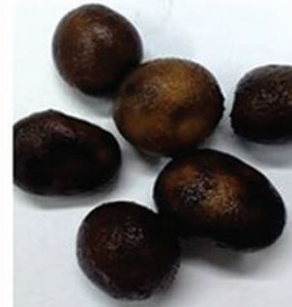 | 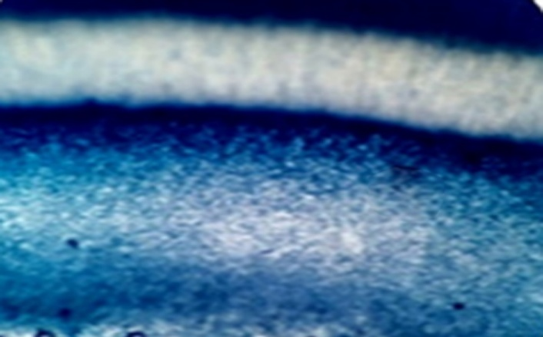
Fig. 1- Mature sporocarp of Astraeus asiaticus. | Fig. 2- The anatomy of Astraeus asiaticus- Cross section of the gleba.
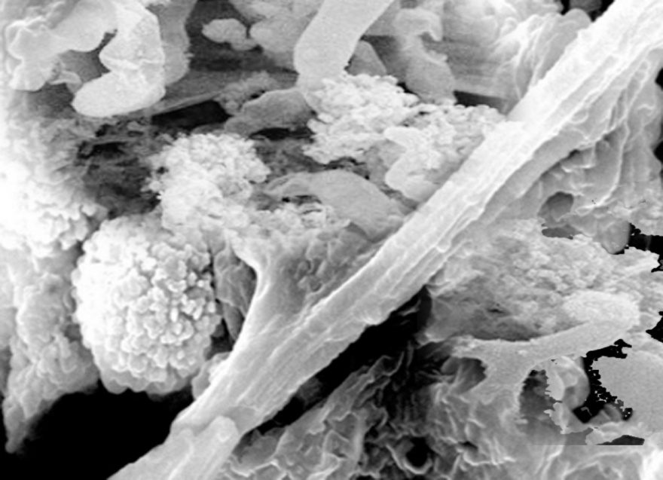
Fig. 3- Scanning electron micrograph of the hyphae of Astraeus asiaticus.
Molecular Identification of Fungal Species
The mushroom sample was recognised as Astraeus asiaticus using BLAST in the NCBI database, with query coverage (100.0%) and identity score (97.00%) (Fig. 4). The phylogenetic tree (Fig. 5) showed that the test organism is closely related to Astraeus asiaticus. As a result, the wild mushroom was identified as belonging to the genus Astraeus asiaticus.
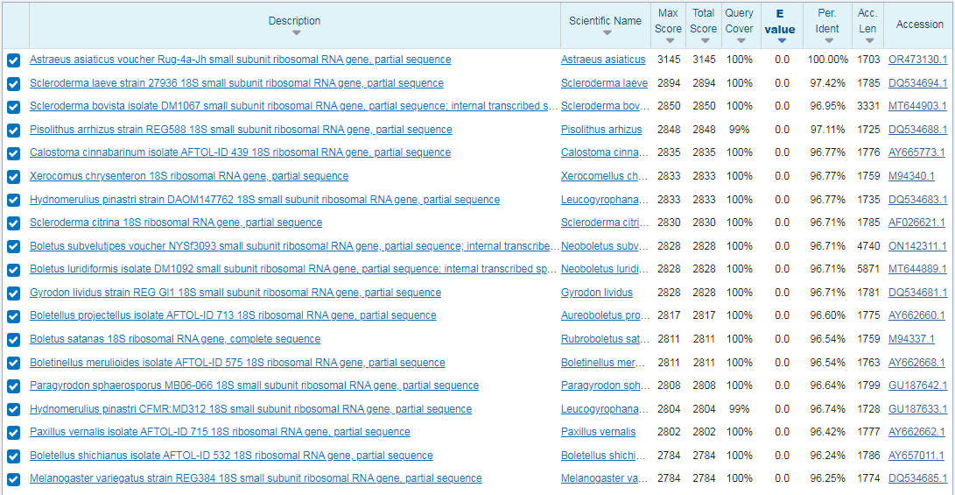
Fig.4- BLAST result of the highest sequence similarity of Astraeus asiaticus.
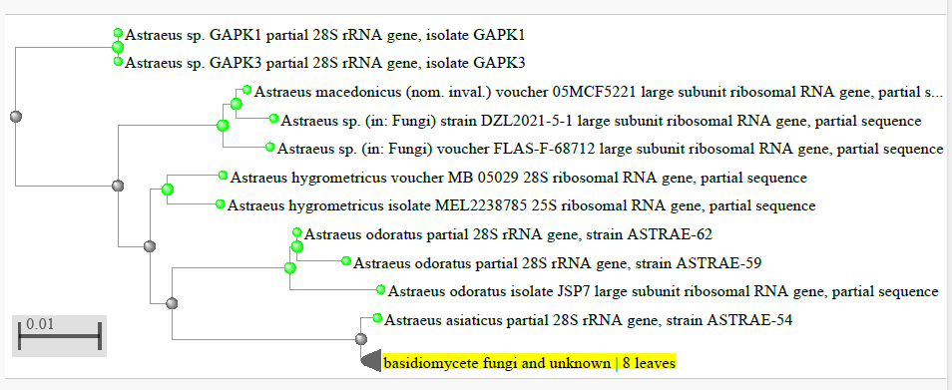
Fig. 5- Neighbor-joining phylogenetic tree showing the evolutionary relationship with gene isolated gene sequence.
Quantitative Analysis of Acetone Extract
The total phenolic content (TPC) of acetone extract was 9.01 ± 0.31 mg GAE.g⁻ ¹, as well as the total flavonoid content (TFC) of this extract was 4.13 ± 0.12 mg QE. g⁻ ¹ .
FT-IR spectral data analysis
Acetone extract showed the different absorption peaks (functional groups) like 3274 cm⁻¹ (–OH stretching vibrations), 2973 cm⁻¹ (aliphatic C–H stretching), 2492 & 2354 cm⁻¹ (CO₂ interference), 1642 cm⁻¹ (C=O, carbonyl or C=C stretching), 1589 cm⁻¹ (C=C stretching), 1394 cm⁻¹ (O–H bending or C–H deformation), 1302 cm⁻¹ (C–N stretching), 1104 cm⁻¹ (C–O stretching band), 654 cm⁻¹ (C–H or halogen-containing functional groups). (Fig. 6; Table 1).
Table 1- FTIR Peak Assignment of Acetone Extract.
Wavenumber (cm⁻¹) | Functional Group | Vibration Type | Possible Assignment
3274 | O–H or N–H stretch | Broad Stretching | Alcohols, phenols, or amines
2973 | C–H stretch | Asymmetric Stretching | Alkanes (methyl, methylene groups)
2492, 2354 |  | Possible overtone or CO₂ interference | Atmospheric CO₂ (artifact) or thiol/acid overtones
1642 | C=O or C=C stretch | Stretching | Carbonyl group (ketones, aldehydes, esters) or alkenes
1589 | C=C or N–H bend | Stretching or bending | Aromatic ring or amine group
1394 | O–H bend or C–H deformation | Bending | Phenols or alkanes
1302 | C–N or C–O stretch | Stretching | Amines or carboxylic acids
1104 | | C–O stretch | Stretching | Alcohols, esters, or ethers
654 | Out-of-plane bending | Bending | Aromatic C–H (substitution pattern) or halo compounds

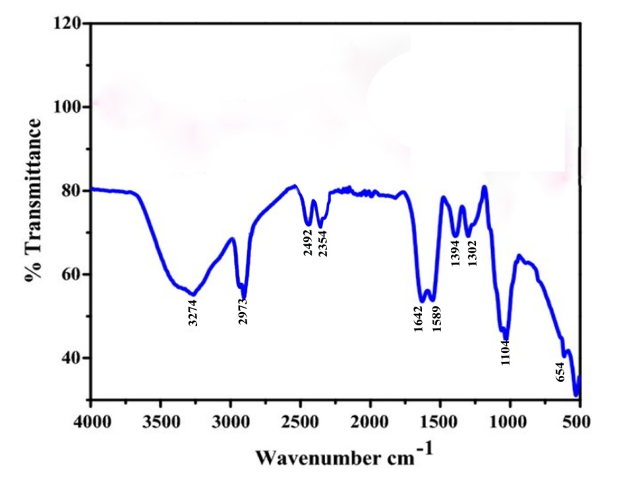
Fig.6- FT-IR Chromatogram of Acetone Extract.
GC-MS analysis
Acetone extract was analyzed by GC-MS and chemo profiling study revealed 09 compounds (Fig. 7). These compounds were identified using the NIST mass spectral library database. Each peak represents a different chemical compound separated by the GC and identified by MS. The largest peak at 10.0 minutes is likely the major component in the sample. Smaller peaks at 3.71, 6.35, 6.71, 15.36, 25.77, 25.36, 19.82, 19.72, and 20.49 minutes indicate minor constituents. The initial broad peak observed near 0 minutes may be attributed to the solvent front or highly volatile substances. The overall baseline remains relatively stable after the early elution phase, indicating good chromatographic performance (Table 2).
Table 2 – Compounds analysis of acetone extract using GC-MS.
Retention Time (min) | Area % | Compound Name
4.657 | 15.57 | 4-Phenylbut-3-ene-1-yne
7.971 | 1.93 | Benzene, (1-methyldecyl)
8.871 | 0.93 | Benzene, (1-methylundecyl)
10.489 | 4.89 | 1-Nonadecene
11.570 | 2.74 | Phytol
17.262 | 1.17 | Decanedioic acid, bis(2-ethylhexyl) ester
18.003 | 1.03 | Pentatriacontane
20.080 | 2.36 | Vitamin E
22.404 | 2.73 | Stigmasta-7,25-dien-3-ol, (3.beta.,5.alpha.)

~

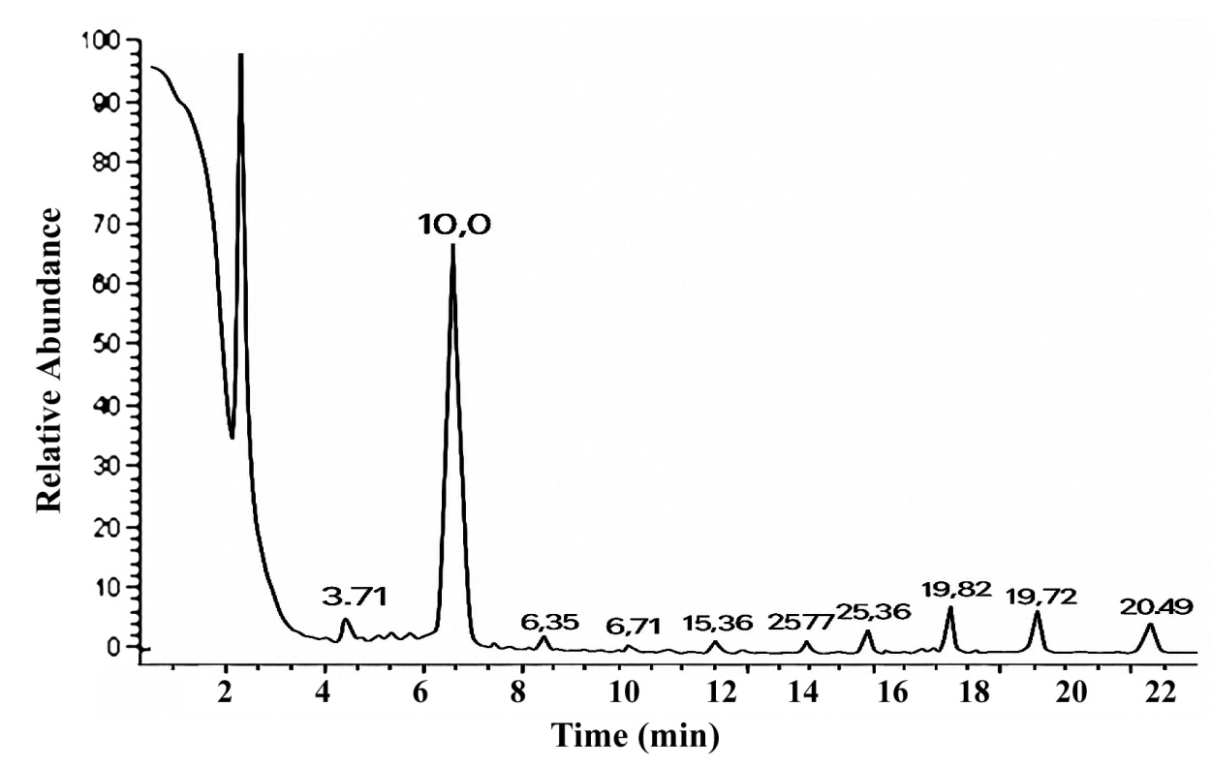
Fig. 7- GC-MS chromatogram of acetone extract.
CONCLUSION
This study presents a comprehensive qualitative and molecular characterization of the Rugda mushroom, offering valuable insights into its taxonomy, morphology, and genetic identity. Macroscopic and microscopic observations confirmed distinct phenotypic traits, while molecular analyses, particularly ITS region sequencing, provided accurate species-level identification. Phylogenetic analysis revealed close genetic relationships with other edible and medicinal fungi, reinforcing its potential for nutritional and pharmacological applications. The integration of morphological and molecular approaches proved essential for resolving taxonomic ambiguities and ensuring reliable identification. Furthermore, the findings highlight the importance of preserving indigenous mushroom species like Rugda, which hold ecological, cultural, and economic significance. This research lays the groundwork for future studies on the bioactive compounds, cultivation methods, and biotechnological applications of Rugda. Overall, this characterization contributes to the expanding knowledge base on wild mushrooms and supports their sustainable utilization in food, medicine, and environmental management.
REFERENCE
Ashok kumar, R. & Ramaswamy, M. (2014) Phytochemical screening by FTIR spectroscopic analysis of leaf extracts of selected Indian medicinal plants. IJCMAS 3 (1), 395–406.
Doyle J., Doyle J. (1987). A rapid DNA isolation procedure for small quantities of fresh leaf tissue. Phytochemistry Bulletin. 19: 11-15.
Ghosh S., Bera T., Pal S. (2020a). Antiproliferative, apoptotic, and antimigration property of ethyl acetate extract of Calocybe indica against HeLa and CaSki cell lines of cervical cancer, and its antioxidant and mycochemistry analysis. Middle East Journal of Cancer. 11 (4): 454-468.
Ghosh, S.K., Pandey, K., Ghosh, M. (2025). Mycochemistry, antioxidant, anticancer activity, and molecular docking of compounds of F12 of ethyl acetate extract of Astraeus asiaticus with BcL2 and Caspase 3. Sci Rep 15, 4313. https://doi.org/10.1038/s41598-025-87775-1
Gardes M., Bruns T. (1993). ITS primers with enhanced specificity for Basidiomycetes-application to the identification of mycorrhizae and rusts. Molecular Ecology. 2: 113-118.
Khaund, P., Joshi, S. (2014). Micromorphological characterization of wild edible mushroom spores using scanning electron microscopy. National Academy Science Letters. 37 (6): 521-527.
Landı́nez-Torres A., Fagua C., López A., Oyola Y., Girometta C. (2021). Pruning wastes from fruit trees as a substrate for Pleurotus ostreatus. Acta Mycologica. 56: 1-13.
Mwangi R., Macharia J., Wagara I., Bence R. (2022). The antioxidant potential of different edible and medicinal mushrooms. Biomedicine & Pharmacotherapy. 147.
Meena B., Sivakumar V., Praneetha S. (2020). Prospects of biodiversity and distribution of mushroom fungi in India. GSC Biological and Pharmaceutical Sciences. 13 (01): 078-085.
Manimaran K., Balasubramani G., Ragavendran C., Natarajan D., Murugesan S. (2021). Biological applications of synthesized ZnO nanoparticles using Pleurotus djamor against mosquito larvicidal, histopathology, antibacterial, antioxidant and anticancer effect. Journal of Cluster Science. 32 (6): 1635-1647.
Pandey, K., Ghosh, S. K. (2023). Biodiversity of Astraeus asiaticus, a wild indigenous edible mushroom, in the forests of Bankura district, West Bengal and its antioxidant property. Acta Mycologica, 58, 1-19. https://doi.org/10.5586/am.575
Phosri C., Martı́n M., Sihanonth P., Whalley A., Watling R. (2007). Molecular study of the genus Astraeus. Mycological Research. 111 (3): 275-286.
Phadannok P., Naladta A., Noipha K., Nualkaew N. (2020). Enhancing glucose uptake by Astraeus odoratus and Astraeus asiaticus extracts in L6 myotubes. Pharmacognosy Magazine. 16 (67): 3-42.
Sanyal, T. & Ghosh, S. K. (2019) Anti-cancer property of Lenzites betulina (L) Fr. on cervical cancer cell lines and its anti-tumor effect on HeLa-implanted mice. BioRxiv 540567.
World Bank. (2022). https://www.worldbank.org/en/topic/biodiversity.

