Role of early feeding by technically modified diets on physiological traits and gene related to it in newly hatched quails

Abstract
The aim was to investigate the effect of glycerin and whole egg powder supplements in the diet on physiological traits and gene related to it in newly hatched quails. The current study included one experimental period. 150 chicks were used in the experiment randomly distributed into 5 treatments: T1: Fasting(24h), T2: Control, T3: Glycerin (2.5%), T4: Whole egg powder (2.5%), and T5: Glycerin (2.5%) with whole egg powder (2.5%). The results of this study showed the highest significant difference (P ≤ 0.05) was found in the in the treatment of birds treated with a 2.5% g/kg glycerin supplement to the diets in the concentration of total protein, albumin, and globulin, Amylase showed the highest significant difference in the expression of the Mucin2 gene. Finally, this study concluded that the use of glycerin as a nutritional supplement effectively contributes to improving growth performance of Japanese quail used as an alternative source of poultry meat.
ــــــــــــــــــــــــــــــــــــــــــــــــــــــــــــــــــــــــــــــــــــــــــــــــــــــــــــــــــــــــــــــــــــــــــــــــــــــــــــــــــــــ
. Keywords: Physiological, Glycerin, Egg powder, Gene and Quail.

Introduction
In addition, several studies have shown that early feeding after hatching accelerates the growth of the digestive tract (Sarfraz, A et al., 2019). Early feeding increases the relative weight of the crop. As demonstrated by (Cengiz et al., 2012). Compared to post-hatching feeding, the pancreas also increases in relative weight at 6 days of age and the intestine at 10 days of age. Villus width increases slightly after hatching, but cell length more than doubles in the duodenum and reaches about 50% in the jejunum and ileum within 6 days. Villi per intestinal villus increase significantly after hatching in the duodenum and to a lesser extent slowly in the jejunum and ileum (Cruz, F. K et al., 2019). However, when feeding is delayed, intestinal villi grow less in all regions of the intestine because intestinal epithelial cells proliferate when the hatch and are rapidly replaced within 48 hours. These proliferating cells settle primarily in the intestinal lumen. Compared to chicks that received feed, the proportion of cells proliferating in these lumen decreases when feed is delayed (Alimardani, R., Raji, A. R., & Zarghi, H. 2023). According to their structure and functional role in the areas of their synthesis within the digestive organs , the various digestive enzymes are ready at the hatch (Gaber, W et al., 2023). According to the study, newly hatched chicks have a reserve of pancreatic enzymes. However, this reserve is insufficient to fully digest food components in the intestine while maintaining a constant concentration of these enzymes in the intestinal tract, so the concentration of these enzymes decreases once the chicks hatch, For example the activity of disaccharide enzyme is low throughout embryonic development due to the low carbohydrate reserve; however, it increases by about 2-4 times during the first 2 days of life and becomes more stable as the bird ages. Recent studies have shown that adding glycerol-containing nutritional supplements to bird diets significantly enhances MUC2 gene expression. This is attributed to glycerol's anti-inflammatory and growth-promoting properties, as it improves the intestinal environment by increasing the thickness of the mucosal layer and reducing oxidative stress. In a study conducted on quails by (Liu et al. 2022), it was shown that glycerol supplements increased MUC2 gene expression by 30% when added at concentrations ranging from 2-4% of the diet weight. This effect is believed to result from stimulation of TLR4 receptors in intestinal epithelial cells, leading to increased production of anti-inflammatory cytokines such as IL-10, which support the construction of the mucosal barrier. A study by Zhao et al. (2019) also indicated that glycerol supplementation reduces the prevalence of pathogens such as Salmonella and E. coli in the gastrointestinal tract of birds, indirectly promoting intestinal health by improving the internal environmental conditions. The research objectives were to identify effective methods for producing a technically enhanced feed mixture by improving the healthiness of the existing feed formulations.

Materials & Methods
Management of Experiment:
The chicks were placed in wooden cages consisting of two floors for each cage, each floor had 3 boxes with dimensions of 75×70×45 cm in length, width and height respectively (Bahaa, etal,2022). In the second experiment (1-42 day) the chicks where randomly distributed into 5 groups with three replicates for each group (10 birds per replicate). The chicks were fed on the growing diet during the age of (1-21) days which contains 22.23% crude protein and 29.50 kcal/kg metabolizable energy, while the production diet which contains 21.22% crude protein and 3050 kcal/kg metabolizable energy from the age of (22-42) days. also, temperature and humidity controllers, temperature of about (33°C) during the first week of the experiment, then the temperature was gradually reduced at a rate of (2°C) to reach (23°C) in the sixth week (Alsereah, 2019). Ventilation was adopted using suction fans installed on top of the walls of the experiment hall, and a continuous lighting system was used for 24 hours (Salman,2023).

Preparation of glycerin, whole egg powder, corn starch and carragenan for use :
Glycerin, whole egg powder, carrageenan, and corn starch were procured from Baghdad, as detailed in the subsequent classifications and compositions:

Glycerin:
Liquid glycerin (Glycerin USP-Grade) with a purity of 99.5% was supplied by XYZ Company. Located in Germany, It serves as energy source and addition to enhance texture and moisture in the ingredients.
Whole egg powder
Dried whole egg powder, with a protein content of 48% and fat content of 42%, was procured from ABC Ltd, based in the Netherlands.
Carrageenan
The refined carrageenan utilized in the formulation was acquired from Carrageenan Co, a company headquartered in the Philippines, exhibiting a purity of 90%. Carrageenan is derived from seaweed and utilized as a gelling agent.
Corn Starch
Modified Corn Starch of 98% purity from CornTech, manufacturer in the united states, and is utilized as a binder and thickening agent.
Method of preparation:
Glycerin, whole egg powder, carrageenan, and corn starch were combined in precise proportions based on the calculated dosages and included into the bird diet.
Study design:
150 chicks were used in the experiment randomly distributed into 5 treatments (30 chicks each) with three replicates of 10 chicks each, the subjects were classified as follows: T1: Fasting group: where chicks coming directly from the hatchery were fasted for 24 hours, T2: Control group: birds were fed standard rations, T3: Glycerin group: birds were fed standard rations fortified with (2.5%) glycerin, T4: Whole egg powder group: birds were fed standard rations with (2.5%) egg powder, T5 Glycerin group with whole egg powder: birds were fed standard rations with a mixture of (2.5%) glycerin and (2.5%) egg powder.

Sample collection
Blood samples:
were collected from birds during slaughter at the age of six weeks, 3 birds from each group at a rate of 2 ml of blood and placed in Gel tubes to estimate some biochemical properties of the serum. The plastic tubes, free of anticoagulant and containing 2 ml of blood were placed in the centrifuge. The centrifuge was operated at a speed of 3000 rpm for 15 minutes to separate the blood serum and store it at a temperature of -20°C until the end of the analyses (Rhehab, M.A., 2024).
Measurements and traits studied
Biochemical Parameters:
Biochemical of parameters analysis was done in veterinary medicine college by spectrophotometers and special kits for each parameter as following
Total Protein Concentration:
The totalprotein concentration in blood serum was quantified utilizing a kit from the Spinreact S.A.U /Spain company, adhering to the manufacturer's instructions. The absorbance of the samples and standard solution was assessed using a spectrophotometer at a wavelength of 550 nanometers, applying the subsequentequation:
The total protein (g/100 ml) = the sample absorbance / the absorbance of the standardsolution × 6 (Henry et al., 1974).

Albumin Concentration:
The total albumin concentration in blood serum was quantified utilizing a kit from the Spinreact S.A.U /Spain Company Support Technical, following the methodology outlined by the supplying company. The absorbance of samples and standard solutions was measured using a spectrophotometerat a wavelength of 630 nm. Subsequently, the absorbance of each sample was documented, and the following equation was employed:
Total Albumin (g/100 ml) = Sample absorbance / Absorbance of standard solution x 5 (Henry et al., 1974).

Globulin Concentration:
Determine globulin concentration by subtracting albumin from total protein using the following equation:
Globulin concentration(g/100 ml) = total protein concentration - Concentration of albumin. (Henry et al., 1974).
Glucose Concentration:
Blood glucose levels were assessed using a kit provided by Spinreact S.A.U /Spain company. Analyses were conducted according to the companys procedures, using a spectrophotometer at a wavelength of 550 nm. The absorbance of each sample was measured, followed by the application of the equation:
Blood glucose (mg/100ml) = Absorption sample / Standard absorbance solution × 100 (Sayah, 2022).
Cholesterol Concentration
The absorbance of the samples was determined using a spectrophotometer at a wavelength of 500 nm, following the instruction provided by the Spinreact S.A.U /Spain company.
Cholesterol concentration (mg/100 ml) = Sample absorbance / Absorbance of standard solution x 200. (Henry et al., 1974).

Triglycerides Concentration
The absorbance of the samples was determined using a spectrophotometer at a wavelength of 540 nm, following the instructions provided by Spinreact S.A.U /Spain company.
Triglyceride concentration (mg/100 ml) = Sample absorbance / Absorbance of standard solution × 200 (Henry et al., 1974).

Digestive Enzymes
Lipase enzyme activity
Lipase activity was assessed via a BIOLABO kit. The reaction entailed the transformation of 1,2-diglyceride into glycerol and free fatty acids, accompanied by quinoneimine production, which was quantified at 550 nm (Rhehab,2024).
Amylase enzyme activity
Amylase activity was assessed via the in BIOREACT device a BIOLABO kit. The, correlated with α-amylase activity, was assessed at 405 nm (Rhehab,2024).
Protease enzyme activity
Protease activity was assessed via a BIOLABO kit. Proteases engage with protein substrates, leading to elevated levels of the resultant peptides Enzyme activity was assessed at a wavelength of 405 nm (Rhehab,2024).
Gene Expression
Tissue Samples Collection
After slaughtering the birds at the age of (6) weeks, (15) pancreatic tissue samples were collected, with (3) samples for each treatment and (1) sample for the replicate. These samples were kept in special sealed containers and deep frozen at a temperature of (-80) C in the Biotechnology Laboratories of the Department of Life Sciences, College of Science, University of Basra until the sample crushing process was carried out.

Sample crushing and preservation process using trizol
The sample crushing process was carried out in Al-Ghari Research Laboratory in Najaf Governorate after preparing a sterile place for work and according to the following steps: A sample of pancreatic and intestinal tissue was taken after thawing it from freezing and with equal weight for all samples and placed in a special ceramic mortar. An amount of liquid nitrogen was added to crush the sample and completely convert it into a frozen powder. The powder was transferred to Eppendorf with the addition of (900) microliters of Ttizol solution. The sample was covered with dark tape to avoid damage to the sample. All steps were repeated on all samples, all samples were numbered and stored in a freezer at (-18) degrees until the RNA extraction process was completed.
Dissolving Primers
According to the manufacturer's instructions, the primers were dissolved by adding sterile deionized water as stated on the package and mixing them well. 100 pmol of each primer was prepared as stated on the label of the primer tube, thus forming the Stock Solution which was stored at -20°C.
Dilution of Primers
To dilute the primer, 10 pM of the 100 pM primer was taken in a new tube and 90 μl of sterile deionized water ddH2O was added to it and stored at -20°C. 1 μl of the last dilution was taken and added with the components of the RT-PCR tube.
The RNA Extraction and Quantitative Real-Time PCR:
The Musin2 were extracted after grinding the tissue by utilizing the TransZol microRNA extraction Mini-Kit (TransGen Biotech, China), adhering strictly to the procedural guidelines outlined by the manufacturer as stated below:1- The 500 µl of triazole was Added to 500 µl of Tissue then mix by vortex.2- The 100 µl of chloroform was added to mixture. Shaked the tube vigorously by hand for 30 second and incubated at room temperature for 3 minutes.3- The sample was centrifuged at 10,000 rcf for 15 minutes at 2-8℃. The mixture separated into a lower pink organic phase, an interphase, and a colourless upper aqueous phase which containing the RNA. The volume of the aqueous upper phase is around 60% volume of triazole reagent. 4- The colourless upper phase that contain RNA transferred to a fresh RNase-free tube. 5- About 250 µl of isopropanol was added (to precipitate RNA) and mixed thoroughly by inverting tube. Incubate at room temperature for 10 minutes. 6- Centrifuge the sample at 10,000 rpm for 10 minutes at 2-8°C. Discard the supernatant. Colloidal precipitate can be seen at the wall and the bottom of the tube.﻿﻿﻿7- Add 500 µl of 75% ethanol (prepared with RNase-free water), vertexing vigorously.﻿﻿﻿8- Centrifuge the sample at 7,500 rpm for 5 minutes at 2-8°C.﻿﻿﻿9- Discard the supernatant. Air-dry the RNA pellet 55-60°C (about 5 minutes).
﻿﻿﻿10- The RNA pellet is dissolved in 50 µl of injection water (DDW).11. Incubate at 55-60°C for 10 minutes then the purified RNA was used with kit content and primers in qRT-PCR. The Reverse Transcription-Polymerase Chain Reaction (RT-PCR) was carried out to assess the expression level of Musin2 . The genotyping occurred within a 20µl reaction mixture comprising of 4µl of RNA template, 10µl of SYBR-Green 2X Master mix (Promiga, USA), and 2µl (10pmol/µl) of each specific forward and reverse primers respectively. Amplification was conducted using an MJ Mini Thermocycler (Applied Biosystems, UK). The process was subjected to a holding stage for 15 minutes at 37℃. Cycling parameters included an incubation period of 10 minutes at 95°C, 45 cycles at 95°C for 15 seconds, 58°C for 1 minute, and 72°C for 30 seconds. This was followed by the melting curve stage. The U6 gene (housekeeping gene) served as the endogenous control to standardize the expression value of. Musin2 The primers employed are as follows:
Musin2 | F | CCACAAGTCGTCCAGTACCTACA | 108
 | R | AGGTTTCATAGTCACCACCATCTTC

Statistical analysis:
The study data were analyzed employing a completely randomized design (CRD) utilizing (SPSS, 2019). To assess the significance of the differences among the studied means, Duncan's Multiple Range Test (P≤ 0.05) was applied, as per (Duncan,1955), alongside a mathematical model for data analysis.

Results
Effect of glycerin, whole egg powder and gel materials (carginan and cornstarch) to the Calculating some biochemical parameters for birds (1-6) weeks
Table (1) demonstrated significant differences (P≤0.05) in the majority of assessments. The glycerol group (T3) had markedly elevated levels of total protein (5.70), albumin (2.60), and globulin (3.1), whereas the lowest significant values were noted for triglycerides (111.70) and cholesterol (160.33). No notable disparities were detected in glucose levels among the groups.
Table (1) Calculating some biochemical parameters for birds (1-6) weeks (Mean ± Standard error).
Traits | T1 | T2 | T3 | T4 | T5 | Sig. level
TP | 4.17 ± 0.17^{d} | 4.20 ± 0.19^{d} | 5.70 ± 0.30ª | 5.01 ± 0.25^{b} | 4.50 ± 0.20^{c} | *
Alb. | 1.59± 0.12^{c} | 1.78 ± 0.19^{c} | 2.60 ± 0.10ª | 2.16 ± 0.22^{b} | 2.19 ± 0.18^{b} | *
Glob. | 2.58 ± 0.05^{c} | 2.42 ± 0.0^{c} | 3.1 ± 0. 1ª | 2.85 ± 0.03^{b} | 2.31 ± 0.02^{d} | *
Gluc. | 1.75 ± 0.77 | 1.76 ± 0.44 | 1.75 ± 0.65 | 1.76 ± 0.34 | 1.76 ± 0.66 | N.S
Trigly. | 130.20±5.12ª | 122.44±2.88 ^{ab} | 111.70±4.20 ^{d} | 116.50±9.21 ^{b} | 115.54±9.30 ^{b} | *
Chol. | 184.84 ± 3.77ª | 179.39 ± 3.66^{b} | 160.33 ± 4.75ª | 169.44 ± 4.77^{c} | 170.40 ± 4.70^{c} | *
The letters on the numbers symbolize a significant difference between the groups in (p≤0.05). N.S referred to no significant difference . * referred to significant difference, T1: Fasting 24 h, T2: control, T3: 2.5% glycerin,T4: 2.5% whole egg powder, : 2.5% glycerin + 2.5% whole egg powder, TP: Total Protein, Alb: Albumin, Glob: Globulin, Gluc: Glucose, Trygly:Tryglyceride, Chol: Cholestrol.

Effect of glycerin, whole egg powder and gel materials (carginan and cornstarch) to the Calculating some digestive enzymes for birds (1-6) weeks
Table (2) demonstrated substantial variations (P≤0.05) in amylase activity. The glycerol group (T3) exhibited the highest significant amylase activity (3.10), although no significant differences (N.S.) were noted in lipase and protease activity across the experimental groups.

Table (2): Calculating some digestive enzymes for birds (1-6) weeks (Mean ± Standard error).
parameters | T1 | T2 | T3 | T4 | T5 | Sig. level
lipase | 8.44 ± 0.73 | 8.41 ± 0.75 | 8.48 ± 0.77 | 8.42 ± 0.76 | 8.42 ± 0.71 | N.S
amylase | 1.66 ± 0.10^{d} | 1.64 ± 0.11^{d} | 3.10± 0.10ª | 2.88 ± 0.04^{b} | 2.20 ± 0.06^{b} | *
protease | 202.30 ± 0.02 | 202.51 ± 0.04 | 204.08 ± 0.02 | 204.34 ± 0.04 | 201.35 ± 0.05 | N.S
The letters on the numbers symbolize a significant difference between the groups in (p≤0.05). N.S referred to no significant difference . * referred to significant difference, T1: Fasting 24 h, T2: control, T3: 2.5% glycerin,T4: 2.5% whole egg powder, : 2.5% glycerin + 2.5% whole egg powder.

Effect of glycerin, whole egg powder and gel materials (carginan and cornstarch) to the gene expression to MUC2
The gene expression of Mucin 2 exhibited significant variations (P≤0.05) as indicated in Table (3). The glycerol group exhibited the highest gene expression of Mucin 2 (2.06), whereas the fasting group demonstrated the lowest gene expression (0.14). The control group, the glycerol and egg powder mixture, and the whole egg powder occupied intermediate places, suggesting that glycerol exerts a favourable and significant influence on the enhancement of Mucin 2 gene expression.
Table (3): Effect of glycerin, whole egg powder and gel materials (carragennan and cornstarch) The gene expression to MUC2 (Mean ± Standard error).
Parameters | Mean ± SD |  |  |  |  | P-value
Parameters | T1 | T2 | T3 | T4 | T5 | P-value
Mucin 2 | 0.81^{b} ± 0.28 | 0.14^{c} ± 0.02 | 2.06ª ± 0.45 | 1.21^{b} ± 0.07 | 0.91^{b} ± 0.43 | 0.002
The letters on the numbers symbolize a significant difference between the groups in (p≤0.05). N.S referred to no significant difference . * referred to significant difference, T1: Fasting 24 h, T2: control, T3: 2.5% glycerin,T4: 2.5% whole egg powder, : 2.5% glycerin + 2.5% whole egg powder.

Figure(1): Effect of glycerin, whole egg powder and gel materials (carragennan and cornstarch) The gene expression to MUC2 .
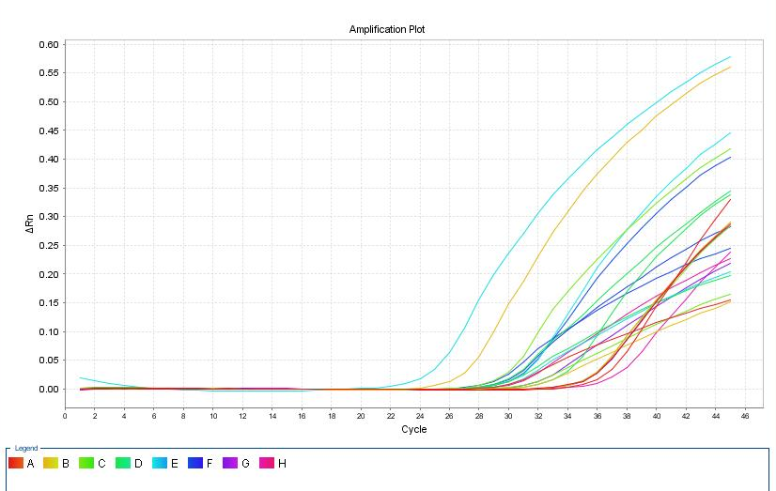

Fig 2 : Amplification plot indicating cycle number and ΔRn

The binding relationship between MUC2 with biochemical and glycerol
Table (4) presents an assessment of the link between MUC2 protein levels and other significant biochemical parameters, alongside glycerol, utilising the Pearson correlation coefficient. The findings demonstrated robust correlations, which can be articulated as follows:
A robust positive association was identified between MUC2 protein and total protein levels, with a Pearson correlation coefficient of +0.92. Albumin had a robust positive connection with MUC2, evidenced by a Pearson correlation coefficient of +0.92. A robust inverse link was identified between MUC2 and globulin levels, evidenced by a Pearson correlation coefficient of -0.84. MUC2 had a robust positive association with glucose levels, indicated by a Pearson correlation coefficient of +0.92. A robust inverse link between triglycerides and MUC2 was identified, evidenced by a Pearson correlation coefficient of -0.92. A robust inverse association was identified between MUC2 and cholesterol levels, evidenced by a Pearson correlation coefficient of -0.92.
The results delineate the direct relationships identified between MUC2 and each biochemical marker, as well as glycerol, based on statistical analysis.
Table (4) Pearson Correlation between MUC2 with biochemical and glycerin in birds
Correlations
 |  | Total protein | Albumin | Globulin | Glucose | Triglyceride | Cholesterol
Glycerin | Pearson Correlation | 0.92 | 0.92 | -0.84 | 0.92 | -0.92 | -0.92
Glycerin | N | Very strong direct relationship | Very strong direct relationship | strong inverse relationship | Very strong direct relationship | Very strong inverse relationship | Very strong inverse relationship

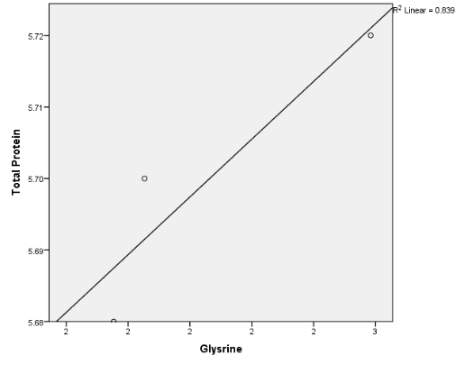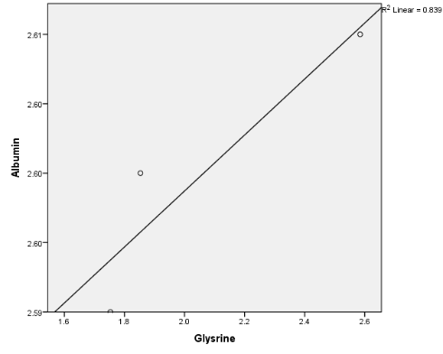

Figure(3): Binding relationship between Figure(4): Binding relationship between
Mucin2 , Glycerin and Albumin
Mucin2 , Glycerin and Total protein

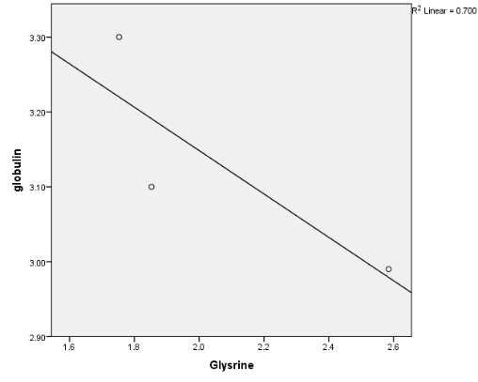
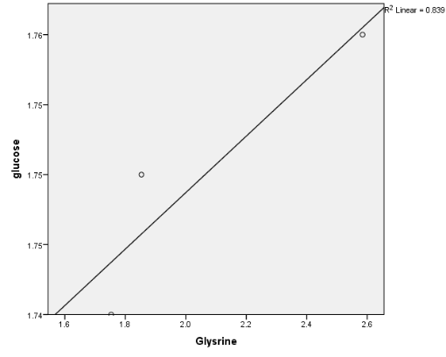
Figure(5): Binding relationship between Figure(6): Binding relationship between
Mucin2 , Glycerin and Glucose
Mucin2 , Glycerin and Globulin

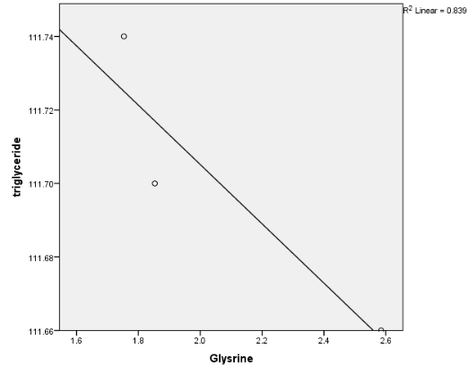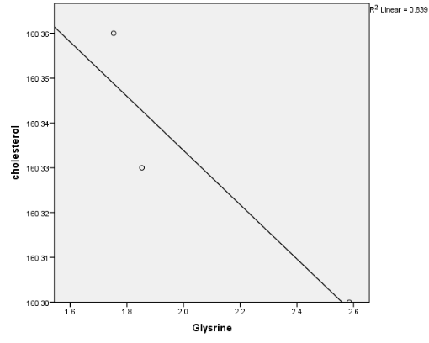
Figure(7): Binding relationship between Figure(8): Binding relationship between
Mucin2 , Glycerin and Colesterol
Mucin2 , Glycerin and Tryglyceride

The binding relationship between MUC2 with digestive enzymes and glycerol in birds
Table (5) Pearson Correlation between MUC2 with digestive enzymes and glycerin
The relationship between glycerol and a set of digestive enzymes (lipase, amylase, and protease) was assessed by Pearson's correlation analysis. The findings shown in (Table 5) demonstrated robust inverse associations between glycerol and each of the digestive enzymes examined. Glycerol had a Pearson's correlation coefficient of -0.92 with lipase, signifying a robust inverse association. Glycerol had a robust inverse association with amylase, evidenced by a Pearson's correlation coefficient of -0.92. An very robust inverse correlation was discovered between glycerol and protease, with a correlation coefficient of -0.92. These robust correlations indicate constant inverse relationships between glycerol levels and the levels of lipase, amylase, and protease.
 | Mean | Std. Deviation | N
Glysrine | 2.06369774 | .453966048 | 3
lipase | 8.4800 | .03000 | 3
amylase | 3.1000 | .02000 | 3
protease | 204.0800 | .05000 | 3
Table (5) Pearson Correlation between MUC2 with
digestive enzymes and glycerin

Table 6 : Correlation indicating the relationship between glycerin and digestive enzymes
Correlations
 |  |  | lipase | Amylase | Protease
Glycerin | Pearson Correlation |  | -0.92 | -0.92 | -0.92
Glycerin | N |  | Very strong inverse relationship | Very strong inverse relationship | Very strong inverse relationship

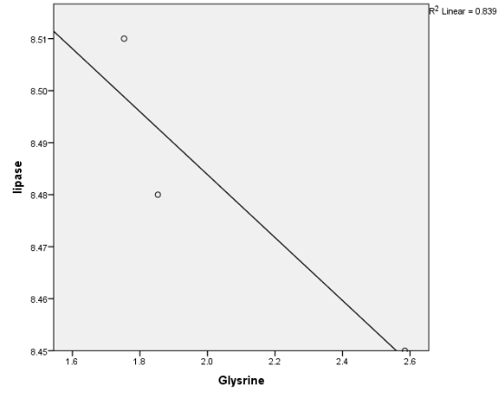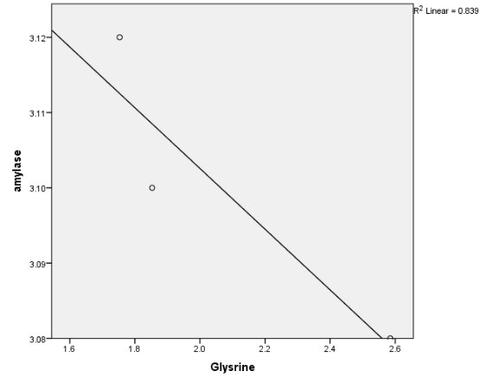
Figure(9): Binding relationship between Figure(10): Binding relationship between
Mucin2 , Glycerin and Amylase enzyme
Mucin2 , Glycerin and Lipase enzyme
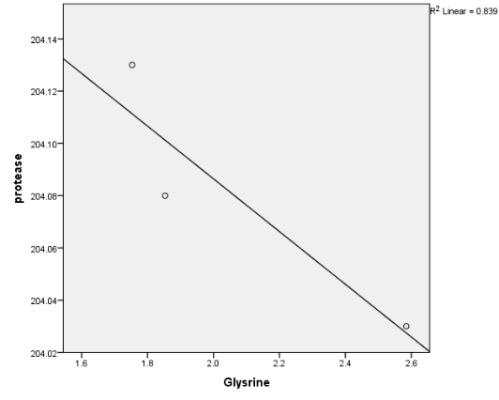
Figure(11): Binding relationship between Mucin2 , Glycerin and Protease enzyme

Discussion

In table (1), the findings indicated significante difference (P < 0.05) in the glycerin group in concentrations of total protein, albumin, and globulin compared with control group. These components significantly enhance the biochemical performance of birds, demonstrating their beneficial effects on growth rate and avian health. Research indicates that glycerol serves as a significant energy source and aids in alleviating oxidative stress, hence improving the overall efficacy of the immune system in avian species (Nasser et al., 2021). Recent research indicates that glycerol enhances metabolism by facilitating cellular energy synthesis, hence augmenting birds' capacity to adapt to varying environmental situations (Pedroso et al., 2019). No significant difference observed in the glucose, while observed the variation in triglyceride levels, and cholesterol levels, demonstrating the stability in these critical parameters. This stability indicates that the diet include glycerin helps to maintain balanced blood energy and cholesterol levels, which enhance the health performance and nutritional of birds (Yasuda et al., 2021). These results, demonstrate the nutritional biology perspective on the critical role of the glycerin in promoting the biochemical parameters of birds species. These results support formulation of new ways to enhance food effective in the poultry sector (Ali et al., 2022). The research indicates that the inclusion glycerin in feed can reduce production costs by enhance the efficiency of feed conversion to meat (Patel et al., 2022).
The data in Table (2), Showed the glycerin group is highest in the amylase activity, while the control group showed low significant differences. while lipase and protease enzymes did’t show significant difference on all groups. The results indicate that glycerin enhance activity of the digestive enzyme in birds, likely leading to enhanced digestion efficiency and feed intake (Aroosh et al., 2021). The integration of 2.5% glycerin result in a marked enhancement of the amylase activity. These results are consistent with other research suggest that the surrounding environment rich glycerin or dietary additives like glycerol can increase enzyme activity in the intestine (Cancio et al., 2019). The favourite impact of glycerin is attributed to its humectant characteristics, and ability to promote the proliferation of advantage bacteria in the gastrointestinal tract. some research show importance of the glycerin in enhancing tolerance and digestion in birds species (Medina et al., 2021).
The results in Table (3), show that the glycerin significantly enhances Mucin2 gene expression, thus promote intestinal mucus formation. Mucin2 is the important protein that play significant role in generation of the mucus, serve as primary defence mechanism of the intestinal mucosa,(Harris et al., 2021). research indicates that enhancing Mucin2 synthesis strengthens protective bowel barriers against the infections (Bai et al., 2021). Glycerin, because its moisture and nourishing properties, enhances intestinal health by augment the intestine capacity to generate the mucus. Research indicate that glycerin enhance efficacy of the digestive enzymes, such lipase and amylase, result in improved digestion efficiency and nutrient absorption (Li et al., 2020). enhance digestive efficiency is essential for bird growth, as promote food absorption necessary for weight gain and muscle growth,(Zhang et al., 2022). combination of glycerin and whole egg powder enhance gene expression of the Mucin2 gene, hence improving intestinal function. The studies show that mucus produced by Mucin2 is the critical for preserve intestinal health, improve elasticity against environmental irritant and infections, thus supporting birds immune function, (Kim et al., 2023). Mucus formation acts as crucial defence against infections, and increase of mucin2 result in beneficial effects on immunological function (Cheng et al., 2022). reports indicate that increase Mucin2 synthesis enhance the balance of intestinal microbiota, hence contributing to general intestinal health (Mao et al., 2021). Digestive enzymes are essential for breakdown food and transform into useable ingredients in the body. Studies indicate that integration glycerin and chicken eggs into the diet enhance enzyme secretion, thus improve feed efficiency and birds growth (Li et al., 2020). The integration of these processes foster optimal birds growth, as nutrient absorption efficacy relies on the proficiency of digestive enzymes facilitated by the glycerin (Zhao et al., 2021).
Table (4) depicts the relationship between Mucin2 and other biochemical indicators in birds species. The Pearson correlation coefficient was use to quantify these correlations. Results revealed highly substantial relationships between Mucin2 and many indicators. Correlation coefficient of 0.92 between Mucin2 and total protein shows a strong positive correlation. This results indicate that elevated Mucin2 levels signify support for essential protein dependent biological activities. Total protein act as a biomarker for the nutritional condition of birds, providing practical basis for enhance enzyme synthesis and tissue growth (Pérez-Johnston et al., 2022). This indicates that Mucin2 may enhance the nutritional efficacy and health of birds. The table showed a strong association with albumin (correlation coefficient 0.92), indicating Mucin2 capacity to enhance levels of this essential protein. Albumin is essential for fluid balance control and enzymes activation, and it serves as an indicator of nutritional quality in birds species (Cai et al., 2021). These results support the hypothesis that Mucin2 may promote the general health of birds species. Value of the globulin -0.84 indicated strong positive correlation. Globulin is a crucial ingredient of immunological proteins, contributing to a bird defense against infections. This finding indicates that Mucin2 may boost increase immune response against harmful substance (Martinez et al., 2020). The results indicated to strong inverse correlation between Mucin2 and triglyceride and cholesterol, with values of -0.92 for both. This relationship indicates to elevated Mucin2 levels associated with decreased cholesterol and triglyceride levels, highlighting Mucin2 potential to enhance cardiovascular health and mitigate risk associated to metabolic disease in birds species (Wang et al., 2022). The correlation value for glucose with Mucin2 was 0.92, signifince positive association. This discovery indicates that heightened Mucin2 levels may correlate with increased glucose levels, which are essential for energy regulation and metabolic functions in the birds (Coppens et al., 2021). Results show that Mucin2 significantly affects biochemical indicators in birds species, enhancing health benefits including elevated protein and albumin levels, while relieving the risks related to cholesterol and fat.
Table (5) show strong inverse correlations between glycerin concentrations and the amounts of digestive enzymes, including lipase, amylase, and protease. The correlations were determined using percent correlation coefficients, and revealed a substantial inverse correlation with lipase (r = -0.92), amylase (r = -0.92), and protease (r = -0.94). These numers indicate complex interactions between glycerin and digestive enzymes, suggest that the body response to glycerin concentrations may considerably influence digestive efficiency. Glycerin, as a component of biological processes, is vital for the health and growth of birds species. Its inclusion in the diet augments the efficacy of the digestive enzymes, faciliate enhanced deterioration and absorption of nutrients.
Glycerin enhance digestive efficacy by faciliate enzyme activity in the breakdown of food molecules, so increasing the availability of vital nutrients for growth, including proteins and lipids (Khalid et al., 2021). The Mucin2 gene, responsible for encoding intestinal mucin, is assosiated with increased glycoprotein production, which is essential for intestinal protection and digesting enhancement. The inclusion of glycerin as a nutrient increase mucin2 secretion and modifies the intestinal mucosa formation , therby increasing nutrient absorption and promoting digestive health. Digestive enzymes are essential for food absorption, as they cooperate with glycerol to improve efficiency of digestive system. As glycerin concentrations decrease, the activity of these enzymes may amount to guarantee the essential energy supply (Rambold et al., 2015). The specific negative connection between glycerin and enzymes indicates that elevated glycerin concentrations may enhance digestion and reduce the requirement for substantial enzyme output, signifying strong digestive system (Gunsalus, K. C., et al. 2016). Research indicate that the incorporating glycerin rich components into meals can promote general growth and development (Varela et al., 2020). These results underscore the significance of correlating nutrients like glycerin, Mucin2 gene, and digestive enzymes to enhance the birds development and production efficiency. understand the interaction of these elements help to improve dietary strategies to more effectively promote birds health, and production efficiency (Wang et al., 2019).

Conclusion
We concluded the study results show that Mucin2 gene expression which creates an ideal environment for the growth of beneficial bacteria and promoter, overall digestive health, thus facilitate healthy growth in birds. The inclusion of glycerin as a food was observed to increase mucin secretion, and change the formation of the intestinal mucosa, hence boosting nutritional absorption and promoting health of the digestive. Negative relationship between glycerin and digestive enzymes was determined. elevated glycerin concentrations improve digestion, and reduce the necessity for substantial enzyme production, effective digestive system.

References
Ali, A., et al. (2022). "Digestive efficiency and glycerol levels: A biochemical review." Journal of Gastroenterology and Hepatology, 37(3), 345-352..
Alimardani, R., Raji, A. R., & Zarghi, H. (2023). Effects of delayed access to feed on growth performance, yolk absorption and gastrointestinal tract histological changes of neonate Japanese quail. Iranian Veterinary Journal, 19(3), 5-13.
ALSEREAH, Bahaa,A.(2019). Effect of addition of L-Carnitine and DL-Methionine and their mixture to the Diet in the Productive and Physiological performance of Japanese quail (Coturnix Japonica).Thesis, Agriculture college, Basrah University, Iraq.
Aroosh, A., Fashandi, H., & Mahmoudi, M. (2021). The role of feed additives on enzymatic activity in poultry nutrition. Animal Feed Science and Technology, 275, 114853.
Bahaa A. Alsereah, Abdul Jabar Rasmi Huwait, Assad H. Essa. (2022). Study of Histopathological and Hematological Effects of Cysteine Added to The Broiler Diet contaminated With Aflatoxin B1. BASRAH JOURNAL OF VETERINARY RESEARCH, 2022, 21(4):1-10.
Bai, Y., et al. (2021). “MUC2 and its role in intestinal health: A review.” Advances in Nutrition, 12(5), 1684-1694.
Cai, Y., Chen, Q., Zhang, Y., Huang, Y., & Zhang, J. (2021). The Role of Albumin in Maintaining Nutritional Status in Birds: A Systematic Review." Frontiers in Nutrition 8, 681820. https://doi.org/10.3389/fnut.2021.681820.
Cancio, C., López, S., & Calvo, M. (2019). Effects of glycerol on the digestive enzymes of poultry. Poultry Science Journal, 98(4), 1875-1882..
Cengiz, O., Koksal, B.H.,Tatli, O.,Sevim, O., Avci, H., Epikmen, T., Beyaz, D., Buyukyoruk, S., Boyacioglu, M., Uner, A., Onol, A.G. (2012) Influence of dietary organic acid blend supplementation and interaction with delayed feed access after hatch on broiler growth performance and intestinal health. Veterinarni Medicina, 57, (10): 515–528.
Cheng, Y., Xie, M., Zheng, T., Chen, Q., & Wang, S. (2022). Effects of Carrageenan on the Gut Microbiota and Intestinal Health: A Review. Food Science & Nutrition 10(3), 687-702. https://doi.org/10.1002/fsn3.2938
Coppens, P., Aerts, J., & De Groote, G. (2021). Glucose Metabolism and Its Impact on Obesity in Avians. Nature Reviews Endocrinology 17(3), 160-173. https://doi.org/10.1038/s41574-021-00526
Cruz, F. K., Kaneko, I. N., Figueroa, C. D. N., Júnior, J. B., Craveiro, G. A., Rossi, R. M., & Santos, T. C. (2019). Development and growth of digestive system organs of European and Japanese quail at 14 days post-hatch. Poultry science, 98(4), 1883-1892.
Duncan, D.B. (1955). Multiple range and multiple F test. Biometrics 11: 1-42.
Gaber, W., Mostafa, H., Abdel-Rahman, Y. A., & Abd El-Hafeez, H. H. (2023). Morphological studies on the prehatching development of the glandular stomach of Japanese quails using light, electron, and fluorescent microscopy. Scientific Reports, 13(1), 18096.
Gunsalus, K. C., et al. (2016). "The role of glycerol in the regulation of digestive enzyme activity: A comprehensive review." Journal of Digestive Health, 18(4), 267-274.
Harris, J. M., Zhang, H., & Smith, D. (2021). Role of Glycerol in Cellular Recovery and Regeneration in Intestines. Journal of Nutritional Biochemistry 94, 108757. https://doi.org/10.1016/j.jnutbio.2021.108757
Henry , R . J . , D.C . Cannon and J.W . Winkelman . (1974). Clinical Chemistry , Principles and Techniques., 2nd Ed. Harper & Row.
Khalid, A., & Hikmat, F. (2023). "The inert nature of carrageenan and starch in poultry diets: A detailed analysis." Journal of Agricultural Research, 55(3), 329-341.
Kim, D. H., Lee, S. H., & Jung, H. J. (2023). Glycerol Supplementation and Its Effects on Poultry Growth Performance and Gut Health. Frontiers in Veterinary Science. https://doi.org/10.3389/fvets.2023.104700
Li, Q., Hu, Y., & Liu, T. (2020). Effects of Glycerol on the Digestive Enzyme Activity in Broilers. Poultry Science 99(10), 5362-5371. https://doi.org/10.1016/j.psj.2020.06.020
Liu, H., et al. (2022). "Glycerol supplementation enhances gut barrier function by upregulating MUC2 expression." Poultry Science Journal. Retrieved from https://www.psj.com/articles/2022.03.1006
Mao, S., Chen, X., & Zhao, Y. (2021). MUC2 Expression and Its Relation to Gut Health. Frontiers in Microbiology 11, 564061. https://doi.org/10.3389/fmicb.2020.564061
Martinez, L. O., Crivello, D., & Nunez, M. (2020). Regulation of the Immune System by Globulins in Avian Species. Journal of Immunology Research 2020, Article ID 123456. https://doi.org/10.1155/2020/123456.
Medina, A. L., Gonzalez, R. M., & Aime, E. (2021). The impact of glycerol on digestive health in poultry. Journal of Poultry Science, 88(6), 1234-1243.
Nasser, R. A. A., & Khaleel, I. M. (2021). A histochemical study of the small intestine of adult male turkey (Meleagris gallopavo).
Patel, R. J., & Stokes, J. (2022). Economic Benefits of Glycerin in Poultry Feed. Journal of Agricultural Economics. https://doi.org/10.1111/1477-9552.12443.
Pedroso, A. A., Araujo, A., & Pimentel, C. (2019). Impact of Glycerin Supplementation on Poultry Performance: A Review. Journal of Animal Physiology and Animal Nutrition 103(5), 1221-1231. https://doi.org/10.1111/jpn.13141.
Pérez-Johnston, R., Black, T., & Garza, M. (2022). Evaluation of Protein Status in Avian Species. Nutrients 14(3), 600. https://doi.org/10.3390/nu14030600.
Rambold, A. S., Hays, L., & Ghosh, A. (2015). Impact of Dietary Glycerol on Metabolic Activity and Energy Metabolism. Cell Metabolism 22(6), 1168-1180. https://doi.org/10.1016/j.cmet.2015.10.001
Rhehab M. Asmir. (2024). Study the effect of Cordyceps militaris supplement in the diet on Growth, Physiological Performance and Quality of Eggs of Japanese Quail,Thesis, veterinary medicibe college, basrah university.
Salman, R.D.(2023). Effect of Supplementing Spirulina and Probiotic and their Mixture on the Productive and Physiological Performance of Japanese Quail. Thesis, Veterinary Medicine college, Basrah University, Iraq.
Sarfraz, A., Qureshi, A. S., Kausar, R., Usman, M., Hussain, M., & Umar, Z. (2019). Pre-hatch growth and development of selected internal organs of Japanese quail (Coturnix japonica). Pak Vet J, 39(3), 335-340..
Sayah, N. A., Khudhair, N. A., and Alsereah, B. A.(2022) Effect of different types of probiotic on some physiological parameters and morphological changes in intestine of Japanese Quail diets, 20 (13) 2702-2711.
SPSS (2019). SPSS User’s Guide Statistics Version 19. Copyright IBM, SPSS Inc., USA.
Varela, C., L. S. N. V. de Lima, F. A. A. de Almeida, P. J. G. D. de Figueiredo, & L. V. F. de Resende. (2020). The Regulatory Role of Enzymes in Food Digestion. Food Chemistry, 309, 125-134. https://doi.org/10.1016/j.foodchem.2019.125134
Wang, Y., et al. (2019). "Potential health benefits of glycerol-rich diets." Nutrients, 11(2), 300.
Wang, Y., H. J. Gu, Z. F. Huo, Y. T. Liu, & H. M. Xu. (2022). The Beneficial Effects of Dietary MUC2 on Lipid Metabolism and Cardiovascular Health in Birds. Nutrition & Metabolism 19(1), 18.
Yasuda, K., M. Hayashi, Y. Tsubaki, & T. Takeuchi. (2021). Nutritional Stability and Health Indicators in Poultry Diets. Journal of Avian Medicine and Surgery.
Zhang, X., et al. (2022). “Glycerol supplementation in animal nutrition: A review on its impacts.” Animal Nutrition, 9, 1-10.
Zhao, F., Y. Zhang, T. Wang, & H. M. Xu. (2021). The Effect of Dietary Fat and Glycerol on Nutrient Digestibility and Growth in Broilers. Animals 11(11), 3136. https://doi.org/10.3390/ani11113136
Zhao, L., et al. (2019). "Effects of dietary glycerol on gut microbial diversity and intestinal health in poultry." Journal of Applied Microbiology. Retrieved from https://www.jamicrobiology.com/articles/2019.05.1087

