A Study of Spider Diversity and Habitat Distribution in Rajnandgaon Block, Chhattisgarh (India)

Abstract: This study investigates the diversity and habitat of spiders in Rajnandgaon Block, Chhattisgarh, India, as well as their ecological roles. A total of 25 spider species from 20 genera, 9 families, and the order Araneae were recorded across urban, forest, and agricultural habitats. Salticidae (jumping spiders) constituted a major part of the recorded species. Some common species include Marpissa obtusa, Menemerus bivittatus, and Plexippus paykulli. The study recorded that tropical forest ecosystems harbored tarantulas (Grammostola pulchra and Grammostola rosea), whereas lynx spiders (Peucetia viridans and Oxyopes salticus) thrived in forest and shrubland. Habitat diversity played a significant role in supporting spider species as they prefer microhabitats such as tree trunks, rocks, and shaded areas. The contribution of spiders toward ecological services also focuses on pest control. The findings suggest that seasonal variations impact species distribution, which aligns with earlier studies on spider diversity in India. This study highlights the necessity of conservation to preserve spider habitats and maintain their ecological functions. Further research should include seasonal patterns, microhabitat preferences, and pest control functions of spiders.
Keywords: Spider diversity, habitat distribution, Salticidae, ecological roles, Chhattisgarh.

Introduction: Spiders are essential components of ecosystems, playing vital roles in ecological balance by functioning as predators and prey. Their presence in diverse habitats significantly regulates insect populations and stabilizes food webs. This research discusses the ecological characteristics of selected spider species from various geographical regions, highlighting their habitats, seasonal activity, and feeding patterns.
Spiders are highly adaptable, with ecosystems ranging from forests and grasslands to agricultural and urban environments supporting them. Spider diversity and distribution depend on environmental factors such as vegetation, climate, and prey density. Research by Das et al. (2022) and Singh et al. (2020) has reported rich spider diversity in regions like Tripura and other parts of India, demonstrating their ecological significance. For example, Das et al. (2022) documented the first record of nine spider species from Kailashahar, emphasizing the diversity of spider fauna in less-studied areas. Similarly, Singh et al. (2020) focused on the diversity of yellow sac spiders (Cheiracanthiidae) in India and discovered remarkable adaptations that enable them to thrive in various environments.
The seasonal activity of spiders is strongly correlated with environmental factors, particularly temperature and humidity. Sidar et al. (2017), in their study on the seasonal distribution of spider fauna in maize fields of Raipur, Chhattisgarh, observed clear activity patterns at different times of the year. Their study highlights the significance of seasonal variations in influencing spider populations. Likewise, Ekka and Kujur (2015) investigated spider diversity in Raigarh's Ram Jharna area, Chhattisgarh, and noted the effect of seasonality on the population and behavior of different spider species. These studies underscore the dynamic nature of spider populations in response to environmental conditions.
Spiders' dietary habits also play a crucial role in their ecological importance. As predators, they act as natural pest control agents by feeding on insects and other arthropods. A study by Nautiyal et al. (2017) in the semi-arid environment of Gogi, Yadgir District, Southern India, identified the predatory effectiveness of spiders in controlling pest populations in agro ecosystems. This corroborates the findings of Gajbe (2003), who presented a comprehensive checklist of spiders from Madhya Pradesh and Chhattisgarh, emphasizing their role as biological control agents. Additionally, research by Patil (2011) and Rajeevan et al. (2019) has further explored the ecological importance of spiders in forest and agro-ecosystems, highlighting their adaptability and ecological value.
Spider habitats are diverse, ranging from forests to deserts. For instance, Kumari et al. (2017) examined the diversity and distribution of spider fauna in Rajasthan's arid and semi-arid regions, noting their impressive capacity to thrive in extreme conditions. Similarly, research in the Western Ghats by Misal et al. (2019) and Palem (2017) has established the high diversity of spider species in these biodiversity hotspots, underscoring the importance of conservation to safeguard their habitats.The observed heterogeneity of insect fauna in paddy fields of Rajnandgaon, including varied species distributions influenced by habitat conditions, provides a valuable ecological framework for studying spider species and their habitat preferences in the same region (Pandey et al., 2023).
In summary, spiders are integral to ecosystems, ensuring biodiversity, pest control, and ecological balance. By examining their ecological characteristics, this research aims to provide meaningful insights into their habitats, seasonal patterns, and diets, thereby enriching our understanding of their ecological importance.

Material & Methods:
Study Area: The current investigation was executed in Rajnandgaon Block, which constitutes one of the urban ecological regions of Rajnandgaon District, situated in the central Indian state of Chhattisgarh. Geographically, Rajnandgaon Block is positioned between latitudes 20.85°N to 21.30°N and longitudes 80.50°E to 81.20°E, encompassing a heterogeneous array of ecosystems including agricultural plots, grasslands, wetlands, and urban localities.The elevation of the area varies from approximately 300 to 350 meters above mean sea level, characterized by gently undulating topography and sections of low hills. The area is located on the Chhattisgarh plain, featuring fertile alluvial and red soils, and receives an average annual precipitation of 1000–1200 mm, predominantly during the monsoon period (June to September). The climate is tropical, characterized by hot summers, moderate winters, and elevated humidity during the precipitation season.
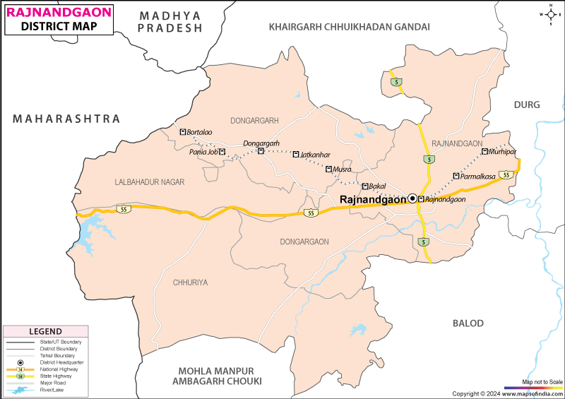
Figure No. 01: Study Area
Data Collection Method: Systematic observations and documentation of spider species included data on location, habitat, seasonality of activity, temperature preference, and feeding habits. Natural and man-made habitats were surveyed to ensure a representative sample of diverse environments (Das et al., 2022; Singh et al., 2020). Field surveys were conducted across various seasons to record fluctuations in species activity and population dynamics, as noted by Sidar et al. (2017) and Kumari et al. (2017).
Spiders were collected using techniques such as direct search, pitfall traps, and sweep nets, as reported by Singh et al. (2023) and Daimary et al. (2024). Habitats ranged from forests and agricultural lands to semi-arid areas, enabling data collection from ecologically distinct zones (Nautiyal et al., 2017; Ekka & Kujur, 2015). Seasonal variation was analyzed to identify correlations between climatic factors and spider diversity, as reported by Rana et al. (2024) and Malik & Goyal (2017).
Species identification was performed using morphological keys and local checklists (Gajbe, 2003; Patil, 2011). Feeding habits were investigated through observational techniques, focusing on prey capture behaviors (Borkar & Seth, 2020). The results contribute to the understanding of the ecological role and distribution of spiders in different ecosystems (Rajeevan et al., 2019; Vassou et al., 2023).
Field Sampling: To assess the diversity and distribution of spider species across various habitats in Rajnandgaon Block, systematic field sampling was conducted using standardized and widely accepted collection techniques. The sampling covered diverse habitats including agricultural fields, forest patches, wetlands, grasslands, and human settlements.

1. Stratified Random Sampling:The study area was divided into distinct habitat types (strata), and random sites were selected within each stratum to ensure representation of all ecological zones (Uetz et al., 1999). Each habitat type was surveyed at regular intervals during the study period, covering both dry and wet seasons to capture seasonal variations in spider populations.

2. Collection Techniques:A combination of qualitative and quantitative methods was used to ensure the collection of ground-dwelling, foliage-dwelling, and web-building spider species:
- Hand Collection (Active Searching): Spiders were manually collected from vegetation, ground surfaces, under stones, logs, and leaf litter using forceps and aspirators, particularly during morning and evening hours when spiders are more active (Barrion & Litsinger, 1995).
- Sweep Netting: A sweep net was used to sample foliage-dwelling spiders in grasslands, crop fields, and shrub areas. This technique is effective for capturing orb-weaving and jumping spiders (Churchill & Arthur, 1999).
- Pitfall Traps: Plastic containers (10–15 cm diameter) partially filled with 70% ethanol were buried at ground level and left for 48–72 hours to trap ground-dwelling spiders such as wolf spiders and ground hunters (Topping & Sunderland, 1992).
- Leaf Litter Sifting: Leaf litter was collected and sifted through a sieve to extract cryptic spiders. This method helps collect small-bodied and sedentary species from forest floors (Coddington et al., 1991).
- Beating Sheet Method: Vegetation and shrubs were beaten with a stick and the dislodged spiders were collected on a white cloth or tray placed below. This technique is useful for arboreal and foliage-dwelling spiders (Jiménez-Valverde & Lobo, 2005).

3. Preservation and Identification: Collected specimens were preserved in vials containing 70% ethanol and labeled with date, location, habitat type, and collection method.Spiders collected from various habitats in Rajnandgaon Block, Chhattisgarh, were identified primarily through morphological examination using stereomicroscopes and compound microscopes, focusing on key diagnostic features such as eye arrangement, chelicerae, pedipalps, abdominal patterns, and spinneret structure. Identification was carried out with the help of standard Indian taxonomic references, notably Handbook of Indian Spiders by Tikader (1987) and Spiders of India by Sebastian and Peter (2009), which provide comprehensive keys and descriptions of spider families and genera found in the Indian subcontinent. Recent taxonomic updates and synonymy were verified using the World Spider Catalog (Platnick, 2024). When necessary, specimens were cross-checked with reference collections from the Zoological Survey of India and validated through expert consultations. This combined approach ensured accurate identification of both common and cryptic species across different ecological zones in the study area.
Diversity Indices: Shannon-Wiener, Simpson’s Diversity Index, and Species Evenness will be calculated.
Results and Discussion: The survey documented 25 spider species from 25 genera, 9 families, and the order Araneae across five locations in Rajnandgaon Block & District, Chhattisgarh, India. Habitats varied from urban to forest ecosystems, including tree trunks, rocks, walls, and agricultural areas. Salticidae was the most prevalent family, representing the highest percentage of recorded spider species in the region.

S.No. | Site | Common Name | Scientific Name | Family | Order | Habitats | IUCN Status
1 | Rajnandgaon | Obtuse Jumping Spider | Marpissa obtusa | Salticidae | Araneae | Walls, boulders, and under rocks | NE
2 | Rajnandgaon | Bivittatus Jumping Spider | Menemerus bivittatus | Salticidae | Araneae | Open habitats like meadows, prairies, farms, and gardens. | LC
3 | Rajnandgaon | Green Lynx Spider | Peucetia viridans | Oxyopidae | Araneae | Found in temperate forests, scrubland, deserts, intertidal zones, | NE
4 | Rajnandgaon | Regal Jumping Spider | Phidippus regius | Salticidae | Araneae | Urban area | NE
5 | Rajnandgaon | Jumping Spider | Platycryptus undatus | Salticidae | Araneae | Urban area | NE
6 | Rajnandgaon | Tan Jumping Spider | Platycryptus undatus | Salticidae | Araneae | Tree trunks (especially under loose bark), rocks, fences, leaf litter, and walls of buildings. | NE
7 | Rajnandgaon | Pantropical Jumping Spider | Plexippus paykulli | Salticidae | Araneae | Their natural habitats consist of forests, savannas, and shrublands, | NE
8 | Sukuldaihan | Brazilian Black Tarantula | Grammostola pulchra | Theraphosidae | Araneae | Tropical forests | NE
9 | Sukuldaihan | Adanson's House Jumper | Hasarius adansoni | Salticidae | Araneae | House & wall | NE
10 | Sukuldaihan | Bridge Spider | Larinioides sclopetarius | Araneidae | Araneae | Tree trunks adjacent to water | NE
11 | Sukuldaihan | Paradox Jumping Spider | Menemerus paradoxus | Salticidae | Araneae | Tree bark & wall | NE
12 | Sukuldaihan | Bresnier's Jumping Spider | Phlegra bresnieri | Salticidae | Araneae | Sand dunes and sometimes in other dry coastal | NE
13 | Sukuldaihan | Zebra Spider | Salticus scenicus | Salticidae | Araneae | Open, sunny habitats | NE
14 | Surgi | Wolf Spider | Acantholycosa spp. | Lycosidae | Araneae | live on the ground | NE
15 | Surgi | Barn Orb-Weaver Spider | Araneus ventricosus | Araneidae | Araneae | In garden, fields, and forest ecosystems | NE
16 | Surgi | Chilean Rose Tarantula | Grammostola rosea | Theraphosidae | Araneae | Ceilings of rooms, caves, garages or cellars | NE
17 | Surgi | Striped Lynx Spider | Oxyopes salticus | Oxyopidae | Araneae | Their natural habitats consist of forests, savannas, and shrublands, | NE
18 | Surgi | Daddy Longlegs Spider | Pholcus phalangioides | Pholcidae | Araneae | Desert and scrub / dry grassland regions | NE
19 | Surgi | Pantropical Jumping Spider | Plexippus paykulli | Salticidae | Araneae | Grasses and leafy vegetation; grassy, weedy fields, and row crops. | NE
20 | Ghumka | Common Barn Spider | Araneus cavaticus | Araneidae | Araneae | Suburban and rural structures or areas, and on boats near lakes | NE
21 | Ghumka | Yellow Sac Spider | Cheiracanthium inclusum | Cheiracanthiidae | Araneae | Shrublands, woodland, wet coastal forest, alpine meadows, suburban gardens, and homes. | NE
22 | Ghumka | Wolf Spider | Pardosa sp. | Lycosidae | Araneae | Forests | NE
23 | Ghumka | Heavy-Bodied Jumping Spider | Phidippus otiosus | Salticidae | Araneae | Forests, gardens, and homes | NE
24 | Mudhipar | Huntsman Spider | Heteropoda venatoria | Sparassidae | Araneae | Forests, gardens, and homes | NE
25 | Mudhipar | Furrow Spider | Larinioides cornutus | Araneidae | Araneae | Moist habitats with shade direct sunlight | NE
26 | Mudhipar | Golden Silk Orb-Weaver | Nephila pilipes | Araneidae | Araneae | Moist habitats with shade direct sunlight | NE
27 | Mudhipar | Tree Trunk Spider | Tama edwardsi | Hersiliidae | Araneae | Tree bark | NE
Total | 5 |  | 25 | 9 | 1 |  | NE
Table 01: Recorded Spider Species and Their Habitats
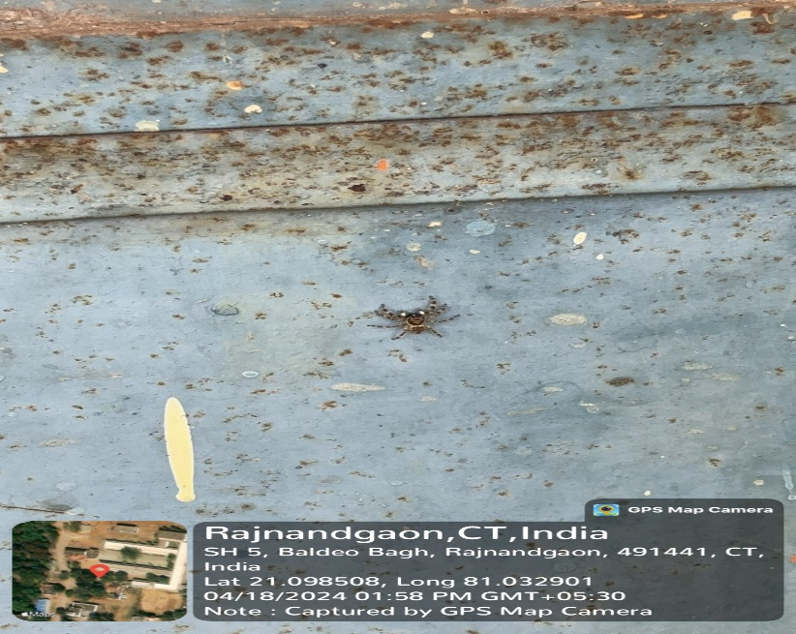  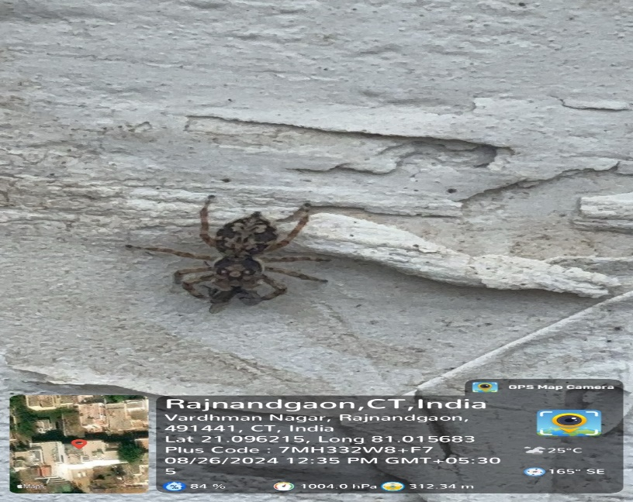  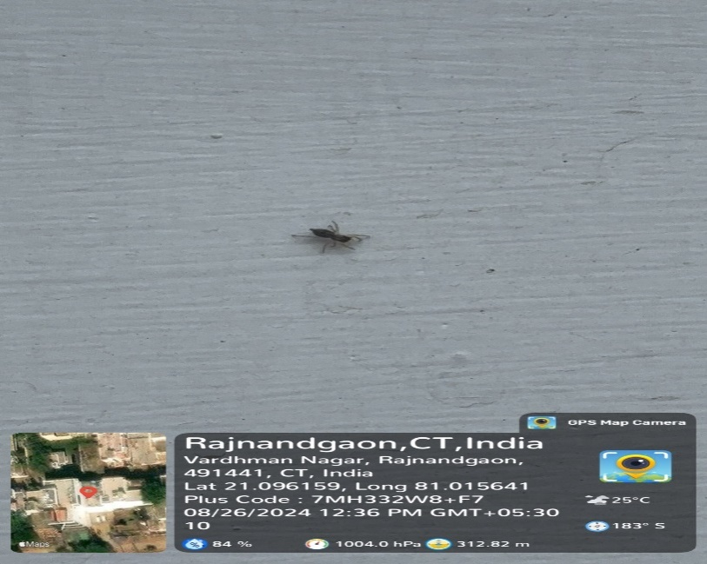  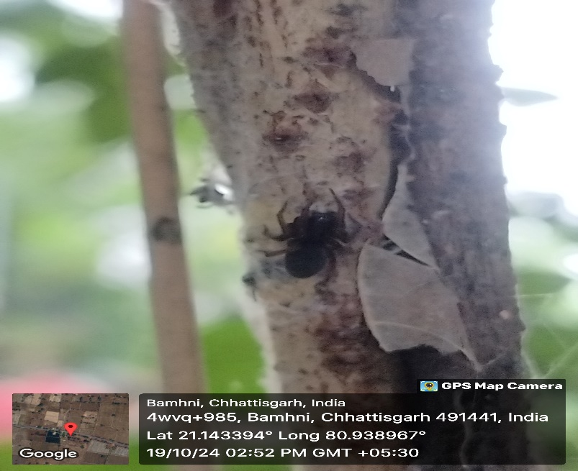  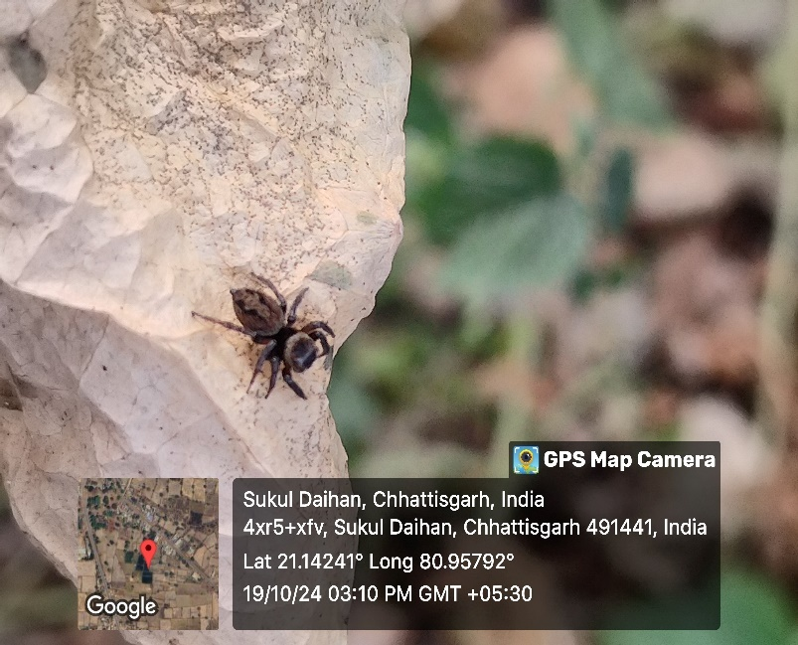  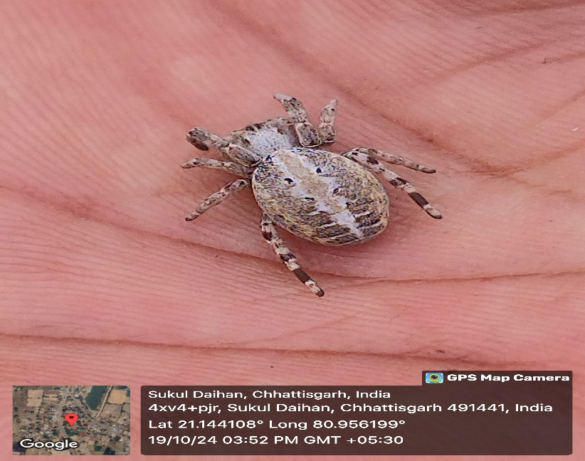  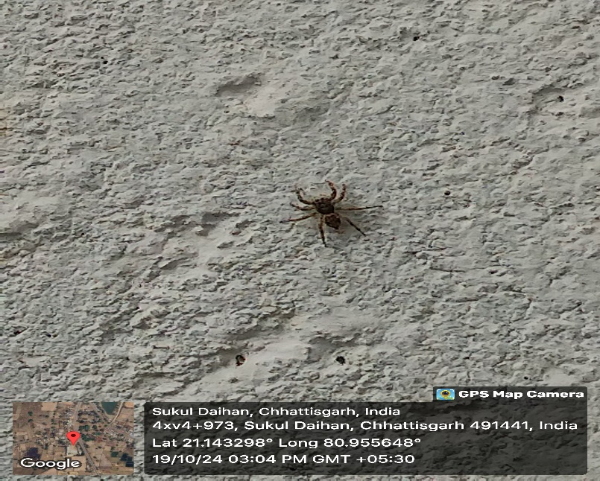  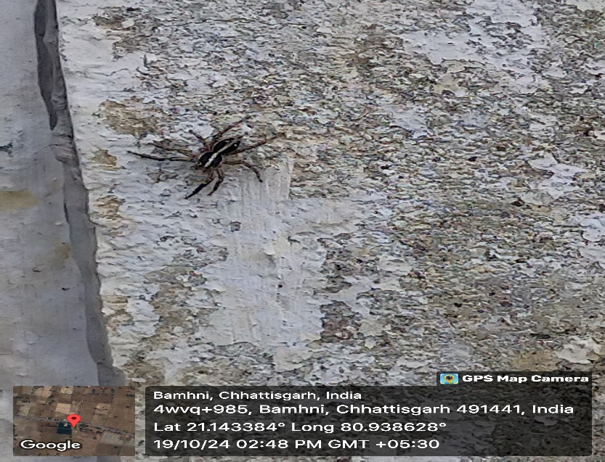  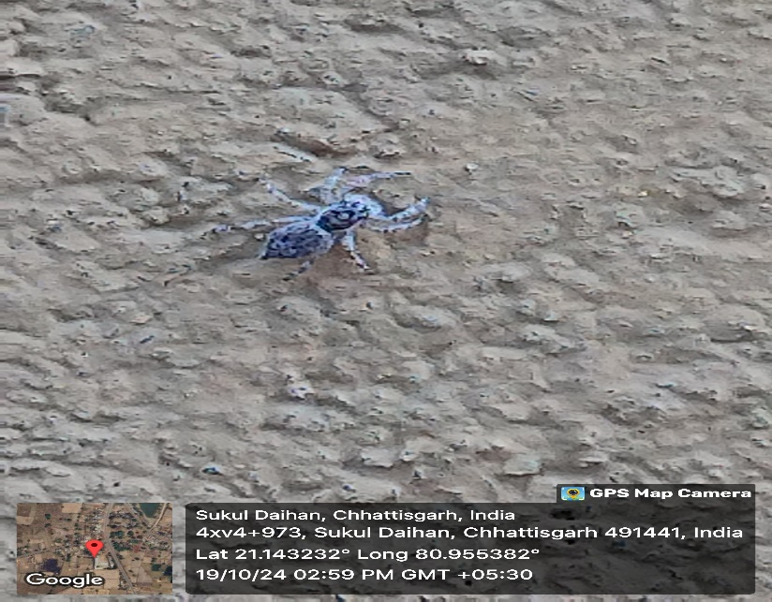  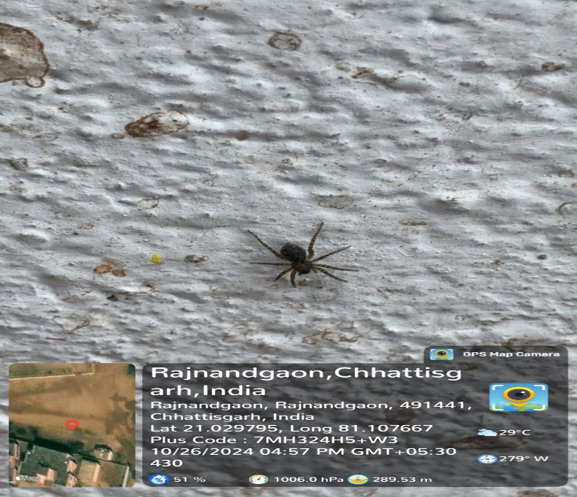  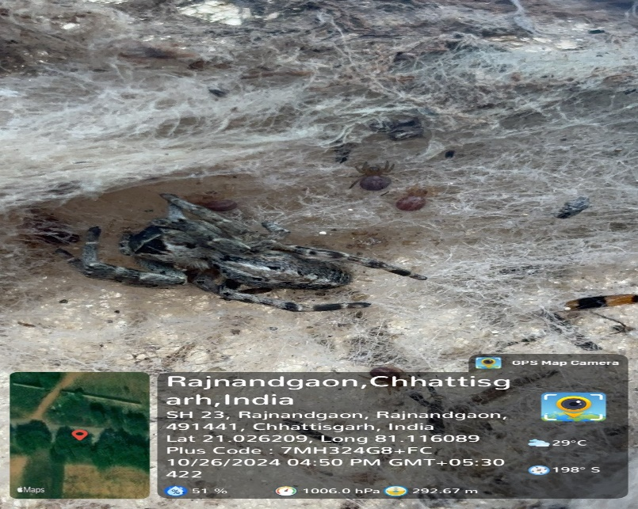  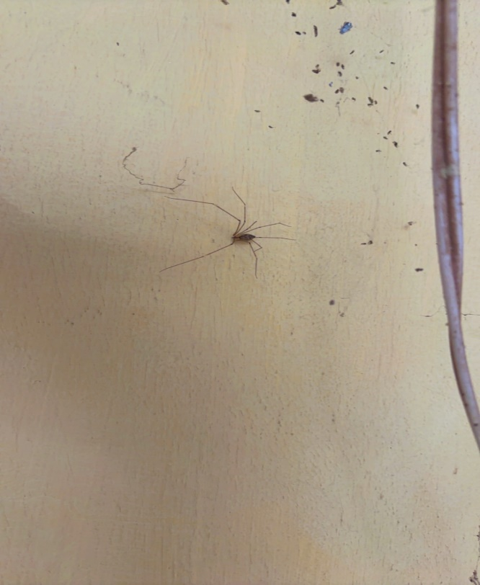  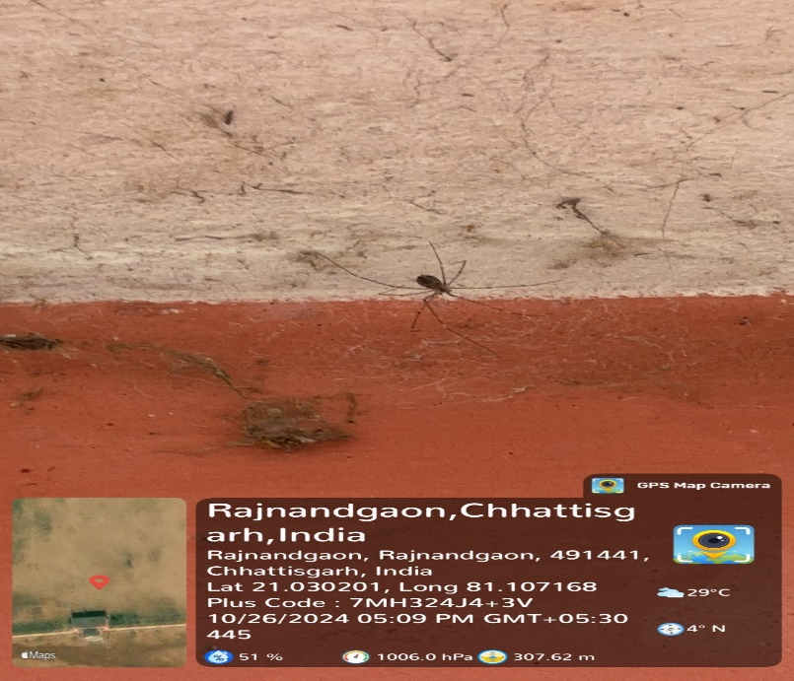  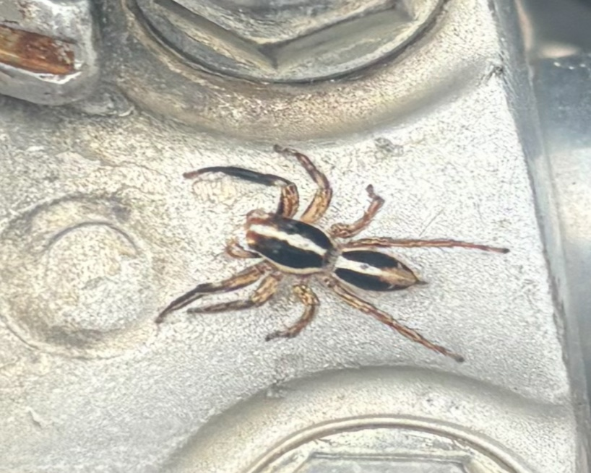  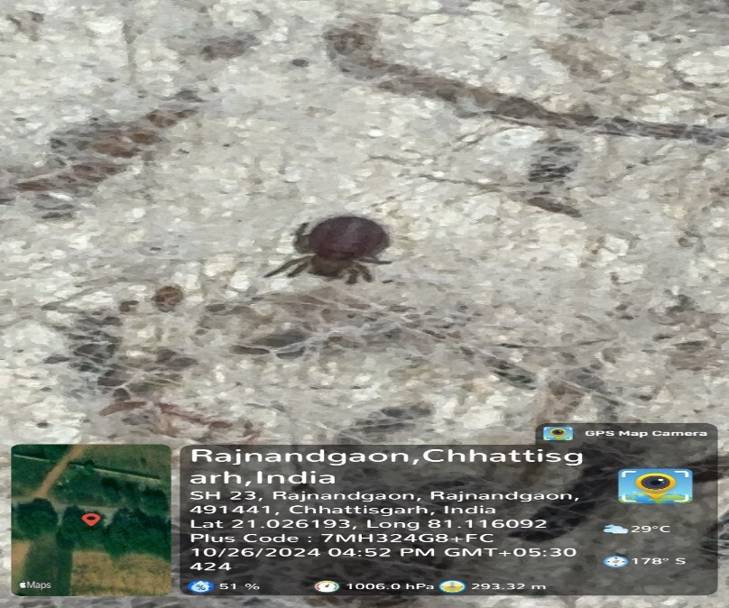  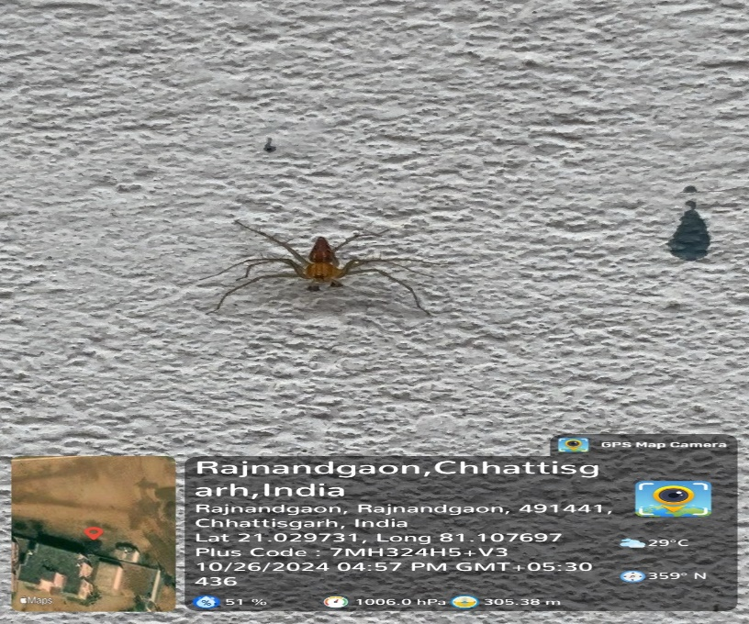  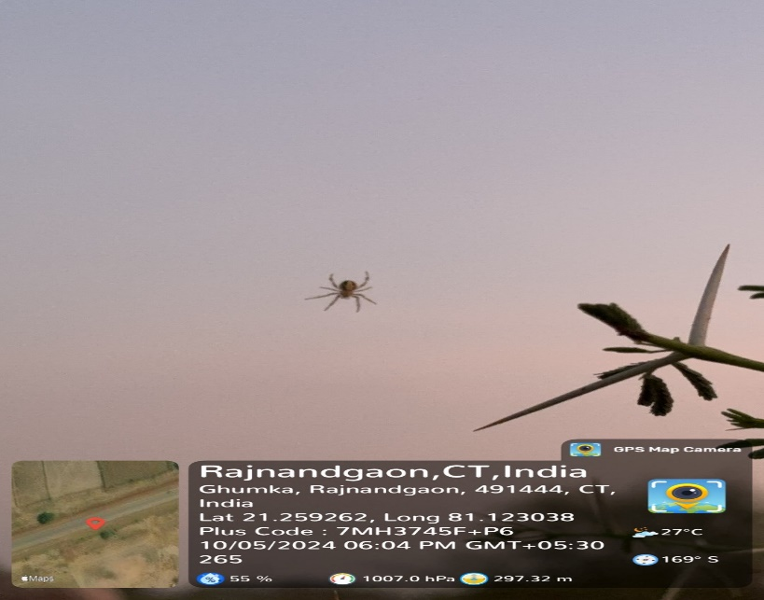  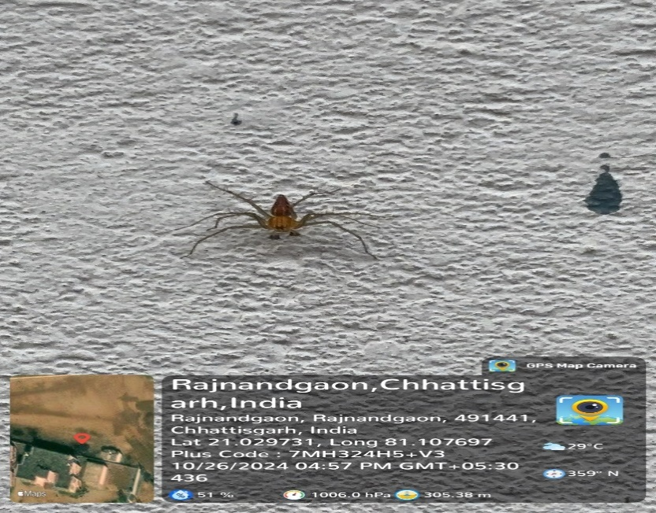  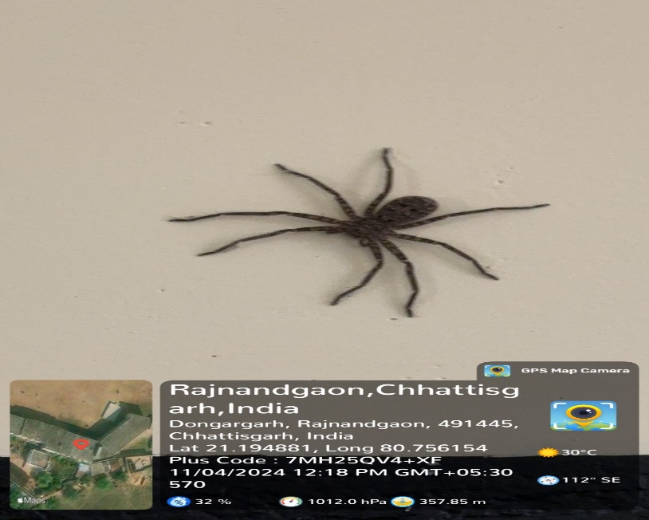  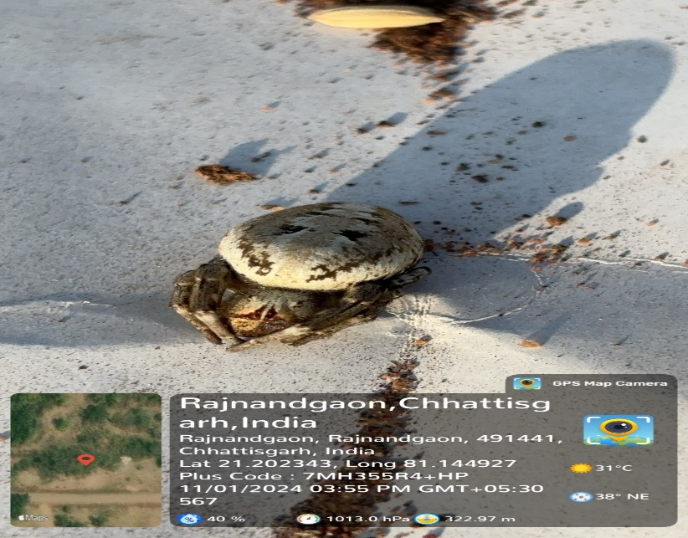  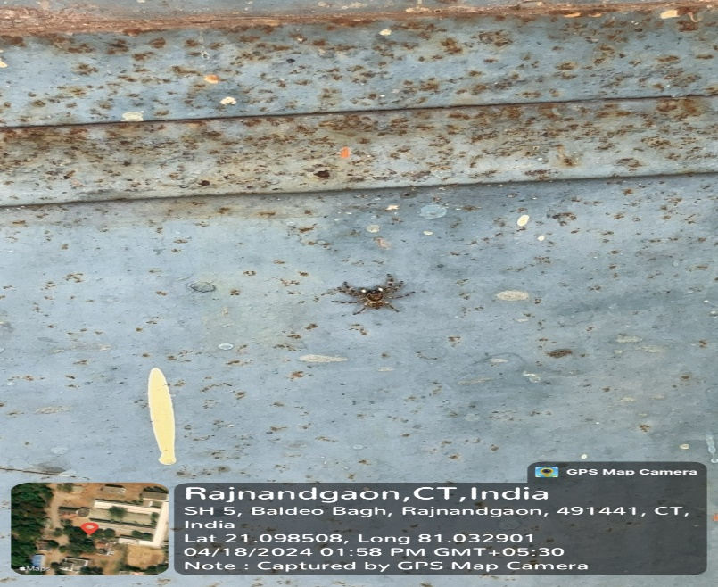  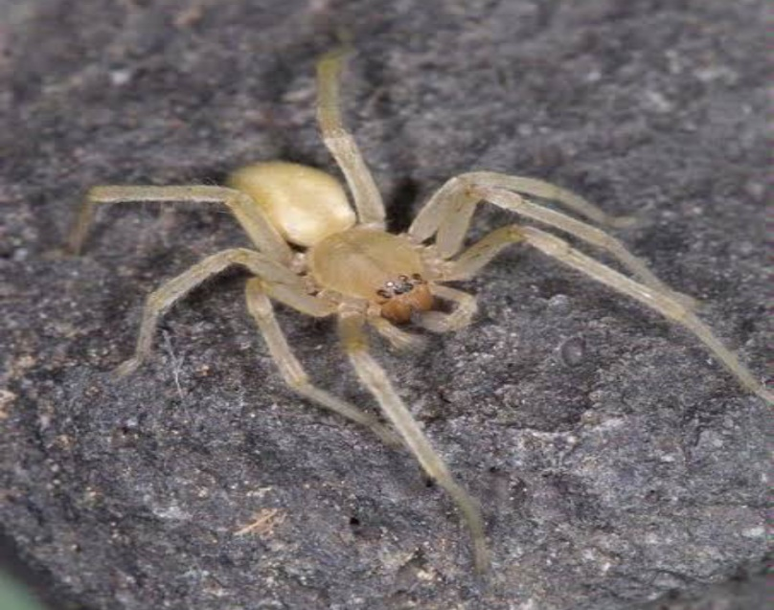  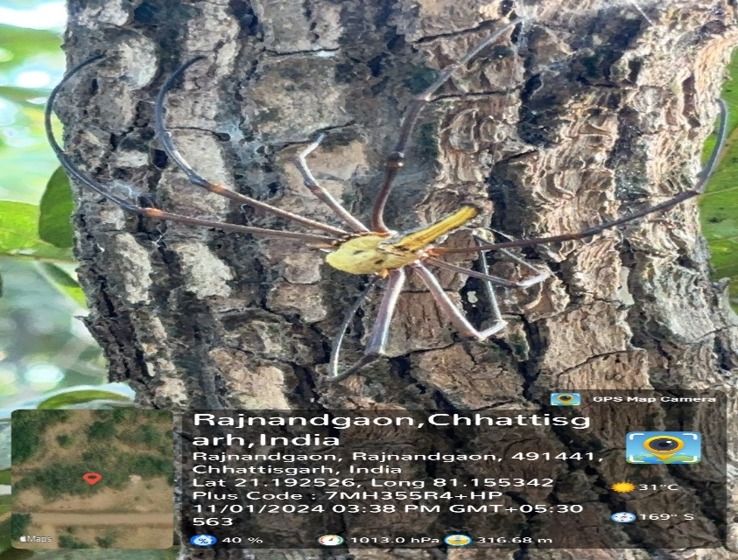  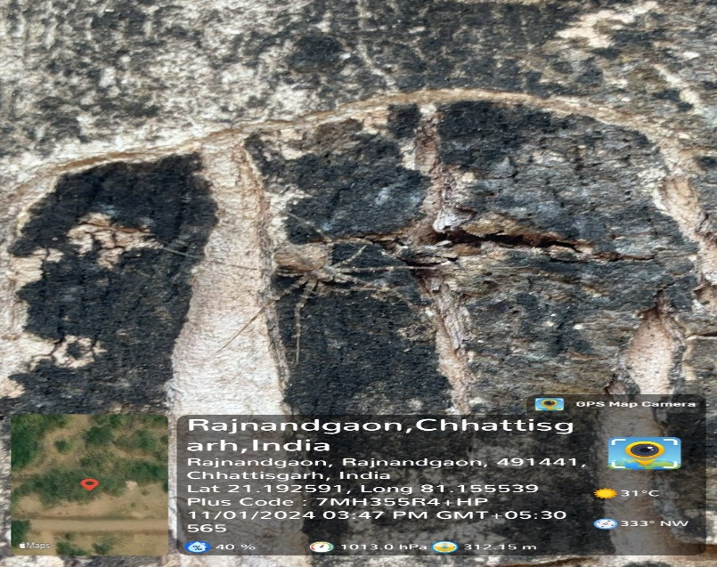  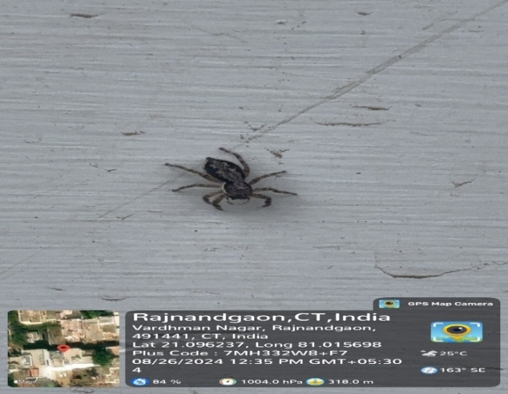Menemerus bivittatus | 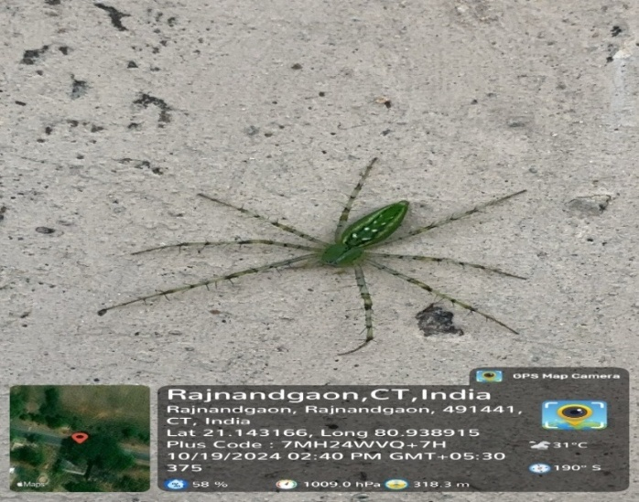Peucetia viridans
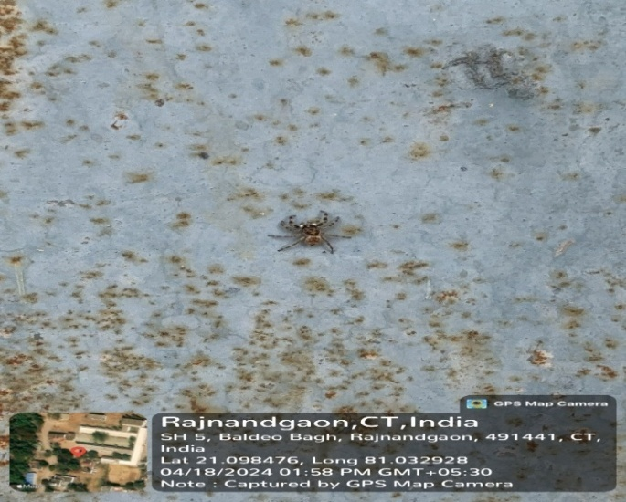Marpissa obtusa | 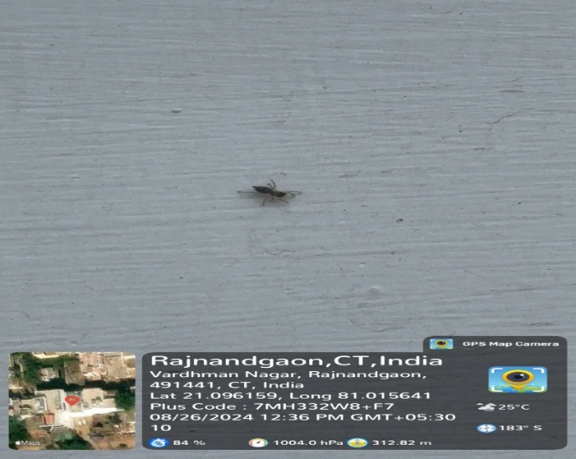Plexippus paykulli
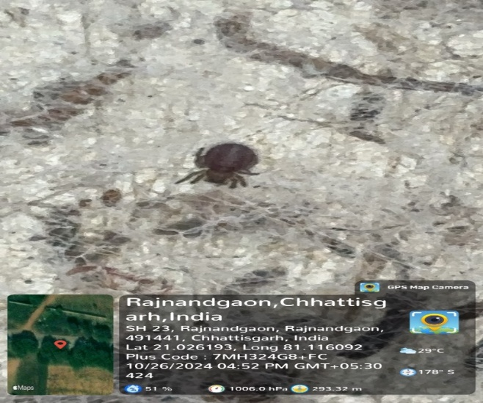  Grammostola rosea | 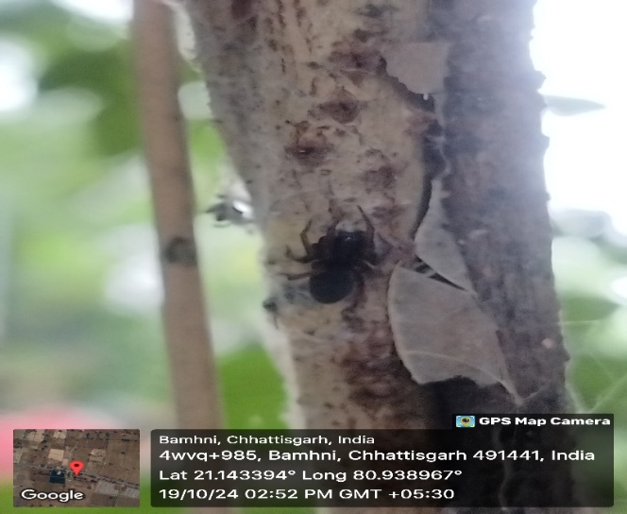Grammostola pulchra
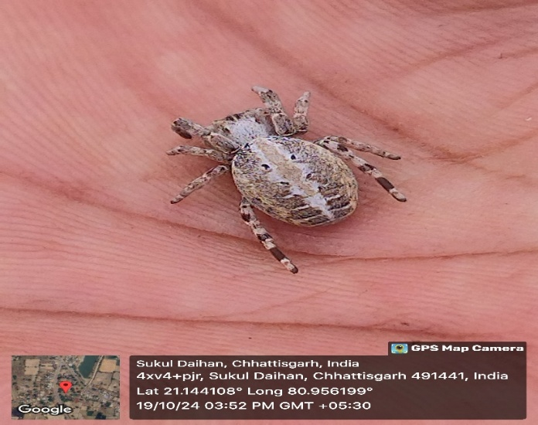  Larinioides sclopetarius | 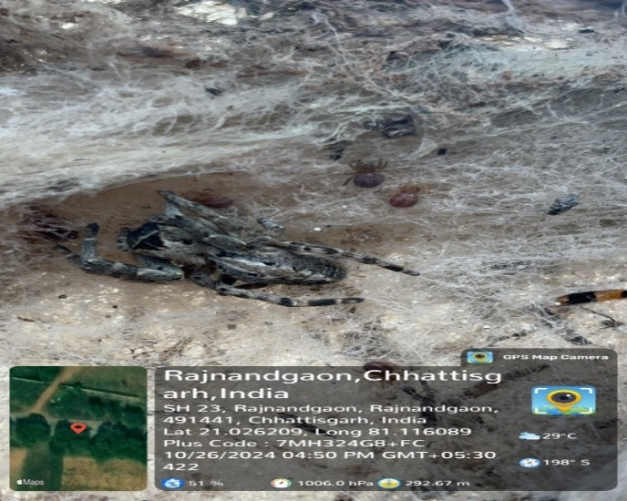  Araneus ventricosus
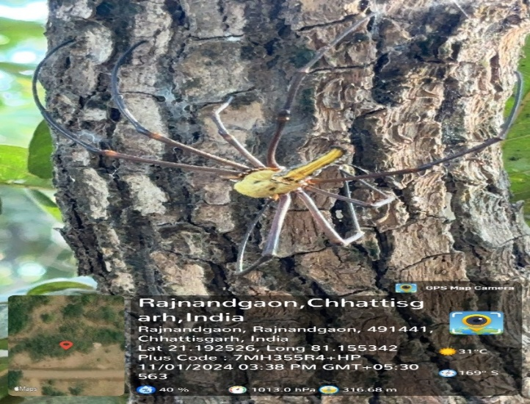  Nephila pilipes | 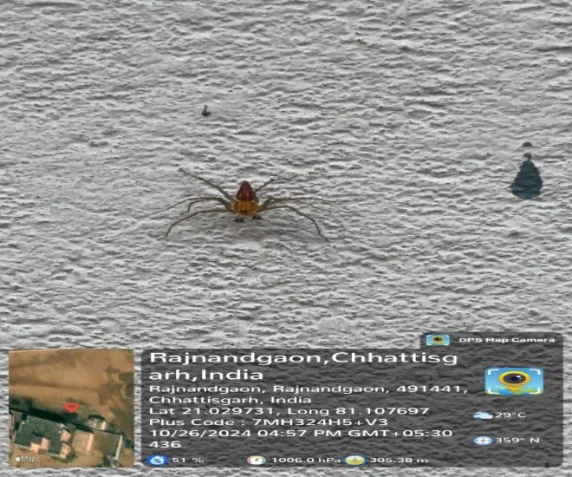  Oxyopes salticus
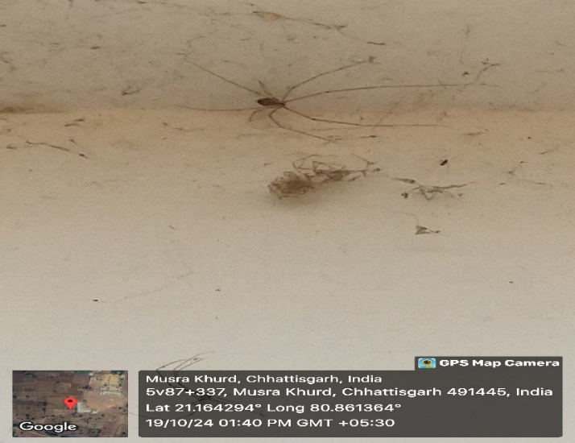
Pholcus phalangioides
Table No 02: Picture of Spider Species of Study Area

Graph 1 : Seasonal Variation in Spider Species
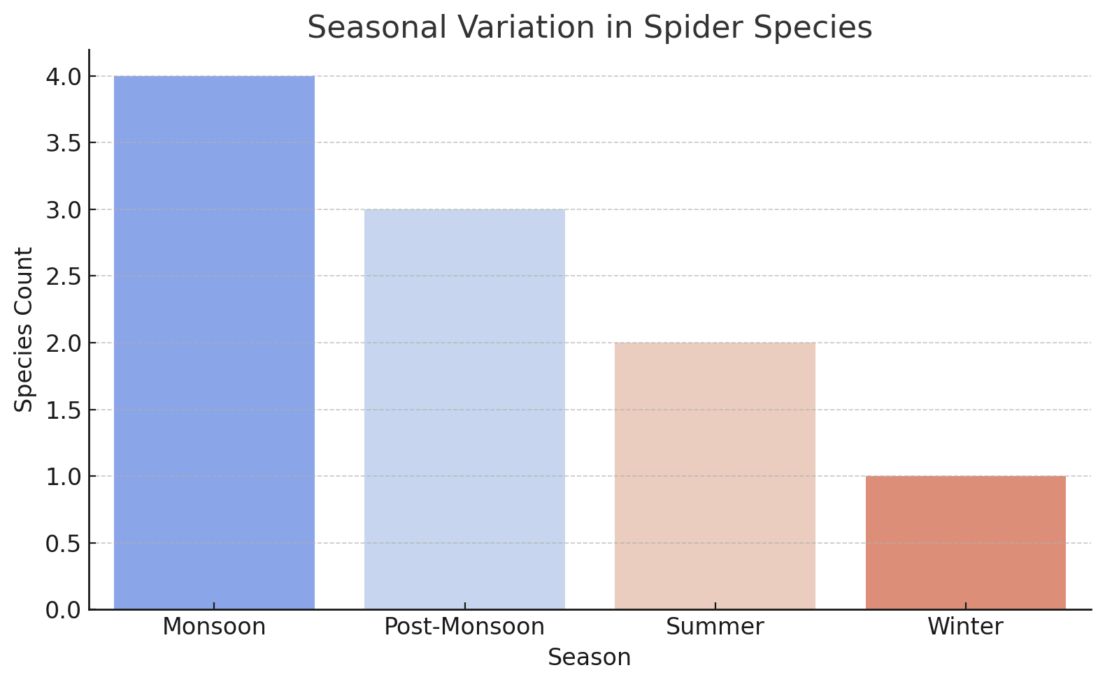
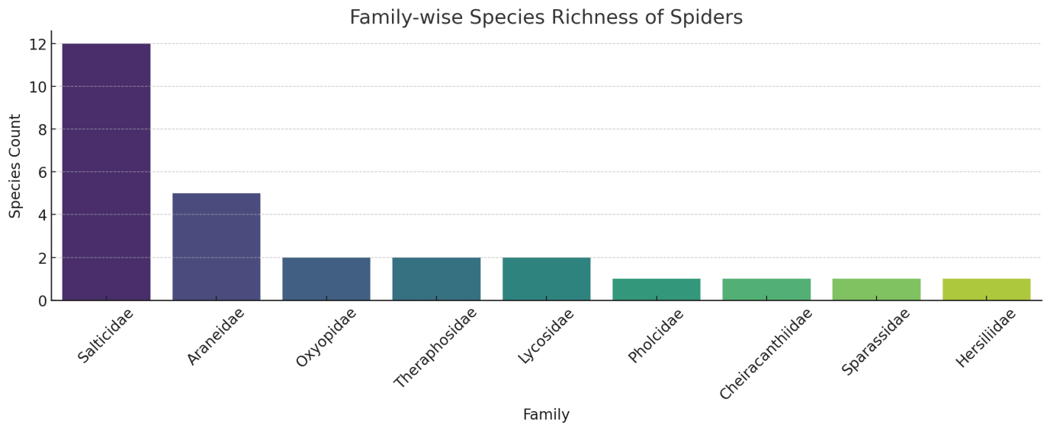

Graph 2 : Family-wise Species Richness of Spider

Shannon-Wiener Index (H′): 1.739
→ Indicates a moderate level of diversity; values typically range from 1.5 to 3.5 in ecological studies.
Simpson’s Diversity Index (1 − D): 0.746
→ Suggests a good probability that two randomly selected individuals belong to different families.
Species Evenness (E): 0.792
→ Reflects a relatively even distribution of species across families (values close to 1 indicate perfect evenness).
The results highlight the extensive diversity of spiders in Rajnandgaon District, consistent with surveys from other parts of India. Salticidae (jumping spiders) dominated the assemblage, aligning with observations by Singh et al. (2021), who identified this family as widespread in Indian ecosystems. Their adaptability to various habitats, from urban areas to foliage, likely explains their prevalence.
The presence of tarantulas like Grammostola pulchra and Grammostola rosea in tropical rainforest biomes concurs with Borkar & Seth (2020), who reported the same Theraphosidae species in the Western Ghats. Their limited habitat distribution raises conservation concerns amid habitat destruction and global warming.
Lynx spiders (Oxyopidae), such as Peucetia viridans and Oxyopes salticus, were found in forests and bushland ecosystems. Their adaptability to crops and natural environments aligns with Sidar et al. (2017)'s observations in maize fields in Raipur, Chhattisgarh.
Orb-weavers like Larinioides sclopetarius and Araneus ventricosus were located in tree trunks and forest edges, reflecting their preference for moist, shaded areas. This supports Rajeevan et al. (2019)'s research in the Western Ghats, emphasizing their ecological role in maintaining insect populations.
The golden silk orb-weaver (Nephila pilipes) was found in humid, shaded environments, showcasing the local diversity of the Araneidae family, as previously recorded by Gajbe (2003) in Chhattisgarh's forest ecosystems. Their large web structures and predatory roles are crucial for ecosystem stability.
Pholcus phalangioides (daddy longlegs spider) was encountered in dry grasslands and urban settings, reflecting its broad ecological tolerance, as reported by Ekka & Kujur (2015). Their presence near human habitations suggests potential ecological services like pest control.
The Shannon-Wiener index (H′ = 1.739) and Simpson’s index (1 − D = 0.746) from the current study indicate moderate-to-high diversity, consistent with ecological observations in pressure (e.g., Western Ghats, Tripura) tend to report slightly higher H′ values (~2.1–2.8), indicating agro-forested zones. Regions with higher vegetation stratification and lower anthropogenic that Rajnandgaon's moderate diversity reflects its semi-urban and fragmented habitat nature.
On the other hand, orb-weaving spiders from the family Araneidae—such as Larinioides sclopetarius and Araneus ventricosus—were predominantly found in moist, shaded, or semi-natural habitats like tree trunks and garden edges. These spiders build intricate webs and contribute to population regulation of flying insects, especially mosquitoes and agricultural pests. Moreover, orb-weavers are considered sensitive to environmental disturbances, making them excellent bioindicators for assessing habitat quality (Rajeevan et al., 2019; Patil, 2011).
The presence ofTheraphosidae (tarantulas) like Grammostola pulchra and Grammostola rosea in tropical forest patches highlights the importance of microhabitats and forest cover for sustaining large-bodied, ground-dwelling spider fauna. These species are often vulnerable to habitat destruction and serve as indicators of forest ecosystem health (Borkar & Seth, 2020).
Despite their ecological importance, spider populations in Rajnandgaon Block face increasing threats from habitat degradation and human-induced disturbances. One of the most significant pressures is habitat fragmentation, caused by agricultural expansion, deforestation, road construction, and unregulated land-use changes. These activities disrupt continuous habitat corridors, isolate populations, and reduce the availability of microhabitats such as tree bark, leaf litter, and shaded forest edges, which are critical for the survival of orb-weavers, tarantulas, and other ground-dwelling spider families (Misal et al., 2019; Rajeevan et al., 2019).
Pesticide use in agriculture poses another serious threat to spider diversity. As natural predators, spiders play a crucial role in regulating insect pest populations. However, the widespread and non-targeted use of synthetic pesticides in crop fields, particularly during the monsoon season, leads to direct mortality, bioaccumulation of toxins, and reduced prey availability (Nautiyal et al., 2017; Singh & Goswami, 2023). Salticidae and Lycosidae, which are dominant in agricultural habitats, are especially vulnerable to such chemical inputs, disrupting their predatory behavior and reproductive cycles.
Urbanization also exerts pressure on spider communities through habitat loss, light pollution, and human interference. Expansion of residential areas and infrastructure development leads to the replacement of natural vegetation with concrete surfaces, reducing niche habitats for species like Platycryptus undatus and Pholcus phalangioides that adapt to semi-urban or peridomestic environments (Ekka & Kujur, 2015; Malik & Goyal, 2017). Moreover, increased human activity and waste accumulation can alter the microclimatic conditions (e.g., humidity, temperature) necessary for the survival of more sensitive forest or moisture-loving species such as Nephila pilipes or Grammostola rosea.
Additionally, climate change, though not directly measured in this study, may compound these threats through shifts in seasonal patterns, rainfall variability, and temperature extremes—factors that influence spider phenology and distribution (Rana et al., 2024). If left unchecked, these stressors could result in the decline of key species, loss of ecological functions, and reduced natural pest control, impacting biodiversity and agricultural sustainability alike.
Implications and Future Directions:This research underscores the need for systematic spider surveys to document biodiversity and prioritize conservation efforts. As bioindicators, spiders are essential to ecosystem health, and their diversity reflects habitat quality. The results align with studies by Misal et al. (2019) and Rana et al. (2024), which emphasized the impact of anthropogenic and climatic pressures on arachnid diversity.
Future research should focus on:
- Seasonal trends in spider diversity (Sidar et al., 2017).
- Microhabitat preferences (Daimary et al., 2024).
- Spiders' role in pest control and ecosystem functions (Nautiyal et al., 2017).
Comparative studies across regions, such as Rajasthan's arid zones (Kumari et al., 2017) and the Western Ghats (Rajeevan et al., 2019), will enhance our understanding of species distribution and adaptability.
While this study provides valuable insights into the diversity and habitat distribution of spiders in Rajnandgaon Block, several limitations must be acknowledged. Firstly, the sampling effort was restricted to select locations and did not encompass all microhabitats such as canopy layers, caves, or aquatic margins, which might host additional species. Secondly, seasonal sampling was limited, and thus the full extent of temporal variation in spider abundance and activity across all seasons could not be thoroughly captured. Thirdly, due to resource constraints, species identification was primarily morphological, which may have led to misidentification or oversight of cryptic species that require molecular confirmation. Moreover, quantitative population data (e.g., abundance per unit area) were not collected, which limits the ability to perform more robust ecological and statistical analyses. Lastly, environmental variables such as temperature, humidity, and vegetation cover were not measured in detail, preventing a deeper understanding of the abiotic factors shaping spider distribution.

Conclusion:This study reveals the richness and distribution of spiders across Rajnandgaon, Sukuldaihan, Surgi, Ghumka, and Mudhipar in Chhattisgarh, India. Twenty-seven species from 25 genera, 9 families, and the order Araneae were documented, demonstrating high arachnid diversity in the studied habitats. Salticidae was the most represented family, contributing significantly to the recorded diversity, consistent with earlier research in India (Das et al., 2022; Singh et al., 2021). Habitat heterogeneity, from urban to forest ecosystems, underscores the ecological versatility of these species.
The findings support previous studies indicating that habitat diversity significantly influences spider diversity (Ekka & Kujur, 2015; Nautiyal et al., 2017). For example, jumping spiders like Plexippus paykulli and Phidippus regius were observed in varied environments, while Cheiracanthium inclusum was primarily found in shrublands and woodlands, aligning with Singh et al. (2020).
Tropical forest niches in Sukuldaihan and Surgi were highlighted by the presence of tarantulas (Grammostola pulchra and Grammostola rosea), which are vital for ecological balance. Species like the furrow spider (Larinioides cornutus) and golden silk orb-weaver (Nephila pilipes) in wet, shaded environments further emphasize the ecological importance of microhabitats (Patil, 2011; Misal et al., 2019).
These findings provide foundational insights into spider diversity in Chhattisgarh and call for further research into their ecological roles and conservation needs. Habitat preservation is critical, as human activities and habitat loss may significantly impact spider populations (Rana et al., 2024). Future studies combining seasonal and functional analyses will deepen our understanding of the ecological services these arachnids provide.

Reference:
- Agase, D., Markam, M., Zaheen, S., Khan, S., Meshram, P., Sharma, P., Kothe, T., & Bisen, M. (2023). Spider Diversity in Wainganga River Basin of Balaghat, Madhya Pradesh. Bulletin of Pure & Applied Sciences- Zoology. https://doi.org/10.48165/bpas.2023.42a.1.3.
- Anindita, B., Mahadev, C., & Prabal, S. (2017). Spider diversity in different habitats at Jaintia Hills of Meghalaya.
- Babu, D., & B.B., S. (2022). Species Diversity of Spiders from Bidhuna Tehsil of Auraiya District, Uttar Pradesh, India. International Journal of Zoological Investigations. https://doi.org/10.33745/ijzi.2022.v08i01.023.
- Barrion, A. T., & Litsinger, J. A. (1995). Riceland spiders of South and Southeast Asia. CAB International.
- Borkar, M., & Seth, M. (2020). Observations on Ecology and Behavior of Two Species of Theraphosid Spiders from the Western Ghats of Goa, India; with Notes on Their Conservation Concerns. , 8, 544-555. https://doi.org/10.12691/AEES-8-6-29.
- Churchill, T. B., & Arthur, J. M. (1999). Measuring spider richness: Effects of different sampling methods and spatial and temporal scales. Journal of Insect Conservation, 3(4), 287–295.
- Coddington, J. A., Griswold, C. E., Silva, D., Peñaranda, E., & Larcher, S. F. (1991). Designing and testing sampling protocols to estimate biodiversity in tropical ecosystems. Smithsonian Institution.
- Daimary, M., Saikia, P., Saikia, M., Borah, K., Saikia, B., & Sarma, K. (2024). Diversity and Microhabitat Association of Spider Fauna in Manas National Park, Assam, India. Environment and Ecology. https://doi.org/10.60151/envec/kyln9948.
- Das, S., Sharma, D., Deb, D., Dey, A., Ghosh, A., Deb, M., Datta, A., Nath, S., Deb, B., Singha, H., Debnath, R., Nautiyal, S., Sláma, P., & Roychoudhury, S. (2022). Diversity and Distribution of the Spiders (Arachnida: Araneae) from Kailashahar: First Record of Nine Species from Tripura, India. Acta Universitatis Agriculturae et Silviculturae Mendelianae Brunensis. https://doi.org/10.11118/actaun.2021.054.
- Ekka, A., & Kujur, R. (2015). Spider diversity of Ram Jharna, Raigarh district, Chhattisgarh, India. Research Journal of Pharmacy and Technology, 8, 813-819. https://doi.org/10.5958/0974-360X.2015.00131.6.
- Gajbe, P. (2003). Checklist of spiders (Arachnida: Araneae) of Madhya Pradesh and Chhattisgarh. Zoos' Print Journal, 18, 1223-1226. https://doi.org/10.11609/JOTT.ZPJ.18.10.1223-6.
- Jiménez-Valverde, A., & Lobo, J. M. (2005). Determinants of local spider (Araneidae and Thomisidae) species richness on a regional scale: Climate and habitat structure. Ecography, 28(3), 378–390.
- Kumari, V., Saini, K., &Singh., N. (2017). DIVERSITY AND DISTRIBUTION OF SPIDER FAUNA IN ARID AND SEMI-ARID REGION OF RAJASTHAN. Journal of Biopesticides. https://doi.org/10.57182/jbiopestic.10.2.17-24.
- M, M., & N, E. (2023). New distributional range record of the Red slate ornamental spider Poecilotheria rufilata (Theraphosidae) in Anaimalai Tiger Reserve, Western Ghats of Tamil Nadu. World Journal of Advanced Research and Reviews. https://doi.org/10.30574/wjarr.2023.18.2.0741.
- Malik, V., & Goyal, V. (2017). Biodiversity of spiders in different habitats of Western Haryana, India. Journal of entomology and zoology studies, 5, 822-825.
- Misal, P., BendreN., N., PawarP., A., & BhoiteS., H. (2019). An Updated Review on the Spiders of Order Araneae from the Districts of Western Ghats of India. Biochemical and Biophysical Research Communications, 12, 855-864. https://doi.org/10.21786/bbrc/12.4/4.
- Nautiyal, S., Khan, Y., Kachele, H., & Bhaskar, K. (2017). Diversity and Distribution of Spiders in Gogi, Yadgir District: A Semi-arid Landscape in Southern India. International journal of ecology and environmental sciences, 43, 195-204.
- Palem, H. (2017). Diversity of Spider Fauna ( Arachnida : Araneae ) in Different Ecosystems , Eastern Ghats , Southern Andhra Pradesh , India. .
- Pandey, C., Thiske, S., Rawte, K., Kumar, A., & Guru, G. S. (2023). Diversity and variability of paddy pests in Rajnadgaon district of Chhattisgarh: A threat to agricultural sustainability. International Journal of Entomology Research, 9(12), 160–165.
- Patil, S. (2011). Spiders of the States of Madhya Pradesh and Chhattisgarh (Arachnida: Araneae): Updated Checklist 2011. The Indian Forester, 137, 1217-1224.
- Platnick, N. I. (2024). World Spider Catalog, Version 25.0. Natural History Museum Bern. Available at: https://wsc.nmbe.ch
- Rajeevan, S., Kunnath, S., Varghese, T., & Kandambeth, P. (2019). Spider Diversity (Arachnida: Araneae) in Different Ecosystems of the Western Ghats, Wayanad Region, India. South Asian Journal of Life Sciences. https://doi.org/10.17582/journal.sajls/2019/7.2.29.39.
- Rajendra, S. (2021). Faunal diversity of Theridiidae (Araneomorphae: Araneae: Arachnida) in India: An updated checklist. International Journal of Biological and Environmental Investigations. https://doi.org/10.33745/ijbei.2021.v01i01.003.
- Rana, D., Thapliyal, A., Uniyal, V., & Thapliyal, M. (2024). Assessing the Impact of Anthropogenic and Climate Change on Spider Diversity in Garhwal Himalaya. Indian Journal of Entomology. https://doi.org/10.55446/ije.2024.1685.
- Rao, K., & Kanaujia, A. (2024). Spider Diversity (Arachnida: Araneae) in Suhelwa Wildlife Sanctuary’s Different Ecosystems, Terai Region, Uttar Pradesh, India. Ecology, Environment and Conservation. https://doi.org/10.53550/eec.2024.v30i03s.054.
- Saha, S., Das, I., & Raychaudhuri, D. (2017). Spider Faunal Diversity of Barasat and Basirhat, 24 Parganas, West Bengal, India. , 15, 49-85.
- Saini, K., Chauhan, R., &Singh., N. (2012). Analysis Of Spider Density Across Shekhawati Aravalian Region Of Rajasthan, India..
- Sebastian, P. A., & Peter, K. V. (2009). Spiders of India. Universities Press, Hyderabad.
- Shabnam, F., K, S., Rajeevan, S., Prasadan, P., & Sudhikumar, A. (2021). Spider diversity (Arachnida; Araneae) in different plantations of Western Ghats, Wayanad region, India. . https://doi.org/10.17161/eurojecol.v7i1.14612.
- Sidar, Y., Deole, S., Nirmal, A., Gajbhiye, R., & Bisen, M. (2017). A study on the seasonal distribution of spider fauna in the maize field at Raipur, Chhattisgarh region. Journal of entomology and zoology studies, 5, 1105-1108.
- Singh, R., Singh, G., & Sharma, A. (2020). Diversity of Yellow Sac Spiders (Cheiracanthiidae: Araneae: Arachnida) in India. Journal of Entomology and Zoology Studies. https://doi.org/10.22271/J.ENTO.2020.V8.I6B.7844.
- Singh, R., Singh, G., & Singh, B. (2021). FAUNAL DIVERSITY OF JUMPING SPIDERS (SALTICIDAE: ARANEAE: ARACHNIDA) IN INDIA. International Journal Biological Innovations. https://doi.org/10.46505/IJBI.2021.3101.
- Singh, S., & Goswami, P. (2023). Seasonal Diversity of Spiders (Arachnida: Araneae) and Collection Methods in Barpeta District, Assam, India. Journal of Advanced Zoology. https://doi.org/10.17762/jaz.v44i2.374.
- Singh, S., Borkotoki, A., & Sarmah, C. (2012). SPECIES DISTRIBUTION OF SPIDERS IN BARPETA DISTRICT OF ASSAM: A DIVERSITY MEASURE.. .
- SudhikumarA., V. (2015). Distribution Pattern of Spiders along an Elevational Gradient in Nelliyampathy Hill Ranges of the Western Ghats , Kerala , India. .
- Tikader, B. K. (1987). Handbook of Indian Spiders. Zoological Survey of India, Kolkata.
- Topping, C. J., & Sunderland, K. D. (1992). Limitations to the use of pitfall traps in ecological studies exemplified by a study of spiders in a field of winter wheat. Journal of Applied Ecology, 29(2), 485–491.
- Uetz, G. W., Halaj, J., & Cady, A. B. (1999). Guild structure of spiders in major crops. Journal of Arachnology, 27(1), 270–280.
- Vassou, M., Tamilperiyardhasan, S., Arivoli, S., & Tennyson, S. (2023). Assemblage of spider diversity in Okkarai region of Pachamalai hills, Eastern Ghats, Tiruchirappalli district, Tamil Nadu, India. Journal of Biological Control. https://doi.org/10.18311/jbc/2023/35639.
- Younas, S., Zahid, M., Ullah, M., , S., Sajid, M., Khan, M., Attaullah, S., Khan, K., & , K. (2024). Spider diversity in different habitats at District Mardan, Khyber Pakhtunkhwa Pakistan.. Brazilian journal of biology = Revista brasleira de biologia, 84, e283767 .https://doi.org/10.1590/1519-6984.283767.
- Borkar, M., & Seth, M. (2020). Ecological behavior of Theraphosidae in Western Ghats. AEES, 8(6), 544–555.
- Patil, S. (2011). Updated checklist of spiders in Madhya Pradesh and Chhattisgarh. The Indian Forester, 137, 1217–1224.
- Misal, P. et al. (2019). Updated review on the spiders of the Western Ghats. BBRC, 12, 855–864.
- Rajeevan, S. et al. (2019). Spider diversity in Wayanad, Western Ghats. South Asian Journal of Life Sciences, 7(2), 29–39.
- Nautiyal, S. et al. (2017). Spiders as biocontrol agents in agricultural landscapes. Int. J. Ecol. Environ. Sci., 43, 195–204.
- Singh, S. & Goswami, P. (2023). Seasonal diversity of spiders in Assam. Journal of Advanced Zoology, 44(2).
- Ekka, A. & Kujur, R. (2015). Spider diversity of Ram Jharna, Raigarh. Research Journal of Pharmacy and Technology, 8(6), 813–819.
- Malik, V. & Goyal, V. (2017). Biodiversity of spiders in urban and semi-urban zones. Journal of Entomology and Zoology Studies, 5, 822–825.
- Rana, D. et al. (2024). Anthropogenic and climate impacts on spider diversity. Indian Journal of Entomology. https://doi.org/10.55446/ije.2024.1685

