On Two Sponge Records along the East Coast of India

Abstract:
The current study reports range extensions of marine sponges to the Indian subcontinent and within it. Stelletta clavosa (Ridley, 1884) is being reported from the Gulf of Kachchh for the first time. Dragmacidon coccineum (Keller, 1891) is being reported to the Indian subcontinent for the first time. This is a significant study that updates the marine sponge biodiversity of India in important biogeographic zones, namely the Gulf of Kachchh and the Lakshadweep Archipelago.
Keywords:
Stelletta clavosa, Gulf of Kachchh, India, New Distributional Record, Dragmacidon coccineum,
Lakshadweep Islands.
Introduction:
Marine sponges (Phylum Porifera), representing one of the most ancient metazoan lineages, are fundamental architects of benthic ecosystems worldwide. As dominant filter-feeders, they process vast volumes of water, playing a critical role in maintaining water quality, nutrient cycling (particularly through the "sponge loop" and microbial loop), sediment stabilization, and energy transfer within marine food webs (Bell, 2008). Their complex three-dimensional structures provide essential habitat, refuge, and nutrition for a diverse array of associated flora and fauna, significantly enhancing local biodiversity, particularly in reef systems where larger sponges contribute disproportionately (Chin et al., 2020; Preciado & Maldonado, 2005). While competition for space occurs, this dynamic can foster shifts in community composition over time (Bell, 2008). Furthermore, their ability to bioaccumulate pollutants positions them as valuable bioindicators of marine environmental health (Mohammed et al., 2023). Despite this immense ecological significance and a global diversity exceeding 9,600 described species (de Voogd et al., 2025) (with estimates suggesting many more cryptic and deep-sea species remain undiscovered), sponges remain profoundly understudied. Alarmingly, only about 20 species are currently listed as threatened, reflecting a critical lack of comprehensive global conservation assessment (Hooper & Van Soest, 2002; Rob et al., 2012; Sustainable development and Biodiversity, 2023).
India, with its vast coastline exceeding 11,098.81 km (Government of India, 2024) and expansive Exclusive Economic Zone (EEZ), encompassing diverse marine environments from the Arabian Sea, Bay of Bengal, and Indian Ocean, harbours significant sponge biodiversity. Peninsular India has yielded records of over 100 marine sponge species, including new records and endemics like Hyattella dhangadhraensis and H. kutchensis (George et al., 2020; Varsha et al., 2020). Freshwater ecosystems contribute another 30 species, 10 of which are endemic to India (Saxena, 2021). The Gulf of Kachchh (GoK), located on the west coast of Gujarat, stands out as a vibrant and ecologically complex region. Characterized by a unique confluence of mudflats, coral reefs, mangroves, seagrass beds, tidal creeks, and islands, the GoK acts as a nutrient-rich interface between the benthic and pelagic zones of the Arabian Sea (Parulekar, 1988; Thomas et al., 1996; Subba Rao & Sastry, 2005). Recent surveys have documented 43 sponge species belonging to 28 families within the GoK, including genera like Cliona, Haliclona, and Spongia (Hatkar et al., 2024; Sabapara & Poriya, 2024), building on foundational work dating back to Dendy's pioneering surveys in the early 1900s (Dendy, 1905, 1915, 1916) and continued by researchers like Ridley (1884), Keller (1891), Thomas (1989), Parulekar (1988), and Subba Rao & Sastry (2005). Similarly, the coral reef ecosystems of the Lakshadweep archipelago have been a focus of sponge research since Gardiner (1903), with significant contributions by Thomas (1973, 1980a, b, 1989), Venkatraman et al. (2004), Prabhakaran et al. (2013), and George et al. (2020).
However, these vital ecosystems and their sponge communities face escalating anthropogenic pressures. The GoK, despite being designated a Marine National Park, is under severe threat from sedimentation, pollution, dredging, maritime traffic, and industrial activities, including oil exploration, concentrated around its natural harbors and creek systems like Kandla, Hansthal, and Nakti (Sabapara & Poriya, 2024). These stressors jeopardize fragile benthic organisms like sponges. Simultaneously, the unprecedented mass coral bleaching event that began in February 2023 and persisted into mid-2024 across the Indo-Pacific, including Lakshadweep (Ove Hoegh-Guldberg et al., 2023), poses a catastrophic threat not only to corals but also to the entire reef-associated fauna, including sponges. Understanding the cascading effects on sponge diversity and distribution necessitates robust baseline data and post-event comparative taxonomic analysis.
Despite a well-established history of taxonomic exploration in India, recent research has predominantly focused on species inventories and new records, with a concerning paucity of ecological studies and conservation assessments specifically addressing anthropogenic impacts on sponges (Sabapara & Poriya, 2024; Mohammed et al., 2023). This knowledge gap is particularly acute given their ecological and burgeoning biotechnological importance as sources of novel bioactive compounds (Varijakzhan et al., 2021). Addressing this gap relies fundamentally on accurate taxonomy. While molecular techniques offer powerful tools, their application to sponges can be challenging. Consequently, classical taxonomy, based on meticulous observation of morphology, anatomy, and especially spicule characteristics (Lukowiak, 2020), remains indispensable, as established since Linnaeus (1758). Detailed morphological studies often reveal cryptic diversity, resolving variations as either intraspecific or leading to the description of new species and sometimes even the redefinition of genera or higher taxa (e.g., Zea & Weil, 2003; Xavier et al., 2010; DeBiasse & Hellberg, 2015).

Materials and Methodology
Sponge specimens were collected during two separate marine surveys: the first in the Gulf of Kachchh, Gujarat (Latitude: N22°27’22.66’’, Longitude: E69°40’33.87’’) on 18 December 2022, and the second at Androth Island, Lakshadweep (Latitude: 10°49.931'N, Longitude: 73°41.235'E) in October 2019. Specimens were photographed in situ before collection via hand-picking (Gulf of Kachchh) and SCUBA diving (Lakshadweep) at depths of 10–30 meters. Post-collection, Gulf of Kachchh specimens were preserved in wet conditions using 30% formalin, while Lakshadweep samples were preserved in shadow drying conditions for transport. The shadow drying process in sponges refers to a drying technique where sponges are dried in the shade rather than using direct sun or high-temperature air drying. This approach is used to better preserve the structural and biochemical properties of the material. Taxonomic identification followed standardized protocols for sponge morphology, emphasizing on spicule architecture and skeletal organization as per Keller (1891) and Hooper & Van Soest (2002), with species validity cross-referenced against the World Porifera Database (WPD) and World Register of Marine Species (WoRMS) (de Voogd et al., 2021a). For skeletal analysis, 0.1 cm-thick sections were dehydrated in xylene and mounted on micro-slides using DPX medium. Spicule isolation involved dissolving sponge tissue in nitric acid to liberate diagnostic spicules. Light microscopy (Nikon Eclipse 50i compound microscope) facilitated spicule imaging and morphometry; for each spicule type, 25 individual spicules were measured (dimensions recorded in mm/µm), with skeletal structures documented using scale-bar-referenced photomicrographs. Voucher specimens were deposited in the National Zoological Collections of the Marine Biology Regional Centre, Zoological Survey of India (MBRC/ZSI), Chennai, with assigned registration numbers (Reg.No: S.634 - Stelletta clavosa) (Reg.No: S.408 - Dragmacidon coccineum) cataloged for future reference.

Systematic accounts:
Phylum Porifera
Class Demospongiae
Subclass Heteroscleromorpha
Order Tetractinellida
Suborder Astrophorina
Family Ancorinidae
Genus Stelletta
Species Stelletta clavosa (Ridley, 1884)
Materials examined:
Registration Number: MBRC/ZSI/S.634 entire specimen, slides of spicules, Locality: Narara, Gulf Kachchh (Lat.: N22°27’22.66’’ E 069°40’33.87’’), (Fig. 1A-D); Date of collection: 18.12.2022. Collected by: Sivaleela & Party. Description. Sponge spherical or hemispherical, and growth form is branched to club-shaped, 2-3 cm in height. Color, light gray in the spot. Consistency, hard and incompressible. The surface is hispid due to the presence of Spicules. Projecting from the interior. The original lacks any additional details.
Spicules: (I) Dichotriaenes. Shaft, 0.9 x 0.052 mm; chord, 0.46 mm. (2) Protriaenes. Shaft long; clads up to 0.05 mm. These spikes project out of the face considerably. (3) Anatriaenes. Clads up to 0.1 mm. (4) Oxea - Size: 0.54 x 0.017 mm. (5) Asters. Rays conical; diameter up to 0.018 mm. Fig.2. A- Preserved specimen (Wet preservation); In situ specimen.

Systematic accounts:
Phylum Porifera
Class Demospongiae
Subclass Heteroscleromorpha
Order Axinellida
Family Axinellidae
Genus Dragmacidon
Species Dragmacidon coccineum (Keller, 1891)

Synonyms: Hymeniacidon coccineum (Keller, 1891); -Pseudaxinella coccinea Keller, 1891;- Reniera coccineum Keller, 1891); -Stylissa coccinea (Keller, 1891)

Materials examined: Registration Number: MBRC/ZSI/S.340/01, entire specimen, dry. Plus slides of spicules, Locality: Androth Island (Lat: 10°49.931'N, Long: 73°41.235'E), Lakshadweep Archipelago, Arabian Sea (Fig. 1A- D); Date of collection: 22.10.2019. Collected by: Tamal Mondal, SCUBA diving
Description.
The studied specimen (Fig. 2A) has a growth form that is encrusting to branched and club-shaped, 2-5 cm in height. Colour orange or red when alive and dark red to violet after drying. The texture is soft and compressible when alive, with a mucous surface and tough after drying. The surface is irregular, with short conules or tubercles. Oscules are slightly elevated, circular, and wide. The choanosomal skeleton (Fig. 2B-D) is a plumoreticulate network (with rounded meshes) interconnected by secondary multi-spicular tracts. It consists of radiate spiculate fibers connected by loose spicules. Thickly encrusting species, a surface covered in tubercles, an ectosome lacking a specific skeleton, and a skeleton that has not been separated into an axial or extra-axial region are among them. The skeleton is composed of thick, multispicular fibers that combine to form irregular or oval meshes with a diameter ranging from 100 to 400 µm. 1-3 spicules are connecting the thick primary fibers, which range in thickness from 50 to 150 µm. Megascleres are styles.

Spicules: Megascleres are smooth styles 300 μm in length, slightly curved, with a proximal blunt end and a distal. Sharply pointed end. (Table 1; Figs 2E and F). Megascleres are smooth styles, 0.3–0.32 mm in length, slightly curved, with a proximal blunt end and a distal point. Sharply pointed end. (Table 1; Figs. 2E and F). Microscales are absent.

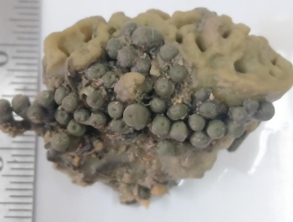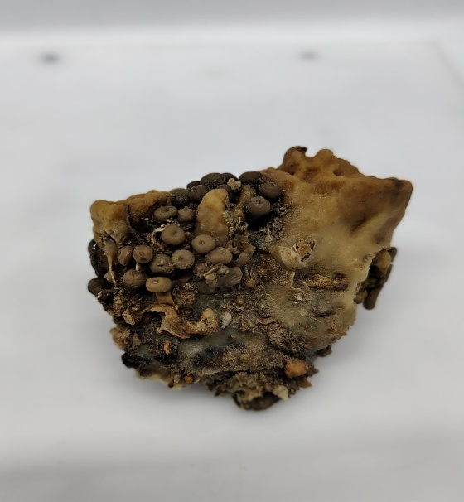
Figure 1 Stellata clavosa (ex situ) Figure 2 Stellata clavosa (wet preservation)
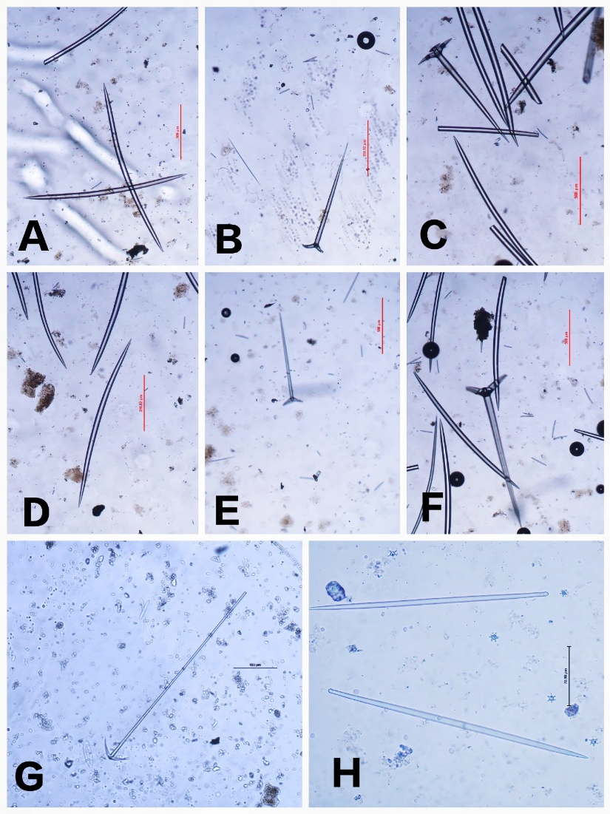
Figure 3 A,D - Oxea; B, E- Dichotriaenes; C, F- Oxea and Dichotriaenes; G - Anatriaenes; H- Asters and Oxea
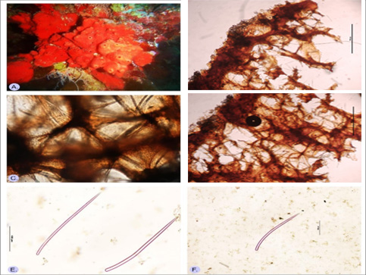
Fig. 4: Dragmacidon coccineum (Keller, 1891) from Androth Island, Lakshadweep Archipelago; A.red to orange studied specimen inhabiting the coral reef; B, C, D- Skeletal network of styles arranged E, F- Skeletal spicules as smooth styles of variable length.

Check List of Marine Sponges from Gujarat:
A total of 128 species belonging to 72 genera, 47 families, and 17 orders
Order: Axinellida
Family: Axinellidae
- Axinella donnani (Bowerbank, 1873)
Family: Raspailiidae
- Endectyon (Endectyon) fruticosum (Dendy, 1887)
- Raspailia (Clathriodendron) arbuscula (Lendenfeld, 1888)
- Thrinacophora cervicornis Ridley & Dendy, 1886
Family: Stelligeridae
- Higginsia Higgins, 1877
Order: Biemnida
Family: Biemnidae
- Biemna fortis (Topsent, 1897)
- Biemna tubulata (Dendy, 1905)
Order: Bubarida
Family: Bubaridae
- Auletta aurantiaca Dendy, 1889
- Auletta elongata Dendy, 1905
- Phakellia radiata (Dendy, 1916)
Family: Dictyonellidae
- Phakettia virgultosa (Carter, 1887)
- Acanthella cavernosa Dendy, 1922
- Acanthella ramosa Kumar, 1925
Order: Chondrillida
Family: Chondrillidae
- Chondrilla mixta Schulze, 1877
- Chondrilla australiensis Carter, 1873

Order: Clathrinida
Family: Clathrinidae
- Clathrina coriacea (Montagu, 1814)
Order: Clionaida
Family: Clionaidae
- Cliona viridis (Schmidt, 1862)
- Cliona celata Grant, 1826
- Cliona varians (Duchassaing & Michelotti, 1864)
- Spheciospongia vagabunda (Ridley, 1884)
- Cliothosa aurivillii (Lindgren, 1897)
- Pione vastifica (Hancock, 1849)
Family: Placospongiidae
- Placospongia melobesioides Gray, 1867
- Placospongia carinata (Bowerbank, 1858)
Family: Spirastrellidae
- Spirastrella coccinea (Duchassaing & Michelotti, 1864)
Order: Dendroceratida
Family: Darwinellidae
- Darwinella australiensis Carter, 1885
Family: Dictyodendrillidae
- Spongionella retiara (Dendy, 1916)
Order: Dictyoceratida
Family: Dysideidae
- Dysidea tupha (Pallas, 1766)
- Dysidea avara (Schmidt, 1862)
- Dysidea granulosa Bergquist, 1965
- Dysidea cinerea Keller, 1889
- Dysidea fragilis (Montagu, 1814)

Family: Spongiidae
- Hippospongia spp. Schulze, 1879
- Hyattella tubaria Lendenfeld, 1889
- Hyattella intestinalis (Lamarck, 1814)
Order: Haplosclerida
Family: Callyspongiidae
- Callyspongia (Cladochalina) aculeata (Linnaeus, 1759)
- Callyspongia (Cladochalina) diffusa (Ridley, 1884)
- Callyspongia crassifibra (Dendy, 1889)
Family: Chalinidae
- Haliclona (Gellius) ridleyi (Hentschel, 1912)
- Haliclona (Soestella) hornelli (Dendy, 1916)
- Haliclona (Reniera) cinerea (Grant, 1826)
- Haliclona (Gellius) cymaeformis (Esper, 1806)
- Haliclona (Reniera) fascigera (Hentschel, 1912)
- Haliclona (Soestella) hornelli (Dendy, 1916)
- Haliclona pacifica Hooper in Hooper & Wiedenmayer, 1994
- Haliclona semifibrosa (Dendy, 1916)
- Haliclona (Gellius) fibulata (Schmidt, 1862)
- Haliclona (Haliclona) oculata (Linnaeus, 1759)
- Haliclona (Reniera) tubifera (George & Wilson, 1919)
- Haliclona (Gellius) cymaeformis (Esper, 1806)
- Haliclona (Reniera) cinerea (Grant, 1826)
- Haliclona (Reniera) topsenti (Thiele, 1905)
Family: Niphatidae
- Gelliodes fibroreticulata (Dendy, 1916)
- Amphimedon viridis Duchassaing & Michelotti, 1864
- Gelliodes fibrosa Dendy, 1905
- Gelliodes petrosioides Dendy, 1905

Family: Petrosiidae
- Neopetrosia chaliniformis (Thiele, 1899)
- Neopetrosia similis (Ridley & Dendy, 1886)
Family: Phloeodictyidae
- Siphonodictyon minutum (Thomas, 1972)
Order: Homosclerophorida
Family: Plakinidae
- Plakina monolopha Schulze, 1880
- Plakortis simplex Schulze, 1880
- Corticium candelabrum Schmidt, 1862
Order: Leucosolenida
Family: Grantiidae
- Leucandra donnani Dendy, 1905
- Leucandra dwarkaensis Dendy, 1916
- Leucandrilla wasinensis (Jenkin, 1908)
- Leucandra barbata (Duchassaing & Michelotti, 1864)
Family: Heteropiidae
- Sycettusa hastifera (Row, 1909)
- Heteropia glomerosa (Bowerbank, 1873)
Family: Syconidae
- Sycon grantioides Dendy, 1916
Order: Poecilosclerida
Family: Acarnidae
- Acarnus tortilis Topsent, 1892
- Acarnus spp. Gray, 1867
Family: Chondropsidae
- Chondropsis kirkii (Bowerbank, 1841)
Family: Coelocarteriidae
- Coelocarteria singaporensis (Carter, 1883)
Family: Coelosphaeridae
- Lissodendoryx (Waldoschmittia) schmidti (Ridley, 1884)
Family: Crellidae
- Crella (Grayella) cyathophora (Carter, 1869
- Crella (Yvesia) ridleyi (Topsent, 1890)
Family: Desmacididae
- Desmapsamma anchorata (Carter, 1882)
- Desmacidon minor Dendy, 1916
Family: Guitarridae
- Guitarra indica Dendy, 1916
Family: Iotrochotidae
- Iotrochota baculifera Ridley, 1884
Family: Microcionidae
- Clathria (Clathria) gorgonioides (Dendy, 1916)
- Clathria (Thalysias) procera (Ridley, 1884)
- Clathria (Thalysias) vulpina (Lamarck, 1814)
- Clathria (Microciona) atrasanguinea (Bowerbank, 1862)
- Clathria (Thalysias) procera (Ridley, 1884)
- Clathria (Microciona) aceratoobtusa (Carter, 1887)
Family: Mycalidae
- Mycale (Zygomycale) parishii (Bowerbank, 1875)
- Mycale (Mycale) grandis Gray, 1867
Family: Myxillidae
- Myxilla (Ectyomyxilla) arenaria Dendy, 1905
- Psammochela elegans Dendy, 1916
Family: Tedaniidae
- Tedania (Tedania) anhelans (Vio in Olivi, 1792)

Order: Polymastiida
Family: Polymastiidae
- Polymastia gemmipara Dendy, 1916
Order: Suberitida
Family: Halichondriidae
- Halichondria (Halichondria) tenuiramosa Dendy, 1922
- Halichondria (Eumastia) sitiens (Schmidt, 1870)
- Halichondria (Halichondria) bowerbanki Burton, 1930
- Halichondria (Halichondria) panicea (Pallas, 1766)
- Hymeniacidon perlevis (Montagu, 1814)
- Amorphinopsis excavans Carter, 1887
- Halichondria (Halichondria) tenuiramosa Dendy, 1922
- Amorphinopsis dichotoma (Dendy, 1916)
- Halichondria (Halichondria) panicea (Pallas, 1766)
Family: Suberitidae
- Terpios cruciatus (Dendy, 1905)
- Pseudosuberites andrewsi Kirkpatrick, 1900
- Suberites carnosus (Johnston, 1842)
- Suberites flabellatus Carter, 1886
- Aaptos aaptos (Schmidt, 1864)
Order: Tethyida
Family: Tethyidae
- Tethya robusta (Bowerbank, 1873)
- Tethya seychellensis (Wright, 1881)
Family: Timeidae
- Timea spp. Gray, 1867
- Timea stelligera (Carter, 1882)

Order: Tetractinellida
Family: Ancorinidae
- Stelletta clavosa Ridley, 1884
- Asteropus simplex (Carter, 1879)
- Jaspis reptans (Dendy, 1905)
- Stelletta purpurea Ridley, 1884
- Dercitus (Stoeba) plicatus (Schmidt, 1868)
- Jaspis diastra (Vacelet & Vasseur, 1965)
Family: Geodiidae
- Geodia variospiculosa Thiele, 1898
- Geodias spp. Lamarck, 1815
Family: Samidae
- Samus anonymus Gray, 1867
Family: Tetillidae
- Tetilla barodensis Dendy, 1916
- Tetilla dactyloidea (Carter, 1869)
- Cinachyrella australiensis (Carter, 1886)
- Cinachyrella hirsuta (Dendy, 1889)
- Tetilla pilula Dendy, 1916
- Cinachyrella cavernosa (Lamarck, 1815)
Order: Verongiida
Family: Aplysinidae
- Aiolochroia crassa (Hyatt, 1875)
- Aplysina lacunosa (Lamarck, 1814)
Family: Pseudoceratinidae
- Pseudoceratina purpurea (Carter, 1880)

Discussion:
Based on the current understanding of marine sponge biodiversity in India, the distribution of Stelletta and Dragmacidon species reflects significant taxonomic and biogeographical patterns. For Stelletta, a genus within the family Ancorinidae, the most recent checklist by Sivaleela and Raghunathan (2024) confirms 11 species in Indian waters: S. agglutinans, S. aruensis, S. cavernosa, S. clavosa, S. herdmani, S. orientalis, S. purpurea, S. tethyopsis, S. trichitriaena, S. validissima, and S. vestigium. Among these, S. agglutinans was originally described by Dendy (1905) from Sri Lanka and South India, with subsequent records in the Gulf of Mannar and Palk Bay confirming its presence in these regions (Thomas 1985). Notably, S. clavosa, initially documented from the Red Sea by Keller (1891), has recently been reported as a zoogeographical range extension in the Gulf of Kachchh, with Indian specimens matching Keller's description in external morphology (dark grey in vivo, brown in preservative), skeletal features, and spicule composition (Sivaleela and Raghunathan 2024). Similarly, S. tethyopsis, first described by Carter (1880) from the Gulf of Mannar, remains a consistent component of the regional sponge fauna.
Conversely, the genus Dragmacidon in india (family Axinellidae) is represented by three confirmed species in India: D. durissimum, D. agariciforme, and D. australe. D. agariciforme, originally described as Thrinacophora agariciformis by Dendy (1905) from Ceylon (Sri Lanka), is documented in the Gulf of Mannar (Thomas 1985; George et al. 2020). D. durissimum, also reported from Sri Lanka and South India by Dendy (1905), includes varieties such as D. durissimum var. massalis (Dendy 1922), though Burton (1959) suggested synonymy of these varieties, indicating unresolved taxonomic complexities. D. australe, first described from New Zealand by Bergquist (1970), has extended its range to the Andaman Islands' Ritchie’s Archipelago, with Indian specimens aligning morphologically in spicule types (oxeas and styles) and skeletal architecture (Pereira and Raghunathan 2020). Additionally, D. coccineum, initially reported as Reniera coccinea from the Red Sea by Keller (1891), has been identified as a new subcontinental record from the Lakshadweep archipelago, exhibiting congruence in shape and spicule characteristics with Keller's description.

References
- Alvarez, B., & Hooper, J. N. A. (2002). Family Axinellidae Carter, 1875. In Systema Porifera (pp. 724–747). Springer, Boston, MA.
- Alvarez, B., & Hooper, J. N. A. (2009). Taxonomic revision of the order Halichondrida (Porifera: Demospongiae) from northern Australia. Family Axinellidae. The Beagle, Records of the Museums and Art Galleries of the Northern Territory, 25, 17–42.
- Alvarez, B., de Voogd, N. J., & van Soest, R. W. (2016). Sponges of the family Axinellidae (Porifera: Demospongiae) in Indonesia. Zootaxa, 4137(4), 451–477. http://doi.org/10.11646/zootaxa.4137.4.1
- Anita M. George, Rob W. M. Van Soest, Robert D. Sluka, & Lazarus, S. (2020). A checklist of marine sponges (Porifera) of the peninsula of India. Zootaxa, 4885(2), 277–300. https://doi.org/10.11646/zootaxa.4885.2.10
- Arti, Joshi, A. Y., Desai, A. J., Bhatt, T. H., & Dave. (2018). Bio-resources and environmental status in Narara and Poshitra Islands at Marine National Park, Gulf of Kachchh, Gujarat. International Journal of Bioresource and Stress Management. https://doi.org/10.23910/IJBSM/2018.9.2.3C0411
- Austin, W. C., Ott, B. S., Reiswig, H. M., Romagosa, P., & McDaniel, N. G. (2013). Two new species in the family Axinellidae (Porifera, Demospongiae) from British Columbia and adjacent waters. ZooKeys, (338), 11. https://doi.org/10.3897/zookeys.338.5535
- Belinda, A., Michael, D., Crisp, F., Driver, J. N. A., Hooper, & Van Soest, R. W. M. (2000). Phylogenetic relationships of the family Axinellidae (Porifera: Demospongiae) using morphological and molecular data. Zoologica Scripta, 29(2), 169–198. https://doi.org/10.1046/J.1463-6409.2000.00029.X
- Bergquist, P. R. (1978). Sponges. Hutchinson & Co., London.
- Burton, M. (1918). Report on some deep-sea sponges from the Indian Museum collected by RIMS ‘Investigator’. Part II. Tetraxonida (concluded) and Euceratosa. Rec Indian Mus, 30, 109–138.
- Burton, M. (1930). Norwegian sponges from the Norman Collection. Proceedings of the Zoological Society of London, 487–546.
- Burton, M. (1959). Sponges. Scientific Reports of the John Murray Expedition 1933-34, 10, 151–281.
- Chandra, K., Raghunathan, C., Sheela, S., & Rizhvi, A. N. (2021). Animal Discoveries 2020: New Species and New Records. Kolkata: Director, Zoological Survey of India.
- De Voogd, N. J., Alvarez, B., Boury-Esnault, N., Carballo, J. L., Cárdenas, P., Díaz, M.-C., Dohrmann, M., Downey, R., Hajdu, E., Hooper, J. N. A., Kelly, M., Klautau, M., Manconi, R., Morrow, C. C., Pisera, A. B., Ríos, P., Rützler, K., Schönberg, C., Vacelet, J., & van Soest, R. W. M. (2021). World Porifera Database. Dragmacidon Hallmann, 1917.
- de Voogd, N. J., Alvarez, B., Boury-Esnault, N., Cárdenas, P., Díaz, M.-C., Dohrmann, M., Downey, R., Goodwin, C., Hajdu, E., Hooper, J. N. A., Kelly, M., Klautau, M., Lim, S. C., Manconi, R., Morrow, C., Pinheiro, U., Pisera, A. B., Ríos, P., Rützler, K., Schönberg, C., Turner, T., Vacelet, J., van Soest, R. W. M., & Xavier, J. (2025). World Porifera Database. Retrieved [insert access date], from https://www.marinespecies.org/porifera https://doi.org/10.14284/359
- Dendy, A. (1905). Report on the Sponges Collected by Prof. Herdman at Ceylon in 1902. Report to the Government of Ceylon Pearl Oyster Fisheries, Gulf of Mannar Supplement 18, 57–246.
- Dendy, A. (1915). Report on the Calcareous Sponges Collected by Mr. James Hornell at Okhamandal in Kattiawar in 1905–1906. Report to The Government of Baroda on the Marine Zoology of Okhamandal in Kattiawar, 2, 79–91.
- Dendy, A. (1916). Report on the Non-Calcareous Sponges collected by Mr. James Hornell at Okhamandal in Kattiawar in 1905–6. Report to The Government of Baroda on the Marine Zoology of Okhamandal in Kattiawar, 2, 93–146.
- Dendy, A. (1922). Report on the Sigmatotetraxonida collected by HMS 'Sealark' in the Indian Ocean. Transactions of the Linnean Society of London, 18(1), 1–164.
- Dickinson, M. (1945). Sponges of the Gulf of California.
- Diaz, M. C., Alvarez, B., & Laughlin, R. A. (1990). The sponge fauna on a fringing coral reef in Venezuela, II: Community structure. In K. Rutzler (Ed.), New Perspectives in Sponge Biology (pp. 367–375). Smithsonian Institute Press, London.
- Dunn, C. W., Leys, S. P., & Haddock, S. H. D. (2015). The hidden biology of sponges and ctenophores. Trends in Ecology & Evolution, 30, 282–291.
- Emmanuelle, R., Eve, G., Laura, F-C., Quentin, S., Alexander, V. E., Jean, V., & Carole, B. (2013). Porifera (Sponges): Recent Knowledge and New Perspectives. https://doi.org/10.1002/9780470015902.A0001582.PUB2
- Erickson, K. L., Beutler, J. A., Cardellina, J. H., & Boyd, M. R. (1997). Salicylihlamides A and B, novel cytotoxic macrolides from the marine sponge Haliclona sp. Journal of Organic Chemistry, 62, 8188–8192.
- Gardiner, J. S. (1903). The fauna and geography of the Maldive and Laccadive Archipelagos. Cambridge University Press.
- George, A. M., van Soest, R. W. M., Sluka, R. D., & Lazarus, S. (2020). A checklist of marine sponges (Porifera) of the peninsula of India. Zootaxa, 4885, 277–300.
- Gopi, M., & Ajithkumar, T. T. (2012). Sponge fauna of Lakshadweep Archipelago. Seshaiyana, 20, 3–5.
- Government of India. (2024). MR-14011/1/2024-TRW (S). Ministry of Ports, Shipping and Waterways, Transport Research Wing.
- Hallmann, E. F. (1917 [1916]). A revision of the genera with microscleres included, or provisionally included, in the family Axinellidae; with descriptions of some Australian species. Proceedings of the Linnean Society of New South Wales, 41(164), 634–675.
- Hoffmann, F., Radax, R., Woebken, D., Holtappels, M., Lavik, G., et al. (2009). Complex nitrogen cycling in the sponge Geodia barretti. Environmental Microbiology, 11, 2228–2243.
- Hooper, J. N. A., & Levi, C. (1993). Axinellida (Porifera: Demospongiae) from the New Caledonia lagoon. Invertebrate Systematics, 7, 1395–1472. https://doi.org/10.1071/IT9931395
- Hooper, J. N. A., & Van Soest, R. W. M. (2002). Systema Porifera. A Guide to the Classification of Sponges (pp. 1–7). Springer, Boston, MA. https://doi.org/10.1007/978-1-4615-0747-5_1
- James, B. (2008). Functional roles of sponges. Estuarine Coastal and Shelf Science, 79(3), 341–353. https://doi.org/10.1016/j.ecss.2008.05.002
- Jonathan, E. (2022). Status and importance of research on marine sponges in India with special reference to sponges on coral reefs. Indian Journal of Geo-Marine Sciences, 51(07), 589–596.
- Keller, C. (1891). Die Spongienfauna des Rothen Meeres (II. Hälfte). Zeitschrift für Wissenschaftliche Zoologie, 52, 294–368.
- Łukowiak, M. (2020). Utilizing sponge spicules in taxonomic, ecological, and environmental reconstructions: a review. PeerJ, 8, e10601. https://doi.org/10.7717/peerj.10601
- Lendenfeld, R. V. (1888). Descriptive Catalogue of the Sponges in the Australian Museum. Taylor and Francis, London.
- Longakit, M. B. A., Sotto, F. B., & Kelly, M. (2005). The shallow water marine sponges (Porifera) of Cebu, Philippines. Science Diliman, 17, 52–74.
- M., S., Varsha, K. K., Joshi, S., & Jasmine. (2020). Six new species of Hyattella (Porifera: Dictyoceratida: Spongiidae) from the Southern Coast of India. Journal of the Marine Biological Association of India. https://doi.org/10.6024/JMBAI.2020.62.1.2206-01
- Mohammed, O. A., Aljahdali, A. B., & Alhassan, B. (2023). The use of marine sponge species as a bioindicator to monitor metal pollution in the Red Sea, Saudi Arabia. Marine Pollution Bulletin. https://doi.org/10.1016/j.marpolbul.2023.115618
- Müller, W. E. G. (1995). Molecular phylogeny of Metazoan (animals): Monophyletic origin. Naturwissenschaften, 82, 321–329.
- Murty, V. S. (2002). Marine ornamental fishes of Lakshadweep. CMFRI, Kochi. Special Publication, 72, 134.
- Ove Hoegh-Guldberg, et al. (2023). Coral reefs are in peril in a record-breaking year. Science, 382, 1238–1240. https://doi.org/10.1126/science.adk4532
- Parulekar, A. H. (1988). Bio-ecology of the Gulf of Kutch. Marine Archaeology of Indian Ocean countries.
- Pattanayak, J. G., & Manna, B. (2001). Distribution of marine sponges (Porifera) in India. Proceedings of the Zoological Society of Calcutta, 54(1), 73–101.
- Pereira, P., & Raghunathan, C. (2020). Porifera. In K. Chandra, C. Raghunathan, & T. Mondal (Eds.), Faunal Diversity of Biogeographic Zones: Coasts of India (pp. 57–82). Kolkata: Director, Zoological Survey of India.
- Pereira, Preeti, & Raghunathan, C. (2020). New records of Indo-Pacific sponges from the Andaman and Nicobar Islands, India. Zootaxa, 4894, 81–97. https://doi.org/10.11646/zootaxa.4894.1.4
- Prachi, S., Hatkar, D., Vachhrajani, K., & Sivakumar. (2024). Marine Benthic Diversity of the Gulf of Kutch, Gujarat: A review. Uttar Pradesh Journal of Zoology. https://doi.org/10.56557/upjoz/2024/v45i154243
- Prabhakaran, M. P. (2008). Ecological studies on the seagrass ecosystem of Minicoy Lagoon, Lakshadweep. (Doctoral dissertation, Cochin University of Science and Technology).
- Prabhakaran, M. P., Pillai, N. G. K., Jayachandran, P. R., & Bijoy Nandan, S. (2013). Species composition and distribution of sponges (Phylum: Porifera) in the seagrass ecosystem of Minicoy Atoll, Lakshadweep, India. In Ecology and Conservation of Tropical Marine Faunal Communities (pp. 43–54). Springer, Berlin, Heidelberg.
- Preciado, I., & Maldonado, M. (2005). Reassessing the spatial relationship between sponges and macroalgae in sublittoral rocky bottoms: a descriptive approach. Helgoland Marine Research, 59, 141–150.
- Reiswig, H. M. (1981). Partial carbon and energy budgets of the bacteriophage Verongia fistularis (Porifera: Demospongae). Marine Ecology, 2, 273–293.
- Ridley, S. O. (1884). Spongiida. Report on the zoological collections made in the Indo-Pacific Ocean during the voyage of H.M.S. 'Alert' 1881–1882. pp. 366–482, 582–630.
- Ridley, S. O., & Dendy, A. (1886). Preliminary report on the Monaxonida collected by H.M.S. ‘Challenger’. Annals and Magazine of Natural History, 18(108), 470–493. https://doi.org/10.1080/00222938609459998
- Rob, W. M. van Soest, Boury-Esnault, N., Vacelet, J., Dohrmann, M., Erpenbeck, D., de Voogd, N. J., Santodomingo, N., Vanhoorne, B., Kelly, M., & Hooper, J. N. A. (2012). Global diversity of sponges (Porifera). PLOS ONE. https://doi.org/10.1371/journal.pone.0035105
- Sabapara, Z., & Poriya, P. (2024). Diversity and first record of Porifera (sponges) from Gujarat Coast, India. Indo-Pacific Journal of Ocean Life, 8(1), 24–38.
- Saxena, M. M. (2021). Freshwater sponge fauna (Porifera) of coastal waters of India. Wetlands Ecology and Management, 29(5), 767–774. https://doi.org/10.1007/s11273-020-09761
- Schonberg, C. H. L. (2002). Substrate effects on bioeroding demosponge Cliona orientalis. 1. Bioerosion rates. Coral Reefs, 23, 313–326.
- Schonberg, C. H. L., & Wilkinson, C. R. (2001). Induced colonization of corals by a clionid bioeroding sponge. Coral Reefs, 20, 69–76.
- Subba Rao, N. V., & Sastry, D. R. K. (2005). Fauna of Marine National Park, Gulf of Kachchh (Gujarat): An overview. Conservation Area Series, 23, 1–79. Zoological Survey of India, Kolkata.
- Thomas, P. A. (1973). The sponge resources of India. CMFRI Special Publication, 693–699.
- Thomas, P. A. (1979). Demospongiae of Minicoy Island (Indian Ocean) Part 1—Orders Keratosida and Haplosclerida. Journal of Marine Biological Association of India, 19, 10–16.
- Thomas, P. A. (1980a). Demospongiae of Minicoy Island (Indian Ocean)—Part 2 Order Poecilosclerida. Journal of Marine Biological Association of India, 22, 1–7.
- Thomas, P. A. (1980b). Demospongiae of Minicoy Island (Indian Ocean)—Part 3 Orders Alichondrida, Hadromerida, Epipolasida, and Choristida. Journal of Marine Biological Association of India, 22, 8–20.
- Thomas, P. A. (1985). Demospongiae of the Gulf of Mannar and Palk Bay. In P. D. B. R. James (Ed.), Recent Advances in Marine Biology (pp. 205–365). Today & Tomorrow’s Printers and Publishers, New Delhi.
- Thomas, P. A. (1989). Sponge fauna of Lakshadweep. CMFRI Bulletin Marine Living Resources of the Union Territory of Lakshadweep: An Indicative Survey with Suggestions for Development, 43, 150–161.
- Thomas, P. A. (1989). Sponge fauna of Lakshadweep. CMFRI Bulletin Marine Living Resources of the Union Territory of Lakshadweep: An Indicative Survey with Suggestions for Development, 43, 150–161.
- Thomas, P. A., Pillai, C. S. G., & Rajagopalan, M. S. (1996). Demospongiae of the Gulf of Kutch. Journal of Marine Biological Association of India, 8(1–2), 124–132.
- Thomas, P. A. (1981). A second collection of marine Demospongiae from Mahe Island in the Seychelles Bank (Indian Ocean). Annales du Musée royal de l'Afrique centrale, Tervuren. Sciences zoologiques, 233, 1–63.
- Varsha, M. S., Ranjith, L., Varghese, M., Joshi, K. K., Sethulakshmi, M., Reshma Prasad, A., Antony, T. P., Parvathy, M. S., Jesuraj, N., Muthukrishnan, P., Ravindren, I., Paulpondi, A., Kanthan, K. P., Karuppuswami, M., Biswas, M., & Gopalakrishnan, A. (2021–2020). Biodiversity of sponges (Phylum: Porifera) off Tuticorin, India. Journal of the Marine Biological Association of India, 62(2), 40–57.
- Varsha, M. S., Sethulakshmi, M., Joshi, K. K., Varghese, M., Thobias, P. A., et al. (2022–2021). Sponge fauna of the Lakshadweep Islands of the Indian Ocean. Journal of the Marine Biological Association of India, 63(1), 97–109.
- Venkataraman, K., Jayabaskaran, R., Raghuram, K. P., & Alfred, J. R. B. (2004). Bibliography and Checklist of Coral and Associated Organisms of India. Zoological Survey of India, Occasional Paper, 226, 1–468.
- Whitelegge, T. (1902). Notes on Lendenfeld’s Types described in the Catalogue of Sponges in the Australian Museum. Records of the Australian Museum, 4, 274–288.
- Ying Yueh, C., et al. (2020). Sponges in shallow tropical and temperate reefs are important habitats for marine invertebrate biodiversity. Marine Biology, 167(11), 164. https://doi.org/10.1007/s00227-02003771-1

