LENGTH–WEIGHT RELATIONSHIP AND CONDITION FACTOR OF MUDSKIPPER, Periophthalamus barbarus LINNEAUS 1766, TELEOSTEI, GOBIIDATE FROM IKO ESTUARY,
NIGER DELTA REGION, NIGERIA

ABSTRACT
This study aimed at analyzing the length-weight relationship and the condition factor of Periophthalamus barbarus originating from Iko estuary, Niger Delta Region, Nigeria. This study was conducted for six months, from December, 2021 to May, 2022. It employed a purposive Sampling technique. The sampling of P. barbarus was carried out using locally fabricated traps and manual capturing. 180 Fish of P. barbarus were captured during the study. The length size of males ranged from 2.50 – 14.70cm and weight range from 2.50-25.3g, while the length of females ranged from 6. 50 - 14. 20cm and weight ranged from 2.10-23.60g. The result indicated that the length- weight relationship of P. barbarus males attained W=0.0115L^{2.5655}, while females attained W=0.0245L^{2.642}. The length and weight relationship P. barbarus indicated negative allometric for both sexes (b<3). The condition factor value of P. barbarus for males and females ranged from 0.799 to 1.043 and 0.815 to 1.019 respectively.

Keywords: Gobiidae, ecological system, growth pattern assessment, negative allometric.

1.0 Introduction:
The family Oxudercidae and subfamily oxudercinae is that of the Periophthalamus barbarus, commonly called mudskipper (Akinrotimi et al., 2019; Bidawi, et al., 2017). It is adapted to two varied habitats, that is aquatic and terrestrial (Akinrotimi et al; 2013), its existence extends to estuary region and subtidal region (Abiaobo et al; 2021). The presence of mangrove forest is most preferred by this species and occupies a dual position as primary and secondary consumers in the food chain in the coastal aquatic ecological system (Polgar and Lim, 2011; Elviania and Sunami 2018).
The various importance of Mudskipper fish has been employed for various benefits, which include medical values (Ravi and Rajagopal, 2009); induce energy at consumption for expectant mothers (Purwaningsin et al., 2013), economic exchange and raw materials for animal and fish food (Muhtadi et al., 2016).
The benefits of Mudskipper at Iko estuary are very high, as different species were observed at the local fisher base, as it constitutes part of the local delicacy and its harvesting prompt food market value. However, there is dearth of information and research with respect to the growth patterns and condition factor of Mudskipper in Iko estuary, Niger Delta Region, Nigeria
The growth pattern and condition factor of fish is established through the measurement of its length and weight (Lanzoni et al., 2018, Philips, 2019 and Amin and Sabrah, 2019; Abiaobo and Udo, 2017). Study on the length-weight relationship of fish is of great essence in the design of fisheries stock assessment and its management. Therefore, this study is geared at examining the length-weight relationship and conditions factor of P. barbarus found in Iko estuary, Niger Delta Region Nigeria.

2.0 MATERIALS AND METHODS
2.1 Study Area
The sampling of P. barbarus was carried out at Iko estuary, Niger Delta Region. The estuary is located between latitude 4⁰30ʹ and 4⁰.45ʹN and longitude 7⁰35 and 7⁰. 40ʹE (Fig.1). The sampling was done for six months from December, 2021 to May, 2022.

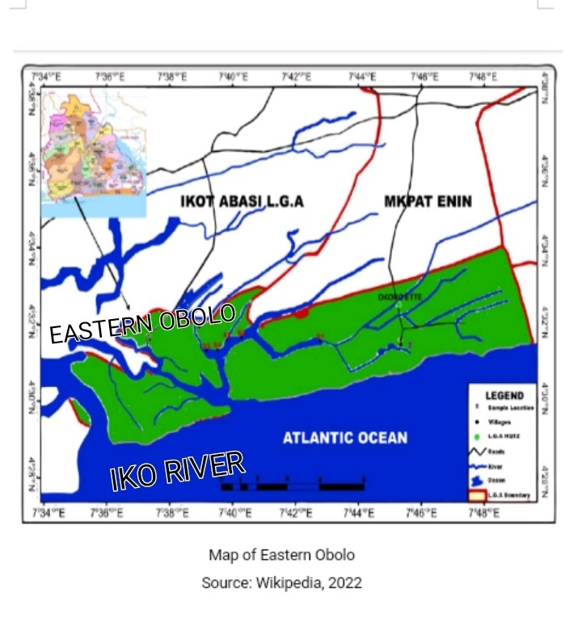

Fig. 1: Map of Eastern Obolo showing Iko River Estuary

2.2 Collection of Specimens
The sampling method employed was purposive low tide sampling technique. The sampling of P. barbarus (plate 1), was done at low tide using two means; the first was the used of traps crafted by the local fishers and installed in the nest, so as to trap any fish animal, then the desired species identified and selected. The second was carried out manually and aided by local fishers who have the technical know-how on capturing of P. barbarus. Furthermore, P. barbarus samples were transported to Zoological laboratory, Akwa Ibom State University for analysis.
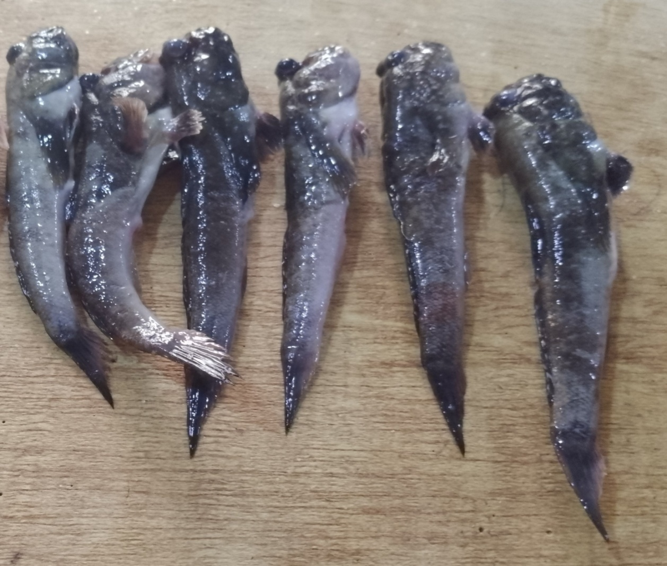
Plate 1: Specimens of P. barbarus from Iko River Estuary

2.3 Measurement of Specimens / Data Analysis
The measurement of the length-weight relationship of P. barbarus was done separately between the males and females’ species and this was aimed at determining the growth pattern of P. barbarus, based on the following equations (Weatherly, 1972):
W=aL^{b} ……………………… (1)
Where L = total length (TL) of fish in (cm)
W= weight of fish in (g)
a = constant (intercept)
b = the length exponent (slope)
One of the main features of fish growth pattern is the Fulton (k) condition factor. This shows the State of physical Capacity for fish survival and reproduction (Effendie, 2002). The coefficient of the Fulton (K) condition factor was determined using the following formula (Okgerman, 2005)
K = WX100/ L³ ……………………… (2)
Where K = condition factor
W = Weight (g)
L = Total length (cm)
3 = Coefficient.
The condition factor values in the range of 0-2 indicate that body of the fish is less flat and the range of 3-4 indicates the body of the fish lightly flat (Effendie,2002)

3.0 Results and Discussion
3.1 Length-weight Relationship of P. barbarus
During the study, captured P. barbarus included 180 fish consisting of 104 males and 76 females. The fish total length size of males P. barbarus ranged from 2.5-14. 70cm and females ranged from 6.50-14.20cm. The fish total weight size of males of P. barbarus ranged from 2. 50-25.30g and females ranged from 2.10-23.60g (Table 1). The monthly size distribution of P. barbarus is shown in (Fig.2). The difference in the morphometrical parameters of the captured fish is natural and could be linked to period of sampling and other factors (Akpan, 2013).

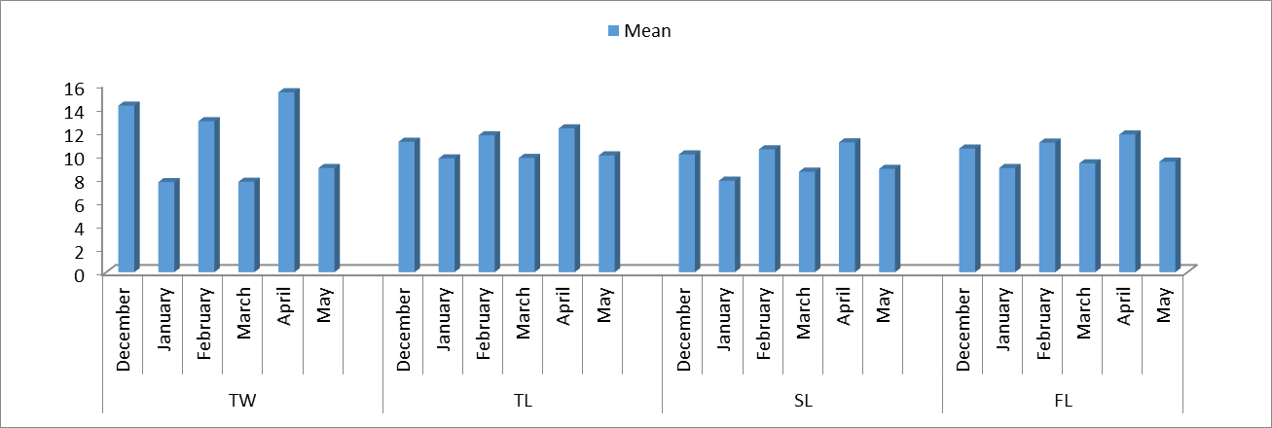
Fig. 2: Monthly size distribution of P. barbarus in the study area

Table I: Fish total length, fish weight and length - weight relationship parameter of P. barbarus in Iko Estuary
Sex | No. of fish | Total Length | (cm) | Weight (g) |  | Length  a | Weight  b | Relationship R²
Sex | No. of fish | Min | Max | Min | Max | Length  a | Weight  b | Relationship R²
Male | 104 | 2.50 | 14.70 | 2.50 | 25.3 | 0.0115 | 2.5655 | 0.9585
Female | 76 | 6.50 | 14.20 | 2.10 | 23.60 | 0.0245 | 2.642 | 0.9204
Combined sex | 180 |  |  |  |  | 0.0119 | 2.597 | 0.9143

The length-weight relationship in fish is very essential in fishery assessment (Obasohan et al., 2012, Sunarmi et al., 2019, Abowei et al., 2019). Table 1, showed the result of the analysis regarding fish total length, fish weight and parameters of fish - length relationship. On the basis of the results, the length - weight relationship of male P. barbarus is W=0.0115L^{2.5055} (Fig.3) and that of female is W = 0.0245L.^{2.642} (Fig.4) The b values (b = 2. 5655 and b = 2.642) attained b<3, which means that the growth pattern of both sexes is negative allometric.

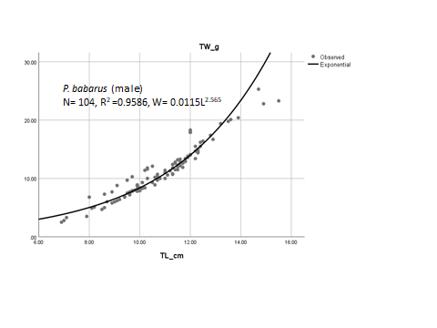
Fig. 3: Length-Weight graph of male P. barbarous

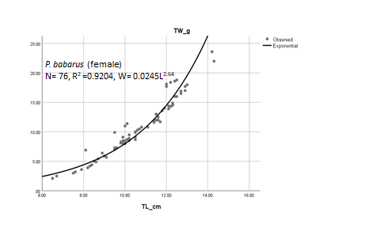
Fig 4: Length-Weight graph of female P. barbarus
The study revealed that combined sexes of P. barbarus captured exhibited negative allometric growth pattern with regression analyses exponent b value less than 3, indicating a high degree of positive correlation (Fig.5). The correlation coefficients (R²) of the fishes ranged between 0.9204 – 0.9586 indicating a high degree of positive correlation between their standard lengths and body weights (Table 1). The results showed that the body weights of fishes were observed to increase with increase in body length, however the rate of increase in weight was less than the rate of increase in length.
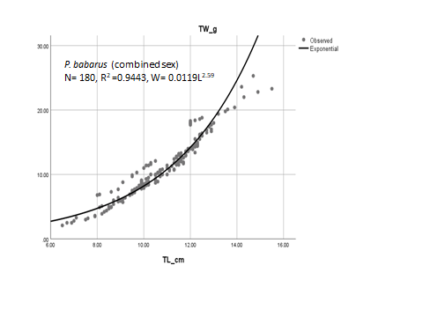
Fig. 5: Length-Weight graph of combined sex for P. barbarus
With reference to the study of Adeyemi et al., 2009, negative allometric growth pattern in fish implied that the weight increases at a lesser rate than the cube of the body length. Similar report of negative allometric growth pattern in many fishes have been reported (Bidawi et al., 2017, Mahadevan et al., 2017, Dewiyanti et al., 2022).
The body length and weight of fish throughout its life cycle are very impactful on the growth value of fish species, such that the factors affecting the duo (length and weight) could positively or negatively affect its growth pattern (Abiaobo and Udo, 2017). Various factors affect fish growth, which include natural factors and anthropogenic factors (King, 1996). The variation in feeding and biosynthetic processes in the aquatic habitat could result in changes in the weight of fish (Merestsky et al., 2000).

3.2 The Condition Factor of P. Barbarus
Condition factors are tailored to assess the general wellbeing of fish (Blackwell et al., 2000, Abowei 2009, Obasohan et al., 2012). The reflection of morphological parameters of the body fat content and growth rate are embodied in the condition factor (Froese 2006, Stevenson and woods, 2006). Table 2 represents the analysis result of the condition factor of P. barbarus in Iko estuary. The results showed that the condition factor of male and female P. barbarus was not the same, ranging between 0.799 to 1.043 and 0.815 to 1.019 respectively. The obtained values of condition factor of P. barbarus indicate that the body of the fish is less flat. The values of condition factor which range from 0-2 indicate that the body of the fish were less flat and the values of condition factor of fish that range from 3 to 4 showed that the body of the fish was slightly flattened. It could be explained that the condition factor of both sexes was not significantly different.

Table 2: Condition factor of P. barbarus
Sex | No. of fish | Condition Factor (k) |  | Mean
 |  | Min | Max
Male | 104 | 0.799 | 1.043 | 0.853
Female | 76 | 0.815 | 1.019 | 0.842

The condition factor is an important tool for the assessment of fish biology, mainly when the species lies at the base by the higher food web. (Diaz et al., 2000). The greater the value of condition factor, the greater the match between the fish species and the aquatic environment. However, this result indicates that the male mean condition factor of P. barbarus was greater than that of female P. barbarus. This result agrees favourably with the findings of (Rahardjo and Simanjuntak, 2008). The observed variation in the condition factor could be attributed to the release of eggs and reproduction process in the females, hence the low values of condition factors recorded during the study. Similar results of males having higher condition factor than females were earlier reported by (Sunarni et al., 2019). The low values of condition factors recorded in the females was noted to be relatively higher when the gonads are filled and attain their peak before spawning takes place. However, condition factor may differ due to season and location of capture, gender, gonadal maturity level and mostly preponderance of nutritional materials and physico-chemical conditions of the aquatic habitat (King, 1995; Udo, 2002a). The presence and density of predators are also likely factors that may impact on condition factors (Murphy et al., 1991 and Blackwell et al., 2000).

4.0 Conclusion
This study expounds the differences in length –weight relationship of male and female P. barbarus. On the basis of the length-weight relationship of P. barbarus, it was noted that the growth pattern of both sexes was negative allometric and the condition factor of the male were higher than the female. The disparity in the pattern of growth and condition factors may be influenced by numerous factors namely, differences in nutritional materials, breeding phase of female fish, level of fish movement and other physico-chemical conditions of the aquatic environment.

5.0 References
Abiaobo, N. O. and Udo, M. T. (2017): The population Dynamics of the Mudskipper, Penohthalamus barbarus (LINNEAUS 1766, TELEOSTEI, GOBIIDAE) and the Implication for conservation and management in the mangrove swamp of Iko River Estuary. Southeastern Nigeria. Journal of Applied Life Sciences International 14(4), 1-19.
Abiaobo, N. O; Asuquo, I.E; Ejogu, I.N and James, E.J(2021): Ecology and Evolutionary Biology Aspect of the Biology of Periophthalamus barbarous (Mudskipper) from Jaja Creek, Niger Delta, Nigeria. Ecology and Evolutinary Biology 6(1):15-22
Abowei, J. F. N. Davies O. A. and Eli A. A. (2009): Study of the length –weight relationship and condition factor of five fish species from Nkoro River, Niger Delta, Nigeria. Current research Journal of Biological Sciences 1(3). 94-98.
Adeyemi, S. O., Bankole, N. O. and Adikwu, I. A. (2009): Length-weight Relationship and condition factor of Protopterus Annectens. Continental J. fisheries and Aquatic Science 3.8-11.
Akinrotimi, O. A., Edun, O. M., Uka, U. and Owhonda, K. N. (2013): Public Perception of Mudskipper Consumption in some Fishing Communities of River State Nigeria. Journal of Fisheries and Aquatic Science 8(1): 208-212.
Akinrotimi, O. A; Amachree, D. and Azunna, A. (2019): Length-weight relationship of MMudskipper, Periophthalamus barbarus (Bloch and Schneider, 1801) from Buguma Creek, Rivers State. International Journal of Fisheries and Aquatic Research.
Akpan, I. I. (2013): Species composition and Abundance in Uta Ewa Creek, Niger Delta Region, Nigeria. Journal of Agriculture and Veterinary Science, Vol.3, Issue 3, pp.56-60.
Amin, A. M. and Sabrah, M. M. (2019): Basic parameters for assessment and management of the short-finned squid Ilex coindeti (Verany, 1839) (cephalopoda, Ommastrephidae) from the deep water of Egyptian Mediterranean Sea. Egyptian Journal of Aquatic Biology and Fisheries 23(1), 13-26.
Anderson, R. O., Gutreuter, S. J. (1983): Leyth-Weight and associated structural indices: (In): Fisheries Techiques (eds.): L. Nielsen, D. Johnson. American Fisheries Society, Bethesda, Maryland.
Bidawi B. Y., Destrita, Yunasfi (2017): Length-weight relationships and condition factor of mudskipper (family: Gobiidae) at the Mangrove ecosystem of the Sembilan Island village of Langkat Regency, North Sumatera. Depik, 6 (3), 228-234. (in Indonesian)
Blackwell B. G.; Brown, M. L.; Willis D. W. (2000): Relative weight (Wr) status and current use in fisheries assessment and management. Review in fisheries science 8(1), 1-44.
Chukwu, K. O. and Deekae, S. N. (2010): Length-weight relationship, condition factor and size composition of P. barbarus (Linneau, 1766) in New Calabar River, Nigeria. Agriculture and Biology Journal of North America 2(7) 1069-1071.
Dewiyanti, I, Melanie, K., Almuniro, S., Damora, A., Nufadillah, N. and Batubara, A. S. (2022). Growth patterns and condition factor of the mudskipper (Periophthalmus gracilis) in mangrove ecosystem rehabilitation areas in Banda Aceh and Aceh Besar, Indonesia. Fisheries and Aquatic Life, 30:85-94.
Diaz L. S.; Roa, A., Garcia C. B.; Acero, A.; Navas G; (2000): Length relationship of dermersal fishes from the upper continental slope off Columbia. NAGA, 23(3), 23-25
Effendie M. I. (2002):Biologi Perkanan(Edisi Revisi). Yayasan Pustaka Nusatara, Yogyakarta, 163.
Eliviana S; Sunarmi (2018): The composition and abundance of Mudskipper species relationship with organic materials in estuary aquatic Merauke Districts. Journal Agribisnis Perikanan, 11(12), 38-43 (in Indonesia)
Froese R. (2006): Cube law, condition factor and weight-length relationship: history, meta-analysis and recommendations. Journal of Applied Ichthyology, 22, 241-253
King. M. (1995): Fisheries Biology: Assessment and Management. Fishing New Books Oxford, 341.
King, R. P. (1996): Population Dynamics of the Mudskipper Periophthalmus barbarous (Gobiidae) in the estuarine swamps of Cross River, Nigeria. Journal of Aquatic Sci. II, 31-34.
Lanzoni, M., Aschonitis, V., Milardi, M., Castaldelli, G., Fano, E. A. (2018): A method to identify bimodal weight-length relations. Possibleontogenic diet and/or metabolism shift effects in anguilla (Actinopterygii; Anguilliformes; Anguillidae) Acta Icthyologica et Piscatoria, 48(2) 163-171.
Mahadevan, G. Ravi, V.; Murugesan, P. (2017): Length-weight relationship of two mudskippers (Gobiidae; Oxudercinae) Oxuderces dentatus (Eydoux&Souleyet, 1850) and Scatelaoshistophorus (Valenciennes, 1837) from Dhamara estuary, Odhisia, India. Journal of Applied Ichthyology 33(6), 1258-1260.
Meretsky, V. J., Valdes, R. A.; Douglas, M. E., Brouder, M. J., Gorman, O. T., Marsh, P. C. (2000): Spatiotemporal variation in length-weight relationship of endangered humpback chub: Implication for Conservation and Management. Transaction of the America Fisheries Society, 129, 419-428.
Muhtadi, A., Ramadhani, S. F., Yunasfi (2016): Identification and habitat type of mudskipper (Family Gobidae) at the Bali Beach District of Batu Bara, North Sumatra province, Biospecies 9(2), 1-6 (in Indonesia).
Murphy, B. R., Brown, M. L., Spinger, T. A. (1991): The relative weight (Wr) index management, status and needs. Fisheries, 16(2), 30-38.
Nsikak Okon Abiaobo, IdopiseAbasi Ekpe Asuquo, Ifeanyi Ntasiobi Ejiogu, Etimfon Joseph James (2021): Aspects of the Biology of Periophthalamus barbarous (Mudskipper), from Jaja Creek, Niger Delta, Nigeria. Journal Ecology and Evolutionary Biology, Vol.6, No.1, pp.15-22.
Obasohan, E. E.; Obasohan, E. E., Imasuen, J. A, and Isidahome, C. E. (2012): Preliminary studies of the length-weight relationships and condition factor of five fish species from Ibiekuma Stream, Ekpoma Edo State, Nigeria. Journal of Agriculture research and development Vol. 2(3). Pp 061-069.
Okgerman, H. (2005): Seasonal variation of the length-weight and condition factor of Rudd (Scardinus erythrophthalmus) in Spanca Lake. International Journal of Zoological Research 1(1), 6-10.
Philips, A. E. (2019): Fisheries Biology of Terapon puta (Cuvier, 1829) from east Egyptian Mediterranean waters. Egyptian Journal of Aquatic Biology and Fisheries 22(1), 197-203.
Polgar, G., Lim, R. (2011): Mudskipper: Human use, ecotoxicology and biomonitoring of mangrove and other soft bottom intertidal ecosystem. In: Mangrove,Ecology, Biology and Taxonomy.Publisher: Nova Science publishers. 51-86
Purwanigsih, S., Salamah, E., Riviani (2013): The changing of chemical composition amino acids and taurine content at glodok fish (Periophthalmodon Schlosseri). Jurnal Pengolahan Hasi Perikanan, Indonesia, 16(1), 12-21.
Rahardjo, M. F.; Simanjuntak, C. P. H. (2008): Length weight relationship and condition factor of belanger’s croaker, Johnius belangerii (Pisces: Sciaenidae) in Mayangan coastal waters, West Java. Journal Ilmu-ilmu Perairan dan perikanan, Indonesia, 15(2) 135-140.
Rider, W. E. (1975): Computation and Interpretation of Biological Statistics of Fish Population. Department of Environment Fisheries and Marine Service Pacific Biological Station. Nanaimo B.C. V9R 5K6.
Stevenson R. D., Woods W. A. (2006): Condition indices for conservation: new uses for evolving tools. In: Integrative and comparative Biology, 46, 1169-1190
Sunarni, Edy, H. P. Melmamlsessy, Norce Mote, Rahmatia, Baigo Hamucena (2019): Length-Weight Relationship and condition factor of mudskipper Baleophthalmus pectinirostris from Maro Estuary Merauke Regency Papua, Journal of Ecological Engineering, Vol. 20, issue 8, pp 199-204.
Udo, M. T. (2002a): Morphometric Relationships and Reproductive Maturation of the Mudskipper, Periphthalmus barbarous from subsistence catches in the Mangrove Swamps of Imo estuary, Nigeria. J. Environ. Sci. 14, 221-226.
Weatherley,A.H (1972): Growth and ecology of fish populations. London: Academic Press.293p
Yang, K. Y., Lee, S. Y., Williams, G. A. (2003): Selective feeding by the mudskipper (Boleophthalmus pectinirostris) on the micro-algal assemblage of a tropical mudflat. Marine Biology, 134(2), 245-256.

