**Pheromone mediated monitoring of *Plutella xylostella* L. (Lepidoptera: Plutellidae) infesting cruciferous crops in Kashmir**

**ABSTRACT**

*Plutella xylostella*, commonly known as the Diamondback moth poses significant challenges to Cole crops, impacting their growth and ultimately affecting yields. Its rapid reproduction coupled with its ability to develop pesticide resistance has elevated the Diamondback moth to a critical concern for farmers and agricultural systems worldwide. The adult population of Diamondback moth was monitored during the year 2023 and 2024 for two cropping seasons (Kharif and Rabi season) at Vegetable Experimental Field, Faculty of Horticulture, SKUAST-K, Shalimar using three different traps (Polyethylene funnel trap, Yellow sticky trap and Water pan trap) lured with two *Plutella xylostella* synthetic sex lures (Commercial Tapas and SKUAST-K lure).

During the year 2024 in both the Kharif and Rabi season, in all the traps (Polyethylene funnel traps, Water Pan trap and Yellow sticky trap) baited with Tapas lure, the adult moth catch of *P. xylostella* was highest (26.14, 19.57 and 12.99; and 21.81, 15.24 and 8.66 moths per trap in both the respective seasons) in comparison to adult moth trap catch in year, 2023 (23.81, 17.23 and 10.66; 16.44, 12.05 and 3.26 moths per trap in Kharif and Rabi season, respectively). Similarly, in SKUAST-K lure baited in all the three traps, during both the Kharif and Rabi season, 2024, the trap catch of adult moth *P. xylostella* was on a higher side (16.57, 12.48 and 6.54; and 12.24, 8.15 and 2.66 moths per trap) in comparison to adult moth trapped during the respective seasons in the year, 2023 (14.23, 10.14 and 4.21; 10.35, 4.81 and 1.54 moths per trap).

**Keyword**s**: Diamondback moth, lures, monitoring, polyethylene funnel trap, water pan trap, yellow sticky trap, trap catch**

**INTRODUCTION**

Since the civilization of mankind, humans are blessed with a wide variety of vegetables by the mother nature. Vegetables are nutritional powerhouses, key sources of micro-nutrients needed for good health. They add diversity, flavor, and nutritional quality to the diet. They are also economic engines for productive and profitable agricultural economy. Vegetable crops occupy an area of 59 million hectares at global level with an annual production of 1173.07 million tons (FAO, 2023). India ranks second in vegetable production in the world, after China. As per National Horticulture Database (Final Estimates), India produced 212.55 million tons of vegetables from an area of 11.35 million hectares (Anonymous, 2023a) accounting for 15 per cent of the world’s production. More than 70 different kinds of vegetables belonging to diverse groups, namely cucurbits, cruciferous crops (Cole crops), solanaceous vegetables, root and leafy vegetables are grown in India (Salaria and Salaria, 2010). In India, the area under cauliflower crop is 480 thousand hectares with an annual production of 9.53 million metric tons and productivity of 19.6 metric tons/ha. The country has a share of 32.50 per cent in total cauliflower production in the world; whereas, the total acreage and annual production of cabbage is 428 thousand hectares and 9.95 million metric tons, respectively (Anonymous, 2023b).

Among the various temperate vegetables produced in Jammu and Kashmir, cruciferous crops are the important ones that add high revenue to the Union Territory (Shankar *et al*., 2016). One of the major factors which limit the successful cultivation of these crops is the variety of insect pests and diseases which reduce the yield and quality. These crops are attacked by insect pests like, the cabbage butterfly (*Pieris brassicae* L.), cabbage aphid (*Brevicoryne brassicae* L.), painted bug (*Bagrada cruciferarum* K.), Diamondback moth (*Plutella xylostella* L.), cabbage semilooper (*Thysanoplusia orichalcea* F.), mustard aphid (*Lipaphis erysimi* K.), mustard saw fly (*Athalia lugens proxima* K.) etc. at different crop growth stages. Among these, the Diamondback moth, *P. xylostella* (Lepidoptera: Plutellidae) is one of the serious insect-pest of the crucifers throughout the world (Grzywacz *et al*., 2010; Furlong *et al*., 2013; Niu *et al*., 2013; Harika *et al*., 2019) because of its enormous appetite, lack of associated natural enemies, high reproductive rate and particularly its resistance to most of the commonly used insecticides (Haseeb *et al*., 2001; Gowri and Manimegalai, 2017). The moth causes 52 - 100 per cent crop loss worldwide (Kamala, 2006; Shelton *et al*., 2008; Shakeel *et al*., 2017; Kawsar *et al*., 2021). Diamondback moth has now been recorded nearly from 145 countries of the world (Saeed *et al*., 2010; Hanife and Saran, 2021).

The pivotal role of insect traps, unravel their significance in monitoring, decision-making, and fostering sustainable coexistence in the intricate realm of pests and crops. There are various types of insect traps designed to capture and monitor different types of insects based on their behaviors, preferences, and habitats (Kammara *et al*., 2023). Synthetic sex pheromone traps are the most common and widely used among different techniques and tools used in pest monitoring. The pheromone traps are the best and most sensitive traps for detecting even low-density pest populations (Gurrero and Reddy, 2001). Water pan traps monitor insect population especially moths and are filled with lure, water and detergent. Any insect landing in the water will sink and be caught (Kammara *et al*., 2023). Pest monitoring and surveillance are an important diagnostics for early pest detection. The small size of Diamondback moth larvae and its propensity to hide in the heart of leaves makes its collection challenging; as a result, it would be good to acquire additional useful monitoring tools that may effectively help in determining the first occurrence and magnitude of the moth flights and subsequent larval populations. Population monitoring links trap captures to an insect species’ abundance or damage inflicted (Gurrero and Reddy, 2001). The main objective of the study was to evaluate the efficiency of different traps and to predict peak period of infestation during Kharif and Rabi season.

**MATERIAL AND METHODS**

# The adult population of Diamondback moth was monitored both in Kharif and Rabi cropping season by using different traps (Polyethylene funnel traps, Water pan traps and Yellow sticky delta traps) and synthetic sex lures (Tapas lure and SKUAST-K lure) replicated thrice during the year 2023 and 2024 at Vegetable Experimental Field, Faculty of Horticulture, SKUAST-K, Shalimar. The traps were installed at the height of crop canopy after 30-45 days of crop transplanting till the harvest of crop. The lures were changed after every fortnight and observations on number of adult Diamondback moth trapped were recorded at weekly interval. The details of traps and lures are mentioned in Table 1:

**Experimental details:**

Design of experiment: Randomized Complete Block Design (RCBD)

Experimental area: 500m2 (01 Kanal)

**Table 1: Details of traps and lures**

|  |  |  |
| --- | --- | --- |
| **Monitoring devices** | **Name of lures/ traps** | **Model/ Make** |
| Pheromone Sex lures | Tapas lure | BigHaat Agro Pvt. Ltd., Bengaluru, Karnataka |
| SKUAST-K lure | Pherobank Technologies Pvt. Ltd., Division of Entomology, SKUAST-K, Shalimar. |
| Insect Monitoring traps | Polyethylene funnel traps | Gaiagen Technologies Private Limited, Bengaluru |
| Water pan traps | WotaTTM traps  Gaiagen Technologies Private Limited, Bengaluru |
| Delta traps | Pherobank Technologies Pvt. Ltd., Division of Entomology, SKUAST-K, Shalimar. |

**RESULTS AND DISCUSSION**

**Monitoring adult *P. xylostella* population during Kharif and Rabi season (2023 and 2024)**

The first adult catch of *P. xylostella* in Polyethylene funnel trap, Water pan trap and Yellow sticky trap baited with Tapas and SKUAST-K lure during Kharif, 2023 got initiated during third week of April (16th SMW) as 16.33, 12.33, 7.33; and 10.66, 6.33 and 1.33 adult moths per trap, respectively; whereas, in the succeeding year, 2024; the first moth trap catch got initiated a week earlier (15th SMW) as 21.66, 14.00, 11.66; and 14.66, 10.66, 4.00 in all the three respective traps baited with both Tapas and SKUAST-K lure. During Kharif, 2023, the adult population in subsequent weeks gradually increased and peaked twice during the 20th SMW (third week of May) as 25.33 and 17.33; 19.33 and 12.33; 13.66 and 5.66 moth per trap and 33.33 and 21.33, 24.33 and 15.33; 16.33 and 8.33 moth per trap during 24th SMW (second week of June) in all the three respective traps and lures. However, during Kharif, 2024; the adult moth catch initiated a week earlier during second week of April (15th SMW) in all the three traps, and with the gradual increase in subsequent weeks, and also peaked twice during 19th SMW (second week of May) to adult catch of 30.66 and 21.66; 23.66 and 15.00; 16.66and 8.66 moth per trap and 22nd SMW (second week of June) as 35.66 and 23.66; 26.66 and 17.66; 18.66 and 10.66 moth per trap. The adult first flight (Biofix) and initial moth trap catch a week earlier during Kharif 2024, could be attributed to a variation in temperature gradient; a higher temperature and lower humidity than observed in the preceding year. The adult *P. xylostella* population in the succeeding weeks gradually subsidized and finally declined to 22.33, 15.33, 4.66; and 9.33, 5.33, 1.66 moth in 26th SMW during Kharif 2023 and 20.66, 16.00, 6.66; and 10.00, 8.00, 4.66 moth in 25th SMW during 2024in all the respective traps and lures coinciding with the crop senescence (Table 2 and 3; Fig. 1 and 2).

Similarly, during Rabi, 2023 the first adult catch of *P. xylostella* in Polyethylene funnel trap, Water pan trap and Yellow sticky trap baited with Tapas and SKUAST-K lure got initiated during third week of August (33rd SMW) as 12.66, 11.66, 1.33; and 7.33, 4.33 and 0.33 adult moths per trap, respectively; whereas, in the year, 2024; the adult moth trap catch got initiated a week earlier (32nd SMW) as 20.33, 13.33, 2.66; and 7.33, 3.33, 1.33 in all the three respective traps and lures. During Rabi, 2023, the adult population gradually increased and in two weeks’ time peaked to maximum catch of 24.66 and 17.66, 20.33 and 9.66, 6.66 and 3.66 moths per trap during 35th SMW (first week of September); and thereafter, the moth population again peaked to adult moth catch of 17.66 and 11.33; 11.66 and 5.66; and 2.33 and 1.33 during fourth week of September (39th SMW) in all the three respective traps. However, during Rabi, 2024; the adult moth catch initiated a week earlier during second week of August (32nd SMW) in all the three traps, and in succeeding weeks (32nd to 37th SMW), the moth catch gradually increased and peaked to a maximum population of 31.33 and 19.33; 22.33 and 13.33; 14.33 and 6.33 moth per trap during 38th SMW (third week of September). The adult first flight (Biofix) and initial moth trap catch a week earlier during Rabi 2024, could be attributed to a variation in temperature gradient; a higher temperature and lower humidity than observed in the preceding year. However, the adult *P. xylostella* population in the succeeding weeks gradually subsidized and finally declined to 6.66, 5.66, 1.33; and 3.66, 1.33, 0.66 moth in 43rd SMW during Rabi 2023 and 16.33, 11.66, 2.33 and 5.66, 3.66, 0.66 moth in 42nd SMW during 2024 in all the respective traps and lures coinciding with the crop senescence (Table 4 and 5; Fig. 3 and 4).

During the present investigations, the consistent decline in moth catches in subsequent observation levels is corroborated with the findings of Reddy and Urs (1996); the authors opined that aging of pheromone lures often leads to declined catch; though, Mayer and Mitchell (1999) attributed low moth catches during rains due to reduced emission rate from the septa. The maximum trap catch and subsequent peaked moth population in present studies during 20th and 24th SMW during Kharif, 2023; and in 19th and 22nd SMW during the Kharif, 2024 could be attributed to the high pheromone volatility and increased emission rates due to consistent temperature increase from 14.86℃ (16th SMW) to 24.59℃ (20th SMW) and to 29.01℃ (24th SMW) during Kharif, 2023; and from 19.0℃ (15th SMW) to 25.07℃ (19th SMW) and finally to 29.37℃ (22nd SMW) in Kharif, 2024. The increased moth catch could be attributed to the accelerated release of the pheromone from the rubber septa is corroborated with the findings of Abbes and Chermiti (2011) and Zahoor *et al*. (2023); and subsequent reduction in trap catches during 25th and 26th SMW (second fortnight of June) finds support from the work of Ahmad and Ansari (2010) and Hidayah *et al*. (2023). The authors too observed decreased moth catches due to the strong influence of the abiotic factors (increased temperatures and humidity). Similarly, during Rabi season, 2023 and 2024, consistent increase in moth captures in the initial crop growth phase till it peaked to maximum trap catch during 35th and 38th SMW could be attributed to congenial climatic conditions with negligible precipitation and warmer temperatures throughout the period of observation. The increased moth catches during present investigations could also be explained because of less rainfall and lower relative humidity; finds support from the work of Hemchandra and Singh (2007) who too reported meager precipitation and less of moisture for high trap catches. The *P. xylostella* adult catch of 31.33 moth per trap in mid-September (38th SMW) during present studies is in accordance with the findings of Prasannakumar *et al*. (2011); the authors too reported maximum adult catch (31.23 moth per trap) during 37th SMW. The results are further supported by the findings of Zahoor *et al*. (2023) who too reported the maximum trap catch during the mid-September (38th SMW). The significant reduction in the adult catch with advancing observation levels in course of present studies could possibly be due to the lower temperature and higher relative humidity as advocated by Hemchandra and Singh (2007) and Maity *et al*. (2018). During both the years and seasons, the moth trap catch declined with crop senescence is supported by the findings of Kulwahara *et al*. (1996); the authors too opined that a sharp decline in population is often coincides with crop harvest.

During the present investigation, in all the traps and lures, Tapas lure had highest adult captures in comparison to SKUAST-K lure which possibly could be due to higher lure volatility and greater attractiveness in trapping adult Diamondback moths. The trap design is also known to affect moth capture rates, though, Sifner *et al*., (1983) opined that the trap catches are not greatly influenced by trap design, however, Malo *et al*., (2001) advocated that for most, some trap designs work better than others. During present studies, Water pan trap had less moth catches than Polyethylene funnel trap; could be due to practical problems like, maintenance of optimum water level, which often recedes due to evaporation; also large birds sit on the trap, which may stoop and spill out the water. The escape of captured moths due to placement of pheromone in the cap covers over the water surface in Water pan trap and the ability of moths to fly for longer duration, often leads to moth escape as compared to Polyethylene funnel trap, is in accordance with the work of (Raj *et al*., 2020). Conversely, during heavy rains, the water pan trap had the disadvantage of overflowing, as small cover allowed enough rain to enter and wash out trapped moths (Jackson and Bohac, 2006). The less moth trap catches in Yellow sticky traps compared to the Polyethylene funnel trap and Water pan trap may possibly be due to sticky surface which quickly become saturated with debris and non-target insects, find support from the work of Whitefield *et al*. (2019).

**CONCLUSION**

Across all the traps and lures in all the seasons and in both the years, it was consistently evident that the Polyethylene funnel trap and Tapas pheromone lure demonstrated superior efficacy in comparison to SKUAST-K lure and other two traps. This study concludes that the distinct seasonal variations in Diamondback moth populations, with peak activity during specific periods of the year. Pheromones are proficient on low population densities and do not affect non-target organisms and therefore, bring about long-lasting minimization in pest populations below economic injury level. Also, these findings offer valuable information for growers and pest control practitioners, enabling them to make informed decisions regarding pest management strategies, thus contributing to the resilience of cole crops in our region.

**Disclaimer (Artificial intelligence)**

Author(s) hereby declare that NO generative AI technologies such as Large Language Models (ChatGPT, COPILOT, etc.) and text-to-image generators have been used during the writing or editing of this manuscript.

**REFERENCES**

Abbes, K. and Chermiti, B. 2011.Comparison of two marks of sex pheromone dispensers commercialized in Tunisia for their efficiency to monitor and to control by mass-trapping *Tuta absoluta* under greenhouses. *Tunisian Journal of Plant Protection* **6**: 133-148.

Ahmad, T. and Ansari, M. S. 2010. Studies on seasonal abundance of Diamondback moth *Plutella xylostella* Lepidoptera: Yponomeutidae on cauliflower crop. *Journal of Plant Protection Research* **50**(3): 281-287.

Anonymous, 2023a. Indian Horticulture Database, National Horticulture board. Government of India.

Anonymous, 2023b.National Horticultural Board.http: //nhb. gov.in.

FAO. 2023. Annual vegetable production report. [www. fao. org](http://www.fao.org)

Furlong, M. J., Wright, D. J. and Dosdall, L. M. 2013. Diamondback moth ecology and management: problems, progress and prospects. *Annual Review of Entomology* **58**: 517-41.

Gomez, K. A. and Gomez, A. A. 1984. Statistical Procedure for Agricultural Research-Handbook.John Wiley & Sons, New York.

Gowri, G and Manimegalai, K. 2017. Life table of diamondback moth, *Plutella xylostella* (L.)(Lepidoptera: Plutellidae) on Cauliflower (*Brassica oleracea* var *botrytis* L.). *Journal of Entomology and Zoological Studies* **5**(4): 1547-1550.

Grzywacz, D., Rossbach, A., Rauf, Russell, D., Srinivasan, R. and Shelton. A. 2010. Current control methods for Diamondback moth and other brassica pests and prospects for improved management with lepidopteran-resistant *Bt* vegetable brassicas in Asia and Africa. *Crop Protection* **29**: 68-79.

Gurrero, A. and Reddy, G. V. P. 2001. Optimum timing of insecticide applications against Diamondback moth *Plutella xylostella* in Cole crops using threshold catches in sex pheromone traps. *Pest Management Science* **57**: 90-94.

Hanife, G. and Saran, C. 2021. Age-stage, two-sex life table of the Diamondback moth, *Plutella xylostella* (Linnaeus, 1758)(Lepidoptera: Plutellidae) on different brassicaeous plants. *Türk Tarımve Doğa Bilimleri Dergisi* **8**(3): 615-628.

Harika, G., Dhurua, S., Sreesandhya, N., Suresh, M. and Rao, G. S. 2019. Biology of Diamondback moth, *Plutella xylostella* (Lepidoptera: Plutellidae) on cauliflower under laboratory condition. *International Journal of Current Microbiology and Applied Sciences* **8**(1): 866-73.

Haseeb, M., Kobori, Y., Amano, H. and Nemoto, H. 2001. Population density of *Plutella xylostella* (Lepidoptera: Plutellidae) and its parasitoid *Cotesia plutellae* (Hymenoptera: Braconidae) on two varieties of cabbage in an Urban Environment. *Applied Entomology and Zoology* **36**: 353-60.

Hemchandra, O. and Singh, T. K. 2007. Population dynamics of DBM, *Plutella xylostella* (L.) on cabbage agro-ecosystem in Manipur. *Indian Journal of Entomology***69**: 154-161.

Hidayah, B. N., Adnyana, I. P. C. P., Suparjan, S., Aisah, A. R. and Rahayu, M. 2023. Moonlight and Rainfall influence efficacy of sex pheromones in controlling *Spodoptera exigua* (Lepidoptera: Noctuidae) on Shallot. IOP Conference Series: Earth and Environment Science 1165 (012009).

Jackson, D. M. and Bohac, J. R. 2006. Evaluation of pheromone traps for monitoring sweetpotato weevils. *Journal of Agricultural and Urban Entomology* **23**(3): 141-158.

Kamala, N. V. 2006. Investigations on natural enemies of Diamondback moth *Plutella xylostella* L. (Lepidoptera: Yponomeutidae) with special emphasis on life history traits of Trichogrammatidae. PhD Thesis, University of Agricultural Sciences, Bangalore. 103p.

Kammara, M., JapaSowjanya, A. K., Mishra, R. and Mohan, M. 2023. Insect Traps: A Useful Tool in Integrated Pest Management. *Emerging Trends in Entomology* **167**: 217-225.

Kawsar, R., Sheikh, B. A., Abdul, R. W., Munazah. Y., Showkat, M., Khalid R., Mohd, A. B. 2021.Seasonal incidence of Diamondback moth *Plutella xylostella*(Lepidoptera: Yponomeutidae) on cabbage. *Pharma Innovation* **10**(11):793-795.

Kulwahara, M., Keinmeesuke, P. and Shirai, Y. 1996.Monitoring field population with pheromone traps and seasonal trend of adult body size of the Diamondback moth, *Plutella xylostella* (L.) in Central Thailand. *Japan International Research Center for Agricultural Sciences* **3**: 17-22.

Maity, L., Padhi, G. and Samanta, A. 2018.Population dynamics and management of Diamondback moth, *Plutella xylostella* (L.) in cabbage ecosystem of West Bengal. *International Journal of Chemical Studies* **6**(1): 381-385.

Malo, E. A., Cruz-lopez, L., Valle-mora, J., Virgen, A., Sanchez, J. A. and Rojas, J. C. 2001. Evaluation of commercial pheromone lures and traps for monitoring male fall armyworm (Lepidoptera: Noctuidae) in the coastal region of Chiapas, Mexico. *Florida Entomologist* **84**: 659-664.

Mayer, M. S. and E. R. Mitchell. 1999. Differences between attractive Diamondback moth, *Plutella xylostella* (L.) (Lepidoptera: Plutellidae), sex pheromone lures are not determinable through analysis of emissions. *Agricultural and Forest Entomology* **1**: 229-236.

Niu, Y. Q., Li, X. W., Li, P. and Liu, T. X. 2013. Effects of different cruciferous crops on the fitness of *Plutella xylostella* (Lepidoptera: Plutellidae). *Crop Protection* **54**: 100-05.

Prasannakumar, N. R., Chakravarthy, A. K., Naveen, A. H. and Narasimhamurthy, T. N. 2011. Influence of weather parameters on pheromone traps catches of selected lepidopterous insects pests on vegetable crops. *Current Biotica* **4**(4): 442-452.

Raj,M. K. N., Girish, R., Hanumantharaya, L., Ravi, C. S. and Ganapathi, M. 2020.Comparison of moth catches in pheromone tarps against tomato pin worm, *Tutaabsoluta* (Meyrick) (Lepidoptera: Gelechiidae) in open field condition. *Journal of Entomology and Zoology Studies* **8**(4): 1064-1066.

Reddy, G. V. P. and Urs, K. C. D. 1996.Comparative performance of five types of traps for sex trapping of Diamondback moth in cole crops. *Journal of Insect Science* **8**(1): 24-26.

Saeed, R., Sayyed, A. H., Shad, S. A. and Zaka, S. M. 2010. Effect of different host plants on the fitness of Diamondback moth, *Plutella xylostella* (Lepidoptera: Plutellidae). *Crop Protection* **29**(2): 178-82.

Salaria, A. S. and Salaria, B. S. 2010.A to Z Horticulture at a glance. Jain brother publications, New Delhi, India

Shakeel, M., Farooq, M. and Nasim, W. 2017. Environment polluting conventional chemical control compared to an environmentally friendly IPM approach for control of Diamondback moth, *Plutella xylostella* (L.) in China: A Review. *Environmental Science and Pollution Research* **24**: 14537-550.

Shankar, U., Kumar, D., Singh, S. K. and Gupta, S. 2016. Pest complex of Cole crops and their management. *Technical bulletin No. 1*, SKAUST Jammu, pp. 14.

Shelton, A. M., Hatch, S. L., Zhao, J. Z., Chen, M., Earle, E. D. and Cao, J. 2008. Suppression of Diamondback moth using Bt-transgenic plants as a trap crop. *Crop Protection* **27**: 403-409.

Sifner, F., Zdarek, J., Hrdy, I. and Kalvoda, L., 1983, Pheromone traps for the pest management of phycitid moths. *Crop Protection* **2**: 463-472.

Whitfield, E. C., Lobos, E., Cork, A., and Hall, D. R. 2019. Comparison of different trap designs for capture of noctuid moths (Lepidoptera: Noctuidae) with pheromone and floral odor attractants. *Journal of Economic Entomology* **112**(5): 2199-2206.

Zahoor, S., Pathania, S. S., Ali, I., Anees, M., Ayoub, L. and Kishore, G. 2023. Advancing Integrated Pest Management: Utilizing Pheromone Traps for Population Monitoring of Plutella Xylostella in Cole Crops. *International Journal of Environment and Climate Change* **13**(10):4435-43.

|  |  |  |  |  |  |  |  |  |  |  |  |  |  |  |  |  |  |  |  |  |  |  |  |  |  |
| --- | --- | --- | --- | --- | --- | --- | --- | --- | --- | --- | --- | --- | --- | --- | --- | --- | --- | --- | --- | --- | --- | --- | --- | --- | --- |
| Traps | | Standard Meteorological Week (SMW) | | | | | | | | | | | | | | | | | | | | | | **Mean** | |
| 16 | | 17 | | 18 | | 19 | | 20 | | 21 | | 22 | | 23 | | 24 | | 25 | | 26 | |
| L1 | L2 | L1 | L2 | L1 | L2 | L1 | L2 | L1 | L2 | L1 | L2 | L1 | L2 | L1 | L2 | L1 | L2 | L1 | L2 | L1 | L2 | **L1** | **L2** |
| Polyethylene Funnel Trap | | 16.33 | 10.66 | 19.33 | 12.33 | 21.33 | 12.66 | 24.33 | 15.33 | 25.33 | 17.33 | 21.66 | 10.33 | 18.33 | 7.66 | 28.33 | 19.33 | 33.33 | 21.33 | 31.33 | 20.33 | 22.33 | 9.33 | **23.81** | **14.23** |
| Water Pan Trap | | 12.33 | 6.33 | 11.66 | 8.33 | 15.33 | 11.33 | 16.33 | 11.66 | 19.33 | 12.33 | 16.66 | 8.33 | 13.66 | 5.66 | 21.33 | 12.66 | 24.33 | 15.33 | 23.33 | 14.33 | 15.33 | 5.33 | **17.23** | **10.14** |
| Yellow Sticky Trap | | 7.33 | 1.33 | 9.33 | 1.66 | 12.33 | 3.66 | 13.33 | 4.33 | 13.66 | 5.66 | 6.33 | 3.33 | 4.33 | 2.33 | 14.33 | 6.33 | 16.33 | 8.33 | 15.33 | 7.66 | 4.66 | 1.66 | **10.66** | **4.21** |
| Mean | | 12.00 | 6.11 | 13.44 | 7.44 | 16.33 | 9.22 | 18.00 | 10.44 | 19.44 | 11.77 | 14.88 | 7.33 | 12.11 | 5.22 | 21.35 | 12.77 | 24.66 | 15.00 | 23.33 | 14.11 | 14.11 | 5.44 | --- | |
| CD (p≤0.05) | Traps | 1.31 | | 2.15 | | 2.54 | | 4.03 | | 3.18 | | 4.25 | | 3.33 | | 3.28 | | 2.90 | | 3.63 | | 3.37 | |
| Lures | 1.07 | | 1.75 | | 2.08 | | 3.29 | | 2.60 | | 3.47 | | 2.72 | | 2.68 | | 2.37 | | 2.96 | | 2.75 | |
| Traps × Lures | 2.38 | | 3.90 | | 4.62 | | 7.32 | | 5.78 | | 7.72 | | 4.72 | | 5.96 | | 5.27 | | 6.59 | | 4.77 | |

|  |  |  |  |  |  |  |  |  |  |  |  |  |  |  |  |  |  |  |  |  |  |  |  |  |  |
| --- | --- | --- | --- | --- | --- | --- | --- | --- | --- | --- | --- | --- | --- | --- | --- | --- | --- | --- | --- | --- | --- | --- | --- | --- | --- |
| Traps | | Standard Meteorological Week (SMW) | | | | | | | | | | | | | | | | | | | | | | **Mean** | |
| 15 | | 16 | | 17 | | 18 | | 19 | | 20 | | 21 | | 22 | | 23 | | 24 | | 25 | |
| L1 | L2 | L1 | L2 | L1 | L2 | L1 | L2 | L1 | L2 | L1 | L2 | L1 | L2 | L1 | L2 | L1 | L2 | L1 | L2 | L1 | L2 | **L1** | **L2** |
| Polyethylene Funnel Trap | | 21.66 | 14.66 | 24.66 | 11.66 | 18.66 | 13.00 | 23.66 | 15.00 | 30.66 | 21.66 | 27.66 | 19.66 | 33.66 | 22.66 | 35.66 | 23.66 | 26.66 | 17.66 | 24.00 | 12.66 | 20.66 | 10.00 | **26.14** | **16.57** |
| Water Pan  Trap | | 14.00 | 10.66 | 17.66 | 7.66 | 14.66 | 8.66 | 17.66 | 13.66 | 23.66 | 15.00 | 21.66 | 14.66 | 25.66 | 16.66 | 26.66 | 17.66 | 18.66 | 14.00 | 19.00 | 10.66 | 16.00 | 8.00 | **19.57** | **12.48** |
| Yellow Sticky Trap | | 11.66 | 4.00 | 7.00 | 4.00 | 9.66 | 3.66 | 14.66 | 6.00 | 16.66 | 8.66 | 16.00 | 8.00 | 17.66 | 10.00 | 18.66 | 10.66 | 15.66 | 6.66 | 8.66 | 5.66 | 6.66 | 4.66 | **12.99** | **6.54** |
| Mean | | 15.77 | 9.77 | 16.44 | 7.77 | 14.33 | 8.44 | 18.66 | 11.55 | 23.66 | 15.11 | 21.77 | 14.11 | 25.66 | 16.44 | 27.00 | 17.33 | 20.33 | 12.77 | 17.22 | 9.66 | 14.44 | 7.55 | --- | |
| CD (p≤0.05) | Traps | 2.15 | | 3.37 | | 1.31 | | 2.54 | | 3.28 | | 3.18 | | 3.63 | | 2.90 | | 4.03 | | 4.25 | | 3.33 | |
| Lures | 1.75 | | 2.75 | | 1.07 | | 2.08 | | 2.68 | | 2.60 | | 2.96 | | 2.37 | | 3.29 | | 3.47 | | 2.72 | |
| Traps × Lures | 3.90 | | 4.77 | | 2.38 | | 4.62 | | 4.45 | | 4.20 | | 5.23 | | 5.33 | | 4.54 | | 4.29 | | 4.72 | |

Table 3: Population monitoring of adult Diamondback moth, *P. xylostella* with different pheromone traps and lures in cruciferous crops during Kharif season, 2024

Table 2: Population monitoring of adult Diamondback moth, *P. xylostella* with different pheromone traps and lures in cruciferous crops during Kharif season, 2023

Table 4: Population monitoring of adult Diamondback moth, *P. xylostella* with different pheromone traps and lures in cruciferous crops during Rabi season, 2023

|  |  |  |  |  |  |  |  |  |  |  |  |  |  |  |  |  |  |  |  |  |  |  |  |  |  |
| --- | --- | --- | --- | --- | --- | --- | --- | --- | --- | --- | --- | --- | --- | --- | --- | --- | --- | --- | --- | --- | --- | --- | --- | --- | --- |
| Traps | | Standard Meteorological Week (SMW) | | | | | | | | | | | | | | | | | | | | | | **Mean** | |
| 33 | | 34 | | 35 | | 36 | | 37 | | 38 | | 39 | | 40 | | 41 | | 42 | | 43 | |
| L1 | L2 | L1 | L2 | L1 | L2 | L1 | L2 | L1 | L2 | L1 | L2 | L1 | L2 | L1 | L2 | L1 | L2 | L1 | L2 | L1 | L2 | **L1** | **L2** |
| Polyethylene Funnel Trap | | 12.66 | 7.33 | 19.66 | 13.66 | 24.66 | 17.66 | 22.33 | 15.66 | 20.66 | 11.66 | 14.33 | 10.33 | 17.66 | 11.33 | 16.33 | 10.66 | 14.33 | 6.33 | 11.66 | 5.66 | 6.66 | 3.66 | **16.44** | **10.35** |
| Water Pan Trap | | 11.66 | 4.33 | 15.33 | 5.66 | 20.33 | 9.66 | 17.66 | 6.66 | 13.33 | 6.33 | 11.33 | 4.66 | 11.66 | 5.66 | 9.66 | 4.66 | 8.33 | 2.33 | 7.66 | 1.66 | 5.66 | 1.33 | **12.05** | **4.81** |
| Yellow Sticky Trap | | 1.33 | 0.33 | 4.33 | 2.66 | 6.66 | 3.66 | 5.66 | 3.33 | 4.33 | 1.66 | 1.66 | 0.66 | 2.33 | 1.33 | 3.33 | 1.66 | 2.66 | 0.66 | 2.33 | 0.33 | 1.33 | 0.66 | **3.26** | **1.54** |
| Mean | | 8.55 | 4.00 | 13.11 | 7.33 | 17.22 | 10.33 | 15.22 | 8.55 | 12.77 | 6.55 | 9.11 | 5.22 | 10.55 | 6.11 | 9.77 | 5.66 | 8.44 | 3.11 | 7.22 | 2.55 | 4.55 | 1.88 | --- | |
| CD (p≤0.05) | Traps | 1.62 | | 3.41 | | 4.20 | | 3.93 | | 3.66 | | 2.10 | | 2.35 | | 2.87 | | 2.32 | | 2.51 | | 2.01 | |
| Lures | 1.32 | | 2.78 | | 3.43 | | 3.21 | | 2.99 | | 1.71 | | 1.92 | | 2.34 | | 1.90 | | 2.05 | | 1.64 | |
| Traps × Lures | 2.29 | | 6.19 | | 7.63 | | 7.14 | | 6.65 | | 2.97 | | 4.27 | | 5.21 | | 3.29 | | 4.56 | | 3.65 | |

|  |  |  |  |  |  |  |  |  |  |  |  |  |  |  |  |  |  |  |  |  |  |  |  |  |  |
| --- | --- | --- | --- | --- | --- | --- | --- | --- | --- | --- | --- | --- | --- | --- | --- | --- | --- | --- | --- | --- | --- | --- | --- | --- | --- |
| Traps | | Standard Meteorological Week (SMW) | | | | | | | | | | | | | | | | | | | | | | **Mean** | |
| 32 | | 33 | | 34 | | 35 | | 36 | | 37 | | 38 | | 39 | | 40 | | 41 | | 42 | |
| L1 | L2 | L1 | L2 | L1 | L2 | L1 | L2 | L1 | L2 | L1 | L2 | L1 | L2 | L1 | L2 | L1 | L2 | L1 | L2 | L1 | L2 | **L1** | **L2** |
| Polyethylene Funnel Trap | | 20.33 | 7.33 | 17.33 | 10.33 | 19.33 | 10.66 | 19.66 | 8.33 | 23.33 | 15.33 | 26.33 | 17.33 | 31.33 | 19.33 | 29.33 | 18.33 | 22.33 | 13.33 | 14.33 | 8.66 | 16.33 | 5.66 | **21.81** | **12.24** |
| Water Pan Trap | | 13.33 | 3.33 | 9.66 | 6.33 | 13.33 | 9.33 | 14.66 | 6.33 | 17.33 | 10.33 | 19.33 | 10.66 | 22.33 | 13.33 | 21.33 | 12.33 | 14.33 | 9.66 | 10.33 | 4.33 | 11.66 | 3.66 | **15.24** | **8.15** |
| Yellow Sticky Trap | | 2.66 | 1.33 | 7.33 | 1.00 | 10.33 | 1.66 | 4.33 | 1.33 | 11.66 | 3.66 | 12.33 | 4.33 | 14.33 | 6.33 | 13.33 | 5.66 | 11.33 | 2.33 | 5.33 | 1.00 | 2.33 | 0.66 | **8.66** | **2.66** |
| Mean | | 12.11 | 4.00 | 11.44 | 5.88 | 14.33 | 7.22 | 12.88 | 5.33 | 17.44 | 9.77 | 19.33 | 10.77 | 22.66 | 13.00 | 21.33 | 12.11 | 16.00 | 8.44 | 10.00 | 4.66 | 10.11 | 3.33 | --- | |
| CD (p≤0.05) | Traps | 3.55 | | 2.50 | | 2.54 | | 4.25 | | 3.18 | | 3.28 | | 2.90 | | 3.63 | | 4.03 | | 1.59 | | 3.41 | |
| Lures | 2.89 | | 2.04 | | 2.08 | | 3.47 | | 2.60 | | 2.68 | | 2.31 | | 2.96 | | 3.29 | | 1.30 | | 2.78 | |
| Traps × Lures | 5.02 | | 4.54 | | 4.62 | | 6.53 | | 5.27 | | 4.86 | | 5.21 | | 5.29 | | 6.23 | | 2.89 | | 4.82 | |

For each table L1: Tapas Lure; L2: SKUAST-K Lure Each value is mean of 3 replications

Table 5: Population monitoring of adult Diamondback moth, *P. xylostella* with different pheromone traps and lures in cruciferous crops during Rabi season, 2024

Fig 1: Adult trap catches of *P. xylostella* with different pheromone traps and lures during Kharif season, 2023

Fig 2: Adult trap catches of *P. xylostella* with different pheromone traps and lures during Kharif season, 2024

Fig 3: Adult trap catches of *P. xylostella* with different pheromone traps and lures during Rabi season, 2023

Fig 4: Adult trap catches of *P. xylostella* with different pheromone traps and lures during Rabi season, 2024

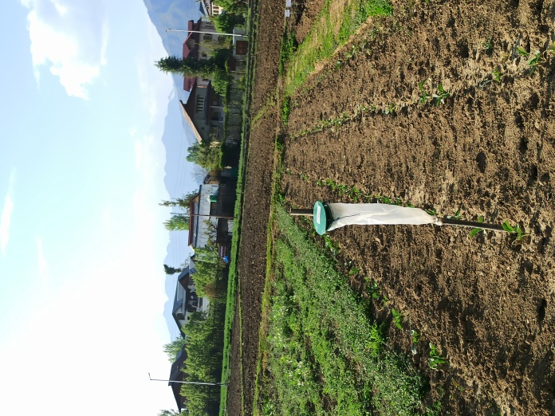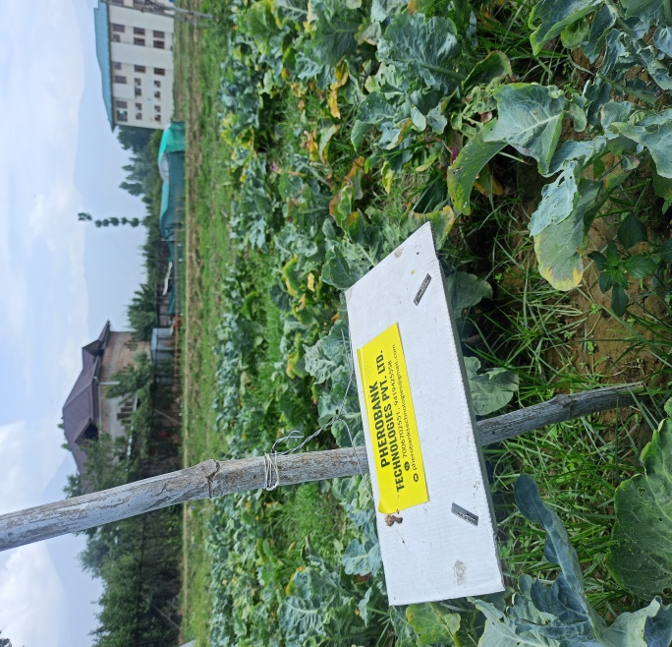

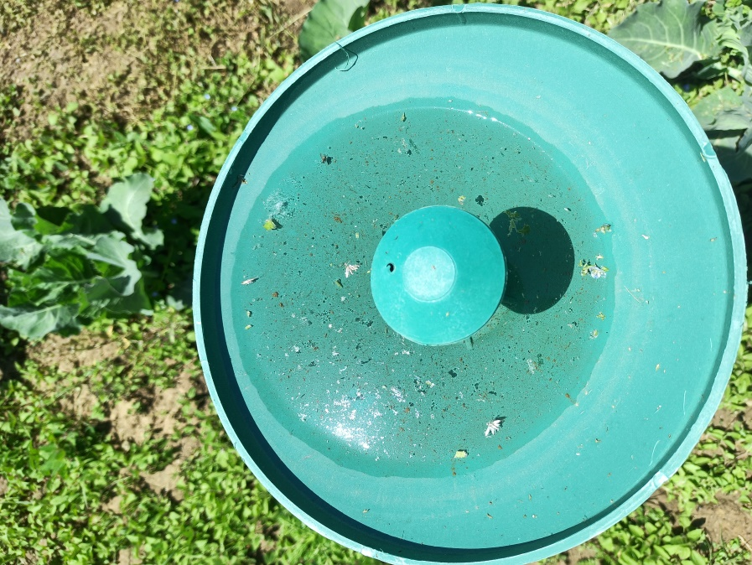

Plate 1 : Installation of different traps for *P. xylostella* monitoring