**Original Research Article**

**Neuropharmacological Evaluation of Aqueous Extracts of Tecoma stans Linn in Mice Models**

**ABSTRACT**

Mood disorders such as major depression and bipolar disorder continue to be leading contributors to global morbidity, often resulting in reduced productivity and increased healthcare burden. According to the World Health Organization (2001), only a small proportion of the estimated 450 million individuals affected by mental or behavioral disorders receive adequate treatment. These conditions accounted for 12.3% of the global disease burden, with projections suggesting a rise to 15% by 2020. This study aimed to evaluate the neuropharmacological effects of *Tecoma stans* flowers in mice, with a focus on validating their traditional medicinal use. The flowers were shade-dried, powdered, and sequentially extracted using solvents of increasing polarity. The aqueous extract was administered orally at doses of 200 mg/kg and 400 mg/kg. Behavioral assessments focused on antipsychotic and CNS depressant activity, and the data were analyzed using one-way ANOVA followed by Dunnett’s post hoc test. The results showed that the aqueous extract of *Tecoma stans* significantly reduced amphetamine-induced stereotypic behaviors and increased pentobarbitone-induced sleeping time in a dose-dependent manner. These findings suggest that the plant possesses notable antipsychotic and CNS depressant properties, supporting its traditional use in managing neuropsychiatric conditions.

*Keywords:**Aqueous extract, Tecoma stans flowers, Haloperidol, Amphetamin*

**1. INTRODUCTION**

The study of how medications impact nervous system function in cells is known as neuropharmacology. Behavioural neuropharmacology and molecular neuropharmacology are the two primary subfields of neuropharmacology. The study of how medications impact human behaviour is the main focus of behavioural neuropharmacology [1]. In molecular neuropharmacology, neurons and their neurochemical interactions are studied to create medications that improve neurological processes [2].To cure neurological conditions. The most commonly used drugs act on the central nervous system. Although selectively acting synthetic medications have severe adverse effects and don't appreciably change the course of the disease, they can be used to treat anxiety, mania, depression, or schizophrenia without changing awareness [3]. In China and around the world, traditional medicinal herbs play a significant role in indigenous medical systems [4].

Due to the unparalleled availability of chemical variety, natural goods offer countless prospects for the development of novel drugs. Between 1960 and 1997, the chance of remission for a child with leukaemia jumped by 85% because of two medications made from the alkaloids of Madagascar's rosy periwinkle (Catharanthus roseus). Novel chemicals, like the one found in a plant in Madagascar lately, have the potential to produce new medications and help stop the spread of antibiotic-resistant illnesses [5]. Considering all of the aforementioned factors, we have chosen the flowers of *Tecoma stans*, a local plant that belongs to the Bignoniaceae family. Because there aren't many scientific publications about *Tecoma stans*, we decided to conduct the current study on this plant and illustrate the neuropharmacological properties of its various extracts.

**2. MATERIALS AND METHODS**

**Materials**

**2.1 Plant**

The *Tecoma stans* flowers are found throughout India. Scientists from the Botanical Survey of India in Pune, Maharashtra, verified the plant's authenticity.

Drug: Haloperidol (Ranbaxy), Amphetamine (Shreeji Pharma International Pvt. Ltd, Phenobarbitone (Sun Pharma. Pvt. Ltd.), Diazepam (Ranbaxy).

**2.2 Chemicals**

All chemicals used were of analytical grade.

1. Petroleum ether
2. Chloroform
3. Ethanol

**2.3 Animals**

A total of 65 Albino Swiss mice weighing between 20-25 gm, were used for the current study. For experimental purposes, they were maintained in the animal house of DCS’s ARA College of Pharmacy, Dhule. All the studies conducted were approved by the Institutional Animal Ethical Committee (IAEC) (REG. No ARACOP/IAEC/24/16)

**3. METHODOLOGY**

**3.1 Plant Collection and Extraction**

*Tecoma Stans* flowers are gathered and allowed to dry in the shade. These dried flowers are ground into a coarse powder, which is then extracted in progressively stronger solvents. Petroleum ether, chloroform, alcohol, and aqueous solvents are among the appropriate solvents used to make different extracts [6].

**3.2 Pharmacological Investigation**

Acute toxicity research (oral) Fixed dosage procedure (FDP).

The proprietary formulation's acute oral toxicity research was conducted by OECD/OCED guideline 420.

Procedure:

As indicated, the investigation was conducted as follows: following the animals' acclimatisation for four to five days:

* Young adult, healthy, nulliparous, non-pregnant Albino Swiss mice weighing 20–25 grams were employed in this investigation. Food—but not water—was withheld for three to four hours, and then again for one to two hours after the research sample was administered.
* Initially, a fixed dose level of 5, 50, and 500 mg/kg was used since it was anticipated that this level would enable the discovery of doses that produced obvious toxicity.

A fixed dose of 2000 mg/kg was added during the validation process to give more details on the substance's low acute toxicity.

Observation:

For a total of 14 days, animals were monitored one-on-one for at least five minutes once during the first half-hour after dosing, then every two hours during the first twenty-four hours and every day after that [7,8].

**3.3 Evaluation of Neuropharmacological properties by the following methods**

**3.3.1 Antipsychotic studies of *Tecoma stans* extracts by compulsive behaviour test**

Five groups of five albino mice, each of either sex and weighing between 20 and 25 grams, are chosen. Animals used in compulsive behaviour tests will be weighed and numbered to assess the aqueous extract's antipsychotic properties. After that, they were split up into five groups, each with five animals. Five animals in the control group will receive a vehicle, and in the second group, five animals will receive amphetamine injections, and they will each be placed in a different beaker. The animals' rearing, sniffing, and licking behaviours will be observed at intervals of 0, 5, and 30 minutes. Cumulative scores at each time interval are recorded and computed, with += presence, + += moderately severe, and + + += intense and continuous action representing the intensity of the response. Animals in the third group received injections of haloperidol and amphetamine at 30-minute intervals. These animals are placed individually in a beaker, and the cumulative score at each time interval is noted and calculated. To the 4th and 5th group aqueous extract of *Tecoma Stans* flowers at 200 mg/kg and 400 mg/kg. 30 minutes later, amphetamine will be injected into these animals. These animals were placed individually in a beaker, and cumulative scores were noted at each time interval, and the score was calculated. Comparisons of the action of amphetamine in normal and haloperidol and *Tecoma stans* flower extract groups are done [9].

**3.3.2 Pentobarbitone-induced sleeping time test**

Four groups of five albino mice, each of either sex and weighing between 20 and 25 grams, are chosen among the animals. *Tecoma Stans* aqueous extract dosages of 200 and 400 mg/kg were administered orally to the test group. In contrast, the standard group got diazepam (1 mg/kg i.p.) and a vehicle as a control. Each mouse was given pentobarbitone (50 mg/kg i.p.) to induce sleep thirty minutes later. The animals were monitored for the duration of their sleep (the interval between the loss and recovery of the righting reflex) and the latent period (the interval between the administration of pentobarbitone and the loss of the righting reflex) [10].

**4. RESULTS**

**4.1 Successive solvent extraction**

Various extracts are made using appropriate solvents, such as petroleum ether, chloroform, alcohol, and aqueous solvents with the Soxhlet apparatus. Table No. 1 lists the varied extracts' percentage yields, colours, consistency, and water solubility.

**Table 1. The percentage yield, colour, consistency, and water solubility of various extracts**

|  |  |  |  |  |  |
| --- | --- | --- | --- | --- | --- |
| **Plant part used** | **Extracts** | **Percentage Yield** | **Colour** | **Consistency** | **Water Solubility** |
| *Tecoma stans*  flower | Petroleum | 2.08 | Dark green | Sticky | Insoluble |
| Chloroform | 1.95 | Dark green | Sticky | soluble |
| Methanol | 1.96 | Dark green | Sticky | soluble |
| Aqueous | 2.13 | Dark brown | Dry powder | soluble |

**4.2 Determination of acute toxicity**

By OECD requirements, an acute oral toxicity study of *Tecoma stans* flowers aqueous extract (AETS) was conducted. According to OECD 420 recommendations, acute toxicity was examined at dosages of 5 mg/kg, 50 mg/kg, 300 mg/kg, and 2000 mg/kg. A dose of 2000 mg/kg exhibited hazardous symptoms; hence, it is regarded as an LD50 cut-off value by OECD rules 420.   
The following lists the doses chosen for pharmacological research using fixed-dose techniques. 1/10th of 2000mg/kg) aqueous extracts of *Tecoma stans* flowers (AETS): 200mg/kg (1/5th of 2000mg/kg) aqueous extracts of *Tecoma stans* flowers (AETS): 400mg/kg.

**4.3 Antipsychotic studies of *Tecoma stans* extracts by compulsive behaviour test**

Table No. 2 below details the outcome of the aqueous flower extract and compares it with the common antipsychotic haloperidol. The effects of various treatments on compulsive behaviours—rearing, sniffing, and licking—were evaluated at 0, 15, and 30 minutes.

Amphetamine (2 mg/kg) significantly increased all compulsive behaviours compared to the control group. The most pronounced effects were observed at 15 minutes: rearing (15.67 ± 0.21), sniffing (16.78 ± 1.09), and licking (19.23 ± 1.09), indicating a strong stimulant-induced compulsive activity.

Haloperidol (3 mg/kg) + Amphetamine reduced these behaviours compared to amphetamine alone, suggesting antipsychotic attenuation. Notably, rearing and licking at 30 minutes were significantly decreased (2.77 ± 0.88 and 3.09 ± 0.11, respectively).

Both AETS 200 mg/kg and 400 mg/kg + Amphetamine groups exhibited a dose-dependent decrease in compulsive behaviours. The higher dose (400 mg/kg) showed stronger suppression of symptoms. For example, at 30 minutes: Rearing reduced to 2.00±0.10**, Sniffing to 1.78±0.65**, and Licking to 1.23±0.10***, indicating statistically significant attenuation (p<0.01 to p<0.001) compared to amphetamine alone.

These results suggest that AETS possesses potential anti-compulsive or anti-stimulant-like effects, similar to haloperidol, with stronger activity at higher doses.

**Table 2. Compulsive behaviour test**

|  |  |  |  |  |  |  |  |  |  |
| --- | --- | --- | --- | --- | --- | --- | --- | --- | --- |
| **Treatments**  **(Dose mg/kg)** | **Severity of responses min** | | | | | | | | |
| **Rearing** | | | **Sniffing** | | | **Licking** | | |
| **0** | **15** | **30** | **0** | **15** | **30** | **0** | **15** | **30** |
| Control | 1.20±0.22 | 1.26±0.98 | 1.22±0.78 | 0.79±0.56 | 0.82±0.88 | 0.82±0.81 | 1.98±0.44. | 2.11±0.67 | 2.09±0.77 |
| Amphetamine  (2mg/kg) | 1.28±0.34 | 15.67±0.21 | 9.45±0.25 | 0.89±0.21 | 16.78±1.09 | 8.23±0.22 | 2.12±0.90 | 19.23±1.09 | 7.21±0.32 |
| Haloperidol  (3mg/kg) + Amphetamine | 0.98±0.93 | 6.78±1.39 | 2.77±0.88 | 0.12±0.23 | 7.21±0.47 | 4.20±1.20 | 0.87±0.67 | 12.98±0.74 | 3.09±0.11 |
| AETS  200mg/kg) +  Amphetamine | 2.01±0.13 | 5.61±1.08 | 3.00±0.30* | 0.64±0.62** | 3.78±0.85** | 2.86±0.45** | 0.71±0.44 | 8.74±0.32** | 2.23±0.34*** |
| AETS  400mg/kg +  Amphetamine | 1.20±0.23 | 3.81±1.09 | 2.00±0.10 | 0.54±0.22** | 2.98±0.85** | 1.78±0.65** | 0.61±0.34 | 5.14±0.51** | 1.23±0.10*** |

*Values are expressed as Mean ± SEM (n=5). Statistical comparison with the* ***Amphetamine (2 mg/kg)*** *group*.*\**p *< 0.05*, **p < 0.01**, \*\*\***p ***< 0.001***

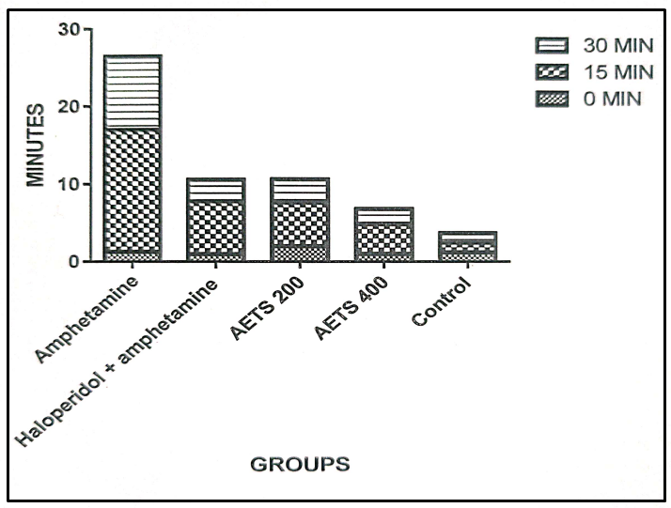

**Fig. 1. Rearing tests in mice (min)**

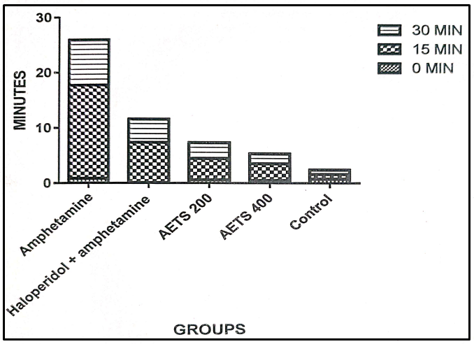

**Fig. 2. Sniffing tests in mice (min)**

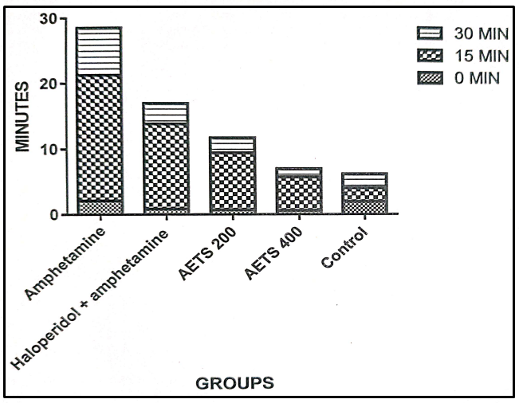

**Fig. 3. Licking test in mice (min)**

**4.4 Effect of Aqueous extract of *Tecoma stans* on pentobarbitone induced sleeping time**

In the control group, where no drug was administered, neither onset nor duration of sleep was observed. The standard group (pentobarbitone only) exhibited a sleep onset of 25 ± 1.721 minutes and a sleep duration of 35 ± 1.628 minutes. Co-administration of AETS at 200 mg/kg with pentobarbitone significantly reduced the onset of sleep to 19 ± 3.373 minutes (p < 0.05) and increased sleep duration to 50 ± 1.358 minutes (p < 0.01) compared to the standard group. AETS at 400 mg/kg further enhanced this effect, producing a significantly shorter onset time of 13 ± 1.628 minutes (p < 0.01) and a markedly prolonged sleep duration of 69 ± 4.380 minutes (p < 0.001). These findings indicate a dose-dependent enhancement of pentobarbitone-induced sedation by Tecoma stans, suggesting its potent CNS depressant activity.

**Table 3. Tecoma stan aqueous extract's impact on pentobarbitone-induced sleep duration.**

|  |  |  |  |
| --- | --- | --- | --- |
| **SL No.** | **Groups** | **Onset of Action Min** | **Duration of Action Min** |
| 1 | Control | 0 | 0 |
| 2 | Standard | 25±1.721 | 35±1.628 |
| 3 | AETS 200 + Pentobarbitone | 19±3.373* | 50±1.358** |
| 4 | AETS 400 + Pentobarbitone | 13±1.628** | 69±4.380*** |

*Mean ± SEM, (n = 5). * p < 0.05, ** p < 0.01, *** p < 0.001 compared to standard (pentobarbitone-only) group.*

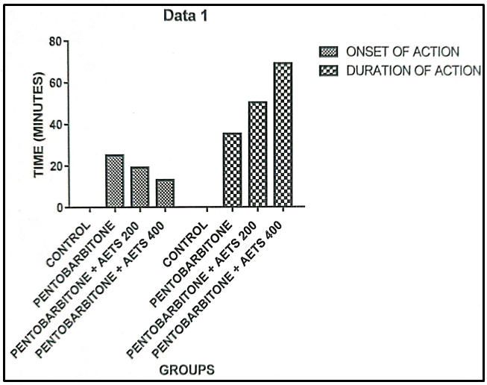

**Fig. 4. Pentobarbitone induce sleeping time (min)**

**DISCUSSION**

The present study explored the neuropharmacological properties of the aqueous extract of *Tecoma stans* (AETS) flowers in Swiss albino mice, focusing particularly on its potential antipsychotic and CNS depressant effects. The extract was evaluated through two key models: the compulsive behavior test induced by amphetamine and the pentobarbitone-induced sleeping time assay.

Amphetamine, a known central stimulant, produced significant increases in stereotypical behaviors such as rearing, sniffing, and licking, particularly evident at the 15-minute interval post-injection. This is consistent with its dopaminergic stimulant profile, which mimics psychotic-like states in animal models [11]. Haloperidol, a typical antipsychotic and dopamine D2 receptor antagonist, significantly attenuated these amphetamine-induced behaviors, validating the test system [12].

Interestingly, the AETS at both 200 mg/kg and 400 mg/kg doses demonstrated a dose-dependent attenuation of these compulsive behaviors. At the higher dose (400 mg/kg), a statistically significant reduction in rearing (2.00 ± 0.10), sniffing (1.78 ± 0.65), and licking (1.23 ± 0.10) was observed at the 30-minute mark (*p*<0.01 to *p*<0.001). These findings suggest that the extract has potent inhibitory effects on stimulant-induced hyperactivity, comparable to haloperidol.

The CNS-depressant effect may be attributed to the presence of bioactive constituents such as flavonoids and saponins identified in the phytochemical screening [13]. These phytoconstituents are known to interact with central dopaminergic and serotonergic pathways and may account for the neuroleptic-like activity observed [14].

Our findings from the pentobarbitone-induced sleeping time test further supports the CNS-depressant action of *Tecoma stans* extract. The extract significantly prolonged the duration of pentobarbitone-induced sleep (from 35 ± 1.62 to 69 ± 4.38 minutes at 400 mg/kg, *p*<0.001) and also decreased the latency to sleep onset (from 25 ± 1.72 to 13 ± 1.62 minutes). These results indicate a potential sedative-hypnotic property of the extract.

The increase in sleeping time and reduction in sleep onset latency are suggestive of CNS depressant activity, possibly mediated by GABAergic facilitation or modulation of related inhibitory neurotransmitters [15]. Such activity may have clinical relevance in treating anxiety or insomnia, offering a herbal alternative with fewer side effects compared to synthetic agents like benzodiazepines [16].

The acute toxicity testing showed that AETS was safe up to 2000 mg/kg orally, with no observed lethal effects. This supports its potential therapeutic use and aligns with the traditional applications of *Tecoma stans* in herbal medicine [17].

This study provides scientific validation for the traditional use of *Tecoma stans* in managing mental health conditions. The observed neuropharmacological activities can be attributed to the presence of active phytochemicals such as flavonoids and saponins. Previous literature reports that these compounds possess neuroprotective, anxiolytic, and antipsychotic effects [18].

Given the increasing interest in plant-based neurotherapeutics, *Tecoma stans* emerges as a promising candidate for further development, particularly in neuropsychiatric disorders where side effects and dependency potential often limit synthetic drugs.

**CONCLUSION**

The aqueous extract of *Tecoma stans* flowers exhibits significant neuropharmacological activity, demonstrating both antipsychotic and CNS depressant effects in validated animal models. These findings support the traditional use of the plant in neuropsychiatric conditions and warrant further investigation into its active constituents, mechanisms of action, and potential clinical application.

According to the current study, additional research is necessary to determine the precise mechanism of action underlying the neuropharmacological effects of *Tecoma stans* flowers, as well as to isolate and characterize the active chemicals causing these effects.

**DISCLAIMER (ARTIFICIAL INTELLIGENCE)**

Author(s) hereby declare that NO generative AI technologies such as Large Language Models (ChatGPT, COPILOT, etc) and text-to-image generators have been used during the writing or editing of manuscripts.

**ETHICAL APPROVAL**

The Institution Animal Ethics Committee (IAEC) has approved the research protocol with the number ARACOP/IAEC0/24/16 following the CPCSEA's current regulations during its session.

**COMPETING INTERESTS DISCLAIMER:**

Authors have declared that they have no known competing financial interests OR non-financial interests, OR personal relationships that could have appeared to influence the work reported in this paper.

**REFERENCES**

1. Everitt, B. J., & Robbins, T. W. (2005). Neural systems of reinforcement for drug addiction: from actions to habits to compulsion. *Nature neuroscience*, *8*(11), 1481-1489.
2. File, S. E. (1987). The contribution of behavioural studies to the neuropharmacology of anxiety. *Neuropharmacology*, *26*(7), 877-886.
3. Ghaemi, S. N. (2022). Symptomatic versus disease‐modifying effects of psychiatric drugs. *Acta Psychiatrica Scandinavica*, *146*(3), 251-257.
4. Karunamoorthi, K., Jegajeevanram, K., Vijayalakshmi, J., & Mengistie, E. (2013). Traditional medicinal plants: a source of phytotherapeutic modality in resource-constrained health care settings. *Journal of Evidence-Based Complementary & Alternative Medicine*, *18*(1), 67-74.
5. Stéphane, F. F. Y., Jules, B. K. J., Batiha, G. E. S., Ali, I., & Bruno, L. N. (2022). Compounds from Medicinal Plants. *Natural medicinal plants*, 147.
6. Wichayapreechar, P., Prasansuklab, A., Charoongchit, P., & Charoenjittichai, R. (2024). The potential of Tecoma stans (Linn.) flower extract as a natural antioxidant and anti-aging agent for skin care products. *Cosmetics*, *11*(6), 214.
7. No, O. T. (2002). 420: Acute oral toxicity-fixed dose procedure. *OECD guidelines for the testing of chemicals, Section*, *4*, 1-14.
8. Rameshwar, G. S., Venkatrao, P. U., Vithalrao, N. A., & Pramodrao, A. M. (2023). OECD Guidelines for Acute Oral Toxicity Studies: An Overview. *Int. J. Res. Ayurveda Pharm*, *14*, 137-140.
9. **Kamble, R. A., Oswal, R. J., Antre, R. V., Adkar, P. P., Bayas, J. P., & Bagul, Y.** (2011). Antipsychotic activity of Catunargaom spinosa (Thumb.). Research Journal of Pharmaceutical, Biological and Chemical Sciences, **2**(1), 664–668.
10. Perez G, R. M., Perez L, J. A., Garcia D, L. M., & Sossa M, H. (1998). Neuropharmacological activity of Solanum nigrum fruit. *Journal of ethnopharmacology*, *62*(1), 43-48.
11. Willner, P. (1997). Validity, reliability and utility of the chronic mild stress model of depression: a 10-year review and evaluation. *Psychopharmacology*, *134*, 319-329.
12. Seeman, P. (2002). Atypical antipsychotics: mechanism of action. *The Canadian Journal of Psychiatry*, *47*(1), 27-38.
13. Middleton Jr, E., Kandaswami, C., & Theoharides, T. C. (2000). The effects of plant flavonoids on mammalian cells: implications for inflammation, heart disease, and cancer. *Pharmacological reviews*, *52*(4), 673-751.
14. Sugavanam, K., Velayutham, S., & Ganesan, A. (2012). CNS depressent activity of different extracts of Tecoma stans flowers. *Asian Journal of Traditional Medicine*, *7*(1), 39-43.
15. Johnston, G. A. (2005). GABAA receptor channel pharmacology. *Current pharmaceutical design*, *11*(15), 1867-1885.
16. Bhattacharya, S. K., Bhattacharya, A., Sairam, K., & Ghosal, S. (2000). Anxiolytic-antidepressant activity of Withania somnifera glycowithanolides: an experimental study. *Phytomedicine*, *7*(6), 463-469.
17. Kirtikar, K. R., & Basu, B. D. (2001). Indian medicinal plants (Vol. 3). Dehradun, India: Bishen Singh Mahendra Pal Singh.
18. Spinella, M. (2002). The importance of pharmacological synergy in psychoactive herbal medicines. *Alternative Medicine Review*, *7*(2), 130-137.