**Purification, characterization and quantification of yolk proteins from mature ovaries of mud crabs (*Scylla serrata)***

**Abstract**

The present study was aimed to purify, characterize and quantify vitellin from the mature ovaries of the mud crabs, *Scylla serrata*. Vitellin was purified using saturated ammonium sulfate method followed by dialysis. Analysis on SDS-PAGE revealed two subunits of 105 kDa and 85 kDa. To analyse the peptide profile of vitellin, the bands obtained were digested with trypsin and the tryptic peptides were sequenced by liquid chromatography-mass spectroscopy and MALDI-TOF analysis. The peptides identified from 105 kDa were spread along the entire sequence of vitellogenin corresponding to the full length of the protein. Purified vitellin was used to raise polyclonal antisera with which an enzyme linked immunosorbent assay method was developed. Typical standard curve using ELISA showed a detectable vitellin sensitivity range between 5.0 ng and 1.0 μg (linear regression analysis: R2= 0.991). Quantification of vitellogenin during natural reproductive cycle of mud crabs, revealed a significant increase (*p*< 0.001) in vitellogenin levels as compared to crabs at immature stage. To conclude, we demonstrated the isolation, purification, characterization and quantification of ovarian yolk protein from mud crabs, *S. serrata* which could be used as an aquaculture tool to identify and assess the signalling molecules that promote seed in hatchery industry.

**Key words**: Aquaculture, crab, ELISA, ovaries, *Scylla serrata*, vitellogenin,

**Introduction**

Crustacean aquaculture industry is one of the revenue spinning industries because of its economic value and also protein rich content (Jayasankar et al., 2020). However, due to limited availability of seed the development of hatchery industry including culturing of mud crabs is hampered and not expanded as expected (Ganesh et al., 2024). During the period 2021-22, it was estimated that India contributed 7.56% of world’s fish production (i.e. nearly 1.6187 million tonnes of seafood worth Rs. 57,586.48 crores equivalent to US$ 7,759.58 million) (MCI, 2023; Mohan Raj et al., 2025). Interestingly, crustaceans include 23 % or equivalent to 6,938 tonnes of crab exports of total aquatic animal trade during the year 2021-2022. In order to promote seed in hatchery industry, several researchers are focusing on the identification of signalling molecules that can able to induce ovarian maturation thereby seed (Sainath et al., 2013; Asmat-Ullah et al., 2023). One of the important aspects of ovarian maturation is induction of a process known as vitellogenesis. Therefore, development of suitable technology to promote vitellogenesis thereby ovarian growth is an emerging area of crustacean endocrinology. To accomplish this task, isolation, purification and characterization of vitellogenin associated with its quantification is a promising tool during assessment of signalling molecules that can able to promote ovarian maturation in crustaceans. It is well known that the developing oocyte is nourished via sequestering of vitellogenin protein into the ovaries from the circulation during ovarian development (Jayasankar et al., 2020). This process is known as vitellogenesis (Subramoniam, 2011; Manfrin et al., 2021; Cohen et al., 2023). During vitellogenesis, high-density lipoproteins, including carotenoid pigments and yolk are synthesized and stored in oocytes. Vitellin, a subunit of vitellogenin, provides nourishment to developing oocytes during ovarian maturation in crustaceans (Tsukumura, 2001). Vitellogenin also acts as a carrier protein for carotenoids, retinoids, thyroxine, and riboflavin in fishes and vertebrates (Metzler and Sandell, 2016). On the other hand, accumulation of carotenoids and detection of retinoids accompanied by elevated levels of vitellogenin during ovarian maturation in crustaceans could reflect the transporter role of vitellin to channel carotenoids and retinoids (Wade et al., 2015; Venkaiah et al., 2019). Hence, analysis of vitellogenin levels in crustacean’s ovary is used as a reproductive marker to assess the vitellogenesis process (Vazquez Boucard et al., 2002).

The mud crab, *Scylla serrata* is popularly known as poor man’s protein and is available in tropical and sub-tropical countries of Asia including India. Because of its nutritional value, its consumption in this part of country is increasing day-by-day. Studies also indicated that mud crabs, *S. paramamosian* can spawn more than once suggesting that their ovaries can re-mature and active during the second developmental period of ovaries, which also equally implicates that the vitellogenesis period is active during first and second ovarian development (Yu et al., 2021). Comparatively similar trend was noticed in chinese mitten crab, *Eriocheir sinensis* (Liu et al., 2011) and swimming crab, *Portunus trituberculatus* (Wu et al., 2010). However, due to limited availability of seed during their captivity, most of the aqua-farmers rely on the naturally occurred populations which also eventually may lead to over exploitation of crab population. This is because of the lack of seed to seed technology in hatchery industry. In order to develop a suitable seed to seed technology in mud crabs, *Scylla serrata*, adequate knowledge about the vitellogenesis is instrumental. The aspect of vitellogenesis is broadly categorized into synthetic level, and molecular levels such as gene and protein levels. The synthetic sites and gene level aspects of vitellogenin were previously reported from the mud crabs, *S. serrata*. The synthetic sites like hepatopancreas and ovaries were previously identified from this species (Warrier and Subramoniam, 2002). Many studies demonstrated the structure and expression of vitellogenin gene from decapods including crabs (Chinese mitten crab, *E. sinensis*: Li et al., 2006; horseshoe crab, *Tachypleus tridentatus*: Yang et al., 2024; mud crab, *S. paramamamosian*: Ren et al., 2022; freshwater crab, *Oziotelphusa senex senex*: Girish et al., 2014). However, the third aspect i.e. at the level of vitellogenin protein level including cleavage pattern, post-translational modifications is not well understood (Mak et al., 2005; Ren et al., 2022).

Herein, we report the methodology of isolation, purification, characterization and quantification of vitellogenin using ELISA from the ovaries of mud crabs, *Scylla serrata*. Moreover, we identified peptide finger printing of Scylla vitellogenin to know the cleavage pattern and post-translational sites using MALDI-TOF analysis. This technology might be useful as a tool to identify signalling molecules that can promote seed in hatchery industry.

**Materials and methods**

*Chemicals*

In this study, the HPLC grade chemicals were purchased from Hi-Media (India) and Sigma Chemicals Co. Ltd. (USA). On the other hand, analytical grade chemicals were purchased from SDH fine chemicals (Chennai, India).

*Collection and maintenance of animals*

Uninjured female mud crabs (body weight: 140 to 150 g; carapace width: 11 ± 2 cm), *S. serrata* at intermolt (C4) stage were collected from the Nellore coast, Andhra Pradesh, India and brought to the laboratory. The *S. serrata* species was identified based on the shape (oval) and colour of carapace (almost black) exhibiting transversal ridges. Ovaries from crabs at mature stage III (Venkaiah et al., 2019) were immediately dissected and cleaned from adhesive tissues and weighed to its nearest milligram. They were stored at -80°C until further analysis. All the experiments were performed at the Department of Biotechnology, Vikrama Simhapuri University, Nellore.

*Isolation, purification and characterization of vitellin from the ovary of crabs*

*Isolation and Purification of vitellin*

Isolation and purification of vitellin (VN: subunits of VTG) from the mature ovaries (stage III) of mud crabs was performed in accordance to the previous protocols (Tsukumura et al., 2000; Sainath, 2009). Briefly, 10 g of ovarian tissue was homogenized using ice-cold mortar and pestle (glass-glass) in 100 mL of buffer (pH 7.8) containing NaCl (0.1 M), Tris (0.05 M), EDTA (1 mM) and Tween-20 (0.1 %) with PMSF (10 mg/mL) followed by the centrifugation of the homogenate at 4000×g for 5 min at 4 °C and the resultant supernatant was carefully transferred to another tube and centrifuged at 20,000 ×g (relative centrifugal force) for 20 min at 4 °C. The supernatant was used for further purification by using saturated ammonium sulphate (SAS) to produce 25, 40, 50 and 60 % SAS solution sequentially. In between, the sequential steps from 25 % SAS to 60 % SAS, an incubation step for 1 h at 4 °C followed by centrifugation step at 20,000×g for 10 min at 4 °C was performed. After centrifugation step, the pellet of 60 % SAS solution was suspended in the homogenization buffer and the suspension was subjected to dialysis (thrice; 4 °C for 12 h). The purified ovarian vitellin was stored at 200C until further use.

*Characterization of VN using mass spectroscopy (MALDI-TOF)*

The purified VN was resolved on denatured sodium-dodecyl polyacrylamide gel electrophoresis (Sainath, 2009) to determine the molecular weights of purified vitellin and characterized by mass spectroscopy (MALDI TOF/TOF Ultraflex III, BRUKERS DALTONICS). Individual gel bands were cut into small fragments and placed into individual 1.5 ml eppendorf tubes. A mixture of acetonitrile and 100 mM of ammonium acetate (50:50) in a 50 μL was added to the tube to just cover the gel fragments and the tubes were shaken for 15 min at room temperature. The liquid was removed and discarded accordingly. This was followed by the addition of 50 μL of 10 mM DTT in 100 mM ammonium acetate to the tube and incubated at 55 ºC for 1 hr. This step was followed by the addition of 50 μL of 50 mM iodoacetamide in 100 mM ammonium acetate and the tube was completely wrapped in aluminium foil and the tubes were shaken at room temperature in the dark for about 1 hr. The gel pieces were washed twice using 50:50 acetonirilie and100 mM ammonium acetate, and dried using lyophilizer or speed vac unit. This step was followed by the rehydration of completely dried gel pieces for 10 minutes with 50 mM ammonium acetate solution containing 0.6 µg of trypsin (sequencing grade: Promega) in 6 µL of 0.01% SDS and incubated for overnight at 37°C on an incubator shaker (Thermo) at 400 rpm. After digestion, the supernatant was transferred to a new tube (1.5 mL) and was suspended in 50 µL of 50:50 acetonitrile: 0.1% triflouroacetic acid (TFA) solution and shaken for 20 minutes. The peptides obtained were mixed with 2 µL of MALDI matrix solution comprising of saturated amount of α-Cyano-4-hydroxycinnamic acid in 1 mL of 1:2 ratio of acetonitrile: 0.1% TFA. After thorough mixing and centrifugation steps, a 1 µL of aliquot of peptide sample was spotted onto the MALDI Anchor plate and allowed to dry. For calibration of peaks a pepmix mixture containing known peptide masses ranging from 1000 to 5000 Da was also spotted on to the MALDI Anchor Plate. The target plate was loaded into the MALDI TOF/TOF Ultraflex III (BRUKERS) mass spectrometer consisting of a laser beam to obtain the Peptide Mass Fingerprint of the proteins. The signal was maximized by adjusting the laser beam around the sample spot. The Flex Control software was used to obtain the spectra with a mass range of 500 to 5000 m/z. The spectra were calibrated using the Pepmix spectra obtained on the software Flex Analysis which includes the baseline correction and smoothening of the peaks. The corrected spectra were then exported on to the Bruker Biotools to perform the search on MASCOT against the database required (Parameters used for MASCOT search: 1. Fixed modification: Carbamidomethyl @ Cysteine; 2. Variable modification: Oxidation @ Methionine; 3. Enzyme: Trypsin; 4. Missed Cleavage: 1).

*Quantification of vitellogenin*

After characterization, the purified vitellin was used to raise antibodies in rabbits (Sainath, 2009) and was used for quantification studies. Enzyme linked immunosorbent assay (ELISA) technique was used to estimate the levels of ovarian vitellogenin from crabs during natural and induced conditions. The protocol used in this study was in accordance to Girish et al. (2015) with minor modifications. Briefly, 20 µL of dialyzed sample diluted in carbonate buffer (1: 10 ratio) was added to wells and parallel blank samples with carbonate buffer (NaCO3: 15 mM and NaHCO3: 35 mM; pH: 9.6) alone were maintained. The plates were incubated overnight followed a four washing steps with 0.1 M phosphate buffered saline (PBS) containing Tween 20 (0.05%) (pH: 7.2). The primary antibody (raised against the purified vitellin from mature ovaries of crabs, VSIII) was diluted (1: 1000) in PBST buffer containing polyvinylpyrrolidine and ovalbumin (PBST-PO) was added to each well followed by an incubation of plates at humid environment for 2 h. The plates were washed four times with PBST and 200 µL of horseradish peroxidase-conjugated secondary antibody (goat anti-rabbit IgG-HRP) diluted in PBST-PO (1: 1000) was added to each well. The plates were incubated at 37 °C for 1 h followed by three washing steps with PBST. 200 μL tetramethyl benzidene substrate was added to each well and kept in dark for 1 h at 37 °C for colour development. The reaction was stopped by adding 1N HCl to each well and the absorbance was measured with ELISA reader at 450 nm. The sensitivity of ELISA was analysed through inter-assay [different concentrations of standard was added to ten different microtitre plates] and intra-assay [same concentration of standard was added ten times to a single microtitre plate)] variation experiments. A standard graph was analyzed with KyPlot (Version 6.0.2) by plotting the concentration of VTG on X axis and absorbance values (obtained at 450 nm) on Y-axis. KyPlot is a statistical tool that best fits the standards by determining polynomial equation. The sensitivity of Prior performing VTG-ELISA, several conditions such as dilution of antibodies, incubation time and range of standard curves were optimized. All standards and sample measurements were performed in triplicate.

Statistical analysis

In this study, the quantification of vitellogenin using ELISA was performed from the ovaries of crabs during different developmental stages and the values were represented as mean ± S.D. of 10 individual crabs per group. The statistical analysis was performed using ANOVA followed by post-hoc test, Tukey test [SPSS (version 16.0) Inc, Chertsey, UK]. The differences in the values between the groups were considered significant at p<0.05.

**Results**

*Isolation and purification of vitellin*

In this study, we employed saturated ammonium sulphate method (salting out process) at different concentrations (25 %, 40 %, 50 % and 60 %) followed by dialysis for isolation and purification of vitellin from the mature ovaries of crabs. This method of isolation and purification eventually resulted in 1 mL of solution comprising of vitellin.

*Characterization of ovarian vitellogenin*

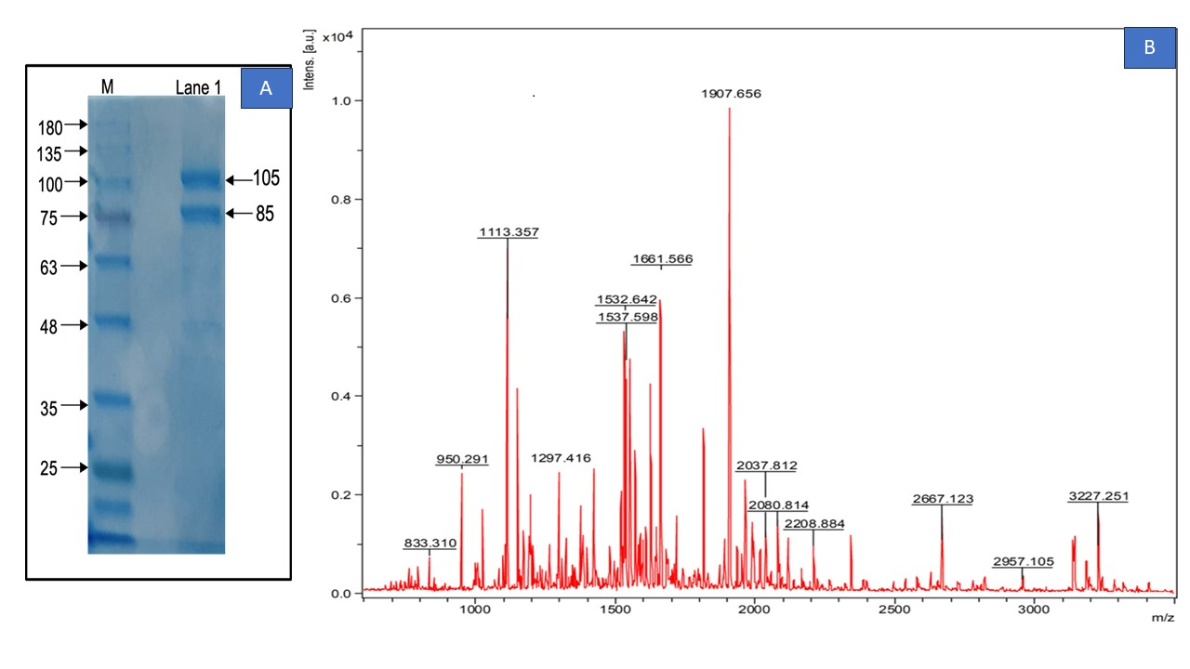The purified ovarian vitellin was separated into two polypeptides on SDS-PAGE gel, having molecular masses of 105 kDa and 85 kDa (**Figs. 1**).

**Figure 1: A. The SDS-PAGE analysis of purified ovarian vitellogenin from the mud crab *Scylla serrata*. Gel was stained with Coomassie Brilliant Blue R250. Lane M: molecular weight markers; Lane 1: purified ovarian vitellogenin. B. Mass spectroscopic analysis of vitellin peptide fragments from mature ovaries of mud crab *Scylla serrata***

Mass spectroscopic analysis was performed using trypsin digestion and Matrix Assisted Laser Disorption/Ionization-Time of Flight (MALDI-TOF) to test the amino acid sequence correspondence to the purified bands 105 kDa. The peptides identified from 105 kDa were spread along the entire sequence of vitellogenin corresponding to the full length of the protein. Mascot peptide mass fingerprint database was used to obtain the corresponded amino acids of the vitellin bands based on the scores using the equation, -10*log10(P), (P = absolute probability). The results revealed that the vitellin bands of *S. serrata* showed three matches corresponding to the peptides of *S. paramamosian* with scores 65 (mass value: 266650; e value: 5.2 e-005; match peptides: 31), 60 (mass value: 266719; e value: 0.00016; match peptides: 30) and 55 (mass value: 289157: e value: 0.00052; match peptides: 30), respectively. For further comparison studies, the mass finger printing peptide score of 65 with an e value 5.2 e-005 was selected. The corresponding All the mass spectroscopic data was shown in supplementary material. Mass spectroscopic data revealed that disulfide bonds, vitellogenin domain, domain of von Willebrand factor (VWFD) with GLLG motif, one consensus cleavage site (RERR), phosphorylation sites and N-glycosylation sites in the deduced amino acid sequence of ovarian vitellogenin of green mud crab (Jia et al., 2013). From the mass spectroscopic results, peptides related to vitellogenin domain, VWFD, phopshorylated amino acids and N-glycosylated amino acids were found in the 105 kDa of purified ovarian vitellin of *S. serrata*. peptides of vitellin (105 kDa) of *S. serrata* against the *S. 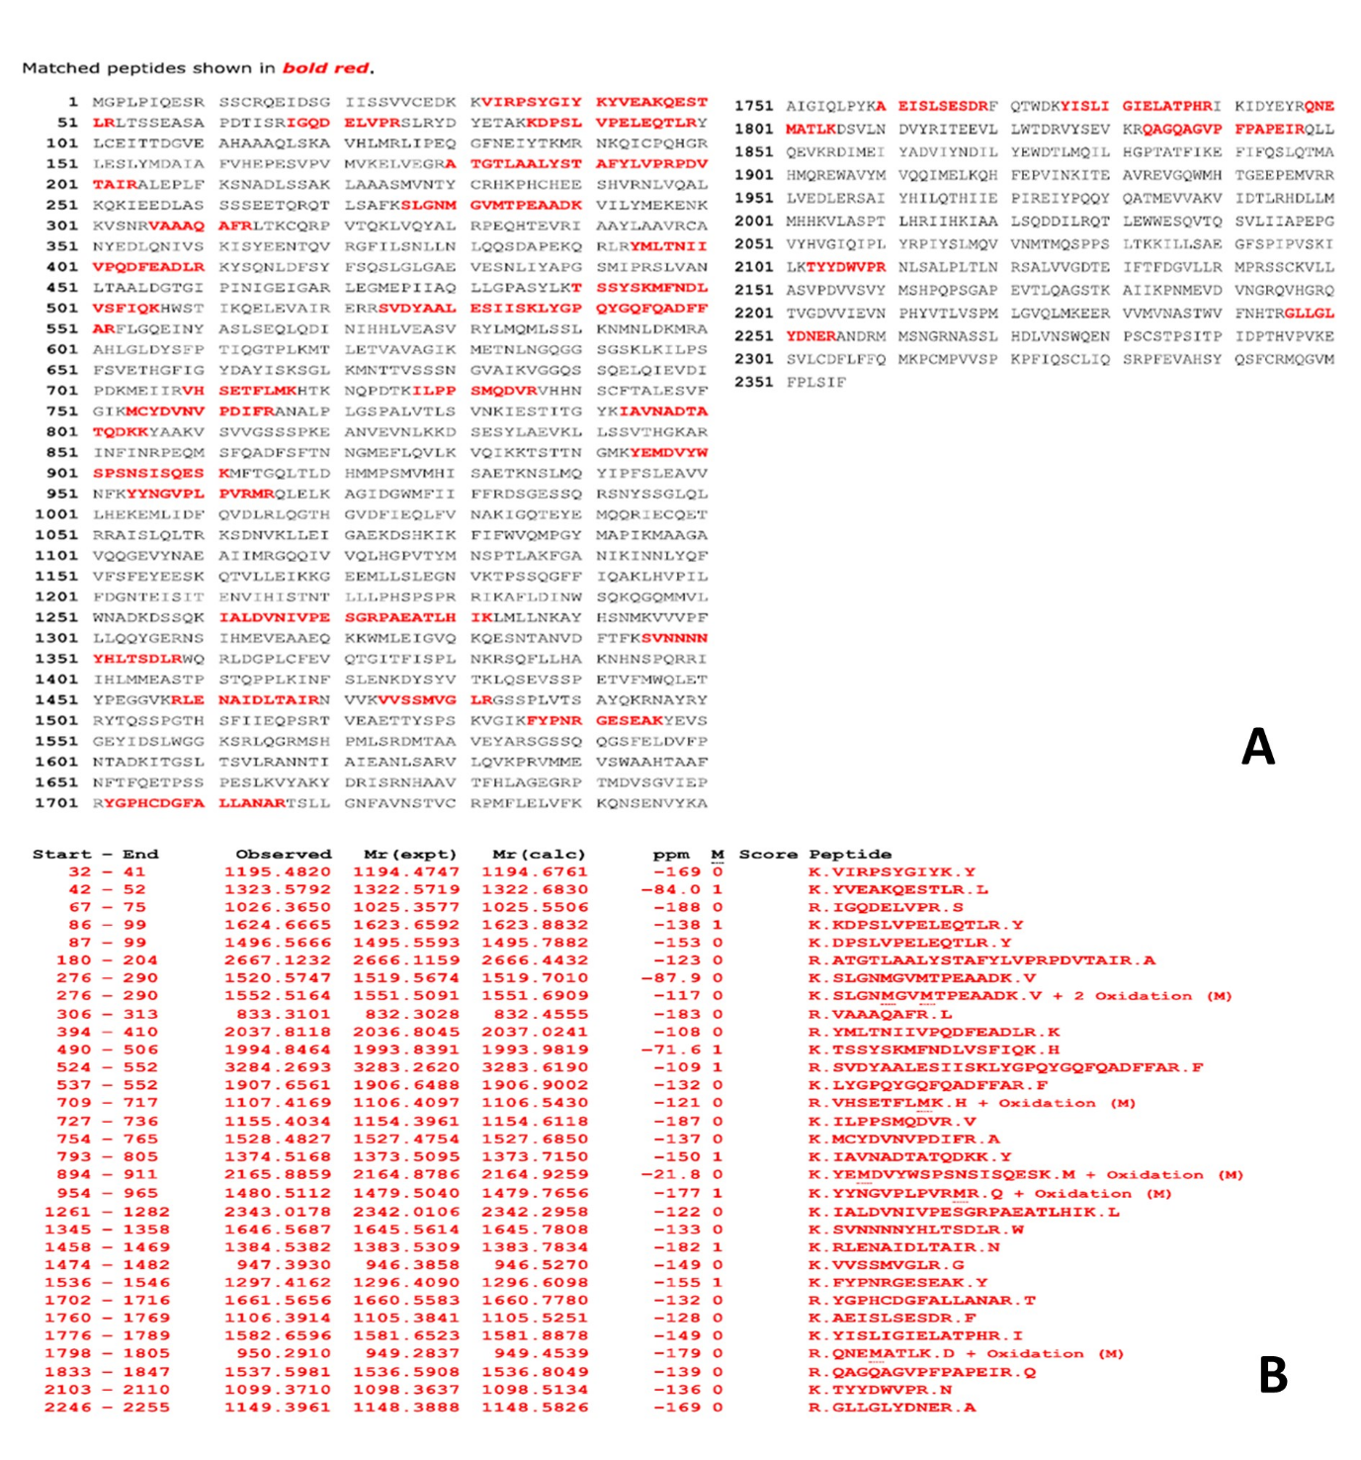paramamosian* (31 matches) were shown in the **Figs. 2**.

**Figure 2: A. Peaks represent vitellin peptide fragments from mature ovary of crabs, *Scylla serrata* using mass spectroscopy (MALDI-TOF) analysis. The identified peptides are listed according to their amino acids position, sequence, and mass. B. Identified peptides were shown in red colour (bold) against the vitellogenin amino acid sequence of *Scylla paramosian* (uniport reference No.: A0A0G2ST52)**

**Figure 3** shows a typical standard curve was observed between 5.0 ng and 1.0 μg of purified VTG (linear regression analysis: R2= 0.991). The intra-assay variation ranged from 4 to 6% (n=10), and the inter-assay variation ranged from 9 to 10.6% (n=10). The sensitivity of VTG-ELISA was found to be as lowest as 5 ng. As expected, there was a significant elevation in ovarian VTG level as the crab progress from immature stage to mature stage (VSI: 171%; VSII: 307%; VSIII: 500%). As expected, there was a significant elevation in ovarian VTG level as the crab progress from immature stage to mature stage and also in ESX crabs over intact untreated crabs (**Figure 3B**).

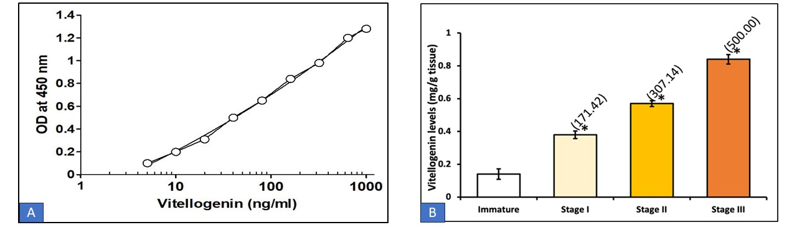

**Figure 3:** A. A typical standard curve of purified *Scylla serrata* vitellogenin. B. Ovarian vitellogenin levels at different reproductive stages in the mud crab, *Scylla serrata* during the natural reproductive cycle. Stages-I, II and III represent vitellogenic stages I, II and III of ovary, respectively. *Significant at *p* < 0.01

**Discussion**

It is well established that the proper development of oocyte is considered important and reflects normal fertility of females, these events lead to continuation of animal populations (Nagahama et al., 2021; Zhang et al., 2025). For proper maturation of oocyte and maintenance of ovary, vitellogenin, an egg yolk protein is one of the key proteins, this is because during vitellogenesis, vitellogenin provides nourishment to the developing oocyte and the absorption of vitellogenin into the ovaries occurs via vitellogenin mediated endocytosis (Tsukimura, 2001; Ruan et al., 2020). Many studies focused on the synthetic sites like ovarian and extra-ovarian sites (hepatopancreas), and cloning of vitellogenin and its *mRNA* levels during different developmental stages of ovaries. In a recent study by Feng et al. (2021), a comparative proteomics study was performed to elucidate the differentially abundant proteins (DAPs) related to vitellogenesis and oocyte development wherein they found fifteen DAPs *viz*., vitelline membrane outer layer protein 1 homolog, farnesyl pyrophosphate synthase, heat shock 70 kDA protein cognate 3 in Chinese mitten crab, *Eriocheir sinensis*. In this study, we showed the cleavage pattern of vitellogenin using mass spectroscopic studies to shed light on the peptide fragments of vitellogenin in crab, *S. serrata*. The findings revealed that the characterization of vitellogenin followed by SDS-PAGE analysis showed two predominant vitellin subunits with molecular weights of 105 kDa and 85 kDa from the ovary of *S. serrata*. Several researchers also characterized vitellin from ovaries of crustaceans (Jayasankar et al., 2020). For example, two major polypeptides with molecular masses of 105 kDa and 76 kDa was noticed in the ovary of crab, *C. feriatus* (Mak et al., 2005), while three polypeptides with molecular masses of 73.3, 84.3 and 100.0 kDa were observed in the fresh water edible crab, *O. senex senex* (Sainath, 2009). The differences in the occurrence of number and mass of polypeptides could be attributed to the cleavage pattern of vitellogenin (Girish et al., 2014). It has been shown that the first cleavage of vitellogenin takes place in hepatopancreas at the consensus motif, RXXR by subtilisin-like protein which leads to the release of two polypeptides into the hemolymph where second cleavage takes place followed by the sequestration of polypeptides/subunits of vitellogenin or vitellin into the ovaries (Subramoniam, 2011). The findings of this study, wherein occurrence of two subunits of ovarian vitellins (105 kDa and 85 kDa) and studies of Thongsaikliang (2020), who showed the occurrence of 90 kDa subunit in the hemolymph of mud crab supports this notion. It was shown that the vitellogenin of *C. feriatus* finds the first intersection above the sequence, LYGPQYGQFQADFFAR (up to 13 amino acids), which is likely the first cut point that splits the size of the vitellogenin protein into two fragments (Mak et al., 2005) and the occurrence of this peptide sequence in the hemolymph (Thongsaikliang, 2020) and ovaries (this study) of mud crabs could support this notion. Surprisingly, the molecular mass of hemolymph vitellin subunit as per the studies of Thongsaikliang, (2020) seems to be lower than the ovarian vitellin (observed in this study) with a molecular mass of 105 kDa. One possible answer could be attributed to a) post-translational modifications that occur in the ovary of crab, b) reprocessing of the smaller subunits into larger subunit and/or both (Warrier and Subramoniam, 2002; Mak et al., 2005; Jimenez-Gutierrez et al., 2019). Accordingly, several glycosylation sites in the peptides of vitellin were observed in the ovary of *S. serrata* (Jia et al., 2013). Studies of Yang et al. (2005) demonstrated that the characterization of vitellogenin on SDS PAGE and Western Blot analysis resulted in identification of several small peptides in the ovary of marine crab, *Protunus trituberculatus* and accordingly, the deduced amino acid sequence of vitellogenin showed multiple cleavage sites for subtilisin-like endopeptidase in the deduced crab, vitellogenin. Studies of Warrier and Subramoniam (2003) showed that the purified vitellogenin from *S. serrata* comprised of an intrinsic protease activity because of which there might be autoproteolysis leading to small peptides. In the current study, mass spectroscopy was performed to investigate the conserved peptides and cleavage sites in the ovarian vitellogenin of *S. Serrata*. Six peptides were identified (peptide 1: VIRPSYGIYKYVEAKQESTLR; peptide 2: IGQDELVPR peptide 3: KDPSLVPELEQTLR; peptide 4: ATGTLAALYSTAFYLVPRPDVTAIR; peptide 4: SLGNMGVMTPEAADK and peptide 6: VAAAQAFR) correspondence to vitellogenin domain, one peptide GLLGLYDNER correspondence to VMFD domain, phosphorylation and N-glycosylation sites To the best of current knowledge, this was the first report indicating the mass spectroscopic analysis of ovarian vitellin subunit (105 kDa) of mud crab, *S. serrata*. Interestingly, studies of Thongsaikliang (2020) have shown that mass spectroscopic analysis of hemolymph vitellogenin from the mud crab, *S. serrata* showed a 90 kDa band (characterized on SDS-PAGE: 12.5%) indicated seven peptides: peptide 1: LYGPQYGQFQADFFAR; peptide 2: ELQIEVDIPDKMEIIR; peptide 3: EANVEVNLK; peptide 4: LSSVTHGK; peptide 5: KDSVLNDVYRI; peptide 6: VLASPTLHR; and peptide 7: GLLGLYDNERANDR. In previous studies, it has been shown that different crustacean species have different cleavage sites, because of which different subunits of vitellogenin was obtained in crustaceans. (Jia et al., 2013; Jimenez-Gutierrez et al., 2019).

In this study, we determined the ovarian vitellogenin levels during natural conditions using ELISA. The results were validated in several ways. We observed that the concentrations of purified vitellogenin added into wells of an ELISA plate showed a linear increase in absorbance. The development of ELISA would be helpful to assess the amount of vitellogenin without extraction of vitellogenin from the hemolymph and ovarian samples. We employed the developed ELISA to detect the vitellogenin from ovaries of crabs at stages of development and the results indicated that the elevated levels of ovarian vitellogenin levels were found in crabs at mature stage as compared to immature stage. The developed ELISA is rapid and sensitive enough to measure the circulatory levels of vitellogenin and also from the ovarian tissues of crabs under various experimental conditions (Sukumaran et al., 2017; Duangprom et al., 2022).

**Conclusion**

The results presented in this paper demonstrate that the characterization and quantification of vitellogenin during natural conditions could be used as a valuable tool to identify a variety of signalling molecules that can induce ovarian growth in crabs. Moreover, this assay can be of use to monitor the ecosystem health and in improving aquaculture practices.

**Conference details**

Proceedings Of International Seminar On “Recent Advancements In Biological Sciences 2025”, PRR& VS Government College, SPSR Nellore District, Andhra Pradesh, India, April 3rd & 4th 2025

Acknowledgement

SBS thank the DST-SERB, New Delhi (Ref No. SB/YS/LS-143/2014) for providing financial assistance.

Disclaimer (Artificial intelligence)

Author(s) hereby declare that NO generative AI technologies such as Large Language Models (ChatGPT, COPILOT, etc.) and text-to-image generators have been used during the writing or editing of this manuscript.

**References**

Asmat-Ullah, M., Rozaimi, R., Fazhan, H., Shu-Chien, A. C., Wang, Y., and Waiho, K., (2023). Eyestalk Ablation to Increase Ovarian Maturation in Mud Crabs. J Vis Exp. (193), e65039.

Cohen, S., Hasan, M., Frishman, N., and Khalaila, I., (2023) A crustacean vitellogenin derived peptide as an oocyte-specific delivery vehicle for gene silencing. Front. Mar. Sci. 10:1128524. doi: 10.3389/fmars.2023.1128524

Duangprom, S., Saetan, J., Phanaksri, T., Songkoomkrong, S., Surinlert, P., Tamtin, M., Sobhon, P. and Kornthong, N., (2022). Acceleration of ovarian maturation in the female mud crab with RNA interference of the vitellogenesis-inhibiting hormone (VIH). Frontiers Marine Sci, 9, p.880235.

Feng, Q. M., Liu, M. M., Cheng, Y. X., and Wu, X. G., (2021). Comparative proteomics elucidates the dynamics of ovarian development in the Chinese mitten crab *Eriocheir sinensis*. Comp Biochem Physiol. Part D, Genomics & proteomics, *40*, 100878.

Ganesh, C., Urkude, A. R. and Kharabe, V. V., (2024). Eye Stalk Ablation. Vigyan Varta 5(9): 284290.

Girish, B.P., Swetha, C., and Reddy, P.S., (2014). Hepatopancreas but not ovary is the site of vitellogenin synthesis in female fresh water crab, *Oziothelphusa senex senex*. Biochem Biophys Res Commun. 447:323-327.

Girish, B.P., Swetha, C., and Reddy, P.S., (2015). Expression of RXR, EcR, E75 and VtG mRNA levels in the hepatopancreas and ovary of the freshwater edible crab, *Oziothelphusa senex senex* (Fabricius, 1798) during different vitellogenic stages. Sci Nat 102, 20. <https://doi.org/10.1007/s00114-015-1272-9>.

Jayasankar, V., Tomy, S., and Wilder, M.N., (2020). Insights on molecular mechanisms of ovarian development in decapod Crustacea: focus on vitellogenesis-stimulating factors and pathways. Front Endocrinol. 11,674. <https://doi.org/10.3389/fendo.2020.577925>.

Jia, X., Chen, Y., Zou, Z., Lin, P., Wang, Y., and Zhang, Z., (2013). Characterization and expression profile of Vitellogenin gene from *Scylla paramamosain*. Gene. 520,119-130. <https://doi.org/10.1016/j.gene.2013.02.035>.

Jimenez-Gutierrez, S., Cadena-Caballero, C.E., Barrios-Hernandez, C., Perez-Gonzalez, R., Martinez-Perez, F., and Jimenez-Gutierrez, L.R., (2019). Crustacean vitellogenin: a systematic and experimental analysis of their genes, genomes, mRNAs and proteins; and perspective to Next Generation Sequencing. Crustaceana. 92,1169-1205. doi:[10.1163/15685403-00003930](https://doi.org/10.1163/15685403-00003930).

Li, K., Chen, L., Zhou, Z., Li, E., Zhao, X., and Guo, H. (2006). The site of vitellogenin synthesis in Chinese mitten-handed crab Eriocheir sinensis. *Comparative biochemistry and physiology. Part B, Biochemistry & molecular biology*, *143*(4), 453–458.

Liu, Z., Wu, X., Cheng, Y., Zeng, C., and Yang, X. (2011). Ovarian re-maturation following the first spawning in the Chinese mitten crab, Eriocheir sinensis (H. Milne-Edwards). Aquac. Res. 42 (3), 417–426.

Mak, A.S.C., Choi, C.L., Tiu, S.H.K., Hui, J.H.L, He, J.G., Tobe, S.S., et al., (2005). Vitellogenesis in the red crab *Charybdis feriatus* Hepatopancreas-specific expression and farnesoic acid stimulation of vitellogenin gene expression*.* Comparative Study. 70(3):288-300.

Manfrin, C., Tom, M., Avian, M., Battistella, S., Pallavicini, A., and Giulianini, P. G., (2021). Characterization and Gene Expression of Vitellogenesis-Related Transcripts in the Hepatopancreas and Ovary of the Red Swamp Crayfish, *Procambarus clarkii* (Girard, 1852), during Reproductive Cycle. Diversity. 13(9), 445. <https://doi.org/10.3390/d13090445>

MIC, Ministry of Commerce and Industry, PIB Delhi. (2023). <https://pib.gov.in/PressReleaseIframePage.aspx>? PRID=1932317.

Nagahama, Y., Chakraborty, T., Paul-Prasanth, B., Ohta, K. and Nakamura, M., (2021). Sex determination, gonadal sex differentiation, and plasticity in vertebrate species. Physiol. Rev. 101, 1237–1308.

Raj, V. Mohan., Sangeetha, R., and George, S., (2025). “A Comprehensive Overview on the Biology and Culture Practices of Mud Crab (*Scylla* Sp.) in India”. Asian Journal of Fisheriesand Aquatic Research. 27 (1):103-8.

Ren, Y., Wang, W., Liu, Z., Luo, M., Fu, Y., Zhang, F., Ma, C., Zhao, M., Chen, W., Jiang, K., and Ma, L. (2022). Insight of vitellogenesis patterns: A comparative analysis of the differences between the primary and secondary vitellogenesis period in the ovary, hepatopancreas, and muscle of mud crab, *scylla paramamosain*. *Frontiers in genetics*, 13, 965070.

Ruan, Y., Wong, N. K., Zhang, X., Zhu, C., Wu, X., Ren, C., Luo, P., Jiang, X., Ji, J., Wu, X., Hu, C., and Chen, T., (2020). Vitellogenin Receptor (VgR) Mediates Oocyte Maturation and Ovarian Development in the Pacific White Shrimp (Litopenaeus vannamei). Frontiers Physiol. 11, 485.

Sainath, S.B., (2009). Elucidation of effect of dopamine, serotonin and melatonin in the regulation of growth, reproduction and metabolism in the crab, *Oziotelphusa senex senex*. S.V. University, Tirupati, AP, India

Subramoniam, T., (2011). Mechanisms and control of vitellogenesis in crustaceans. Fish Sci. 77(1),1-21. <https://doi.org/10.1007/s12562-010-0301-z>.

Sukumaran V., Jose, S., Chekidhenkuzhiyil, J., Lalithabai, M.D., Nair, S.B., Christo, D., Kizhakedath, V.K., Paran, B.C., Philip, R., Sarojini, B.I., (2017). ELISA detection of vitellogenin in the haemolymph of Penaeus monodon (Fabricius, 1798) (Caridea: Penaeidae): indirect indicator of female maturity, J Crustacean Biol. 37(4): 473–480.

Thongsaikliang, T., (2020). Identification of vitellogenin proteins in marine crab blood (*Scylla serrata* Forsskal, 1775) by LC-MS/MS technique in the Book Full story Kasetsart University Academic Conference No. 58: Science, Engineering and Architecture, Agro-Industry, Natural Resources and Environment (ISBN:978-616-278-562-7)

Tsukumura, B., (2001). Crustacean vitellogenesis: its role in oocyte development. Integrat. Comparat. Biol. 41,465–476. <https://doi.org/10.1093/icb/41.3.465>.

Tsukumura, B., Bender, J.S., and Linder, C.J., (2000). Development of an anti-vitellin ELISA for the assessment of reproduction in the ridgeback shrimp, *Sicyonia ingentis*. Comp Biochem Physiol. 127,215-224. <https://doi.org/10.1016/S1095-6433(00)00255-5>.

Vazquez Boucard, C.G., Levy, P., Ceccaldi, H.J., and Brogren, C.H., (2002). Developmental changes in concentrations of vitellin, vitellogenin, and lipids in hemolymph, hepatopancreas, and ovaries from different ovarian stages of Indian white prawn *Fenneropenaeus indicus.* J Exp Mar Biol Ecol. 281,63-75. <https://doi.org/10.1016/S0022-0981(02)00409-4>.

Venkaiah, K., Daveedu, T., and Sainath, S.B., (2019). Detection and mode of action of retinoids on ovarian development in the mud crab, *Scylla serrata*. Int J Aquat Biol. 7, 245-253. <https://doi.org/10.22034/ijab.v7i5.687>.

Wade, N.M,, Gabaudan, J., and Glencross, B.D., (2015). A review of carotenoid utilisation and function in crustacean aquaculture. Rev Aquac. 0,1-16. <https://doi.org/10.1111/raq.12109>.

Warrier, S., and Subramoniam, T., (2002). Receptor mediated yolk protein uptake in the crab Scylla serrata: crustacean vitellogenin receptor recognizes related mammalian serum lipoproteins. Mol Reprod Dev. 61,536-548. doi: 10.1002/mrd.10106.

Warrier, S.R., and Subramoniam, T., (2003). Instability of crab vitellogenin and its immunological relatedness with mammalian atherogenic lipoproteins. Mol Reprod Dev. 64, 329-340.

Wu, X., Cheng, Y., Zeng, C., Wang, C., and Cui, Z. (2010). Reproductive performance and offspring quality of the first and the second brood of female swimming crab, Portunus trituberculatus. Aquaculture 303 (1-4), 94–100.

Yang, F., Xu, H. T., Dai, Z. M., and Yang, W. J. (2005). Molecular characterization and expression analysis of vitellogenin in the marine crab Portunus trituberculatus. Comparative biochemistry and physiology. Part B, Biochemistry & molecular biology, 142(4), 456–464.

Yang, X., Tan, K., Su, B., Lim, L. S., Waiho, K., Kwan, K. Y., and Tan, K. (2024). Cloning and functionally characterization of TtVtg2-like in horseshoe crab Tachypleus tridentatus: A special focus on ovarian development. Int J Biol Macromolecules, *278*(Pt 1), 134667.

Yu, G., Wang, Y., and Jin, Z. (2021). Comparative analysis of nutrient composition of the ovaries and hepatopancreas in the mud crab *Scylla paramamosain* at two stages of ovary maturation. Mar. Sci. 45 (09), 12–20.

Zhang, L., Wu, K., Li, H. *et al.* (2025) Vitellogenin receptor mediates heat adaptability of oocyte development in mud crabs and zebrafish. Nat Commun**.**16, 3722 (2025). https://doi.org/10.1038/s41467-025-59035-3