Studies on Growth and Morphometrics in Bombyx mori (L.) Fed on Morus alba: Insights for Enhanced Sericulture
ABSTRACT

The present study investigates the morphometric and biological parameters of the silkworm, Bombyx mori (L.), reared on Morus alba under controlled laboratory conditions at the College of Agriculture, KSNUAHS, Shivamogga. Observations from 25 individuals per stage revealed progressive increases in body dimensions across developmental stages, with fifth instar larvae showing the maximum length (59.35 mm) and breadth (7.09 mm). Cocoon and pupal measurements averaged 3.19 × 1.82 cm and 1.91 × 0.79 cm, respectively. Adult females were consistently larger than males in wingspan, body length and breadth. The egg incubation period averaged 9.00 ± 1.41 days with a high hatching percentage (93.30%). The complete life cycle ranged between 54 to 56 days depending on sex. Female fecundity averaged 334.55 eggs. Environmental parameters such as temperature (29.7°C) and humidity (60.1%) were closely monitored. The results aligned with previous studies and reinforce the influence of host plant quality and environmental control on silkworm growth, reproduction, and silk yield.

Keywords: [Silkworms, Preoviposition period, sex ratio, Longevity, Mulberry and Morphometry]

1. INTRODUCTION
The silkworm, Bombyx mori (L), is a lepidopteran insect of paramount importance to the global silk industry. Domesticated over 5,000 years ago, this species has undergone extensive artificial selection, transforming it into a fully domesticated organism that can no longer survive in the wild without human assistance (Goldsmith et al., 2005). Originally native to China, Bombyx mori is now raised in many parts of Asia and around the world for its silk. It has become an important part of the culture and economy in countries like India and China. The life cycle of B. mori consists of 4 stages: egg, larva, pupa and adult. Among these, the larval stage holds the most economic significance. After hatching from eggs, the larvae pass through 5 instars, 4 moults during their development (Chand Asaf & Mahavishnu, 2018). The 5th instar is particularly crucial, as it is during this stage larvae begin to spin their cocoons. These cocoons are composed of a continuous silk filament, typically measuring between 900 and 1,500 meters in length (Mondal et al., 2007). Uniquely, B. mori is a monophagous, means it feeds exclusively on the leaves of the mulberry tree (Morus alba). This dietary restriction contrasts with many other lepidopteran species that are polyphagous and consume a variety of plant materials (Anonymous, 2003). This dependency on mulberry leaves not only affects the geographical distribution of silkworm farming (sericulture) but also ties the quality of silk to the nutritional content of the mulberry. Adult female moths lay around 300 to 500 eggs after mating. Initially creamy white, fertile eggs soon darken to black, indicating viability. Upon hatching, the larvae are small, black and covered in fine hairs also called Ants, Kengo or Chawki. These larvae grow rapidly and each subsequent moult allows for increased size and silk gland development (S.K Gupta et al., 2024). The final larval stage culminates in cocoon formation, wherein the larva encases itself in silk and transitions into the pupal stage. India and China account for over 60% of the world’s silk production. India, in particular, has witnessed significant growth in sericulture, especially during the 1980s and 1990s. This progress can be attributed to the coordinated efforts of the Central Silk Board (CSB), various research institutions and universities, which have focused on the development and dissemination of new technologies and improved silkworm breeds (Dandin et al., 2003). These interventions have expanded sericulture to a wide range of Agro-climatic zones, allowing for year-round silk production in many regions. Successful sericulture depends on a several complex factors of genetic, environmental and managerial factors. Quality silkworm layings is evaluated based on fertility, egg viability, hatching uniformity and the rearing performance of the progeny (Miyashita Y., 1986). Environmental conditions such as temperature, humidity and nutrition play a critical role in larval development and adult fecundity. Improved rearing conditions during the larval period have been linked to enhanced reproductive output, cocoon quality and overall silk yield (Nazim et al., 2020). Beyond its industrial applications, B. mori has gained recognition as a valuable model organism in life science research. Its relatively short life cycle, ease of maintenance and well-characterized genetics make it ideal for laboratory studies. Importantly, the complete genome of B. mori has been sequenced, opening new avenues in molecular biology, genetics and biotechnology (Xia et al., 2009). Silk is famous around the world for its beauty, strength, and smooth texture. Known as the “Queen of Textiles,” silk has special qualities like a natural shine, strong fibres, light weight, and the ability to absorb dyes well. Indian silk is especially popular for its detailed designs, bright colours, and unique weaving styles from different regions (Dandin et al., 2003). Silk weaving and textile art are a big part of India’s culture and provide jobs for millions of artisans and small businesses (Sivanesh et al., 2024).
2. material and methods

An experimental study on the biology of B. mori (Linnaeus) was conducted from Mar 2025 to May 2025 at the Postgraduate Laboratory of the Department of Entomology, College of Agriculture, Navule, KSNUAHS, Shivamogga, Karnataka, India. Disease-free layings (DFLs) of B. mori were sourced from the Government Silk Model Grainage, Hassan, Karnataka, and maintained under controlled laboratory conditions. The rearing of silkworms was carried out in accordance with the standardized silkworm rearing protocols. Initially, the DFLs were kept at ambient room temperature to facilitate natural incubation and hatching. Upon hatching, the neonate larvae were offered freshly harvested, succulent mulberry leaves (Variety: S36). Specifically, the top two fully developed leaves below the apical growing bud were selected, finely chopped into small segments ranging from 0.4 to 1.2 cm² and evenly sprinkled over the newly hatched larvae. The larvae readily responded to the cut edges of the leaves and initiated feeding behavior. After an acclimatization period of 30 to 40 mins, the larvae along with the leaf bits were gently transferred to rearing trays using a soft bird feather to avoid injury. The larvae were then evenly spread over the rearing bed using chopsticks to ensure optimal spacing and feeding conditions. This process marked the beginning of mass rearing during the first instar stage. Subsequent rearing stages were managed in synchronous to larval development, with particular attention to feeding quantity, bed space and hygiene maintenance. The quantity of food provided remained consistent per feeding and the mulberry leaves were chopped to appropriate sizes depending on the larval instar. Four feedings were administered daily at fixed intervals: 7:30 AM, 11:00 AM, 4:00 PM and 7:00 PM. During moulting, larvae were not disturbed and no food was provided, allowing them to undergo successful ecdysis.
As the larvae matured, the quantity of food was progressively increased in accordance with their growth and development. Mature larvae were identified based on their translucent, creamy-white appearance and cessation of feeding. These larvae were carefully handpicked and placed on rotary mountages to facilitate cocoon spinning. The spinning process was allowed to continue uninterrupted for 20 to 24 hours.
Following the spinning phase, adult moths were allowed to emerge. Mating was occurred under semi-dark conditions during early morning hours, typically within a 6 to 8-hour window. Once oviposition occurred, the eggs laid on egg sheets were subjected to surface sterilization. This involved treatment with a 2% formalin solution for 8 to 10 mins, followed by air drying. Subsequently, the eggs were immersed in a hydrochloric acid solution for 30 mins, thoroughly rinsed with running water and dried under shade to ensure complete disinfection. Only disinfected eggs were utilized for subsequent experimental observations on the biology and developmental parameters of Bombyx mori. This meticulous protocol ensured standardization and minimized external variables, thereby enabling precise biological assessments under laboratory conditions.
The study on biology of B. mori on M. alba, with the following parameters are assessed:
Egg period: The time between date of egg laying to egg hatching. The colour and shape of eggs were also observed. Size of eggs is measured under microscope with the help of ocular micrometers.
Number and duration of larval instars: The newly hatched larvae were transferred and kept individually in the plastic Petri-dishes (110 mm) and fed with mulberry leaves. The size of each instar larva was measured under microscope with the help of ocular micrometers.
Total larval period: From the date of egg hatching to the date of formation of pre-pupa.
Pre-pupal period: Observed the larvae from the time when they stopped feeding and became sluggish when they turned to pupae.
Pupal Period: The duration between pupal formation to the emergence of adult.
Length and breadth of Cocoons: Soon after formation of cocoon, the length and breadth were measured with help of venire caliper.
Length and breadth of Pupa: Cocoons were cut slantly without no damage to pupa and it was taken out from it. Measurement regarding length and breadth of pupa was also recorded.
Colour and longevity of adults: Adult emergence from pupa was observed for their colour and longevity. Male and female were differentiated on the basis of sex marks and shape of their abdomen.
Sex ratio: Determined by keeping 10 sets of cocoons from 20 to 25 cocoons noted emerge out male and female moth.
Pre-oviposition period: The newly emerged 10 pairs of adult moths of B. mori were kept separately on starch paper sheet covered with cellules individually. The period between the emergence of adult female and commencement of egg laying was recorded as the pre-oviposition period.
Oviposition period: Period between commencement of the egg laying and ceasing of the egg laying by individual female was recorded as oviposition period.
Post-oviposition period: Period between ceasing of egg laying to death of female was considered as post-oviposition period.
Fecundity: Eggs laid by female were collected and counted daily in the early morning (6:00 to 8:00 am). The total number of eggs laid during the life span of the adult female was considered as its fecundity.
Longevity: Male and female moths were calculated separately from the date of emergence to death of adults. Total life cycle was considered as the period between the date of egg laying to the death of adults.
The data on various parameters were analyzed by calculating average values.

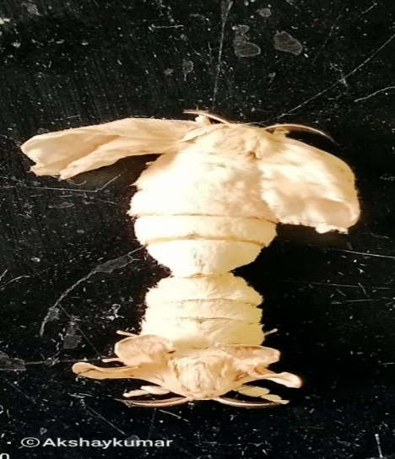
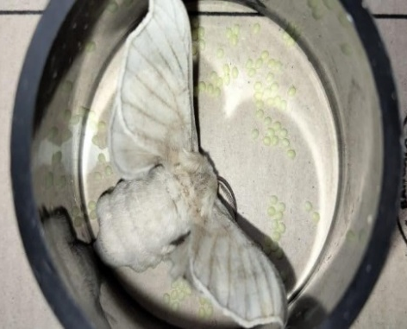

Fig 1: Egg laying moth
Fig 2: Adult mating
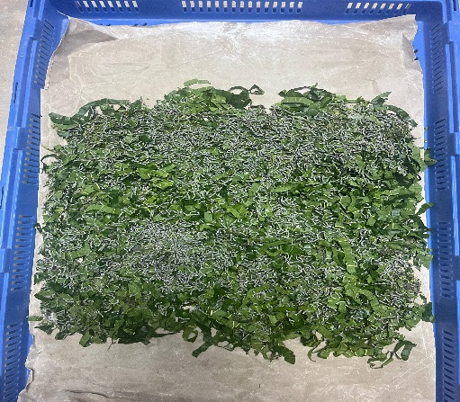
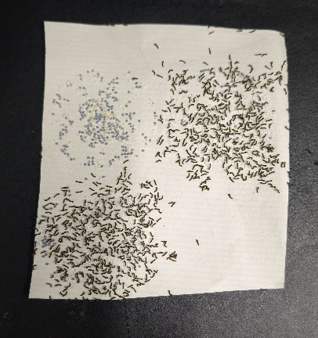

Fig 4: Chawki worms
Fig 3: Hatched worms (Kengo)

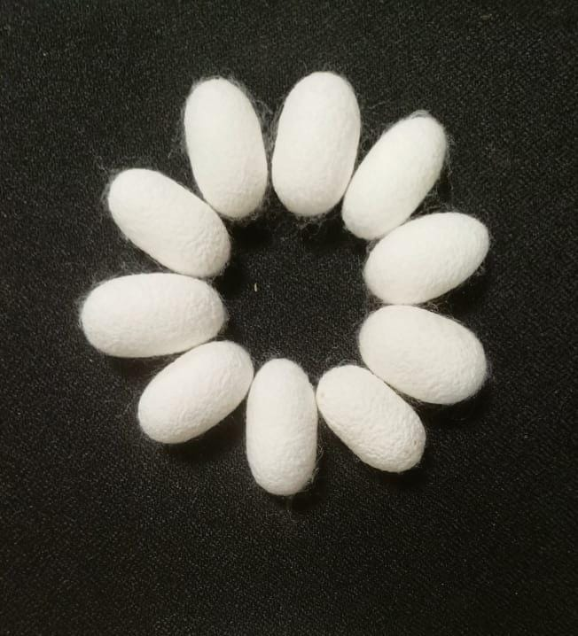
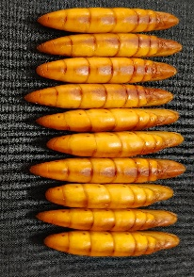
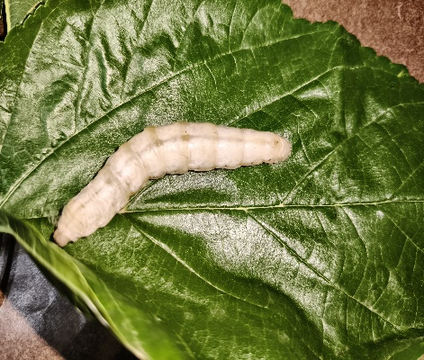
Fig 6: Pupa
Fig 5: Lattage Silkworm
Fig 7: Cocoons

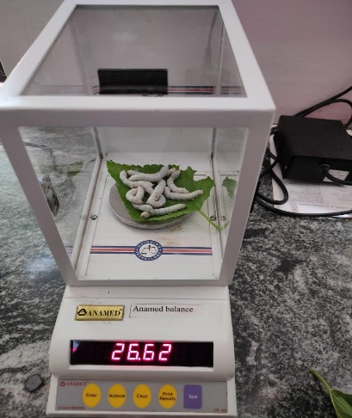

Fig 8: Weighing balance

3. results and discussion

The morphometric analysis of different developmental stages of Bombyx mori is presented in Table 1. The egg stage exhibited a length ranging from 1.00 mm to 1.29 mm, with an average of 1.15 ± 0.21 mm and a breadth between 0.92 mm and 1.26 mm, averaging 1.09 ± 0.24 mm.
The larval stage showed progressive increase in both length and breadth across the five instars. The I instar larvae measured between 2.98 mm and 3.81 mm in length (mean 3.39 ± 0.41 mm) and 0.88 mm to 0.98 mm in breadth (mean 0.93 ± 0.07 mm). In 2nd instar, the length increased to a range of 7.84 - 9.67 mm (mean 8.75 ± 0.92 mm) and the breadth from 0.95 - 1.60 mm (mean 1.27 ± 0.45 mm). The 3rd instar larvae showed further growth with length ranging from 12.10 mm to 15.96 mm (mean 14.03 ± 2.72 mm) and breadth from 1.95 mm to 3.85 mm (mean 2.99 ± 0.95 mm). 4th instar larvae had length between 29.45 mm and 38.39 mm (mean 33.92 ± 6.32 mm) and breadth from 4.46 mm to 5.20 mm (mean 4.83 ± 0.37 mm). The 5th instar larvae were the largest, with length ranging from 50.00 mm to 68.70 mm (mean 59.35 ± 9.35 mm) and breadth from 5.98 mm to 8.20 mm (mean 7.09 ± 1.56 mm). The pupal stage, measured in cms, had length ranging from 1.68 cm to 2.15 cm (mean 1.91 ± 0.33 cm) and breadth between 0.64 cm and 0.95 cm (mean 0.79 ± 0.21 cm). The cocoon measurements also showed consistent morphology, with length ranging from 3.07 cm to 3.30 cm (mean 3.185 ± 0.16 cm) and breadth between 1.59 cm and 2.01 cm (mean 1.82 ± 0.29 cm). Overall, this result shows a clear trend of gradual growth in both length and breadth across the successive developmental stages of B. mori, from egg to cocoon. The data were based on observations from 25 individuals (n=25).

Tables 1: Morphometrics of various stages of B. mori
Sl. No. | Stages | Length |  |  | Breadth
Sl. No. | Stages | Min. | Max. | Av. ± S.D. | Min. | Max. | Av. ± S.D.
1. | Egg | 1.0 | 1.29 | 1.15 ± 0.21 | 0.92 | 1.26 | 1.09 ± 0.24
2. | Larva
 | I instar (mm) | 2.98 | 3.81 | 3.39 ± 0.413 | 0.88 | 0.98 | 0.93 ± 0.07
 | II instar (mm) | 7.84 | 9.67 | 8.75 ± 0.915 | 0.95 | 1.60 | 1.27 ± 0.45
 | III instar (mm) | 12.10 | 15.96 | 14.03 ± 2.72 | 1.95 | 3.85 | 2.99 ± 0.95
 | IV instar (mm) | 29.45 | 38.39 | 33.92 ± 6.32 | 4.46 | 5.20 | 4.83 ± 0.37
 | V instar (mm) | 50.00 | 68.70 | 59.35 ± 9.35 | 5.98 | 8.20 | 7.09 ± 1.56
3. | Pupa (cm) | 1.68 | 2.15 | 1.915 ± 0.33 | 0.64 | 0.95 | 0.79 ± 0.21
4. | Cocoon (cm) | 3.07 | 3.30 | 3.185 ± 0.16 | 1.59 | 2.01 | 1.82 ± 0.29
n= 25
The morphometric measurements of adult Bombyx mori revealed distinct differences between females and males, as summarized in Table 2. The wingspan of female moths ranged from 3.80 cm to 4.15 cm, with an average of 3.97 ± 0.24 cm. In comparison, male moths exhibit slightly smaller wingspan, ranging from 3.26 cm to 3.40 cm, with a mean value of 3.33 ± 0.09 cm. The average body length of females was also greater than that of males, ranging from 1.70 cm to 2.11 cm (mean 1.90 ± 0.28 cm) for females and 1.49 cm to 1.68 cm (mean 1.58 ± 0.12 cm) for males. Similarly, the body breadth of females ranged from 0.61 cm to 0.75 cm (mean 0.68 ± 0.07 cm), whereas males showed a breadth between 0.45 cm and 0.70 cm (mean 0.57 ± 0.17 cm). Overall, female moths were observed to be larger than males in all 3 morphometric parameters - Wingspan, length and breadth. These measurements were based on 25 specimens per sex (n = 25).
Table 2: Morphometrics of adults of B. mori
Sl. No. | Particulars | Female |  |  | Male
Sl. No. | Particulars | Min. | Max. | Av. ± S.D. | Min. | Max. | Av. ± S.D.
1. | Wing span (cm) | 3.80 | 4.15 | 3.97 ± 0.24 | 3.26 | 3.40 | 3.33 ± 0.09
2. | Length (cm) | 1.70 | 2.11 | 1.90 ± 0.28 | 1.49 | 1.68 | 1.58 ± 0.12
3. | Breadth (cm) | 0.61 | 0.75 | 0.68 ±0.07 | 0.45 | 0.70 | 0.57 ± 0.17
n= 25
The biological parameters of Bombyx mori reared on Morus alba were thoroughly assessed (Table. 3). The incubation period of eggs ranged from 8.00 to 10.00 days, with an average of 9.00 ± 1.41 days, and a hatching percentage of 93.30 ± 3.90%, indicating high egg viability. The larval development was completed in five instars. The duration of the larval instars increased progressively: I instar: 3.00 ± 0.70 days, II instar: 3.75 ± 1.06 days, III instar: 4.25 ± 1.06 days, IV instar: 5.25 ± 1.06 days and V instar: 6.00 ± 1.41 days. The total larval period ranged from 19.00 to 25.50 days, with an average of 22.25 ± 4.59 days. The pre-pupal and pupal stages lasted for 2.75 ± 1.06 days and 9.5 ± 2.12 days, respectively. In terms of reproductive behavior, the pre-oviposition, oviposition and post-oviposition periods were 6.75 ± 1.25 hours, 21.00 ± 3.00 hours and 108 ± 24.04 hours, respectively. The adult emergence rate was fairly high at 85.00 ± 5.00%. The observed sex ratio favored females, averaging 1:1.30 (Male: Female). Female moths lived for 127.87 ± 33.09 hours, while males showed slightly longer longevity at 145 ± 63.64 hours. The total life cycle duration varied slightly between sexes. Females completed their life cycle in 55.73 ± 8.10 days, whereas males completed it in 54.80 ± 13.14 days. In terms of reproductive output, females showed an average fecundity of 334.55 ± 92.73 eggs. Environmental conditions during the study ranged from 25.00°C to 34.40°C, with a mean temperature of 29.7 ± 6.64°C and relative humidity between 50.00% and 70.20% with an average of 60.1 ± 14.28%.
Table 3: Biology of B. mori on M. alba
Sl. No. | Particulars | No. observed | Periods
Sl. No. | Particulars | No. observed | Min. | Max. | Av. ± S.D.
1 | Incubation period (Days) | 50 | 8.00 | 10.00 | 9.00 ± 1.41
2 | Hatching percentage (%) | 4812 | 89.99 | 97.81 | 93.30 ± 3.90
3 | Larval period (Days)
 | I instar | 50 | 2.5 | 3.5 | 3.00 ± 0.70
 | II instar | 50 | 3.00 | 4.5 | 3.75 ± 1.06
 | III instar | 50 | 3.5 | 5.00 | 4.25 ± 1.06
 | IV instar | 50 | 4.5 | 6.00 | 5.25 ± 1.06
 | V instar | 50 | 5.00 | 7.00 | 6.00 ± 1.41
 | Total larval period (Days) | 50 | 19.00 | 25.50 | 22.25 ± 4.59
4 | Pre-pupal (Days) | 50 | 2.00 | 3.5 | 2.75 ± 1.06
5 | Pupal period (Days) | 50 | 8.00 | 11.00 | 9.5 ± 2.12
6 | Pre-oviposition period (hrs) | 50 | 5.50 | 8.00 | 6.75 ± 1.25
7 | Oviposition period (hrs) | 50 | 18.00 | 24.00 | 21.00 ± 3.00
8 | Post-oviposition period (hrs) | 50 | 91.00 | 125.00 | 108 ± 24.04
9 | Adult emergence (%) | 267 | 80.00 | 90.00 | 85.00 ± 5.00
10 | Sex ratio (Male: Female) | 455 | 1:1.10 | 1:1.50 | 1:1.30
11 | Adult longevity (hrs)
 | Female | 50 | 104.50 | 151.25 | 127.87 ± 33.09
 | Male | 50 | 100.00 | 190.00 | 145 ± 63.64
12 | Total life cycle (Days)
 | Female | 50 | 50.0 | 61.47 | 55.73 ± 8.10
 | Male | 50 | 45.51 | 64.10 | 54.80 ± 13.14
13 | Fecundity (No.) | 30 | 269.0 | 400.11 | 334.55 ± 92.73
14 | Temperature (ºC) | - | 25.00 | 34.40 | 29.7 ± 6.64
15 | Relative humidity (%) | - | 50.00 | 70.20 | 60.1 ± 14.28
The morphometric and biological study of Bombyx mori reared on Morus alba revealed progressive growth through its developmental stages. Egg dimensions averaged 1.15 × 1.09 mm. Larval size increased across instars, with fifth instar larvae measuring 59.35 × 7.09 mm. Pupal and cocoon sizes averaged 1.91 × 0.79 cm and 3.19 × 1.82 cm, respectively. Adult females were larger than males in wingspan, length, and breadth. Eggs hatched in 9 days with 93.3% viability. The larval period lasted 22.25 days, with pupal and pre-pupal stages of 9.5 and 2.75 days. Fecundity averaged 334 eggs, with a female-biased sex ratio (1:1.3). These results were similar with Patel, et al., 2013 and Gurjar et al., 2018, The biology of silkworm on mulberry variety S-30 was studied under lab conditions in Nov-Dec 2017. Each female laid an average of 331 eggs, which hatched in about 8.7 days with a 95.9% success rate. The larval stage lasted 23.8 days with four moults, followed by pre-pupal and pupal periods of 2.3 and 10.2 days. Female moths lived longer (142 hrs) than males (112 hrs), with a sex ratio of 1:1.3 (Male: Female) and also correlated with Lakra et al., 2022, conducted experiments in 2021-22 at the Entomology Laboratory, Barrister Thakur Chhedilal College, Bilaspur (Chhattisgarh), examined the biology of Bombyx mori. Females laid 300-500 oval eggs, about 1 mm in diameter, covered with a sticky gelatinous substance. The incubation period ranged from 8-10 days with a 95.5% hatching rate. Newly hatched larvae were yellowish-brown with dark heads and hair-covered bodies. The larval stage lasted 27.5 days. Pupation took 10 days following a 2.5-day pre-pupal stage. Adult emergence ranged from 60-75%. Males completed their life cycle in 53.5 days, females in 55.5 days. Meeramaideen et al. 2017, The average length and breadth of pupa were 2.57± 0.20 and 2.21± 0.11cm respectively.

4. Conclusion
This experimental investigation confirms that Bombyx mori reared on Morus alba exhibits predictable and significant developmental changes across its life cycle stages. The results demonstrate a clear correlation between larval development, instar progression, and eventual cocoon and adult morphology. Fifth instar larvae were the largest and most critical for cocoon spinning, directly impacting silk production. A high egg viability rate and female-biased sex ratio (1:1.3) reflect favourable rearing conditions. Female moths exhibited higher fecundity and larger body size, contributing positively to reproductive efficiency. The average total life cycle of approximately 55 days is comparable with previous studies, confirming the suitability of M. alba (S36 variety) as a high-quality mulberry host. Proper feeding, hygiene and environmental regulation (temperature and humidity) were crucial in achieving these results. The findings contribute valuable baseline data for optimizing sericulture practices and breeding strategies, particularly in tropical regions like Karnataka, where climatic conditions can support year-round silk farming.
Declaration

No animals and human participants are harmed.

Disclaimer (Artificial intelligence)
Option 1:
Author(s) hereby declare that NO generative AI technologies such as Large Language Models (ChatGPT, COPILOT, etc.) and text-to-image generators have been used during the writing or editing of this manuscript.
Option 2:
Author(s) hereby declare that generative AI technologies such as Large Language Models, etc. have been used during the writing or editing of manuscripts. This explanation will include the name, version, model, and source of the generative AI technology and as well as all input prompts provided to the generative AI technology
Details of the AI usage are given below:
1.
2.
3.

References

Anonymous. Package of practices for silkworm rearing and mulberry cultivation in Kashmir. technical document. Directorate of extension education, Sher-eKashmir University of agricultural sciences and technology of Kashmir. 2003;13-20.

Chand Asaf & Mahavishnu. (2018). Morphometric Studies of Silkworm, Bombyx Mori (L.) Fed with Spirulina Treated Mr2 Mulberry Leaves. Plant archives, 18, 316-319.

Dandin, S.B., Jayaswal, K.P., Giridhar, K. (2003). Handbook of Sericulture Technologies. Central Silk Board, GOI.
Goldsmith, M. R., Shimada, T., Abe, H. (2005). The genetics and genomics of the silkworm, Bombyx mori. Annual Review of Entomology, 50:71-100. https://doi.org/10.1146/annurev.ento.50.071803.130456.
Gurjar, T., Mukesh, R., Siddhapara., Pratik., Surani, S. (2018). Biology of mulberry silkworm, Bombyx mori L. on mulberry, Morus alba L. Journal of Entomology and Zoology Studies, 6(4): 276-280.
Lakra, Archana Kerketta, R.K.S., Tomar, S.K., Verma, N.K., Chaure, and Awasthi, A.K. (2022). Biology of mulberry silkworm (Bombyx mori. L.) in laboratory at Bilaspur (Chattisgarh). Journal of Pharmaceutical Innovation, 11(7): 4219-4222.
Meeramaideen, M., Rajasekar, P., Sumathi., Prabu, G. (2017). Studies on the morphometric and economic parameters analysis of silkworm, Bombyx mori (L.) (Lepidoptera: Bombycidae) fed with amino acid (Lysine) treated MR2 mulberry leaves. International Journal of Current Research and Review, 5(1):1468-1473.
Miyashita Y. A report on mulberry cultivation and training methods suitable to bivoltine rearing in Karnataka. 1986;1-7.
Mondal, M., Trivedy, K., Nirmal Kumar, S. (2007). The silk proteins, sericin and fibroin in silkworm, Bombyx mori Linn.: A review. Clinical Biochemistry, 32(1):14-20. https://doi.org/10.1016/j.jbiosc.2006.05.008.
Nazim, N., Mir, M. R., Baqual, M. F., Noor-ul-Din., Akther, F., Mir, S. A., & Qayoom, S. (2020). Performance of Double Hybrid of Silkworm (Bombyx mori L.) Fed on Leaf Raised under Different Fertilizer Schedules. Current Journal of Applied Science and Technology, 39(48), 439–444. https://doi.org/10.9734/cjast/2020/v39i4831256.
Patel, S. R., Pandya, H. V., Patel, S. D., Naik, M. M. (2013). Biology of Bombyx mori L. (Lepidoptera: Bombycidae). International Journal of Plant Protection, 6(2): 382 389.
Sanjai Kumar Gupta, Ram Pravesh Pandey, Purshottam Yadav and Vikas Singh. (2024). Studies on varietal performance of Morus on growth and economic parameters of mulberry silkworm Bombyx mori Linn. International Journal of Applied Research, 10(10): 162-167.

Sivanesh, H., Stephenraj, D., Azhagu, Raj R. (2024). Growth performance of the Bombyx mori (Hybrid CSR2 x CSR4) using G4 and MR2 mulberry varieties. International Journal of Entomology Research. 9 (2), 66-70.
Xia, Q., Zhou, Z., Lu, C., Cheng, D., Dai, F., Li, B. (2009). A draft sequence for the genome of the domesticated silkworm (Bombyx mori). Science, 306(5703): 1937–1940. https://www.science.org/doi/10.1126/science.1102210.

