Original Research Article
A Comparative Clinical Analysis of Atovaquone-Azithromycin and Triple antimicrobial therapy in Canine Babesiosis

Abstract
The present study was conducted to investigate the comparative effect of Atovaquone+ Azithromycin combination and triple antimicrobial therapy for the management of Babesia gibsoniinfection in dogs. Twenty-four dogs were randomly divided into two equal groups (group A and group B). Group A was treated with triple antibiotic therapy (Doxycycline @ 10 mg/kg, orally, daily+ Clindamycin @ 11 mg/kg, orally, twice daily+ Metronidazole @ 15 mg/kg, orally, twice daily) for 21 days whereas group B was treated with Atovaquone–Azithromycin Combination (Atovaquone @ 13.3 mg/kg, orally, three times daily with a fatty meal + Azithromycin @ 10 mg/kg, orally, once daily) for 10 days. Blood and serum samples were taken before therapy (day 0), day 10, day 20 and day 60 after therapy for haemato-biochemical analysis. Both are groups showed progressiveimprovement, but group B was better as compare to group in terms of disappearance of clinical signs, parasitological clearance, normalization of haemato-biochemical values,faster recovery andreduced chances of reoccurrence. It is concluded that for Babesia gibsoni infection, treatment with Atovaquone–Azithromycin Combination is better than triple antibiotic therapy
Key words: Canine babesiosis, Azithromycin, antimicrobial therapy, Clinical Analysis, hemoprotozoan parasites

Introduction

Canine babesiosis is caused by hemoprotozoan parasites of the genus Babesia, with Babesia gibsoni being the most common species infecting dogs (Karasová et al., 2022).Babesiosis caused by Babesia gibsoni is less severe and persistent compared to Babesia canis (Yogeshpriyaet al., 2018). Babesiosis is characterised by parasite reproduction in the host's red blood cells, which leads to cell lysis (Sojka et al., 2022). Clinical signs include anorexia, lethargy, icterus, vomiting, and loss of body condition. Pathologic abnormalities may include haemoglobinuria, hypoglycemia, acid-base disturbances, azotemia, and elevated liver enzyme levels (Idrees, 2022). Additionally, B. gibsoni induces regeneration haemolyticanaemia and thrombocytopenia(Karasová et al., 2022).Rhipicephalus sanguineus is the primary vector of B. gibsoni in India, with only transstadial transmission reported (Chao et al., 2017). The illness can be transmitted directly through B. gibsoni-containing blood, such as through blood transfusions, infected equipment used for mass ear cropping or tail reduction or using the same injection needle repeatedly. Direct transfer can occur during dog fights or through bite wounds (Karasová et al., 2022).Haematologicaland serological changes often include regenerated haemolyticanaemia, poikilocytosis, polychromasia, anisocytosis, thrombocytopenia, decrease in albumin, increase in alpha & beta globulins (Birkenheuer, 2021). It was stated previously that the infection with B. gibsoni in dogs causes marked alterations in serum biochemistry parameters, including those related to the protein profilethat were characterized by lower concentrations of albumin and higher proportion ofγ-globulins with low A/G ratio (Tóthováet al., 2020).Diagnosis can be done by microscopic examination of Giemsa-stained thin blood smears prepared from the ear margin showed signet ring shape in erythrocytes and polymerase chain reaction (Kushwaha et al., 2018).

Small Babesia spp. often reappears following therapy, even if the dog seems healthy and parasitemia is no longer detectable by PCR analysis. Drugs can only reduce mortality and alleviate illness symptoms (Karasová et al., 2022).There are many drugs were studied for treatment of B. gibsonibut most of them are ineffective. B. gibsoni can be treated with atovaquone at a dose of 13.3 (or 13.5) mg/kg of body weight orally with a fatty meal every 8 hours in combination with azithromycin at a dose of 10 mg/kg of body weight orally every 24 hours for 10 days (Gallego et al., 2016). Another regimen for treatment includes combination of clindamycin (25 mg/kg of body weight orally every 12 h), metronidazole (15 mg/kg of body weight orally every 12 h per day), and doxycycline (5 mg/kg of body weight orally every 12 h) (Suzuki et al., 2007). Atovaquone preferentially blocks protozoal mitochondrial electron transport, which inhibits pyrimidine and adenosine triphosphate production (Silva et al., 2016).Combining atovaquone and azithromycin provides a synergistic therapeutic effect, but taking atovaquone alone leads to return of clinical symptoms. The most successful therapy for B. gibsoni infection in dogs is the combination of atovaquone and azithromycin, which reduces parasitemia below detectable levels by PCR (Karasová et al., 2022). Along with this therapy, supportive care should be based on a thorough assessment of the patient’s clinical condition. Intravenous fluid treatment may be used for shock, severe infection, dehydration, intravascular haemolysis, haemoglobinuria, and decreased kidney function. Crystalloids, together with solutions to address acid-base imbalance and electrolyte imbalances, are the most appropriate intravenous solutions. Blood transfusion is indicated in patients with severe anemia (hematocrit <15%) and severe dyspnoea or tachypnoea (Malyuk et al., 2023).

2 Materials and Methods
The study was conducted at the Referral Veterinary Polyclinic Teaching Veterinary Clinical Complex (RVP–TVCC), ICAR-Indian Veterinary Research Institute (IVRI), Izatnagar, on dogs presented with history suspected withhemoprotozoa infection. A total of 24 dogs of various breeds, sexes, and aged between 1 to 8 years were included in this study. All dogs presented with clinical signs consistent with babesiosis, including fever, lethargy, pale mucous membranes, and thrombocytopenia were included in this study. Some dogs were also having icteric sclera (Figure 6).
2.1Criteria for the Study
Infection with Babesia gibsoni confirmed by Giemsa-stained peripheral blood smear (Figure- 7) and polymerase chain reaction (PCR) (Figure-8).
- Dogs not treated with anti-babesial therapy in the preceding month.
- No concurrent co-infection with Ehrlichia or other hemoprotozoan (confirmed through PCR).
- No pre-existing hepatic or renal disease.

2.2 Grouping of dogs and Treatment Protocols
The 24 dogs were randomly divided into two equal groups (n = 12 per group). Group A received triple antimicrobial therapy consisting of doxycycline at 10 mg/kg orally once daily (SID), clindamycin at 11 mg/kg orally twice daily (BID), and metronidazole at 15 mg/kg orally twice daily (BID) for a duration of 21 days. Group B was treated with an atovaquone–azithromycin combination, where atovaquone was administered at 13.3 mg/kg orally three times daily (TID) with a fatty meal, and azithromycin at 10 mg/kg orally once daily (SID) for a duration of 10 days. Supportive therapy including antipyretics(Meloxicam), hepatoprotectants(hepamust), antacid(Pantoprazole) IV fluids, and nutritional supplements were administered as needed, based on individual clinical needs.

2.3 Clinical and Laboratory Monitoring
All dogs underwent detailed haemato-biochemical examinations on day 0, day 10, day 20, and day 60 post-initiation of treatment. The parameters evaluated included hematological parameters such as hemoglobin (Hb), packed cell volume (PCV), and albumin:globulin (A/G) ratio, as well as biochemical parameters including alanine aminotransferase (ALT) and blood urea nitrogen (BUN). Blood samples were collected aseptically from the cephalic vein. Hematological assessments were performed using a fully automated veterinary hematology analyzer (URIT-3000-VET PLUS), while serum biochemical values were analyzed using an automated biochemistry analyzer (Chem 5x, Erba Mannheim Biochemical Analyzer, Transasia Bio-Medicals Ltd., Mumbai, India).

2.4 Parasitological Evaluation
Parasitic load was assessed using:
- Giemsa-stained peripheral blood smears, observed under oil immersion (100×) on Day 0 and Day 60 to assess treatment efficacy and confirm parasite clearance.
- PCR analysis for Babesia gibsoni DNA was performed on Day 0 and Day 60 to assess treatment efficacy and confirm parasite clearance.

Clinical Evaluation

Clinical signs, including rectal temperature, mucous membrane color, appetite, and activity level, were carefully monitored daily throughout the treatment period and weekly thereafter up to Day 60 to assess the therapeutic response; any signs of adverse drug reactions or clinical relapses were also recorded during this observation period.

The data were statistically analyzed using SPSS software (version XX). Comparison of parameters within and between groups over time was done using repeated measures Multiple t-test. A p-value < 0.05 was considered statistically significant.
3 Results
3.1 Hematological and Biochemical Parameters
A total of 24 dogs diagnosed with Babesia gibsoni infection confirmed by Giemsa-stained peripheral blood smear and real-time PCR were evaluated for their clinical and hematobiochemical responses to two different antimicrobial regimens over a 60-day period.
Both treatment groups exhibited progressive and statistically meaningful improvement in hematological and biochemical parameters over time. However, the rate, magnitude, and consistency of recovery were more favorable in Group B (Atovaquone–Azithromycin combination therapy) as compared to Group A (Triple therapy: Doxycycline–Clindamycin–Metronidazole) (Table.1&2).
3.1.1 Hemoglobin(g/dL)Hemoglobin levels increased significantly in both groups throughout the study period, reflecting effective recovery. However, Group B demonstrated a more marked rise in hemoglobin concentration, reaching a mean of 12.10 ± 0.85 g/dL by Day 60, compared to 10.38 ± 0.82 g/dL in Group A (Fig.1).
3.1.2 Packed Cell Volume (PCV %)PCV values also improved significantly in both groups over time, indicating a gradual correction of anemia. Dogs in Group B exhibited higher PCV levels at each post-treatment interval, reaching 36.30 ± 2.55% by Day 60, whereas Group A attained 31.14 ± 2.46% (Fig.2).
3.1.3 Albumin:Globulin (A/G) RatioA progressive increase in A/G ratio was observed in both groups, suggesting resolution of systemic inflammation and improved protein balance. Group B showed a faster and more consistent rise in A/G ratio, reaching 1.12 ± 0.12 by Day 60, compared to 1.02 ± 0.11 in Group A(Fig.3).
3.1.4 Alanine Aminotransferase (ALT, IU/L)ALT values, which indicate liver function and possible hepatocellular injury, declined steadily in both groups over the course of treatment. Group B dogs experienced a sharper and more substantial decrease in ALT activity, dropping to 48.10 ± 6.70 IU/L by Day 60, while Group A recorded 56.14 ± 7.27 IU/L. The reduction was statistically notable, highlighting better hepatic recovery in dogs treated with Atovaquone–Azithromycin(Fig.4).
3.1.5 Blood Urea Nitrogen (BUN, mg/dL)BUN levels, used as a marker of renal function and protein metabolism, showed significant decline in both groups. By Day 60, BUN concentrations were reduced to 25.90 ± 3.40 mg/dL in Group B compared to 29.57 ± 3.78 mg/dL in Group A (Fig.5).
Across all hematobiochemical parameters, repeated measures analysis revealed a highlysignificant effect of time, confirming that both therapies were effective in promoting recovery. However, the treatment group effect and interaction between time and treatment were also statistically significant in each parameter, confirming the superior performance of the Atovaquone–Azithromycin protocol.

3.2 Parasitological and Clinical Outcomes
3.2.1 Parasitological ClearanceParasitic load was assessed by microscopic examination of Giemsa-stained peripheral blood smears and molecular detection using PCR on Day 0 and Day 60. Group B demonstrated superior efficacy in parasite elimination, with 91.6% of dogs testing negative on both smear and PCR by Day 60, compared to 66.6% clearance in Group A. These findings indicate more effective suppression of parasitemia withdual therapy.
3.2.2 Recurrence RateClinical relapses and reappearance of parasitemia were monitored up to Day 60. In Group A, 4 out of 12 dogs (33.3%) showed recurrence of clinical signs and tested positive again for Babesia gibsoni. In contrast, only 1 out of 12 dogs (8.3%) in Group B relapsed during the follow-up period. This suggests a significantly lower recurrence rate in dogs receiving Atovaquone–Azithromycin therapy (Table.3).
3.2.3 Clinical improvementClinical parameters including rectal temperature, appetite, mucous membrane color, and general activity improved more rapidly and consistently in Group B. Full clinical resolution was achieved in nearly all Group B dogs by Day 20, with sustained improvement through Day 60. In Group A, although there was improvement, several dogs showed delayed or incomplete recovery, and some exhibited signs of relapse during the post-treatment period.

Table.1Hematobiochemical ParametersofGroup ADay | Hemoglobin (g/dL)(Mean ± SD) | PCV (%)(Mean ± SD) | A/G Ratio(Mean ± SD) | ALT (IU/L) (Mean ± SD) | BUN (mg/dL) (Mean ± SD)
Day 0 | 5.52 ± 1.46 | 16.58 ± 4.39 | 0.53 ± 0.11 | 173.43 ± 25.79 | 58.00 ± 6.45
Day 10 | 8.32 ± 0.66ª | 24.96 ± 1.98ª | 0.74 ± 0.10 | 111.00 ± 13.56ª | 44.14 ± 4.53ª
Day 20 | 9.23 ± 0.60ª | 27.69 ± 1.80ª | 0.89 ± 0.07ª | 76.43 ± 6.45ª | 37.67 ± 3.07ª
Day 60 | 10.38 ± 0.82ª | 31.14 ± 2.46ª | 1.02 ± 0.11ª | 56.14 ± 7.27ª | 29.57 ± 3.78ª

Table.2Hematobiochemical ParametersofGroup B
Day | Hemoglobin (g/dL)  (Mean ± SD) | PCV (%)  (Mean ± SD) | A/G Ratio  (Mean ± SD) | ALT (IU/L)  (Mean ± SD) | BUN (mg/dL)  (Mean ± SD)
Day 0 | 5.48 ± 1.43 | 16.44 ± 4.29 | 0.57 ± 0.12 | 170.50 ± 24.80 | 57.50 ± 6.30
Day 10 | 9.47 ± 0.63^{b} | 28.41 ± 1.89^{b} | 0.82 ± 0.11 | 97.20 ± 12.10^{b} | 39.80 ± 4.10^{b}
Day 20 | 10.08 ± 0.72^{b} | 30.24 ± 2.16^{b} | 0.97 ± 0.08^{b} | 68.80 ± 5.90^{b} | 33.40 ± 2.80^{b}
Day 60 | 12.10 ± 0.85^{b} | 36.30 ± 2.55^{b} | 1.12±0.12^{b} | 48.10 ± 6.70^{b} | 25.90 ± 3.40^{b}

Superscripts a and b indicate statistically significant differences (p < 0.05) between Group A and Group B on the same day.

Table.3 Summary of results (Group A V/S Group B)
Group | Parasite Clearance | Clinical Recovery | Recurrence Rate
A | Moderate (66.6%) | Partial | 4/12 (33.3%)
B | High (91.6%) | Complete | 1/12 (8%)

Fig.1 Graphical Representation of Hemoglobin (g/dL) over Time in Dogs

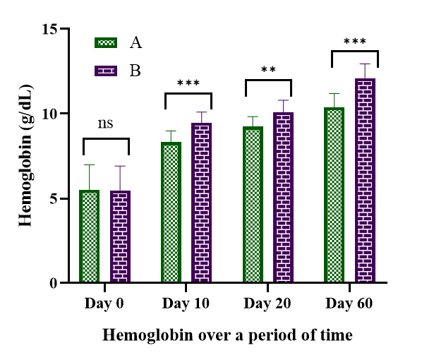

Fig.2 Graphical Representation of Packed Cell Volume (PCV, %) over Time in Dogs

Fig.3 Graphical Representation of Albumin: Globulin (A/G) Ratio over Time in Dogs

Fig.4 Graphical Representation of Alanine Aminotransferase (IU/L) over Time in Dogs

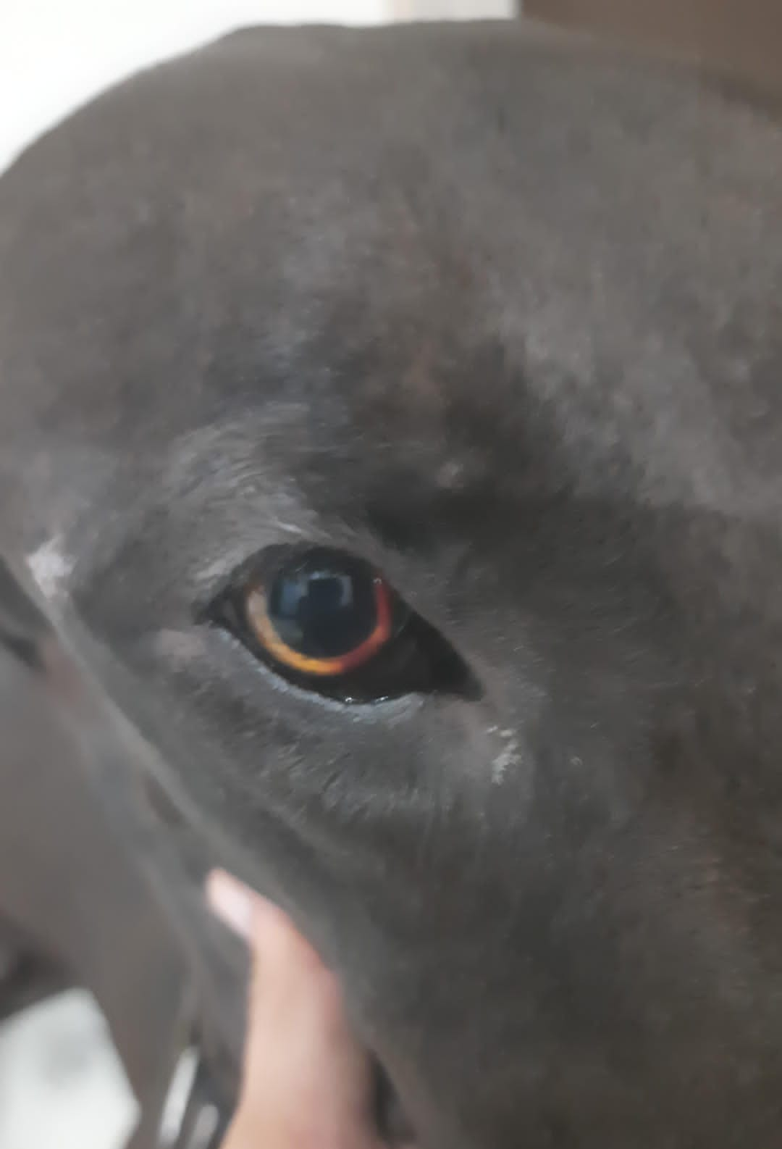

Fig.5 Graphical Representation of Blood Urea Nitrogen (BUN, mg/dL) over Time in Dogs

Fig. 6 Icteric sclera in diseased dog

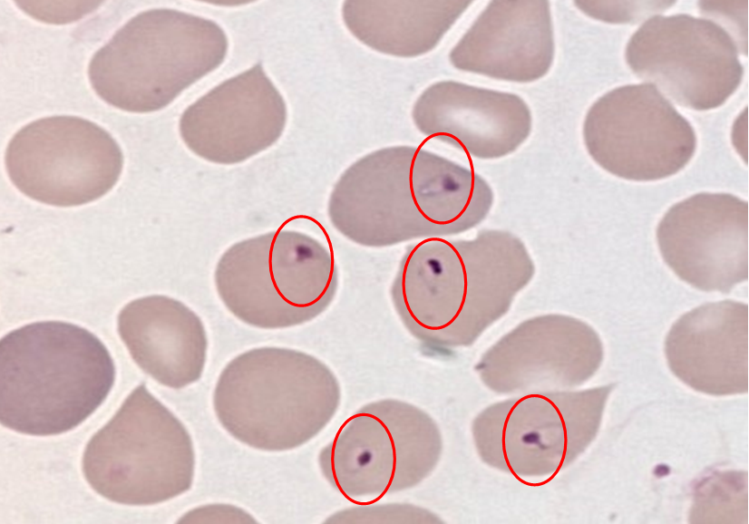

Fig. 7 Signet shaped intracellular organism in RBC

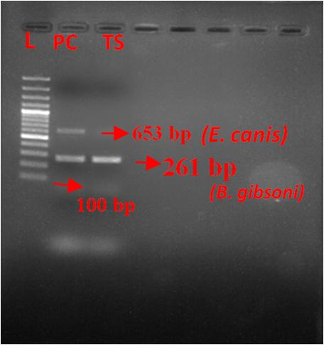

Fig. 8 B. gibsoni in the blood sample of a dog by PCR and 2D gel electrophoresis. L: Ladder, PC: Positive Control, TS: Test Sample

Discussion
In this study, we compared two therapeutic regimens for canine Babesia gibsoni infection. Both treatments i.e. triple therapy (doxycycline, clindamycin, metronidazole) and atovaquone+ azithromycin—achieved statistically significant clinical and hematobiochemical improvements. However, the atovaquone–azithromycin protocol demonstrated superior efficacy in terms of faster recovery, higher parasitological clearance, and lower relapse rates. Dogs treated with atovaquone (13.3 mg/kg q8h) plus azithromycin (10 mg/kg q24h) achieved a 91.6% PCR-negative rate by Day 60, versus 66.6% in the triple therapy group. Atovaquone–azithromycin is the recommended first-line treatment for small Babesia species due to its superior efficacy and ability to reduce chronic carrier states (Baneth, 2018). Group B dogs exhibited faster improvement in the concentration of hemoglobin, PCV, and A/G ratio, indicative of rapid correction of anemia and systemic inflammation. This aligns with clinical observations by Baneth (2018), who noted the hematological benefits of rapid parasitemia reduction with this regimen. Decreased A/G ratio was observed in dogs before treatment, indicating overproduction of γ-globulins as a humoral immune response to B. gibsoni-induced chronic inflammation. The majority of published research was intended to describe the protein fraction distribution in Babesia-infected dogs compared to healthy animals, as well as the pathophysiological and biochemical alterations in the blood after experimental infection with these parasites (Brown et al., 2015). Improvements in ALT and BUN further confirm better hepatic and renal recovery attributable to effective parasite clearance with group B. Atovaquone–azithromycin–treated dogs achieved full clinical recoveryresolution of fever, lethargy, and appetite—by Day 20, with sustained improvement through Day 60. In contrast, triple therapy resulted in slower clinical recovery and a higher incidence of relapse (33.3%). These observations support prior reports describing the limited capacity of triple antibiotic regimens to eradicate infection or prevent recurrence (Köster et al., 2015).Atovaquone acts by inhibiting mitochondrial electron transport in protozoa, while azithromycin targets the apicoplast—together, they exert synergistic effects that reduce parasitemia below detectable thresholds. In contrast, triple therapy relies on bacteriostatic antibiotics with indirect or inconsistent anti-protozoal activity, resulting in slower and less reliable outcomes (Kumari, 2022).Though atovaquone therapy is more expensive and requires administration with a fatty meal to optimize absorption, the reduced treatment duration (10 vs. 21 days) enhances owner compliance and minimizes adverse effects. Supportive care—including fluids, hepato-protectants, antipyretics, and nutritional support—remains essential across regimens to manage clinical complications. Artesunate is therefore considered a very safe drug in terms of the development of side effects. The effect of artesunate on the elimination of B. gibsoni has been confirmed in vitro, but it is also recommended to increase its babesicidal effect in combination with other drugs. As per the Goris et al. (1985) hypothesis, the multiple organ dysfunction syndrome develops as the consequence of dysregulation of proinflammatory and anti-inflammatory mechanisms, resulting in overwhelming auto-destructive inflammation. In this case, the increase in the creatinine value can be explained by the fact that the affected animal with multiple organ dysfunction syndrome will have hypotension, which causes poor perfusion to the renal tissue (Matijatkoet al., 2009).
5. Conclusion
This study supports the atovaquone–azithromycin combination as a more effective and reliable first-line therapy for canine Babesia gibsoni infection, delivering faster parasitological clearance, improved clinical outcomes, and lower relapse rates compared to triple antimicrobial therapy. Simplified dosing and enhanced efficacy make it a preferred option in clinical settings, with further studies needed to evaluate long-term outcomes and resistance concerns.
Ethical Approval
Animal Ethic committee approval has been collected and preserved by the author(s)
Disclaimer (Artificial intelligence)
Option 1:
Author(s) hereby declare that NO generative AI technologies such as Large Language Models (ChatGPT, COPILOT, etc.) and text-to-image generators have been used during the writing or editing of this manuscript.
Option 2:
Author(s) hereby declare that generative AI technologies such as Large Language Models, etc. have been used during the writing or editing of manuscripts. This explanation will include the name, version, model, and source of the generative AI technology and as well as all input prompts provided to the generative AI technology
Details of the AI usage are given below:
1.
2.
3.

References
Baneth G. Antiprotozoal treatment of canine babesiosis. Vet Parasitol.2018;254:58–63. https://doi.org/10.1016/j.vetpar.2018.03.001
Birkenheuer AJ. Babesiosis. In: Greene CE, editor. Infectious Diseases of the Dog and Cat. 5th ed. Philadelphia: WB Saunders; 2021. p. 1203–1217. https://doi.org/10.1016/b978-0-323-50934-3.00097-5
Brown AL, Shiel RE, Irwin PJ. Clinical, haematological, cytokine and acute phase protein changes during experimental Babesia gibsoni infection of beagle puppies. Exp Parasitol.2015;157:185–196. https://doi.org/10.1016/j.exppara.2015.08.002
Chao LL, Liao HT, Ho TY, Shih CM. First detection and molecular identification of Babesia gibsoni from Rhipicephalus sanguineus ticks. Acta Trop.2017;166:356–362. https://doi.org/10.1016/j.actatropica.2016.09.022
de Oliveira Silva E, dos Santos Gonçalves N, Alves dos Santos R, Jacometti Cardoso Furtado NA. Microbial metabolism of atovaquone and cytotoxicity of the produced phase I metabolite. Eur J Drug MetabPharmacokinet.2016;41:645–650. https://doi.org/10.1007/s13318-015-0294-1
Goris RJ, Bockhorst TP, Nuytinek JK, Gimbrere JS. Multiple-organ failure. Generalized auto destructive inflammation? Arch Surg.1985;120:1109–1115.
Idrees A. Clinico-biochemical studies on acute kidney injury in common infectious diseases of dogs and response to antioxidant therapy in Babesia gibsoni infection [PhD thesis]. Kerala: Kerala Veterinary and Animal Sciences University; 2022.
Karasová M, Tóthová C, Grelová S, Fialkovičová M. The etiology, incidence, pathogenesis, diagnostics, and treatment of canine babesiosis caused by Babesia gibsoni infection. Animals. 2022;12(6):739. https://doi.org/10.3390/ani12060739
Köster LS, Lobetti RG, Kelly P. Canine babesiosis: A perspective on clinical complications, biomarkers, and treatment. Vet Med Res Rep.2015;6:119–128. https://doi.org/10.2147/vmrr.s60431
Kumari, D.M., 2022. Babesia associated multiorgan dysfunction in dogs and its ameliorative measures.
Kushwaha N, Mondal D, Singh KP, Mahapatra RR. Comparative evaluation of different diagnostic tests for B. gibsoni in dogs. Indian J Anim Res. 2018;52(11):1642–1648. https://doi.org/10.18805/ijar.b-3413
Malyuk M, Kulida M, Klymchuk V, Dovbnya Y, Honchar V. The effect of transfusion of erythrocyte mass on clinical and haematological indicators of dogs with hemolytic anaemia caused by babesiosis. Ukr J Vet Sci. 2023;14(4). https://doi.org/10.31548/veterinary4.2023.126
Matijatko V, Kiš I, Torti M, Brkljačić M, Barić Rafaj R, Žvorc Z, Mrljak V. Systemic inflammatory response syndrome and multiple organ dysfunction syndrome in canine babesiosis. Vet Arhiv. 2010;80(5):611–626. https://doi.org/10.1016/j.vetpar.2009.03.011
Sojka D, Jalovecká M, Perner J. Babesia, Theileria, Plasmodium and hemoglobin. Microorganisms. 2022;10(8):1651. https://doi.org/10.3390/microorganisms10081651
Solano-Gallego L, Sainz Á, Roura X, Estrada-Peña A, Miró G. A review of canine babesiosis: The European perspective. Parasites Vectors.2016;9:336. https://doi.org/10.1186/s13071-016-1596-0
Suzuki K, Wakabayashi H, Takahashi M, Fukushima K, Yabuki A, Endo Y. A possible treatment strategy and clinical factors to estimate the treatment response in Babesia gibsoni infection. J Vet Med Sci. 2007;69(5):563–568. https://doi.org/10.1292/jvms.69.563
Tóthová C, Karasová M, Blaňarová L, Fialkovičová M, Nagy O. Differences in serum protein electrophoretic pattern in dogs naturally infected with Babesia gibsoni and Babesia canis. Sci Rep.2020;10:18904. https://doi.org/10.1038/s41598-020-75908-7
Yogeshpriya S, Sivakumar M, Saravanan M, Venkatesan M, Veeraselvam M, Jayalakshmi K, Selvaraj P. Clinical, haemato-biochemical and ultrasonographical studies on naturally occurring Babesia gibsoni infection in dogs. J EntomolZool Stud.2018;6:1334–1337. https://doi.org/10.20546/ijcmas.2018.708.159

