**Protective effect of *Portulaca oleracea* L in Cisplatin induced oxidative stress in chick embryos: A study with reference to teratogenic deformities**

**Abstract**

Cisplatin is a planar platinum complex consisting of two chloride leaving groups in the cis-position around platinum and is one of the most effective anticancer drugs administered to treat a variety of cancers, such as ovarian, testicular, bladder, head and neck, and uterine cervix carcinomas. Cisplatin is an active cytotoxic agent that has proved to be a successful antineoplastic agent in the treatment of various types of solid tumours. This study was conducted to study the effect of cisplatin on morphological and biochemical changes in amniotic fluid and to determine whether *Portulaca oleracea* L. extract can modulate these alterations at the embryonic level against cisplatin toxicity by using chick embryo as an animal model. Allthe results were expressed as mean ± standard error (SE) for five groups in each group, and the difference between groups was considered significant when the P value determined by unpaired Student’s t-test and less than 0.05 and 0.01 have been as indicated significant represented in astric mark in tables and figures. The morphological changes, including change in volume of amniotic fluid, body weight and alterations of amniotic fluid (AF) biochemical parameters, were studied after 24 hours of incubation by comparing cisplatin (100 µg) treated groups with their respective controls. It showed a significant dose versus time dependent reduction in volume of amniotic fluid as well as body weight of chick embryos. A dose-related increase in embryo lethality, and gross morphological deformities were observed. There was a significant change in the biochemical levels of glucose, protein, urea, creatinine, uric acid, alkaline phosphatase, alanine and aspartate transaminases with cisplatin treatment. *Portulaca oleracea* L.extract is also reported as an excellent source of the antioxidant vitamins such as α -tocopherol, ascorbic acid and β-carotene, as well as glutathione. It reveals to test this extract as an embryo protective agent against cisplatin-induced toxicity. In our findings, the main reason for growth retardation may be due to altered properties of the yolk sac, or extra embryonic extra-embryonic vascular network may reduce nutrient transfer to the embryo. Thus, the changes in the gross morphological deformities and biochemical parameters in AF with cisplatin treatment were ameliorated by pretreatment of *Portulaca oleracea* L.extract (1mg and 3mg) by acting as a potent protective agent at the embryonic level.

**Keyword**: Cisplatin, amniotic fluid, morphological changes, biochemical parameters and chick embryo.

**Introduction**

“Cisplatin, cisplatinum, or cis-diamminedichloroplatinum, has been a clinically crucial chemotherapeutic drug for decades. The compound cis-[Pt(NH3)2Cl2] was first described by Italian chemist Michele Peyrone in 1845. In 1965, an American physiologist–Barnett Rosenberg–first discovered the biological properties of cisplatin, inhibiting cell division. This discovery launched the medicinal applications of cisplatin and made it become the first heavy metal compound to be used as an antineoplastic. Cisplatin was first used to treat malignant tumours in 1971 and officially approved by the FDA in 1978. To date, it is widely used for the treatment of bladder, ovarian, testicular, head and neck, lung, and other major cancers. In addition, cisplatin is used to treat pediatric tumours such as neuroblastoma, osteosarcoma, and hepatoblastoma” (Wang et al., 2023). “Cisplatin (CDDP, cis-diamminedichloroplatinum) is a planar platinum complex consisting of two chloride leaving groups in the cis-position around platinum and is one of the most effective anticancer drugs administered to treat a variety of cancers such as ovarian, testicular, bladder, head and neck, and uterine cervix carcinomas” (Thigpen *et al*., 1994). “The efficacy of cisplatin is limited, however, by its dose-limiting nephrotoxicityand hepatotoxicity” (Hesketh *et al*., 1990). Cisplatin-induced toxicity is closely associated with an increase in lipid peroxidation in the affected tissues by causing the generation of reactive oxygen metabolites and inhibiting the activity of antioxidant enzymes.

“Chick embryos are a potential alternative model for chemical toxicity and carcinogenicity research. Hence, chick embryo is considered an exciting model lying on the borderline between cell cultures and adult laboratory animals. Having extensive use of history by research scientists in many laboratories” (Nusrat *et al*., 2017)as well as our previous findings, supports the chick embryo as a convenient experimental model. “The studies of toxicity and teratogenicity done in the chick embryo can often be directly applied to mammalian and human embryos despite some differences in morphology and physiology that is at the cellular and organ levels.The uses of chick embryonic model for toxicological and pharmacological studies are promoted, as the mother does not influence the pharmacokinetics of the drug. Amniotic fluid studies are having a wide used in clinical diagnosis and management. The analysis of amniotic fluid is an index of fetal status in utero”. (Hamilton *et al*., 1983).

“The *Portulaca oleracea* L., commonly known as purslane, is distributed all over the world and easily grows in diverse soil and climatic conditions. It has been traditionally used as a nutritious and ethnomedicinal food across the globe. Various studies have shown that the plant is a rich source of various important phytochemicals such as flavonoids, alkaloids, terpenoids, proteins, carbohydrates, and vitamins such as A, C, E, and B, carotenoids and minerals such as phosphorus, calcium, magnesium and zinc” (Kumar et al., 2022; Srivastava et al., 2023). *“Portulaca oleracea* L.is a plantwhich is so prevalent around the World and has achieved almost identical recognition in each culture for its benefits. Scientifically, Po provides a rich plant source of nutritional benefits. It is one of the richest green plant sources of Omega-3 fatty acids. Pursulane is also reported as an excellent source of the antioxidant vitamins α -tocopherol, ascorbic acid and β-carotene, as well as glutathione, and amino acids such as isoleucine, leucine, lysine, methionine, cysteine, phenylalanine, tyrosine, threonine, valineand also an excellent source of minerals. It has been reported to be rich in α-linolenic acid and beta carotene and has been reported to be a healthy food for patients with cardiovascular diseases. Po has shown other beneficial effects such as antibacterial, analgesic, anti - inflammatory and wound healing activities”. (Omara-Alwala *et al*., 1991)

The present study reports the use of amniotic fluid as an indicator for drug toxicity in developing fetuses using the chick model. We analysed the embryo toxic effects (i.e Growth retardation, morphological changes and biochemical changes) after the single administration of different doses of cisplatin on 12th-day-old chick embryos, and the possible protective efficacy of *Portulaca oleracea* L. extract against cisplatin-induced embryo toxicity was studied.

**Materials and Methods**

Cisplatin was gifted by Prof. B. Nagarajan, Head, Department of Tumour Biochemistry and Microbiology, Cancer Institute, Adyar, Chennai, India. Acids, bases, solvents and salts used for the investigation were of analytical grade and were obtained from Qualigens and Merck, Mumbai, India.

**Maintenance of eggs**

Freshly laid Bobcock strain zero-day-old fertilised eggs were procured from the Govt. Veterinary University, Tirupati and Balaji hatcheries, Chittoor, Chittoor District, Andhra Pradesh and were used for the study after clearance from the Institutional Animal Ethical Committee. Immediately after bringing the eggs to the laboratory, they were cleaned with distilled water and then alcohol. They were placed in an egg incubator maintained at 37°C with 65 per cent relative humidity. The day the eggs were set was designated as ED 0. The humidity of the incubator is maintained by keeping the tray full of water inside. The eggs were injected with different doses of Cisplatin and *Portulaca oleracea* L. extract into the air sac of chick embryo.

**Preparation of Portulaca oleracea L. extract**

Aerial parts of *Portulaca oleracea* L. were collected in and around marshy places of Tirupati and Tirumala Hills. The plant was authenticated in the Department of Botany, Sri Venkateswara University, Tirupati, Chittoor District, Andhra Pradesh, India. Aerial parts were cleaned and dried under shade for 1 week and made into fine powder Plant material (100 gm) was kept in double-distilled water for 48 h. The aqueous extract was taken and concentrated in Buchi Rotavapour, and the concentrated material was weighed (yield 2 gm) and stored at 4°Cin a refrigerator.

**Experimental design**

The chick embryos were divided into 5 groups of six eggs each. Group I received normal saline (served as control), Group II received only aqueous extract of *Portulaca oleracea* L. at a dose of 3mg/egg, Group III chick embryos received only cisplatin at a dose of 100μg/egg, Group IV and Group V chick embryos received pre-administration of aqueous extract of *Portulaca oleracea* L. at a dose of 1mg and 3mg 6 hours prior to the CDDP 100μg treatment. The protective role of *Portulaca oleracea* L. extract was assessed after 24 hours of treatment.

**Collection of chick embryo and amniotic fluid**

After 24 hours of treatment with CDDP and Po extract, 12th-day-old chick embryos were sacrificed by opening at the air sac. Amniotic fluid and chick embryos were collected aseptically, stored in chilled saline at -20°C and used for evaluation of morphological and biochemical changes.

**Biochemical analysis**

Amniotic fluid was collected from the incubated eggs with the help of a sterile disposable syringe without contamination of blood and centrifuged at 3000 rpm for 10 minutes to remove cell debris. Clear supernatant was taken for the biochemical assays.

Protein content of amniotic fluid was estimated by the method of Lowry *et al.,*(1951), Glucose by the method of Sasaki and Matsui (Sasaki & Matsui 1972), Uric acid by the method of Caraway (1963), Cholesterol by the method of Zlatkis (Zlatkis *et al*., 1953) and Creatinine by the method of Broad and Sirota (Broad & Sirota 1948). Liver marker enzymes like alkaline phosphatase (ALP), alanine aminotransferase (ALT) and aspartate aminotransferase (AST) are measured by kit method.

**Statistical Methods**

Allthe results were expressed as mean ± standard error (SE) for five groups in each group, and the difference between groups was considered significant when the P value determined by unpaired Student’s t’ test and less than 0.05 and 0.01 have been as indicated significant represented in astric mark in tables and figures.

**Results**

The present investigation was undertaken to assess the embryotoxic effects of cisplatin and protective role of *Portulaca oleracea* L. extract and to specify the malformation anomalies and biochemical changes induced by cisplatin with a view to establishing time and dose-dependent effects. Cisplatin (100μg) was administered through air-sac on the 12th day-old chick embryo, and changes in amniotic fluid volume and body weight were determined after 24 hours of treatment. Table 1 shows a significant decrease in volume of amniotic fluid and body weight of embryos when compared with their controls in the dose versus time.

**Teratological changes**

The main teratological changes noted were multiple and never single in any fetus. The morphological changes are hydrocephalus and hemorrhagic brain, thickening of neck, scanty feathers, displaced limbs and shortening of beak. Growth retardation was the main defect found with different doses of CDDP Highest malformations in embryos were observed with higher concentration of CDDP (100μg) treatment (Figure 1). Pretreatment with Po extract (1mg and3mg) shows a lower rate of teratological changes (Figure 2).

**Amniotic fluid**

Administration of cisplatin to chick embryos revealed a significant alteration in the biochemical parameters of amniotic fluid (Table 2). Treatment with *Portulaca oleracea* L. extract afforded significantly improved protection against cisplatin induction.

Table 2 depicts the considerable alterations in glucose, protein, urea, creatinine, uric acid, levels with cisplatin treatment, where as with pre-treatment of Po extract showed a significant decrease in glucose, protein, urea, creatinine, uric acid, urea, creatinine, levels are observed in group IV (P<0.05) and V (P<0.01) compared to group III.

The enzymatic activity of alkaline phosphatase was elevated considerably with cisplatin treatment, whereas the enzyme activity was markedly decreased in group IV and V (P <0.01) with Po treatment. AST and ALT enzyme activities were increased with cisplatin treatment, but significantly decreased in groups IV and V (P<0.01) with Po pretreatment.

Ascorbic acid, cholesterol levels are depleted with cisplatin treatment in group III animals. whereas pre-treatment with Po extract caused a significant increase in biochemical parameters of group IV and V groups compared to group III. No significant variations were observed in *Portulaca oleracea* L. extract-treated group II embryos when compared to group I controls.

**Discussion**

“In the present study, injection of cisplatin was made directly into the amniotic fluid surrounding the chick embryo. Cisplatin administration inhibits the development of the chick embryo *in vivo* and causes a number of developmental defects, which are related to the stage of development at the time of treatment. The significant decrease in weight of chick embryo is due to the decreased energy supply, as evidenced by the altered properties of macromolecules of yolk-sac are extra-embryonic vascular network which in turn reduce the nutrient transfer and are hence responsible for affecting embryonic growth when compared to controls. During chick embryo development, there is an antioxidant/prooxidant balance in tissues which is responsible for normal embryonic development and post-hatch chick viability. Alterations in amniotic fluid volume due to various teratogenic agents have been reported. A significant decrease in the volume of amniotic fluid is caused by less albumin entering the amniotic fluid via the sero-amniotic connection, and conditions that retard the perforation of the sero-amniotic plate affect the fluctuations in volume of amniotic fluid.” (Surai, 1999). (Table 1).

“Internal haemorrhage, and growth retardation represent the most frequent malformations with cisplatin treatment. In our findings, the main reason for growth retardation may be due to altered properties of the yolk sac, or extra extra-embryonic vascular network may reduce nutrient transfer to the embryo” ((Surai, 1999). In comparison to controls, growth retardation was less apparent at the later stages of embryonic development, suggesting partial compensation of cell loss during the later stages of development. (Figure 1).

**Protective efficacy of Po extract effect**

In the present study, cisplatin at lower doses cannot cause any significant damage to embryos, but higher doses are reported to cause more damage. Oxidative stress generated by cisplatin may be the causative reason for the above changes. Our results are also in agreement with previous observations in rats and mice.

“The developmental abnormalities caused by CDDP resemble those of a series of abnormalities and related substances which interfere with purines and pyrimidine metabolism. The data suggests that drugs which interfere with DNA synthesis and cell division by limiting the nucleotides available for DNA synthesis produce a similar pattern of toxicity and developmental abnormalities in chick embryos” (Surai, 1999).

**Amniotic fluid**

“The glucose levels in amniotic fluid were significantly elevated in CDDP-treated groups when compared with controls. The change in glucose levels is an indication of alterations in carbohydrate metabolism. CDDP shows toxic effects on carbohydrate metabolism, and the increased levels of glucose in amniotic fluid may be due to changes in membrane permeability and diffusion of embryonic glucose into amniotic fluid. The elevated levels of glucose are brought back to near normal with pretreatment of *Portulaca oleracea* L. extract” (Surai, 1999). The reason may be due to antioxidant supplementation through Po will act against oxidative stress caused by CDDP. (Table 2).

Increased levels of urea, uric acid and creatinine may be due to the stress caused by CDDP on kidneys. Uric acid, the metabolic end product of purine metabolism, has been proven to be a selective antioxidant, capable of reacting with free radicals. Urea production is the end product of nitrogen metabolism. Wershana *et al.,*(2001) reported that “an elevated level of creatinine is evidence of marked impairment of kidney function, and its retention is thus an index of glomerular insufficiency. The elevated biochemical parameters have come down to near normal with pretreatment of Po extract. The elevated levels of proteins in amniotic fluid indicate the leakage of RBC cells into amniotic fluid.Elevated levels of protein, IP and potassium levels came down to near normal with Po administration. The reason behind this may be due to Po administration protecting the system from oxidative damage caused by CDDP. (Table 2). “The signi111ficant increases in the activities of enzymes in AF are due to the effect of cisplatin on normal hepatocytes, which causes possible leakage of these enzymes to AF.The restoration activities of AST, ALT and ALP to near normal were observed with pretreatment of *Portulaca oleracea* L. extract. The reason behind this may be due to Po pretreatment protecting the hepatic cells against oxidative stress caused by CDDP” (Surai, 1999). Our results are in agreement with Masthan *et al.,*(2007), who reported decreased activities of AST, ALT and ALP with pretreatment of *Baccopa monnera* L. in chick embryos. (Table 2)”.

**Table 1: Weight and volume of amniotic fluid in 12th day old chick embryo after 24h of cisplatin treatment**

|  |  |  |  |  |  |  |  |  |  |
| --- | --- | --- | --- | --- | --- | --- | --- | --- | --- |
| **After 24 h cisplatin treatment** | | | | | | | | | |
|  | **Day of exposure**  **(12th day)** | **Group-I (Control)** | | **Group II (Po-3mg)** | | **Group III**  **(CDDP-100μg)** | | **Group IV Group (Po-1 (Po-3 mg+CDDP-mg+ 100μg)**  **CDDP 100)** | |
| Weight of Embryo | After 24 hrs | 7.24±0.4 | 6.15±0.07 | | 5.36±0.08** | | 4.01±0.14*4.86±.0.2 | |
| Volume of amniotic fluid | After 24 hrs | 4.53±0.04 | | 3.90±0.05* | | 3.38±0.05** | | 3.00±0.03**3.1±20.4 | |

Values are average of six sets of separate experiments (Mean±SE)

Weight of embryo – Values are expressed as mg/egg weight

Amniotic fluid – Values are expressed as ml/embryo

Statistically significant alterations are expressed as * P < 0.05; ** P < 0.01; NS-Not Significant.

Comparisons are made between Group-II, III and IV with Group-I.

**Table 2: Pre-treatment of *Portulaca oleracea* L. extract on biochemical studies in amniotic fluid after 24 hrs cisplatin treatment**

|  |  |  |  |  |  |  |
| --- | --- | --- | --- | --- | --- | --- |
| **SNo.** | **Biochemical Parameters** | **Group I (Control)** | **Group II (Po-3mg)** | **Group III (CDDP-100μg)** | **Group IV (Po-1 mg+CDDP- 100μg)** | **Group V (Po-3 mg+CDDP-100μg)** |
| 1 | Glucose (mg/dL) | 31.76±0.21 | 34.76±0.27 | 47.98±0.06 | 43.85±0.11** | 35.33±0.33** |
| 2 | Protein (mg/dL) | 8.06±0.09 | 8.55±0.12 | 12.41±0.13 | 11.35±0.11** | 9.20±0.09** |
| 3 | Uric acid (mg/dL) | 14.01±0.13 | 14.06±0.08 | 18.25±0.13 | 17.23±0.13* | 14.06±0.08** |
| 4 | Urea (mg/dL) | 8.18±0.08 | 9.33±0.14 | 15.43±0.26 | 13.50±0.21* | 8.96±0.06** |
| 5 | Creatinine (mg/dL) | 0.53±0.03 | 0.76±0.03 | 1.26±0.04 | 1.03±0.03* | 0.70±0.02** |
| 6 | ALP (IU/L) | 4.90±0.19 | 5.08±0.06 | 9.26±0.13 | 8.05±0.12** | 5.46±0.10** |
| 7 | ALT (IU/L) | 8.73±0.14 | 9.73±0.15 | 16.60±0.15 | 15.01±0.06* | 11.05±0.10** |
| 8. | AST (IU/L) | 3.81±0.12 | 4.06±0.05 | 7.86±0.13 | 6.81±0.09* | 4.20±0.06** |

Values are average of six sets of separate experiments (Mean±SE)

Statistically significant alterations are expressed as * P < 0.05; ** P <0.01; NS-Not significant

Comparisons are made between Group-IV and V against Group-III.

There was no significant difference between Group-II and Group-I.

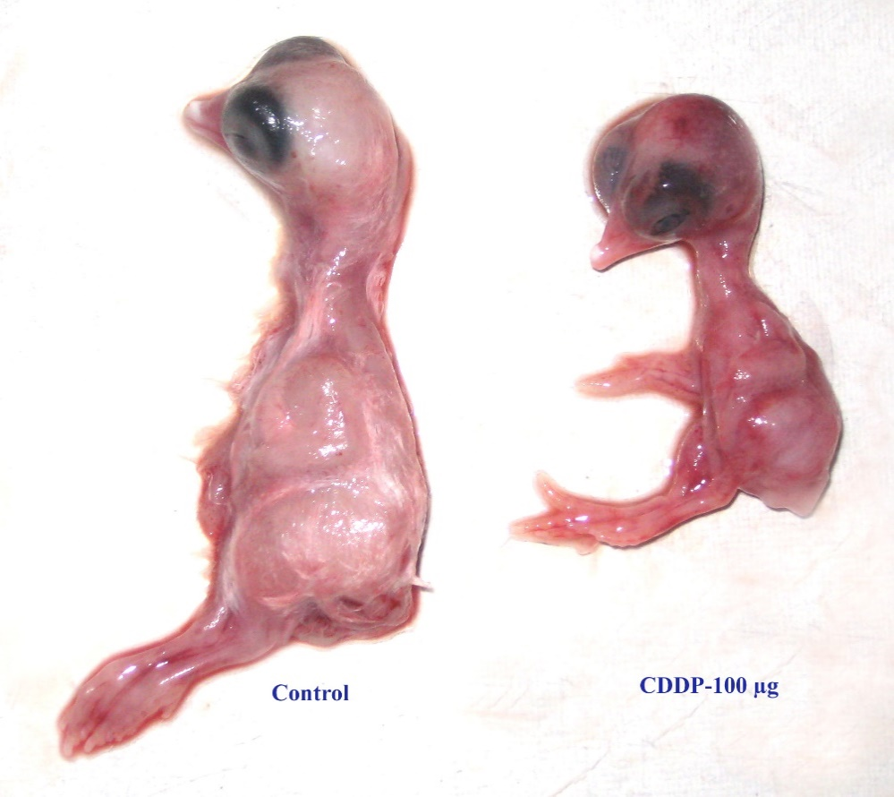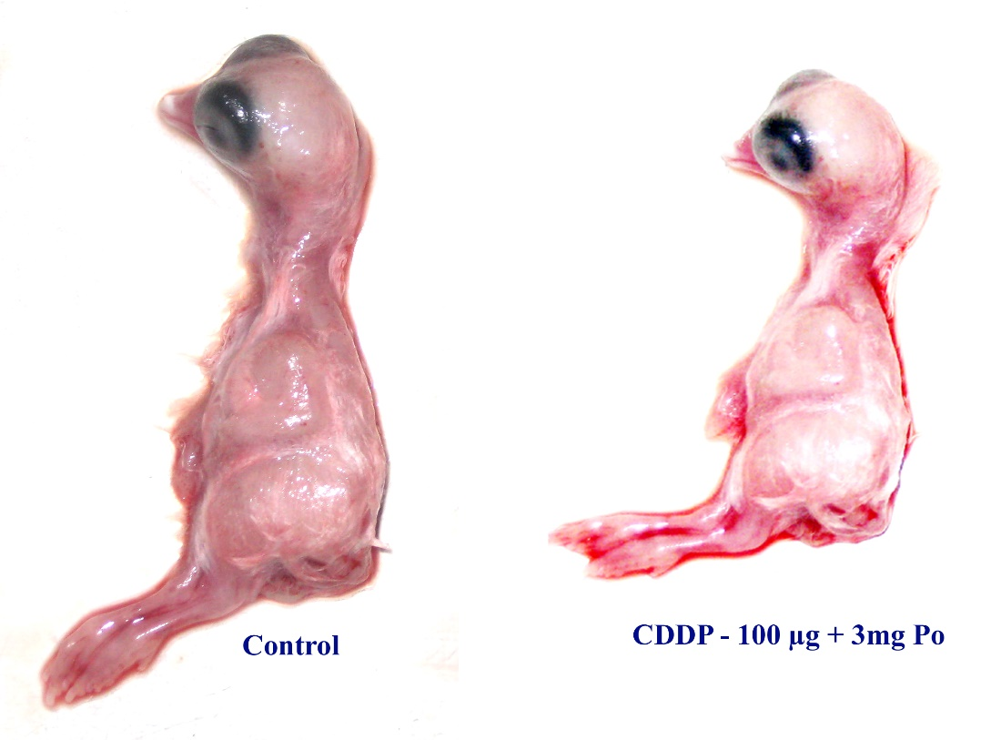

**Figure 1 : Effect of *Portulaca oleracea* L. extract on teratogenic deformities in Cisplatin induced chick embryos**

**Conclusion**

Changes in the embryo lethality, gross morphological deformities and biochemical parameters in AF with cisplatin treatment contribute towards the development of teratological changes in chick embryos and were ameliorated by pretreatment of *Portulaca oleracea* L.extract by acting as a potent protective agent during embryonic development.

**Abbreviations:** AF,amniotic fluid; ALP,alkaline phosphatase; ALT,alanine aminotransferase; AST,aspartate aminotransferase; CDDP, cis-diamminedichloroplatinum; ED,embryonic development; LD50,lethaldose; Po, *Portulaca oleracea*;

Conference details

Proceedings Of International Seminar On “Recent Advancements In Biological Sciences 2025”, PRR& VS Government College, SPSR Nellore District, Andhra Pradesh, India, April 3rd & 4th 2025

Ethical Approval

Animal Ethic committee approval has been collected and preserved by the author(s)

Disclaimer (Artificial intelligence)

Option 1:

Author(s) hereby declare that NO generative AI technologies such as Large Language Models (ChatGPT, COPILOT, etc.) and text-to-image generators have been used during the writing or editing of this manuscript.

Option 2:

Author(s) hereby declare that generative AI technologies such as Large Language Models, etc. have been used during the writing or editing of manuscripts. This explanation will include the name, version, model, and source of the generative AI technology and as well as all input prompts provided to the generative AI technology

Details of the AI usage are given below:

1.

2.

3.

**References**

Broad., J, & Sirota, J.,H., (1948). Renal clearance of endogenous creatinine in man. *Journal of Clinical Investigation,* 27; 645.

Caraway, W.T., (1963). Uric acid in *Standard methods of clinical chemistry.* Vol. 4, edited by D Seligson, D (Academic Press, New York), 239.

Hamilton, J,W., Denison, M.S.m & Bloom, S.E., (1983). Development of basal and induced aryl hydrocarbon (Benzo α pyrene) hydroxylase activity in the chicken embryo in ovo. *Proceedings of the National Academy of Sciences*, 80 ; 3372.

Hesketh, M.A., Twaddell, T., & Finn, A, A. (1990). possible role for cisplatin (DDP) in the transient hepatic enzyme elevation noted after ondansetron administration. *Proceedings American Association of Clinical Oncology*, 9; 323.

Lowry, O.H., Rosebrough, N.J., Farr, A.L., & Randall, R.J., (1951). Protein measurement with folin-phenol reagent. *Journal of Biological Chemistry,* 193; 265.

Mastan, M., Prasad, U.V., & Parthasarathy, P.R., (2007). Protective effect of *Bacopa monniera* L. on cytarabine induced biochemical changes in chick embryo. *Indian Journal of Clinical Biochemistry*, 22; 122.

Nusrat Z., Nosheen K., Lubna A., & Jaweria F., (2017). Utilizing Chick Embryo in Ovo Model System to Study the Effects of Misoprostol on Early Embryogenesis - A Pilot Study. *Journal of Stem Cell Research and Therapy*, 2(1).

Omara-Alwala, T.R., Mebrahu, T., Prior, D.E, & Ezekwe, M.O., (1991). Omega three fatty acids in purslane (*Portulaca oleracea* L.) tissues. *Journal of the American Oil Chemists' Society,* 68; 198.

Sasaki, T., & Matsui, S., (1972). Effect of acetic acid concentration on the color reaction in the o-toluidine-boric acid method for blood glucose determination. *Japanese Journal of Clinical Pathology,* 1; 346.

Surai, P.F., (1999). Tissue-specific changes in the activities in the activities of antioxidant enzymes during the development of the chick embryo. *British Poultry Science,* 40; 397.

Thigpen, T., Vance, R., Puneky, L., & Khansurt, T, (1994). Chemotherapy in advanced ovarian carcinoma: current standard of care based on randomized trials. *Gynecologic Oncology Reports*, 55 ;597.

Wershana, K.Z., Kaabees, A.Y., & Shaban, W.M., (2001). The role of two antidotes in the prevention of acetaminophen-induced toxicity in male rabbits. *The Science*, 1;157.

Zlatkis, A., Zak, B., & Boyle, A.J., (1953). A new method for the direct determination of serum cholesterol. *Journal of Laboratory and Clinical Medicine*, 41; 486.

Wang, X., Zhou, Y., Wang, D., Wang, Y., Zhou, Z., Ma, X., ... & Dong, Y. (2023). Cisplatin-induced ototoxicity: From signalling network to therapeutic targets. Biomedicine & pharmacotherapy, 157, 114045. Kumar, A., Sreedharan, S., Kashyap, A. K., Singh, P., & Ramchiary, N. (2022). A review on bioactive phytochemicals and ethnopharmacological potential of purslane (Portulaca oleracea L.). Heliyon, 8(1).

Srivastava, R., Srivastava, V., & Singh, A. (2023). Multipurpose benefits of an underexplored species purslane (Portulaca oleracea L.): A critical review. Environmental Management, 72(2), 309-320.