Histo-Morphological and Ultra-Structural study of the effect of a new sulfa drug derivative on brain and liver poisoning by cypermethrin in male domestic pigeons(Columba livia)

Abstract
This study reports the synthesis and characterization of a novel sulfa-drug derivative based on sulfapyridine and piperonal, and its application in mitigating cypermethrin-induced toxicity in domestic pigeons (Columba livia), and investigates the morphological and histopathological effects of a new sulfa drug derivative on the brain and liver of domestic pigeons exposed to cypermethrin toxicity. The study highlights the prevalence of cypermethrin, a synthetic pyrethroid insecticide, and its harmful effects on bird health. The research included 24 male pigeons, classified into control, infected, and treatment groups. The pigeons were subjected to specific doses of cypermethrin, followed by administration of the sulfa derivative to evaluate its protective effects.
Histopathological analysis of brain and liver tissues in the cypermethrin-exposed group revealed extensive vascular congestion, inflammatory infiltration, necrosis, and disruption of cellular architecture. Ultrastructural examination further confirmed severe mitochondrial damage, chromatin condensation, and blood-brain barrier impairment. In contrast, pigeons treated with the sulfa derivative exhibited marked improvement in tissue integrity, including restored cellular morphology, reduced inflammation, and activation of autophagy-related repair mechanisms.
This manuscript holds significant value for the scientific community as it sheds light on the toxicological impact of cypermethrin on different avian species, using domestic pigeons as a model, and addresses the pressing issue of pesticide-induced toxicity. By detailing the histopathological damage caused by such environmental toxins, the study provides critical insights into the potential health hazards facing both humans and animals. Moreover, the investigation into sulphonamide-based therapeutic strategies introduces a promising avenue for mitigating these harmful effects, contributing to the development of safer pharmacological interventions. This work enriches current toxicological literature and may serve as a foundation for future research in environmental health and therapeutic innovation.
Keywords: Cypermethrin, brain, liver, domestic pigeon, sulfa drug, TEM

Introduction
The domestic pigeon, “Columba livia”, is primarily a free-living, cliff-dwelling species of granivore. Pigeons are one of the most widespread and easily observed birds in all the governorates of Iraq. In addition to forming a small part of the human diet, they are kept for ornamental purposes (fine pigeons), as pets, in human sports (racing and performance), and for biological and medical experiments (1).
Animals and birds are exposed to these environmental pesticides through ingestion, inhalation, and skin contact. Through these methods, pesticides enter the body, accumulate in various organs, and cause toxicity. Other risks include causing changes in blood composition and various hormonal changes(2).
Cypermethrin is a synthetic pyrethroid used as an insecticide in large-scale commercial agriculture and consumer products for household purposes. Synthesized in 1974, it is an industrial chemical similar to the pyrethrins found in pyrethrum extract (derived from the chrysanthemum plant) (WHO, 1989). Cypermethrin acts as a fast-acting neurotoxin in insects and readily degrades in soil and on plants, but can remain effective for weeks when applied to indoor inert surfaces. Exposure to sunlight, water, and oxygen accelerates its decomposition (3)
The main effect of cypermethrin is on neuronal cell membranes by disrupting sodium-gated closure during the repolarization phase. In the normal state of neurons, sodium channels open in response to nerve impulses, allowing sodium ions to flow into the cell, resulting in depolarization. Next, the channels are closed to restore the membrane potential during repolarization.
If cypermethrin interferes with this process at low concentrations, it causes extended opening of sodium channels, leading to hyperactivity and erratic behavior in insects. This hyperactivity can lead to increased predator exposure and environmental challenges. At higher concentrations, persistent disruption of sodium channel function leads to paralysis, as neurons fail to reset their membrane potential. This paralysis may eventually lead to respiratory failure and death (4).
It is known to use sulfa therapy to control poultry diseases, particularly in the treatment of cecal coccidiosis, a parasitic infection caused by Eimeria species. Among its most prominent harms are poultry production problems and economic losses(5)
Populations of bacteria have developed resistance to various antibiotics, including sulfonamides, and this emerging resistance underscores the critical need for continuous monitoring and judicious use of antimicrobial agents in veterinary medicine (6).
Sulfa compounds were discovered and used in the early twentieth century, representing a pivotal advance in the field of chemotherapy. The introduction of sulfonamides is now highlighted as it represents an important turning point in therapeutic approaches, facilitating the effective management of bacterial infections and paving the way for the development of subsequent antimicrobial agents. The historical importance of sulfa drugs lies not only in their therapeutic efficacy but also in their role in shaping antimicrobial practices and resistance management strategies in veterinary contexts (7).
The study was designed to explore the histo-morphological and ultra-structural changes of infected pigeons by exposing them to chemical pesticides (Cypermethrine )and to experiment with treatment using a novel sulfa drug derivative prepared.

Material & Methods
1- Experimental animals:
The male pigeons were purchased from the old Basrah market, and the pigeons ranged in weight (322g). They were maintained for two weeks after the experiment was conducted to keep the birds healthy.
A total of 24 male domestic pigeons
Under normal laboratory conditions. Birds were divided as follows:
1 5 male pigeons were used in the LD50 experiment.
2. 4 male pigeons were used in the experiment to induce pesticide infection.
3 . 15 pigeons were used in the final experiment (5 males in the control group, 5 males in the pesticide-infected group, and 5 males in the pesticide-infected group treated with the sulfa derivative).
- Sampling for morphological study
Male pigeons were euthanized by the method of inhalation anesthesia, and then a longitudinal incision was made through the body
and chest to study the anatomical structures. The parameters used during the gross study include measurements of the length and width by using Vernia. (8)
B-Sampling for Histopathological Study
Brain and Liver were fixed in buffered formalin (10 %), dehydrated in ethyl alcohol and xylene, embedded in paraffin, cut into 5- 6 µm sections, and stained with hematoxylin and eosin for microscopic investigation. All histological alterations were recognized(9)
C-Transmission Electron Microscope Study
The tissue was cut into small pieces and fixed in a solution of 2.5% glutaraldehyde in phosphate buffer for 2 hours. The samples were then washed three times to remove stabilizer residue. Secondary fixation was performed using 1% osmium tetroxide in the same buffer for 1 hour. The samples were then dried with ethanol solutions, acetone, and Epon 812 resin. For embedding, the samples were permeated in acetone and Epon 812 resin, immersed in pure resin three times, and embedded in molds. The samples were then analyzed using light microscopy and electron microscopy. Semi-thin sections were cut at 1.5 µm and stained with toluidine blue, while ultra-thin sections were compared to uranyl acetate and lead citrate and examined using electron microscopy. Examinations were conducted using a transmission electron microscope (Philips EM208S) at an acceleration voltage of 100 kV in specialized laboratories in Tehran, Iran. (10)
2- Insecticide used:
Common name: cypermethrin
Trade name: Piperone, Cyprin, Keppra
Chemical name: (S)-α-cyano-3-phenoxy benzyl (Z)-cis-3-(2,2-dichloroethane)-2,2-dimethyl cyclopropane carboxylate
Chemical class: pyrethroid
Manufacturer: The producing company “YUFULL”
LD50: 200 mg/kg of body weight.
3-Synthesis of sulfa drug derivative
(0.002 mmol 5.0 gm) Sulfapyridine was added to a hot ethanolic solution, and 1.203 mmol (0.3 g) of piperonal. Three drops of glacial acetic acid were added, and the resulting solution was refluxed for three hours before being refrigerated overnight. The product was recrystallized using chloroform: methanol (8:2, v/v) to get orange crystals of
Scheme 1: Preparation of sulfa drug derivative

Results
Clinical Observation
Birds were monitored for behavioral and physiological changes, including vomiting, wing twitching, head shaking, throat irritation, appetite reduction, aggression, and weight loss. After treatment, changes in food intake and weight gain were recorded.
Morphological study
Brain
The brain of the pigeon showed congestion of surface blood vessels, edema, and localized hemorrhages, suggesting vascular disturbances and brain tissue swelling. Fig1.
After being treated with a new sulfa drug derivative, the pathogen decreased, was normal in appearance and size, and had a mild amount of fluid.
Liver
The liver of the pigeon exhibited congestion and swelling with dark red discoloration and scattered yellowish foci, indicating vascular disturbances and possible necrotic or fatty changes.
After being treated with a new sulfa drug derivative, the decreased pathogenin appearances, color, and size. Fig 2.
Histopathological study
Cerebrum
Cross sections of the cerebrum in the group of affected showed prominent histological changes, represented by severe vascular congestion, in which the blood vessels were filled with erythrocytes. Areas of surrounding nervous tissue were also observed, showing fragmentation and disruption, with scattered neural and glial elements, indicating damage to the tissue structure of the brain.Fig3
In contrast, histological sections from the group of treated showed significant improvement, with neural tissue appearing normal without obvious signs of congestion or fragmentation. These results indicate the effectiveness of treatment in reducing the histological changes associated with injury, reflecting a positive effect in maintaining the integrity of the brain's histological structure. Fig 4
Liver
A cross-section of liver in the group of affected individuals revealed significant pathological alterations. Notably, there was marked dilation and congestion of the central vein, accompanied by inflammatory infiltration. The hepatic parenchyma exhibited extensive congestion, with inflammatory cell infiltration and degeneration of hepatocytes. Furthermore, areas of hepatocellular necrosis were observed, indicating substantial tissue damage and compromised hepatic function. Fig5
In contrast, liver sections from the treatment group demonstrated preservation of normal histological architecture. Hepatocytes appeared healthy and were arranged in cords radiating from the central vein. The sinusoids were regularly distributed and lined by intact endothelial and Kupffer cells, reflecting the restoration of normal hepatic microarchitecture. Fig6

Ultrastructure (TEM ) study

Cerebrum

Transmission electron microscopy of the cerebrum in the affected group showed fine structural changes indicating severe damage to nerve tissue. These changes consisted of an imbalance or impairment of the blood-brain barrier function, leading to leakage of harmful substances and pesticides into the cerebral tissue. Axonal degeneration and destruction of myelinated membranes have also been observed, indicating neurotoxicity resulting from pesticide exposure.Fig7

Upon examination at higher magnification, a change in the shape of the cells that make up the blood-brain barrier to a circular shape and damage as a result of exposure to cypermethrin were observed. The sections also showed the presence of oxidative stress that led to the cessation of neural stem cell proliferation, in addition to the destruction of mitochondria in nervous tissue, leading to loss of cellular energy and organelle hypertrophy.Fig8

In contrast, transmission electron microscopic sections of the cerebrum in the treatment group showed a significant improvement in the cytoskeleton. A partial restoration in the blood-brain barrier function was observed, with an improvement in the integration of the nucleus and nuclear membrane, suggesting a restoration of normal cellular activity. Autovesicles, lysosomes, and chromatin were also observed, demonstrating the activation of cellular repair mechanisms such as autophagy, a process that helps eliminate damaged cellular components and promote internal homeostasis. Fig 9,10

These results suggest that the administered treatment has contributed to the reduction of microstructural alterations associated with toxicity, reflecting a positive effect in the recovery of brain function and the maintenance of the integrity of nervous tissue.
Liver
Transmission electron microscopy of the liver in the infected group showed fine structural changes indicating severe hepatocellular damage. These changes were chromatin clumping and nucleolar fragmentation, indicating programmed cell death. Accumulations of lipofuscin granules Fig. 11, which are fatty oxidation products that are an indicator of oxidative stress and accumulation of byproducts in cells, have also been observed. In addition, mitochondria were swollen and malformed, with loss of internal membranes, suggesting a defect in cellular energy function. Changes were also observed in the cytoplasm, becoming softer, with an increase in the number of lysosomes, showing a cellular response to damage. Fig 12
In contrast, transmission electron microscopy of the liver in the treatment group showed significant improvement in the cytoskeleton. A partial restoration in mitochondrial organization was observed, with relative stability in nucleus and chromatin, suggesting restoration of normal cellular activity Fig. 13. Autovesicles, lysosomes, and chromatin were also observed, demonstrating the activation of cellular repair mechanisms such as autophagy, a process that helps eliminate damaged cellular components and promote internal homeostasis. Fig 14
These results suggest that the administered treatment has contributed to the reduction of microstructural changes associated with toxicity, reflecting a positive effect in the recovery of hepatic function and maintenance of hepatocellular integrity.

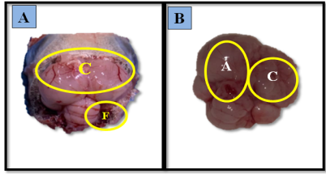
Fig1: A\Anatomical section from brain of (infected group) showing ,(C) congested surface blood vessels,(F) Foam material \ B\ Showing ,(C) congested surface blood vessels,(A) Atrophy

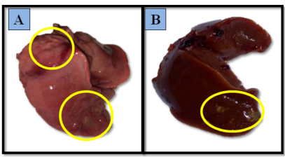
Fig 2: Anatomical section from the liver of the infected group showing the liver appears enlarged, friable, and stained with bile. The liver surface is irregular with pale foci and areas of hemorrhage.

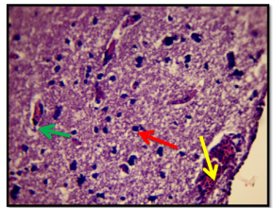
Fig 3 : Cross section from cerebrum of (infected group ) shows, demonstrating marked vascular congestion (yellow arrows). Numerous blood vessels are engorged with erythrocytes (green arrows). The surrounding neuropil appears disrupted in some regions, with scattered neuronal and glial elements visible (red arrows ). (H&E stain 40X)

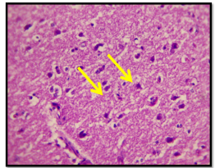
Fig4: Cross section from the cerebrum of( treatment group) shows normal neuropil (H&E stain 40X)

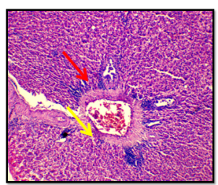
Fig 5: Cross section from liver of (infected group ) shows dilation and congestion, an inflammation of central vein (yellow arrows), congestion with inflammation and degeneration of hepatocytes, and necrosis of some hepatocytes( red arrows) (H&E stain 40X)

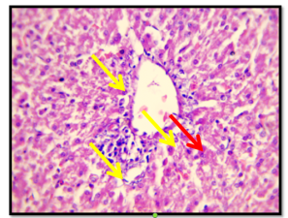
Fig 6: Cross section from liver of ( treatment group shows normal hepatocytes arranged in cords radiating from the central vein (yellow arrows). Sinusoids are lined by endothelial and Kupffer cells and appear regularly distributed (red arrows).. (H&E stain 40X)

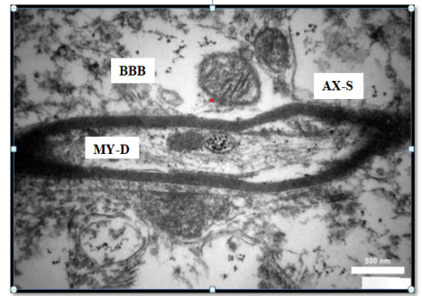
Fig7 : Transmission electron micrograph from cerebrum of (infected group) shows (BBB) Imbalance or weakness in the blood-brain barrier, which leads to the leakage of harmful substances, and(AX-S) axonal degeneration is observed. (MY-D) Myelin sheaths are disrupted. Scale bar = 500 μm

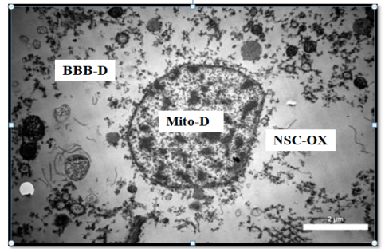
Fig 8\ Transmission electron micrograph from cerebrum of (infected group) show, (BBB-D) The shape of the cells that make up the (BBB) changes to a circular shape and is damaged, (NSC-OX) Oxidative stress leads to the cessation of neural stem cell proliferation, (Mito-D) Mitochondrial damage in nervous tissue e leads to loss of cellular energy and enlargement of organelles. Scale bar = 2 μm

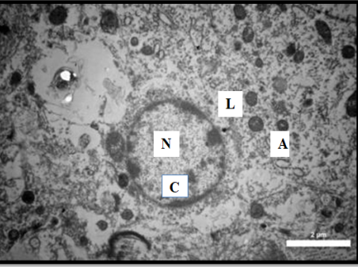
Fig 9\ Transmission electron micrograph from cerebrum of (treatment group) shows that partial recovery is visible. (N) Nucleus and Nuclear membrane integrity are improved (A). Autophagosomes represent a cellular defense mechanism in which a cell recycles its damaged components, restoring homeostasis. (L) Lysosome, (C) Chromatin. Scale bar = 2 μm.

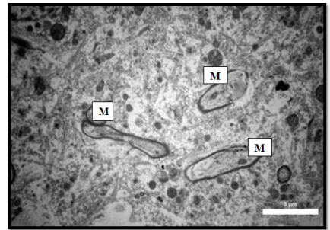
Fig10 \ Transmission electron micrograph from cerebrum of( treatment group) shows (M) myelin sheaths appear partially restored. Reduced cytoplasmic vacuolation and improved organelle arrangement. Scale bar = 3 μm."

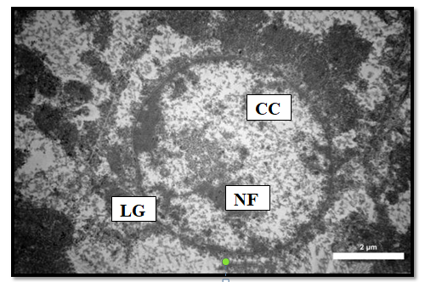
Fig11 \ Transmission electron micrograph from liver( infected group) showing. (CC) Chromatin clumping, (NF) nuclear fragmentation, (LG) lipofuscin granules. Scale bar = 2 μm

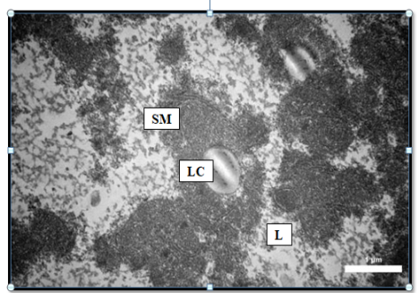
Fig12 \ Transmission electron micrograph from liver (infected group) showing (SM) swollen mitochondria,(LC) Loose cytoplasm, and (L) Lysosome. Scale bar = 1 μm

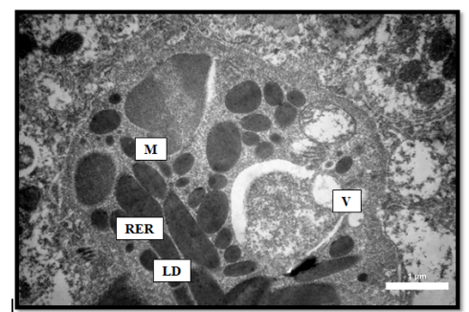
Fig 13\ Transmission electron micrograph from liver( treatment group) showing Improvement in cellular structure is observed: (M) partial restoration of mitochondrial organization and relative nuclear stability, and (RER) and (LD) lipid droplets. (V) Some vacuoles remain. Scale bar = 1 μm

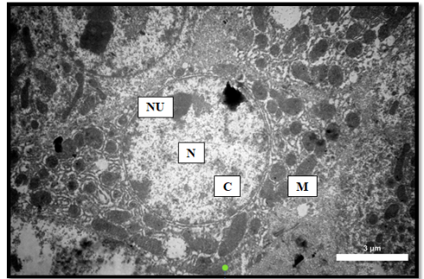
Fig 14\ Transmission electron micrograph from liver( treatment group) showing, Improvement in cellular structure is observed: (N) Nucleus (NU) Nuclei, (C ) Chromatin ( M) mitochondrial organization and relative nuclear stability. Scale bar = 1 μm

Discussion

Cpermethrin is a synthetic pyrethroid insecticide that has been widely utilized for over four decades, accounting for a significant proportion of global insecticide use. It is derived from chrysanthemum flowers and is known to exert its toxic effects by interfering with the voltage-gated sodium channels of neuronal membranes (11,12).
In this study, pigeons exposed to cypermethrin demonstrated marked pathological alterations, especially in hepatic and neural tissues. These alterations are consistent with previous reports indicating that cypermethrin undergoes hepatic metabolism primarily through microsomal enzyme systems involving hydrolytic cleavage and oxidative pathways (13).
The above findings were confirmed by histopathological changes in the liver under the effect of cypermethrin..This study observed marked damage to the liver tissues, vascular congestion, and hepatic necrosis. The changes in this histoarchitecture of the liver could be due to the toxic effect of cypermethrin, which affects the structure of hepatocytes, causing their dysfunction. These results are similar to those (14)
The current findings confirm that cypermethrin induces axonal degeneration and disruption of the blood-brain barrier, congestion, and inflammatory changes, similar to neurotoxic changes, corroborating the neurotoxic potential of cypermethrin described by (15, 16).
Interestingly, the present study also observed significant protective effects following treatment with a novel sulfa drug derivative. Treated groups displayed improvement in both histological and ultrastructural features of the brain and liver, including the restoration of cellular architecture and reduced signs of necrosis and inflammation. These outcomes are in alignment with emerging evidence highlighting the antioxidative and membrane-stabilizing properties of sulfonamides (17).
Overall, the data advocate for the potential application of sulfa compounds as a therapeutic intervention against pesticide-induced toxicity of domestic pigeons. Future research should aim at elucidating the molecular mechanisms underlying this protection and evaluating the efficacy of such treatments across different species and environmental conditions.
Conclusion
The present study offers compelling evidence that exposure to cypermethrin, a widely used synthetic pyrethroid insecticide, induces marked histopathological and ultrastructural alterations in the brain and liver tissues of domestic pigeons (Columba livia). These pathological effects include vascular congestion, neuronal and hepatocellular degeneration, mitochondrial damage, and disruption of tissue architecture, confirming the neurotoxic and hepatotoxic nature of cypermethrin.
Significantly, the administration of a novel sulfa drug derivative demonstrated considerable protective and restorative effects. Treated pigeons showed a substantial reduction in tissue damage, with clear improvement in cellular morphology and ultrastructure in both neural and hepatic tissues. These findings suggest that the sulfa compound facilitated tissue recovery, potentially through its antioxidant and membrane-stabilizing properties, as supported by transmission electron microscopy and histological assessments.
This study not only highlights the toxicological risks posed by environmental pesticides such as cypermethrin but also underscores the therapeutic promise of sulfonamide-based interventions in mitigating such damage. Further research should aim to investigate the molecular mechanisms underlying the observed protective effects and evaluate the efficacy of this treatment across different avian species and toxicological contexts. Collectively, these findings contribute valuable insight into veterinary toxicology and support the continued exploration of sulfa derivatives as a protective strategy against chemical-induced organ toxicity.
Ethical approval
College of Veterinary Medicine Committee Medicine, University of Basra, accredited All procedures used in this study were in By License No.71/2024.
Disclaimer (Artificial intelligence)
Option 1:
Author(s) hereby declare that NO generative AI technologies such as Large Language Models (ChatGPT, COPILOT, etc.) and text-to-image generators have been used during the writing or editing of this manuscript.
Option 2:
Author(s) hereby declare that generative AI technologies such as Large Language Models, etc. have been used during the writing or editing of manuscripts. This explanation will include the name, version, model, and source of the generative AI technology and as well as all input prompts provided to the generative AI technology
Details of the AI usage are given below:
1.
2.
3.
References
1. Al-Barwari, S. & Saeed, I. (2012). The Parasitic Communities of the Rock Pigeon *Columba livia* from Iraq: Component and Importance. Turkiye Parazitol Derg ;36(4):232-239
2. Chourasiya, S., & Mahobiya, P. (2022). Toxicology and Mode of Action of Cypermethrin. Department of Zoology, University of Sagar, (M.P.), India
3. Velisek, J., Wlasow, T., & P.(2006) . Effects of Cypermethrin on Rainbow Trout (Oncorhynchus mykiss). Veterinarni Medicina, 51, (10): 469–476
4. Baker, R. R., & Hargreaves, B. (2012). "Pesticide action: Mechanisms and effects." In Pesticide Chemistry and Toxicology (pp. 123-145). Springer
5. Kiser, J. S., Waters, M. K., Wirshup, M. I., & Bottorff, C. A. (1946). Sulfonamide Blood Concentrations in Chickens and Turkey Poults. *Volume 27, Issue 2*, 1 March 1948, Pages 219-222.
6. Al-Masoudi, W. A.; Faaz, R. A.; Al-Asadi, R. H.; Jabbar, H. S. Synthesis, Antimicrobial Activity and Modelling Studies of Some New Metal Complexes of Schiff Base Derived from Sulphonamide Drug in Vitro. Eur. J. Chem. 2016, 7, 102-106.
7. Mohammed, S. J., Azzam, A. A., & Al-Hadedi, S. A. (2022). The Role of Sulfa Drugs in Our Lives. Rafidain Journal of Science. Vol. 31, No.3, pp.64-74.
8. Schmidt, R. E., & Reavill, D. R. (2015). Pathology of Pet and Aviary Birds (2nd ed.). Wiley-Blackwell.
9. Luna, L.G.(1968) . Manual of Histological Staining Method of Armed Forces. Institute of Pathology. 3rd ed. Raw Hill Book Co., New York.
10. Xiao, J., Wang, F., Liu, Z., & Yang, C. (2013). Telocytes in liver: Electron microscopic and immunofluorescent evidence. Journal of Cellular and Molecular Medicine, 17(12), 1552-1560
11. World Health Organization (WHO). (1989). Cypermethrin (Environmental Health Criteria 82). International Programme on Chemical Safety. Retrieved from https://www.inchem.org/documents/ehc/ehc/ehc82.htm
12. Cox, C. (1996). Insecticide fact sheet: Cypermethrin. Journal of Pesticide Reform, 16(2), 15–20.
13. Khan, A. (2022). The cellular mechanism involved in cypermethrin-induced neurotoxicity. Research in Pharmaceutical Biotechnology, 14(2), 45–53. Retrieved from
14. Kouamo, J., Kouatcho, F. D., Zanseh, G. G. Y., Vemo, B. N., & Ngoula, F. (2021). Effects of cypermethrin on growth, biochemical, and reproductive parameters in female Japanese quails (Coturnix japonica). Journal of Infertility and Reproductive Biology, 9(1), 43-51
15.Al-Azizz, S. A. (2012). Neurotoxic effects of cypermethrin in Wistar rats: A haematological, biochemical and histopathological study. Journal of Health Science, 58(3), 300–307.
16. Nieradko-Iwanicka, B., & Borzęcki, A. (2008). Effect of cypermethrin on memory, movement activity, and coordination in mice after transient incomplete cerebral ischemia. Pharmacological Reports, 60(5), 699–705.ResearchGate+3ResearchGate+3scientifictrends.org+3
17. Mohammed, A. A., El-Banna, H. A., & El-Khatib, A. H. (2022). Antibacterial activities of sulfonyl or sulfonamide-based derivatives: A short review. European Journal of Medicinal Chemistry, 229, 114009

