Scanning Electron Microscopic Analysis of Some Vital Structures of Oncorhynchus mykiss (Family: Salmonidae) from Kashmir Himalayas

ABSTRACT
The study uses Scanning Electron Microscopy (SEM) to analyze the lower jaw and gills of Oncorhynchus mykiss collected from Kashmir's clear mountain streams. A total of eight specimens were analyzed. The high-resolution images provide detailed information about these parts, helping researchers understand their functional adaptations. SEM work on the rainbow trout showed that the lower jaw and gills are finely adapted for feeding and breathing. The lower jaw displays a dense arrangement of teeth: strong forward points grip prey while softer, finer teeth process food. SEM examinations revealed the occurrence of canine teeth, ranging from 11-13 (designated as CT). The mean diameter of a tooth in Oncorhynchus mykiss was relatively small, measuring between about 1 and 2 millimeters. The jaw is divided into a smooth front half and a folded, ridged back half with a central bump or tubercle. The gills (arches, rakers, and filaments)work together to move oxygen into the blood and remove carbon dioxide. Long, thin filaments arranged in two rows along the arch, forming anterior and posterior hemibranches. Gill rakers (comb-like structures) filter debris to protect the gill filaments. Primary lamellae branch out into many secondary lamellae, increasing the respiratory surface area available to the fish. The study highlights the structural features that facilitate feeding, respiration, and environmental interactions, providing useful knowledge for fish farmers and conservation biologists.
Keywords: Rainbow trout, gills, lower jaw, SEM, Kashmir
- INTRODUCTION
Oncorhynchus mykiss(or Rainbow trout) is an important species in terms of its ecological and economic value (Yoğurtçuoğluet al., 2021). It was introduced in Kashmir in 1912 and is now established in almost all the cold-water streams of the valley (Shah et al., 2013). The distinct climate and altitude of Kashmir provide a rich context to examine how these fish adapt their body shape and fin structure to the extreme streams of the region (Ahmad et al., 2023). Most adults weigh between 2 and 3 kilograms and specimens as large as 25.4 kilograms and 120cm total length have been recorded (Froese and Pauly, 2009). Rainbow trout prefer clear, cold headwaters, tributary creeks, small to large rivers, deep lakes, and even brackish intertidal zones in mild coastal estuaries (Page and Burr, 2011). Anadromous populations ascend coastal streams to spawn (Page and Burr, 1991) and are stocked in various water bodies but typically not in water that exceeds summer-temperature peaks above 25 °C or chronic low-oxygen levels (Swales, 2006). Most trout consume drifting insects, crustaceans, small fry, or zooplankton, whereas marine migrants supplement their diet with larger fish and squid, learning to recognize prey visually as they leave freshwater (Benjamin et al., 2013). When spawning time nears, undertake short to moderate migrations, though true anadromous fish and lake-strain trout may traverse tens of kilometers before reaching their natal gravel beds (Kottelat and Freyhof, 2007). Many countries culture rainbow trout, and often artificially bred and hatched trout fry are released into rivers and lakes to attract recreational fishers (Fausch, 2007).
The gills are the site of respiration and are vital for the extraction of oxygen from water (Brauner and Val, 2005). The complex gill structure, with primary and secondary lamellae, serves to maximize the surface for gas exchange and allows for efficient O2 exchange under fluctuations in the aquatic environment (Fernandeset al., 2007). Study on the micro-details of the gills under SEM gives us an opportunity to know about the adaptations that may be essential for sustaining respiratory efficiency in the non-polluted, cold and oxygen-rich waters of Kashmir, by the trout. Such knowledge is crucial to evaluate how ecological changes like temperature changes of the water and pollution may influence the respiratory health and the survival of the species. The rainbow trout lower jaw is central to feeding and prey capture (Konow and Sanford, 2008). Jaw morphology, such as the pattern, form, and organization of teeth, has a direct impact on the ability of the trout to grasp, manipulate, and process prey items (Hyatt, 1979). SEM examination of the lower jaw offers clear photographs of these structures and enables us to see how the trout dentition accommodates its diet, comprising aquatic and terrestrial invertebrates and small fishes. Recognition of these adaptations is important for assessing the feeding efficiency of the trout and ecological interactions in the habitat. Examination of these two structures has important ecological and utilitarian ramifications.
Scanning Electron Microscopy (SEM) gives a high-resolution view, uncovering fine details that improve our comprehension of the functionality and adaptation of diverse features (Zhou et al., 2007). SEM analysis focuses on revealing the intricate physiological adaptations facilitating the survival of Rainbow trout in contrasting aquatic habitats. By investigating the anatomy and physiology of their gills, essential for oxygen capture and respiratory efficiency, and the mechanics of their lower jaw, essential for feeding and prey capture, this study aims to explain how such anatomical structures enable the trout to survive and thrive ecologically. This study has important implications for aquatic biology, as it strengthens our knowledge of fish physiology and informs conservation efforts, enhances aquaculture practice, and supports the management of freshwater ecosystems by elucidating how the environment may influence these important physiological features.

- MATERIAL AND METHODS
Specimens of Rainbow trout (Plate 1) were collected from a trout farm and brought to the Fisheries Resource Management Laboratory, Faculty of Fisheries, RangilGanderbal. Gills and lower jaw were dissected. Immediately after their removal, they were cleaned using a fine bush washed thoroughly with double-distilled water and were fixed in 2% glutaraldehyde (CDH, Batch No. 036080) prepared in 0.1M Sodium Cacodylate buffer (CDH, Batch No. 030118) at pH of 7.2 for 24 hours at 4°C. Following the primary fixation, the tissues were washed in Sodium Cacodylate buffer for 15-30 minutes. Dehydrated in ascending grades of acetone and dried in Tetramethylsilane (Deyet al., 1989). The dried samples were secured with double-sided adhesive tape A conductive coating of gold was applied to the sample using an Ion-Sputter coater by creating a low vacuum in the sputtering chamber.The gold coating overcomes the problem of charging and beam damage.The coated samples were examined using a scanning electron microscope using secondary electron emission mode at an accelerating voltage of 10 volts.
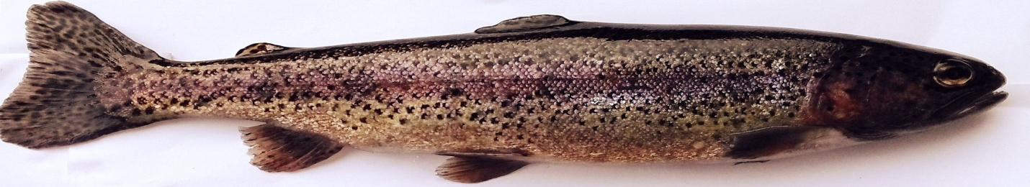
Plate 1: Sample of Oncorhynchus mykiss (Rainbow trout)

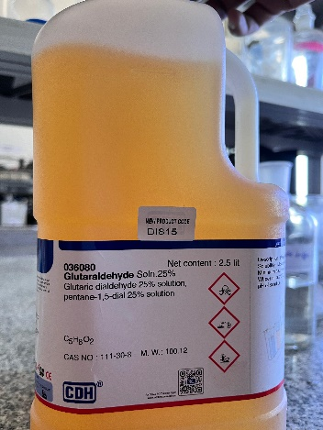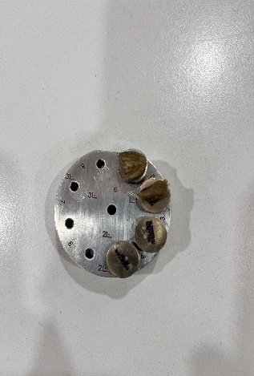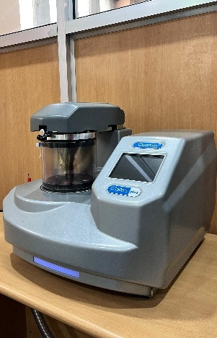
Figure 1: Glutaraldehyde
Figure 2: Sodium Cacodylate
Figure 3: Loading of samples for gold coating

- RESULTS
Scanning Electron Microscopy (SEM) examination of Oncorhynchus mykiss lower jaw (Figure 4) showed a number of important features necessary for feeding and sensory functions. The jaw surface had a high concentration of teeth that were of different sizes and shapes. There were larger and stronger teeth along the anterior region of the jaw, which were presumably used for biting and tearing prey. Finer, slenderer teeth were found towards the back, perhaps to ease food manipulation and processing. SEM examinations revealed the occurrence of canine teeth, ranging from 11-13 (designated as CT). The mean diameter of a tooth in Oncorhynchus mykiss was relatively small, measuring between about 1 and 2 millimeters. The lower jaw was characterized by a tubercle located centrally at the juncture of its two halves. The jaw was separated into anterior and posterior areas. The anterior area slopes downward smoothly on each side, and the epithelium covering this area appeared smooth (labeled as EP). The epithelium over the posterior area appeared folded. The gills of Oncorhynchus mykiss consisted of complex lamellar structures essential for effective gas exchange. Each gill consisted of a gill arch (GA 1, 2, 3, 4, 5), gill rakers (GR), and gill filaments (GF) as shown in Figure 5a. Figure 5b illustrated the ultrastructure of gill filaments. The gill filaments were located in the posterior portion of epibranchial and ceratobranchial bones and were arranged in two rows along the arch length, forming anterior and posterior hemibranches, both of which constitute the holobranch. From the gill arch arose several gill filaments, equidistant from each other, giving it a leaf-like structure. The length of the gill filaments varied with different locations in the gill arch. Figure 5c depicted the gill rakers present on the anterior side with some elevation on the posterior side. Gill rakers appeared comb-like in structure. Such rakers were responsible for sifting out trash and keeping it from damaging the thin gill filaments when breathing. The rakers were placed side by side against the branchial filaments, directed towards the opercular cavity. Figure 5d illustrated the high-powered view of gill lamellae. The main lamellae, which were supported by a central gill arch, extended into secondary lamellae, enormously expanding the respiratory surface area.

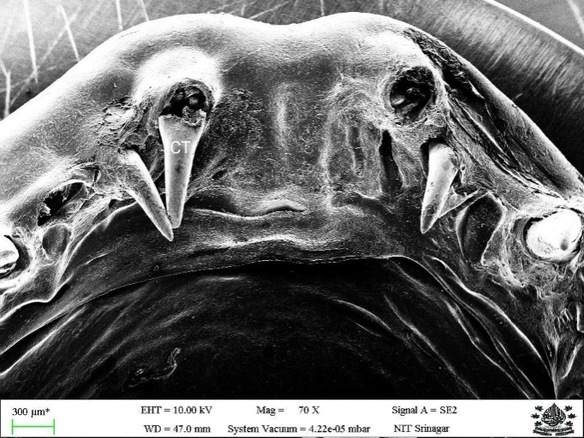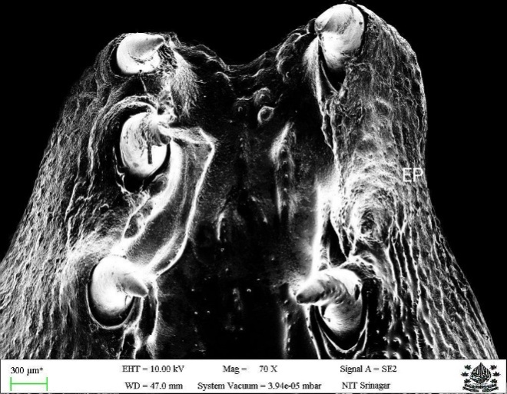
Figure 4: Scanned image of teeth from the Lower Jaw of Oncorhynchus mykiss

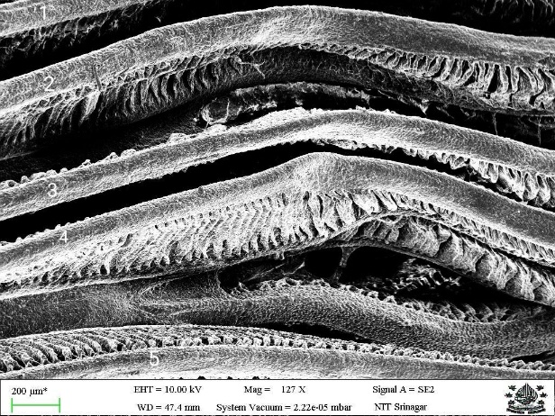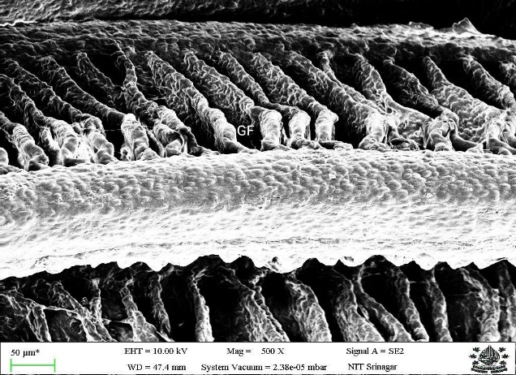
Figure 5(b): depicted the ultrastructure of gill filaments
Figure 5 (a): SEM analysis of gill of rainbow trout shows the surface structure of five-gill arches marked as (GA1-GA5) and gill filaments(GF) which are narrow at the ends and wider in between.

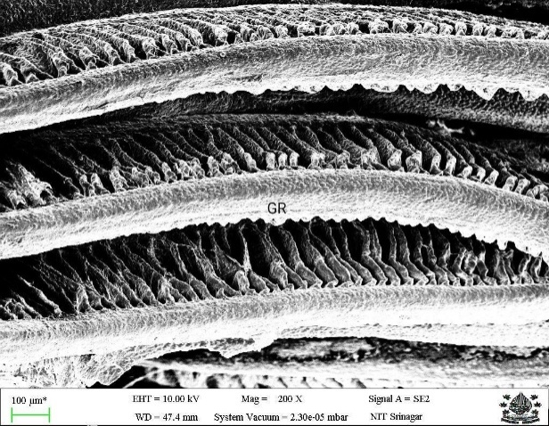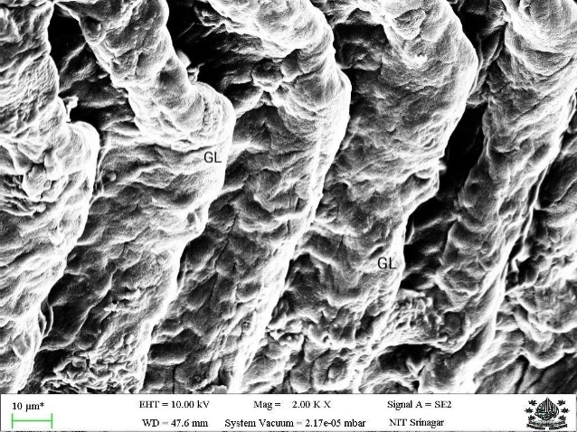
Figure 5(d): magnified image of gill lamellae
Figure 5(c): depicted the length of each filament exceeds the width and gill rakers(GR) are present on the anterior side with some small elevations on the posterior side

- DISCUSSION
The microstructural adjustments seen in the lower jaw and gills of Oncorhynchus mykiss reflect the species' success in adapting to varied environmental conditions. The strong dentition and sensory system of the lower jaw optimize prey capture and sensing of the environment, vital for survival in the dynamic Kashmir aquatic environments (Belsare, 2007). The Scanning Electron Microscopy (SEM) study of the lower jaw of Oncorhynchus mykiss has offered useful information on its feeding and sensory adaptations. The dentition found indicates a complex tooth arrangement that reflects the dietary and feeding habits of the fish. The larger, more heavily built teeth at the front of the jaw indicate that they are used to grasp and tear the prey. This specialization is necessary for predation activities, enabling the fish to successfully capture and manipulate its prey (Hyatt, 1979). Conversely, the smaller, more fragile teeth toward the back of the mouth are probably specialized for handling and processing food, enabling efficient ingestion and digestion (Gerking, 2014). The SEM examination further revealed the presence of canine teeth, 11 to 13 in number, with an average diameter of about 1 to 2 millimeters. The comparatively small size of the teeth follows the type of feeding of Oncorhynchus mykiss, which is mainly the capture and processing of smaller prey items. The lower jaw is also characterized by a central tubercle at the junction between its two halves, possibly helping in the structural stability of the jaw or its movement. The fact that the division of the jaw into anterior and posterior parts presents a smooth epithelium for the anterior and a folded epithelium for the posterior implies functional differentiation. The smooth surface of the anterior part can allow for efficient movement of prey into the mouth, whereas the folded epithelium in the posterior part might contribute to increased sensory perception or food processing (Yadev, 2006). In-depth anatomical analyses have demonstrated that the specialized morphology of the lower jaw, in terms of tooth arrangement and tooth replacement rate, is directly associated with feeding habits and ecological niches of the fish (Gould, 1977). Such adaptations explain pressures acting on the feeding mechanism of carnivorous fish during evolution. Overall, these structural attributes indicate the intricate adaptations of Oncorhynchus mykiss' lower jaw to its ecological niche and feeding behaviors.Godoy et al. (2022) studied a comprehensive SEM investigation of mandible bone in the Oncorhynchus mykiss and showed that mineral bioavailability and environmental conditions modifies the skeletal microstructure which is according to our results that jaw morphology and functional adaptation of Kashmir population are strongly correlated.
In this study, the morphology of Oncorhynchus mykiss gills was thoroughly described to clarify its functional gill adaptations for gas exchange. Our careful observation identifies a number of essential structural features of the gills, which are the essence of their efficiency during respiration. The structures of the gills, with their broadened surface area and protective attributes, provide effective respiration as well as resistance against external stressors (Farrell and Richards, 2009). The gills consist of various different components such as the gill arches (GA 1, 2, 3, 4, 5), gill rakers (GR), and gill filaments (GF). The gill arches act as the supportive scaffolding from which gill filaments project (Sackville et al., 2024). The gill filaments that exist within the posterior parts of the epibranchial and ceratobranchial bones are placed in two parallel rows along the axis of each arch, and these form the anterior and posterior hemibranches. The hemibranches combined form the holobranch. This arrangement is crucial for maximizing the surface area to achieve gas exchange (Hughes, 2023). The gill filaments occur equidistantly on the gill arch to give it a leaf-like structure. This regular spacing increases the efficacy of water circulation through the gills (Satchell, 1971). Filament length variation along the arch is a developmental adaptation that probably maximizes respiratory performance along varying regions of the gill to allow for effective gas exchange, whatever the local hydrodynamic conditions (Turko, 2018). The comb-like shape of the gill rakers occurs on the anterior surface of the gills. These rakers, distinguished by their height on the posterior aspect, play a vital role in their filtering process. They act to capture and eliminate particulate debris from the water before it hits the sensitive gill filaments. This protective role is vital in the preservation of the integrity of the gill surface and guaranteeing unhindered respiratory function (Evans et al., 2005). The lamellar structure of the gills illustrates the main lamellae, supported by the central gill arch, branching out into secondary lamellae. Through this branching, the respiratory surface area is greatly increased, helping to enhance the gills' capacity for efficient gas exchange (Bernal et al., 2001). The added surface area created by the secondary lamellae is important in the achievement of fish's metabolic needs, particularly under conditions of high activity or in fluctuating environmental conditions (Jenjan, 2011). The complex structural characteristics evident in the Oncorhynchus mykiss gills are indicative of a high level of specialization for effective respiratory exchange of gases. Systematic gill filament arrangement, gill raker protective role, and extensive lamellae surface area in combination all enable the fish to survive in its aquatic environment. This exhaustive characterization not only enhances our knowledge of rainbow trout gill morphology but also serves as a comparative framework within other species of fish. These high-resolution morphological observations presented by SEM can guide aquaculture practices by identifying characteristics related to health and growth performance. Additionally, knowing these adaptations can help in monitoring the environmental health of aquatic ecosystems in Kashmir.
- CONCLUSION
SEM analysis is useful in illuminating the lower jaw and gills of Oncorhynchus mykiss and showing adaptations that make feeding more efficient and respiratory function more effective in the special environment of Kashmir. The research forms part of wider knowledge on the morphology of fish and provides applied utility in aquaculture and environmental science.
DISCLAIMER (ARTIFICIAL INTELLIGENCE)

Author(s) hereby declare that NO generative AI technologies such as Large Language Models (ChatGPT, COPILOT, etc) and text-to-imagegenerators have been used during writing or editing of this manuscript.

References
Ahmad, S. U., Zafar, I., Bibi, S., Jan, Z., Ullah, A., Ahmad, I., ... & Rather, M. A. (2023). The Rainbow Trout Genome: A Significant Milestone for Aquaculture Development. In Coldwater Fisheries and Aquaculture Management (pp. 1-33). Apple Academic Press.
Belsare, D. K. (2007). Introduction to biodiversity. APH Publishing.
Benjamin, J. R., Connolly, P. J., Romine, J. G., & Perry, R. W. (2013). Potential effects of changes in temperature and food resources on life history trajectories of juvenile Oncorhynchus mykiss. Transactions of the American Fisheries Society, 142(1), 208-220.
Bernal, D., Dickson, K. A., Shadwick, R. E., & Graham, J. B. (2001). Analysis of the evolutionary convergence for high performance swimming in lamnid sharks and tunas. Comparative Biochemistry and Physiology Part A: Molecular & Integrative Physiology, 129(2-3), 695-726.
Brauner, C. J., & Val, A. L. (2005). Oxygen transfer. Fish Physiology, 21, 277-306.
Dey, S., Baul, T. B., Roy, B., &Dey, D. (1989). A new rapid method of air‐drying for scanning electron microscopy using tetramethylsilane. Journal of Microscopy, 156(2), 259-261.
Evans, D. H., Piermarini, P. M., &Choe, K. P. (2005). The multifunctional fish gill: dominant site of gas exchange, osmoregulation, acid-base regulation, and excretion of nitrogenous waste. Physiological reviews, 85(1), 97-177.
Farrell, A. P., & Richards, J. G. (2009). Defining hypoxia: an integrative synthesis of the responses of fish to hypoxia. In Fish physiology (Vol. 27, pp. 487-503). Academic Press.
Fausch, K. D. (2007). Introduction, establishment and effects of non‐native salmonids: Considering the risk of rainbow trout invasion in the United Kingdom. Journal of Fish Biology, 71, 1-32.
Fernandes, M. N., Moron, S. E., &Sakuragui, M. M. (2007). Gill morphological adjustments to environment and the gas exchange function. Fish respiration and environment, 93-120.
Froese, R., & Pauly, D. (2009). FishBase. World Wide Web electronic publication. Available at: http://www.fishbase.org
Gerking, S. D. (2014). Feeding ecology of fish. Elsevier.
Godoy, K., Sandoval, C., Manterola-Barroso, C., Vásquez, C., Sepúlveda, N., Rojas, M., & Salazar, L. A. (2022). Study of the mandibular bone microstructure and blood minerals bioavailability in rainbow trout (Oncorhynchus mykiss, walbaum 1792) from freshwater. Animals, 12(12), 1476.
Hughes, G. M. (2023). General anatomy of the gills. In Fish Physiology (Vol. 40, pp. 9-78). Academic Press.
Hyatt, K. D. (1979). Feeding strategy. In Fish physiology (Vol. 8, pp. 71-119). Academic Press.
Jenjan, H. B. (2011). Quantitative analysis of the fine structure of the fish gill: environmental response and relation to welfare (Doctoral dissertation, University of Glasgow).
Konow, N., & Sanford, C. P. (2008). Biomechanics of a convergently derived prey-processing mechanism in fishes: evidence from comparative tongue bite apparatus morphology and raking kinematics. Journal of Experimental Biology, 211(21), 3378-3391.
Kottelat, M. and J. Freyhof, 2007. Handbook of European freshwater fishes. Publications Kottelat, Cornol and Freyhof, Berlin. 646 pp.
Page, L. M., & Burr, B. M. (1991). A field guide to freshwater fishes: North America north of Mexico. Houghton Mifflin Harcourt, 432 p.
Page, L. M., & Burr, B. M. (2011). Peterson field guide to freshwater fishes of North America north of Mexico. Houghton Mifflin Harcourt: 663p.
Sackville, M. A., Gillis, J. A., &Brauner, C. J. (2024). The origins of gas exchange and ion regulation in fish gills: evidence from structure and function. Journal of Comparative Physiology B, 1-12.
Satchell, G. H. (1971). Circulation in fishes (No. 18). CUP Archive.
Shah, T. H., Balkhi, M. H., Asimi, O. A. & Khan, I. (2013). Length weight relationship and ponderal index of rainbow trout (Oncorhynchus mykiss W., 1792) from Dachigam stream of Kashmir. African Journal of Agricultural Research, 8(14), 1277-1279.
Swales, S. (2006). A review of factors affecting the distribution and abundance of rainbow trout (Oncorhynchus mykissWalbaum) in lake and reservoir systems. Lake and Reservoir Management, 22(2), 167-178.
Turko, A. (2018). Coping with Life on Land: Physiological, Biochemical, and Structural Mechanisms to Enhance Function in Amphibious Fishes (Doctoral dissertation, University of Guelph).
Yadev, B. (2006). Fish and Fisheries. Daya Books.
Yoğurtçuoğlu, B., Bucak, T., Ekmekçi, F. G., Kaya, C., &Tarkan, A. S. (2021). Mapping the establishment and invasiveness potential of rainbow trout (Oncorhynchus mykiss) in Turkey: With special emphasis on the conservation of native salmonids. Frontiers in Ecology and Evolution, 8, 599881.
Zhou, W., Apkarian, R., Wang, Z. L., & Joy, D. (2007). Fundamentals of scanning electron microscopy (SEM). Scanning microscopy for nanotechnology: techniques and applications, 1-40.

