Synthesis and characterization of a new sulfa-drug derivative and application on cypermethrin-poisoned domestic pigeons(Columba livia )

Abstract
This study reports the synthesis and characterization of a novel sulfa-drug derivative based on sulfapyridine and piperonal, and its application in mitigating cypermethrin-induced toxicity in domestic pigeons (Columba livia). A computational ADMET analysis was conducted to predict pharmacokinetic and toxicological properties. In vivo experiments were conducted to assess the protective effect of the synthesized compound against cypermethrin toxicity, using parameters such as LD50 determination and measuring the levels of interleukin biomarkers (IL-6, IL-10) in cypermethrin-exposed pigeons. Results indicated that the synthesized derivative reduces cypermethrin-induced mortality, lowers levels of the pro-inflammatory cytokine IL-6, and elevates levels of the anti-inflammatory cytokine IL-10, suggesting a modulation of the inflammatory response and a protective effect against pesticide-induced tissue damage. thoroughly characterized using FT-IR, ¹H-NMR, and ¹³C-NMR spectroscopy. The FT-IR spectrum confirmed the presence of key functional groups, including broad N–H stretching bands, strong imine (C=N) absorption at 1625 cm⁻¹, and characteristic S=O, C–O–C, and C–S vibrations, supporting the formation of sulfonamide and benzodioxole moieties, ¹H-NMR analysis revealed distinct signals corresponding to aromatic protons, methylenedioxy groups, aliphatic methylene units adjacent to heteroatoms, and sulfonamide N–H protons, while the absence of aldehydic signals confirmed complete reaction of the starting aldehyde, ¹³C-NMR spectroscopy further validated the molecular structure through chemical shifts associated with imine carbons (160–170 ppm), aromatic systems (120–140 ppm), oxygen-linked carbons (90–110 ppm), and nitrogen-bound carbons (~40 ppm). Collectively, the spectral data confirm the successful synthesis of the target compound, incorporating an imine linkage, sulfonamide functionality, and a benzodioxole ring, with no residual aldehyde detected. The results suggest that the synthesized derivative exhibits potential pharmacological activity and offers a protective effect against pesticide-induced tissue damage in pigeons.
This research focuses on understanding the pathophysiological effects of pyrethroid-class insecticides. Also, it opens new horizons for future studies on the development of new sulfa-derived protective agents and treatments against environmental toxins.
Keywords: Cypermethrin, sulfapyridine, piperonal, ADMET, IL-6, and LD50%

Introduction

The domestic pigeon, “Columba livia”, is primarily a free-living, cliff-dwelling species of granivore. Pigeons are one of the most widespread and easily observed birds in all the governorates of Iraq. In addition to forming a small part of the human diet, they are kept for ornamental purposes (fine pigeons), as pets, in human sports (racing and performance), and for biological and medical experiments (1).
Animals and birds are exposed to these environmental pesticides through ingestion, inhalation, and skin contact. Through these methods, pesticides enter the body, accumulate in various organs, and cause toxicity. Other risks include causing changes in blood composition and various hormonal changes (2).
Cypermethrin is a synthetic pyrethroid used as an insecticide in large-scale commercial agriculture and consumer products for household purposes. Synthesized in 1974, it is an industrial chemical similar to the pyrethrins found in pyrethrum extract (derived from the chrysanthemum plant) (WHO, 1989). Cypermethrin acts as a fast-acting neurotoxin in insects and readily degrades in soil and on plants, but can remain effective for weeks when applied to indoor inert surfaces. Exposure to sunlight, water, and oxygen accelerates its decomposition. The main effect of cypermethrin is on neuronal cell membranes by disrupting sodium-gated closure during the repolarization phase. In the normal state of neurons, sodium channels open in response to nerve impulses, allowing sodium ions to flow into the cell, resulting in depolarization. Next, the channels are closed to restore the membrane potential during repolarization. (3)
It is known to use sulfa therapy to control poultry diseases, particularly in the treatment of cecal coccidiosis, a parasitic infection caused by Eimeria species. Among its most prominent harms are poultry production problems and economic losses (4).
Populations of bacteria have developed resistance to various antibiotics, including sulfonamides, and this emerging resistance underscores the critical need for continuous monitoring and judicious use of antimicrobial agents in veterinary medicine (5).
Sulfa compounds were discovered and used in the early twentieth century, representing a pivotal advance in the field of chemotherapy. The introduction of sulfonamides is now highlighted as it represents an important turning point in therapeutic approaches, facilitating the effective management of bacterial infections and paving the way for the development of subsequent antimicrobial agents. The historical importance of sulfa drugs lies not only in their therapeutic efficacy but also in their role in shaping antimicrobial practices and resistance management strategies in veterinary contexts (6).
Material & Methods
1- Experimental animals:
The male pigeons were purchased from the old Basrah market, and the pigeons ranged in weight (300- 322g). They were maintained for two weeks after the experiment was conducted to keep the birds healthy.
A total of 48 male domestic pigeons
Under normal laboratory conditions. Birds were divided as follows:
1 . 10 male pigeons were used in the LD50 experiment.
2. 8 male pigeons were used in the experiment to induce pesticide infection.
3. 30 pigeons were used in the final experiment (5 males and 5 females in the control group, 5 males females in the pesticide-infected group, and 5 males females in the pesticide-infected group treated with the sulfa derivative).

2- Insecticide used:
LD50: 200 mg/kg of body weight.
1- 15% cypermethrin concentration was prepared. Given for a week, twice a day. The result was that the organs were very damaged and the tissue was irreparable.
2- 10% concentration was prepared. Given for a week, twice a day. The result was the same.
3- 10% concentration. Given for a week, once a day. The result was that the tissue was damaged but curable
3-Synthesis of sulfa drug derivative
(0.002 mmol 5.0 gm) of sulfapyridine was added to a hot ethanolic solution, and (1.203 mmol (0.3 g) of piperonal was added. Three drops of glacial acetic acid were added, and the resulting solution was refluxed for three hours before being refrigerated overnight. The product was recrystallized using chloroform: methanol (8:2, v:v) to get orang of crystals .(7)
Scheme 1: Preparation of sulfa drug derivative

4-ADMET technique
A computational approach was used to evaluate the ADMET (absorption, distribution, metabolism, excretion, and toxicity) properties of selected drug-like compounds. Initially, the chemical structures of the compounds were obtained in SMILES format and uploaded to freely accessible web platforms such as SwissADMET.
Each compound was evaluated based on key ADMET criteria, including intestinal absorption, blood-brain barrier permeability, cytochrome P450 enzyme inhibition, renal clearance, and various toxicological endpoints. The expected results were then analyzed and compared to identify compounds with optimal pharmacokinetic properties. This computational method enables the filtering of candidates at an early stage, thus reducing the likelihood of drug failure at the late stage due to unfavorable ADMET properties. (8)
5- LD50 Determination
Medial lethal dose LD50 is performed on 4-16 weeks old pigeons, average weighing 100-180 g at the time of experiment, by using an up-and-down method (Dixon, 1980).
Ten pigeons are injected directly into the intraperitoneal space by using a disposable syringe with various doses of the novel compound after conducting episodes of test levels. The equal interval between injections is documented, and a series of trials is performed using this method: increased dose after a negative response and decreased dose after a positive response. Testing is stopped until the chosen "nominal" sample dose is recorded. LD₅₀ is determined after estimating the final result (response-dead (X) or non-response alive (O). (9)
Table (1): Dixon values

 | K represented serial tests started with:-
 | OOOO | OOO | OO | O
OXXX | 0.154- | 0.154- | 0.154- | 0.157- | XOOO
OXXO | 0.860- | 0.860- | 0.861- | 0.878- | XOOX
OXOX | 0.741 | 0.741 | 0.747 | 0.701 | XOXO
OXOO | 0.182 | 0.181 | 0.169 | 0.084 | XOXX
OOXX | 0.381 | 0.380 | 0.372 | 0.305 | XXOO
OOXO | 0.142- | 0.144- | 0.169 | 0.305- | XXOX
OOOX | 1.549- | 1.544 | 1.500 | 1.288 | XXXO
OOOO | 1.000 | 0.985 | 0.0897 | 0.555 | XXXX
 | XXXX | XXX | XX | X

The following formula is used
LD50 = XF + Kd
LD₅₀ = XF + Kd
LD₅₀ = Median Lethal Dose
XF = Last dose used in the experiment
k = Factor of change from the table
d = Difference between doses
O Symbol of survival animal after 24 hours of dosing
X = Symbol of dead animal after 24 hours
LD50 = Xf +Kd LD50 =
700+1.544 × 50
700+78
LD50=778 mg/kg B.W.
1/10 of LD50=77.8 mg/kg
6-Interleukin 6 and 10 kit
Sample Collection and Preparation
A. Serum Samples:
1. Collect whole blood and allow it to clot at room temperature for 2 hours or at 2–8°C overnight.
2. Centrifuge at 1000×g for 20 minutes.
3. Collect the supernatant (serum) and assay immediately or store aliquots at –20°C or –80°C for future use.
B. Plasma Samples:
1. Collect blood using EDTA-Na₂/K₂ /K₂ as an anticoagulant.
2. Centrifuge at 1000×g for 15 minutes at 2–8°C within 30 minutes of collection.
3. Collect the supernatant (plasma) and assay immediately or store aliquots at –20°C or –80°C.
C. Tissue Samples:
1. Place the tissue on ice and wash it with pre-cooled PBS (0.01 M, pH 7.4) to remove residual blood.
2. Weigh the tissue and homogenize it in PBS (9 mL per gram of tissue) containing protease inhibitors (e.g., 1 mM PMSF).
3. Further disrupt the homogenate using ultrasonic disruption or freeze-thaw cycles.
4. Centrifuge at 5000×g for 5 minutes and collect the supernatant for analysis.
Assay Procedure
1. Preparation:
Bring all reagents and samples to room temperature (18–25°C) before use.
Prepare all reagents, standards, and samples as directed in the kit manual.
2. Assay Steps:
Add 100 µL of standard, sample, or control to each well.
Cover the plate and incubate for 90 minutes at 37°C.
Remove the liquid and add 100 µL of biotinylated detection antibody.
Incubate for 1 hour at 37°C.
Wash the plate 3 times with wash buffer.
Add 100 µL of HRP-conjugated streptavidin.
Incubate for 30 minutes at 37°C.
Wash the plate 5 times with wash buffer.
Add 90 µL of TMB substrate.
Incubate for 15 minutes at 37°C in the dark.
Add 50 µL of stop solution to each well.
Read the absorbance at 450 nm using a microplate reader within 5 minutes.
3. Data Analysis:
Construct a standard curve by plotting the average absorbance of standards against their concentrations.
Determine the concentration of samples by comparing their absorbance to the standard curve. (10)
Results
Chemistry
A\ FT-IR Analysis:
The spectrum of the synthesized compound, formed by the condensation of sulfapyridine and piperonal, exhibited characteristic absorptions that confirm the structure:
A broad band between 3660–3200 cm¹ is attributed to N–H stretching vibrations, indicating the presence of sulfonamide moieties.
Sharp peaks around 3054 and 3030 cm-¹ correspond to aromatic C–H stretching vibrations from both the pyridine and benzodioxole aromatic systems.
A weak absorption at 2361 cm¹ is likely due to atmospheric CO₂ interference and is not structurally significant.
A strong absorption band at 1625 cm¹ is assigned to C=N stretching, confirming the formation of an imine (Schiff base) linkage.
Bands at 1444–1310 cm¹ correspond to C–N stretching and S=O bending vibrations, consistent with a sulfonamide group.
A strong absorption at 1259 cm-¹ indicates symmetric S=O stretching.
Peaks between 1131 and 1081 cm⁻¹ are assigned to C–O–C stretching vibrations of the benzodioxole ring system.
Additional bands in the range 1028–779 cm¹ are due to C–H bending of the aromatic structures.
A band at 660 cm-¹ is attributed to C–S bond vibrations, reinforcing the presence of the sulfonamide group.
The FT-IR data support the successful formation of the target compound containing imine (C=N), sulfonamide (SO₂NH), and benzodioxole functionalities. Fig 1
B\ 1H-NMR Analysis:
The spectrum of the newly synthesized compound was recorded in DMSO-d₆ at 400 MHz using a Bruker spectrometer. The spectrum revealed a pattern of signals consistent with the proposed molecular structure, indicating successful synthesis and expected functional group incorporation:
A singlet observed at ~11.9 ppm is attributed to an N–H proton, most likely from a sulfonamide or secondary amide group. Its downfield chemical shift suggests involvement in hydrogen bonding and/or the influence of electron-withdrawing neighboring atoms.
A series of multiplets between 7.0 and 8.5 ppm is assigned to aromatic protons. These signals arise from multiple aromatic systems present in the molecule, including pyridine, phenyl (benzene ring), and benzodioxole moieties, confirming the aromatic nature of the compound.
A distinct singlet at ~6.0–6.5 ppm is attributed to the methylenedioxy bridge protons (–O–CH₂–O–) of the benzodioxole group. This signal is characteristic and supports the presence of the benzodioxole architecture in the synthesized compound.
Broad signals observed around 4.0–5.0 ppm may correspond to exchangeable protons, such as hydroxyl (–OH) or secondary amine (–NH) protons, often broadened due to rapid exchange with the DMSO solvent.
Singlets detected at ~3.2–3.5 ppm are consistent with methylene (–CH₂–) protons adjacent to heteroatoms like nitrogen or sulfur (e.g., –CH₂–N or –CH₂–S), supporting the presence of aliphatic linkers within the molecule.
Importantly, no signals were detected in the 9–10 ppm range, which is typical for aldehydic protons, confirming the complete consumption of aldehyde reactants during the condensation reaction.
These ¹H-NMR findings are in full agreement with the proposed chemical structure and suggest the successful formation of the intended compound, incorporating sulfonamide, aromatic, and benzodioxole functionalities, while confirming the absence of unreacted aldehyde groups. Fig2
C\13C-NMR Analysis:
The 13C-NMR spectrum of the new compound, recorded in DMSO-d₆, revealed chemical shifts consistent with the proposed structure:
A resonance signal observed between 160–170 ppm is assigned to the carbon atom of the imine group (C=N), confirming the successful condensation reaction.
Multiple signals between 120–140 ppm are characteristic of aromatic carbon atoms, corresponding to carbons from the pyridine ring, benzene ring (from sulfapyridine), and benzodioxole structure.
Signals appearing around 110–90 ppm are attributed to carbons connected to oxygen atoms (C–O–C) within the benzodioxole moiety.
A distinct signal at approximately 40 ppm is associated with carbons attached to nitrogen atoms, likely from the sulfonamide group linked to the pyridine ring.
The 13C-NMR spectrum matches the expected structure of the newly synthesized compound, confirming the presence of imine linkage, sulfonamide groups, and benzodioxole architecture. No signals corresponding to aldehydic carbons were observed, indicating complete consumption of the aldehyde functionality during the condensation reaction.Fig3
ADMET:
The Bowel Permeability Estimation Method (BOILED Egg) is used to obtain an accurate predictive model.
The molecule “Molecule 1” is located within the HIA region (high intestinal absorption), white color, and at the edge of the BBB region (possibility of crossing the blood-brain barrier), yellow color.
This means that the compound is well absorbable through the intestine, and may have some limited ability to cross the brain (not very high), Fig. 4
Bioavailability Radar Fig 5 showed that the coloured area where the following characteristics were:
LIPO: Lipophilicity is high, SIZE: is moderate, POLR: polarity is few to moderate, INSOLU: insolubility is moderate, INSATU: insaturation is present in the linkage, and FLEX: Flexibility is few to moderate
The pkCSM revealed that Lazar and Protox were given. Fig6
IL-6 and IL-10:
The significant rise in IL-6 and IL-10 levels in female pigeons is attributed to the stimulating effect of female hormones (especially estrogen) on the inflammatory response (Figs. 7 and 8), while the inhibitory effect of testosterone in males may explain their absence of significant differences
This finding supports previous studies that have shown immunological differences between the sexes that are associated with hormonal regulation.
Although significant differences were recorded in IL-6 and IL-10 levels within tissues (7,8), serum results did not show significant differences between groups (group infected with cypermethrine and group treated with the new sulfa drug). This is due to the local nature of the inflammatory response resulting from exposure to the pesticide cypermethrin, in addition to the therapeutic effect of the drug used, which contributed to containing the inflammatory response locally and preventing its spread to the blood circulation. Furthermore, blood cytokine levels may not accurately reflect local changes in tissues, especially in the case of limited injuries.

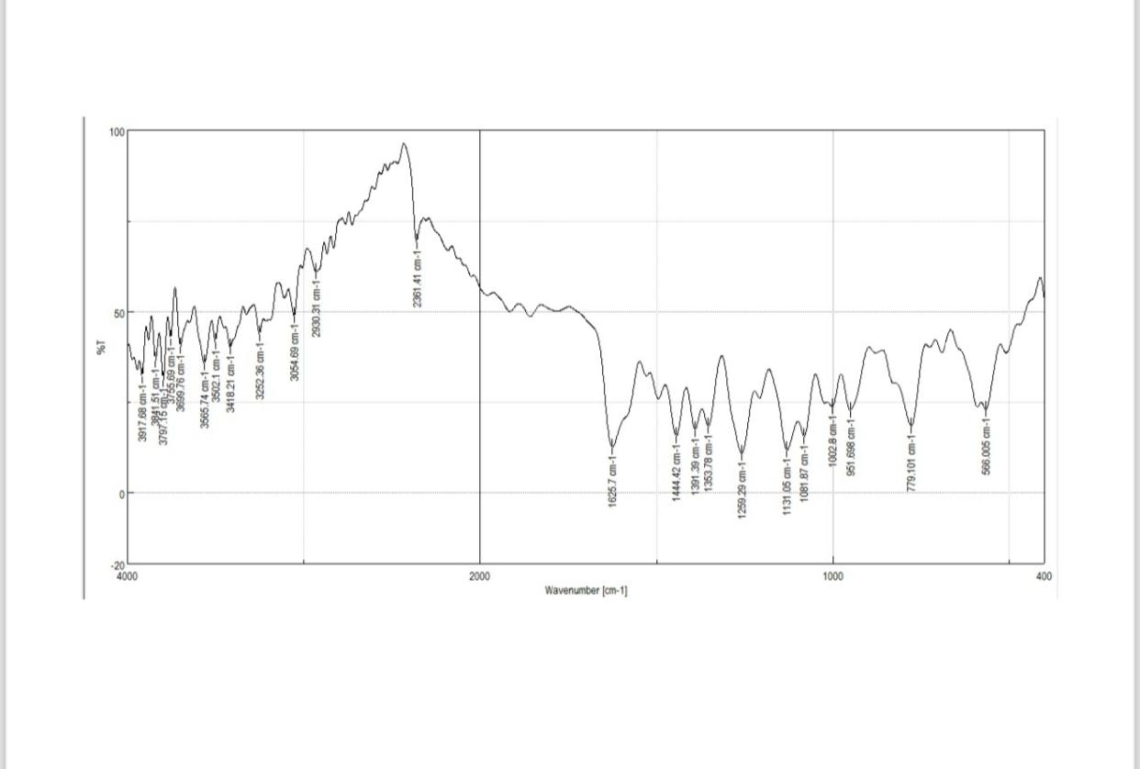
Fig 1. FT-IR. The spectrum reveals key functional groups, including sulfonamide, imine, and benzodioxole, confirming Schiff base formation, S=O and C–O–C signals, and complete piperonal reaction without aldehyde-related peaks.

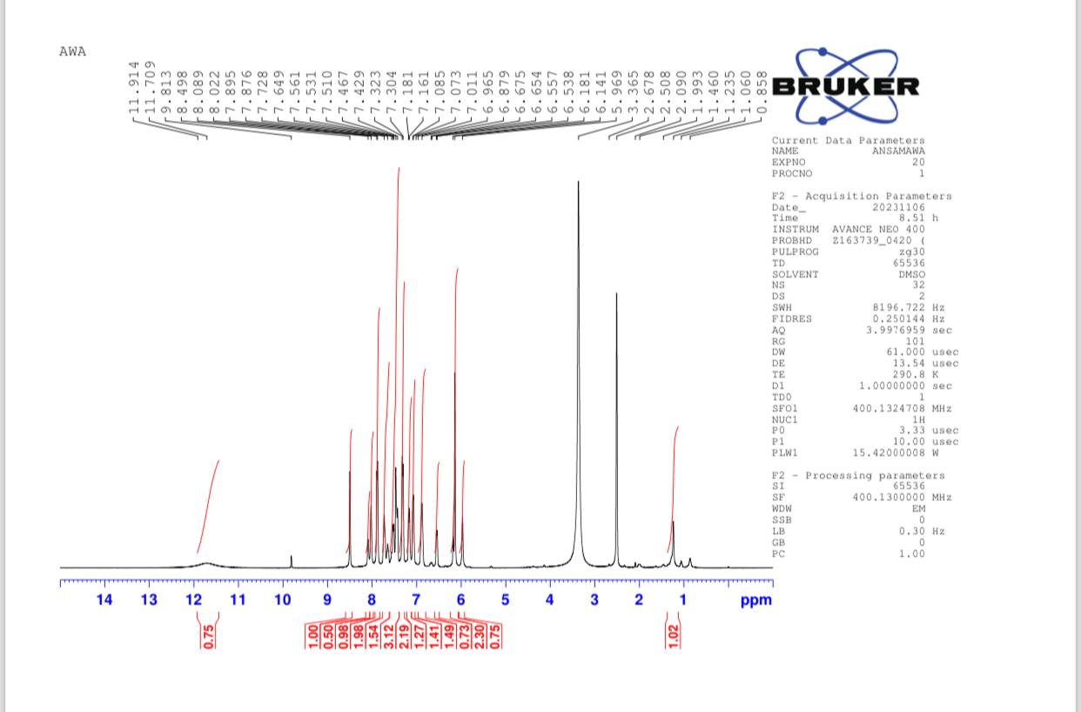
Fig 2. 1H NMR The proton NMR spectrum reveals aromatic multiplets, pyridine and benzodioxole rings, and the presence of a methylenedioxy group, confirming the presence of an intact methylenedioxy group. Absence of aldehydic proton signals confirms full condensation.
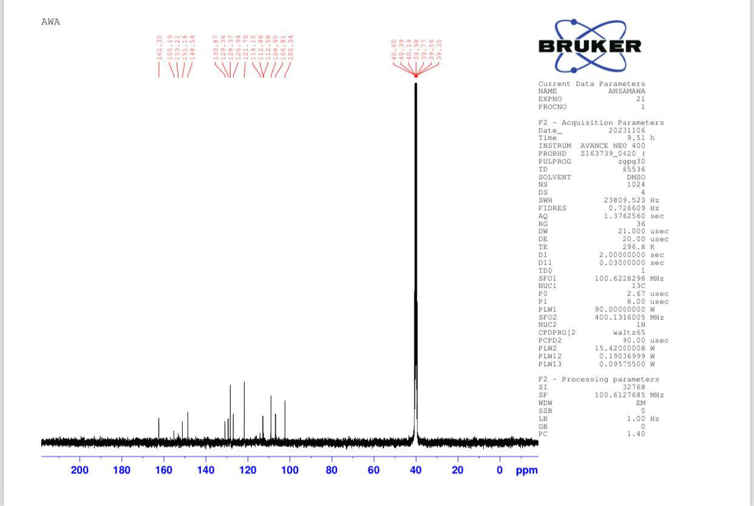
Fig 3. 13C NMR. The molecule's carbon framework is confirmed by the spectrum, which reveals imine, aromatic, oxygenated, and nitrogen-adjacent carbons, aligning perfectly with the proposed structure.
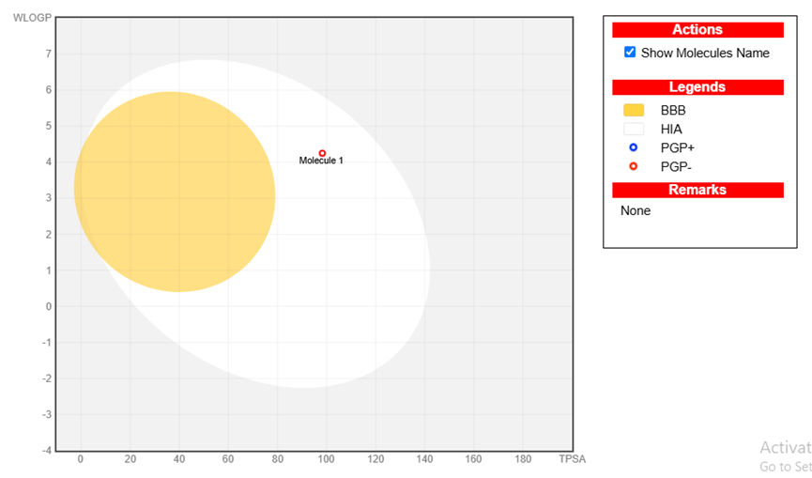
Fig 4: BOILED-Egg Plot (SwissADME), the compound's location within the HIA white zone indicates excellent oral bioavailability, but its partial overlap with the yellow BBB zone suggests limited blood-brain barrier permeability.
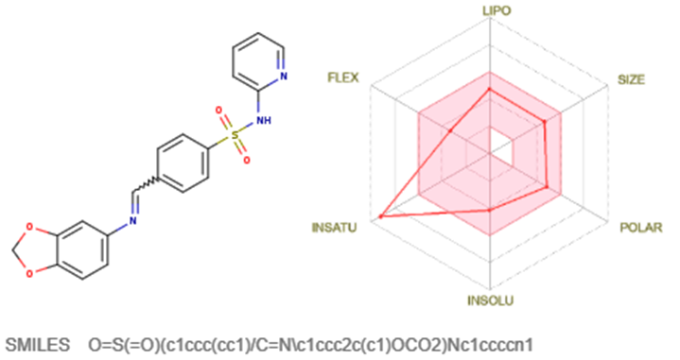
Figure 5: The Bioavailability radar using Swiss ADME predictor shows a compound with favorable drug-likeness, including high lipophilicity, moderate polarity, acceptable size and flexibility, and unsaturation, making it an optimal oral drug candidate.
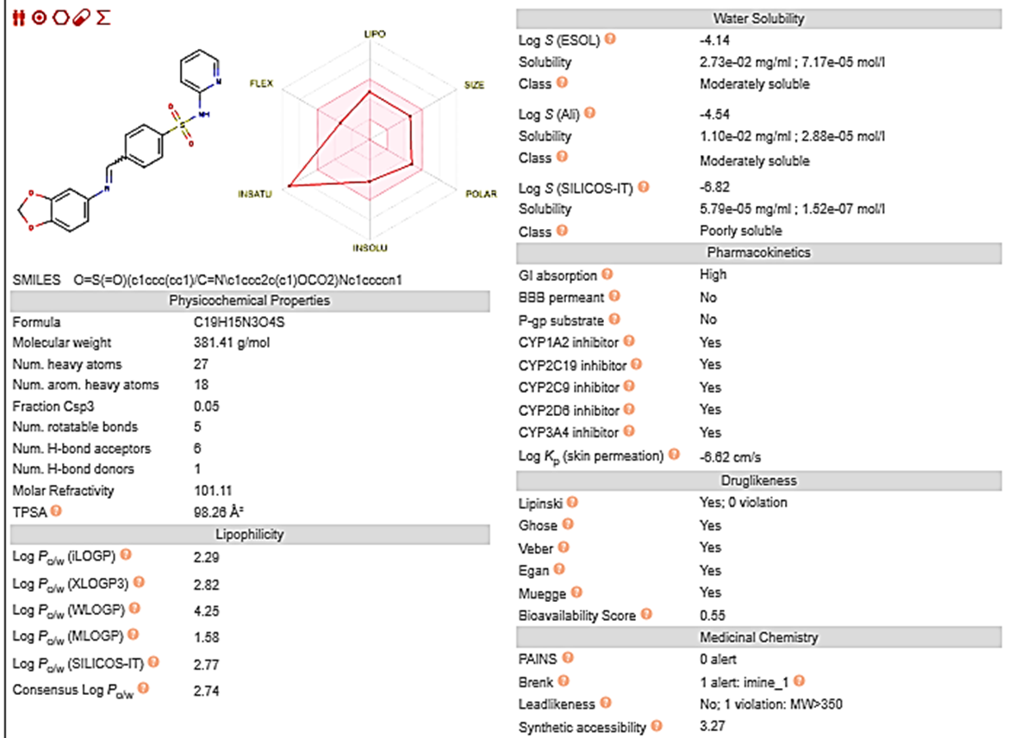
Figure 6: The Bioavailability radar using Swiss ADME predictor, the Bioavailability radar using Swiss ADME predictor, shows a compound with favorable drug-likeness, including high lipophilicity, moderate polarity, acceptable size and flexibility, and unsaturation, making it an optimal oral drug candidate.
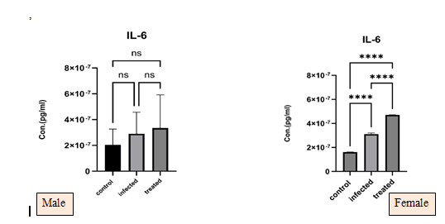
Fig.7: These figures reveal significant sex-based differences in liver cytokine expression.IL-6 levels are higher in females, indicating a stronger inflammatory response due to estrogen stimulation

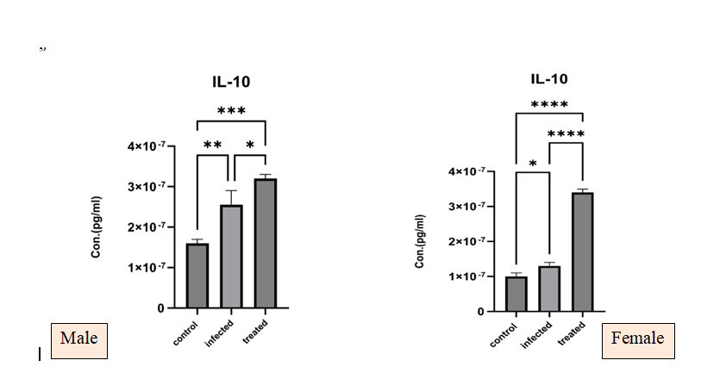
Fig 8. These figures reveal an elevation in females, pointing to a compensatory anti-inflammatory effect. The therapeutic group shows reduced IL-6 and elevated IL-10, suggesting that the compound effectively mitigates inflammation and promotes healing, especially in female subjects.

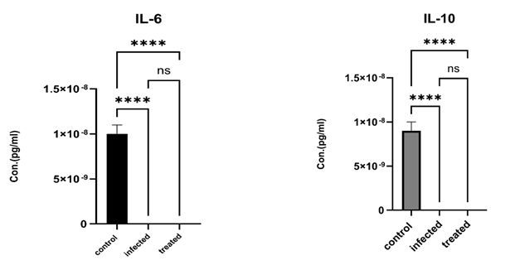
Fig 9; Serum cytokine levels show no significant difference between treated and untreated groups, indicating localized inflammatory response and drug action in the liver, emphasizing the importance of tissue-level biomarkers.

Discussion
The Fourier Transform Infrared (FTIR) spectrum confirmed the successful formation of a sulfa-drug derivative incorporating imine (C=N), sulfonamide (SO₂NH), and benzodioxole moieties. The strong absorption at 1625 cm¹, corresponding to the C=N stretch, indicates the formation of a Schiff base—a finding consistent with previous studies that synthesized similar sulfonamide-based imine derivatives (9). Additional characteristic absorptions such as S=O symmetric stretching at 1259 cm⁻¹ and C–O–C stretches of the benzodioxole ring between 1131–1081 cm⁻¹ further substantiate the proposed structure (4).
The ¹H-NMR spectrum presented a singlet around 11.9 ppm attributed to sulfonamide N–H protons, along with aromatic proton multiplets in the 7.0–8.5 ppm range, typical for polyaromatic systems. The distinctive singlet at 6.0–6.5 ppm confirms the presence of methylenedioxy groups. Absence of aldehydic signals in the 9–10 ppm range strongly suggests complete condensation of the aldehyde, aligning with findings reported by (11), who synthesized benzodioxole derivatives with similar substitution patterns.
Chemical shifts in the ¹³C-NMR spectrum corresponded well to theoretical expectations. Signals between 160–170 ppm verified the presence of imine carbons. Aromatic carbons resonated in the 120–140 ppm range, consistent with those observed in sulfa-based aromatic frameworks (6). Oxygen-linked carbons in the benzodioxole ring (90–110 ppm) and nitrogen-bound aliphatic carbons (~40 ppm) further confirmed the successful synthesis of the target compound.
The computational ADMET profile, generated using SwissADME and pkCSM platforms, indicated high intestinal absorption (HIA+) and potential limited permeability across the blood-brain barrier (BBB), placing the molecule at the border of central nervous system availability. The compound's bioavailability radar showed acceptable values for lipophilicity, polarity, size, and flexibility—properties favorable for oral bioavailability, as discussed in earlier works on sulfa-based drugs (Lazar & Protox, 2020). These results echo similar pharmacokinetic profiles seen in Piperonal and sulfapyridine hybrid compounds (11).
The favorable ADMET characteristics, including non-inhibition of key CYP450 enzymes and lack of acute toxicity in in silico models, support the compound's potential as a low-risk therapeutic candidate. These predictions are in line with prior assessments of sulfonamide derivatives, which demonstrated suitable
absorption and metabolism without significant systemic toxicity (4)
IL-6 is a key pro-inflammatory cytokine involved in acute and chronic inflammatory responses. In the present study, cypermethrin exposure led to elevated IL-6 levels, particularly in female pigeons, while treatment with the synthesized sulfa-drug derivative significantly reduced these levels in liver tissue, indicating suppression of inflammation at the local tissue level.
These results align with previous findings where IL-6 was found to be markedly upregulated following exposure to environmental toxins such as pesticides (12and 13). Moreover, the sex-related difference observed—higher IL-6 levels in females—correlates
With hormonal influences, estrogen has been shown to enhance IL-6 expression, while testosterone exhibits suppressive effects on pro-inflammatory signaling (14).
The reduction in IL-6 levels following sulfa-derivative administration mirrors the anti-inflammatory effects observed in earlier research on sulfonamide derivatives, which demonstrated the ability to attenuate cytokine storms and oxidative stress in animal models (6).
IL-10 acts as an anti-inflammatory cytokine, promoting immune tolerance and tissue healing. The current study recorded significantly elevated IL-10 levels in the liver tissues of pigeons treated with the sulfa-drug derivative, compared to both control and cypermethrin-only groups. This indicates an immunomodulatory effect promoting the resolution of inflammation and tissue repair.
These observations are consistent with prior findings by (4), who emphasized the immune-balancing properties of sulfa-based agents in reducing inflammation while enhancing protective immune responses. Additionally, elevated IL-10 in female birds also corresponds to findings in immunology that suggest estrogen enhances IL-10 transcription via ER-mediated pathways (15).
However, it's notable that serum IL-6 and IL-10 levels did not reflect significant changes, likely due to the localized nature of inflammation and the compound's tissue-specific effects. This is supported by(16), who emphasized that serum cytokine concentrations may not reliably indicate localized tissue-level immune activity, especially in acute pesticide-induced conditions.
Conclusion
This study successfully synthesized and evaluated a novel sulfa-drug derivative for its ability to counteract cypermethrin toxicity in domestic pigeons. Computational ADMET analysis revealed favorable pharmacokinetic properties and low predicted toxicity. In vivo results demonstrated the compound's therapeutic potential through improved survival rates, reduced levels of the pro-inflammatory cytokine IL-6, and increased levels of the anti-inflammatory cytokine IL-10. These findings underscore the value
of integrating synthetic chemistry, computational modeling, and animal studies in the development of novel veterinary therapeutics for pesticide poisoning.

Ethical approval

College of Veterinary Medicine Committee Medicine, University of Basra, accredited All procedures used in this study were in By License No.71/2024.

Disclaimer (Artificial intelligence)
Option 1:
Author(s) hereby declare that NO generative AI technologies such as Large Language Models (ChatGPT, COPILOT, etc.) and text-to-image generators have been used during the writing or editing of this manuscript.
Option 2:
Author(s) hereby declare that generative AI technologies such as Large Language Models, etc. have been used during the writing or editing of manuscripts. This explanation will include the name, version, model, and source of the generative AI technology and as well as all input prompts provided to the generative AI technology
Details of the AI usage are given below:
1.
2.
3.
References
1. Al-Barwari, S. & Saeed, I. (2012). The Parasitic Communities of the Rock Pigeon *Columba livia* from Iraq: Component and Importance. Turkiye Parazitol Derg ;36(4):232-239

2. Chourasiya, S., & Mahobiya, P. (2022). Toxicology and Mode of Action of Cypermethrin. Department of Zoology, University of Sagar, (M.P.), India
3. Velisek, J., Wlasow, T., & P.(2006) . Effects of Cypermethrin on Rainbow Trout (Oncorhynchus mykiss). Veterinarni Medicina, 51, (10): 469–476
4. Mohammed, S. J., Azzam, A. A., & Al-Hadedi, S. A. (2022). The Role of Sulfa Drugs in Our Lives. Rafidain Journal of Science. Vol. 31, No.3, pp.64-74.
5. Kiser, J. S., Waters, M. K., Wirshup, M. I., & Bottorff, C. A. (1946). Sulfonamide Blood Concentrations in Chickens and Turkey Poults. *Volume 27, Issue 2*, 1 March 1948, Pages 219-222.
6. Al-Masoudi, W. A.; Faaz, R. A.; Al-Asadi, R. H.; Jabbar, H. S. Synthesis, Antimicrobial Activity and Modelling Studies of Some New Metal Complexes of Schiff Base Derived from Sulphonamide Drug in Vitro (2016). Eur. J. Chem. 2016, 7, 102-106.
7. Vaickelionienė R, Petrikaitė V, Vasˇkevičienė I, Pavilonis A, Mickevičius V. (2023) Synthesis of novel sulphamethoxazole derivatives and exploration of their anticancer and antimicrobial properties. PLoS ONE 18(3): e0283289. https://doi.org/10.1371/journal. pone.0283289
8. Golub, A. (2022, January 21). Importance of ADME/Tox in Early Drug Discovery. Life Chemicals. https://lifechemicals.com/blog/computational-chemistry/424-importance-of-adme/tox-in-early-drug-discovery
9. Dixon, W. J. (1980). Efficient analysis of experimental observations. Annual Review of Pharmacology and Toxicology, 20, 441–462. https://doi.org/10.1146/annurev.pa.20.040180.002301 Annual Reviews+2SCIRP+2PubMed+2
10. FineTest. (2022, June 6). ELISA Sample Preparation Protocol. Wuhan Fine Biotech Co., Ltd. https://www.fn-test.com/content/uploads/2022/06/ELISA-Sample-Preparation-Protocol-2022.6.6.pdf
11. Meriga, B., Parim, B., Chunduri, V. R., Naik, R. R., Nemani, H., Suresh, P., Ganapathy, S., & VVU, S. B. (2017). The antiobesity potential of Piperonal: promising modulation of body composition, lipid profiles, and obesogenic marker expression in HFD-induced obese rats. Nutrition & Metabolism, 14, 72. doi:10.1186/s12986-017-0228-9
- Chourasiya, S., & Mahobiya, P. (2022). Toxicology and Mode of Action of Cypermethrin. Department of Zoology, University of Sagar, (M.P.), India
- Velisek, J., Wlasow, T., & P.(2006) . Effects of Cypermethrin on Rainbow Trout (Oncorhynchus mykiss). Veterinarni Medicina, 51, (10): 469–476

14. Klein, S. L., & Flanagan, K. L. (2016). Sex differences in immune responses. Nature Reviews Immunology, 16(10), 626–638. https://doi.org/10.1038/nri.2016.9
15. Straub, R. H. (2007). The complex role of estrogens in inflammation. Endocrine Reviews, 28(5), 521–574. https://doi.org/10.1210/er.2007-0001
16. Baker, M., & Hargreaves, P. (2012). Limitations of serum cytokine measurements in detecting localized inflammation. Journal of Clinical Immunology, 32(4), 568–576. https://doi.org/10.1007/s10875-012-9693-0

