Responses of Benthic Macroinvertebrates to Hydrological Variations in Buyo Hydroelectric Dam, Sassandra River, Côte d’Ivoire

.
ABSTRACT

Background: The modification of the natural flow regime alters the habitat's natural and aquatic fauna. These alterations cause changes in the structure of benthic macroinvertebrate communities. In the Sassandra river basin, despite significant hydrological changes observed when electric turbine sluice gates were opened or closed, studies of the impact of these disturbances on benthic macroinvertebrates are non-existent. Following the inventory and characterisation of spawning grounds, it was important to assess the impact of closing and opening the Buyo dam gates on benthic macroinvertebrates, an essential and sensitive component in any environmental disturbance.
Aim: This work aimed to determine the impact of hydrological variations downstream of Buyo Lake on benthic macroinvertebrate communities.
Methodology: The study was conducted at the Climate Change and Biodiversity Department, Natural Environments and Biodiversity Conservation Laboratory, Hydrobiology Research Unit, between June 2018 and May 2019. Benthic macroinvertebrates were sampled using a Van Veen grab from June 2018 to May 2019 at three selected sites. Hydrological data were provided by the Ivorian Company of Electricity (CIE) of Buyo. These data concern the water flows released by the gates of the dam and the water flows generated from the hydroelectric plant.

Results: In total, 1011 individuals, distributed among 4 phyla, 7 classes, 12 orders, 16 families, and 23 taxa, were inventoried. The most represented families were Thiaridae (89.51%). This was followed by the Chironomidae (4.94%). Among species, Melanoides tuberculata was the most dominant (89.51%). The peak of species richness was observed in December when the water flow released was 108.59 m³/s. The low value of species richness was observed where the water flow was 1549.54 m³/s. As for abundance, the peak was observed in June when the turbid water flow was 291.61 m³/s. The lowest was observed in September at water flows released of 1139.17 m³/s. Student's t-test showed that taxonomic richness is greater during the overflow rates (p = 0.0001).

Conclusion: This study allowed for the inventory of the benthic macrofauna downstream of the dam and showed the effect of water flows generated by the activities of the dam on benthic macroinvertebrates. These results will serve to the development of appropriate measures to ensure better management of aquatic organisms for future developments on the Sassandra River.

Keywords: Benthic macroinvertebrates, Hydrological impacts, hydroelectric dam, Buyo Lake, Côte d’Ivoire

1. INTRODUCTION

In developing countries, hydropower production has been developing rapidly, and may increase by more than 70% in the next few decades. Of the 37,600 dams higher than 15 m, more than 8600 dams worldwide primarily designed for hydropower generation are in operation. There are 32 countries that currently use hydropower to produce over 80% of their electricity requirements (Yoshida et al., 2020). In Côte d'Ivoire, the hydrographic network consists of large rivers (Cavally, Sassandra, Bandama, and Comoé) and about ten small coastal rivers (Teugels et al., 1988). Aside from the Comoé and Cavally rivers, the other waterways have been subject to development through the construction of hydroelectric dams. The Sassandra River, located in the Southwest, is not excluded from these developments. On this watercourse, two dams have been erected, the Buyo dam and the Soubré dam were built respectively in 1981 and 2017. The filling of the Soubré dam located downstream of the Buyo dam has led to significant changes in the hydrological regime. These hydrological changes were manifested by the closing and opening of the sluice gates of the Buyo dam in order to supply the Soubré dam with water for electricity production. According to Aliko et al. (2014), the filling of this second dam on the Sassandra River modified the water flow downstream of the Buyo dam. For these authors, hydrological variations have impacted the distribution of fish as well as their breeding sites. Also, these new conditions could affect macroinvertebrates that have limited movement. According to Soulsby et al. (2010), the modification of the natural flow regime alters the habitat's natural and aquatic fauna. These alterations cause changes in the structure of benthic macroinvertebrate communities. Furthermore, there is ample evidence that hydrological conditions are driving forces influencing the distribution and abundance of aquatic organisms (Christopher et al., 2007). Aquatic macroinvertebrates are model organisms for evaluating the ecological status of river ecosystems, as well as for detecting anthropogenic impacts of very different origin, spanning organic matter and nutrient contamination, deoxygenation and alteration of the flow regime. Wide variations in river discharge and water velocity have been shown to alter the physical structure of the riverbed through either sediment clogging or flushing and to affect macroinvertebrate community structure (Laini et al., 2019; Devi & Sarma, 2023).
In the Sassandra river basin, despite significant hydrological changes observed when electric turbine sluice gates were opened or closed, studies of the impact of these disturbances on benthic macroinvertebrates are non-existent. Therefore, the aim of this study is to demonstrate the impact of hydrological variations on benthic macroinvertebrate communities, with a view to improving management of this ecosystem.

2. Materials and methods
2.1 Study environment
The Sassandra River is located in the west of Côte d'Ivoire. It originates in the region of Bela in Guinea under the name of Féredougouba (Girard et al., 1971). In Côte d'Ivoire, the Sassandra River is 650 km long. The present study was conducted in the lower basin, downstream of the Buyo hydroelectric dam (Kouamé, 2023). Three stations were selected: AV1 (06°13'08.29''N and 07°02'44.24''W) situated at the confluence of the flood discharge canal and the drainage canal carrying water turbined by the hydroelectric power station. The second station, AV2 (06°13’43.72’’N and 07°02’52.86’’W), was located near a village of farmers and fishermen. The third station, AV3 (06°13'30.9''N and 07°02'54.71''W), was located downstream of the other two stations and was dominated by a heavy canopy (Fig. 1).
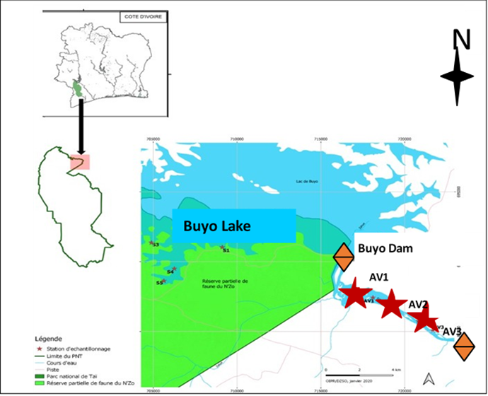
Fig. 1: Benthic macroinvertebrates sampling stations in the downstream part of the Buyo dam from June 2018 to May 2019
2.2 HYDROLOGICAL DATA SAMPLING
The hydrological data downstream of the Buyo dam were provided by the Ivorian Electricity Company (CIE) of Buyo. The data considered were discharge water flow (DED) and turbine water flow (DET) between June 2018 and May 2019. In the present study, the classification of hydrological seasons was based on the opening and closing of the Buyo dam gates.. During the sampling periods, gate closures were observed from June to August 2018 and in April 2019. In the other months, namely September 2018 to March 2019 and May 2019, the sluice gates of the Buyo dam were open.
2.3 BENTHIC MACROINVERTEBRATES SAMPLING
Benthic macroinvertebrates were sampled monthly from June 2018 to May 2019 using a Van Veen grab. Ten (10) grabs were collected at each station. Benthic organisms were identified at the lowest possible taxonomic level using the standard identification keys of Dejoux et al. (1981) and Tachet et al. (2003).
2.4 DATA ANALYSIS AND PROCESSING
Species richness was defined by the number of species N collected. The relative abundance (AR) of individuals was determined as follows: $AR=\frac{n_{i}}{n_{t}}×100$ with n_{i} = number of individuals of a taxonomic group (species, family or order) and n_{t} = total number of individuals. The Student's t-test was used to compare the numerical and weighted values of benthic macroinvertebrates according to the closure periods and opening of the gates, as well as the hydrological data.
3. RESULTS
3.1. HYDROLOGICAL DATA
The discharged water flows (DED) varied from 0 to 1549.54 m³/s. Higher DED values were observed during the periods from June to August, from November to January and from April to May. Turbine water flows (DET) varied from 29.11 to 354.38 m³/s. Low values were observed in April, and high values were recorded in August. Student's t-test showed a significant difference (p = 0.001) between DED and DET (Table I).
Table 1: Variation of hydrological data downstream of the Buyo dam from June 2018 to May 2019.
Hydrological data
Months | DED (m³/s) | DET (m³/s)
July | 0±0 | 291.61±17.07
June | 0±0 | 316.15±17.78
August | 0±0 | 354.38±18.82
September | 1139.17±33.75 | 309.29±17.58
October | 1549.54±39.36 | 317.18±17.80
November | 269.01±16.40 | 286.1±16.91
December | 108.59±10.42 | 313.93±17.71
January | 231.87±15.22 | 253.69±15.92
February | 441.11±21.11 | 272.26±16.50
Mars | 436.15±20.88 | 353.9±18.80
April | 121.95±11.04 | 29.11±5.39
May | 227.84±15.09 | 197.7±14.06
DED: water flow discharged; DET: water flow turbined

3.2. BIOLOGICAL DATA
3.2.1. QUALITATIVE ANALYSIS OF MACROINVERTEBRATE COMMUNITIES
The faunistic list of the collected macroinvertebrate communities was presented in Table 2. In total, 23 taxa distributed across 4 phyla, 7 classes, 12 orders, and 16 families have been recorded. The Phylum Mollusca was the most diverse group, comprising 9 families and 13 taxa. The Gastropoda class was the most diverse, with 8 taxa, followed by Insects, which account for 6 taxa.
Table 2: Benthic macroinvertebrate faunistic list collected downstream of Buyo dam from June 2018 to May 2019.
 |  |  |  | Status of gates
Phyla | Families | Taxa |  | Opened | Closed
Annelids | Erpobdellidae | Erpobdella sp. |  |  | +
Platyhelminthes | Planariidae | Planaria torva (Müller, 1776) |  | +
Arthropods | Chironomidae | Ablabesmyia sp. |  | +
 |  | Chironomus sp. (Meigen, 1803) |  |  | +
 |  | Polypedilum fuscipenne (Meigen, 1818) |  | + | +
 |  | Polypedilum sp. |  | + | +
 | Gomphidae | Gomphida sp. |  | +
 | Polymitarcyidae | Ephoron virgo (Olivier, 1791) |  | +
 | Potamanthidae | Potamanthus luteus (Linnaeus 1767) |  |  | +
 | Hydrachnidae | Hydrachna globosa (De Geer, 1778) |  | +
Molluscs | Unionidae | Unio acroloxus (Linnaeus, 1758) |  |  | +
 | Bithyniidae | Ferrissia sp (Tryon, 1863) |  |  | +
 | Lymnaeidae | Bithynia tentaculata (Linnaeus, 1758) |  | + | +
 | Planorbidae | Omphiscola sp. |  | +
 |  | Ancylus fluviatilis (Müller, 1774) |  | + | +
 |  | Biomphalaria pfeifferi (Krauss, 1848) |  |  | +
 | Lithoglyphidae | Lithoglyphus naticoides (Pfeiffer, 1828) |  | +
 | Thiaridae | Melanoides tuberculatus (Müller, 1774) |  | + | +
 | Viviparidae | Bellamya unicolor (Olivier, 1804) |  |  | +
 |  | Viviparus viviparus (Linnaeus, 1758) |  | + | +
 | Ancylidae | Ferrissia eburnensis (Binder 1957) |  |  | +
 |  | Ferrissia sp |  | +
 | Unionidae | Unio Acroloxus (Linnaeus, 1758) |  | +
4 | 16 | 23 |  | 15 | 14
+ = Presence of taxa
3.2.2 QUANTITATIVE ANALYSIS OF MACROINVERTEBRATE COMMUNITIES
A total of 1011 individuals of macroinvertebrates were collected downstream of the Buyo dam. The benthic community was dominated by the class Gastropoda, which accounted for 93.47% of the total abundance. It was followed by Insects, which represent 5.63% of the total communities. The other classes account for less than 1% of the total abundance. The most represented family was Thiaridae (89.51%), followed by Chironomidae (4.94%), Viviparidae (2.27%) and Planorbidae (1.18%). The other families contained only 2.06% of communities (Fig. 2). Among species, Melanoides tuberculata were the best represented with a proportion of 89.51%. It was followed by Viviparus viviparus (2.17%), Polypedilium sp. (1.68%) and Polypedilium fuscipenne (1.58%). Other species were poorly represented, with a proportion of 4.88% (Fig. 3). In terms of weight abundance, Thiaridae dominated the benthic communities with a biomass of 93.40%. They were followed by Bithyniidae (3.72%) and Unionidae (1.78%). Other families represented only 1.1% of the total mass (Fig. 4). According to species, Melanoides tuberculata contains the highest biomass with 93.40% of the total mass. It was followed by Bithynia tentaculata and Unio acroloxus with 3.7% and 1.60% of the total weight, respectively. The other species, Ancylus fluviatilis, Ablabesmya sp., Biomphalaria pfeifferi, Bellamya unicolour, Chironomus sp., Ephoron virgo, Eprpobdella sp., Ferrisia sp., globose hydracarines, Omphiscola sp., Planaria sp., Polypedilium fuscipenne, Viviparus viviparus and Polypedilium sp., were the least represented with a proportion of 1.28% (Fig. 5).
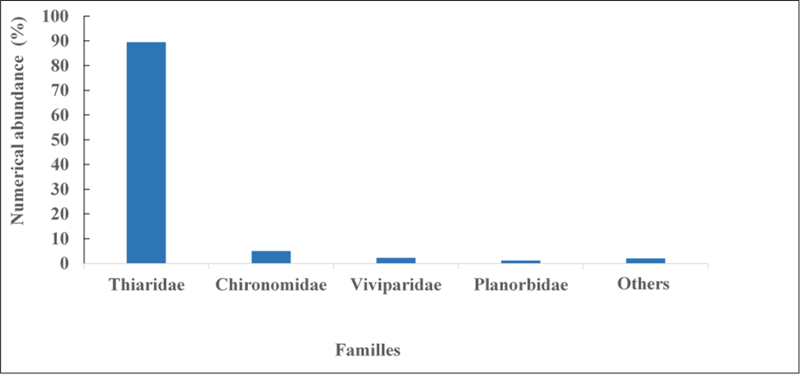

Fig. 2: Numerical abundance of main families of benthic macroinvertebrates collected downstream of the Buyo dam from June 2018 to May 2019
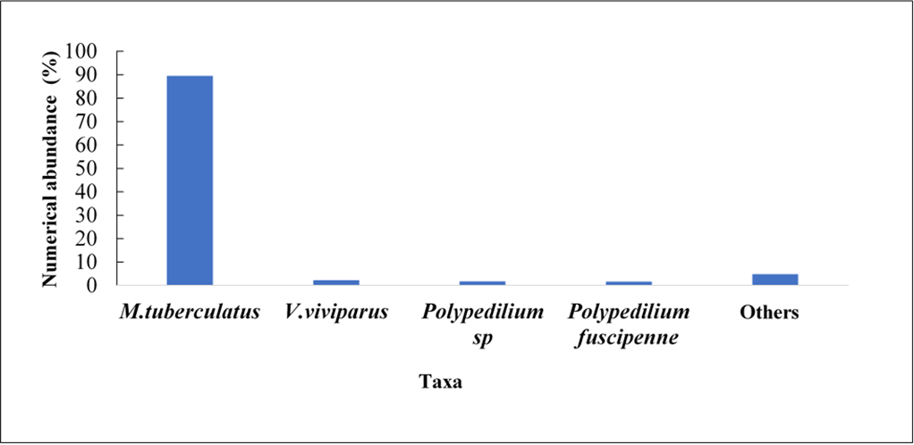

Fig. 3: Numerical abundance of main species of benthic macroinvertebrates collected downstream of Buyo dam from June 2018 to May 2019

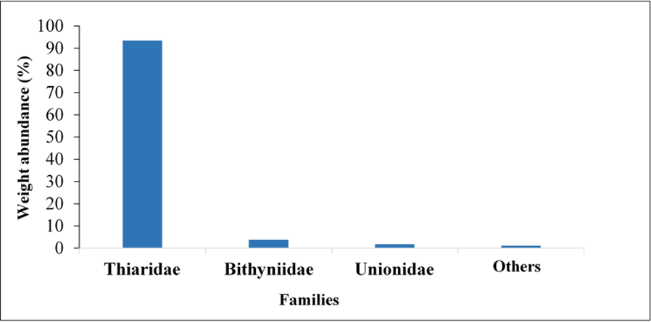

Fig. 4: Weight abundance of main families of benthic macroinvertebrates collected downstream of Buyo dam from June 2018 to May 2019
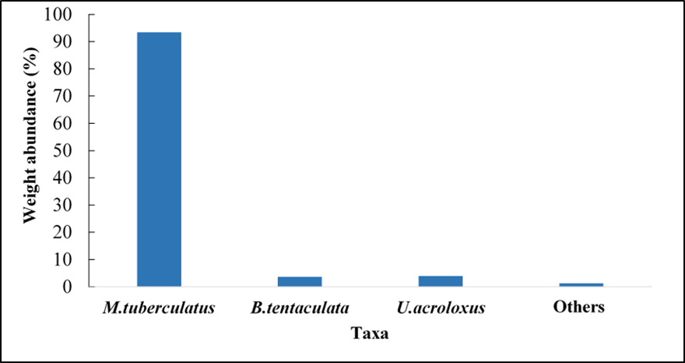

Fig. 5: Weight abundance of the main taxa of benthic macroinvertebrates collected in downstream of Buyo dam from June 2018 to May 2019
3.3 IMPACTS OF HYDROLOGICAL CONDITIONS ON THE DISTRIBUTION OF BENTHIC MACROINVERTEBRATES
3.3.1 RELATIONSHIP BETWEEN OPENING OR CLOSING OF TURBINE GATES AND DISTRIBUTION OF BENTHIC MACROINVERTEBRATES
During the gates closure periods, the Thiaridae family were the most abundant in population (80.96%). They were followed by Chironomidae (6.22%), Viviparidae (3.80%) and Planorbidae (2.76%). The other families were poorly represented, with a proportion of 6.2%. During this period, the following families were present: Gomphidae, Hydrachnidae, Polymitarcyidae, Lymnaeidae and Planariidae (Fig. 6). Among species, Melanoides tuberculata (81.25%) dominated the population. It was followed by Ablasbesmya sp. and Viviparus viviparus which each represent 3.81% of the collected individuals. The other taxa, such as Ancylus fluviatilis, Ephoron virgo, Bithynia tentaculata, Hydracariens globosa, Omphiscola sp., Planaria sp., Polypedium fuscipenne, Unio acroloxus and Polypedium sp., contain overall 11.06% of total individuals. Also, Ablabesmya sp. Ephoron virgo, Hydracariens globosa, Omphiscola sp. and Planaria sp. have been identified only during the gate closure (Fig. 7).
During the turbine gates' opening periods, Thiaridae predominated, with 92.93%. This family was followed by Chironomidae (4.43%). Among species, Melanoides tuberculata dominated the population with a proportion of 92.93%, followed by Polypedium sp. and Polypedium fuscipenne, which represent 1.93% and 1.80% of the collected individuals, respectively. Other species, such as Ancylus fluviatilis, Bithynia tentaculata, Unio acroloxus, Viviparus viviparus, Ferrissia sp., Biomphalaria pfeifferi, Chironomus sp., Bellamya unicolour and Erpobdella sp., represent only 3.32% of the population. Biomphalaria pfeifferi, Bellamya unicolour, Ferrissia sp., Erpobdella sp. and Chironomus sp. have only been observed during the periods of gate opening (Fig. 7).
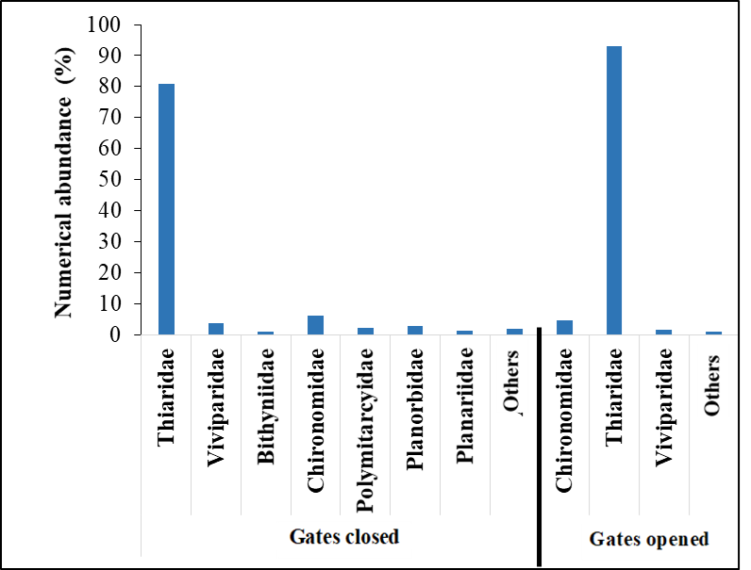

Fig. 6: Variation in the numerical abundance of the main families of macroinvertebrates during closed and opened turbine gates of Buyo dam from June 2018 to May 2019

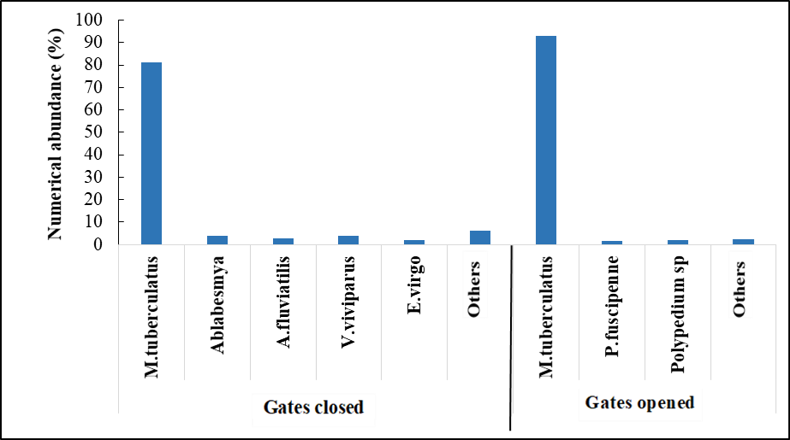

Fig. 7: Variation in the numerical abundance of the main taxa of macroinvertebrates during closed and opened turbine gates of Buyo dam from June 2018 to May 2019
3.3.2 RELATIONSHIP BETWEEN WATER FLOW AND BENTHIC MACROINVERTEBRATE ABUNDANCE
The highest values for species richness were recorded in December, and the lowest in October. As for overflow rates, the lowest values (108.59 m³/s) were recorded in December and the highest (1549.54 m³/s) in October. Student's t-test showed that taxonomic richness is greater during t overflow rates (p = 0.0001). Regarding numerical abundance, the peak was observed in June (20.92%) when the turbine water flow was low, with a value of 291.61 m³/s. The lowest abundance was recorded in September (0.81%), and the discharged water flow was 1139.17 m³/s. Thus, low values of species richness and numerical abundance were observed in September and October when the flow rate had reached its maximum. Student's t-test showed a variation in the abundance of benthic macroinvertebrates (Fig. 8).
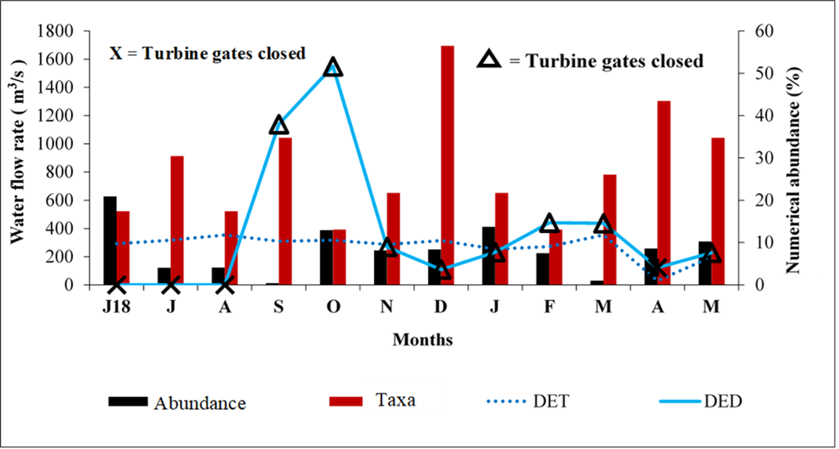

Fig. 8: Monthly variation of abundance and taxonomic richness of macroinvertebrates benthic based on water flows of Buyo dam from June 2018 to May 2019. DET = Turbine water flow; DED = Discharged water flow
4. DISCUSSION
The observation of flows during the periods of valve closure and opening shows that the water flow was largely related to the influence of the activities of the dams. The zero flow observed during the closure period is due to a lack of flow at the valve level. So, when the gates were closed, the water turbined by the dam's power plant flows downstream. The peak flow of water discharged observed in October (1549.54 m³) during the opening period is explained by the fact that this month corresponds to the rainy season. During this period, the lake basin fills up and reaches its maximum level. At this moment, the water is continuously discharged by the valves so that it does not overflow the dikes. In total, 16 families and 23 taxa were collected downstream of the Buyo dam. The number of families and taxa recorded in this study remains largely lower than the work previously conducted by Konan et al.,(2015). This author recorded 33 families and 63 taxa. The difference observed could be related to the number of surveyed stations and the new environmental conditions. Indeed, the low number of families and taxa observed in this study could be explained by the intensity of anthropogenic pressures such as the use of motorised canoes on the water body, hydroelectric developments and urbanisation in the environment. This observation fits within the same hypotheses concluded by certain authors, such as Prommi and Payakka (2015). These authors state that an environment subjected to strong anthropogenic pressures was a source of low taxonomic richness. The families most represented were the Thiaridae (89.51%) and the Chironomidae (4.94%). The dominance of these families would be due to the conditions of the environment. They would be transported and then deposited downstream of the dam under the action of strong water flows. Also, it should be added that these families would have the ability to quickly colonise anthropised environments (Olomukoro and Oviojie, 2015). These organisms with limited movement and unable to fight against strong water currents would be adapted to this place. Furthermore, the presence of these organisms would indicate organic pollution of the environment. Indeed, according to Tanon et al. (2020), these benthic organisms were known as pollution-resistant indicators of poor water quality. Thus, everything suggests that the dominance of these organisms in all seasons is related to their lifestyles or their adaptation to the new environmental conditions. Consequently, the regular opening of the Buyo dam gates would transport these organisms from the lake downstream of the dam. Thus, the composition of the benthic organisms confirmed downstream of the dam would come from the lake of Buyo. In this study, the dominance of Thiaridae and Chironomidae was observed in the same environments by Konan et al., (2015). The abundance of Melanoides tuberculata in this study could be explained by the fact that this species tolerates the numerous variations of environmental factors. It would therefore have adapted to the new hydrological conditions. Indeed, Motchié et al. (2020) revealed that the management of waterways promotes the establishment of habitats for the development of molluscs. Furthermore, this taxon has been reported as important for public health as it is an intermediate host of Paragonimus westermani and Clonorchis sinensis, responsible for pulmonary diseases (Reeves et al., 2008). Taxonomic richness was more affected by water flows. Indeed, high richness was observed in December when the dam gates were open, while the highest abundance was observed when the dam was closed in June. This high taxonomic richness observed during the opening turbine gates could be due to the fact that these macroinvertebrates would be carried from the lake downstream by the current. Also, when water current velocity is high, some of these benthic organisms could burrow into the substrate to hide. According to McMullen and Lytle (2012), some taxa were able to burrow deeper into the substrate to escape disturbances in the hydrological regime. Low values of taxonomic richness and their abundance were observed in September and October when the dam gates remained open. During these two months, water flows released by the dam reach their maximum values. These flows could disrupt the development of these organisms. According to Brasher et al. (2010), some hydrological metrics regarding flow variation were correlated with variables such as the abundance and diversity of benthic invertebrates. Death (2008) estimates that an increase in flow can result in a drift of invertebrates and a decrease in nutritional resources present at the substrate level. Similar results have been observed in the Reunion Rivers (Dedieu et al., 2016). When the dam gates were closed, the riverbed was only drained by the turbine waters from the Buyo hydroelectric plant. At this time, the water level drops, and this makes the habitats less disturbed and stable, which would explain the high number of individuals captured in June. Chaves-Ulloa et al. (2014) explained that the waters turbined restore quickly after hydroelectric production and thus without major consequences on benthic macroinvertebrates.

5. CONCLUSION
Variations of water levels resulting from turbine operations have a considerable impact on the abundance and distribution of benthic macroinvertebrates. Such disruption can lead to functional imbalance within the aquatic ecosystems on which the Buyo hydroelectric dam lake depends. For the sustainable management of aquatic life, an integrated policy taking into account the stakeholders involved in the management of the dam and the opening and closing of the turbine gates is crucial.
Disclaimer (Artificial intelligence)
Option 1:
Author(s) hereby declare that NO generative AI technologies such as Large Language Models (ChatGPT, COPILOT, etc.) and text-to-image generators have been used during the writing or editing of this manuscript.
Option 2:
Author(s) hereby declare that generative AI technologies such as Large Language Models, etc. have been used during the writing or editing of manuscripts. This explanation will include the name, version, model, and source of the generative AI technology and as well as all input prompts provided to the generative AI technology
Details of the AI usage are given below:
1.
2.
3.

REFERENCES
Brasher, A.M.D., Konrad, C.P., May, J.T., Edmiston, C.S., & Close, R.N. (2010). Stream flow characteristics and benthic invertebrate assemblages in streams across the western United States: U.S. Geological Survey Fact Sheet, 2010-3110, 4p.
Chaves-Ulloa, R., Umaña-Villalobos, G., & Springer, M. (2014). Downstream effects of hydropower production on aquatic macroinvertebrate assemblages in two rivers in Costa Rica. Revue. Biologie tropicale, 62 (2) : 179-201.
Christopher, A.T., Granata, T.C., Murphy, R.P., & Livchak, C.J. (2007). Using a coupled eco-hydrodynamic model to predict habitat for target species following dam removal, Ecological Engineering, 30(3) : 215–230.
Death, R. G. (2008). The effect of floods on aquatic invertebrate communities. Aquatic insects: challenges to populations, 2008, 103-121 ref. many
Dejoux, C., Elouard, J.M., Forge, P., & Maslin, J.L. (1981). Iconographic catalog of aquatic insects of the Ivory Coast. Report of the Overseas Scientific and Technical Research Office (ORSTOM, 42): 178.
Girard, G., Sircoulon, J., & Touchebeuf, P. (1971). Overview of hydrological regimes. In: The natural environment of the Ivory Coast (Avenard J.M., Girard G., Sircoulon J., Touchebeuf P., Guillaume J.L., Adjanohoun E. & Perraud A., eds.). ORSTOM Memoir 50:109-155.
Dedieu, N., Clavier, S., Vigouroux, R., Cerdan, P., & Céréghino, R. (2016). A multimetric macroinvertebrate index for the implementation of the European Water Framework Directive in French Guiana, East Amazonia. River Research and Applications, 32(3), 501-515.
Kouame, FC (2023). ANALYSIS OF RIVER FLOOD RISK USING A MULTI-CRITERIA HIERARCHICAL APPROACH IN THE DEVELOPED BASIN OF THE SASSANDRA RIVER IN SOUBRE (IVORY COAST). Geography review of the Leïdi laboratory: Territorial dynamics and development , (30 (2023)).
Konan, K. F., Edia, O. E., Bony, K. Y., Kouamé, K. M., & Gourène, G. (2015). Fish diversity and assemblages according to distance from source along a coastal river gradient (Ehania River south-east of Ivory Coast). Iranian Journal of Fisheries Sciences, 14(1), 112-129.
Aliko, N., Boussou, K., Konan, K., Da Costa, K., & Ouattara, A. (2014). Trends in artisanal fisheries in a tropical man-made lake, Taboo hydroelectric lake in Ivory coast of West Africa. Int. J. Fish. Aquat. Stud, 2(2), 73-77.
McMullen, L.E., & Lytle D.A., (2012). Quantifying invertebrate resistance to floods: a globalscale meta-analysis, Ecological Society of America, 22 : 2164-2175.
Motchié, F.E., Konan, Y.A., Gooré, Bi.G., Etilé, N.R., & Yao, S.S., (2020). Diversity of benthic macroinvertebrates and biotic indices to evaluate water quality in Lake Sokotè (Côte d’Ivoire). Journal of Biodiversity and Environmental Sciences, 16 (4) : 53-60.
Olomukoro, J.O., & Oviojie, E., (2015). Diversity and distribution of benthic macroinvertebrate fauna of Obazuma Lake in Benin city, Nigeria. Journal of Biology, Agriculture and Healthcare, 5 (1) : 94-100.
Prommi, T., & Payakka, A. (2015). Aquatic insect biodiversity and water quality parameters of streams in Northern Thailand. Sain Malaysiana, 44 : 707-717.
Reeves, W.K., Dillon, R.T., Jr., & Dasch, G.A. (2008). Freshwater snails (Mollusca: Gastropoda) from the commonwealth of Dominica with a discussion of their roles in the transmission of parasites. American Malacological Bulletin, 24 : 59-63.
Soulsby, R.L., Manning, A.J., Whitehouse, R.J.S., & Spearman, J.R. (2010). Development of a generic physically-based formula for the settling ﬂux of natural estuarine cohesive sediment: Final Report-summary, HR Wallingford company research project DDY0409. 1 p.
Tanon, D.Y., Camara, A.I., Kouadio, K.N., Doumbia, L., Ouattara, A. & Diomandé, D. (2020). Taxonomic diversity and structure of benthic macroinvertébres of Taabo lake (basin of Bandama ; IvoryCoast). Journal of Environnement Science Studies, 3 (1) : 1-14.
Tachet, H., Richoux, P., Michel, B. & Polatera, P.U., (2003). Invertébrés d’eau douce : Systématique, biologie, écologie. CNRS, Paris, France, 587p.
Teugels, G.G., Lévêque, C., Paugy, D., & Traoré, K. (1988). State of knowledge on the ichthyological fauna of the coastal basins of Côte d’Ivoire and western Ghana. ORSTOM (Paris), Revue d’Hydrobiologie Tropicale, 21(3): 221-237.
Yoshida, Y., Lee, H. S., Trung, B. H., Tran, H. D., Lall, M. K., Kakar, K., & Xuan, T. D. (2020). Impacts of mainstream hydropower dams on fisheries and agriculture in lower Mekong Basin. Sustainability, 12(6), 2408.
Laini, A., Viaroli, P., Bolpagni, R., Cancellario, T., Racchetti, E., & Guareschi, S. (2019). Taxonomic and Functional Responses of Benthic Macroinvertebrate Communities to Hydrological and Water Quality Variations in a Heavily Regulated River. Water, 11(7), 1478.
Devi, D., & Sarma, A. K. (2023). Impact of interbasin transfer hydroelectric project on downstream aquatic habitat. Ecohydrology, 16(8), e2584.

