Original Research Article
TITANIUM DIOXIDE NANOPARTICLE SYNTHESIZED VIA SOL-GEL METHOD FOR WATER PURIFICATION AND EVALUATION OF BIOLOGICAL ACTIVITIES

Abstract:
Titanium dioxide is an extremely active in a variety of reactions, nontoxic, and reasonably priced and it also used extensively in water purification processes such as photocatalysis, catalysis, and dye degradation. Titanium dioxide nanoparticles (TiO₂ NPs) potent oxidizing ability through the production of free radicals promotes the inactivation of bacteria by reducing their development. TiO₂ NPs, using the sol-gel method, titanium precursors are combined with isopropanol, deionized water, and acids to create titanium dioxide nanoparticles. The present study focused on characterization and evaluation of synthetic TiO₂ NPs for its anti-inflammatory, antioxidant and antimicrobial ability. Anti-inflammatory activity tested using bovine serum albumin/anti-denaturation assay, In-vitro antioxidant assay by (DPPH) and antibacterial activity by Agar well diffusion method was also performed. At a concentration of 100 µg/ml, the results showed that chemically produced TiO₂ NPs have the ability to scavenge the free radical DPPH, neutralizing 72% of the radicals. It was shown that a sample of 100 µl of TiO₂ NPs had strong anti-inflammatory properties and inhibited 69% of protein denaturation. TiO₂ NPs were tested against pathogenic bacterial strains at varying concentrations (50, 75, and 100 mg/ml), they demonstrated significant antibacterial activity by inhibiting both Gram positive and Gram-negative bacteria. In the present study the prepared TiO₂ NPs showed potent water purification property in the artificial polluted water.
Keyword: Antibacterial activity, Anti-inflammatory activity, DPPH assay, Sol gel method, Titanium dioxide nanoparticle, Titanium dioxide Nanobeads, Water treatment

1. Introduction
A significant field of nanotechnology research focuses on creating nanoparticles with regulated monodispersity, dimensions, and various chemical compositions. Its applications in science and technology for the creation of novel materials at the nanoscale level, nanotechnology is becoming a fast-expanding area. Applications of nanotechnology in pharmacology and biology have grown significantly. Titanium dioxide (TiO₂) nanoparticles (NPs) have been widely used as a clean and environmentally friendly photocatalyst in recent years due to its optical qualities, high chemical stability, and nontoxicity. Titanium dioxide NPs are among the most crucial ingredients for skin care products, cosmetics, and medications. They are especially useful for shielding skin from UV radiation, whiteness, and opacity in paints, plastics, papers, inks, food coloring, and toothpastes. The Sol–gel method is the most widely used technique for creating TiO₂ NPs because it is easy, affordable, and effective. Synthesis of TiO₂ NPs in a variety of shapes, including sheets, tubes, particles, wires, rods, mesoporous, and aerogels, is made possible via the sol–gel process (Alavi and Karmi, 2018). The most researched semiconductor is TiO₂, which has been investigated for its antibacterial and organic dye degradation properties. Its great stability, low toxicity, and affordability are the reasons. The NPs were synthesized via pulse ablation deposition, sol-gel, and co-precipitation. As a result, researchers are already creating low-cost, straightforward techniques that do not require the use of dangerous materials (Alavi and Karmi, 2018). Antioxidants are essential for preventing food from becoming oxidatively rancid because they scavenge free radicals produced during the oxidation process. Oxidative stress results from metabolic processes that produce free radicals or reactive oxygen species, as well as other processes that exceed a biological system's antioxidant capacity. Oxidative stress is implicated in cancer, heart disease, neurological illnesses, and aging. The antioxidant activity of the leaf extract and NPs was measured by the 1,1-diphenyl-2-picryl-hydrazyl (DPPH) assay with slight modifications, as reported by (Villano et al.) Ascorbic acid was utilized as a positive control. Inflammation has been found to be caused by protein denaturation. There are indications that inflammation happens when living tissues are damaged. Redness, discomfort, heat, swelling, and loss of function in the afflicted area are such symptoms. Electrostatic, hydrogen, hydrophobic, and disulfide connections within the protein structure are all disrupted. Furthermore, the protein loses its molecular structure and functions or becomes denatured as a result of a complicated series of events that include enzyme activation, mediator release, cell migration, tissue disintegration, and repair (Bailey-Shaw et al., 2017). Therefore, it can be concluded that substances can stop these alterations and stop heat-induced or thermally-induced protein denaturation may have therapeutic value as anti-inflammatory agents. By using NSAIDs to stabilize heat-treated BSA as a substitute for animals in the initial steps of non-steroidal anti-inflammatory drug screening. Meanwhile, TiO₂ NPs has the application of anti-inflammatory activity (Moyo et al., 2010). The modified Kirby Bauer disc diffusion method was used to examine the antibiotic susceptibility pattern for bacterial culture against the following antibiotics (drug concentration in µl): Gentamycin (30). Gram-positive and Gram-negative bacteria were added to the Mueller-Hinton agar (MHA) plate as supplements (Daniel et al., 2023). In many applications, nanocrystalline TiO₂, a well-known semi-conductor with photocatalytic properties, has enormous potential as a self-cleaning and self-disinfecting substance. TiO₂ has been widely utilized to eradicate various microorganisms, such as viruses, fungus, and bacteria, due to its chemical stability, broad-spectrum antibiosis, and high photoreactivity. According to an early test, TiO2 NPs are quite effective against Pseudomonas aeruginosa, Escherichia coli, and Staphylococcus aureus. They may also be a safer substitute for traditional antimicrobial and antibacterial drugs. TiO2 NPs have an impact on the membrane channel protein and phosphotyrosine protein levels, which blocks the membrane transport and signaling pathways and ultimately kills the bacterial cells (Deborah et al., 2015). Water has an important role as one of the fundamental requirements of living things and is an essential component of natural resources. Some of the renewable resources in this modern world are becoming polluted nowadays, among these are water resources. Dye wastewater is now a serious environmental hazard. It will become evident that releasing untreated wastewater into streams poses a significant risk to life. It is challenging to fully break down and eliminate these chemicals' complicated structures. Utilizing TiO₂ NPs in bioremediation could be an effective method to eradicate toxic dyes (Gjipalaj et al., 2017). The potential of nanostructured materials as catalysts or adsorbents to extract poisonous and hazardous chemicals from wastewater has drawn a lot of attention. Because of its tiny particle size (nanoparticle), TiO2 is particularly effective in eliminating organic pollutants from treated wastewater, but it also presents challenges when separating from water (Santosh kuamr et al., 2015) and (Sathya et al., 2020). Semiconducting particle suspensions have been used in numerous studies on the photocatalytic destruction of pollutants in recent years (Sathya et al., 2020). Among the many benefits of nanomaterials are their high specific surface areas, rapid dispersion, strong reactivity, and sorption capacity for bacteria, heavy metals, and various organic pollutants (Sayan et al., 2013). Many constraints exist with conventional disinfection procedures, but fortunately, new research has discovered a number of sophisticated ways to get around these restrictions by using NPs (Shahid et al., 2015). The simplicity, economic viability, and disinfection effectiveness of these procedures make them highly promising. Several biological remediation technologies, including as phytoremediation, bioremediation, rhizoremediation, and remediation based on nanotechnology, have been successfully developed in the modern day²⁹. However, research gaps were existing pertaining to TiO₂ NPs dye degradation property and optimization of its biological activity. Hence the present study focused on preparation of TiO₂ NPs by hydrolyzing titanium (IV) isopropoxide and assess the resulting film's photon to current conversion efficiency. TiO₂ NPs were prepared in our present study by hydrolyzing titanium (IV) iso-propoxide, which was done by creating TiO₂crystalline powders in a single step is the self-hydrolysis of titanium (IV) iso-propoxide. FT-IR, SEM, UV-visible spectroscopy, and characerization techniques were used to investigate the characteristics of the synthesized TiO₂ NPs (Ameer and Velukumar, 2023). Therefore, the present study was aimed to synthesis and characterization of TiO₂ NP loaded alginate beads and determination of potassium dichromate and AZO dye mixed water remediation property and further evaluation of its biological activity (Thakur and Thakur, 2024) and (Sree Kumari et al., 2015).
2. Material and Methods

Titanium (IV) Isopropoxide (TTIP) was commercially purchased from SRL (India), Isopropanol, Acetic acid, Nitric acid or hydrochloric acid were procured from Qualigens chemicals, (India).
2.1 Preparation process of TiO₂Nanoparticles
All the chemical substances used for the experimental process were analytical reagent grade and they used without auxiliary refinement. The synthesis process of titanium dioxide nanoparticle by the sol-gel method was made through by hydrolysis of TTIP. Initially,5ml of titanium tetra isopropoxide (TTIP) was mixed and added drop by drop slowly with isopropanol solution, the obtained mixture was stirred for 15 minutes, and then 75 ml of deionized water was added drop-wise into this mixture resulting in the formation of white precipitate followed by converted into the white solution. Further solution was stirred thoroughly by controlling its temperatures at 80°C for 1hour.then the 2.5 ml of acetic acid was added drop-wise to this solution and the resulting solution was stirred for about 5 hours. After 5 hours of stirring, 1 ml of nitric acid (HNO₃) or the hydrochloric acid (HCL) was added to the obtained solution drop-wise for the peptization and this the hydrolysis process, the resulting solution was allowed to stirred for 2 hours and a gel like substance formed. The formed solution was cooled naturally up to room temperature and dried at 60 °C in the vacuum oven. The obtained powder was grounded in a mortar pestle to make a fine powder and then finally annealed at 500 °C for 3 hours which results in the formation of pure white titanium dioxide Nanoparticle (Bosco et al., 2023).
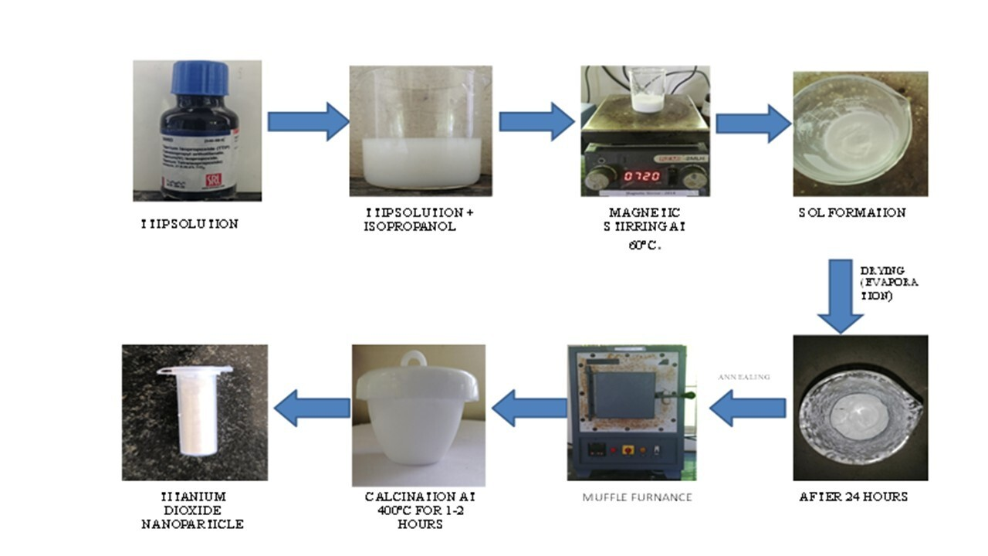
Figure 1: Schematic representation of TiO₂ Nanoparticle synthesis
2.2 Characterization techniques
To evaluate the chemical interfaces of functional groups were evaluate by Fourier transform infrared (FT-IR) spectra studies using Perkin Elmer RX-1 brand spectrophotometer. The Scanning Electron (SEM) microscope is a valuable system to define the surface morphologies of the as given nanomaterial (Bosco et al., 2023). The optical absorption properties and their related direct and indirect bandgap energy values were organized via UV-Vis diffuse reflectance spectrophotometer (UV-Vis DRS; Perkin ELMER UV/Vis Lambda 19) at the wavelength of 200-400 nm (Bosco et al., 2023) and (Khataee et al., 2009).
2.3 Antioxidant activity
The free radical scavenging potential of chemically synthesized TiO₂ NPs was determined using DPPH. The DPPH solution (0.006% w/v) was prepared in 95% methanol. Different concentrations of the TiO₂ nanoparticle (20, 40, 60, 80 and 100 µg/mL) was prepared in methanol. 3 ml of different concentration of synthesized Titanium dioxide nanoparticles were mixed with 1 ml of DPPH solution in dark. Ascorbic acid, which is a strong antioxidizing agent is taken as standard, prepared in different concentrations using ethanol (20, 40, 60, 80 and 100 μg/mL). 3 ml of different concentration of standard solution of ascorbic acid was mixed with 1 ml of DPPH solution in dark. The prepared solution of ascorbic acid and TiO₂ NPs samples were incubated for 30 minutes and then absorbance was measured using U.V. Spectrophotometer at 517 nm (Mao et al., 2006). Methanol serves as a blank and the experiment was expressed as the inhibition percentage of free radical by the sample and was calculated using the following formula:
Optical density of Control – Optical density of Test
DPPH radical scavenging activity (%) =----------------------------------------------------------------------×100
Optical density of Control

2.4 Anti-inflammatory activity
Dissolved 500 mg of BSA in 100 ml of water, Phosphate Buffer Saline pH 6.3 Dissolved 8 g of sodium chloride (NaCl), 0.2 g of potassium chloride (KCI), 1.44 g of disodium hydrogen phosphate (Na₂HPO₄), and 0.24 g of potassium dihydrogen phosphate in (KH₂PO₄) in 800 ml distilled water. The pH was adjusted to 6.3 using 1N hydrochloric acid (HCl) and made the volume to 1000 ml with distilled water. Test solution (0.5ml) consists of 0.45ml of Bovine serum albumin (0.5% W/V aqueous solution) and 0.05 ml of test solution of various concentrations. Test control solution (0.5ml) consists of 0.45ml of bovine serum albumin (0.5% W/V aqueous solution) and 0.05ml of distilled water. Product control (0.5ml) consists of 0.45ml of distilled water and 0.05 ml of test solution. Standard solution (0.5ml) consists of 0.45ml of Bovine serum albumin (0.5% W/V aqueous solution) and 0.05ml of Diclofenac sodium of various concentrations. About 0.05 ml various concentrations (100,200,300,400 and 500 µg/mL) of test drugs and standard drug diclofenac sodium (20, 40, 60, 80 and 100 µg/mL) were taken respectively and 0.45 ml (0.5% W/V BSA) mixed. The samples were incubated at 37°c for 20 minutes and the temperature was increased to keep the samples at 57°C for 3 minutes. After cooling and add 2.5 ml of phosphate buffer to the above solutions. The absorbance was measured using UV-Visible spectrophotometer at 255 nm. The control represents 100% protein denaturation (Ngoepe et al., 2020). The results were compared with Diclofenac sodium. The percentage inhibition of protein denaturation can be calculated as.

Optical density of Control – Optical density of Test
Percentage inhibition (%) =---------------------------------------------------------------------- ×100
Optical density of Control

2.5 Antibacterial activity
To analysis the antibacterial effect towards the Gram-Positive bacteria such as Pneumonia and Bacillus and also the Gram-Negative bacteria such as Escherichia coli (E.coli), proteus as a test bacterium of the TiO₂nanoparticle synthesized using sol gel method. Petriplates were prepared by pouring 20 ml of Muller Hinton and the 5 mm diameter wells were cut since the agar by a sterile cork-borer and drying it. After the Plates were dried, 0.1 ml inoculums suspensions were poured and spread uniformly. These inoculums were kept to dried. After drying for 5 minutes, bacterial plates were incubated for24 hours at 37 °C. The inhibition was observed in the plates. The synthesized TiO₂ NP sample shows the effect on such Gram-Positive and Gram-Negative Bacteria. Thus, the prepared samples which possess the antibacterial property. Antibacterial activity was evaluated by the diameter of zone of inhibition (ZOI) in mm range against the bacteria and the DMSO were used as solvent control (Mizushima et al., 1968) and (Molyneux P., 2004).
2.6 Preparation of titanium dioxide nanoparticles based alginate beads
The 2g of sodium alginate was weighed and dissolved in the 100 ml of double distilled water mixed with 100 mg of titanium dioxide NPs. It was introduced dropwise from a glass syringe with a size-22 needle into 100 ml of an aqueous calcium chloride solution being stirred at 400 rpm. The concentration of calcium chloride in the solution for 4 gram. The stirring was continued for one hour and the calcium alginate beads was harvested by filtration, washed with distilled water, and air dried overnight (Ramesh et al., 2012) and (Rikta., 2019).
(a) 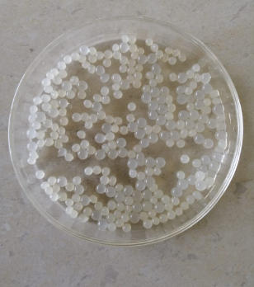 (b) 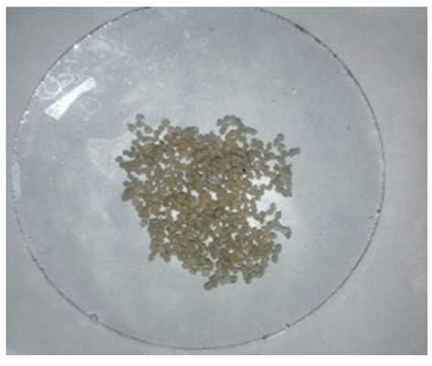
Dry TiO₂nanoparticles based alginate beads.
Wet TiO₂nanoparticles based alginate beads

(c)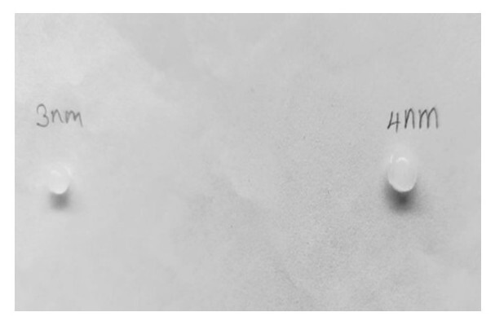
Size of the TiO₂ nanoparticle based alginate nanobeads

Figure 2: Photographic image of Titanium dioxide nanoparticles (a) Wet, (b) Dry and (c) Size based alginate nanobeads.
2.7 Potassium dichromate remediation property:
The prepared bead was evaluated as environmental remediation agents using batch experiment for the removal of the k₂Cr₂O_{7.} The similar trend was observed in the case of turbidity water (Thakur, 2023) and (Sree Kumari et al., 2015).
2.8 Preparation of standard k₂Cr₂O₇ Solution (sample-1)
Stock solution of potassium dichromate was prepared by weighing 100 mg of the potassium dichromate (k₂Cr₂O₇) and dissolved in 100 ml of double distilled water.
2.9 Preparation of standard AZO dye solution (sample-2)
Stock solution of AZO dye solution was prepared by 100 mg of AZO dye was weighed accurately and dissolved in 100 ml of double distilled water.
2.10 Assessment of potassium dichromate remediation:
Methods to check water purification
Testing water quality is essential to ensure its safe for domestic, drinking purposes and other purposes. The following methodology was adopted to check the water purification.
- Turbidity test
It measure water clarity by checking suspended particle using calorimeter at 540 nm.A calorimeter is a laboratory instrument used to measure the concentration of a substance by analyzing its color intensity.
(2) pH test
Determine the acidity and alkalinity of water sample using pH meter.
- TDS [Total Dissolved Solid] test
Measure the total concentration of dissolved solids using a TDS meter.
3. Results and Discussion
Ultra violet – visible ( UV-Vis) absorption spectra analysis
Titanium dioxide (TiO₂) nanoparticles' UV-Vis spectrum is displayed in Figure 3."UV-Vis Transmission(%T)" on the y-axis and "wavelength (nm)" on the x-axis of a graph. Transmittance (%) is seen in the spectrum as a function of wavelength (nm). At 298.5 nm, a peak with a transmittance of 49.367 percent is seen. The significant UV absorption of titanium dioxide nanoparticles, usually below 400 nm, is well recognized. The longer wavelength region appears to have higher transmittance, according to the overall trend (Alavi and Karmi, 2018) and (Bosco et al., 2023).
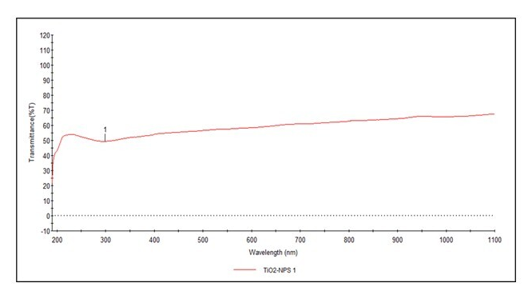
Figure 3: UV-Visible spectra of synthesized Tio2 nanoparticles
3.1 FT-IR spectra analysis
The graphic displays the TiO2 NPs Fourier Transform Infrared Spectroscopy (FT-IR) spectrum. Titanium dioxide NPs infrared absorption properties are shown in figure 4. The transmittance (%T) is represented by the y-axis, and the wavenumber (cm-1) is represented by the x-axis.which features characteristic peaks at wavenumbers of 1382.37 (cm-1), 1161.35 (cm-1), 1126.54 (cm-1), 812.67 (cm-1), 615.00 (cm-1), 1629.66 (cm-1), 1462.27 (cm-1), and 3358.33 (cm-1)³. The peak 3358.33 (cm-1) indicates the presence of hydroxyl groups by indicating O-H stetching vibrations. The stretching vibration of the C-H (alkyl group) is 2972.44 (cm-1), the C=C (alkene group) is 1629.66 (cm-1), and the methylene group may have -CH2-stretching vibrations, as shown by 1462.27 (cm-1). CH3 (methyl group) has a stretching vibration of 1382.37 (cm-1), while C-O-C (ether linkage) has a stretching vibration of 1161.35 (cm-1). 1126.54 (cm-1) indicates that the Ether group contains C-O stretching vibrations. The stretching vibration of C-H (Aromatic group) is represented by 812.67 (cm-1), and the composition of the nanoparticle is confirmed by the Ti-o-Ti stretching vibrations in Titanium dioxide, which are represented by the 615.00 (cm-1) peak (Alavi and Karmi, 2018) and (Bosco et al., 2023)
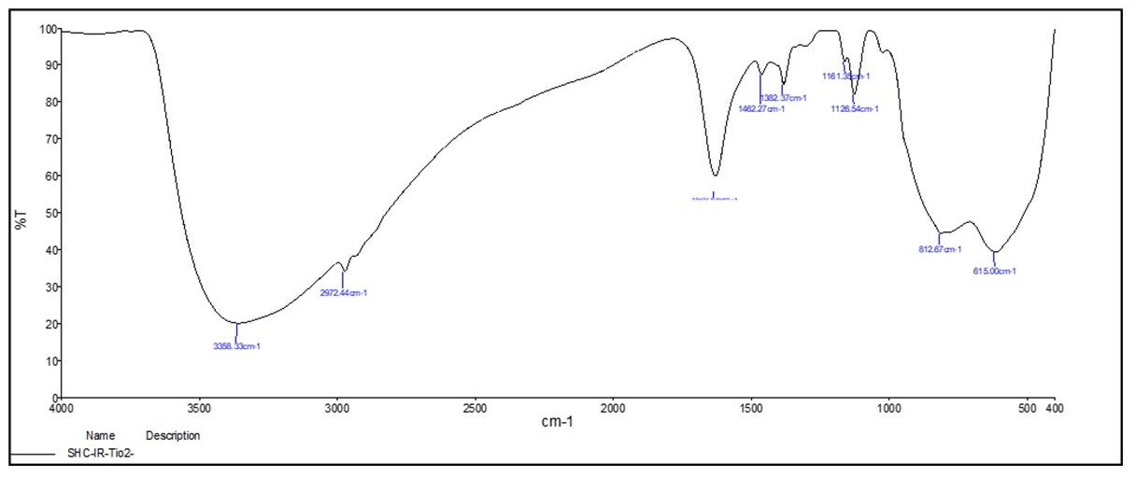
Figure 4: FT-IR spectra of synthesized TiO₂ Nanoparticles
3.2 Scanning Electron Microscope (SEM) analysis
SEM analysis was used to determine the surface morphology and microstructures of the as-synthesized TiO₂ NPs. A representative image obtained at 40,000× magnification depicts spherically shaped aggregated TiO₂ NPs. The particles appear clustered, suggesting strong particle-particle interactions, either as a result of van der Waals forces or surface hydroxyl groups. The scale bar is 200 nm, and individual nanoparticle sizes seem to be in the 20–50 nm range (Ameer and Ramya., 2023) and (Bosco et al., 2023).
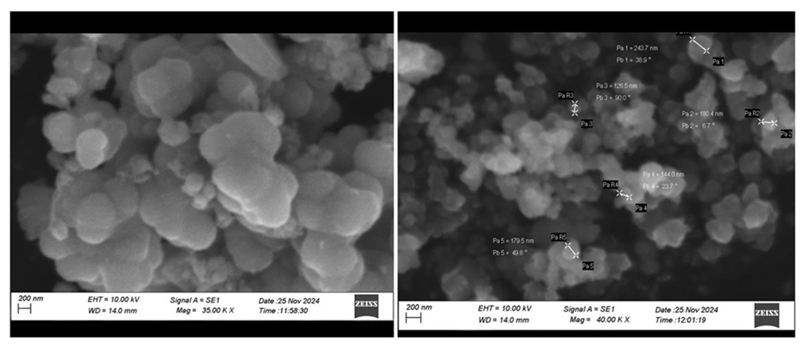
Figure 5: SEM images of TiO₂ Nanoparticles
3.3 Antioxidant activity
The DPPH antioxidant assays determine the relative ability of antioxidant for chemically synthesized TiO₂ NP to scavenge the free radicals generated in the reaction mixture. Fig.6. represents the in-vitro DPPH radical scavenging effect of the synthesized TiO₂ NPs scavenge the free radical at dose dependent manner. The TiO₂ NP (concentration ranges from 20-100 µg/ml) shows the potent DPPH radical scavenging activity (ranges from 72%) by neutralizing free radicals in the reaction mixture. The antioxidant effect of the NP on DPPH radical is mainly relies on their hydrogen donating capacity. Radical like DPPH scavenging mechanism is widely accepted one for antioxidant activity screening of TiO₂ NP. In this DPPH assay, the DPPH radical in the reaction mixture is reduced from violet colour to yellow coloured diphenyl picryl hydrazine product by the action of the nanoparticle on dose dependent manner. DPPH radical scavenging assay method has been used by several researchers to determine the antioxidant properties because this analysis requires relatively very short time finding of our study revealed that chemically synthesized TiO₂ NP had DPPH free radical scavenging activity when compared to standard ascorbic acid. The obtained data suggest that TiO₂ NPs effectively scavenge the free radicals because of its capacity to transfer electrodonor donating hydrogen ions (Ngoepe et al., 2020) and (Pinto et al., 2020).
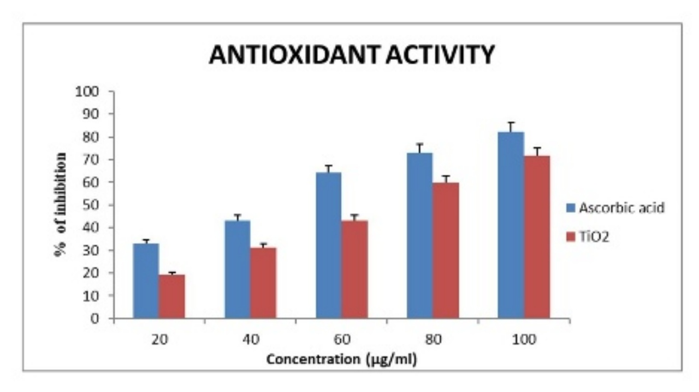
Figure 6: Antioxidant activity of TiO₂ Nanoparticles, Data represented as mean ± SE (n=3)
3.4 Anti-inflammatory activity
The anti-inflammatory activity of the TiO₂ NP is depicted in figure.7. The chemically synthesized TiO₂ NP shows significant anti-inflammatory activity at dose dependent manner. The activity is compared with diclofenac sodium, a standard anti-inflammatory drug. The TiO₂ NP at the volume of 20-100µl shows 63% inhibition of protein denaturation. In the development of some arthritic diseases, denaturation of the proteins found in the tissues may cause the auto-antigen production, which causes the tissue injury. Hence denaturation of tissue protein is thought to be a significant clinical marker for tissue inflammation and disease like arthritis. Protein denaturation preventing agents could be potential candidate for the development of anti-inflammatory drugs. In view of this point, in the current study, the protein denaturation bioassay study was selected to assess the in-vitro anti-inflammatory activity of TiO₂ NP with a wide range of dose concentrations. The data obtained from the present findings shows that the chemically synthesized TiO₂ NP exhibit dose dependent inhibition of protein denaturation. The increased absorbance in TiO₂ NP and the standard drug indicates the inhibition of protein denaturation (increase the protein stabilizing activity) with increased concentration (Priyanka et al., 2016) and (Deborah et al., 2015).
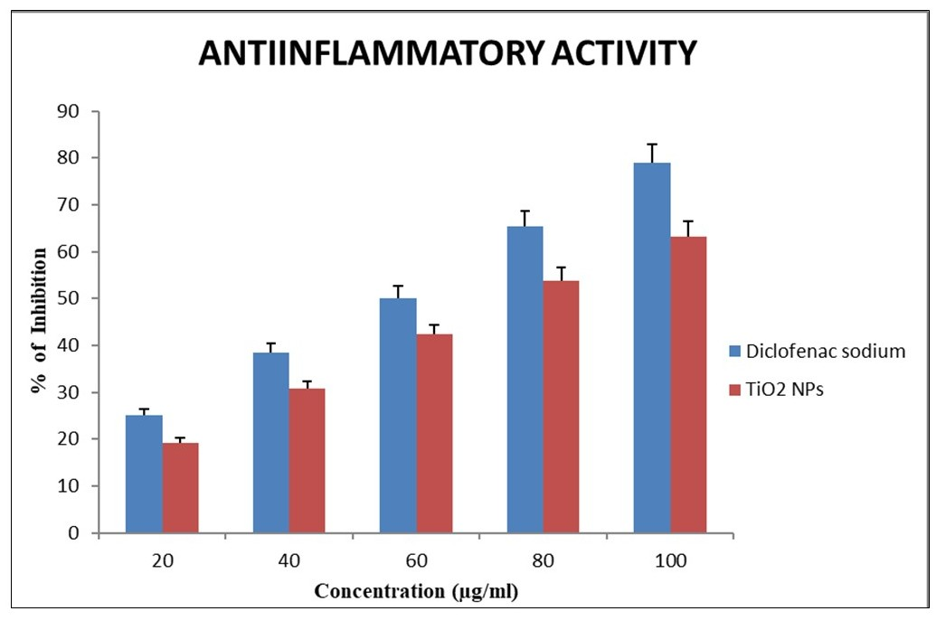
Figure 7: Anti-inflammatory activity of TiO₂ Nanoparticles, Data represented as mean ± SE (n=3).
3.5 Antibacterial activity
The agar well diffusion method was performed against the Gram-positive bacterium such as Bacillus sublitis, Enterococcus sp. and Gram-negative bacterium such as Escherichia coli, Klebsiella pneumonia and Proteus. When the chemically synthesized titanium dioxide NPs were tested against pathogenic bacterial strains at varying concentrations (50, 75, and 100 mg/ml). The zone of inhibition Table.1 indicates that synthesized TiO₂NPs displayed antibacterial activity of pathogenic strains of the maximum activity found at 100 µg. The synthesized TiO₂NPs Bacillus sublitis (19mm), Enterococcus (20mm), E. coli (21mm), Proteus (17mm), Klebsiella pneumonia (21mm) respectively. Antibacterial activity was evaluated by the diameter of zone of inhibition (ZOI) in mm range against the bacteria and the DMSO were used as solvent control. The maximum zone of inhibition (21 mm) was observed in the TiO₂NPs against E. coli and Klebsiella pneumonia at the concentration of 100 µg/ml were shown in Table.1 (Alavi and Karmi, 2018), (Ahmad, N. S. et al., 2020) (Figure 8).
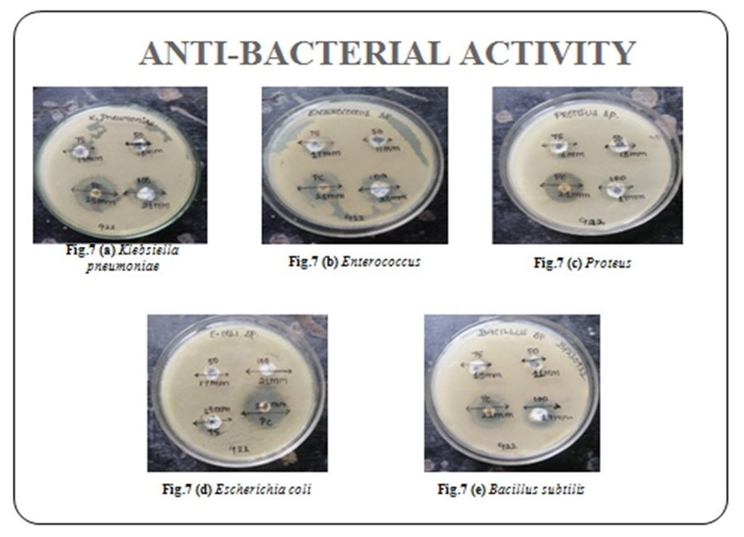
Figure 8: Zone of Inhibition of TiO₂ Nanoparticle
3.6 Table 1. Antibacterial activity of TiO₂Nanoparticles
S . No | Organisms | Positive control(mm)  Gentamycin | Zone of Inhibition
S . No | Organisms | Positive control(mm)  Gentamycin | 50  µg/ml | 75  µg/ml | 100  µg/ml
1. | Bacillus sublitis | 22mm | 11mm | 15mm | 19mm
2. | Enterococcus | 21mm | 11mm | 17mm | 20mm
3. | Proteus | 21mm | 13mm | 16mm | 17mm
4. | Escherichia coli | 23mm | 17mm | 19mm | 21mm
5. | Klebsiella pneumoniae | 25mm | 13mm | 17mm | 21mm
All experiments were performed in triplicate (n=3).

3.7 Water purification by TiO₂ Nanoparticles

TiO₂ nanobeads were made in accordance with the literature that was accessible, and because of their strong photocatalytic activity, they were employed to purify water. the capacity to break down organic pollutants and have antibacterial qualities. By combining the processes of oxidation and photocatalysis adsorption, these nanobeads aid in the removal of pollutants. Data on the efficacy of water treatment, particularly for a sample containing potassium dichromate, is shown in sample 1. Using measurements of pH, TDS, and optical density at 540 nm, it contrasts the water quality before and after treatment^{30, 31}. This experiment involves purifying water using alginate nanobeads based on TiO₂ NPs (Thakur and Thakur, 2024), (Sree Kumari et al., 2015). According to the data, the treatment method has following effects:
Sample- 1: potassium dichromate
1. pH Analysis:
Based onthe results pH increased from 5.9 to 6.1, indicating a slight neutralization.
2. TDS Analysis:
The TDS decreased from 529 ppm to 138 ppm, indicating that dissolved solids, likely heavy metal pollutants had been significantly removed.
3. Optical Density Analysis:
A decrease in optical density from 0.05 to 0.02 suggests a decrease in turbidity or chromate content.
Sample 2 provides information on the efficacy of water treatment, particularly for a sample that contains AZO color. By measuring pH, TDS, and optical density at 540 nm, it compares the quality of the water before and after treatment.
Sample 2: AZO dye water solution
1. pH Analysis
The pH increased from 6.5 to 6.8, indicating a slight shift toward neutrality.
2. Total Dissolved Solids (TDS) Reduction
TDS was reduced by 50%, from 876 ppm to 438 ppm...This suggests the efficacy of the treatment in eliminating dissolved materials, most likely color molecules, salts, and other pollutants.
3. Optical Density (OD) Reduction
Optical Density dropped from 0.72 to 0.47, which means a 34.7% reduction in color intensity.
This is consistent with the well-known photocatalytic and adsorptive capabilities of TiO2-alginate nanobeads, which can absorb heavy metals via the binding ability of alginate and breakdown pollutants when exposed to light.
3.8 Table 2. (a) Sample- 1 potassium dichromate
Sample 1 (potassium dichromate)
Test | Before Treatment | After Treatment
pH | 5.9 | 6.1
TDS | 529 ppm | 138 ppm
Optical density | 0.05 | 0.02

3.9 Table 3. (b) Sample- 2water with AZO dye
Sample 2 (AZO dye water)
Test | Before Treatment | After Treatment
pH | 6.5 | 6.8
TDS | 876 ppm | 438 ppm
Optical density | 0.72 | 0.47
All experiments were performed in triplicate (n=3).

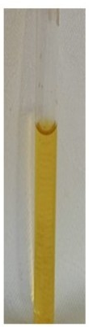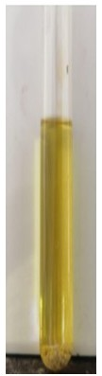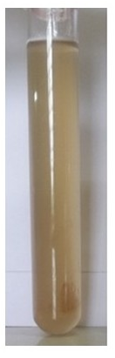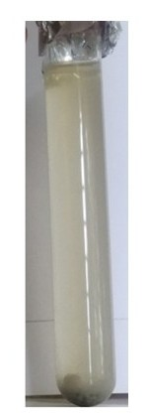
AFTER TREATMENT
AFTER TREATMENT
BEFORE TREATMENT
BEFORE TREATMENT

Figure 9: Water purification by TiO₂ Nanoparticles based alginate beads

4. Conclusion
In conclusion, TiO₂ NPs synthesized using sol gel approach was structurally characterized by UV-Vis absorption spectra confirm their UV-blocking capabilities by showing high absorption below 400 nm. The presence of metal oxide linkages within the NPs was confirmed by the Fourier-transform infrared (FTIR) spectroscopy data, which provided crucial chemical characterization. The calculated crystallite size, according to the SEM examination, is 22.2 nm. This titanium dioxide nanoparticle exhibits potent antioxidant ability by scavenging free radicals and exhibit strong anti-inflammatory effect against protein denaturation. The TiO₂ NP also exhibits strong antibacterial activity against various microorganisms, including both gram-positive and gram-negative bacteria. This work also showed that significant elimination of potassium dichromate by entrapped TiO₂ NPs beads in a batch experiment indicated that it will be the best to remove the pollutants in near future in the market. This study confirms that TiO₂-alginate nanobeads are effective in water purification, particularly in removing heavy metals and organic dyes. The combination of adsorption and photocatalysis significantly improves water quality, making these nanobeads a promising approach for waste water removal. Further optimization of this study helpful its potential usage in biomedical applications and environmental remediation.

COMPETING INTERESTS DISCLAIMER:
Authors have declared that they have no known competing financial interests OR non-financial interests OR personal relationships that could have appeared to influence the work reported in this paper.

Disclaimer (Artificial intelligence)
Option 1:
Author(s) hereby declare that NO generative AI technologies such as Large Language Models (ChatGPT, COPILOT, etc.) and text-to-image generators have been used during the writing or editing of this manuscript.
Option 2:
Author(s) hereby declare that generative AI technologies such as Large Language Models, etc. have been used during the writing or editing of manuscripts. This explanation will include the name, version, model, and source of the generative AI technology and as well as all input prompts provided to the generative AI technology
Details of the AI usage are given below:
1.
2.
3.

References
- Alavi, M., & Karimi, N. (2018). Characterization, antibacterial, total antioxidant, scavenging, reducing power and ion chelating activities of green synthesized silver, copper and titanium dioxide nanoparticles using Artemisia haussknechtii leaf extract. Artificial cells, nanomedicine, and biotechnology, 46(8), 2066-2081(2018).
- Alavi, M., & Karimi, N. Characterization, antibacterial, total antioxidant, scavenging, reducing power and ion chelating activities of green synthesized silver, copper and titanium dioxide nanoparticles using Artemisia haussknechtii leaf extract. Artificial cells, nanomedicine, and biotechnology, 46(8), 2066-2081(2018).
- Ameer Baig Ali Baia, Velukumar Ramya Structural and Antibacterial study of Titanium dioxide nanoparticles with the impact of amino-acids by Convection microwave irradiation method Volume7(2) ( 2023).
- Ahmad, N. S., Abdullah, N., & Yasin, F. M. (2020). Toxicity assessment of reduced graphene oxide and titanium dioxide nanomaterials on gram-positive and gram-negative bacteria under normal laboratory lighting condition. Toxicology Reports, 7, 693-699.
- Bailey-Shaw, Y. A., Williams, L. A., Green, C. E., Rodney, S., & Smith, A. M. . In-vitro evaluation of the anti-inflammatory potential of selected jamaican plant extracts using the bovine serum albumin protein denaturation assay. International Journal of Pharmaceutical Sciences Review and Research, 47(1), 145-153(2017).
- D. Daniel Lawrence, Dominic Savio C, S. Rahul, A. Dhayal Raj Antibacterial property of MgO nanoparticles prepared through green synthesis route from orange peel extract, Journal of functional materials and Biomolecules 7 (2), 784 – 788(2023)
- Deborah, M., Jawahar, A., Mathavan, T., Dhas, M. K.,& Franklin Benial, A. M. Preparation and characterization of oxidized multi-walled carbon nanotubes and glycine functionalized multi-walled carbon nanotubes. Fullerenes, Nanotubes and Carbon Nanostructures, 23(7), 583-590(2015).
- Gjipalaj, J., & Alessandri, I. Easy recovery, mechanical stability, enhanced adsorption capacity and recyclability of alginate-based TiO2 macrobead photocatalysts for water treatment. Journal of environmental chemical engineering, 5(2), 1763-1770(2017).
- Gopalkrishnan v.,Poongothai A., Sivaelango G., phytochemical screening and In-vitro anti-inflammatory activity of Thespesia poplunia fruit extract. Journal of functional materials and biomolecules,7(2),696 – 699(2023).
- Govindarajan S. and Noor Ayesha., Isolated fractions of Aloe vera carbohydrate
ameliorate streptozotocin-induced pancreatic β-cell damage and bidirectionally regulated AMPK activity, Res. J. Biotech, 18(20), 86-96 (2023).
- J. Bosco Franklin, Jeevajothi I., Sachin S., John Sundaram S.,Synthesis and
characterization ofZnO Nanoparticles. Journal of functional materials and biomolecules ,7(2),676 – 680(2023).
11. Khan, M. A., Akhtar, M. S., & Yang, O. B. (2010). Synthesis, characterization and application of sol–gel derived mesoporous TiO2 nanoparticles for dye-sensitized solar cells. Solar energy, 84(12), 2195-2201 (2010).
12. Khataee, A. R., Pons, M. N., & Zahraa, O. Photocatalytic degradation of three azo dyes using immobilized TiO2 nanoparticles on glass plates activated by UV light irradiation: Influence of dye molecular structure. Journal of hazardous materials, 168(1), 451-457 (2009).
13. Mao, L. C., Pan, X., Que, F., & Fang, X. H. Antioxidant properties of water and ethanol extracts from hot air-dried and freeze-dried daylily flowers. European Food Research and Technology, 222, 236-241(2006).
14. Mizushima, Y., & Kobayashi, M.. Interaction of anti-inflammatory drugs with serum proteins, especially with some biologically active proteins. Journal of Pharmacy and Pharmacology, 20(3), 169-173(1968).
15. Molyneux P., The use of the stable free radical diphenylpicryllhydrazyl (DPPH) for
estimating antioxidant activity,Songklanakrin Journal Science and Technology, 26, 211-
16 (2004).
16. Moyo, M., Ndhlala, A. R., Finnie, J. F., & Van Staden, J. Phenolic composition,
antioxidant and acetylcholinesterase inhibitory activities of Sclerocaryabirrea and
Harpephyllumcaffrum (Anacardiaceae) extracts. Food Chemistry, 123(1), 69-76(2010).
17. Nandhini, N. T., Rajeshkumar, S., & Mythili, S. The possible mechanism of eco-friendly
synthesized nanoparticles on hazardous dyes degradation. Biocatalysis and Agricultural
Biotechnology, 19, 101138(2019).
18. Ngoepe, N. M., Mathipa, M. M., &Hintsho-Mbita, N. C. Biosynthesis of titanium
dioxide nanoparticles for the photodegradation of dyes and removal of
bacteria. Optik, 224, 165728(2020).
19. Pawar, V., Kumar, M., Dubey, P. K., Singh, M. K., Sinha, A. S. K., &Singh,. Influence
of synthesis route on structural, optical, and electrical properties of TiO2. Applied
Physics A, 125(9), 657 (2019).
20. Pinto, M., Ramalho, P. S. F., Moreira, N. F. F., Gonçalves, A. G., Nunes, O. C., Pereira,
M. F. R., & Soares, O. S. G. P. Application of magnetic nanoparticles for water
purification. Environmental Advances, 2, 100010 (2020).
21. Priyanka, K. P., Sukirtha, T. H., Balakrishna, K. M., & Varghese, T. Microbicidal
activity of TiO2 nanoparticles synthesised by sol–gel method. IET
nanobiotechnology, 10(2), 81-86 (2016).
22. Rajeshkumar, S., Vanaja, M., &Kalirajan, A. (2021). Degradation of Toxic Dye Using
Phytomediated Copper Nanoparticles and Its Free‐Radical Scavenging Potential and
Antimicrobial Activity against Environmental Pathogens. Bioinorganic Chemistry and
Applications, 2021(1), 1222908 (2021).
23. Ramesh, P., Muthukkumarasamy, S., Dhanabalan, K., Sadhasivam, T., & Gurunathan,
K. Synthesis and characterization of Ag and TiO2 nanoparticles and their anti-microbial
activities. Dig J NanomaterBiostruct, 7(4), 1501-1508(2012).
24. Rikta, S. Y. Application of nanoparticles for disinfection and microbial control of water
and wastewater. Nanotechnology in water and wastewater treatment, 159-176 (2019).
25. Santhoshkumar, T., Rahuman, A. A., Jayaseelan, C., Rajakumar, G., Marimuthu, S.,
Kirthi, A.V., & Kim, S. K. . Green synthesis of titanium dioxide nanoparticles using
Psidium guajava extract and its antibacterial and antioxidant properties. Asian Pacific
journal of tropical medicine, 7(12), 968-976(2014).
26. Sathya, S., Ragul, V., Veeraraghavan, V. P., Singh, L., & Ahamed, M. N. An in vitro
study on hexavalent chromium [Cr (VI)] remediation using iron oxide nanoparticles
based beads. Environmental Nanotechnology, Monitoring & Management, 14,
100333(2020).
27. Sayan, B., Indranil, S., Aniruddha, M., Dhrubajyoti, C., Uday, C. G., & Debashis, C.
(2013). Role of nanotechnology in water treatment and purification: potential
applications and implications. Int J Chem Sci Technol, 3(3), 59 (2013).
28 Shahid, M., McDonagh, A., Kim, J. H., & Shon, H. K. Magnetised titanium dioxide
(TiO2) for water purification: preparation, characterisation and
application. Desalination and WaterTreatment, 54(4-5), 979-1002 (2015).
29. Sharma, A., Karn, R. K., & Pandiyan, S. K. . Synthesis of TiO2 nanoparticles by sol-gel
method and their characterization. J Basic Appl Eng Res, 1(9), 1-5 (2024).
30. Sree Kumari C., Yasmin N., Raffiq Hussain M. and Babuselvam M., Invitro Anti-
inflammatory & Anti-arthritic property ofRhizoporamucromata leaves, International
Journal of Pharma Sciences and Research,6(3), 482-485 (2015).
31. Thakur, N., Thakur, N. Degradation of textiles dyes and scavenging activity of spherical
shape obtained anatase phase of Co–Ni-doped TiO₂ nanocatalyst. J Mater Sci: Mater
Electron 35, 134 (2024). https://doi.org/10.1007/s10854-023-11851-3.

