Comparative Bioinformatics Approach to Identify a ZnO Nanoparticle Drug Targeting Mutant CHRNA5 in Humans and Gorillas

Abstract
Our current work focuses on the CHRNA5 protein's susceptibility to lung cancer. This gene encodes nicotinic acetylcholine receptor subunits, which are ligand-gated ion channels that speed up signal transmission at synapses. A higher incidence of type 2 lung cancer (Non-Small Cell Lung Cancer (NSCLC)) has been linked to gene abnormalities. The primary purpose of this study is to investigate the efficacy of Cordia dichotoma-derived ZnO nanoparticles when combined with an existing anticancer drug against the mutant CHRNA5 of humans and Gorilla gorilla. Both humans and Gorillas are orthologous species as they share a similar sequence homology. The probable mutant areas were first identified using protein modelling tools and visualizers, and their three-dimensional structures studied. After modelling, we employed an automated docking service to link the modelled protein to our chosen molecule. Discovery Studio Software, a powerful molecular visualization tool, was utilized to confirm the electrostatic interactions between the ligand and protein complex. Our chosen nano particles’ efficacy against the CHRNA5 protein was validated by binding interactions. Based on the docking scores and H-bond interactions, we conclude that the chosen molecule has the potential to be a promising Lung Cancer therapeutic agent. The drug was also tested against Gorilla gorilla to prove its efficiency against a homologous species. Our current study can be expanded into the areas of Clinical Oncology and Pharmacoinformatics.
Keywords: CHRNA5, ZnO , lung cancr, CB Dock server, Drug Docking.
- INTRODUCTION
A serious concern to the global population, malignant lung cancer remains a contemporary clinical issue [Vicidomini G et al., 2023, Rina A et al., 2024]. Many screening initiatives have been launched in recent years to increase the statistics of early lung cancer detection, with the concurrent goal of improving the disease's prognosis [Gasparri R et al., 2023, Li C et al., 2021, Dama E et al., 2021]. Given that long-term, heavy smokers have a higher chance of acquiring lung cancer, the National Lung Screening Trial (NLST) program was established in the United States between 2002 and 2004. Patients from the greatest risk groups—those aged 55 to 74 who were active smokers with a history of more than or equal to 30 pack-years—were included in this study. Low-dose computed tomography (LDCT) screening was done on eligible individuals once every year. According to the study's findings, individuals screened using LDCT had a roughly 20% lower relative chance of dying than those observed with traditional X-rays. Nevertheless, this was linked to a significant number of false positives and unnecessary thoracic surgical procedures. Scientists have been working for a number of years to comprehend the molecular mechanisms that are helpful in the efficient selection of the best medicine for patients at different stages of the disease, given the lack of trustworthy, population-wide screening [Chehelgerdi M et al., 2023]. The clinical utility of lung carcinoma gene polymorphisms is becoming well understood. At first, it was believed that these investigations would enable the prediction of the reaction to the application of traditional cytostatics like cisplatin. Finding tumor polymorphisms may be a component of the panel of prognostic markers, according to an increasing amount of data [Zhou Y et al., 2024, Zhao Y et al., 2021].
According to Thandra K.C. et al. (2021), lung cancer is the most common cause of cancer-related deaths worldwide and the most frequently diagnosed malignant tumor. The most common type of cancer worldwide is lung cancer. According to the International Agency for Research on Cancer's (IARC) most recent estimates, the following are the global cancer statistics by world region for 2022. 9.7 million people died from cancer in 2022, including non-melanoma skin cancers (NMSCs), and there were about 20 million new instances of cancer in 2022 [Bray F et al., 2024]. One in five men and women are predicted to have cancer at some point in their lives. Cancer claims the lives of one in nine men and one in twelve women. In 2022, lung cancer was the most frequently diagnosed cancer. The disease affected 2.5 million new cases, or one in eight malignancies worldwide (12.4% of all cancers worldwide). Prostate cancer (7.3%), colorectal cancer (9.6%), stomach cancer (4.9%), and breast cancer in women (11.6%) were the next most frequent cancers. With an anticipated 1.8 million deaths (18.7%), lung cancer was also the most common cause of cancer-related mortality. Colorectal cancer (9.3%), liver cancer (7.8%), breast cancer in women (6.9%), and stomach cancer (6.8%) took the next positions. The most prevalent cancers in males and women, respectively, were lung and breast cancer. Our research investigation focus on increasing the efficiency of an existing anti-cancer drug using Zinc oxide nano particle using Insilico molecular docking studies. Cancer remains the biggest cause of death worldwide, despite substantial advances in treatment and prevention. This declaration recognizes the continued difficulty of studying, detecting, preventing, and treating this complicated disease.
Because gorillas and humans have a close evolutionary link, they have a surprising amount of similarities. Given that they have roughly 98.3% of our DNA in common, gorillas are among our closest living cousins. There are many physical, biochemical, and behavioral similarities as a result of this genetic proximity. Molecular comparative studies were carried out in this research work between the CHRNA5 of the orthologous species, Homo sapiens and Gorilla gorilla. It was also found out that by combining nanoparticles with existing anti-cancer drugs, the efficiency of the drug can be increased drastically [Städele V et al., 2022, Lameira AR, (2020), Sharp PM et al., 2020,Dodd, G. K., & Keşmir, C. (2025)].
- METHODOLOGY
3D Drug Docking: This protein sequence of CHRNA5 cholinergic receptor nicotinic alpha 5 subunit was obtained from the UnitProt database for Homo sapiens (https://www.uniprot.org/uniprotkb/P30532/entry) and for Gorilla gorilla (Western lowland gorilla) (https://www.uniprot.org/uniprotkb/G3QUJ5/entry). The SwissModel server (https://swissmodel.expasy.org/) was used to create a three-dimensional model of the CHRNA5 [Smolarz, B et al., 2025] protein (Waterhouse A et al., 2018). Docking testing was performed using the mutant protein CHRNA5 and cyclophosphamide (CID: 2997) and zinc oxide (CID: 14806). Yang Liu et al. (2022) and Xiaocong Yang et al. (2022) used the CB Dock tool. The CB dock server employs a protein-ligand docking technique that leverages AutoDock Vina to execute molecular docking after automatically determining the binding sites, calculating the center and size, and customizing the docking box size based on the query ligands. (https://cadd.labshare.cn/cb-dock2/index.php) It is used to predict the three-dimensional interaction of the receptor and ligand molecules. The ligand and receptor sequence (CHRNA5) was obtained in 3D docked file format. The CB Dock investigation also clarified H-bond interactions. Three-dimensional drug-receptor interactions: A molecular visualization tool called Discovery Studio Software was utilized to show the three-dimensional structure after CHRNA5 molecular drug docking research on the combination of cyclophosphamide and zinc oxide nanoparticles.
Picture 1 : Diagrammatic representation of the entire research work

- RESULTS AND DISCUSSION
MAARGSGPRA LRLLLLVQLV AGRCGLAGAA GGAQRGLSEP SSIAKHEDSL LKDLFQDYER
WVRPVEHLND KIKIKFGLAI SQLVDVDEKN QLMTTNVWLK QEWIDVKLRW NPDDYGGIKV
IRVPSDSVWT PDIVLFDNAD GRFEGTSTKT VIRYNGTVTW TPPANYKSSC TIDVTFFPFD
LQNCSMKFGS WTYDGSQVDI ILEDQDVDKR DFFDNGEWEI VSATGSKGNR TDSCCWYPYV
TYSFVIKRLP LFYTLFLIIP CIGLSFLTVL VFYLPSNEGE KICLCTSVLV SLTVFLLVIE
EIIPSSSKVI PLIGEYLVFT MIFVTLSIMV TVFAINIHHR SSSTHNAMAP LVRKIFLHTL
PKLLCMRSHV DRYFTQKEET ESGSGPKSSR NTLEAALDSI RYITRHIMKE NDVREVVEDW
KFIAQVLDRM FLWTFLFVSI VGSLGLFVPV IYKWANILIP VHIGNANK

Fig.1: Normal sequence of CHRNA5 with V at 134th amino acid position and D at 398th amino acid position highlighted in yellow.

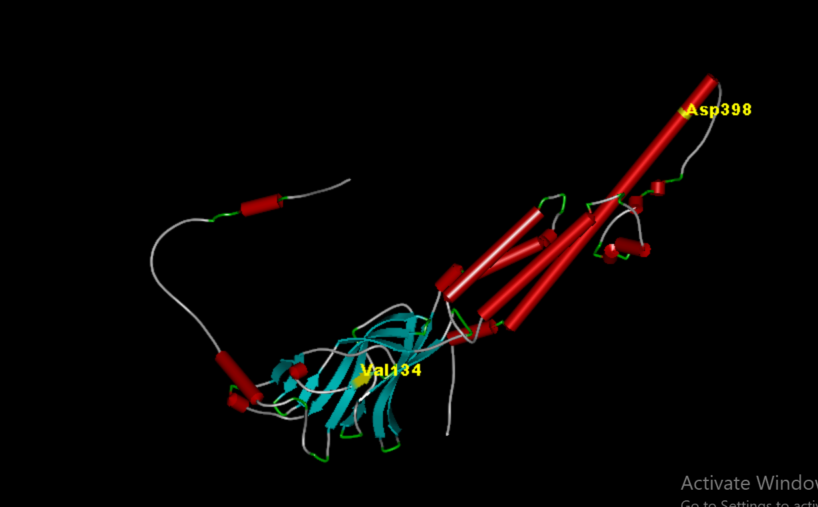

Fig.2: Normal 3D structure of CHRNA5 with V at 134th amino acid position and D at 398th amino acid position highlighted in yellow visualized using Discovery Studio software. A computational method for predicting the three-dimensional structure of proteins and RNAs is called 3D structure prediction. When creating drugs, 3D structures are important both structurally and functionally. The 3D arrangement of the helices and the stabilization of the structure with intricate tertiary connections are the primary components of RNA 3D structure prediction.

MAARGSGPRA LRLLLLVQLV AGRCGLAGAA GGAQRGLSEP SSIAKHEDSL LKDLFQDYER
WVRPVEHLND KIKIKFGLAI SQLVDVDEKN QLMTTNVWLK QEWIDVKLRW NPDDYGGIKV
IRVPSDSVWT PDIILFDNAD GRFEGTSTKT VIRYNGTVTW TPPANYKSSC TIDVTFFPFD
LQNCSMKFGS WTYDGSQVDI ILEDQDVDKR DFFDNGEWEI VSATGSKGNR TDSCCWYPYV
TYSFVIKRLP LFYTLFLIIP CIGLSFLTVL VFYLPSNEGE KICLCTSVLV SLTVFLLVIE
EIIPSSSKVI PLIGEYLVFT MIFVTLSIMV TVFAINIHHR SSSTHNAMAP LVRKIFLHTL
PKLLCMRSHV DRYFTQKEET ESGSGPKSSR NTLEAALNSI RYITRHIMKE NDVREVVEDW
KFIAQVLDRM FLWTFLFVSI VGSLGLFVPV IYKWANILIP VHIGNANK

Fig.3: Mutated sequence of CHRNA5 with I at 134th amino acid position and N at 398th amino acid position highlighted in yellow.

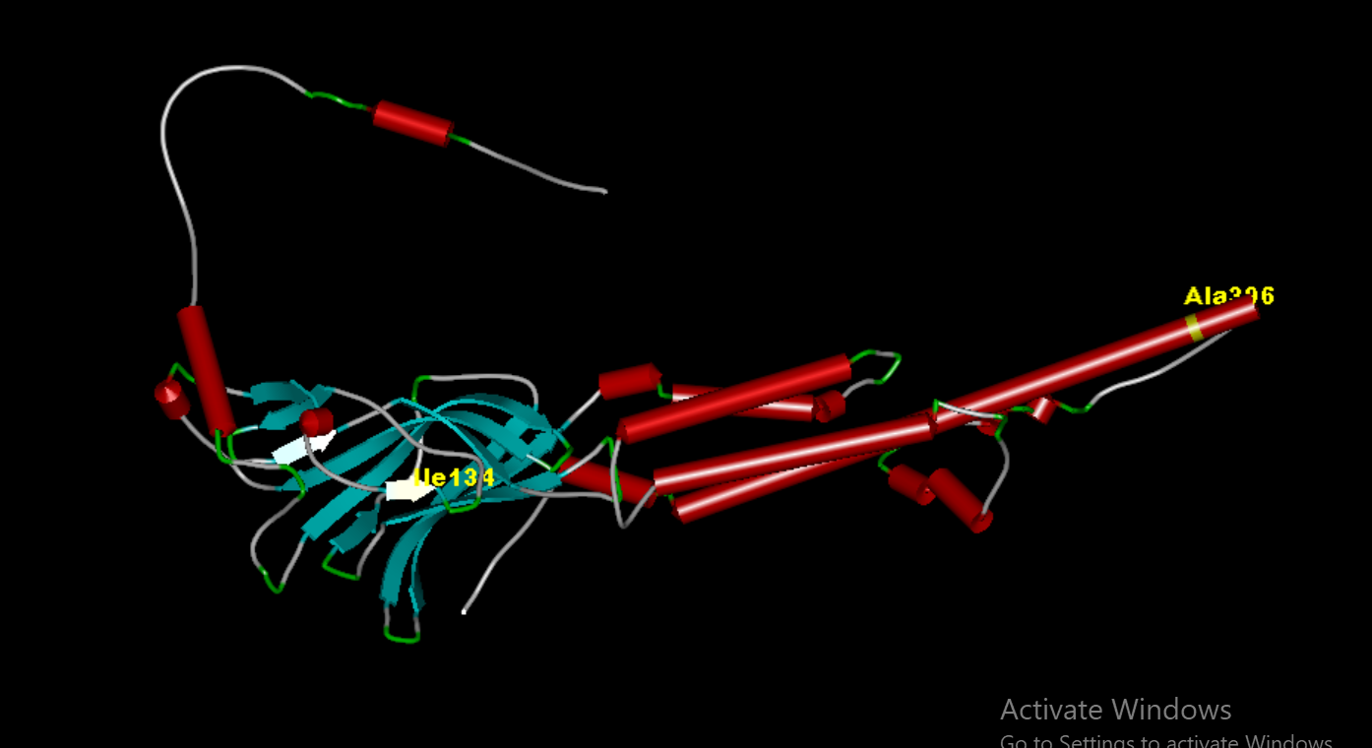

Fig.4: Mutated 3D structure of CHRNA5 with I at 134th amino acid position and N at 398th amino acid position highlighted in yellow visualized using Discovery Studio software. 3D structure prediction refers to a computational method used to predict the three-dimensional structure of proteins and RNA. When developing medications, 3D structures are critical both structurally and functionally. The fundamental components of RNA 3D structure prediction are the 3D arrangement of helices and the stabilization of the structure via complicated tertiary connections.
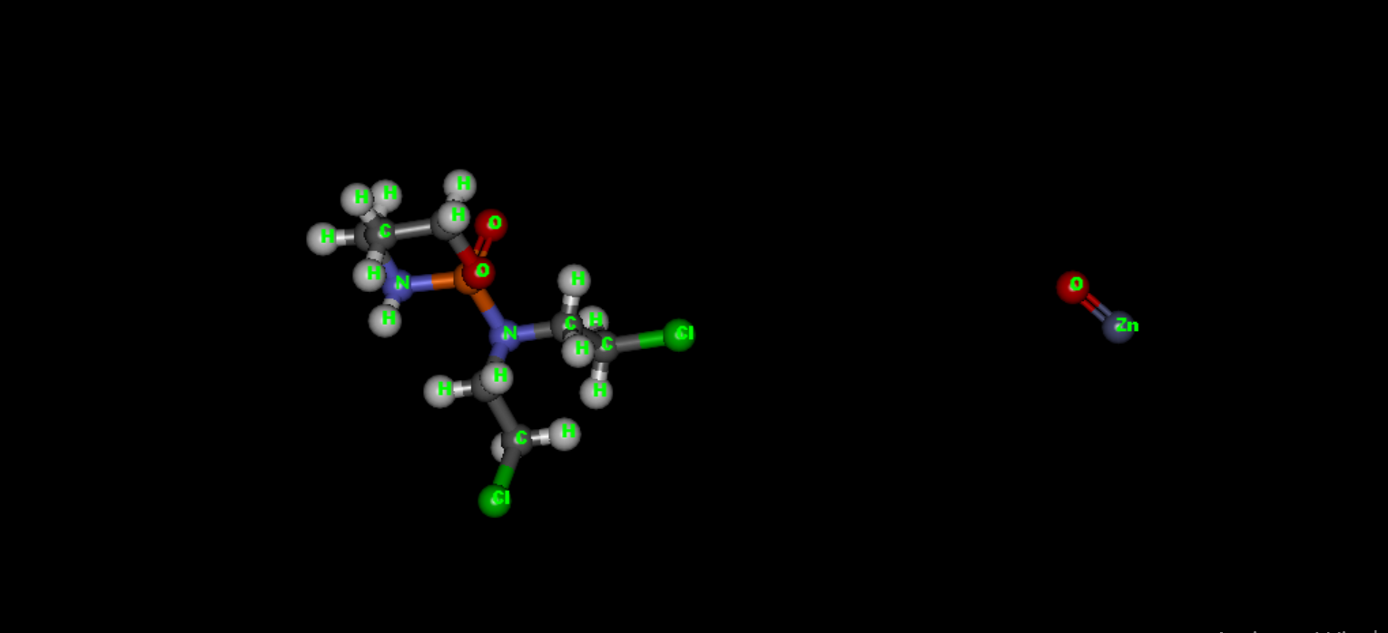

Fig.5: 3D structure of Cyclophosphamide and Zinc oxide nanoparticle indicated by an arrow and viewed using Discovery Studio software. Cyclophosphamide is an antirheumatic medication which can cause can cause cancer, alkylation, immunosuppression, antineogenesis, environmental contamination, xenobiotics, and drug allergies. It is a nitrogen mustard, an organochlorine chemical, and a phosphorodiamide.

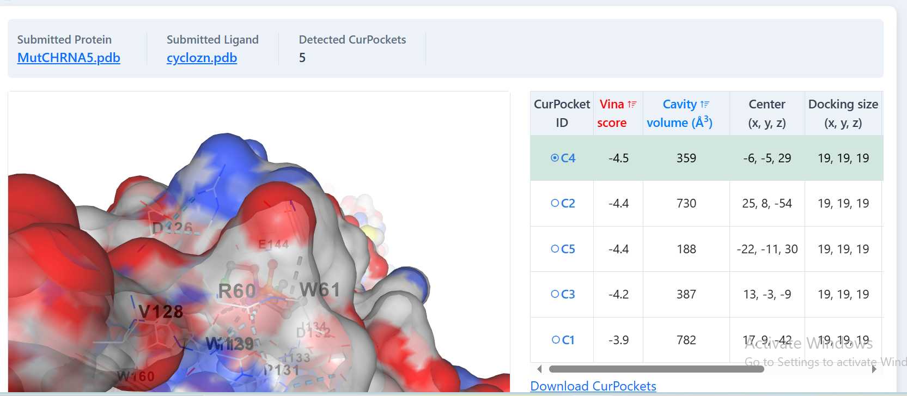
Fig.6: 3D interaction between CHRNA5 and the novel drug candidate with respective docking scores. Higher negative value indicates a higher binding efficiency between the drug and the receptor. In the domains of computational chemistry and molecular modeling, scoring functions are mathematical functions that are used to estimate the binding affinity between two molecules following docking. Scoring functions have also been created to estimate the intensity of intermolecular interactions between two proteins or between a protein and DNA.

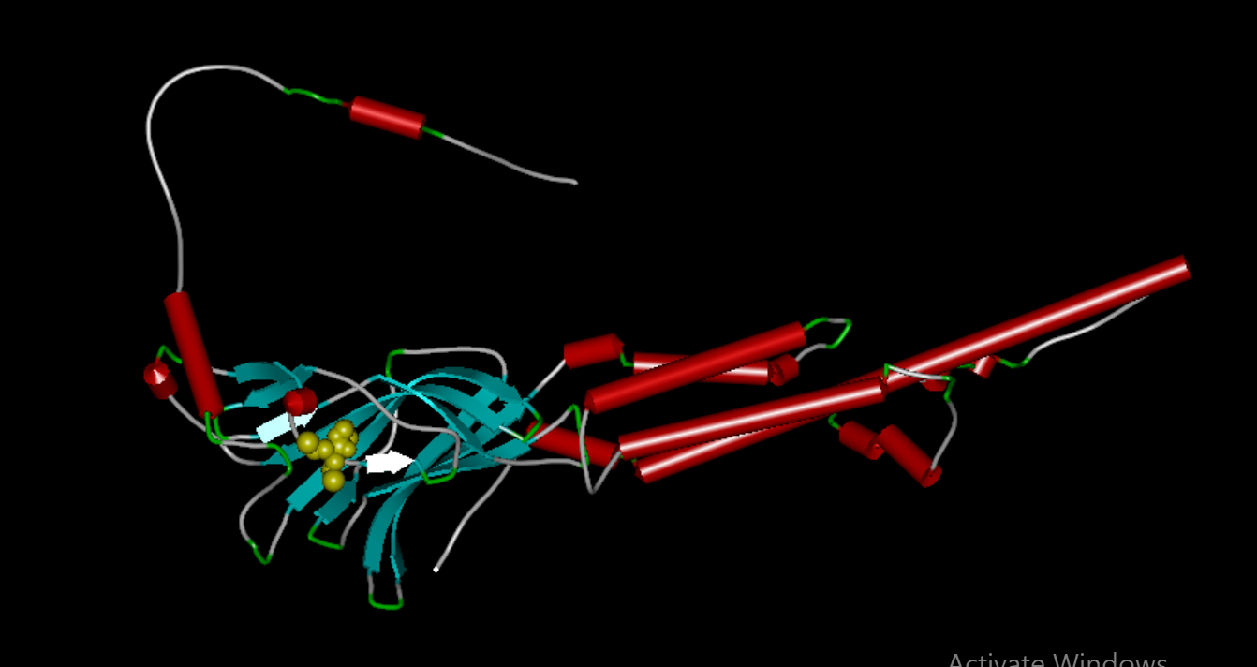

Fig.7: 3D interaction between CHRNA5 and the novel drug candidate viewed using Discovery Studio software.

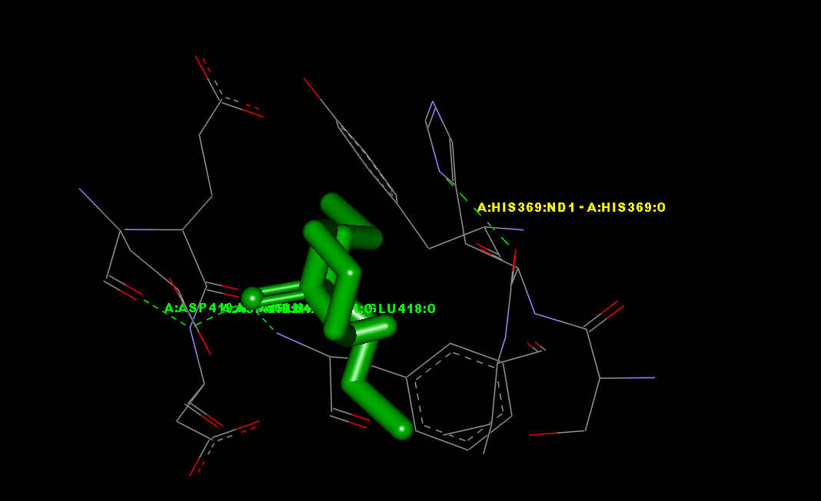

Fig.8: H-bond interaction between CHRNA5 and the novel drug candidate with amino acids present at the binding site viewed using Discovery Studio software. Hydrogen (H) bonds are abundant in nature and perform critical roles in protein folding, protein-ligand interactions, and catalysis. H-bonds are widely regarded as facilitators of protein-ligand binding.

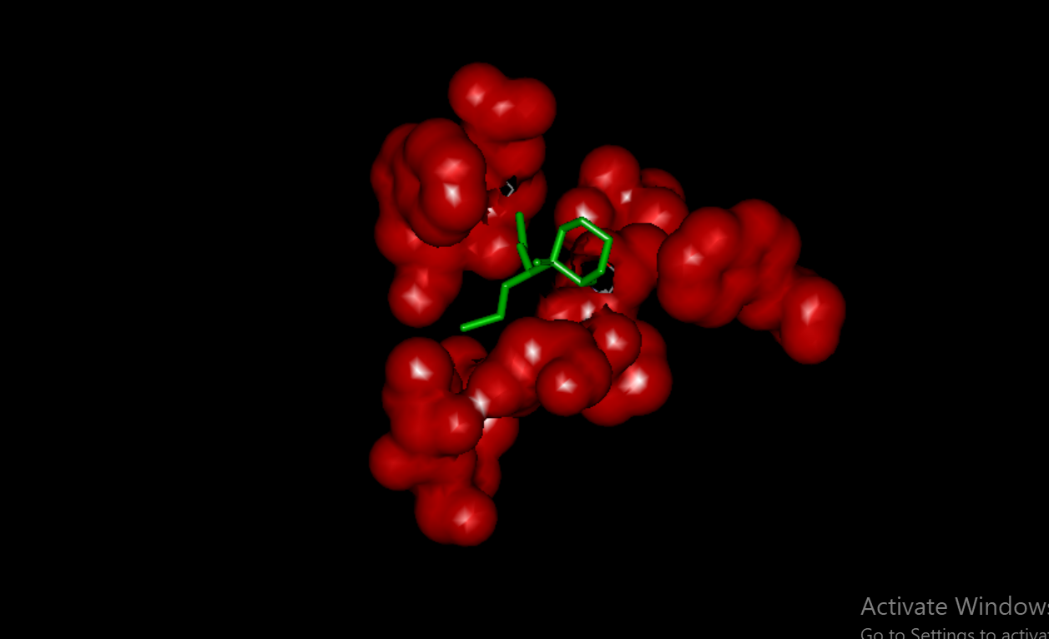

Fig.9: Electrostatic interaction between CHRNA5 and the novel drug candidate viewed using Discovery Studio software. Electrostatic interaction is the force of attraction or repulsion between charged objects or particles that is governed by Coulomb's Law. It is a fundamental factor in physics, influencing a wide range of events, from atomic structure to material behaviour.

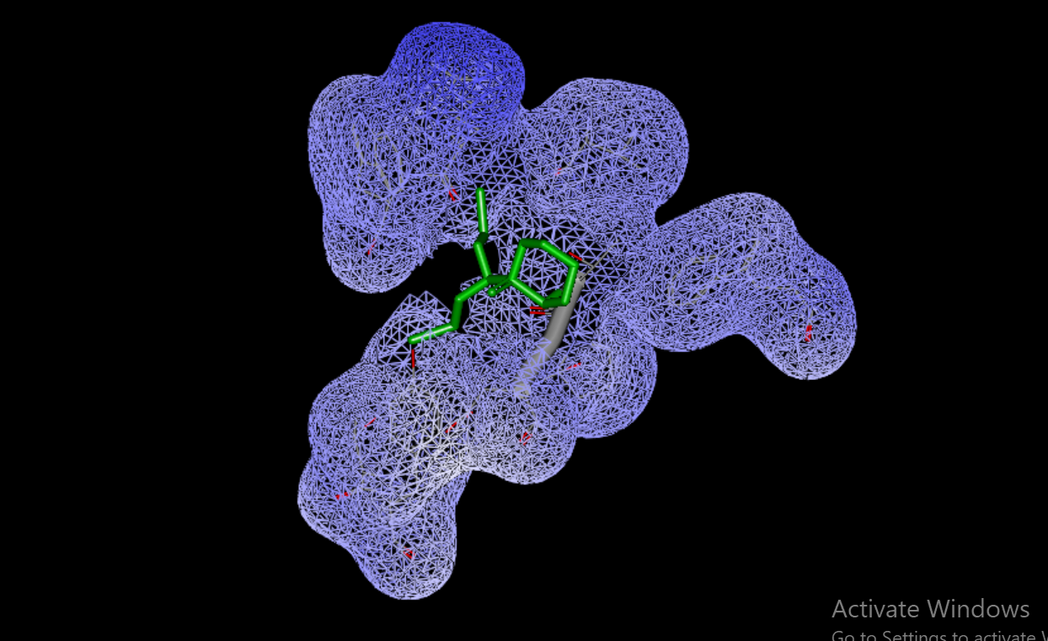

Fig.10: Van der Waals interaction between CHRNA5 and the novel drug candidate viewed using Discovery Studio software. Van der Waals forces are caused by induced electrical interactions between two or more atoms or molecules that are extremely near together. The Van der Waals interaction is the lowest of the intermolecular forces between molecules. However, when a large number of Van der Waals forces contact between two things, the interaction can be quite strong.

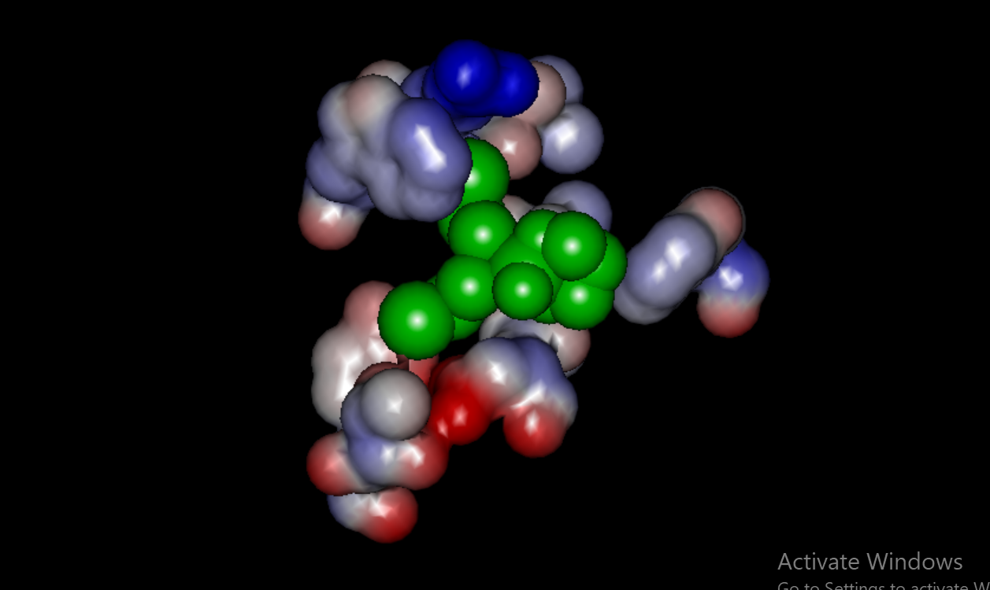

Fig.11: Hydrophobic interaction between CHRNA5 and the novel drug candidate viewed using Discovery Studio software. Hydrophobic interactions are a sort of non-covalent force that occurs when nonpolar molecules, such as oils or fats, cluster together in water to avoid contact with it. This clustering arises because water molecules prefer to interact with one another rather than with hydrophobic molecules, resulting in their "exclusion" from the interface between hydrophobic species.
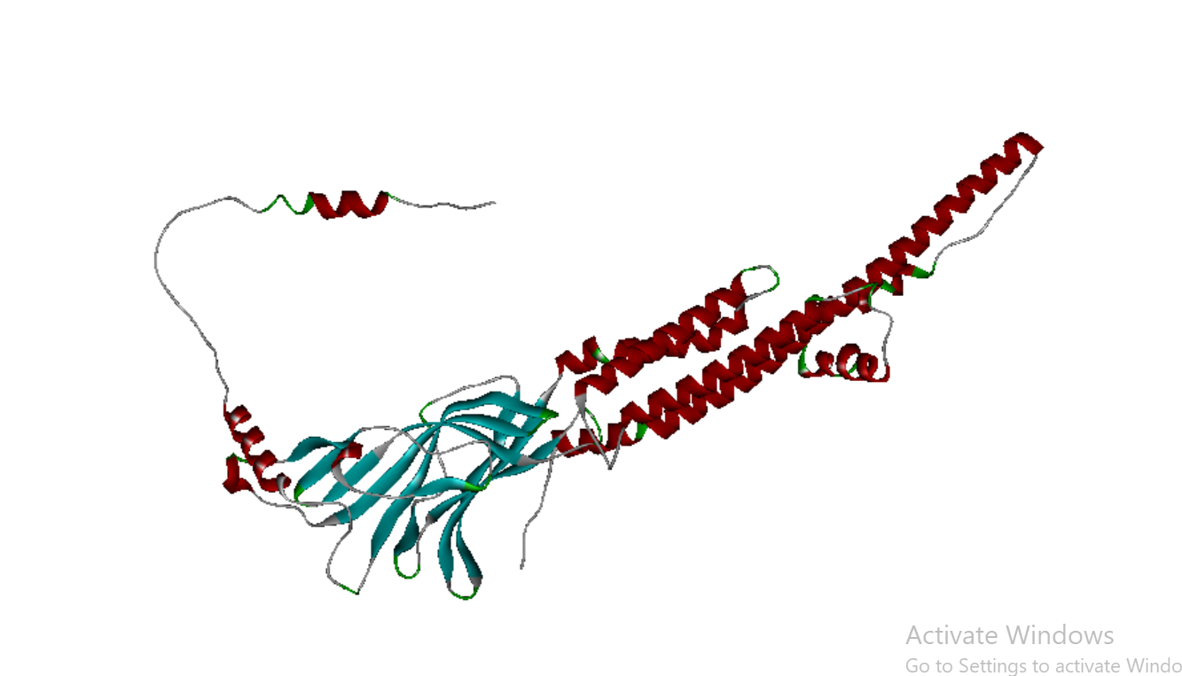
Fig.12: The 3D structure of CHRNA5 of Gorilla gorilla was viewed using Discovery Studio software.
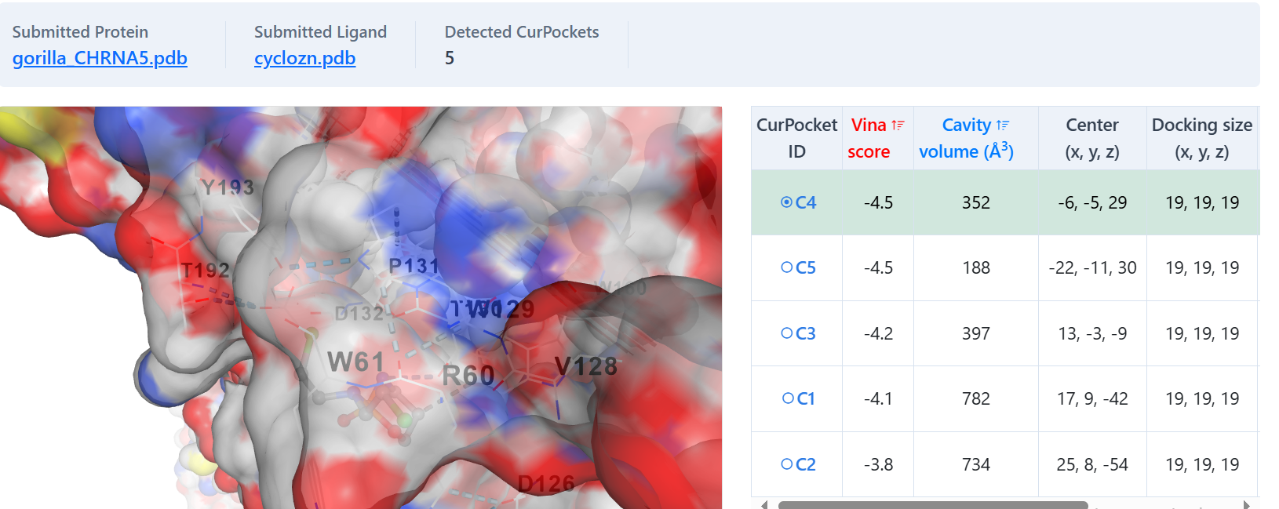
Fig.13: 3D interaction between CHRNA5 of Gorilla gorilla and the novel drug candidate with respective docking scores. The expected binding affinity between a ligand (a tiny molecule, usually a medicine) and a protein target is represented numerically by a docking score in the context of molecular docking. In essence, it shows the likelihood that a ligand will bind to a protein; lower scores often indicate stronger binding interactions. When determining possible medication candidates and assessing the efficacy of various substances, docking scores are essential.

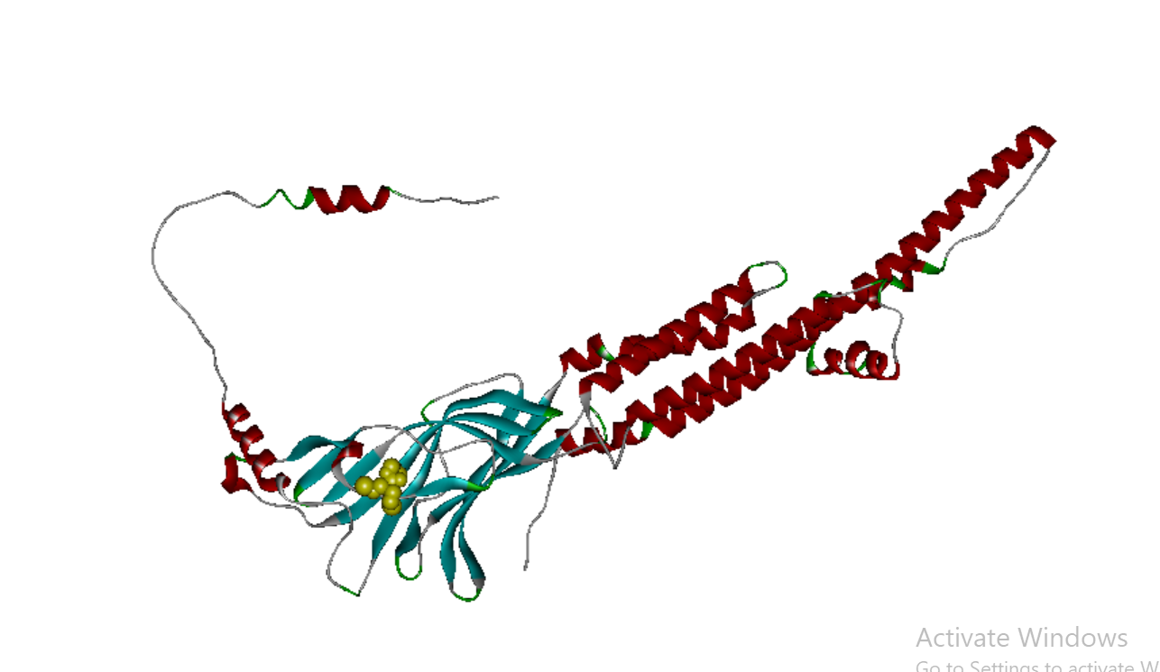
Fig.14: 3D complex structure of CHRNA5 of Gorilla gorilla with the designed ZnO nanoparticle represented in yellow colour.

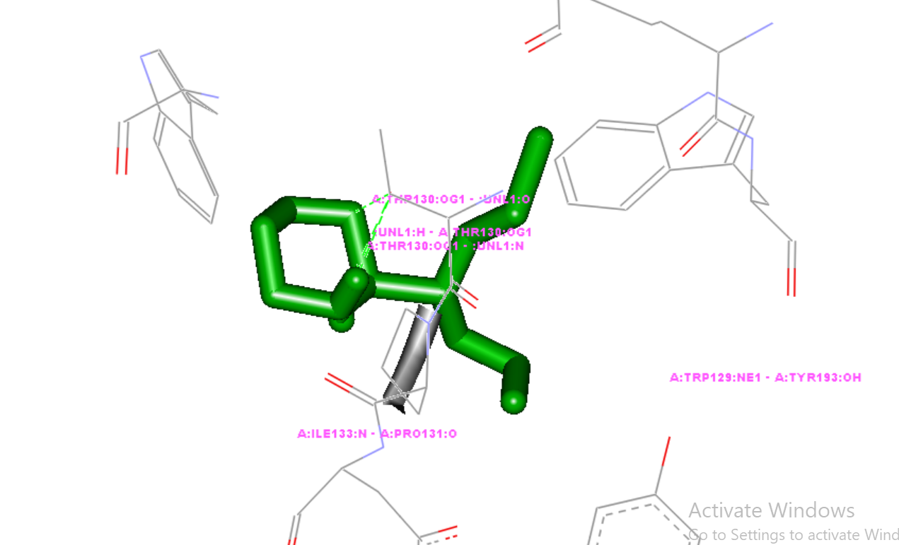
Fig.15: 3D interaction between CHRNA5 of Gorilla gorilla with ZnO nanoparticle. The picture clearly depicts how ZnO nanoparticle interacts at the corresponding amino acid positions. As a particular instance of dipole-dipole interactions, hydrogen bond interactions are a form of attractive intermolecular force that arises between an electronegative atom and a hydrogen atom that is linked to a strongly electronegative atom (such as N, O, or F). The structure and characteristics of many molecules and materials depend on these interactions.
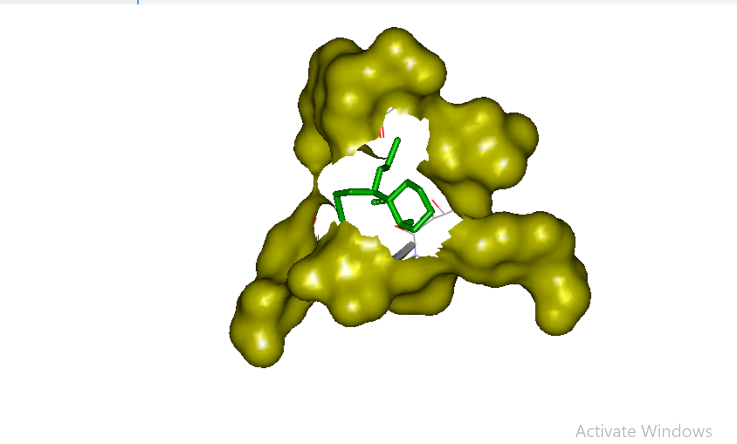
Fig.16: 3D Van der Waals interaction between CHRNA5 of Gorilla gorilla and ZnO nanoparticle. The binding interaction between the receptor and ligand is shown in Surface – Stick model view viewed using Discovery Studio software. When two or more atoms or molecules are in close proximity to one another, they create electrical interactions that drive van der Waals forces. Of all the intermolecular forces that attract molecules to one another, the van der Waals interaction is the weakest.
Previus research works have proved that Homo sapiens and Gorilla gorilla share a high percentage of genome sequence homology. [Jorstad NL et al., 2023]. In this research work, we have selected Cyclophosphamide, a widely used anti-cancer drug. Simultaneously, we used Zinc oxide. Several researches have proved that Zinc oxide is a potent nanoparticle [Rusli, R. K et al., 2024, Khajuria AK, et al., 2025]. Among all malignant tumor types, lung cancer resulting from a mutation in CHRNA5 has a high incidence rate and fatality rate (Thai et al., 2021). The largest risk factor for lung cancer is smoking, according to numerous epidemiological studies carried out globally (Balata et al., 2019; Gallaway et al., 2019). Tobacco contains over 50 different types of substances that can cause cancer, and nicotine is the primary addictive component of smoking, which can accelerate the growth of lung tumors. Studies show that nicotine has a variety of effects, including promoting cancer cell proliferation, motility, and immune regulation and playing a key role in tumor metastasis, invasive behavior, and the epithelial-mesenchymal transition (EMT) (Zhang et al., 2016). Fig. 1 and 2, clearly represent the normal 3D sequence of CHRNA5 with respective amino acid positions. Fig. 3 and 4 show the mutated 3D sequence of CHRNA5 also showing the amino acid positions. Fig. 5 shows the 3D structure of Cyclophosphamide drug combined with Zinc oxide nanoparticle using Molinspiration tool and viewed using Discovery Studio software.
We use the CB dock server, a drug-protein docking server (Ramarao, Venkatajothi et al., 2025) Archana. G and Sundararaj. R 2024, Archana. G and Sundararaj. R 2024, Suvedha, A et al., 2024) ) (Fig. 3). Our lab created the protein–ligand blind docking server B-Dock [Liu Y et al., 2020] [R.Sathya, and Thirumagal .J. 2024] [R.Sathya, and Thirumagal .J. 2024]. The molecular docking with AutoDock Vina (version 1.1.2) was guided by our protein-surface-curvature-based cavity identification method (CurPocket) (Eberhardt J et al., 2021). Since its initial release in 2019, the CB-Dock website has received more than 200 job submissions every day from all over the world. Several researchers have used CB-Dock to investigate the molecular mechanism and the drugs' binding characteristics. For example, Alvarez et al. used CB-Dock to detect a non-charged binding pocket and dock with acetic acid, which allowed them to identify a protein functional area (Alvarez A.F et al., 2021). Singh et al. predicted the curcumin binding sites on Vibrio cholerae cytolysin (VCC) using the CurPocket method in CB-Dock (Singh M et al., 2022). In particular, CB-Dock has been widely utilized in the investigation of COVID-19 treatment drugs. (Mishra P.M et al., 2021, Ye X.-W et al., 2021, Somasekharan S.P et al., 2021, Padhi A.K et al., 2021, Hosseini M et al., 2021, Dey D et al., 2020).
The score for molecular docking using the CBDock server is -4.5 kcal/mol Fig : 6. Software called Discovery Studio was used to validate the findings. Similarly, the binding score between CHRNA5 of Groilla gorilla with ZnO nanoparticle obtained using CB-Dock server was -4.5 kcal/mol. The transmembrabe doman docking [Munivelan Balaji. (2020)] It is caused by the electrostatic attraction between the partially negative electronegative atom and the partially positive hydrogen. These bonds are necessary for proteins, DNA, and many of the properties of water. The following amino acids of our designed drug interact at the H-bond region of Homo sapiens: ARG60 TRP61 LEU99 GLN101 SER125 ASP126 VAL128 TRP129 THR130 PRO131 ASP132 ILE133 ILE134 PHE143 GLU144 GLY145 THR146 SER147 TRP160 THR192 TYR193 ,HIS369. The functional domain present in CHRNA5 from 368 - 371 (PS00006) Casein kinase II phosphorylation site functional domain ranges. The primary finding of this lung cancer research study is that our unique medication, cyclophosphamide combined with zinc oxide, inhibits the functional and active sites of CHRNA5.
Similarly, the following amino acids of our designed drug interact at the H-bond region of Gorilla gorilla: TYP: 129 , TRY:193 ,THR:130, ILE: 133, PRO:131. The functional domain present in CHRNA5 from 48-249 (PF02931) is called Neurotransmitter-gated ion-channel ligand-binding [Hille B, (2022)] . The primary finding of this lung cancer research study is that our unique medication, cyclophosphamide combined with zinc oxide, inhibits the functional and active sites of CHRNA5 of both Homo sapiens and Gorilla gorilla.

- CONCLUSION
The current study focuses on a novel medication against the mutated lung cancer protein, CHRNA5. An existing anti-cancer drug, Cyclophosphamide was combined with Zinc oxide nano particle and its interaction with the cancer protein was observed. The overall drug docking scores of Homo sapiens and Gorilla gorilla and 3D interaction studies clearly elucidated that the novel drug directly binds to structural and functional part of the mutated CHRNA5 lung cancer protein. All of these were visualized clearly using 3D molecular visualization tools. Hence, we finally conclude that in order to increase the efficiency of the existing drug, Cyclophosphamide in combination with Zinc oxide nano particle acts as a potential therapeutic agent for lung cancer. Hence, we also conclude that Gorilla gorilla can be efficiently used for testing protocols. This modelled drug can be subject to anti-cancer cell line studies and Clinical Pharmacology for further research in the field of Lung cancer.

COMPETING INTERESTS DISCLAIMER:
Authors have declared that they have no known competing financial interests OR non-financial interests OR personal relationships that could have appeared to influence the work reported in this paper.

Disclaimer (Artificial intelligence)
Option 1:
Author(s) hereby declare that NO generative AI technologies such as Large Language Models (ChatGPT, COPILOT, etc.) and text-to-image generators have been used during the writing or editing of this manuscript.
Option 2:
Author(s) hereby declare that generative AI technologies such as Large Language Models, etc. have been used during the writing or editing of manuscripts. This explanation will include the name, version, model, and source of the generative AI technology and as well as all input prompts provided to the generative AI technology
Details of the AI usage are given below:
1.
2.
3.

5 REFERENCES
- Archana, G., & Sundararaj, R. (2024). Protein-Protein Docking Studies on Magnesium Chelatase of Ulva Fasciata against the Human TSHR Protein. UPJOZ, 45, 109-115.
- Archana, G., & Sundararaj, R. (2024). Protein-Protein Interaction Studies Between TSHR Protein in Human and Photosystem II Protein D1 of Ulva Fasciata Using In Silico Protocols. UPJOZ, 45, 102-108.
- Balata H., Fong K. M., Hendriks L. E., Lam S., Ostroff J. S., Peled N., et al. (2019). Prevention and early detection for NSCLC: advances in thoracic oncology 2018. J. Thorac. Oncol. 14 (9), 1513–1527. 10.1016/j.jtho.2019.06.011
- Bray, F., Laversanne, M., Sung, H., Ferlay, J., Siegel, R. L., Soerjomataram, I., & Jemal, A. (2024). Global cancer statistics 2022: GLOBOCAN estimates of incidence and mortality worldwide for 36 cancers in 185 countries. CA: a cancer journal for clinicians, 74(3), 229-263.
- Chehelgerdi, M., Chehelgerdi, M., Allela, O. Q. B., Pecho, R. D. C., Jayasankar, N., Rao, D. P., ... & Akhavan-Sigari, R. (2023). Progressing nanotechnology to improve targeted cancer treatment: overcoming hurdles in its clinical implementation. Molecular cancer, 22(1), 169.
- Dama, E., Colangelo, T., Fina, E., Cremonesi, M., Kallikourdis, M., Veronesi, G., & Bianchi, F. (2021). Biomarkers and lung cancer early detection: state of the art. Cancers, 13(15), 3919.
- Gallaway M. S., Huang B., Chen Q., Tucker T. C., McDowell J. K., Durbin E., et al. (2019). Smoking and smoking cessation among persons with tobacco- and non-tobacco-associated cancers. J. Community Health 44 (3), 552–560. 10.1007/s10900-019-00622-z
- Gasparri, R., Sabalic, A., & Spaggiari, L. (2023). The Early Diagnosis of Lung Cancer: Critical Gaps in the Discovery of Biomarkers. Journal of Clinical Medicine, 12(23), 7244.
- Li, C., Wang, H., Jiang, Y., Fu, W., Liu, X., Zhong, R., ... & Liang, W. (2022). Advances in lung cancer screening and early detection. Cancer biology & medicine, 19(5), 591-608.
- Liu, Y., Yang, X., Gan, J., Chen, S., Xiao, Z. X., & Cao, Y. (2022). CB-Dock2: improved protein–ligand blind docking by integrating cavity detection, docking and homologous template fitting. Nucleic acids research, 50(W1), W159-W164.
- Ramarao, V., Periaswamy, S., & Selvam, M. B. (2025). Identification of a Novel Peptide-based Medicine Derived from Boerhavia diffusa against β-lactamase TEM of Klebsiella pneumonia Using In silico Approaches. UTTAR PRADESH JOURNAL OF ZOOLOGY, 46(10), 385–393. https://doi.org/10.56557/upjoz/2025/v46i104997
- Rina, A., Maffeo, D., Minnai, F., Esposito, M., Palmieri, M., Serio, V. B., ... & Colombo, F. (2024). The Genetic Analysis and Clinical Therapy in Lung Cancer: Current Advances and Future Directions. Cancers, 16(16), 2882.
- Smolarz, B., Łukasiewicz, H., Samulak, D., Piekarska, E., Kołaciński, R., & Romanowicz, H. (2025). Lung Cancer—Epidemiology, Pathogenesis, Treatment and Molecular Aspect (Review of Literature). International Journal of Molecular Sciences, 26(5), 2049.
- Suvedha, A., BrindhaDevi, G. B., Logeswari, E., & Revathi, K. (2024). Micro and Macro Nutrient Analysis on Vermicomposting Properties of Native Indian Lampito mauritii. UTTAR PRADESH JOURNAL OF ZOOLOGY, 45(19), 408-418.
- Thai A. A., Solomon B. J., Sequist L. V., Gainor J. F., Heist R. S. (2021). Lung cancer. Lancet 398 (10299), 535–554. 10.1016/S0140-6736(21)00312-3
- Thandra, K. C., Barsouk, A., Saginala, K., Aluru, J. S., & Barsouk, A. (2021). Epidemiology of lung cancer. Contemporary Oncology/Współczesna Onkologia, 25(1), 45-52.
- Venkatajothi, R., & Balaji, M. (2025). 3D peptide–protein docking between a novel peptide derived from Boerhavia diffusa and a Cervical cancer protein, Transmembrane Protein 50A (TM50A), using insilico strategies. Int.J.Appl.Res, 11(2): 293 -298. DOI:10.22271/allresearch.2025.v11.i2d.12376.
- Vicidomini, G. (2023). Current challenges and future advances in lung cancer: Genetics, instrumental diagnosis and treatment. Cancers, 15(14), 3710.
- Waterhouse, A., Bertoni, M., Bienert, S., Studer, G., Tauriello, G., Gumienny, R., ... & Schwede, T. (2018). SWISS-MODEL: homology modelling of protein structures and complexes. Nucleic acids research, 46(W1), W296-W303.
- Yang, X., Liu, Y., Gan, J., Xiao, Z. X., & Cao, Y. (2022). FitDock: protein–ligand docking by template fitting. Briefings in Bioinformatics, 23(3), bbac087.
- Zhang C., Ding X. P., Zhao Q. N., Yang X. J., An S. M., Wang H., et al. (2016). Role of α7-nicotinic acetylcholine receptor in nicotine-induced invasion and epithelial-to-mesenchymal transition in human non-small cell lung cancer cells. Oncotarget 7 (37), 59199–59208. 10.18632/oncotarget.10498
- Zhao, Y., Xie, Y., Jia, D., Ma, C., Wei, D., & Zhang, X. (2021). Application of gene polymorphisms to predict the sensitivity of patients with locally advanced non-small cell lung cancer undergoing chemoradiotherapy. American Journal of Translational Research, 13(6), 7382.
- Zhou, Y., Tao, L., Qiu, J., Xu, J., Yang, X., Zhang, Y., ... & Zhao, Y. (2024). Tumor biomarkers for diagnosis, prognosis and targeted therapy. Signal transduction and targeted therapy, 9(1), 132.
- Rusli, R. K., Hilmi, M., Mahata, M. E., Yuniza, A., Zurmiati, Z., Reski, S., Mutia, R., & Hidayat, C. (2024). Green synthesis of zinc oxide nanoparticles utilizing extract from Garcinia mangostana leaves: Characterization and optimization of calcination temperature. Journal of advanced veterinary and animal research, 11(3), 573–582. https://doi.org/10.5455/javar.2024.k807
- Khajuria, A. K., Kandwal, A., Sharma, R. K., Bachheti, R. K., Worku, L. A., & Bachheti, A. (2025). In vitro antioxidant and antibacterial activities of biogenic synthesized zinc oxide nanoparticles using leaf extract of Mallotus philippinensis Mull. Arg. Scientific reports, 15(1), 6541.
- R.Sathya, and Thirumagal .J. 2024. “In Silico Docking Studies Between Atorvastatin and Human Cholesteryl Ester Transfer Protein (CETP) Facilitating the Conversion of Triglycerides Found in VLDL into Cholesterol Esters Found in HDL of Pan Troglodytes”. UTTAR PRADESH JOURNAL OF ZOOLOGY 45 (20):60-68.
- R.Sathya, and Thirumagal .J. 2024. “Molecular Interactions Between Kaempferol and Apolipoprotein A-I (APOA1) of Rattus Norvegicus of Using Drug Docking”. UTTAR PRADESH JOURNAL OF ZOOLOGY 45 (19):500-508.
- Hille B. (2022). Ionic channels in nerve membranes, 50 years on. Progress in biophysics and molecular biology, 169-170, 12–20.
- Dodd, G. K., & Keşmir, C. (2025). In silico functional analysis of the human, chimpanzee, and gorilla MHC-A repertoires. Immunogenetics, 77(1), 12.
- Munivelan Balaji. (2021) Identification of the mutated sites present in the transmembrane regions of SCN1A_HUMAN (Sodium Voltage-Gated Channel Alpha Subunit 1) using Insilico techniques. Int. J Pharm. Int. Biosci.; 5(1): 1-6.
- Borgo, C., D'Amore, C., Sarno, S., Salvi, M., & Ruzzene, M. (2021). Protein kinase CK2: a potential therapeutic target for diverse human diseases. Signal transduction and targeted therapy, 6(1), 183.
- de Groot, N. G., Heijmans, C. M. C., de Ru, A. H., Otting, N., Koning, F., van Veelen, P. A., & Bontrop, R. E. (2020). The HLA A03 Supertype and Several Pan Species Major Histocompatibility Complex Class I A Allotypes Share a Preference for Binding Positively Charged Residues in the F Pocket: Implications for Controlling Retroviral Infections. Journal of virology, 94(9), e01960-19.
- Sharp, P. M., Plenderleith, L. J., & Hahn, B. H. (2020). Ape Origins of Human Malaria. Annual review of microbiology, 74, 39–63.
- Lameira, A. R., & Call, J. (2020). Understanding language evolution: Beyond pan‐centrism. BioEssays, 42(3), 1900102.
- Jorstad, N. L., Song, J. H., Exposito-Alonso, D., Suresh, H., Castro-Pacheco, N., Krienen, F. M., & Bakken, T. E. (2023). Comparative transcriptomics reveals human-specific cortical features. Science, 382(6667), eade9516.

