Original Research Article
Clinical Babesiosis in a Dog Caused by Babesia vogeli: A Case Report from India

Abstract
A one year old male dog with signs like fever, dullness, loss of appetite, and vomiting was presented at the Referral Veterinary Clinical Complex, Indian Veterinary Research Institute, Izatnagar. On clinical examination, it was found with ticks on the body, a pale mucous membrane, pyrexia (103.1), and dehydration. Haematological examination revealed decreased RBC and thrombocyte counts, and Giemsa’s stained blood smear manifested Babesia vogeli organisms, i.e., followed as the main method of diagnosis in the study. The dog was treated with imidocarbdipropionate @6.6 mg/kg IM and doxycycline @ 6 mg/kg body weight IV in divided doses, along with fluid and vitamins as supportive care against babesiosis, and the animal showed progressive recovery within 2-3 days of treatment. This study could provide essential information while deciding preventive measures against emerging vector-borne parasites at an early stage, especially against canines.
Keywords: Babesia vogeli, ticks, Babesiosis, Blood smear, Veterinary
Introduction:
Babesia Spp. are tick-borne protozoan parasites found worldwide and infect the red blood cells of various vertebrate hosts, including humans. Canine babesiosis is a frequent illness that can also be fatal [1]. The most common Babesia species known to infect dogs are Babesia canis, B. vogeli, B. rossi, and B. gibsoni. Babesiosis is a disease spread by the bite of ticks [2].
Rhipicephalus sanguineus sensu lato, which is mostly prevalent in tropical and subtropical regions, is the vector that spreads B. vogeli [3, 12]. In general, B. vogeli is thought to be very slightly harmful, producing subclinical or extremely mild illness [4,5]. Babesia vogeli infection can cause serious, potentially fatal symptoms in dogs who have had their spleen removed [2]. Clinical symptoms, hematological results, and the identification of intracellular parasites in blood smears are frequently used to diagnose the infection [6].
Case Presentation
In March 2025, the Indian Veterinary Research Institute, Izatnagar's Referral Veterinary Clinical Complex, Bareilly, Uttar Pradesh, India, was notified of a dog exhibiting symptoms of despair, anorexia, and fever. The patient did not have a history of blood in the urine, but a clinical examination detected pyrexia (103.1°F), a pale mucous membrane, and was infested with ticks on the body.
The history did not clarify how vaccination and deworming came to be. The blood collected for haematology and smears made from peripheral blood were screened using an oil immersion compound binocular light microscope, fixed with methanol, and stained using the conventional Giemsa’s staining technique. The ticks were collected from the dog's body so that their morphology could be examined to ascertain the species.
Hematological complications included thrombocytopenia, leukopenia, and anemia in the dog (Table 1). When the blood smear was examined for blood parasites using a binocular compound light microscope, many big, pear-shaped, paired organisms were found inside the erythrocytes at an acute angle in the center (Fig.1). Rhipicephalus sanguineus was determined to be the tick based on its morphology, that was collected from the dog's body (Fig 2a and 2b). In this instance, intramuscular injection of imidocarb dipropionate at a dosage of 6.6 mg/kg B.W. in divided doses was the recommended treatment of canine babesiosis. The antibiotic Doxycycline was suggested to be given orally for 7-10 days at a dose of 5-10 mg/kg body weight per day. The supplementary treatment comprises an IV infusion of 5 percent DNS, afterward Ringer's lactate (RL) to restore lost fluid for 3 days; daily intravenous administration of pantoprazole at 0.5 mg/kg; and IV injections of vitamin B-complex at 2 ml once daily for 3 days.

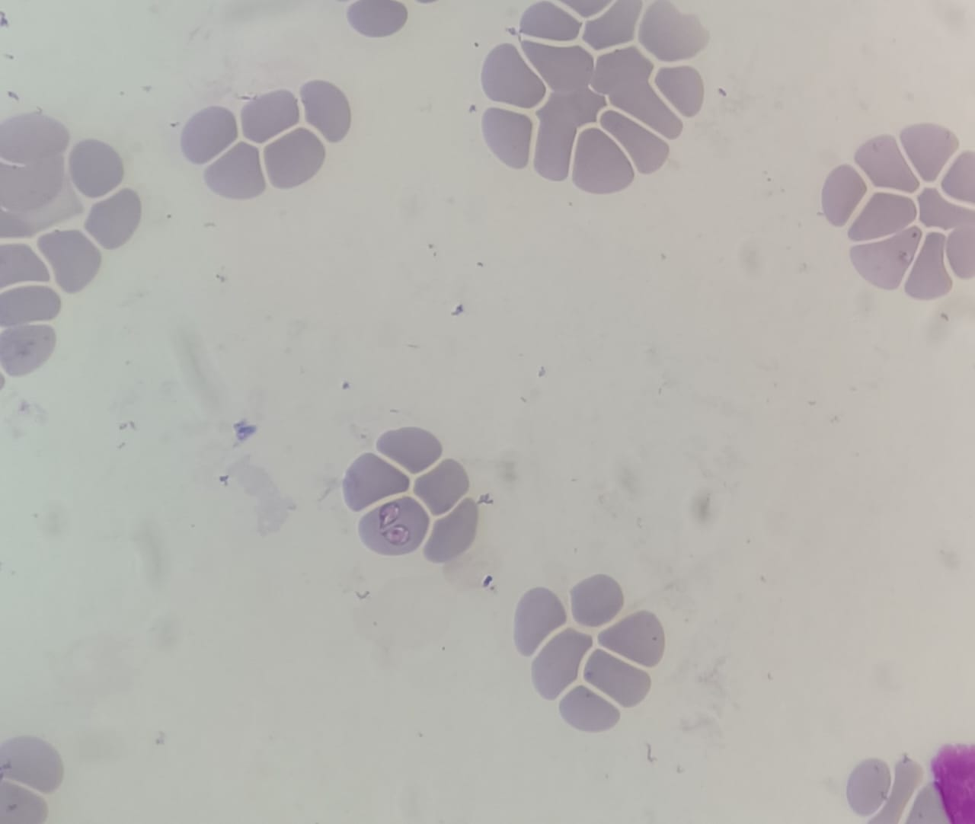
Pear-shaped large piroplasm
1a

Fig 1: Pear-shaped large piroplasm stage in pair at acute angle inside RBC of dog

Table 1. Complete blood count of the presented dog with their normal reference range
Tests | Results | Reference range | Units | Comments
WBC | 4 | 4.5-16.5 | 10³/µL | Leukopenia
RBC | 3.7 | 5.8-9.0 | 10⁶/µL | Anaemia
HGB | 8 | 13-20 | g/dL | Anaemia
HCT | 27 | 38-58 | g/dL | Less
MCV | 73 | 60-75 | fL | -
MCH | 26 | 19-28 | pg | -
MCHC | 32 | 30-37 | g/dL | -
Platelets | 167 | 180-525 | 10³/µL | Thrombocytopenia

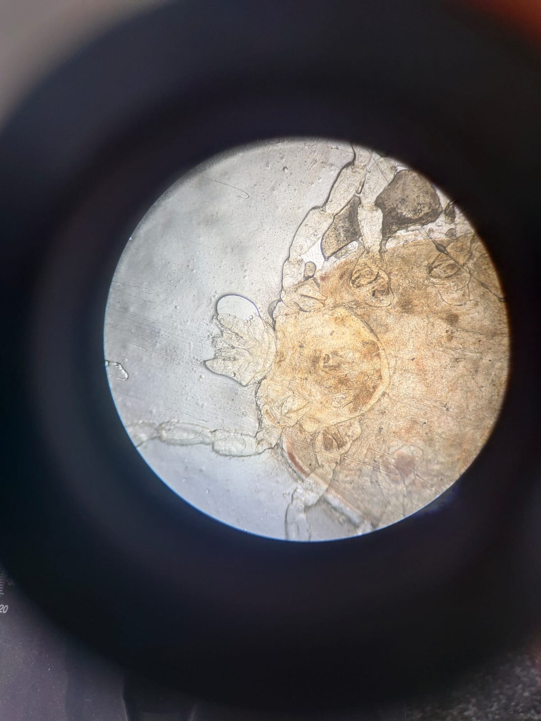
2a
First coxae deeply bifid
Mouth parts
Hexagonal basis capitulum
One third Scutum in female

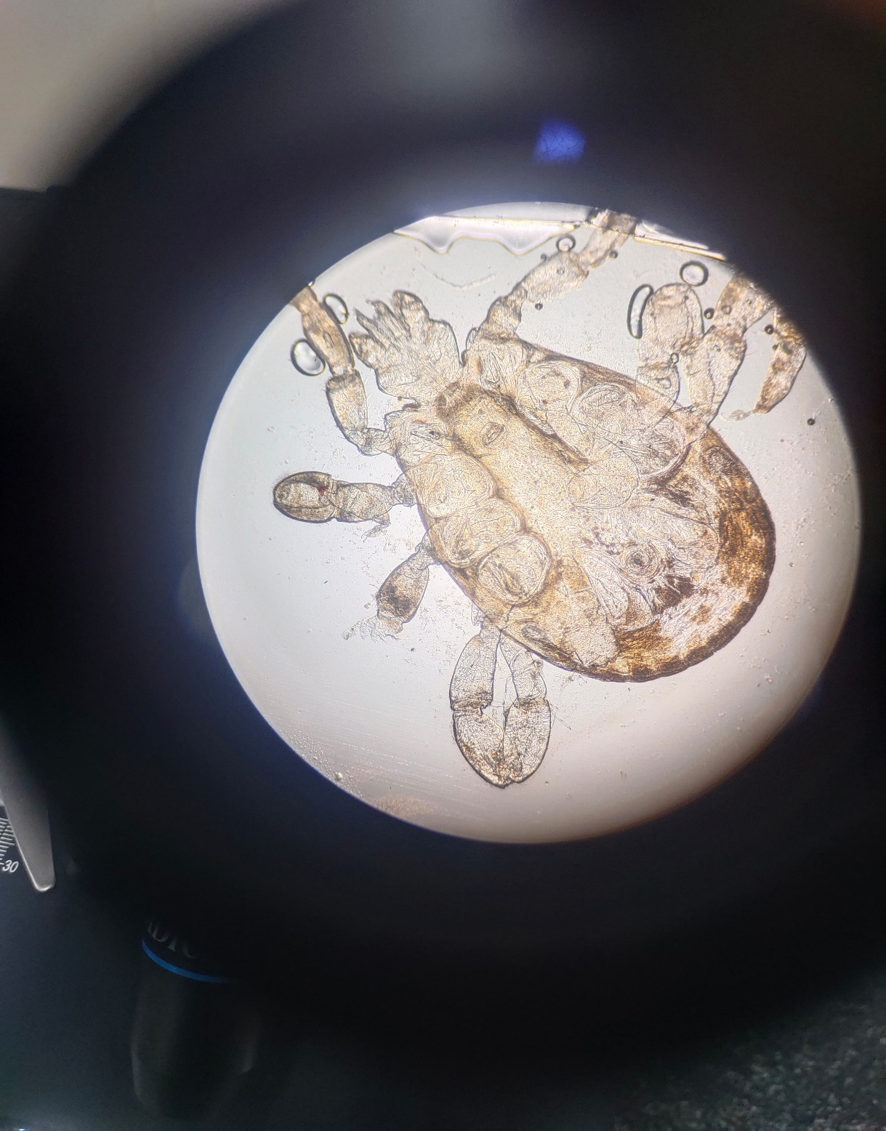
Mouth parts (Chelicerae and pedipalp)
Hexagonal basis capitulum
First coxae deeply bifid
Festoons present in male
Metastriata (Anal groove posterior to anal pore)
2b

Fig 2a: Anterior end of female tick 2b: Complete male tick

Discussion
In a recent study, it was found that canine babesiosis is the most prevalent tick borne disease in South Asian countries, with a 26.09% prevalence rate, followed by other organisms like Ehrlichia canis with a 5.87 % rate [14]. Among the Babesia species detected in dogs, Babesia vogeli is one of the most significant infections. The study's findings supported the theory that males are more prone than females to contract B. vogeli [7]. Babesia vogeli, i.e., considered as a mild form, has recently been reported to cause fatal disease when coinfected with Ehrlichia canis and Hepatozoon canis in a dog from Argentina [13]. We recognized the vector R. sanguineus, based on the characters, as Reichenow reported in his 1935 [8] research, and compared the huge size (2-5µm) of the piroplasm to distinguish it from the small form (0.5-1.5 µm) of Babesia Spp. or for a confirmatory diagnosis.
Additionally, reports of naturally occurring infected dogs have raised the possibility that immunosuppressed canines may be more vulnerable to B. vogeli infections [4,9]. Low hemoglobin levels indicate anemia, which may result from hemoglobin losses due to rupture of RBCs in dogs [10].
When comparing a mild to moderate disease with B. vogeli to moderate disease with B. canis, the clinical symptoms of infection with other small and large Babesia species are often more severe. Prior to and for a longer period than parasitemia, thrombocytopenia occurred. Some canines showed signs of profound but brief neutropenia [11].
Conclusion
Caution should be taken while analyzing the clinical manifestations, therapy, and prevention of canine babesiosis/piroplasmosis because the causal organism is commonly referred to as B. canis; however, it can be presumed that B. vogeli is associated and in my knowledge this is the first case in this region that lead to a disease condition.
Subsequently, there is a rise in the prevalence of vector-borne diseases in animals, which causes serious illnesses and losses in canines, along with other livestock. Modern infection control methods, like vaccination, natural predators, etc, are essential to prevent vector-borne parasite infections in animals. Epidemiological studies should be carried out to know the prevalence of Babesia vogeli along with other Babesia species and its potential health effects, so that control measures could be taken.

Disclaimer (Artificial intelligence)
Author(s) hereby declare that NO generative AI technologies such as Large Language Models (ChatGPT, COPILOT, etc.) and text-to-image generators have been used during the writing or editing of this manuscript.

References
1. Selim, A., Megahed, A., Ben Said, M., Alanazi, A. D., & Sayed-Ahmed, M. Z. (2022). Molecular survey and phylogenetic analysis of Babesia vogeli in dogs. Scientific Reports, 12(1), 6988. https://doi.org/10.1038/s41598-022-11079-x
2. Wang, J., Zhang, J., Kelly, P., Zheng, X., Li, M., You, J., ... & Wang, C. (2018). First description of the pathogenicity of Babesia vogeli in experimentally infected dogs. Veterinary parasitology, 253, 1-7. https://doi.org/10.1016/j.vetpar.2018.02.028
3. Ćoralić, A., Gabrielli, S., Zahirović, A., Stojanović, N. M., Milardi, G. L., Jažić, A., ... & Otašević, S. (2018). First molecular detection of Babesia canis in dogs from Bosnia and Herzegovina. Ticks and tick-borne diseases, 9(2), 363-368. https://doi.org/10.1016/j.ttbdis.2017.11.013
4. Solano-Gallego, L., & Baneth, G. (2011). Babesiosis in dogs and cats—expanding parasitological and clinical spectra. Veterinary parasitology, 181(1), 48-60. https://doi.org/10.1016/j.vetpar.2011.04.023
5. Köster, L. S., Lobetti, R. G., & Kelly, P. (2015). Canine babesiosis: a perspective on clinical complications, biomarkers, and treatment. Veterinary Medicine: Research and Reports, 6, 119–128. https://doi.org/10.2147/VMRR.S60431
6. Mittal, M., Kundu, K., Chakravarti, S., Mohapatra, J. K., Singh, V. K., Kumar, B. R., ... & Kumar, A. (2019). Canine babesiosis among working dogs of organised kennels in India: A comprehensive haematological, biochemical, clinicopathological and molecular epidemiological multiregional study. Preventive veterinary medicine, 169, 104696. https://doi.org/10.1016/j.prevetmed.2019.104696
7. Daniel, L. N., Kujul, N. B., Kemza, S. Y., & Ibukunoluwa, M. R. (2016). Retrospective study of the risk factors associated with canine babesiosis diagnosed at veterinary clinic federal college of animal health and production technology, Vom, north central Nigeria, 1999–2006. Int. J. Sci. Appl. Res, 1(1), 86-93.
8. Reichenow, E. (1935). Uebertragungsweise und Entwicklung der Piroplasmen. Zbl Bakt I Orig, 135, 108-199.
9. Irwin, P. J. (2009). Canine babesiosis: from molecular taxonomy to control. Parasites & vectors, 2(Suppl 1), S4. https://doi.org/10.1186/1756-3305-2-S1-S4
10. Venkatesa kumar, E., Kumar, V., & Ramprabhu, R. (2018). Diagnosis and Management of Concurrent Ehrlichiosis and Babesiosis in a Dog. Intas Polivet, 19(2), 267-268.
11. Meinkoth, J. H., Kocan, A. A., Loud, S. D., & Lorenz, M. D. (2002). Clinical and hematologic effects of experimental infection of dogs with recently identified Babesia gibsoni-like isolates from Oklahoma. Journal of the American Veterinary Medical Association, 220(2), 185-189. https://doi.org/10.2460/javma.2002.220.185
12. Penzhorn, B. L. (2020). Don’t let sleeping dogs lie: unravelling the identity and taxonomy of Babesia canis, Babesia rossi and Babesia vogeli. Parasites & vectors, 13, 1-9. https://doi.org/10.1186/s13071-020-04062-w
13. Facelli Fernández, M.C., Barolin, J., Stassi, A.F. et al. (2025). Fatal coinfection with Hepatozoon canis, Babesia vogeli, Ehrlichia canis, and Bartonella clarridgeiae in a dog from Argentina. Vet Res Commun 49, 244. https://doi.org/10.1007/s11259-025-10810-z
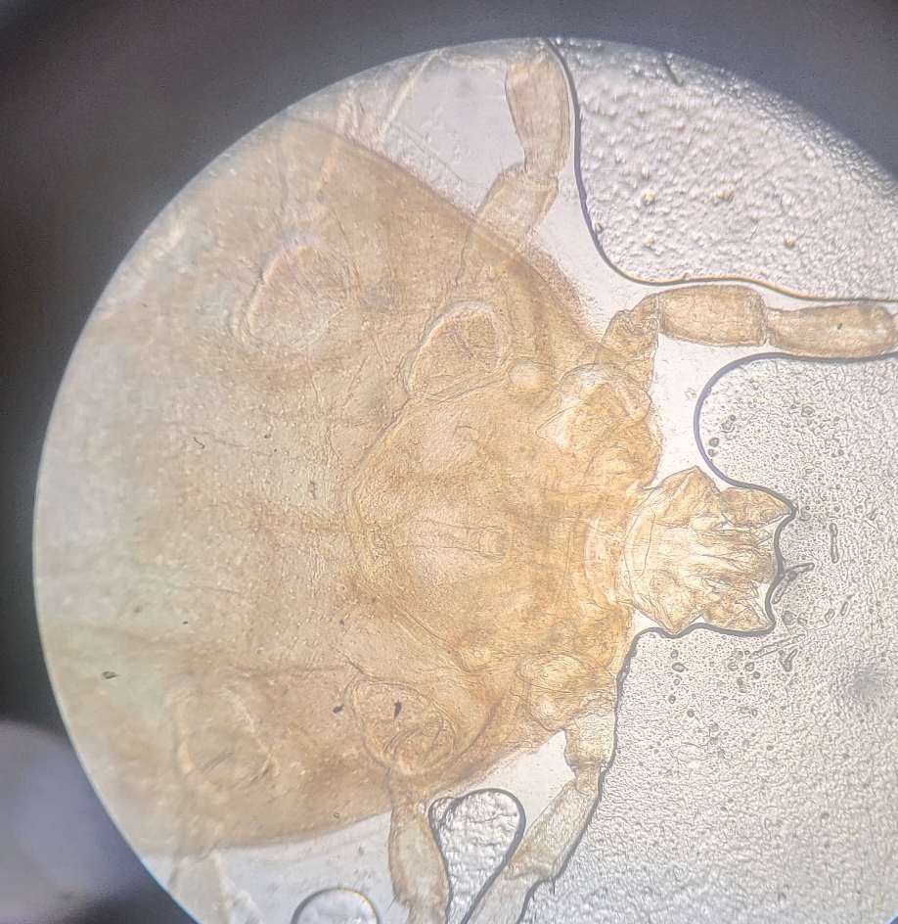
14. Aryal, S., Bhattarai, R. K., & Thapa, K. (2025). Comprehensive study of ticks and tick-borne diseases in dogs in Nepal: molecular identification, risk analysis and hematological alterations. BMC Veterinary Research, 21(1), 309. doi: 10.1186/s12917-025-04777-x

