Original Research Article

Hymenopteran species diversity recorded on Citrullus lanatus (Thunb.) intercropped with garlic and lemongrass plants in West-Côte d’Ivoire

.
ABSTRACT

The watermelon (Citrullus lanatus (Thunb.)) is an important source of vitamins and minerals that contribute to food security. Its production is enhanced by the presence of little-known predatory, parasitoid and pollinating Hymenopterans. This study aims to evaluate the insecticidal effects of garlic (Allium sativum) and lemongrass (Cymbopogon citratus) on hymenopteran species diversity on watermelon crops. The experimental setup was a fisher block with four treatments. Insects were collected ten times, each week by direct observation and by setting pitfall traps. A total of six Hymenopteran species, grouped into 3 families and 4 subfamilies, were collected on C. lanatus plots. Camponotus nigriceps, Lasius niger, Brachymyrmex patagonicus, Crematogaster sp., Polistes carnifex and Apis mellifera were the hymenopteran species recorded in C. lanatus plots. The Shannon index (H') was higher than 0.87 in the control plot and in the C. lanatus plots with garlic or lemongrass and it was 0.84 in the plot treated with the insecticide Tihan 175 O-TEQ. The Margalef index confirmed this diversity, which was higher than 0.6 on the control plot and in the C. lanatus plots with garlic or lemongrass plants. It was 0.44 in the plot treated with insecticide. The distribution of insects was more even in the plot treated with the insecticide (E = 0.6) than in the control plot (E = 0.49), and the plots with garlic and lemongrass plots (E = 0.49 and E = 0.50, respectively). P. carnifex (Vespidae) and A. mellifera (Apidae) were not sampled in the C. lanatus plots treated with the insecticide. A. sativum and C. citratus plants cultivated alongside C. lanatus would contribute to the conservation of hymenopterans that are useful for pollination and the crop protection.

Keywords: Allium sativum, association crops, biological control, Citrullus lanatus, Cymbopogon citratus, Hymenoptera

1. INTRODUCTION

The watermelon Citrullus lanatus Thunb. (Cucurbitaceae) occupies an important place in world agriculture (Achour and Khaled, 2019). This plant is cultivated for its fruit, which is rich in proteins, vitamins (A and C), phenolic compounds and minerals such as potassium and magnesium, which promote human health when consumed (Kader, 2002; Musa et al., 2020; Burdulis et al., 2025). Cucumis lanatus contributes to better hydration of the human body due to its high water content, and protects against certain cardiovascular diseases (Musa et al., 2020; Burdulis et al., 2025). Global watermelon production exceeds 100 million tonnes, with China, India and the United States being among the main producers (Musa et al., 2020; Burdulis et al., 2025). However, this crop is frequently affected by insect pests and diseases, forcing farmers to use pesticides. These pesticides affect the auxiliary fauna responsible for pollinating flowers and controlling pests. Numerous studies demonstrated the negative effects on hymenopterans, especially bees (Ohoueu et al., 2017; Franzén et al., 2024). Thus, the use of insecticides can negatively impact the economic viability of farms and food security (Ali et al., 2017; Saha et al., 2020). Excessive insecticides use leads to soil, water and air pollution, which affects ecosystems health and non-target organisms (Bajwa & Sandhu, 2019). Furthermore, insect pests can develop resistance to insecticides, rendering treatments less and less effective over time and necessitating the use of increasingly higher doses (Shi et al., 2004; Ali et al., 2017). Consequently, the use of chemical insecticides poses a significant challenge to the sustainability of agricultural production and environmental preservation (Koul et al., 2008; Diabaté, 2016). In this context, using of plants with some insecticidal properties is emerging as a promising alternative. Some plants, including neem (Azadirachta indica), pyrethrum, tobacco and castor, contain bioactive compounds such as alkaloids, flavonoids, and terpenes, which have repellent, antifeeding and insecticidal effects against a wide range of pests (Isman, 2006, Diabaté et al., 2014). In addition, the use of insecticidal plants helps preserve insect biodiversity and maintain the ecological balance of agricultural systems (Yasmin et al., 2020). Ants, for example, are pollinators and predators of other insects (Lutinski et al., 2024). Yasmin et al. (2020) and Lutinski et al. (2024) found that 34 genera and 70 species of ants are used for biological control in agrosystems. These include the genera Camponotus, Crematogaster, Oecophylla, Selonopsis and Wasmannia, which are predators of Lepidoptera, Coleoptera and other crop pests. Insecticidal plants have the advantage of reducing dependence on chemical insecticides, while being less harmful to non-target organisms, especially pollinators and natural predators of pests. This study aimed to evaluate the insecticidal effects of garlic (Allium sativum) and lemongrass (Cymbopogon citratus) on hymenopteran species infesting the watermelon plants.

2. material and methods

2.1 Study site
This study was conducted in the entomological plot at the University of Man (7°21'09'‘N and 7°36'57’'W), in the Tonkpi region (west-Côte d'Ivoire. Three watermelon seeds were sown per clusters with a distance of 2 m between plants and 1 meters between rows. Six clusters were placed per ridge measuring 7.5 m long, 1.5 m wide and 0.30 m high. The spacing between ridges was 0.8 m within a treatment consisting of 4 ridges. Each ridge constituted a repetition. Treatments were spaced 5 m apart. A 1 m-wide border was established around the treatments. After germination, the plants were separated to obtain two plants per cluster. The plot was weeded as required. The climate is monomodal, characterized by a dry season and a rainy season. The average annual temperature is 25°C. Average annual rainfall is 1,632 mm, with humidity at 82%. Ferralitic soils of average chemical fertility are predominant (Tiessé, 2020).
2.2 Evaluation of treatment effectiveness
Lemongrass (Cymbopogon citratus) (T1) and garlic (Allium sativum) (T2) plants were planted in staggered rows on 4 ridges of C. lanatus and were not treated with insecticide. Four ridges were treated with the insecticide Tihan 175 O-TEQ (Lubendiamide 100g/L + Spirotetramat 75 g/L: T3) and while 4 ridges of the control plot (T0) were not treated with any insecticide and did not receive lemongrass (Cymbopogon citratus) and garlic (Allium sativum) plants. The treatment T3 did not receive lemongrass (Cymbopogon citratus) and garlic (Allium sativum) plants.
2.3 Insect sampling
Insect sampling was carried out ten times during the trial in a watermelon plot, each week, by direct observation on watermelon plants and by setting pitfall traps.
2.3.1 Direct observation
Direct observation is an active method which consists of moving around the field and observing the lower and upper sides of the watermelon plants to check for the presence or absence of insects.
2.3.2 Pitfall traps
Three pitfall traps were placed lengthwise along the midline of each ridge. Each trap was two-thirds filled with soapy water, salt and vinegar to facilitate insect capture to prevent insect’s decomposition before collection.
2.4 Conservation and insect identification
Hymenoptera species were collected from each treatment. The collected specimens were then preserved in labeled pillboxes containing 70% alcohol. Each label indicated the sample number, as well as the date, time and place of collection (treatment). The insects were identified by observing the distinctive characteristics necessary for their classification using a binocular magnifying glass and the dichotomous keys for insect orders and families (Roth, 1974).
2.5 Relative abundance (RA) of insects on C. lanatus plants
The relative abundance of insects was calculated according to the following formula:

$AR (\%)=\frac{n * 100}{N}$ (1)
Where,
n = total number of individuals collected of a given species collected;
N= total number of individuals collected.
2.6 Determination of biodiversity indices
The diversity indices determined were species richness, Shannon (H'), Margalef and equitability indices
2.6.1 Species richness
Species richness (S), which is the total number of insect species collected in the C. lanatus plots, is determined.
2.6.2 Shannon diversity index
The Shannon diversity index (H') takes into account both the specific richness and abundance of the different insect families found in a plot (Akpesse et al., 2022). This index is calculated using the following formula :
$H^{'}=- Σ pi ln pi$ (3)
Where:
pi = probability of encountering family i ;
pi=ni/N ;
ni = abundance of species i ;
and N = total abundance.
2.6.3 Margalef index
The Margalef index (d) is used to determine insect diversity at a given site. It is calculated according to the following formula :
$d=\frac{(S-1)}{\ln{N}} (5)$
where :
N = total number of individuals of a species ;
and S = species richness.
2.6.4 Equitability index
The equitability index (E) determine equitable distribution of individuals. It aims to observe the equilibrium of the present populations. This index is determined according to the following formula :
$E=\frac{H'}{\ln{S}} (4)$
with : H' = Shannon diversity Index ;
and S = species richness.
The value of E ranges from 0 (one species dominates) to 1 (equitable distribution of species).
2.7 Statistical data analysis
The Shannon, equitability and Margalef indices were determined using Estimate version 22.0 (IBM, New York, USA).
3. results and discussion

3.1 Biological diversity and relative abundance of Hymenoptera families in watermelon C. lanatus
Six Hymenoptera species grouped into 3 families and 4 subfamilies were collected in C. lanatus plots. On the control plot (Control : T0), the plots of C. lanatus with lemongrass plants (T1) or with garlic plants (T2) in staggered rows, six species of Hymenoptera grouped into 3 families and 4 subfamilies were collected. These hymenoptera species were Camponotus nigriceps, Lasius niger, Brachymyrmex patagonicus (Formicidae/Formicinae), Crematogaster sp. (Formicidae/Myrmicinae), Polistes carnifex (Vespidae/Polistinae) and Apis mellifera (Apidae/Apinae). In the C. lanatus plot treated with Tihan 175 O-TEQ (T3), only 4 species from Formicidae was sampled. The relative abundance of subfamilies Formicinae, Mymicinae, Polistinae and Apinae were 59.78%, 40.11%, 0.07% and 0.03%, respectively in the control plot, 30.53%, 69.02%, 0.26 and 0.18%, respectively in the C. lanatus plot with lemongrass plants, and 73.36%, 26.16%, 0.41% and 0.07%, respectively in the plot with garlic plants. In C. lanatus plots treated with the insecticide Tihan 175 O-TEQ, the relative abundance of Formicinae, Mymicinae, Polistinae and Apinae were 56.73%, 43.26%, 0% and 0%, respectively (Fig. 2, Table 1). The highest number of hymenoptera individuals were collected on the control plot with the value of 2,725 insects and the lowest on the plot treated with Tihan 175 O-TEQ (846 insects). The number of Hymenoptera species recorded on the C. lanatus plot with garlic plants (1,464 insects) was higher than on the C. lanatus plots with citronella plants. The control plot and the C. lanatus plots with garlic plants or with lemongrass plants had the highest diversity of Hymenoptera species with a Shannon index (H’) greater than or equal to 0.87. The lowest diversity of Hymenoptera species were recorded in the plot treated with insecticide Tihan 175 O-TEQ which had an H' of 0.84. The Margalef index confirmed this diversity, which was higher than 0.6 in the control plot and in the C. lanatus plots with garlic or lemongrass plants, and equal to 0.44 in the insecticide-treated plot. The hymenopteran species recorded in the C. lanatus distribution were more homogeneous in the plot treated with Tihan 175 O-TEQ (E = 0.6) than in the control plot (E = 0.49), C. lanatus plot with garlic plants (E = 0.49) or with the lemongrass plants with E = 0.50 (Table 1).
Table 1. Diversity indices of Hymenoptera species of Citrullus lanatus

Diversity indices | T0 | T1 | T2 | T3
Taxa_S | 6 | 6 | 6 | 4
Individuals | 2725 | 1117 | 1464 | 846
Shannon_H | 0.87 | 0.88 | 0.90 | 0.84
Margalef | 0.63 | 0.71 | 0.68 | 0.44
Equitability_J | 0.49 | 0.49 | 0.50 | 0.60

T0 : Control; T1: Cymbopogon citratus in association with C. lanatus; T2: Allium sativum in association with C. lanatus, T3: Tihan 175 O-TEQ

AR0 : Relative abundance in the control ; ARC : Relative abundance in Citrulus lanatus plot with C. citratus ; ARa : Relative abundance in C. lanatus plot with A. sativum, ARi : Relative abundance in C. lanatus plot treated with the insecticide Tihan 175 O-TEQ
Fig. 1. Hymenopteran families and subfamilies found on Citrullus lanatus

3.2 Relative abundance of Hymenoptera species on watermelon C. lanatus
Hymenoptera species play an important role in crop protection as predators of pests or parasitoids and they are involved in pollinating C. lanatus flowers. The most abundant Hymenoptera species collected on C. lantus control plot (T0), on C. lanatus plot with lemongrass plants (T1), C. lanatus plot with staggered garlic plants (T2), and on C. lanatus plot treated with the insecticide Tihan 175 O-TEQ (T3) were the Formicidae B. patagonicus and Crematogaster sp. (Figure 2a). The relative abundance of B. patagonicus in the control plot, plots with lemongrass or garlic plants and plots treated with the insecticide was 55.12%, 21.84%, 65.23% and 53.07%, respectively. The relative abundance of Crematogaster sp. was 40.11%, 69.02%, 26.16% and 43.26%, respectively. The relative abundance of Formicidae C. nigriceps (Figure 2b) and L. niger (Figure 2c) were lower than 6.5% in all C. lanatus plots. The relative abundance on the control plot (T0), the plot with citronella plants (T1) or the plot with garlic plants (T2) and the plot treated with insecticide Tihan 175 O-TEQ (T3) were 1.32%, 6.44%, 1.91% and 0.71% for C. nigriceps, and 3.34%, 2.24%, 6.21% and 2.95% for L. niger, respectively. P. carnifex (Vespidae) and A. mellifera (Apidae) (Figure 2d) were not sampled on C. lanatus plots treated with the insecticide Tihan 175 O-TEQ. The relative abundances of Polites carnifex and A. mellifera were lower in the control plots (T0), C. lanatus plots with citronella plants (T1) and with garlic plants (T2), ranging from 0.03% to 0.5%. In the C. lanatus control plots, with citronella or garlic plants, the relative abundances of P. carnifex and A. mellifera were 0.07% and 0.03%, 0.26% and 0.18% and 0.41% and 0.07%, respectively (Table 2).
Table 2. Relative abundance of Hymenoptera species of Citrullus lanatus

Insects | Suborder | Family/  subfamily | Insect  status | T0 |  | T1 |  | T2 |  | T3
 |  |  |  | N | AR | N | AR | N | AR | N | AR
Camponotus nigriceps | Apocrita | Formicidae/  Formicinae | Po/Pr | 36 | 1,32 | 72 | 6,44 | 28 | 1,91 | 6 | 0,71
Lasius niger | Apocrita | Formicidae/  Formicinae | Po/Pr | 91 | 3,34 | 25 | 2,24 | 91 | 6,21 | 25 | 2,95
Brachymyrmex patagonicus | Apocrita | Formicidae/  Formicinae | Po | 1502 | 55,12 | 244 | 21,84 | 955 | 65,23 | 449 | 53,07
Crematogaster sp. | Aculeata | Formicidae/  Myrmicinae | Po/Pr | 1093 | 40,11 | 771 | 69,02 | 383 | 26,16 | 366 | 43,26
Polistes carnifex | Apocrita | Vespidae  /Polistinae | Po/Pa | 2 | 0,07 | 3 | 0,26 | 6 | 0,41 | 0 | 0
Apis mellifera | Apocrita | Apidae/  Apinae | Po | 1 | 0,03 | 2 | 0,18 | 1 | 0,07 | 0 | 0
Total |  |  |  | 2725 | 100 | 1117 | 100 | 1464 | 100 | 846 | 100

AR : relative abundance ; N : number of individuals, Pa: parasitoid, Po: pollinator, Pr: predator, T0: control; T1: C. citratus in association with C. lanatus; T2: A. sativum in association with C. lanatus, T3: Tihan 175 O-TEQ
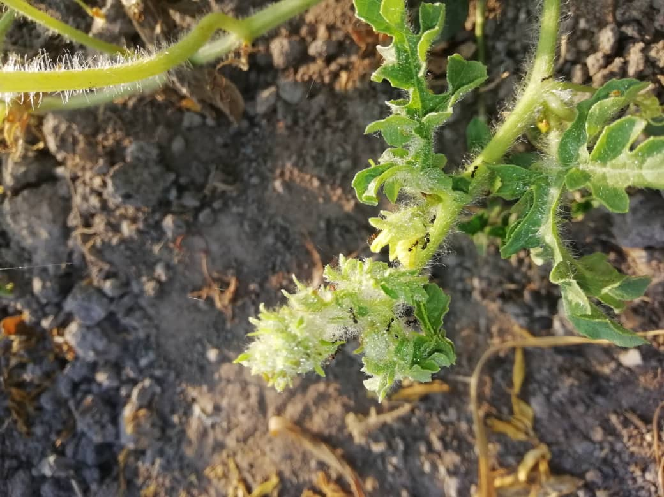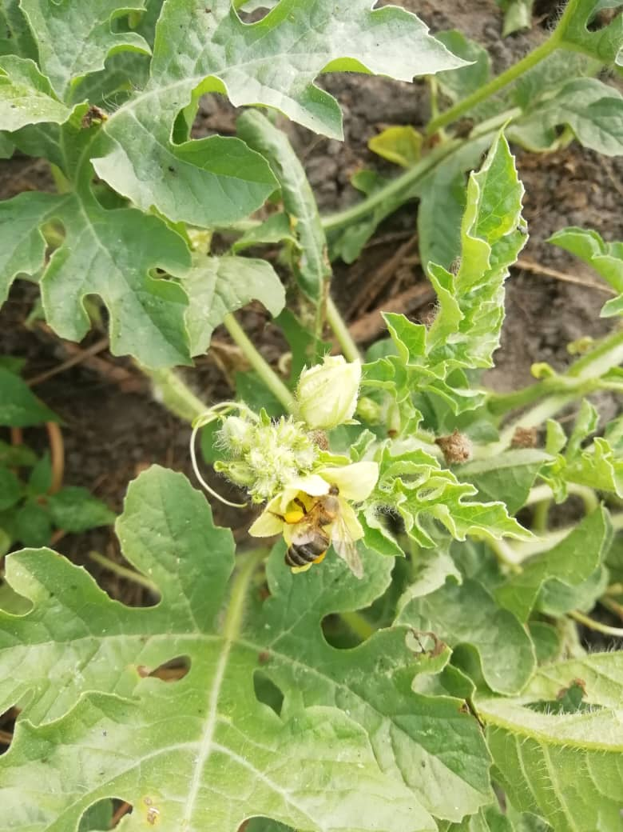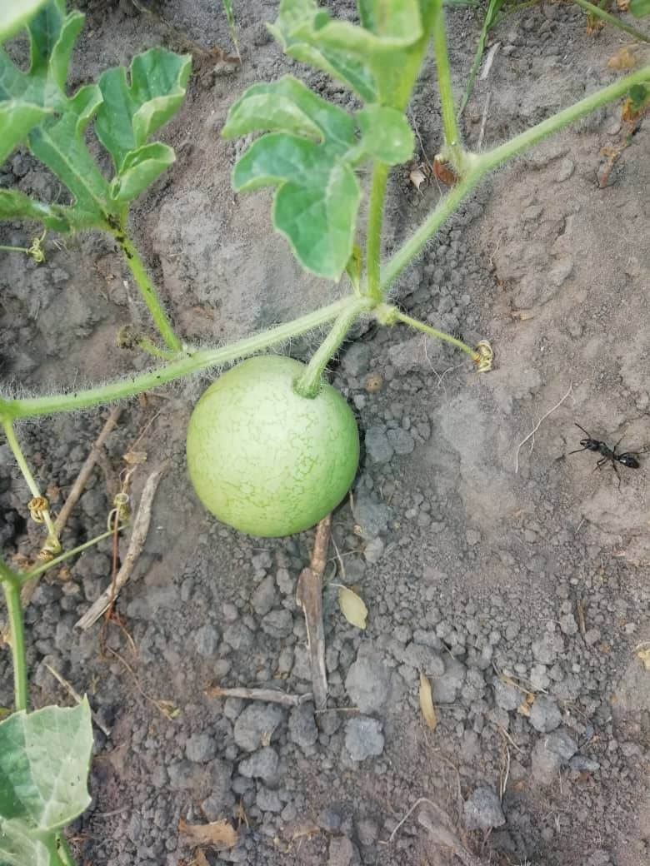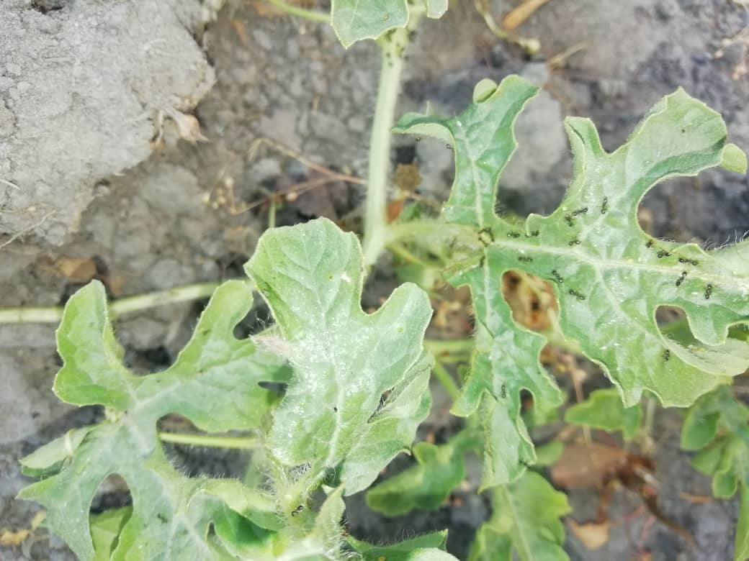
a
c
d
b
Fig. 2. Hymenoptera species on Citrullus lanatus (Crematogaster sp. on leaf (a) ; C. nigriceps on flowers (b) ; L. niger (c) and A. mellifera on flowers (d).
Lemongrass and garlic plants provide more protection for auxiliary insects, particularly Hymenoptera, than the insecticide Tihan 175 O-TEQ. The insecticide Tihan 175 O-TEQ significantly decreases the number of Hymenoptera in C. lanatus plots compared to control plots and plots with staggered rows of lemongrass or garlic plants. Crematogaster sp. is the most abundant hymenopteran on control plots, and on plots with garlic or lemongrass plants. However, its numbers were considerably reduced by the insecticide Tihan 175 O-TEQ. Similar results were obtained by Kumar et al. (2021) and Martinez et al. (2022), who showed that natural treatments better preserve auxiliary insects, such as ladybugs (Coccinella cheilomenes) and hymenopterans, which contribute to pest regulation and flower pollination. However, a reduction in the number of bees (A. mellifera) was observed in plots with garlic and lemongrass. This suggests that a possible repellent effect of garlic and lemongrass plants on these pollinators. According to Nguyen et al. (2020), the citronella (C. citratus) contains citral and geraniol, that repel insects and disrupt their olfactory systems. The garlic (A. sativum) contains sulfur compounds such as allicin, that repel insects and disrupt their nervous systems (Singh et al., 2019 ; Nguyen et al., 2020). In addition to its insecticidal effect, garlic and lemongrass plants would protect the C. lanatus crop while maintaining high Hymenoptera populations within the crop. According to Lutinski et al. (2024), ants are increasingly used as biological pest control agents in agrosystems. The genera Camponotus and Crematogaster, which were collected during this study, are predators that are used in biological control. These insects protect C. lanatus from insect pests, thereby amplifying the effectiveness of insecticidal plants. The use of these two plants in association with other crops is a sustainable alternative to combat insect pests, while preserving the environment, auxiliary insects and human health (Martinez et al., 2022). Furthermore, no bees were collected on plots treated with the insecticide Tihan 175 O-TEQ. The insecticide Tihan 175 O-TEQ exert toxicity on A. mellifera by contaminating the sap of C. lanatus flowers, and by inhibiting reproduction and food intake. According to Taimanga et al. (2024), pesticides destroy the immune system of Cand reduce their longevity. consequently, bees populations, pollination and crop yield were decreased. These results are similar to those of Ohoueu et al. (2017) and Franzèn et al. (2024), who showed that the use of insecticides considerably reduces bee populations that are useful for pollinating flowers. Hymenoptera are involved in pollination and the biological regulation of pests. The spraying of the insecticide Tihan 175 O-TEQ on C. lanatus reduced hymenopterans biodiversity, causing an agrosystem imbalance.

4. Conclusion

Garlic and lemongrass preserve the Hymenoptera population on watermelon crops. The Hymenoptera species C. nigriceps, L. niger, B. patagonicus, Crematogaster sp., P. carnifex and A. mellifera were collected on C. lanatus plots. The highest number of individuals were collected on the control plot and the lowest number in the plot treated with the insecticide Tihan 175 O-TEQ. The C. lanatus plot with garlic plants had a higher number of Hymenoptera insects than the plots with citronella. Hymenoptera species are more diverse in the untreated plot, the C. lanatus plot with garlic or lemongrass plants, with a Shannon index (H') greater than or equal to 0.87, compared with the insecticide-treated plot (H'=0.84). P. carnifex (Vespidae) and A. mellifera (Apidae) were not sampled on insecticide-treated C. lanatus plots. The presence of A. sativum and C. citratus plants alongside C. lanatus would contributes to the conservation of hymenopterans that are useful for pollination and protect this crop against pests. A. sativum and C. citratus plants offer an environmentally friendly alternative to chemical pesticides.

Consent

Not applicable.

Ethical approval

Not applicable.

AVAILABILITY OF DATA AND MATERIAL
The datasets used and/or analysed during the current study available from the corresponding author on reasonable request.
DISCLAIMER (ARTIFICIEL INTELLIGENCE)
Authors hereby declare that no generative AI technologies (ChatGPT, COPILOT, ect) and text-to-image generators have been used during writing or editing of this manuscript.

References

Achour, M., & Khaled, N. (2019). Importance économique des Cucurbitacées dans les régions sèches. Journal d’Agronomie et d’Environnement, 45(2), 112-125.
Akpesse, A.A.M., Diabaté, D., Coulibaly, T., Kouadja, Y.O, Koua, K.H., & Kouassi, K.P. (2022). Termitic diversity of the Dalhia Fleurs partial natural reserve (Bingerville, Côte d’Ivoire). Journal of Agricultural and Ecology Research International, 23(6), 82-92. DOI: 10.9734/JAERI/2022/v23i6501
Ali, M., Rahman, M. M., & Hasan, M. (2017). Impact of insect pests and diseases on watermelon production : A global perspective. International Journal of Agricultural Research, 12(3), 203-215.
Bajwa, U., & Sandhu, K. S. (2019). Effect of pesticide residues on human health: A review. Journal of Food Science and Technology, 56(4), 1312-1326.
Burdulis, D., Kasètaitè, A., Trumbeckait, S., Benetis, R., Dauksienè, J., Burdulienè, K., & Raudenè, L. (2025). Cultivation of watermelon (Citrullus lanatus (Tunb.)) in a temperature climate : Agronomic strategies and phytichemical composition. Agronomy, 15 (933), 25 p. https://doi.org/10.3390/ agronomy15040933
Diabaté, D., Gnago, A. J., Koffi, K. & Tano, Y. (2014). The effect of pesticides and aqueous extracts of Azadirachta indica (A. Juss) and Jatropha curcas L. on Bemisia tabaci (Gennadius) (Homoptera : Aleyrididae) and Helicoverpa armigera (Hübner) (Lepidoptera : Noctuidae) found in tomato plants in Côte d’Ivoire. Journal of Applied Biosciences, 80, 7132-7143.
Diabaté, D. 2016. Impact et mode d’action de quelques biopesticides et insecticides classiques en culture maraîchère dans la région du Moronou (Bongouanou, Côte d’Ivoire). Thèse unique de Doctorat, Université Félix Houphouët-Boigny, Côte d’Ivoire, 148 p.
Franzén, M., & Stenmark, M. (2024). Exploring biodiversity through the lens of Knautia arvensis pollinators Walks as a monitoring method. Insects, 15, 563. https://doi.org/10.3390/ insects15080563
Isman, M. B. (2006). Botanical insecticides, deterrents, and repellents in modern agriculture and an increasingly regulated world. Annual Review of Entomology, 51, 45-66.
Koul, O., Walia, S., & Dhaliwal, G. S. (2008). Essential oils as green pesticides : Potential and constraints. Biopesticides International, 4(1), 63-84.
Kumar, S., Gupta, A., & Sharma, R. (2021). Antifungal and antibacterial properties of garlic- derived allicin: A review. Journal of Natural Products, 17(2), 102-118.
Lutinski, J.A., Lutinski, C.J., Ortiz, A., Zembruski, F.S., Ripke, M.O., & Garcia, F.R.M. (2024). Biological control using ants : curent statuts. Opportunities and limitations. Agronomy, 14 (1558), 25 p. https://doi.org/10.3390/agronomy14071558
Martinez, S., Pereira, J. L., & Rocha, F. (2022). Sustainable pest management using botanical insecticides : A review on their application in agriculture. Environmental Science and Pollution Research, 29(8), 11234-11245.
Musa, H. H., Zhou, B., & Liu, H. (2020). Nutritional value and health benefits of watermelon: A review. Journal of Food and Nutrition Sciences, 11(3), 212-225
Nguyen, H. T., Pham, K. D., & Tran, Q. L. (2020). Chemical composition and insecticidal properties of Cymbopogon citratus essential oil. Journal of Agricultural and Food Chemistry, 68(10), 4253-4260.
Ohoueu, E.J.B., Wandan, E.N., Kone, D., & Assielou, B.A. (2017). Impact de l’utilisation des produits phytosanitaires en production cotonnière et cacaoyère sur la production apicole en Côte d’Ivoire. European Scientific Journal, 13, 42-55.
Roth, M. (1974). Initiation à la morphologie, la systématique et la biologie des insectes. Editions de l’office de la recherche scientifique outre-mer, Paris, France, 212 p.
Saha, D., Dutta, P., & Roy, A. (2020). Pest and disease management in watermelon production : A review. International Journal of Horticultural Science, 15(4), 245-260.
Shi, A. M., Lougarre, A., Alies, C., Fremaux, I., Tang, Z. H. & Stojan, J. (2004). Acetylcholinesterase alterations reveal the fitness cost of mutations conferring insecticide resistance. BMC Evolutionary Biology, 4(5),1-8.
Singh, P., Kaur, G., & Verma, S. (2019). Garlic-based bioinsecticides: Efficacy and mechanisms of action. International Journal of Pest Management, 22(1), 85-97.
Taimanga, A.M., Tchindebe, G., Mohammadou, M., Youssoufa, O., Fouelifack-Nintidem, B., Ifoue, A.V.T., Toukem, A.S.K., Dabole, O.M., Aziz, O.A., Tchoubou-Sale, A., Tsekane, S.J., Kosini, D., Mbianda, P. A., & Kenne M. (2024). Effect of the botanical insecticides on Amegilla Friese, 1897 (Hymenoptera : Apidae) foraging on the cowpea flowers in Dang (Adamaoua, North-Cameroon). American Journal of Entomology, 8(3), 76-101.
Tiessé, B.A.C. (2020). Apport de la télédétection et des SIG pour le suivi spatio-temporel de l’occupation du sol et la cartographie de la sensibilité à l’érosion hydrique dans la région montagneuse du Tonkpi (Ouest de la Côte d’Ivoire). Thèse Unique de Doctorat, Institut National Polytechnique Felix Houphouët-Boigny, Yamoussoukro, Côte d’Ivoire, 171p.
Yasmin, S., Banik, S., & Islam, M. T. (2020). Plant-derived bioinsecticides: A sustainable approach for insect pest management in agriculture. Journal of Applied Agricultural Sciences, 25(3), 198-214.

