Original Research Article
Assessment and Analysis of Microplastics in Commercially Sold Bivalves from Los Baños, Laguna, and Lipa, Batangas, Philippines
Abstract
Microplastics were extracted from Perna viridis (Asian green mussel), Venerupis philippinarum (Manila clam), and Corbicula manilensis (“tulya”, a freshwater clam), which were bought from Los Baños, Laguna and Lipa, Batangas, Philippines commercial markets, using hydrogen peroxide digestion and density floatation. The isolated microplastics were verified and characterized using hot needle test and Attenuated Total Reflectance Fourier Transform Infrared (ATR-FTIR). The microplastic concentration among these bivalves ranged from 0.52 ± 0.13 to 2.94 ± 0.65 MP/g FW and 1.50 ± 0.34 to 2.67 ± 0.66 MP/individual, which were compared to the values from existing studies. Fibers and fragments dominated the shape of the extracted microplastics. The possible types of microplastics identified were PP/EVA, PP, PP/PETE, PP/Nitrile, PU, dominated by LDPE/EVA using ATR-FTIR spectrometer. Their sources were linked to the origin of the samples namely Bacoor, Cavite and Lucena, Quezon. The implication of the level of microplastic pollution on the human diet was also analyzed to assess its risk on the consumers.
Keywords – Bivalves, density floatation, microplastics, seafood, ATR-FTIR, MP contamination

Introduction
Plastics have become a commodity used by most people worldwide due to its versatile properties, inexpensiveness, and persistent nature (Horton, 2022). These characteristics have made plastics durable and degrade slowly, allowing them to persist as marine litter (Andrady, 2015). Its buoyancy property, among its other physico-chemical properties, significantly affects its movement in the environment and its bioavailability (Wright et al., 2013).
Plastic pollution has become a global environmental threat to marine flora and fauna and to biodiversity and human life due to its harmful effects as plastic debris. Plastic debris enters the aquatic environment from the discharge of wastewater and run-off water and landfills (Thevenon et al., 2014). A serious aspect of plastic pollution is the manifestation of microplastics (MPs) in the aquatic ecosystems (Solomon and Palanisami, 2016, Du et al., 2021, Huang et al., 2021,). Microplastics are particles with size ranging from 1 nm to <5 mm. Its formation can be of direct manufacture origins such as industrial scrubbers, plastic powders, micro-beads for cosmetic purposes, and industrial plastic nanoparticles; and fragmentation and weathering controlled by environmental factors such as chemical, physical and biological processes (GESAMP, 2015).
Microplastics contribute to pollution due to its particle size which makes it bioavailable to organisms. Marine species such as zooplankton, polychaetes, bivalves, ascidians, echinoderms, and sponges risk the ingestion of the microplastics (Santana et al., 2016) which results in adverse effects at the cells and tissues in some organisms as described by experiments done under laboratory conditions (von Moos et al., 2012; Browne et al., 2013; Besseling et al., 2013; Rochman et al., 2014). Microplastics have also been observed in fishes where they are categorized based on their size, shape, color, and polymer type (Motivarash et al., 2024). Furthermore, the bioavailability of microplastics among aquatic biota exposes humans to food safety risks and economic and livelihood threats (Santana et al. 2016).
Determination of the microplastic content was conducted in the three commercially available bivalves namely Perna viridis (Asian green mussels), Venerupis philippinarum (Manila clam), and Corbicula manilensis (a freshwater clam locally known as tulya) from the commercial markets of Los Baños, Laguna and Lipa, Batangas, Philippines, originating from various fishing ports. Bivalves were chosen as samples due to their extensive filter-feeding activity which then results in their direct contact with present microplastics (Li et al., 2015). Bivalves are benthic organisms and since microplastics have a buoyancy property, bivalves are prone to microplastic ingestion as they enter the benthos (Murray and Cowie, 2011).
Seafood has been a major part of human consumption and it is significant to examine if it has been already affected by the microplastic pollution to maintain the safety of the consumers and retain the quality in the products of the seafood-based markets. The main objective of the study is to assess the microplastic content in the three commercially available bivalves from the commercial markets of Los Baños, Laguna and Lipa, Batangas, Philippines.

Materials and methods
Bivalves samples were bought from commercial markets of Los Baños, Laguna (Perna viridis and Venerupis philippinarum) and Lipa, Batangas (Corbicula manilensis), originating from various fishing ports: Perna viridis and Corbicula manilensis from Bacoor, Cavite, and Venerupis philippinarum from Lucena, Quezon. The samples were washed with distilled water before storing at -20 °C (Naji et al., 2018). The methodology of the study conducted was adapted from Li and colleagues (2015) with some modifications.
Wet Digestion using Hydrogen Peroxide (H₂O₂)
The inner contents of 3-5 individuals per replicate of each bivalve were emptied into a pre-washed 400-mL beaker. Five replicates were prepared for each bivalve. Afterward, about 50-100 mL of 50% pre-filtered H₂O₂ (technical grade) was added to each replicate to digest the organic matter. The samples were allowed to stand for a short period of time and then heated intermittently for two to four hours at 60 °C. The samples were covered and allowed to stand for 48 hours. The digested inner contents were decanted and the remaining contents were washed with distilled water thrice and air-dried overnight.
Density Separation
About 100 mL of filtered saturated sodium chloride solution (ρ = 1.2 g cm⁻³) was added to each beaker. The extraction was performed two to three times. Afterward, the liquid was filtered out using a filter paper (Advantec No. 2, pore size = 8μm) which was then rinsed with distilled water.
Identification and Characterization of Microplastics
Visual identification of the microplastics was done using a digital microscope with a magnification capacity of 200x. A hot needle test was performed for preliminary verification of microplastics. Verification of the polymer identity of the microplastics was conducted via Attenuated Total Reflectance Fourier Transform Infrared Spectrometer (ATR-FTIR, Shimadzu IR Spirit X).
Statistical Analysis
Analysis of variance (ANOVA) and Welch’s t-test were applied to compare the microplastic content among the genera of the commercial bivalve samples (Mathalon & Hill, 2014) as well as the means of microplastics for each trial.

Results and Discussion
The abundance of microplastics in the bivalves was measured by two microplastic units: microplastic per gram Fresh Weight (MP/g FW) and microplastic per individual (MP/individual). The average number of microplastics in Perna viridis was 0.52 MP/g FW and 2.67 MP/individual; in Venerupis philippinarum, 0.57 MP/g FW and 2.03 MP/individual; and in Corbicula manilensis, 2.94 MP/g FW and 1.50 MP/individual. Corbicula manilensis showed the highest MP/g FW while Perna viridis showed the highest MP/individual. Fibers, specifically black fibers, were found to dominate the type of microplastics present in the bivalves. The sizes of the microplastics vary from 0.25 mm to less than 5mm.
For MP/g FW, Perna viridis versus Venerupis philippinarum showed no significant difference while Perna viridis versus Corbicula manilensis and Venerupis philippinarum versus Corbicula manilensis showed significant differences. For MP/individual, only Perna viridis versus Corbicula manilensis showed significant difference. Table 1 summarizes the values of the microplastics extracted from the bivalves.
Table 1. Microplastic values among the genera of the bivalves (n=10).
SPECIES | MP/g FW* | MP/INDIVIDUAL
Perna viridis | 0.52 ± 0.13^{a, a} |  | 2.67 ± 0.66^{a, a}
Venerupis philippinarum | 0.57 ± 0.16^{b, a} |  | 2.03 ± 0.59^{b, ab}
Corbicula manilensis | 2.94 ± 0.65^{c, b} |  | 1.50 ± 0.34^{c, b}
* Microplastic per gram Fresh Weight
Common superscript letter before comma in the same column indicates not significant difference at 95% confidence level based on one-way analysis of variance (ANOVA). Common superscript letter after comma in the same column indicates not significant difference based on Tukey’s multiple comparison test.
The MP/g FW results of the study were compared to the values from existing studies regarding microplastics in bivalves. Perna viridis (0.52 MP/g FW) has higher MP concentration than the results of the studies of De Witte and colleagues (2014), Van Cauwenberghe and Janssen (2014), Van Cauwenberghe and colleagues (2015), Vandermeersch and colleagues (2015), Cho and colleagues (2018), and Ding and colleagues (2019). Meanwhile, it has lower MP concentration compared to the studies of Mathalon and Hill (2014), Li and colleagues (2016), Li and colleagues (2015), Murphy (2018), Qu and colleagues (2018), and Khoironi and colleagues (2018). Venerupis philippinarum (0.57 MP/g FW) MP concentration is comparable with the range given by Davidson and Dudas (2016). However, it has a higher concentration compared to the study of Covernton and colleagues (2019) and lower concentration compared to the results of Murphy (2018). Corbicula manilensis (2.94 MP/g FW) MP concentration is comparable with the range of the study conducted by Su and colleagues (2016). Meanwhile, it has a higher concentration compared to the study of Nibalvos and colleagues (2024). The difference in the results of this study versus the literature results can be accounted by different methodologies and laboratory conditions employed in the studies.
Verification of microplastic under a digital microscope and a hot needle test showed curling of fiber, melting of the faint pink fragment, and sticking of a fragment to the needle as seen in Figure 1.
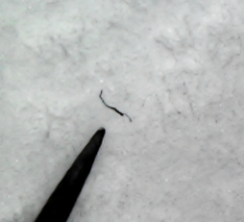
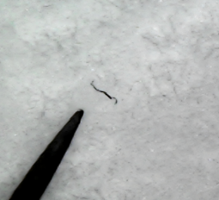
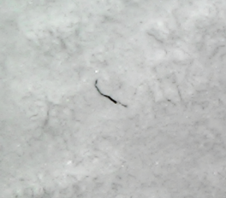
A

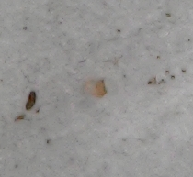
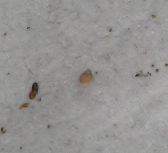
B

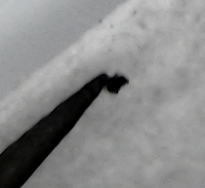
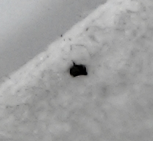
C

Figure 1. Photographs of hot needle test: A) curling of black fiber; B) melting of faint pink fragment; and C) sticking of a black fragment to the hot needle (20x magnification).
The most commonly occurring type of microplastics extracted from the bivalves were fibers, followed by fragments as shown by Figure 2. The colors of the fibers ranged from black, red, and blue. Meanwhile, the colors of the fragments observed were brown, red, black, gray, transparent, faint pink, and pink.

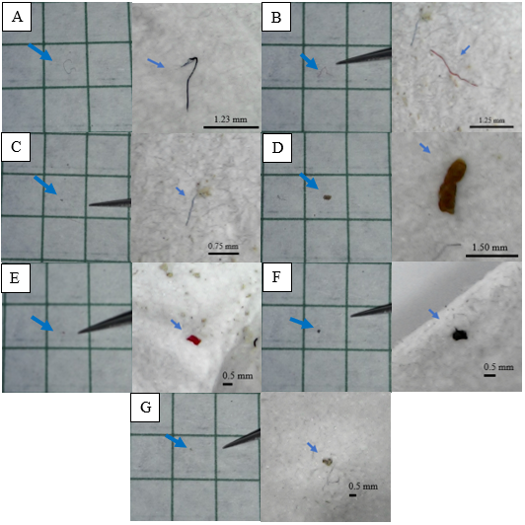

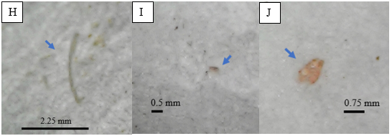

Figure 2. Photographs of different types of microplastics in Perna viridis, Venerupis philippinarum, and Corbicula manilensis from Los Baños and Lipa commercial markets, taken on a graphing paper using a cellular phone camera (Samsung J7 Pro, 13.0 megapixels) and on the filter paper using a digital microscope (200x magnification). (A-C) indicate fibers and (D-J) indicate fragments.
The identification of the suspected microplastics was done using ATR-FTIR and the results were summarized on Table 2. Black fibers were the most abundant type of microplastics among the bivalves. However, as per the IR spectrum for each sample, it was found that they were of different identities of microplastics. The most common identity among the tested microplastics was LDPE/EVA, followed by PP/EVA.
Table 2. Summary of identified MPs from the samples.
SPECIES | TYPE OF MICROPLASTIC | IDENTITY | IMAGE
Perna viridis | black fiber | PP/EVA | 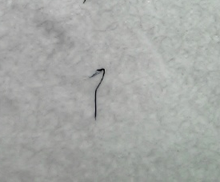
 | blue fiber | LDPE/EVA | 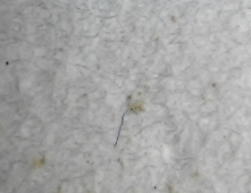
 | red fiber | LDPE/EVA | 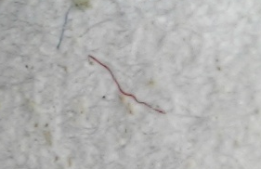
 | brown fragment | LDPE/EVA | 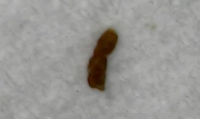
 | red fragment | PP | 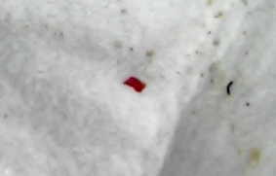
Venerupis philippinarum | black fiber | PP/PETE | 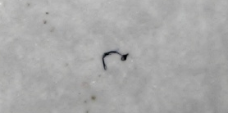
 | red fiber | LDPE/EVA | 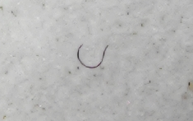
Corbicula manilensis | black fiber | LDPE/EVA | 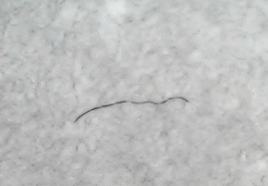
 | black fragment | PP/Nitrile | 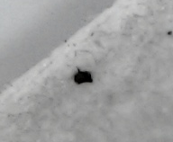
 | gray fragment | PU | 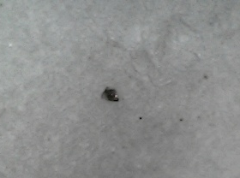
PP - polypropylene; EVA – ethylene vinyl acetate; LDPE – low density polyethylene; PETE – polyethylene terephthalate; PU - polyurethane
Bivalves uptake microplastics due to land-based and ocean-based sources of plastic wastes, facilitated by their filter-feeding mechanism. Microplastic concentration in bivalves can be influenced by proximity to sources (Murphy, 2018). Perna viridis and Corbicula manilensis samples, although bought from different markets, originated from a similar location which was Bacoor, Cavite. Meanwhile, the Venerupis philippinarum samples originated from Lucena, Quezon. Commercial establishments, subdivisions, business enterprises, manufacturing companies, and assembly plants are widespread in these locations which can be the sources of microplastics identified from sampled organisms. Another probable influence for the differences of microplastic content is the size of the bivalves. Perna viridis has the greatest size among the samples followed by Venerupis philippinarum then Corbicula manilensis. Microplastics have infiltrated Philippine local markets of bivalves as well as fishes, where MPs are detected from the samples caught in selected barangays of Borongan City, Samar Island (Nibalvos et al, 2024).
Mixtures of plastics were evident in the isolated MPs. This can originate from one type of plastic layered with another type of plastic depending on its manufacturing features. Another reason is polymer blending which results in the mixture of plastics of different properties compared to its original plastics. The ratio of the plastics to be mixed is important as it grants new properties to the blended plastic. LDPE/EVA has reduced volatility of essential oils, thus developing microbial activity for packing food and agricultural products (Wattananawinrat et al., 2014). Meanwhile, PP/EVA has enhanced impact strength which is useful for manufacturing companies (Dikobe and Luyt, 2009). PP/PETE blend is used in automotive and industrial applications (Omnexus, 2019). Lastly, PP/nitrile has enhanced elasticity which is useful for the industrial sector.
Both Perna viridis and Venerupis philippinarum are famous in aquaculture which supports the shellfish industry and livelihood of people. Microplastics in bivalves affect aquaculture, however, this sector also contributes to the alarming rate of plastic pollution. PA ropes are used for line culture (mussels), and plastic materials are used for bottom culture (clams). Spat collection utilizes monofilament PA, PE mesh bags, or PA or PP rope. Shellfish longline cultures which are often found in East Asia use extended polystyrene (EPS) floats to support floatation (Lusher et al. 2017). Previous studies have documented the contribution of fishing gear, local fisheries sources, and EPS buoys to microplastics in marine environment (Dantas, Barletta and Costa 2012; Lusher et al. 2013; De Witte et al. 2014; Mathalon and Hill 2014; and Jang et al. 2016; as cited in Lusher et al. 2017). The cultured mussels from Bacoor, Cavite have been found with microplastics as stated in the study of Argamino and Janairo (2016).
Seafood is a pathway for dietary intake of microplastics. As of 2015, the global seafood consumption is over 20 kg/year per capita which converts to 54.76 g/day per capita (Smith et al. 2018). According to the 2013 Food and Agriculture Organization of the United Nations (FAO) (2017) data, one Filipino consumes 86.46 g of seafood per day. Microplastics have penetrated the food web and are found in many species eaten by humans.
Perna viridis, Venerupis philippinarum, and Corbicula manilensis have been the commercially available bivalves in Los Baños and Lipa as observed in their public markets. Microplastics have also been found in these species which can pose a risk to the consumer population of the said locations. Using the Philippine data of Food and Agriculture Organization (FAO), the intake values of microplastics were derived by multiplying the microplastic concentration to the said data. The results are 45.26 MP/day, 49.56 MP/day, and 253.97 MP/day for Perna viridis, Venerupis philippinarum, and Corbicula manilensis, respectively. In the case of MP/individual, if a person eats at least 20 individuals of the three bivalves daily, the intake values of microplastics are 53.33 MP/day, 40.67 MP/day, and 30 MP/day, for Perna viridis, Venerupis philippinarum, and Corbicula manilensis, respectively. However, these estimations have limitations. The data from FAO account seafood consumption, thus the percentage for the shellfish intake is not specified. The description “shellfish” is also further shared by both crustaceans and mollusks. Therefore, there is a scarcity of the data of Perna viridis, Venerupis philippinarum, and Corbicula manilensis consumption in the Philippines.
The presence of microplastics in the commercially available bivalves raises food safety and livelihood concerns due to its physical and chemical potential risk on human health which may subsequently affect the fishing and aquaculture industry. The MP/g FW and MP/individual values estimate the human exposure to the intake of microplastics.

Conclusions
Microplastic contents of three commercially available bivalves namely Perna viridis (Asian green mussel), Venerupis philippinarum (Manila clam), and Corbicula manilensis (tulya) bought from Los Baños, Laguna and Lipa, Batangas were assessed using hydrogen peroxide digestion and density floatation. The extracted microplastics were verified and identified using hot needle test and ATR-FTIR. The microplastic contents among the genera of the bivalves showed significant differences as influenced by proximity to sources and probably, their sizes. The level of microplastic pollution in the bivalves ranged from 0.52-2.94 MP/g FW and 1.50-2.67 MP/individual. These values were compared to the literature studies. The result of the FT-IR analysis suggested that the fibers composed of PP/EVA, LDPE/EVA, and PP/PETE dominated the extracted MPs, followed by fragments composed of LDPE/EVA, PP, PP/Nitrile, and PU. The sources of these microplastics were related to the origin of the samples namely Bacoor, Cavite and Lucena, Quezon. Estimations were also done to assess the risk of microplastics in bivalves on human health.

COMPETING INTERESTS DISCLAIMER:
Authors have declared that they have no known competing financial interests OR non-financial interests OR personal relationships that could have appeared to influence the work reported in this paper.

Disclaimer (Artificial intelligence)
Author(s) hereby declare that NO generative AI technologies such as Large Language Models (ChatGPT, COPILOT, etc.) and text-to-image generators have been used during the writing or editing of this manuscript.

References
1. Horton, A. A. (2022). Plastic pollution: when do we know enough? Journal of Hazardous Materials, 422, 126885. https://doi.org/10.1016/j.jhazmat.2021.126885
2. Andrady, A.L. (2015). Persistence of Plastic Litter in the Oceans. In: Bergmann, M., Gutow, L., Klages, M. (Eds), Marine Anthropogenic Litter (pp. 57-72). Springer, Cham. https://doi.org/10.1007/978-3-319-16510-3_3
3. Wright, S. L., Thompson, R. C., & Galloway, T. S. (2013). The physical impacts of microplastic on marine organisms: a review. Environmental Pollution, 178, 483–492. https://doi.org/10.1016/j.envpol.2013.02.031
4. Thevenon, F., Carroll, C., & Sousa, J. (2014). Plastic debris in the ocean: the characterization of marine plastics and their environmental impacts, situation analysis report. Gland, Switzerland: IUCN.
5. Solomon, O. O., & Palanisami, T. (2016). Microplastics in the marine environment: current status, assessment methodologies, impacts and solutions. Journal of Pollution Effects & Control 4(2), 1-17. http://dx.doi.org/10.4172/2375-4397.1000161
6. Du, S., Zhu, R., Cai, Y., Xu, N., Yap, P., Zhang, Y. et al. (2021). Environmental fate and impacts of microplastics in aquatic ecosystems: a review. RSC Advances, 11, 15762–15784. https://doi.org/10.1039/D1RA00880C
7. Huang, W., Song, B., Liang, J., Niu, Q., Zeng, G., Shen, M. et al. (2021). Microplastics and associated contaminants in the aquatic environment: A review on their ecotoxicological effects, trophic transfer, and potential impacts to human health. Journal of Hazardous Materials. 405, 124187. https://doi.org/10.1016/j.jhazmat.2020.124187.
8. [GESAMP] Group of Experts on the Scientific Aspects of Marine Environmental Protection. (2015). Sources, fate and effects of microplastics in the marine environment. London, England: Joint Group of Experts on the Scientific Aspects of Marine Environmental Protection.
9. Santana, M. F. M, Ascer, L. G, Custódio, M. R., Moreira, F. T., & Turra, A. (2016). Microplastic contamination in natural mussel beds from a Brazilian urbanized coastal region: rapid evaluation through bioassessment. Marine Pollution Bulletin, 106, 183-189. https://doi.org/10.1016/j.marpolbul.2016.02.074
10. Von Moos, N., Burkhardt-Holm, P., & Köhler, A. (2012). Uptake and effects of microplastics on cells and tissue of the blue mussel Mytilus edulis L. after an experimental exposure. Environmental Science & Technology, 46(20), 11327–11335. http://dx.doi.org/10.1016/j.marpolbul.2016.02.074
11. Browne, M. A., Niven, S. J., Galloway, T. S., Rowland, S. J., & Thompson, R. C. (2013). Microplastic moves pollutants and additives to worms, reducing functions linked to health and biodiversity. Current Biology, 23, 2388–2392. https://doi.org/10.1016/j.cub.2013.10.012
12. Besseling, E., Wegner, A., Foekema, E. M., Heuvel-Greve, M. J., & Koelmans, A. A. (2013). Effects of microplastic on fitness and PCB bioaccumulation by the lugworm Arenicola marina (L.). Environmental Science & Technology, 47, 593–600. https://doi.org/10.1021/es302763x
13. Rochman, C. M., Kurobe, T., Flores, I., & Teh, S. J. (2014). Early warning signs of endocrine disruption in adult fish from the ingestion of polyethylene with and without sorbed chemical pollutants from the marine environment. Science of the Total Environment, 493, 656–661. http://dx.doi.org/10.1016/j.scitotenv.2014.06.051
14. Motivarash, Y., Bhatt, A., & Kardani, H. (2024). Microplastic (MP) occurrence in pelagic and demersal fishes of Gujarat, northwest coast of India. Environmental Science and Pollution Research, 31, 17239–17255. https://doi.org/10.1007/s11356-024-32361-7
15. Li, J., Yang, D., Li, L., Jabeen, K., & Shi, H. (2015). Microplastics in commercial bivalves from China. Environmental Pollution, 207, 190-195. https://doi.org/10.1016/j.envpol.2015.09.018
16. Murray, F., & Cowie, P. R. (2011). Plastic contamination in the decapod crustacean Nephrops norvegicus (Linnaeus, 1758). Marine Pollution Bulletin, 62, 1207-1217. https://doi.org/10.1016/j.marpolbul.2011.03.032
17. Naji, A., Nuri, M., & Vethaak, A. D. (2018). Microplastics contamination in molluscs from the northern part of the Persian Gulf. Environmental Pollution, 235, 113-120. https://doi.org/10.1016/j.envpol.2017.12.046
18. Mathalon, A., & Hill, P. (2014). Microplastic fibers in the intertidal ecosystem surrounding Halifax Harbor, Nova Scotia. Marine Pollution Bulletin, 81, 69-79. https://doi.org/10.1016/j.marpolbul.2014.02.018
19. De Witte, B., Devriese, L., Bekaert, K., Hoffman, S., Vandermeersch, G., Cooreman, K., et al. (2014). Quality assessment of the blue mussel (Mytilus edulis): Comparison between commercial and wild types. Marine Pollution Bulletin, 85(1), 146–155. https://doi.org/10.1016/j.marpolbul.2014.06.006
20. Van Cauwenberghe, L., & Janssen, C. R. (2014). Microplastics in bivalves cultured for human consumption. Environmental Pollution, 193, 65-70. https://doi.org/10.1016/j.envpol.2014.06.010
21. Van Cauwenberghe, L., Claessens, M., Vandegehuchtem M. B., & Janssen, C. R. (2015). Microplastics are taken up by mussels (Mytilus edulis) and lugworms (Arenicola marina) living in natural habitats. Environmental Pollution, 199, 10–17. https://doi.org/10.1016/j.envpol.2015.01.008
22. Vandermeersch, G., Van Cauwenberghe, L., Janssen, C. R., Marques, A., Granby, K., Fait, G. et al. (2015). A critical view on microplastic quantification in aquatic organisms. Environmental Research 143:46–55. https://doi.org/10.1016/j.envres.2015.07.016
23. Cho, Y., Shim, W., Jang, M., Han, G. M., & Hong, S. H. (2018). Abundance and characteristics of microplastics in market bivalves from South Korea. Environmental Pollution, 245, 1107-1116. https://doi.org/10.1016/j.envpol.2018.11.091
24. Ding, J., Li, J., Sun, C., Jiang, F., Ju, P., Qu, L. et al. (2019). Detection of microplastics in local marine organisms using a multi-technology system. Analytical Methods, 11, 78-87. https://doi.org/10.1039/C8AY01974F
25. Li, J., Qu, X., Su, L., Zhang, W., Yang, D., Kolandhasamy, P. et al. (2016). Microplastics in mussels along the coastal waters of China. Environmental Pollution, 214, 177–184. https://doi.org/10.1016/j.envpol.2016.04.012
26. Murphy, C. L. (2018). A comparison of microplastics in farmed and wild shellfish near Vancouver Island and potential implications of contaminant transfer to humans [Master’s thesis]. British Columbia, Canada: Royal Roads University.
27. Qu, X., Su, L., Li, H., Liang, M., & Shi, H. (2018). Assessing the relationship between the abundance and properties of microplastics in water and in mussels. Science of the Total Environment, 621, 679–686. https://doi.org/10.1016/j.scitotenv.2017.11.284
28. Khoironi, A., & Anggoro, S. (2018). The existence of microplastic in Asian green 554 mussels. In: IOP Conference Series: Earth and Environmental Science, vol 131. IOP 555 Publishing. No. 1, p. 012050.
29. Davidson, K., & Dudas, S. E. (2016). Microplastic ingestion by wild and cultured Manila clams (Venerupis philippinarum) from Baynes Sound, British Columbia. Archives of Environmental Contamination and Toxicology, 71(2), 147-156. https://doi.org/10.1007/s00244-016-0286-4
30. Covernton, G. A., Collicutt, B., Gurney-Smit, H. J., Pearce, C. M., Dower, J. F., Ross, P. S. et al. (2019). Microplastics in bivalves and their habitat in relation to shellfish aquaculture proximity in coastal British Columbia, Canada. Aquaculture Environment Interactions 11, 357-374. https://doi.org/10.3354/aei00316
31. Su, L., Xue, Y., Li, L., Yang, D., Kolandhasamy, P., Li, D. et al. (2016). Microplastics in Taihu Lake, China. Environmental Pollution, 216, 711-719. https://doi.org/10.1016/j.envpol.2016.06.036
32. Nibalvos, A. V. G., Nibalvos, C. T., & Obina, M. T. (2024). Microplastic detection and identification in edible bivalves from Dolores and Oras, Eastern Samar. Edelweiss Applied Science and Technology. 8 (6), 5766-5779. http://dx.doi.org/10.55214/25768484.v8i6.3247
33. Nibalvos, A. V. G., Nibalvos, C. T., & Acorin, L. D. A. (2024). Detection and Identification of Microplastics from Locally Sold Fishes in Borongan City, Samar Island, Philippines. Open Journal of Ecology, 14 (11), 845-856. https://doi.org/10.4236/oje.2024.1411048
34. Wattananawinrat, K., Threepopnatkul, P., & Kulsetthanchalee, C. (2014). Morphological and thermal properties of LDPE/EVA blended films and development of antimicrobial activity in food packaging film. Energy Procedia, 56, 1-9. https://doi.org/10.1016/j.egypro.2014.07.125
35. Dikobe, D. G., & Luyt, A. S. (2009). Morphology and properties of polypropylene/ethylene vinyl acetate copolymer/wood powder blend composites. Express Polymer Letters, 3(3), 190-199. http://dx.doi.org/10.3144/expresspolymlett.2009.24
36. Omnexus. (2019). Polyethylene terephthalate (PET): a comprehensive review. https://omnexus.specialchem.com/selection-guide/polyethylene-terephthalate-pet-plastic
37. Lusher, A., Hollman, P., & Mendoza-Hill, J. (2017). Microplastics in fisheries and aquaculture (Technical paper). Food and Agriculture Organizaion of the United Nations. http://www.fao.org/3/a-i7677e.pdf
38. Dantas, D. V., Barletta, M., & Costa, M. F. (2012). The seasonal and spatial patterns of ingestion of polyfilament nylon fragments by estuarine drums (Sciaenidae). Environmental Science and Pollution Research 19(2), 600–606. https://doi.org/10.1007/s11356-011-0579-0
39. Lusher, A. L., McHugh, M., & Thompson, R. C. (2013). Occurrence of microplastics in the gastrointestinal tract of pelagic and demersal fish from the English Channel. Marine Pollution Bulletin, 67(1), 94-99. https://doi.org/10.1016/j.marpolbul.2012.11.028
40. Jang, M., Shim, W. J., Han, G. M., Rani, M., Song, Y. K., & Hong, S. H. (2016). Styrofoam debris as a source of hazardous additives for marine organisms. Environmental Science & Technology, 50, 4951-4960. http://dx.doi.org/10.1021/acs.est.5b05485
41. Argamino, C. R., & Janairo, J. I. B. (2016). Qualitative assessment and management of microplastics in Asian green mussels (Perna viridis) cultured in Bacoor Bay, Cavite, Philippines. Environment Asia, 9(2), 48-54. http://dx.doi.org/10.14456/ea.2016.7
42. Smith, M., Love, D. C., Rochman, C. M., & Neff, R. A. (2018). Microplastics in seafood and the implication for human health. Current Environmental Health Reports, 5, 375-386. https://doi.org/10.1007/s40572-018-0206-z
43. [FAO] Food and Agriculture Organization of the United Nations. (2017). Fish and seafood consumption, 2013. https://ourworldindata.org/grapher/fish-and-seafood-consumption-per-capita?time=1961..2013

