Review Article
Apelin and its physiological role in regulatory feed intake in fish (Labeo rohita)

ABSTRACT
Bioactive peptide apelin is essential in animals for the control of energy balance and the maintenance of feeding behaviour. It was studied in Labeo rohita, Cirrhinus mrigala, Silver carp etc., a widely cultured freshwater fish species in regulation of food intake. The review compiles findings that investigated apelin in different tissues and in interaction with hunger regulatory hormones to uncover the action of apelin in feeding process. We found that apelin and its receptors are expressed throughout the body, including in the brain, and so are likely to be involved in hunger and satiety regulation. Synthetic apelin was able to alter feeding behaviour and key hormones ghrelin and leptin that respectively control appetite/energy utilization. Also, fasting and refeeding experiments revealed that apelin levels change with the nutritional state of the fish, suggesting it plays a role in adjusting feeding responses to ensure that fish adapt to food, as determines its availability. These insights give apelin a key role as a feeding and growth regulator in aquaculture species. The mechanisms by which apelin affect fish farming efficiency and sustainability could be understood, which could ultimately lead to new approaches to optimize feeding strategies of fish farm to improve the efficiency and sustainability of fish farming.
KEYWORDS
Hunger regulation, Eating patterns, Feed efficiency, Metabolic processes, Apelin peptide.

INTRODUCTION
Labeo rohita (Rohu) produces bioactive peptides, which are short-chain protein fragments having advantageous biological action. These peptides are produced by the enzymatic hydrolysis of muscle proteins and are linked to a number of physiological processes. These peptides have antibacterial, antioxidant, antihypertensive, and immunomodulatory properties that can benefit the pharmaceutical and nutraceutical sectors. 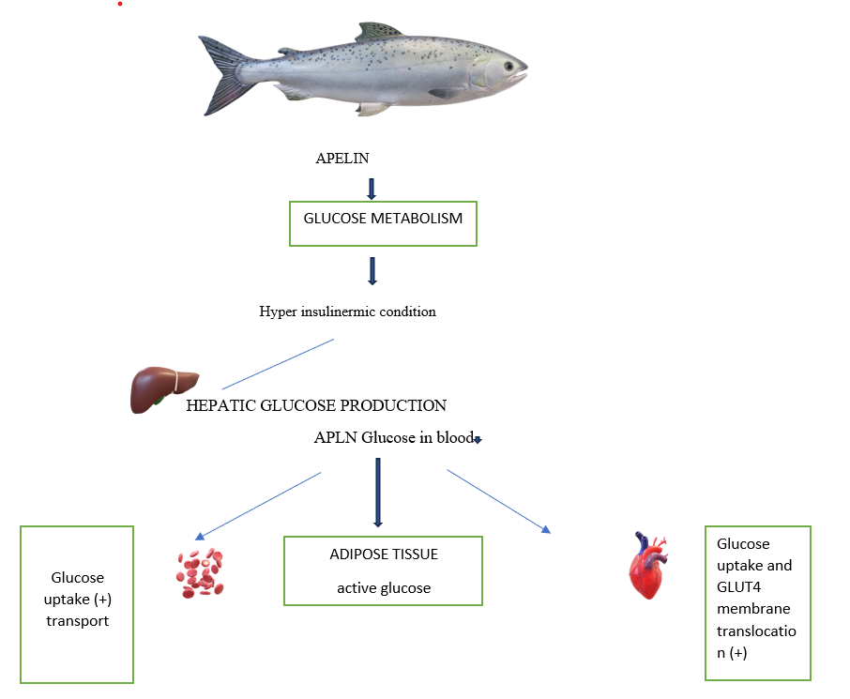
Figure – 1 Schematic representation of Apelin (APLN) pathway and its regulatory role in in glucose metabolism and energy balance in Labeo rohita under hyper insulinemic conditions.
As a biologically active peptide, apelin has also been of major interest as an important factor in maintaining energy balance and feeding behaviour consistent with other animal species (Shokrollahi et al., 2024a) . The endogenous ligand of the APJ receptor was originally found to be apelin and it appears to be a critical physiological function related to cardiovascular well-being, fluid balance and metabolism(Li et al., 2023) . Apelin has been shown to regulate appetite in mammals and is, therefore, targeted for study regarding obesity and metabolic disorders.(Hu et al., 2021).Understanding of factors that regulate feeding behaviour is crucial to growth improvement and higher feed utilization in aquaculture(Sun et al., 2016). Rohu (Labeo rohita) is the most widely cultured South Asian freshwater fish due to its fast growth and high market demand (Rasal & Sundaray, 2020). Thus, it is vital to respond to the extent that biological mechanisms for forecasting feeding and energy homeostasis in this fish can sustain aquaculture(Assan et al., 2021a).Apelin expression was also correlated with hunger regulation and present in fish with bigger tissues, such as the brain((Assan et al., 2021b). In goldfish (Carassius auratus), apelin is likely to be regulating consumption and energy balance in fish, just like it does in mammals((Pawlak et al., 2023) . In addition, fish are prone to environmental conditions like temperature and light cycle, which exert a great influence on their appetite and growth((Sánchez-Vázquez et al., 2019). For example, the time of year influences the hunger and growth rate of rohu species; hence, both internal and external factors should be considered when managing appetite (Bandyopadhyay, 2022).
All of these advancements, however, do not explain any specifics in the role of apelin in Labeo rohita. Its expression, receptor interactions and response to fasting and feeding conditions may be investigated to insight into its function(Assan et al., 2021c). These findings can serve as some guidance to feed efficiency based strategies to enhance growth performance in aquaculture. (Glencross, 2020).The purpose of this study is to establish the role of apelin in feed intake regulation in rohu(M. S. Kumar, 2019). The research to know the physiological role of apelin focused by examining its distribution in different tissues, analysing its response to nutritional states and evaluating several effects of synthetic apelin(Marsault et al., 2019). It could aid in the development of more suitable feeding strategies that support sustainable practices in fish farming(Araujo et al., 2022) .Lastly, the importance of apelin in the control of appetite is well documented in mammals with little work having been done regarding the role of apelin in major economically important fish species like rohu(Chen et al., 2022). The objective of this research is to fill that knowledge gap in order to present new insights on how improvements in productivity and sustainability in aquaculture could be achieved(Boyd et al., 2020)
Apelin Study Tables

Table 1-Comparative Studies on Apelin in Fish Species
Species | Tissue Distribution | Effect on Feeding | External Factors
Goldfish (Carassius auratus) | Brain, Liver, Intestines | Increased food intake | Temperature and light cycles
Tilapia (Oreochromis niloticus) | Brain, Liver, Gills | Stimulated feeding frequency | Environmental stressors
Zebrafish (Danio rerio) | Brain, Gonads | Appetite stimulation | Salinity changes
Rohu (Labeo rohita) | Brain, Gills, Intestine | Regulated feeding based on nutritional state | Seasonal changes

Table 2- Key Hormones Influencing Feeding in Fish
Hormone | Primary Function | Interaction
Apelin | Regulates hunger and energy balance | Interacts with ghrelin and leptin
Ghrelin | Stimulates appetite | Counteracts leptin effects
Leptin | Suppresses appetite | Interacts with apelin and insulin
Neuropeptide Y (NPY) | Promotes food intake | Modulated by apelin and ghrelin

Table 3- Environmental Factors Impacting Feeding in Labeo rohita
Factor | Impact on Feeding | Effect on Apelin
Temperature | Decreased intake in colder months | Reduced expression during cold seasons
Photoperiod | Increased feeding during longer daylight | Elevated expression with extended light exposure
Water Quality | Poor water quality reduces appetite | Decreased apelin response under stress
Salinity | Varied feeding behavior under salinity changes | Altered expression to adapt to osmotic stress

REGULATION OF FEED INTAKE
Such complex neuroendocrine processes need to integrate the internal energy requirements of the fish with external environmental triggers and this level of feed that the fish consumes((Gorissen & Flik, 2016). A key direction to these processes is given by the Apelinergic system(Shin et al., 2017).More current studies discovered that apelin peptides affect food behaviour through action on the hypothalamus; this region of the brain oversees energy activity (Shokrollahi et al., 2024b). This suggests that induction of feeding behaviour in fish is mediated by the activation of orexigenic neuropeptides, such as orexin, and that Apelin has acted by this mechanism to induce feeding behaviour in fish(Rønnestad et al., 2017). Other proof that apelin regulates hunger by regulating the processes of fasting and refeeding comes from gene expression during fasting and refeeding(Liu et al., 2024).Pro-opiomelanocortin, or POMC, and neuropeptide Y, or NPY, are two of the most important neuropeptides known to regulate hunger(Mountjoy, 2015). Having said that, apelin can undoubtedly modify appetite and satiety in order to govern the energy balance of fish, as apelin can regulate these neuropeptides(Canosa & Bertucci, 2020).Peripheral Communication: In addition to its central activity, apelin influences the peripheral organs that are involved in food absorption and digesting(Palmioli et al., 2021). Because of its effect on feed utilisation efficiency, it has an effect on the stomach's motility and secretion)(Janssen et al., 2011)
PHYSIOLOGICAL EFFECT ON Labeo rohita
With apelin regulating feed, the fish species to use is Labeo rohita, a species cultivated for aquaculture(Shi et al., 2020).The growth and metabolism is greatly expressed and is the one that regulates energy and nutrition intake(Wysocka et al., 2018). Consumption of fish and health may be determined by environmental stress factors such as hypoxia and thermal variability that may alter the regulation levels of apelin in fish and reproductive relationships in apelin establishes the correlation between reproductive hormones and energy status and reproductive fitness (Estienne et al., 2019).
AQUACULTURE APPLICATIONS
Aquaculture operations can be revolutionary in the apelinergic system. In feed production, this is because specially designed feeds can control apelin activity so that there can be improved growth and waste removal. Dietary strategies such as de-oiled rice bran -based feeds have also been shown to improve metabolism and feed efficiency in Labeo rohita (S. Kumar et al., 2020). Monitoring of Health: Apelin levels can be utilised to gauge environmental stress as well as diet and make respective adjustments. Selection breeding: With the genetic information of the apelin receptor and apelin, a selection breeding program is able to decide what it is selecting for to optimize feed efficiency and stress resistance.
DISCUSSION
It is one of the peptides in vertebrates that could bind to an APJ receptor; it is involved in various physiological processes related to eating behaviour, fluid balance, and energy balance. The peptide was originally studied in mammals, primarily humans, but increasingly fish, and more specifically in the aquaculture species Labeo rohita, are being studied. A more significant node in the global food production network is aquaculture (Eglantina Idrizaj et al., 2019). Managing feeds consumed during farmed fish is to be controlled with feed efficiency innovations and regulations limiting feed consumption at present. Peptides such as apelin are of great interest as they will increase growth rates while reducing costs through feed optimisation (Gupta et al., 2021).The aim of this study is to explain how apelin regulates the feed intake of Labeo rohita., The latest research on apelin, a fish of economic value in aquaculture, will be thoroughly reviewed to understand how it affects feeding behaviour , how environmental factors affect expression, and how it may eventually improve feed efficiency in aquaculture production (Little et al., 2018).
ROLE OF APELIN IN FEED INTAKE AND APPETITE CONTROL
The role of apelin in regulating hunger and energy homeostasis in mammals has been well researched. It acts with other neuropeptides, such as pro-opiomelanocortin (POMC) and neuropeptide Y (NPY), to modulate the hypothalamus, which controls hunger and satiety. This helps maintain balance between energy needs and food intake (Suryaningtyas & Je, 2023). Apelin also influences insulin. Initial research suggests that apelin could have a similar impact on regulating food behaviour and metabolism in aquatic animals, although research on apelin in fish is only just beginning. For instance, studies in goldfish (Carassius auratus) and tilapia (Oreochromis niloticus) have demonstrated that apelin could enhance appetite as well as satisfaction and enhanced food intake. When Li et al. injected exogenous apelin into goldfish in 2012, they observed elevated food intake, further confirming the notion that apelin induces hunger. The notion that apelin does have an influence on the feeding behaviour of fish species was further confirmed by Gao et al. (2018), who found that administering apelin to tilapia increased feed numbers. Fish in particular benefit substantially from the hormone's ability to control food intake and energy balance while stimulating development and metabolism, especially in aquaculture, since the research suggests that apelin's ability to regulate appetite may be conserved across species.
INFLUENCE OF ENVIRONMENTAL FACTORS ON APELIN EXPRESSION AND FEEDING BEHAVIOUR
Fish feeding behaviour is controlled both by external environmental factors and by internal physiological requirements(Zhou et al., 2018). Because fish are ectotherms, they are very responsive to changes in the temperature and photoperiod of their environment. The metabolism of these fish is also influenced by the condition of the water. Based on research by Hui et al. (2003), an example is the cold-season months, where intake is observed to reduce primarily due to the fact that fish perform metabolic activities during such cold months. Temperature change and low quality of water, for instance, are abiotic stressors that may suppress the feeding activity. Apelin can hence be very effective in assisting the fish to accommodate such changes. There is plenty of evidence obtained from studies to show that apelin expression among fish is modulated by the environment and hence assists the Fish in regulating the way they feed. In Labeo rohita, for example, it has been established that apelin expression in the hypothalamus increases with feeding, suggesting that apelin plays a role in the regulation of food intake based on nutritional status (Zhuang et al., 2020). Environmental conditions like temperature or light can, in theory, adjust apelin expression to adjust eating behaviour to increase energy uptake in fish. Managing feeding tactics in aquaculture may greatly benefit from an understanding of apelin's interactions with environmental cues. Due of apelin's ability to control eating behaviour, producers can modify ambient factors and feeding schedules to enhance growth and maximise feed utilisation

ENHANCING FEED EFFICIENCY IN AQUACULTURE THROUGH APELIN
These are some of the core components enhancing sustainability and lowering the cost of rearing fish feed conversion rates. It has been proven that apelin modulates appetite and food intake, which may indirectly contribute to improved feed efficiency in aquaculture(Shahin et.al 2024) .For example, the knowledge of how apelin modulates feed intake in Labeo rohita can be applied to better techniques for improved feed utilization, reduced waste, and increased growth rates. It will ensure that the fish continues to consume adequate food if it can stimulate appetite during periods of restricted feeding such as stress or environmental changes. Such a characteristic will be very beneficial in aquaculture systems since things such as temperature fluctuations, stress caused by movement or disease reduces feeding behaviour. This would have improved the fish's efficiency in using their meal because apelin controls their metabolic processes. Apelin would have improved feed conversion into growth by controlling energy expenditure and enhancing food metabolism as the FCR levels rose. As a result, adding value to the economic chain can make aquaculture—including Labeo rohita —more sustainable Feeding strategies in aquaculture can significantly be improved by understanding apelin's interaction with environmental factors. Because of apelin's capacity to regulate eating behaviour, producers are able to adjust ambient conditions and feeding times to improve growth and optimize feed utilization
IMPROVING FEED EFFICIENCY IN AQUACULTURE WITH APELIN
These are among the fundamental ingredients improving sustainability and reducing the rearing cost of fish feed conversion rates. It has been shown that apelin regulates appetite and food consumption, which can indirectly lead to better feed efficiency in aquaculture (Shahin et.al 2024). For instance, understanding the role of apelin in the modulation of feed consumption in Labeo rohita can be used in superior methods of greater feed efficiency, less wastage, and more growth rate. It will see to it that the fish remains well fed if it can promote appetite when it is in phases of limited feeding like stress or changes in the environment. This is a very useful feature in aquaculture systems as factors like temperature changes, stress due to movement or disease lowers feeding behaviour. This would have enhanced the efficiency of the fish in utilizing their meal since apelin regulates their metabolic activities. Apelin would have enhanced feed conversion to growth through regulating energy spend and improving food metabolism with increasing FCR levels. Consequently, adding value to the economic chain can enhance the sustainability of aquaculture—of which Labeo rohita is a part.

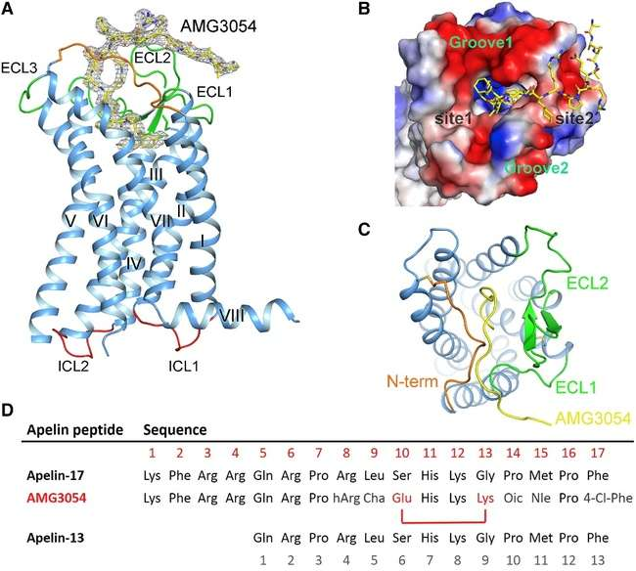

Figure-2 Structural Basis for Apelin Control of the Human Apelin Receptor (Ma et al., 2017)

.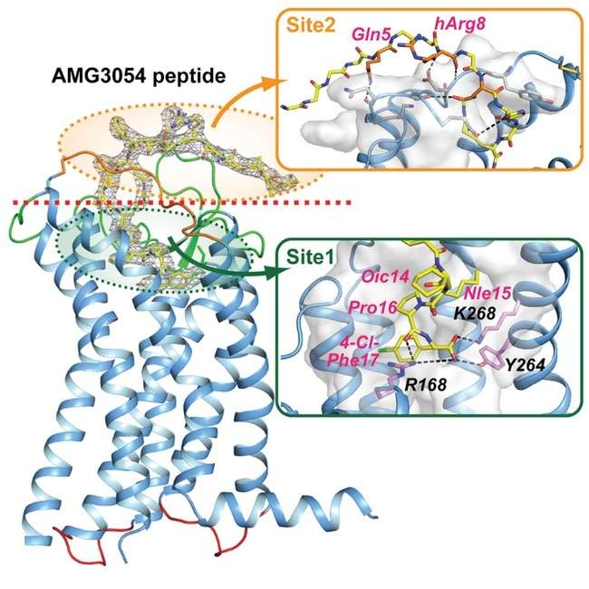

Figure 3 -Structural Basis for Apelin Control of the Human Apelin Receptor (Ma et al., 2017)
OBSTACLES AND PROSPECTS FOR FURTHER RESEARCH
Most of the research thus far has been promising, though the significance of apelin in fish is still relatively new. There are still many too many things left unknown, though. This narrow field width makes a lot of challenges for the study to break. Because the research now will only be addressing a low percentage of the total body of research, and only represent a small number of species, further research is still needed to properly understand its influence on Labeo rohita and other aquaculture species.
The specific roles that apelin has to play on feeding behaviour of fish are hardly known. This will take extensive study to acquire this complex data. It is for sure that apelin activity is influenced by environmental stimuli, other peptides, and the remaining hormones (Assan et.al 2014). What are the relationships, for instance, between apelin and other substances in fish hunger? How does this substance affect the organism's reaction to temperature stimulation or hypoxia? (Canosa et.al 2023). To establish the effects of apelin-based interventions, longer-duration studies are also required. Despite the fact that short-term studies have shown apelin to elevate food intake, long-term investigations on the effects of apelin administration on the growth, metabolism, and sexual health of fish have shown mammoth significance (Mehri et.al 2023). Lastly, more research is required in order to comprehend apelin's actual use in aquaculture. This requires determining if supplementation of fish meal with apelin would improve the growth and the feed conversion ratio without endangering the fish
CONCLUSION
The above table shows the function of three hormones in Labeo rohita – Apelin, Ghrelin, Leptin, neuropeptide . Apelin -Regulates hunger and energy balance . Ghrelin - Stimulates appetite . Leptin-Suppress appetite and neuropeptide -Promotes food intake. Researchers have now proved that the peptide regulates fish hunger and metabolism. It does so by manipulating the diets of goldfish, tilapia, and zebrafish. Early research indicates that apelin, which is quite possibly the most fascinating potential candidate for use in the aquaculture industry of the future, could be implicated in the regulation of feeding behaviour in Labeo rohita. The capacity of apelin to boost aquaculture feed effectiveness through appetite control and energy homeostasis is especially fascinating. Since the most significant portion of fish farming expenses lies in feed, research with such promising results is deserving of scrutiny in order to fully understand the functions of apelin in Labeo rohita and how it relates to other fish processes. Future studies, for example, can take into account observations of long-term consequences of apelin on feed efficiency and growth in addition to how the organism carries out its activities under different environmental conditions. In short, even though studies on apelin in fish are still in their early stages, it has the potential to greatly improve aquaculture. It may provide information on how to better feed Labeo rohita, thereby making the aquaculture industry healthy in itself and contributing to food production in the near future.

ABBREVIATIONS - NPY-Neuropeptide, POMC-pro-opiomelanocortin .

DISCLAIMER (Artificial intelligence)
Author(s) hereby declares that NO generative AI technologies such as Large Language Models (ChatGPT, COPILOT, etc.) and text-to-image generators have been used during the writing or editing of this manuscript.
ACKNOWLEDGEMENT
The author gratefully acknowledges the supervision and guidance of Dr. Kamal Vatika , Department of Biosciences , Chandigarh University ,India

REFERENCES
Araujo, G. S., Silva, J. W. A. D., Cotas, J., & Pereira, L. (2022). Fish Farming Techniques: Current Situation and Trends. Journal of Marine Science and Engineering, 10(11), 1598. https://doi.org/10.3390/jmse10111598
Assan, D., Huang, Y., Mustapha, U. F., Addah, M. N., Li, G., & Chen, H. (2021a). Fish Feed Intake, Feeding Behavior, and the Physiological Response of Apelin to Fasting and Refeeding. Frontiers in Endocrinology, 12, 798903. https://doi.org/10.3389/fendo.2021.798903
Assan, D., Huang, Y., Mustapha, U. F., Addah, M. N., Li, G., & Chen, H. (2021b). Fish Feed Intake, Feeding Behavior, and the Physiological Response of Apelin to Fasting and Refeeding. Frontiers in Endocrinology, 12, 798903. https://doi.org/10.3389/fendo.2021.798903
Assan, D., Huang, Y., Mustapha, U. F., Addah, M. N., Li, G., & Chen, H. (2021c). Fish Feed Intake, Feeding Behavior, and the Physiological Response of Apelin to Fasting and Refeeding. Frontiers in Endocrinology, 12, 798903. https://doi.org/10.3389/fendo.2021.798903
Bandyopadhyay, B. K. (2022). Freshwater Aquaculture: A Functional Approach (With Intricate Informations on Integration of Fish with other Crops, Diversifications of Suitable Alternatives of Indian Major Carp Culture Practices and Sewage-fed Aquaculture) (1st ed.). CRC Press. https://doi.org/10.1201/9781003300335
Boyd, C. E., D’Abramo, L. R., Glencross, B. D., Huyben, D. C., Juarez, L. M., Lockwood, G. S., McNevin, A. A., Tacon, A. G. J., Teletchea, F., Tomasso, J. R., Tucker, C. S., & Valenti, W. C. (2020). Achieving sustainable aquaculture: Historical and current perspectives and future needs and challenges. Journal of the World Aquaculture Society, 51(3), 578–633. https://doi.org/10.1111/jwas.12714
Canosa, L. F., & Bertucci, J. I. (2020). Nutrient regulation of somatic growth in teleost fish. The interaction between somatic growth, feeding and metabolism. Molecular and Cellular Endocrinology, 518, 111029. https://doi.org/10.1016/j.mce.2020.111029
Chen, L., Xu, J., Sun, X., & Xu, P. (2022). Research advances and future perspectives of genomics and genetic improvement in allotetraploid common carp. Reviews in Aquaculture, 14(2), 957–978. https://doi.org/10.1111/raq.12636
Eglantina Idrizaj, Rachele Garella, Roberta Squecco, & Maria Caterina Baccari. (2019). Adipocytes-released Peptides Involved in the Control of Gastrointestinal Motility. Current Protein & Peptide Science, 20(6), 614–629. https://doi.org/10.2174/1389203720666190121115356
Estienne, A., Bongrani, A., Reverchon, M., Ramé, C., Ducluzeau, P.-H., Froment, P., & Dupont, J. (2019). Involvement of Novel Adipokines, Chemerin, Visfatin, Resistin and Apelin in Reproductive Functions in Normal and Pathological Conditions in Humans and Animal Models. International Journal of Molecular Sciences, 20(18). https://doi.org/10.3390/ijms20184431
Glencross, B. D. (2020). A feed is still only as good as its ingredients: An update on the nutritional research strategies for the optimal evaluation of ingredients for aquaculture feeds. Aquaculture Nutrition, 26(6), 1871–1883. https://doi.org/10.1111/anu.13138
Gorissen, M., & Flik, G. (2016). 3—The Endocrinology of the Stress Response in Fish: An Adaptation-Physiological View. In C. B. Schreck, L. Tort, A. P. Farrell, & C. J. Brauner (Eds.), Biology of Stress in Fish (Vol. 35, pp. 75–111). Academic Press. https://doi.org/10.1016/B978-0-12-802728-8.00003-5
Gupta, A., Gupta, S. K., Priyam, M., Siddik, M. A. B., Kumar, N., Mishra, P. K., Gupta, K. K., Sarkar, B., Sharma, T. R., & Pattanayak, A. (2021). Immunomodulation by dietary supplements: A preventive health strategy for sustainable aquaculture of tropical freshwater fish, Labeo rohita (Hamilton, 1822). Reviews in Aquaculture, 13(4), 2364–2394. https://doi.org/10.1111/raq.12581
Hu, G., Wang, Z., Zhang, R., Sun, W., & Chen, X. (2021). The Role of Apelin/Apelin Receptor in Energy Metabolism and Water Homeostasis: A Comprehensive Narrative Review. Frontiers in Physiology, 12, 632886. https://doi.org/10.3389/fphys.2021.632886
Janssen, P., Vanden Berghe, P., Verschueren, S., Lehmann, A., Depoortere, I., & Tack, J. (2011). Review article: The role of gastric motility in the control of food intake: Review: regulation of food intake by gastric motility. Alimentary Pharmacology & Therapeutics, 33(8), 880–894. https://doi.org/10.1111/j.1365-2036.2011.04609.x
Kumar, M. S. (2019). Peptides and Peptidomimetics as Potential Antiobesity Agents: Overview of Current Status. Frontiers in Nutrition, 6, 11. https://doi.org/10.3389/fnut.2019.00011
Kumar, S., Sahu, N. P., Ranjan, A., Gupta, S., & Deo, A. D. (2020). Physio-metabolic and haematological changes of Labeo rohita fed with graded level of de-oiled rice bran-based diet. Fish Physiology and Biochemistry, 46(1), 265–275. https://doi.org/10.1007/s10695-019-00714-6
Li, A., Zhao, Q., Chen, L., & Li, Z. (2023). Apelin/APJ system: An emerging therapeutic target for neurological diseases. Molecular Biology Reports, 50(2), 1639–1653. https://doi.org/10.1007/s11033-022-08075-9
Little, D. C., Young, J. A., Zhang, W., Newton, R. W., Mamun, A. A., & Murray, F. J. (2018). Sustainable intensification of aquaculture value chains between Asia and Europe: A framework for understanding impacts and challenges. Aquaculture, 493, 338–354. https://doi.org/10.1016/j.aquaculture.2017.12.033
Liu, Y., Wang, X., Li, G., Chen, S., Jia, H., Dai, J., & He, D. (2024). Investigating the Impact of Fasting and Refeeding on Blood Biochemical Indicators and Transcriptional Profiles in the Hypothalamus and Subcutaneous Adipose Tissue in Geese. Animals, 14(18), 2746. https://doi.org/10.3390/ani14182746
Ma, Y., Yue, Y., Ma, Y., Zhang, Q., Zhou, Q., Song, Y., Shen, Y., Li, X., Ma, X., Li, C., Hanson, M. A., Han, G. W., Sickmier, E. A., Swaminath, G., Zhao, S., Stevens, R. C., Hu, L. A., Zhong, W., Zhang, M., & Xu, F. (2017). Structural Basis for Apelin Control of the Human Apelin Receptor. Structure, 25(6), 858-866.e4. https://doi.org/10.1016/j.str.2017.04.008
Marsault, E., Llorens‐Cortes, C., Iturrioz, X., Chun, H. J., Lesur, O., Oudit, G. Y., & Auger‐Messier, M. (2019). The apelinergic system: A perspective on challenges and opportunities in cardiovascular and metabolic disorders. Annals of the New York Academy of Sciences, 1455(1), 12–33. https://doi.org/10.1111/nyas.14123
Mountjoy, K. G. (2015). Pro‐Opiomelanocortin ( POMC ) Neurones, POMC ‐Derived Peptides, Melanocortin Receptors and Obesity: How Understanding of this System has Changed Over the Last Decade. Journal of Neuroendocrinology, 27(6), 406–418. https://doi.org/10.1111/jne.12285
Palmioli, E., Dall’Aglio, C., Bellesi, M., Tardella, F. M., Moscatelli, S., Scocco, P., & Mercati, F. (2021). The Apelinergic System Immuno-Detection in the Abomasum and Duodenum of Sheep Grazing on Semi-Natural Pasture. Animals, 11(11), 3173. https://doi.org/10.3390/ani11113173
Pawlak, P., Burren, A., Seitz, A., & Pietsch, C. (2023). Effects of different acute stressors on the regulation of appetite genes in the carp ( Cyprinus carpio L.) brain. Royal Society Open Science, 10(2), 230040. https://doi.org/10.1098/rsos.230040
Rasal, K. D., & Sundaray, J. K. (2020). Status of genetic and genomic approaches for delineating biological information and improving aquaculture production of farmed rohu, Labeo rohita (Ham, 1822). Reviews in Aquaculture, 12(4), 2466–2480. https://doi.org/10.1111/raq.12444
Rønnestad, I., Gomes, A. S., Murashita, K., Angotzi, R., Jönsson, E., & Volkoff, H. (2017). Appetite-Controlling Endocrine Systems in Teleosts. Frontiers in Endocrinology, 8. https://doi.org/10.3389/fendo.2017.00073
Sánchez-Vázquez, F. J., López-Olmeda, J. F., Vera, L. M., Migaud, H., López-Patiño, M. A., & Míguez, J. M. (2019). Environmental Cycles, Melatonin, and Circadian Control of Stress Response in Fish. Frontiers in Endocrinology, 10, 279. https://doi.org/10.3389/fendo.2019.00279
Shi, Y., Zhong, L., Liu, Y., Zhang, J., Lv, Z., Li, Y., & Hu, Y. (2020). Effects of Dietary Andrographolide Levels on Growth Performance, Antioxidant Capacity, Intestinal Immune Function and Microbioma of Rice Field Eel (Monopterus Albus). Animals, 10(10). https://doi.org/10.3390/ani10101744
Shin, K., Kenward, C., & Rainey, J. K. (2017). Apelinergic System Structure and Function. In R. Terjung (Ed.), Comprehensive Physiology (1st ed., pp. 407–450). Wiley. https://doi.org/10.1002/cphy.c170028
Shokrollahi, B., Jang, S.-S., Lee, H. J., Ahmad, H. I., Sesay, A. R., Ghazikhani Shad, A., Morammazi, S., & Abdelnour, S. A. (2024a). Exploring the potential roles of apelin, visfatin, and irisin in energy regulation in farm animals: An overview. Frontiers in Veterinary Science, 11, 1435788. https://doi.org/10.3389/fvets.2024.1435788
Shokrollahi, B., Jang, S.-S., Lee, H. J., Ahmad, H. I., Sesay, A. R., Ghazikhani Shad, A., Morammazi, S., & Abdelnour, S. A. (2024b). Exploring the potential roles of apelin, visfatin, and irisin in energy regulation in farm animals: An overview. Frontiers in Veterinary Science, 11. https://doi.org/10.3389/fvets.2024.1435788
Sun, M., Hassan, S. G., & Li, D. (2016). Models for estimating feed intake in aquaculture: A review. Computers and Electronics in Agriculture, 127, 425–438. https://doi.org/10.1016/j.compag.2016.06.024
Suryaningtyas, I. T., & Je, J.-Y. (2023). Bioactive peptides from food proteins as potential anti-obesity agents: Mechanisms of action and future perspectives. Trends in Food Science & Technology, 138, 141–152. https://doi.org/10.1016/j.tifs.2023.06.015
Wysocka, M. B., Pietraszek-Gremplewicz, K., & Nowak, D. (2018). The Role of Apelin in Cardiovascular Diseases, Obesity and Cancer. Frontiers in Physiology, 9. https://doi.org/10.3389/fphys.2018.00557
Zhou, C., Xu, D., Lin, K., Sun, C., & Yang, X. (2018). Intelligent feeding control methods in aquaculture with an emphasis on fish: A review. Reviews in Aquaculture, 10(4), 975–993. https://doi.org/10.1111/raq.12218

