Beta -Defensin 3 Gene Expression upon Staphylococcus aureus infection in Catla catla fish of Narmada river of Madhya Pradesh, India

Abstract
The historical and cultural significance of fish as a staple food has driven advancements in fish farming technologies, aiming to enhance yield and sustainability. Understanding the immunological aspects of fish is crucial for enhancing aquaculture practices and ensuring the health of fish populations in natural ecosystems. This study explores the immune response of Catla catla, a freshwater fish species of Narmada river of Madhya Pradesh, by examining the expression of the β-defensin 3 gene following exposure to the bacterial pathogen Staphylococcus aureus at laboratory setup. This study provided a comprehensive framework to analyse the gene expression pattern of β-defensin 3, shedding light on the immunological response of Catla catla fish species under bacterial infection. Live specimens of Catla catla were carefully collected from the Narmada River near Bhopal, Madhya Pradesh to investigate the expression of the β-defensin 3 gene. Total RNA was extracted from the tissue samples using TRIZOL reagent. For reverse transcription, 1000 ng of RNA was used to synthesise complementary DNA (cDNA) using the iScript™ cDNA Synthesis Kit. The expression of β-defensin 3 was analysed using quantitative PCR (qPCR) on the AriaMx Real-time PCR System. Specific primers were designed to amplify the target gene and the housekeeping gene. This methodological approach ensured the precise evaluation of β-defensin 3 gene expression under controlled laboratory conditions, providing valuable insights into the immune responses of Catla catla to bacterial infection. The findings demonstrate a significant increase in the expression of the β-defensin 3 gene in infected Catla catla compared to uninfected control fish. This was quantitatively analysed using polymerase chain reaction (qPCR), revealing a pronounced response to the bacterial challenge. Statistical analysis through an unpaired t-test yielded a p-value of 0.0108, indicating that the elevation of β-defensin 3 expression is a vital immune response mechanism to bacterial infection. The increased levels of β-defensins, known for their antimicrobial properties, underscore their importance in the innate immune system of fish, functioning as a first line of defence against a variety of pathogens. These peptides exhibit the capabilities to disrupt bacterial membranes, which is critical for inhibiting pathogen growth and protecting the host. Additionally, our results highlight the broader implications of environmental factors, particularly water quality, on the immune health of Catla catla. Frequent exposure to harmful bacteria due to pollution necessitates robust immune responses, indicating the need for effective water management strategies in habitats supporting these fish. This study not only sheds light on the immunological mechanisms at play within Catla catla but also emphasises the importance of maintaining healthy aquatic environments to support fish health and resilience. Such insights are vital for promoting sustainable aquaculture practices, ensuring the health of fish populations, and sustaining biodiversity in freshwater ecosystems.

Keywords: Catla catla, β-defensin 3, gene expression, unpaired t-test, Staphylococcus aureus, innate immunity, immunological mechanisms

Introduction
Water is one of Earth's most essential natural resources, playing a vital role in supporting life across diverse ecosystems. Aquatic environments, particularly rivers, sustain a rich variety of fish species that contribute significantly to human diets due to their nutritional value. Fish are well-suited for producing high-quality protein. However, within the fish stocks of the hatcheries, it is often observed that some individuals grow more slowly than their peers of the same age, regardless of the same housing and breeding conditions. This phenomenon causes considerable economic loss. Therefore, one way of development in producing as much fish meat as possible can be the identification of genes that affect the growth of the species. The practical significance of gene expression studies is that if the activity of the genes studied can be correlated with the quantitative or qualitative traits being examined (for example: stress tolerance, resistance to disease, growth, reproduction, etc.), then by selection or influencing environmental factors, genes with higher activity could be used to produce fish stocks that are more economical (Balog et al., 2022). Fish are an invaluable source of high-quality protein and n-3 fatty acids, which are essential for human health and play a crucial role in several metabolic activities (Shan, et al., 2016). Consuming fish twice a week is often recommended, not only for their health benefits but also for their culinary versatility and importance in traditional diets. The biochemical composition of fish is key in evaluating their food value, ensuring both nutritional and eating quality standards (Ahmed et al., 2022). The historical and cultural significance of fish as a staple food has driven advancements in fish farming technologies, aiming to enhance yield and sustainability. However, healthy fish populations form the cornerstone of successful aquaculture practices, and thus, researchers have focused on understanding the immunological aspects of fish species to improve farming outcomes (Zhu et al.,2013). In this context, the impact of environmental stressors, such as water pollution, on fish health has become a pressing area of study. The Narmada River, flowing through Madhya Pradesh, India, supports various important fish species, including Catla catla and Labeo rohita (rohu). These species are particularly valued for their ecological and economic contributions. Importantly, Catla catla, the fastest growing major Indian carp cultured in Indian subcontinent, is highly susceptible to this disease (Pradhan et al., 2019). Endocrine disruptors possess the ability to interfere with hormonal signaling pathways in fish, causing an array of physiological and behavioral changes such as adverse effects on fish reproduction, development, and growth, raising concerns about population sustainability and the ecological repercussions within aquatic ecosystems. When paired with chemical pollution, climate change-related stressors like rising water temperatures and acidification can exacerbate the effects of endocrine disruptors on ecosystems and species (Das et al., 2025). In the present study, we aim to assess the immunological effects of water pollution on Catla catla by evaluating the expression of the β-defensin 3 gene. Defensins, as highlighted by Ganz (2003), are cysteine-rich antimicrobial peptides (AMPs) that exhibit significant activity against bacteria, fungi, and viruses. These peptides, characterised by their amphipathic and cationic properties, are integral to the innate immune system in fish and other organisms. β-defensins have been identified in multiple fish species, including zebra fish, olive flounder, and common carp (Casadei et al., 2009). Ruangsri et al. (2013) reported the stimulatory effects of β-defensins on phagocytic activity in Atlantic cod, while Hou et al. (2021) documented the cloning and expression patterns of β-defensin 3 in common carp, with implications for mucosal immunity. The antimicrobial properties of defensins, as noted by Rome et al. (2003), depend on the β-hairpin loop structure involved in bacterial membrane permeabilisation, growth inhibition, and binding. Considering the increasing threat posed by water pollution and its harmful impact on aquatic organisms, this study investigates the laboratory-based expression of the β-defensin 3 gene in Catla catla from the Narmada River under bacterial infection.

Methodology
Sample collection: For investigate the expression of the β-defensin 3 gene, live specimens of Catla catla were carefully collected from the Narmada River near Bhopal, Madhya Pradesh. Expression Pattern of β-Defensin 3 found in the small Intestine of Catla catla fish Species.

Bacterial Challenge: For the bacterial challenge, a culture of Staphylococcus aureus grown overnight at 28 °C in Luria-Bertani medium containing 3% NaCl under constant shaking. During the injection process, fish will be intraperitoneally administered with 20 µL of Staphylococcus aureus at two concentrations, 100 mg/g and 50 mg/g per fish, while the control group will receive PBS injections. Following the challenge, all fish will be housed in a separate rectangular tank with fresh water. After 12 and 24 hours post-challenge, the fish will be euthanized, and the small intestines will be sampled for total RNA extraction. Three unchallenged fish will be maintained as controls throughout the study. This study provide a comprehensive framework to analyse the gene expression pattern of β-defensin 3, shedding light on the immunological response of Catla catla fish species under bacterial infection.

Care was taken to handle the fish with minimal stress, ensuring the quality of the samples. Muscle tissue was immediately excised, frozen in liquid nitrogen, and stored individually at -20 °C to maintain the integrity of RNA for further analysis.

RNA Extraction and cDNA Synthesis. Total RNA was extracted from the tissue samples using TRIZOL reagent, following the protocol established by Meng et al. (2010). The quality and quantity of the RNA were assessed using a Qubit RNA HS Assay Kit and spectrophotometric analysis. Additionally, RNA integrity was confirmed by observing the characteristic bands of 18S and 28S ribosomal RNA through agarose gel electrophoresis. To ensure the removal of genomic DNA, the RNA samples were treated with RNase-free DNase I.

For reverse transcription, 1000 ng of RNA was used to synthesise complementary DNA (cDNA) using the iScript™ cDNA Synthesis Kit. This step converted the extracted RNA into a stable format suitable for downstream gene expression studies.

Quantitative PCR (qPCR): The expression of β-defensin 3 was analysed using quantitative PCR (qPCR) on the AriaMx Real-time PCR System. Each reaction was prepared in a 20 μL volume, containing SYBR Green Premix, specific primers for β-defensin 3, and the synthesised cDNA. The thermal cycling program included an initial denaturation step at 95 °C for 30 seconds, followed by 40 cycles of amplification at 95 °C for 5 seconds and 60 °C for 30 seconds. Fluorescence data were collected in real time, and the quantification cycle (Cq) values were determined. Gene expression levels were calculated using the ΔΔCT method, normalizing against a housekeeping gene (18S rRNA) as an internal control.

Primers Used: Specific primers were designed to amplify the target gene and the housekeeping gene. The sequences for the β-defensin and 18S rRNA primers, as previously described by Duan et al. (2016), were as follows:

Forward: 5′-TAGCGACGGGCGGTGTGT-3′

Reverse: 5′-TGATTGGGACTGGGGATTGAA-3′

β-defensin/F2 GGGTGGTGTTTTGGAGTCGT

β-defensin/R2 TAGCGAGCCTGAGTTGTTGGT

This methodological approach ensured the precise evaluation of β-defensin 3 gene expression under controlled laboratory conditions, providing valuable insights into the immune responses of Catla catla to bacterial infection.

Results and Discussion
Our study revealed a significant increase in the expression levels of the β-defensin 3 gene in Catla catla when exposed to Staphylococcus aureus, particularly when compared to the uninfected control group (Table 1, Figure 1). The results from our quantitative PCR (qPCR) analysis showcased a pronounced response in the infected fish, as evident from the substantially elevated levels of this critical antimicrobial peptide. Such heightened expression strongly suggests an activation of the immune response as the fish strive to combat the bacterial threat. In fact, statistical evaluation using an unpaired t-test provided a p-value of 0.0108, which affirms that the significant elevation of β-defensin 3 expressions is a fundamental immune response mechanism that these fish engage upon facing bacterial infections (Wang et al., 2023). This underscores the effectiveness of the immune system in Catla catla, reflecting an intricate biological process that highlights their ability to adapt and respond to environmental stressors effectively.
The role of β-defensins in the innate immune system is pivotal, as they act as a crucial first line of defence against various harmful pathogens, including bacteria, fungi and viruses. The substantial increase in β-defensin 3 expression, which is observed in our study, particularly after exposure to pathogens, reinforces the significance of these peptides in the protective mechanisms of fish. They are known to exert their antimicrobial effects by disrupting bacterial membranes, leading to increased permeability and ultimately, the death of the pathogens. This mechanism, which is critical for maintaining health in aquatic organisms, is well described in structural analyses by Pulido-Gomez et al. (2014).
Moreover, our data showed that the fold change in β-defensin 3 expression in infected Catla catla was markedly higher (1.741 ± 0.1790) compared to the control group (1.090 ± 0.1065). This contrast illustrates the enhanced immune activity triggered by the presence of bacteria. The calculated mean difference of -0.6506 ± 0.2083, along with a 95% confidence interval ranging from -1.115 to -0.1865, further emphasises the crucial role that β-defensin 3 plays in immune responses to microbial threats (Edilia et al., 2017). These findings suggest that Catla catla possesses an adaptive immune mechanism that can be activated in response to environmental pathogens, thereby providing a broader understanding of fish immunology.
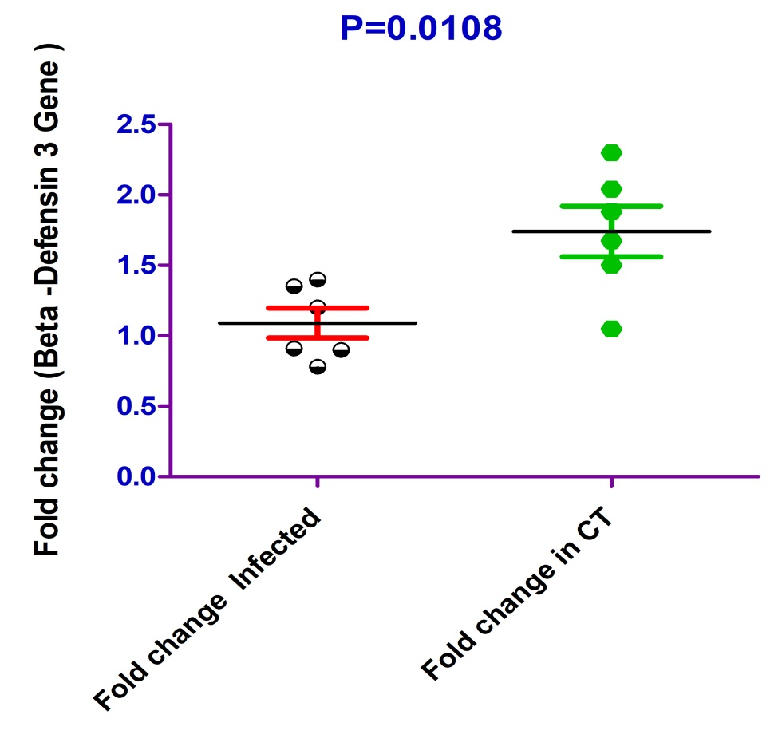

Figure 1:- The graph showing the t test analysis for the β-defensin 3 in infected and non-infected Catla catla fish species

This study extends beyond the immediate responses of Catla catla to bacterial infections; they also sheds light on the pressing issue of water pollution and its consequential effects on fish health. When fish are repeatedly exposed to deleterious bacteria stemming from poor water quality, they are compelled to mount a vigorous immune response (Ganz, 2003). This revelation underscores the urgent need for effective water quality management within ecosystems where these species inhabit. As fish are increasingly subjected to stressors related to pollution, their ability to maintain health and bolster their immune responses becomes paramount.

Table.1: t test analysis for the Beta -Defensin 3 in infected and non- infected Catla catla Fish species

Table Analyzed | Data 1
Column A | Fold change Infected
Vs | Vs
Column B | Fold change in CT
Unpaired t test
P value | 0.0108
P value summary | *
Are means signif. different? (P < 0.05) | Yes
One- or two-tailed P value? | Two-tailed
t, df | t=3.123 df=10
How big is the difference?
Mean ± SEM of column A | 1.090 ± 0.1065 N=6
Mean ± SEM of column B | 1.741 ± 0.1790 N=6
Difference between means | -0.6506 ± 0.2083
95% confidence interval | -1.115 to -0.1865
R squared | 0.4938

A clean and healthy aquatic environment is essential not only for the well-being of Catla catla but also for the wider ecosystem and the sustainability of the aquaculture industry. This research highlights the intricate connection between environmental health and fish resilience, indicating that maintaining water quality is crucial for the survival and prosperity of both wild and farmed fish populations. Sustainable aquaculture practices must focus on creating environments that support the natural immune functions of fish, thereby facilitating their growth and productivity.
The insights derived from our study affirm the significance of β-defensin 3 as a key player in the immune defence of Catla catla. The marked up regulation of this gene in response to bacterial infection illustrates not only the adaptability of these fish but also the critical need for maintaining ecological balance within freshwater habitats. Future research should continue to explore the molecular responses of Catla catla and other fish species to various environmental challenges, further strengthening our understanding of fish immunity and informing effective management practices that support both aquatic biodiversity and aquaculture sustainability.

Conclusion
Our study highlights the significant upregulation of the β-defensin 3 gene in Catla catla following exposure to bacterial infection, underscoring the critical role of this antimicrobial peptide in the fish's innate immune response. These findings emphasise the importance of maintaining healthy aquatic environments to support fish health and resilience, ultimately contributing to sustainable aquaculture practices and the conservation of freshwater biodiversity.

Disclaimer (Artificial intelligence)
Option 1:
Author(s) hereby declare that NO generative AI technologies such as Large Language Models (ChatGPT, COPILOT, etc.) and text-to-image generators have been used during the writing or editing of this manuscript.
Option 2:
Author(s) hereby declare that generative AI technologies such as Large Language Models, etc. have been used during the writing or editing of manuscripts. This explanation will include the name, version, model, and source of the generative AI technology and as well as all input prompts provided to the generative AI technology
Details of the AI usage are given below:
1.
2.
3.
References
- Wang, L., Qin, T., Zhang, Y., Zhang, H., Hu, J., Cheng, L., & Xia, X. (2023). Antimicrobial peptides from fish: Main forces for reducing and substituting antibiotics. Turkish Journal of Fisheries and Aquatic Sciences, 24(1).
- Pulido-Gomez, D. (2014). Expanding the scope of the ribonuclease A super family in the host immune defense system: Structural determinants of human RNases involved in antimicrobial host defense. Universitat Autònoma de Barcelona.
- Edilia Avila, E. (2017). Functions of antimicrobial peptides in vertebrates. Current Protein and Peptide Science, 18(11), 1098-1119.
- Ganz, T. (2003). The role of antimicrobial peptides in innate immunity. Nature Reviews Immunology, 3(10), 710–720.
- Duan, J. R., Fang, D. A., Zhang, M. Y., Liu, K., Zhou, Y. F., Xu, D. P., Xu, P., Aftabuddin, M., & Sharma, A. P. (2014). Nutrition and feeding of Indian major carp—A bibliography. Central Inland Fisheries Research Institute.
- Shan, S., Wang, L., Zhang, F., Zhu, Y., An, L., & Yang, G. (2016). Characterization and expression analysis of Toll interacting protein in common carp Cyprinus carpio L, responding to bacterial and viral challenge. Springer Plus, 5, 639-641.
- Casadei, E., Wang, T., &Zou, J. (2009). Characterization of three novel β-defensin antimicrobial peptides in rainbow trout. Molecular Immunology, 46, 3358-3366.
- Ganz, T. (2003). The role of antimicrobial peptides in innate immunity. Integrative and Comparative Biology, 43, 300–304.
- Rome stand, B., Molina, F., Richard, V., Roch, P., & Granier, C. (2003). Key role of the loop connecting the two beta strands of mussel defensin in its antimicrobial activity. European Journal of Biochemistry, 270, 2805–2813.Balog, K., Bagi, Z., Tóth, B., Hegedűs, B., Fehér, M., Stündl, L., & Kusza, S. (2022). Association study between relative expression levels of eight genes and growth rate in Hungarian common carp (Cyprinus carpio). Saudi Journal of Biological Sciences, 29(1), 630-639.
- Pradhan, P. K., Paria, A., Pande, V., Verma, D. K., Arya, P., Rathore, G., & Sood, N. (2019). Expression of immune genes in Indian major carp, Catla catla challenged with Flavobacterium columnare. Fish & shellfish immunology, 94, 599-606.
- Das, B. K., Roy, S., Kumar, V., Adhikari, A., Ganguly, S., & Bisai, K. (2025). Modulation of immune gene expression profile in Labeo catla with chronic toxicity to emerging endocrine disruptors through a multiorgan approach. Scientific Reports, 15(1), 11244.

