Predicting Shear Strength of Steel Fiber-Reinforced Concrete Beams Using Artificial Neural Networks (ANN)

ABSTRACT
The study presents a highly efficient computational model for estimating the shear strength of steel fiber-reinforced concrete (SFRC) beams using Artificial Neural Networks (ANN). An ANN model was developed using 105 experimental cases compiled from reference studies in this field. The target output was the shear resistance (Vu), while the 11 input parameters included: beam width, beam height, shear span, fiber shape factor, fiber tensile strength, shear span-to-effective depth ratio, fiber volume fraction, longitudinal reinforcement ratio, maximum aggregate size, concrete compressive strength (f'c), and effective depth.
This configuration achieved an exceptional correlation coefficient of R = 0.98306 and This methodological advancement represents a significant departure from prior reference studies, which relied exclusively on empirical and statistical models accounting only for fundamental variables such as Primary beam dimensions, Shear span characteristics, Specified concrete compressive strength (f'c), Properties of embedded steel fibers, Gradation characteristics of coarse aggregates within the concrete mixture matrix.

Keywords: Steel fibers, Regression analysis, Artificial neural network, Shear Strength, Concrete Beams.

Introduction
Our analysis of reference studies reveals that research efforts have developed semi-empirical equations to calculate shear resistance in concrete beams, yet these suffer from computational complexities and reliance on restrictive experimental conditions. International codes have predominantly considered concrete compressive strength as the basis for estimating other mechanical properties – properties that must be empirically verified from the actual concrete mix. However, these approaches fail to account for potential variations in failure modes or fracture mechanics of tested specimens due to influential factors, particularly:
- Interlocking of aggregates and their size distribution
- Characteristics of added steel fibers (where applicable)
With advancements in artificial intelligence, Artificial Neural Networks (ANN) have emerged as a viable methodology to address these challenges. Our research operates within this paradigm to develop a computational model for predicting shear strength with sufficient accuracy, leveraging ANN's capacity to process complex datasets.
The significance of this work lies in its pursuit to computationally extrapolate shear resistance of steel fiber-reinforced concrete (SFRC) mixtures through rapid, precise digital means – replacing traditional calculation and experimental methods. Our model explicitly incorporates:
- Compositional characteristics of concrete constituents
- Fiber reinforcement properties
- Aggregate interaction effects
to achieve the precision required for designing fiber-reinforced beams. This approach carries important implications for:
- Developing updated structural codes
- Ensuring safety compliance
- Enabling cost-optimized structural designs
particularly given the global shift toward AI-driven solutions in civil engineering, where our ANN model achieved R = 0.98306 correlation in validation studies
"This research aims to develop an artificial neural network (ANN) model for predicting the shear strength of steel fiber-reinforced concrete (SFRC) beams by utilizing experimental data compiled from reference studies of prior research. The data is employed to train and validate the model, with shear resistance serving as the target output. Within this framework, researcher Hadi conducted a study discussing ANN applications in structural engineering, particularly in design based on implementation results. The study demonstrated that artificial neural networks are highly suitable for this field due to their result accuracy, user-friendliness, implementation simplicity, and high flexibility in handling diverse problems [1].
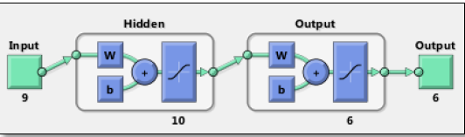
Figure (1) The Artificial Neural Network (ANN) Model [5]
The study concluded that the selected Artificial Neural Network (ANN) model demonstrated highly accurate prediction of ultimate shear stress through the input parameters considered, when compared with experimental results and international design codes [5].
Researcher Andres Winston C. Oreta et al. conducted a study applying Artificial Neural Networks to simulate the size effect on shear strength in concrete beams without transverse reinforcement. They created an ANN model using /155/ cases of reinforced concrete beams collected from previous studies. The model was structured using five input parameters: characteristic concrete compressive strength, beam width, effective depth, shear span-to-effective depth ratio, and longitudinal reinforcement ratio, as shown in Figure (2).
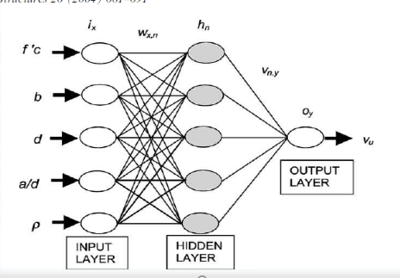
Figure (2) Artificial Neural Network (ANN) Model [4]
The study demonstrated that the model provides good predictive results compared to numerical and theoretical results, as well as design equations in international codes. It successfully simulates the size effect on ultimate shear stress at diagonal tension failure [4].
Methodology:
- ANN Model Development:
An artificial neural network (ANN) model was constructed using 105 experimental cases compiled from reference studies in this field. The target output variable was the ultimate shear resistance (Vu), with 11 input parameters:
  - Beam width (b)
  - Beam height (h)
  - Shear span (a)
  - Fiber shape factor
  - Tensile strength of steel fibers
  - Shear span-to-effective depth ratio (a/d)
  - Fiber volume fraction (Vf)
  - Longitudinal reinforcement ratio (ρ)
  - Maximum aggregate size (dₐ)
  - Characteristic concrete compressive strength (f'c)
  - Effective depth (d)
MATLAB's Neural Fitting Tool (NFTOOL) was employed to build the mathematical model and determine optimal network specifications through iterative trials. The finalized architecture consisted of:
  - Input layer: 11 neurons
  - Single feedforward hidden layer: 18 neurons
  - Output layer: 1 neuron
achieving a correlation coefficient of R = 0.98306.
- Network Training and Validation:
Following the network construction through multiple optimization trials, training was conducted using NFTOOL's approximation and fitting functions. The training error was quantified by Mean Squared Error (MSE). For each network architecture, comprehensive training, validation, and testing procedures were implemented.
Table (1) details the network development process in MATLAB using a trial-and-error approach, presenting correlation coefficients (R) for all phases:
  - Training phase
  - Validation phase
  - Testing phase
The standard dataset partitioning (70% training, 15% validation, 15% testing) was maintained without modification, as it yielded optimal results.
Table (1): Network Training Results
Neurons | R Training | R Validation | R Test | Overall R | Cause of Stop
1 | 0.93745 | 0.89373 | 0.92648 | 0.93242 | Validation Stop
5 | 0.97598 | 0.96637 | 0.95415 | 0.96522 | Validation Stop
7 | 0.99028 | 0.9639 | 0.9442 | 0.97298 | Validation Stop
9 | 0.99264 | 0.96514 | 0.9691 | 0.98222 | Validation Stop
10 | 0.99141 | 0.95133 | 0.96791 | 0.98168 | Validation Stop
12 | 0.99182 | 0.92692 | 0.96435 | 0.95493 | Validation Stop
15 | 0.99265 | 0.93695 | 0.98592 | 0.98235 | Minimum gradiant reached
18 | 0.99002 | 0.98914 | 0.96006 | 0.98306 | Validation Stop
22 | 0.98273 | 0.94531 | 0.95809 | 0.96977 | Minimum gradiant reached
25 | 0.99394 | 0.96533 | 0.94164 | 0.95882 | Validation Stop
30 | 0.99126 | 0.97459 | 0.9256 | 0.97068 | Minimum gradiant reached
"Based on the training results shown in the previous table, it was observed that the final optimal neural network yields the highest values for the correlation coefficient R with an acceptable minimal error. This network has an architecture comprising:
- 11 units in the input layer,
- One hidden layer containing 18 neurons,
- One output layer.
According to NFTOOL, the activation function for the hidden layer is the hyperbolic tangent sigmoid function (TANSIG), while the activation function for the output layer is the pure linear function (PURELIN), as illustrated in Figure (3)."
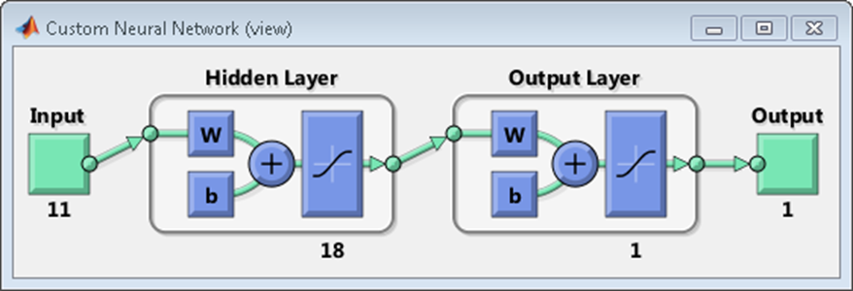
Figure (3): Representation of the Neural Network
Figure (4) shows the training results of the designed and trained neural network. It illustrates the correlation coefficient R between the actual shear strength values in steel fiber-reinforced concrete beams and the predicted values generated by the network: 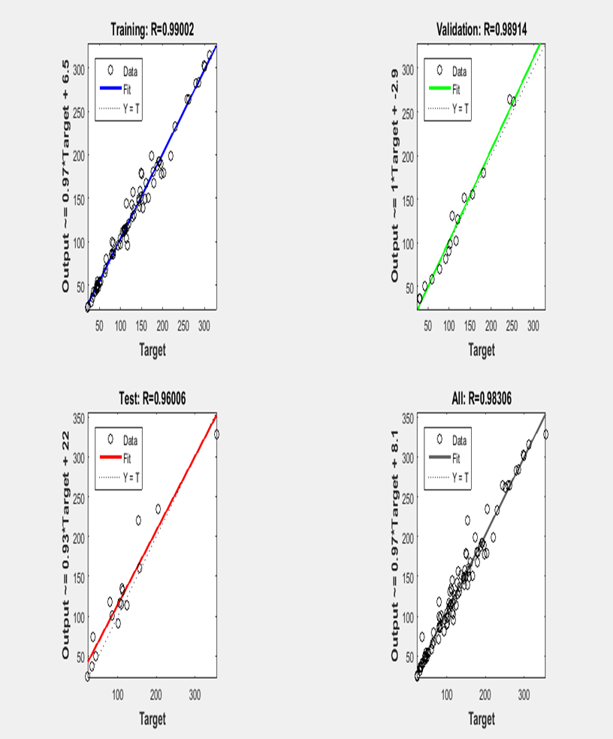
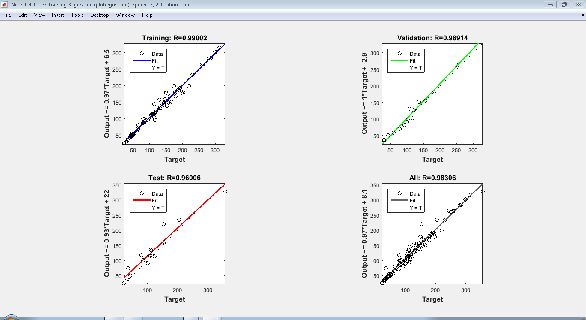
Figure (4): Neural Network Training Results
Where:
- X-axis: Actual Outputs (True Values)
- Y-axis: Predicted Outputs (Network-Generated Values)
- O: Input Data Points
- FIT: Convergence Curve
- R: Correlation Coefficient
- Dotted Line: Ideal/Best-Fit Line
To assess the strength of the relationship, note the correlation coefficient values:
- Training Phase: R = 0.99002
- Validation Phase: R = 0.98914
- Testing Phase: R = 0.96006
These values are excellent and very close to 1, indicating a strong correlation (closer to 1 signifies a stronger relationship).
Figure (5) shows the neural network’s performance. The lowest Mean Squared Error (MSE) was 119.2382 at 6 iterations, which is considered acceptable relative to the actual shear strength values of the input steel fiber-reinforced concrete beams
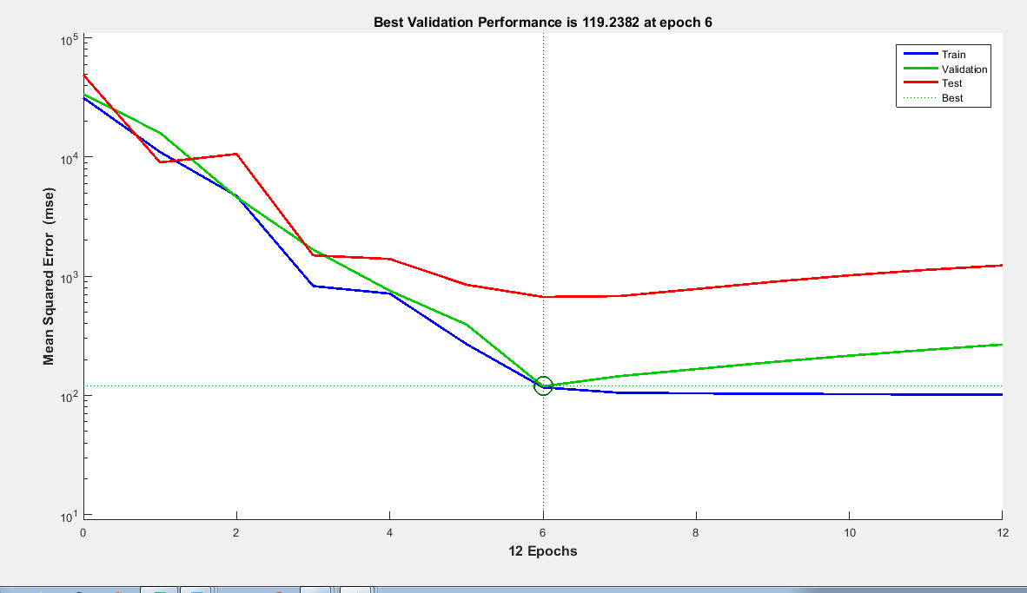
Figure (5): Neural Network Performance
Figure (6) shows that the error function gradient (Gradient) = 74.5174 at Epoch = 12. The initial value of the µ parameter (mu), which updates the weights based on error changes, was MU = 1. The bottom value indicates the number of effective parameters (weights and biases) involved in network training: Validation Checks = 6.
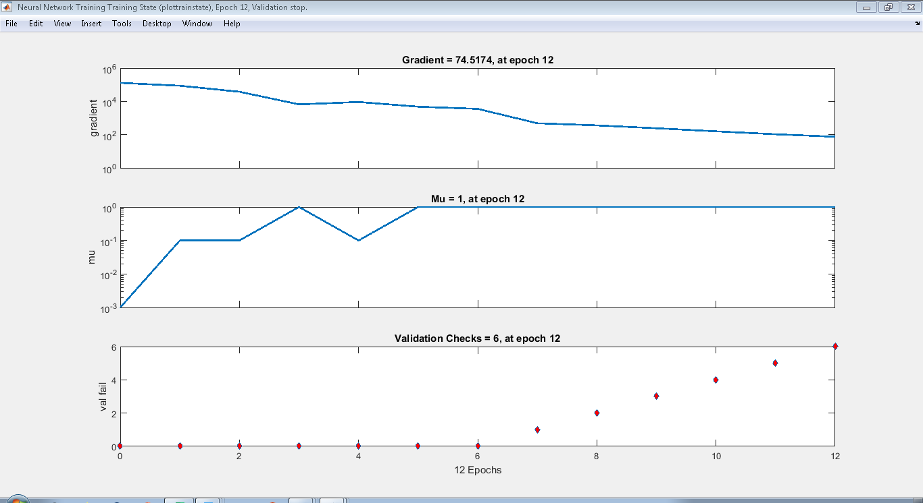
Figure (6): Number of Effective Parameters
Results of testing the designed and trained neural network for the research objective:
The network was supplied with a set of new, previously unseen input cases (15 verification cases). The network generated predictions, enabling a comparison between the network-calculated output values and the actual output values (true shear strength values of these beams) collected from published research, as shown in Table (2) below:
م | Bw | h | d | L span | p | a/d | da | f′c | Vf % | Lf/df | Ften
1 | 85 | 150 | 130 | 1160 | 0.0205 | 3.02 | 9.6 | 30.6 | 0.5 | 133 | 2000
2 | 152 | 455 | 381 | 2136 | 0.0196 | 3.44 | 10 | 38.1 | 1 | 55 | 1100
3 | 152 | 455 | 381 | 2136 | 0.0263 | 3.44 | 10 | 49.2 | 1 | 80 | 1100
4 | 205 | 685 | 610 | 3558 | 0.0152 | 3.5 | 10 | 29.6 | 0.75 | 80 | 1100
5 | 152 | 254 | 221 | 2100 | 0.0239 | 2.5 | 10 | 34 | 0.5 | 60 | 1130
6 | 152 | 254 | 221 | 2100 | 0.0239 | 3.5 | 10 | 34 | 0.5 | 60 | 1130
7 | 150 | 225 | 197 | 1603.2 | 0.0136 | 2.8 | 20 | 29.1 | 0.5 | 60 | 1260
8 | 300 | 700 | 570 | 5000 | 0.0287 | 2.98 | 18 | 60.2 | 0.75 | 86 | 2200
9 | 140 | 375 | 340 | 1910 | 0.0167 | 2.5 | 19 | 36 | 1 | 60 | 1100
10 | 120 | 200 | 167.5 | 720 | 0.0132 | 1.43 | 13 | 23.9 | 1.5 | 60 | 1100
11 | 200 | 300 | 260 | 1800 | 0.0355 | 3.46 | 14 | 46.4 | 0.25 | 65 | 1100
12 | 200 | 300 | 260 | 1800 | 0.0355 | 3.46 | 14 | 43.2 | 0.5 | 65 | 1100
13 | 152.4 | 304.8 | 282.6 | 1524 | 0.0199 | 2.5 | 9.6 | 33.2 | 1 | 100 | 1100
14 | 125 | 250 | 222 | 1200 | 0.0145 | 1.8 | 10 | 30 | 0.5 | 80 | 1225
15 | 120 | 300 | 266 | 1100 | 0.0126 | 1.13 | 20 | 31.9 | 0.6 | 50 | 834
Table (2): Input Values from Laboratory Experiments in Published Literature
Where:
- Bw: Beam width (mm)
- h: Beam height (mm)
- d: Effective depth (mm)
- L span: Beam span (mm)
- ρ: Longitudinal reinforcement ratio (%)
- a/d: Shear span-to-effective depth ratio
- dmax: Maximum aggregate size (mm)
- f'c: Characteristic concrete strength (MPa)
- Vf: Fiber volume fraction (%)
- Lf/ d f: Fiber shape factor
- Ften: Fiber tensile stress (MPa)
After testing and verifying the results in Table (3), the error percentage between actual and predicted values ranged between [0.667% – 1.139%]. These values indicate acceptably small errors, with the maximum relative error not exceeding 5% (in Experiment 1). This prediction error margin is remarkably small relative to shear strength magnitudes.

Table (3): Network Test Results with New Inputs
Project Number | True Value | Calculated Value | Absolute Error | Relative Error %
1 | 22 | 23.13995 | 1.139951 | 5%
2 | 174 | 171.3338 | 2.666224 | 2%
3 | 220 | 225.2934 | 5.293442 | 2%
4 | 228 | 220.8137 | 7.186261 | 3%
5 | 65 | 65.66746 | 0.667457 | 1%
6 | 50 | 50.94313 | 0.943132 | 2%
7 | 53 | 51.5004 | 1.4996 | 3%
8 | 522 | 510.2391 | 11.76088 | 2%
9 | 155 | 149.0939 | 5.906148 | 4%
10 | 85 | 81.58872 | 3.41128 | 4%
11 | 111 | 113.9154 | 2.915394 | 3%
12 | 121 | 124.1903 | 3.190339 | 3%
13 | 146 | 147.5876 | 1.587604 | 1%
14 | 79 | 80.0195 | 1.019498 | 1%
15 | 146 | 147.0814 | 1.081355 | 1%

Figure (7) shows the test sample results during the verification phase, displaying both the true shear strength and the neural network-predicted shear strength for each case."

Figure (7): Comparison of Neural Network-Predicted Shear Strength vs. True Shear Strength
The relative error between the true shear strength and the neural network-predicted shear strength was calculated for each test sample using the formula:
(Predicted Shear Strength – True Shear Strength) / True Shear Strength
The maximum percentage error reached 5%, as shown in Figure (8) below:


Figure (8): Error Percentage in Estimating the Shear Strength Under Study
Conclusions and Recommendations:
It is concluded that the developed model can predict shear strength with acceptable accuracy, achieving a correlation coefficient (R) of 0.99 during training and 0.960 during testing. The relative error ranged between 1% to 5%. It is recommended to apply these results to verify the design of steel fiber-reinforced concrete beams. Increasing the training sample size will improve the model's performance.

Disclaimer (Artificial intelligence)
Author(s) hereby declared that no generative AI technologies such as Large Language Models (ChatGPT, COPILOT, etc.) or text-to-image generators have been used during the writing or editing of this manuscript.

References
[1]. An-Najjar H.M., " Prediction of Ultimate Shear Strength of Reinforced Concrete Deep Beams Using Artificial Neural Networks", M.Sc. Thesis, Department of Civil / StructuralEngineering, Islamic University, Gaza, 2005.
[2] Tully S.H., "A Neural Network Approach for Predicting the Structural Behavior of
Concrete Slabs", M.Sc. Thesis, Faculty of Engineering and Applied Science, University
of Newfoundland, Canada, 1997.
[3] Nandy S., "Assessing External Reinforcement on Reinforced Concrete Beams Using
Neural Networks", M.Sc. Thesis, Department of Civil Engineering, University of
Florida, 2001.
[4] Oreta A.W. C., "Simulating Size Effect on Shear Strength of R.C. Beams Without
Stirrups Using Neural Networks", Engineering Structures, Vol. 26, 2004, pp. 681-691.
[5]. Mansour M. Y., Dicleli M., Lee J.Y., and Zhang J., "Predicting the Shear Strength ofReinforced Concrete Beams using Artificial Neural Networks", Engineering StructuresVol. 26, 2004, pp. 781-799.
[6] Yousif S. T., "Artificial Neural Networks Modeling of Elasto_Plastic Plates", Ph.D.
Thesis, Department of Civil Engineering, University of Mosul, Iraq, 2007.
[7] Yousif, S. T. and Abdullah, S. “Artificial neural networks model for predicting
compressive strength of concrete.", Tikrit Journal of Eng. Sciences, Vol.16, No.3,
September 2009, pp.55 - 63.

[8] Kavya, B. R., Shrikanth, A. S., & Sreekeshava, K. S. (2025). Optimized artificial neural network model for shear capacity estimation in steel fiber-reinforced concrete beams. Journal of Building Engineering, *78*, 107532.

[9] Suganya, R., Gowsalyaa, R., & Theenathayalan, R. (2022). Machine learning approaches for shear behavior analysis of fiber-reinforced concrete structural elements. Structures, *44*, 1643–1656.

[10] Nezaminia, H. (2024). Advanced predictive modeling of shear strength in SFRC beams using hybrid ANN-GA algorithms. Engineering Structures, *308*, 117891.

