Original Research Article

ADAPTATION STRATEGIES FOR CLIMATE-RESILIENT HOUSING IN AYETORO COASTAL COMMUNITY, ONDO STATE, NIGERIA: AN EMPIRICAL STUDY

ABSTRACT:
Aims: This study examines the various strategies employed by residents of Ayetoro to mitigate the effects of climate change on their residential buildings. It also assesses the effectiveness of these strategies and proposes practical, culturally appropriate frameworks to enhance housing resilience within the community.
Coastal communities in Nigeria are increasingly vulnerable to the effects of climate change, with serious consequences for housing quality, safety, and livelihoods. Ayetoro, a small coastal settlement in Ondo State, has experienced frequent climate-related hazards over the past decade, prompting residents to adopt various coping and adaptation measures to protect their homes and way of life.
Study design: The study employed a mixed-methods, cross-sectional, and inferential design. The non-response rate was 7.1%, and this research achieved a 92.9% success rate. However, the analyses were conducted using counts, simple percentages, bar charts, pie charts, funnel charts, cross-tabulations, t-tests, Analysis of variance, chi-square tests, relative risk, and relative effectiveness indices, employing two statistical tools: Statistical Package for the Social Sciences (SPSS) and Microsoft Excel. The results show that residents have adopted a variety of adaptation strategies, such as elevating house foundations, reinforcing roofs, relocating homes, using locally available resilient materials, and organising community-led flood control initiatives. While these measures have offered some protection, their long-term effectiveness is hindered by limited financial resources, technical challenges, and weak institutional support.
Methodology: The study data was gathered using a pre-tested, self-administered questionnaire, sectioned into three different parts. The 27 instruments of the questionnaire had a Cronbach’s Alpha Coefficient of 0.878. Therefore, with a projected population of 33,173 and using the sample size calculator, a sample size of 379 is required to achieve a 95% confidence level and a 5% margin of error. The following hypotheses were tested: 1. There is no significant difference in climate-related impacts, such as increased indoor temperatures, across building foundations in Ayetoro from 2012 to 2022. 2. There is no significant difference in vulnerability to permanent flooding across building locations (dry land vs. swampy land) in Ayetoro from 2012 to 2022. 3. There is no significant difference in vulnerability to climate-related impacts, such as soil erosion due to increased rainfall, across different building ages in Ayetoro from 2012 to 2022.
Result: The results show that residents have adopted a variety of adaptation strategies, such as elevating house foundations, reinforcing roofs, relocating homes, using locally available resilient materials, and organising community-led flood control initiatives. While these measures have offered some protection, their long-term effectiveness is hindered by limited financial resources, technical challenges, and weak institutional support.
Conclusion: The study emphasises the significance of indigenous adaptation practices in mitigating climate risks. Still, it underscores the need for a more coordinated and well-supported framework to improve housing resilience in Ayetoro. It recommends a community-driven approach that integrates local knowledge with modern housing solutions, effective land-use planning, and stronger policy backing.

Keywords: Climate change adaptation, housing resilience, Coastal communities, Ayetoro, Climate hazards
1. INTRODUCTION
Climate change has posed significant obstacles in the last few decades from the perspectives of the physical, social, economic, and psychological spheres. The intensity of heavy rains, the frequency of cold days and frosts, the frequency of hot days, and the length of heatwaves, as well as an increase in the global average temperature, are some of these challenges (Intergovernmental Panel on Climate Change, 2023). These days, we must contend with retreating glaciers, shifting river flows, and changing ecosystems on a daily basis (Adger et al., 2014). These extreme weather events have a significant impact on the quality of life for households in both urban and rural regions.
Understanding the housing strategies used is necessary if policies and initiatives in the riverine Ilaje area are to be implemented. To improve the housing situation in the riverine area, the study will help both public and private housing cooperatives (oil firms). Additionally, it will aid in the reconstruction of the catastrophe zone, which has been severely affected by sea erosion, and facilitate the resettlement of the war-torn Ilaje Ward for both public and private oil companies. According to the IPCC (2023), a shift in climate refers to a sustained alteration of an area's usual meteorological conditions, including average temperature, precipitation, and frequency of windstorms. Global warming is primarily caused by an increase in greenhouse gas emissions, which include nitrous oxide, carbon dioxide, and methane. These gases trap heat in the Earth's atmosphere. This suggests that over the next few decades, the range of conditions anticipated in many areas is expected to vary. In a similar vein, the United States Environmental Protection Agency (EPA) (2017) claims that any significant changes to the climate will be held back by climate change for an extended period. In other words, climate change refers to significant, long-term changes in temperature, precipitation, and wind patterns, among other effects. According to the United States Global Research Program (USGCRP) (2014), the average global temperature has increased by 1.5°F during the previous century. It is expected to grow by an additional 0.5°F to 8.6°F over the next few centuries. Ultimately, this will lead to significant and potentially catastrophic changes in the climate and weather patterns. According to National Geographic (2019), the oceans have mitigated the effects of human-caused greenhouse gas emissions in the atmosphere by absorbing more than 90% of the heat. Additionally, the oceans are being overheated as a result of this process. Global warming or climate change has caused sea level rise (SLR) of nearly 23 cm since 1880, with an average of 7.5 cm gained in the last 25 years.
The coastal environment of Ilaje is dynamic and distinct, allowing for constant change. Along the continental borders, tides, waves, and erosion characteristics are shaped by the interaction of land, water, and the atmosphere. Building techniques vary from culture to culture and place to place. Due to the low-lying terrain, frequent annual flooding, and environmental and topographical conditions, Ayetoro's housing strategies have evolved over time. It is shown that variations in temperature, windstorm frequency, sea level rise (SLR), and rainfall patterns have a significant impact on the environment. In the Ayetoro community, biodiversity, structures, and ecosystems are negatively impacted (Oladeji 2022; NDDC, 2014; Raimi et al., 2021). Road buckling, mud splash coverage, drainage and culvert destruction, building and jetty collapse, ecosystem destruction without a portable water supply, electrification, waste and effluent disposal systems, transportation, and other infrastructural facilities are the resultant effects of climate change in this community. The extent to which the ongoing devastation brought about by the impact of climate change and the intervention tactics utilised by stakeholders to address the dire situation in the coastal village of Ayetoro are still subjects of investigation. There is a paucity of research on housing options in the Ayetoro community; however, there is a wealth of research on the causes and impacts of extreme weather events, along with various adaptation tactics in the coastal area. According to Akpan (2024), the majority of research on the effects of climate change on housing and the environment in coastal areas has focused on the impact of persistent gas flares (anthropogenic and overheating), oil spills, industrialisation that causes SLR, flooding, and windstorms that negatively affect the environment, ecosystems, and most buildings. In the coastal region of the Ayetoro community, it is evident that there are no records of professional services, housing approvals from relevant authorities, or coordinated housing adaptation strategies in place before construction, which can withstand the effects of climate change. This study aims to close this gap. As a result, this study evaluates the buildings currently in use in the Ayetoro coastal community, regardless of their completion status, to determine their susceptibility and ultimately help establish building adaptation methods for the study region. To improve the housing situation in the riverine area, the study will help both public and private housing cooperatives (oil firms).
Additionally, it will aid in the reconstruction of the catastrophe zone, including communities swept away by sea erosion, and facilitate the resettlement of the war-torn Ilaje Ward for both public and private oil businesses. The Ayetoro hamlet in Nigeria's Ondo State, specifically in the Ilaje Local Government Area, served as the study site. This study focuses on floods, windstorms, and sea level rise (SLR), among all the meteorological events related to climate change. There is an urgent need for effective adaptation techniques due to the devastating effects of extreme weather events on dwellings, ecosystems, and the environment in coastal areas. Fortification of structures is one strategy that can be very helpful in mitigating these effects. This concept illustrates the domains and connections of interest that Conner bridges, explaining a research framework in a graphic or narrative form.
Climate impact assessment paves way for the timely identification of multi-stakeholder infrastructure resilience, as demonstrated in the literature review, which shows that the continuous impact of extreme weather events on houses in the Ayetoro community is partly due to factors such as constant SLR, flooding, windstorm, poverty, information, low awareness, policy criteria, and low government responses (Adger et al., 2014). that highlights the key elements (causes and effects) with particular attention to the research project (building adaptation to the impacts of climate change) through increased local technology and building material awareness, construction technologies, and the selection of these structural materials. Depending on regional factors like the kind of building impacts that could be disrupted by climate change, the community's current environmental status, the degree of socioeconomic development, including public infrastructure, the availability of data, technical know-how, and financial resources, as well as cultural preferences, the best option for this framework will differ depending on assessments. At this level of the hierarchy, housing adaptation can save the entire community and will involve a range of strategies, such as incorporating climate change adaptation into or near infrastructure and the surrounding environment. This is consistent with reports by Biessbroek et al., (2010) and Makino (2017), which found that employing interdisciplinary approaches set to integrate expert and academic viewpoints in assessing climate change effects through an appropriate and applicable framework through proper information and awareness of the current situation, policy formulation, planning/design, implementation by using appropriate coastal friendly construction materials and adequate supervision, ensures appropriate choices for flexibility that will bring about a favourable and sustainable home development as well as a sustainable environment in the coastal area. To mitigate the impact of climate change on housing quality, adaptation and mitigation techniques must be implemented. Using climate-resilient building materials, enhancing building rules and regulations, and incorporating sustainable design principles are a few examples of these tactics.
Additionally, raising awareness and promoting resilient housing methods can be significantly enhanced by community involvement and education. Here, the term "conceptual framework" refers to the expression of ideas that support the creation of policies, designs, and other initiatives aimed at mitigating the environmental and building impacts of climate change adaptation. The framework is used to differentiate between necessary and desired research interests, as well as regulatory angles and essential research interests. It begins with awareness and progresses through design criteria, strategy implementation, and monitoring to ensure that strategies align with policy standards for projects involving coastal development. It can be used to address mitigation, adaptation, or responses to sudden or unexpected situations.
Ayetoro, a community in the Ilaje Local Government Area of Ondo State, according to Akpan et al., (2024), has a climate model that includes two peak rainy seasons, accompanied by short and long dry seasons. The rainy season runs from March to mid-July and from late August to mid-November. The short dry season runs from mid-July to early August, while the long dry season runs from late November to March. The year-round temperature ranges from 21 to 33°c while humidity is relatively high. Annual rainfall ranges from 2,000 mm in the southern regions to 1,150 mm in the northern areas increase annual meteorological data for Ondo State, Nigeria for 10 years (2012 to 2022) using monthly data from the Nigeria Meteorological Agency (NIMET) and WASCAL under the Bureau of Meteorology and Climate science and Technology, (FUTA) Akure uses the TAMSAT Platform which displays a descriptive analysis of precipitation, temperature and relative humidity.
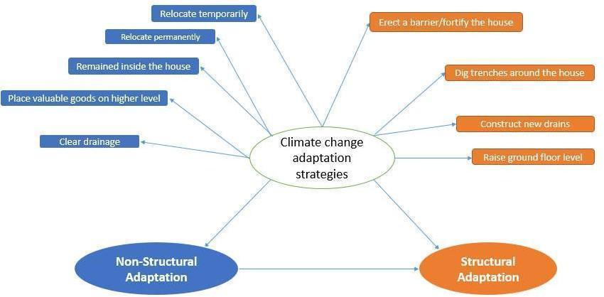
Figure 1: Schematic Representation of the Climate Change Adaptation Model
Source: Researchers' work, 2024
1.1. Empirical Review of Literature
- Climate change elements that impact housing infrastructure
The IPCC (2023) establishes that altered patterns of extreme climatic events – including temperature extremes, precipitation variability, floods, and storms, directly compromise roads, bridges, and critical infrastructure through thermal stress, material degradation, and hydraulic loading.
- Examine the effects of climate change elements on the housing characteristics.
Aydin et al., (2022) assessed the hydrochemistry and anthropogenic pollutants in water, sediment and representative fish samples of Ayetoro coastal waters. Thirteen sampling stations (including two groundwater stations and three control stations) were selected to determine the concentrations and spatial distributions of hydrochemical characteristics and heavy metal concentrations. Revealed that sea-level rise, land degradation, flooding and human-induced anthropogenic activities have negatively impacted the Ayetoro community
Wilson et al., (2018) aimed to contribute to the global efforts to enhance flood resilience in urban areas by introducing a physical vulnerability index for buildings in flood-prone urban regions and exploring its connection with flood hazard, as defined by the European Union Directive 2007/60/EC. An index-based methodology is proposed to assess the physical vulnerability of buildings to flooding, utilising the Portuguese Census and Georeferenced Buildings Database, collected on a nationwide scale. The physical vulnerability of buildings is evaluated in the context of the Lisbon Metropolitan Area (LMA) in Portugal, and the results are compared across different scales, contrasting flood hazard information for the entire LMA with that of areas identified under the Flood Directive as having significant flood risk potential. Using cluster analysis, spatial patterns of flood risk are identified, highlighting areas where high flood depths and flood velocities overlap with high vulnerability of buildings. Variations in flood depth and velocity along the floodplains express different degrees of loss to buildings.
IPCC (2023) synthesises the scientific literature through a metadata analysis within the scope of US coastal infrastructure system risk due to climate change-induced recurrent flooding in seven key coastal infrastructure systems across different coastal regions, namely, New England, the Mid-Atlantic, the Southeast and Gulf, and the West Coast. The review found that SLR and storm surge-induced coastal flooding are increasingly impacting critical coastal infrastructure systems across all coastal regions in the US.
Abbade (2020) analysed mortgages, apartment values, and residential land sale prices over 16 years for different localities across Jamaica. For rainfall data, the Global Precipitation Measurement (GPM) satellite mission database, which provides half-hourly observations at a 0.1° resolution, was utilised, with high-resolution rainfall averages measured in millimetres (mm). Excess rainfall was identified when the daily rainfall exceeded the 90th percentile of a grid’s non-zero values throughout the study.
The analysis revealed that mortgages are adversely affected by excess rainfall, while apartment sale prices are reduced by hurricanes but increased by excess rain. However, residential land prices remain unaffected by both events.
Yin et al., (2021) examined ﬂooding scenarios in Shanghai. This indicates which buildings (including residential, commercial, office, and industrial) will be exposed to flooding and their associated damage. The extreme compound ﬂood scenarios (1/200-, 1/500-, 1/1000-, and 1/5000-year ﬂoods) and building metadata were aggregated using a risk analysis chain. The results showed that the inundation area is significantly larger in the low-probability, high-impact ﬂood scenarios. In all four considered scenarios, areas near the Huangpu River and along the coastal regions are consistently affected by building damage. The central downtown areas of Shanghai have a high risk of being exposed to and affected by extreme floods, partly due to their high density of buildings.
- Adaptation strategies adopted by the residents of coastal communities to mitigate the impacts of climate change on their residential buildings
Sharma et al., (2020) conducted a study to examine the potential of bamboo as a building material in organically shaped buildings. The study revealed that using bamboo can mitigate the impact of flooding. Bamboo has a powerful fibre that makes it a suitable building material. Bamboo has double the compressive strength of concrete and a tensile strength comparable to steel. Bamboo fibre has a higher shear stress than wood. Bamboo has a longer lifespan than wood. Bamboo may also be bent without breaking. Bamboo is regarded as one of the strongest building materials, with tensile strengths greater than and less than 28,000 N per square inch, as opposed to steel, which has a tensile strength of 23,000 N per square inch.
Akpan et al., (2024) gathered adaptation strategies for reducing or mitigating the impact of rising sea levels (RSLs) on Nigerian coastal communities, thereby encouraging the continuation of agricultural activities. A comprehensive review of the literature was conducted on similar subject matter, based on previous studies carried out by researchers worldwide. The study further presents a wide range of different and well-defined native adaptation strategies utilised by the affected coastal communities to combat the impact of the RSLs. These strategies included wetland protection and restoration, as well as coastal engineering solutions.
The IPCC (2023) emphasises the significance of stakeholder engagement in climate change adaptation within the context of coastal resilience. Academics, particularly those involved in environmental research, are more likely to prioritise environmentally friendly approaches, while others lean towards strategies for economic efficiency. Those involved in local authorities and academia tended to rate community engagement, flood-proofing, and insurance measures higher than proactive risk reduction strategies.
Singh et al., (2021) identify and analyse key Community-Based Adaptation (CBA) strategies implemented in coastal areas to assess their effectiveness in reducing vulnerability and increasing resilience, and to explore the role of local knowledge, resources, and governance in developing a successful change strategy. The results show significant improvements in several key areas. Income increased by 25%, and 35% of households adopted climate-resilient lifestyles. Economic losses from disasters were reduced by 45%, and key infrastructure was strengthened by 80% against climate risk. The study found a 28% reduction in climate-related diseases, a 90% increase in water quality, and the restoration of 600 hectares of biodiversity, resulting in a net gain of biodiversity above 20%. Additionally, 75% of the community actively participated in decision-making, and 65% of the reform projects incorporated traditional knowledge. These findings suggest that CBA strategies not only effectively reduce the immediate risks of climate change but also build long-term resilience by empowering communities to lead the adaptation process.
Satta et al., (2020) provide a comprehensive account of predicted climate impacts and corresponding adaptation measures for three key sectors of the coastal economy in the Puglia region, the easternmost part of the Italian peninsula. The analysis conducted in this study focuses on the sectors of aquaculture, coastal tourism, and coastal erosion along the Apulian Adriatic coast. The study suggested that Climate change-induced alterations in ecosystems, production cycles, infrastructure, and the physiology of organisms produced or harvested from nature will have profound consequences for Apulian aquaculture, leading to rising water temperatures and potential decreases in summer.
Codjoe et al., (2020) explored the multifaceted effects of climate change on seafront communities in Ghana, revealing a cascade of challenges that span livelihood disruptions, environmental degradation, health issues, social disruptions, and species extinction, through interviews and eight focus group discussions. The study highlights adaptation strategies adopted by communities, including agricultural diversification, relocation, housing adaptation, flood management, and marine safety practices, as indispensable in mitigating climate adversities and fortifying the resilience of Ghana’s coastal communities. Yet, such efforts cannot stand alone; concerted efforts at local, national, and global levels are imperative to safeguard the future of Ghana’s coastal communities and, indeed, those worldwide.
- Literature Gap
While longitudinal studies, such as those by Raimi et al., (2021) (a 15-year Pacific analysis), exist, there is a dearth of studies that focus on climate change elements impacting housing infrastructure, and most existing studies are cross-sectional. Similarly, the majority of studies reviewed were conducted in other countries, such as Ghana (IPCC, 2023), Italy Satta et al., 2020), Shanghai (Singh et al., 2021), and the United States. Unegbu et al., (2024) and Akpan et al., (2024) have only limited studies focused on Nigeria, such as those by Akpan et al., (2024) and Aydin et al., (2022). The study, therefore, assesses the impact of climate change on housing quality in Ayetoro Coastal Community, with a focus on identifying adaptation strategies to enhance housing resilience between 2012 and 2022.
3. MATERIAL AND METHODS
3.1. The Study Area
The Ayetoro community in llaje Local Government (ILG) area of Ondo state, Nigeria (Figure 1), lies on latitude 6°13.785 N and longitude 4 °38.975' E, it is situated at about 160 km East of Lagos and separated from the mainland by about 40 km of swampy terrain inhabited by Ilaje people. The Ilaje people are a Yoruba ethnic group in Nigeria, residing in the coastal region of the southern senatorial district of Ondo State. Ayetoro and other communities along the Atlantic Ocean in Ondo State, Nigeria, have been incorporated into a local government, known as Ilaje Local Government Area (ILGA), with its headquarters located in Igbokoda, Ondo State, Nigeria (Figure 2). It hosts most of the oil-prospecting companies and their wells in the state. This community is located in the Ugbo kingdom but remained autonomous due to its theocratic status. The Ayetoro community was selected because of its high degree of vulnerability to the damaging effects of extreme weather events like SLR/flooding and windstorms on the environment and buildings, which could be appropriately contained. Additionally, the community was chosen because of the immediate sea incursion that has encroached into it by more than 900 meters, severely damaging the infrastructure and buildings, and requiring corrective intervention strategies without displacing the locals. Until recently, the only ways to travel from Ayetoro to other settlements were via river or ocean, as there was no road connection. The majority of the neighbourhood is vulnerable to periodic flooding due to the marshy surroundings. Closeness to the low-lying environment and the Atlantic Ocean. The Ayetoro village has no fenced-in buildings (Jiboye et al., 2020).
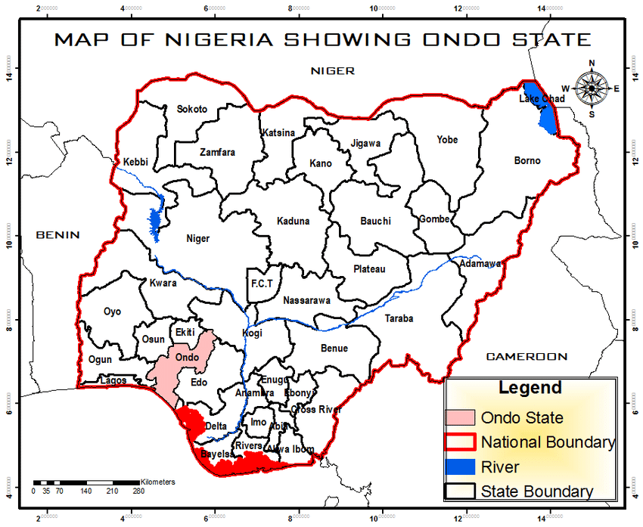
Figure 2: Map of Nigeria showing Ondo State in the National Setting
Source: Ondo State Ministry of Works and Housing (2023).
3.2. Research Design
A mixed-methods approach, comprising quantitative (questionnaire survey) and qualitative (interviews and direct observations), was employed in the study. A mixed-methods approach enables an investigation that addresses more complex research questions, collecting complementary data that allows researchers to gain a deeper contextual understanding of the phenomenon being researched. The study was also a cross-sectional study, conducted in partial fulfilment of a PhD program. Cross-sectional studies are conducted over a short to medium time period.
3.3 Research Population
This is a comprehensive collection of individuals or objects that are the primary focus of a scientific inquiry (Hu, 2024; Masuwai et al., 2024). According to the Digest of Demographic Statistics of Ondo State, (DDS), (2006), Ayetoro community has a provisional census figure of about 20,070 according to the 2006 census and a projection of 33,173 as of 2023 using a 3% constant annual growth rate as recommended by the National Population Commission (NPC). The research population encompasses all categories of buildings (residential, religious, civic, and commercial), streets, and the environment in the Ayetoro community.
3.4 Sampling Techniques and Sample Size
- Sample Techniques:
The sample and sampling techniques involved both determining an appropriate sample size and selecting suitable sampling methods for the study. Since it would be technically wasteful and impractical to collect data from the entire population of the Ayetoro community, it was necessary to adopt a sampling process suitable for the target population. This study employed a random sampling procedure to select the most affected streets within the study area. Out of the existing 54 streets in the community, twenty-three (23) streets were selected alternately along the main Broad Street, representing about 42.6% of the total streets in the Ayetoro community. Systematic random sampling with a fixed interval of 5 was used to select buildings for assessment along each chosen street. A total of 379 buildings were selected across the 23 streets, with 74 buildings along Broad Street, which runs the full length of the community, and 305 buildings from the other 22 streets. One house owner or occupant was surveyed per selected building. Between 12 and 14 buildings were chosen per street, depending on the length and size of each street. According to Wu et al., (2020) simple random sampling is a technique in which every member of a population has an equal chance of being selected. It is considered the most straightforward sampling method, offering high internal and external validity while reducing the risk of research sampling and selection biases.
- Sample Size
This process involves selecting the number of observations or prototypes to include in a statistical sample. It is a crucial component of any empirical study aimed at making inferences about a population from a sample (Elfil & Negida, 2021; Wang et al., 2023). Regarding the purpose of this study, consideration was given to the method of Krejcie and Morgan (1970) for determining the sampling size for a finite population, due to its simplicity and clarity (Table 1 and Equation 1). Thus, the total population, which consists of a fixed number of elements and the updated cartographic maps, forms the basis for an estimated population upon which quantitative information obtained from the respondents in the study area was utilised (Ige-Olumide et al., 2018). Therefore, with a projected population of 33,173 and using the sample size calculator, a sample size of 379 is required to achieve a 95% confidence level and a 5% margin of error. A total of 379 respondents were chosen for this research (Table 1). Responses were retrieved from 352 participants, resulting in a completion rate of 92.9%. These respondents were used to generalise the assessment of the impact of climate change on buildings and the environment in the Ayetoro community.
b. Sample Frame
The sample frame for this study comprised the entire Ayetoro community, as represented by randomly selected representatives. The sample frame has been limited to owners or occupants of the 379 sampled buildings in the study areas, either completed or uncompleted (excluding unoccupied or uninhabited buildings). Information was collected from owners or occupants above the age of twenty-one (21) years who were domiciled in the community. These respondents have reasonable knowledge and control over their environment and buildings, and could be in a position to provide appropriate information on the state of the buildings.
3.5 Method of Data Analysis
The study data were analysed using statistical tools for both descriptive and inferential analysis. Qualitative data sets from focus group discussions (FGDs) were analysed using visual and thematic content analyses. The study employed a mixed-methods analytical approach, combining both descriptive and inferential statistical techniques to interpret the gathered data. Data were collected from 379 respondents, yielding 352 valid responses, which represents a 92.9% response rate and a 7.1% non-response rate. Quantitative data were analysed using Statistical Package for the Social Sciences (SPSS) alongside Microsoft Excel for data visualisation and preliminary processing.
Descriptive analyses, including counts, simple percentages, means, bar charts, pie charts, and funnel charts, were employed to summarise respondents' socio-economic characteristics and perceptions. For inferential analysis, the study utilised Chi-square tests to examine associations between building characteristics and climate change impacts. Further analysis included cross-tabulations, t-tests, and Analysis of Variance (ANOVA) to assess significant differences in the effects of climate hazards on housing types. The Product Moment Correlation Coefficient (r), a further bivariate measure, was used to assess the strength and degree of relationships between variables related to the chosen materials and the building condition characteristics. Additionally, Relative Risk (RR) and a Relative Effectiveness Index (REI) were calculated to assess the performance of different adaptation strategies in mitigating climate-induced housing damage.
3.6 Relative Effectiveness Index (REI) was employed to rank the adaptation strategies adopted by local residents based on perceived effectiveness. This simple, yet powerful tool involved assigning weighted values to each strategy and calculating an index score to identify which measures were considered most helpful in coping with hazards (Belouafa et al., 2017).. Together, these statistical tools helped to reveal both the patterns of vulnerability and the practical effectiveness of local responses to climate risks.
REI = ∑w/AxN
Where:
w = weighting assigned to each responses (e.g., 1 = Not Effective, 2 = Effective, 3 = Very Effective)
A = Highest weight (3)
N = Number of respondents
This was applied in Figure 4.7 (Effectiveness of adaptation strategies)
4. RESULTS AND DISCUSSION
Table 1: Results of Reliability Test of the Instrument of the Questionnaire
Reliability Statistics
Cronbach's Alpha | N of Items
.846 | 57

Table 2: Climate change elements that impacted housing infrastructure in the Ayetoro coastal community from 2012 to 2022.
Climate Element | Agree | Disagree | Neutral | Agreement (%) | Decision
Collapse of the building due to extreme weather conditions | 346 | 6 | 0 | 98.30 | Majorly agree
Erosion of supporting soils caused by an increase in rainfall | 346 | 3 | 3 | 98.30 | Majorly agree
Surges of saltwater intrusion into our waterways and roadways near the coasts due to sea level rise | 335 | 3 | 14 | 95.17 | Majorly agree
Permanent flooding in the low-lying areas. | 346 | 4 | 2 | 98.30 | Majorly agree
Increase in the extent and depth of tidal permanent flooding | 346 | 0 | 6 | 98.30 | Majorly agree
Increasing temperatures, particularly room temperature | 320 | 4 | 28 | 90.91 | Majorly agree
Wet concrete due to a flood breeds bacteria and mould, causing microbial effects like skin inflammation | 333 | 3 | 16 | 94.60 | Majorly agree
Disruption of the movement of humans and vehicles due to permanent flooding | 340 | 0 | 12 | 96.59 | Majorly agree
Increase in the attraction of filthiness and dirt in the surroundings | 342 | 0 | 10 | 97.16 | Majorly agree
Climate change has caused the destruction of residents’ belongings between 2012 and 2022. | 349 | 0 | 3 | 99.15 | Majorly agree
Permanent flooding caused by climate change has prevented access to the residents’ building | 330 | 0 | 22 | 93.75 | Majorly agree
Permanent flooding caused by climate change has damaged critical infrastructure in the community | 339 | 3 | 10 | 96.31 | Majorly agree
There have been extreme weather conditions that have brought a threat to the lives of the residents of the community | 342 | 0 | 10 | 97.16 | Majorly agree

Table 2 presents the respondents’ perceptions of how various climate elements have impacted housing infrastructure in Ayetoro Coastal Community. The data revealed an overwhelming consensus across all listed climate-related stressors, with nearly all elements receiving agreement rates above 90%.
The highest level of agreement was observed for property damage, indicating that residents widely recognised the destructive impact of climate change on their belongings and home structures. Building collapse, permanent flooding, and tidal flooding also ranked among the most unanimously acknowledged effects, with minimal disagreement or neutrality. These responses reflect the community’s lived experience of severe structural deterioration, especially in vulnerable low-lying areas.
Soil erosion and saltwater intrusion also drew strong agreement, underscoring how shifting environmental conditions, particularly increased rainfall and sea-level rise, have led to the gradual degradation of building support systems and roadways. Similarly, mould exposure and filth accumulation have been widely acknowledged, highlighting the increase of health-related risks associated with persistent dampness, wet concrete, and unhygienic surroundings resulting from flooding.
Functional disruptions, such as movement obstruction and blocked access to homes, were also highlighted by respondents. These underscore how climate change is not only undermining physical structures but also compromising daily life, mobility, and emergency response capacity. Additionally, rising indoor temperatures received strong agreement, reflecting thermal discomfort and energy inefficiencies that further diminish housing quality.
The high agreement percentages across all variables suggested that residents perceive climate change as a direct and multifaceted threat to their homes, health, and quality of life. This implies a profound awareness of both structural and functional vulnerabilities, underscoring the need for urgent and multidimensional adaptation interventions within the community.
Table 3: T-test: Two-Sample on climate change impact by foundation
 | Building Foundation
 | Block | Plank
Mean | 4.28 | 4.03
Variance | 0.36 | 0.27
Observations | 53 | 299
Pooled Variance | 0.282
Hypothesised Mean Difference | 0
df | 350
t Stat | 3.24
P(T<=t) one-tail | 0.000653
t Critical one-tail | 1.65
P(T<=t) two-tail | 0.00131
t Critical two-tail | 1.97
H₀₁: There is no significant difference in climate-related impacts, such as increased indoor temperatures, across building foundations in Ayetoro from 2012 to 2022.
- Mean (Block): 4.28
- Mean (Plank): 4.03
- t-Statistic: 3.24
- p-Value (two-tail): 0.0013
- t Critical (two-tail): 1.97
Conclusion: Since the p-value (0.0013) is less than 0.05, the null hypothesis is rejected.
This implies that there was a statistically significant difference in the perceived climate-related impacts (e.g., indoor heat) between buildings with concrete block foundations and those with wooden plank foundations. Specifically, buildings with block foundations reported greater resilience, suggesting they were better insulated or structurally adapted to rising temperatures over the period under review.
Table 4: T-test: Two-Sample on climate change impact by location
 | Building location
 | Dry | Swamp
Mean | 3.7 | 4.26
Variance | 0.23 | 0.30
Observations | 10 | 289
Pooled Variance | 0.293
Hypothesised Mean Difference | 0
df | 297
t Stat | -3.56
P(T<=t) one-tail | 0.00257
t Critical one-tail | 1.81
P(T<=t) two-tail | 0.00515
t Critical two-tail | 2.23
H₀₂: There is no significant difference in vulnerability to permanent flooding across building locations (dry land vs. swampy land) in Ayetoro from 2012 to 2022.
- Mean (Dry Land): 3.70
- Mean (Swamp): 4.26
- t-Statistic: -3.56
- p-Value (two-tail): 0.0052
- t Critical (two-tail): 2.23
Conclusion: Since the p-value (0.0052) is less than 0.05, the null hypothesis is rejected.
This implies that buildings located on swampy lands experienced significantly more climate-related impacts, particularly flooding, than those on dry lands. This finding highlights the geographical vulnerability of low-lying coastal zones and supports the need for terrain-specific adaptation planning and building reinforcement in flood-prone areas.
Table 5: Summary Statistics of Climate Change Impact by Age of Building
Groups | Count | Sum | Average | Variance
5 years and below | 39 | 168 | 4.307692 | 0.218623
6-15 years | 38 | 183 | 4.815789 | 0.154339
16-25 years | 11 | 44 | 4 | 0
26-35 years | 130 | 556 | 4.276923 | 0.387835
36-45 years | 134 | 587 | 4.380597 | 0.237515

Table 6: ANOVA result
Source of Variation | SS | df | MS | F | P-value | F crit
Between Groups | 10.3501 | 4 | 2.587524 | 9.38817 | 3.25E-07 | 2.397678
Within Groups | 95.63854 | 347 | 0.275615
Total | 105.9886 | 351
H₀₃: There is no significant difference in vulnerability to climate-related impacts, such as soil erosion due to increased rainfall, across different building ages in Ayetoro from 2012 to 2022.
- F-Statistic: 9.39
- F Critical: 2.40
- p-Value: 3.25 × 10⁻⁷
Conclusion: Since the p-value is extremely small (<< 0.05) and F > F-critical, the null hypothesis is rejected. This implies that there were significant differences in climate-related vulnerabilities across buildings of different ages. Notably, buildings aged 6–15 years had the highest average impact score (4.82), suggesting that they might be structurally vulnerable due to design limitations or inadequate retrofitting. This age group may represent structures that are no longer new but have not yet been renovated to withstand worsening climate conditions.

Table 7: Descriptive Statistics of Climate Adaptation Strategies
 | N | Mean | Std. Deviation
Place valuable goods on a higher level | 352 | 4.34 | 0.49
Relocate temporarily | 352 | 4.32 | 0.61
Raise the ground floor level | 352 | 4.28 | 0.50
Construct new drains | 352 | 4.21 | 0.51
Clear drainage | 352 | 4.20 | 0.49
Erect a barrier/fortify the house | 352 | 4.20 | 0.53
Dig trenches around the house | 352 | 4.18 | 0.47
Relocate permanently | 352 | 3.67 | 0.94
Remain in the house | 352 | 1.99 | 0.89

Table 7 showed that placing valuables on higher levels (Mean = 4.34, SD = 0.49) and raising the ground floor (Mean = 4.28, SD = 0.50) were the top-rated strategies.
Relocating temporarily (Mean = 4.32, SD = 0.61) and clearing drainage (Mean = 4.20, SD = 0.49) also received high ratings.
These low standard deviations implied strong agreement among respondents on their effectiveness.
Remaining in the house had the lowest mean (1.99, SD = 0.89), indicating it was seen as risky and inconsistent in effectiveness.
Relocating permanently (Mean = 3.67, SD = 0.94) showed more mixed opinions.
This implied a strong preference for practical, in-place strategies.
Higher variability in less favoured strategies reflected economic or cultural differences.
Overall, localised, low-disruption approaches were prioritised by the community.
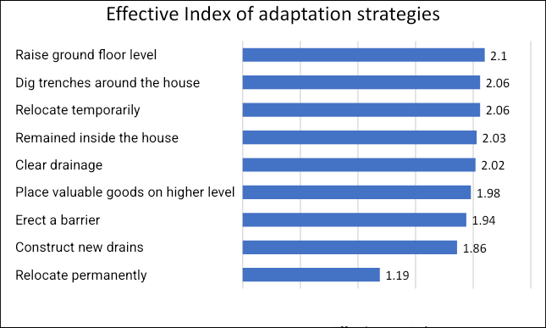
Figure 3: Effective Index of Adaptation Strategies
Source: Researcher's work, 2025
The bar chart above (Figure 3) presents the Effectiveness Index (EI) for nine adaptation strategies assessed in the Ayetoro Coastal Community between 2012 and 2022. The EI was calculated using weighted values assigned to community ratings:
Not Effective = 1, Effective = 2, and Very Effective = 3.
The highest EI was recorded for "Raise ground floor level" (EI = 2.11), indicating it was widely perceived as very effective. This suggests that physically altering building structures to adapt to flooding or water levels is considered a sustainable and proactive approach by residents.
Close behind were "Dig trenches around the house" (EI = 2.06), "Remained inside the house" (2.03), "Clear drainage" (2.02), and "Relocate temporarily" (2.02), all of which were perceived as highly effective community-driven responses. These strategies focus on either temporary relocation or in-situ mitigation, both emphasising flexibility and responsiveness.
On the lower end of the scale, "Relocate permanently" had the lowest EI (1.10), showing that it was primarily viewed as ineffective. This could be due to social, cultural, or economic reasons, making permanent relocation undesirable or unfeasible for most residents.
Moderately effective strategies include "Erect a barrier" (1.94), "Construct new drains" (1.89), and "Place valuable goods on a higher level" (1.98), which were useful but not rated as consistently successful.
Overall, the results highlight a community preference for strategies that maintain connections to the home environment while enhancing resilience to climate-related risks, such as flooding. Strategies involving permanent displacement were less favoured, emphasising the importance of locally viable, cost-effective solutions.
Plate 1a shows the Oba's palace in its condition during the wet season, and Plate 1bshows the environmental condition.
From personal observations, the massive Oba's palace exhibits different building conditions and characteristics compared to the adjacent structures, which are bungalows. The heavy structure is sinking laterally, with no cracks or major defects on the wall. Meanwhile, the bungalows remain as built, exhibiting only efflorescence effects on the walls and continuous floor net conditions that affect their floors, finishes, and furniture.
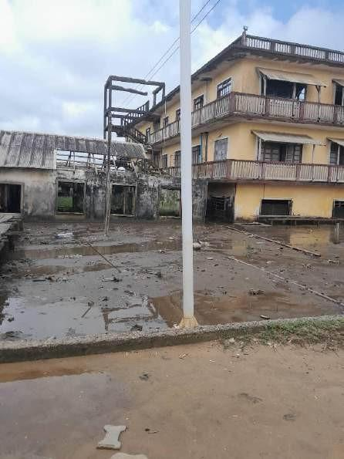
Plate 1a: Effects of Sea-Level Rise on Ayetoro Oba Palace (Wet season)
Researcher's work, 2023
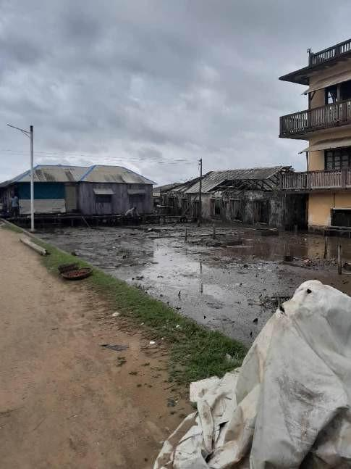
Plate 1b: Effects of Sea-Level Rise on Ayetoro Oba Palace Environment (Wet season)
Researcher's work, 2023
4.1 Thematic Analysis:
Theme 1: Use of Stilt Plant Raised Far from the Sea
Stilt structures are a traditional strategy employed by many indigenous and coastal communities to protect their homes from floods and tidal surges. In Ayetoro, the use of stilt planks and wood for building foundations is a dominant adaptation method.
“Most builders in Ayetoro make use of stilt planks and wood for foundation. This is because the constant flooding will affect a normal structure, which is not raised.” (FGD 2 pt 7, October 27, 2025).
“We use adaptive stilt house construction, vital for disaster mitigation. This is to ensure that residents have a place to stay when rainfall is high and sea levels rise, causing flooding. Many residents have no other place to go; therefore, stilt house construction is their most preferred adaptation strategy.”
The steeply pitched roofs of Umah Pitu Ruang, designed to facilitate rapid rainwater runoff, share a functional similarity with traditional houses in Japan. In mountainous regions of Japan, as noted by Tamura (2024), steep roofs prevent the accumulation of snow or rain, demonstrating ecological adaptation tailored to local environmental conditions.
Additionally, the use of local durable materials such as ulin hardwood enhances the resilience of Umah Pitu Ruang to extreme weather conditions, similar to practices in the Philippines, where traditional houses employ local materials like bamboo and hardwood to withstand typhoons and floods (See et al., 2024).
Theme 2: Embankments
Another prevalent adaptation measure in Ayetoro is the construction of embankments, strong earthen walls to prevent flooding and erosion.
“We residents of Ayetoro have learnt to adapt to the changing climate. One of the ways we adapt is by building embankments to protect our homes and farms from flooding.”
“Embankments help us maintain our income sources, protect our culture and save lives, even though maintenance is a challenge.”
This finding aligns with Ward et al. (2017), who found that flood protection can be achieved using embankments. An embankment is a strong earthen structure, a raised wall used in building projects to withstand flooding and erosion. They offer access to over sloping terrain and guard against flooding-related catastrophe.
Samuel Thomas (2018) noted that other measures include river channel maintenance activities such dredging for river improvement; basin management measures in water retention areas, such as land-use control and natural land conservation; basin management measures in lowland areas, such as the development of inland water drainage facilities; and damage mitigation measures such as the promotion of water-resistant buildings.
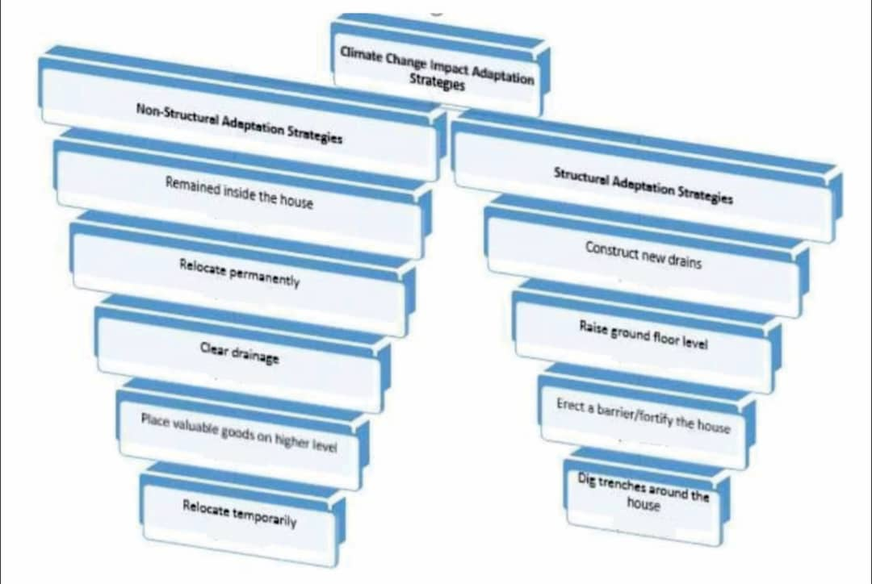
Figure 4: Hierarchical archetypes of climate change impact adaptation strategies.
Source: Researcher's work, 2025
4.2 Summary of Key Findings
Table 2 establishes the severity of climate impacts, including flooding (98.3%), building collapse, soil erosion, and displacement. Table 6 confirmed significant differences in housing resilience based on foundation type and location, with swampy areas and plank foundations more vulnerable. Table 7 showed that strategies such as temporary relocation (mean = 4.32) and raising floors (mean = 4.28) were rated as the most effective by respondents.
4.3 Discussion of Findings
This study comprehensively examined the adaptation strategies for climate resilient housing in Ayetoro Coastal Community, Ondo State, Nigeria. The analysis revealed significant linkages between environmental factors, socio-economic dynamics, and the structural attributes of buildings, offering insights into how these variables interact to shape vulnerability and adaptation outcomes over time.
4.4 Structural Adaptation Strategies
The use of Reinforced Foundations (Concrete Piles, Fibre Cement panels) is justified through quantitative analysis in Tables 3 and 4, which show that plank foundations are correlated with higher climate-induced impacts. Thematic analysis (FGDs) revealed a reliance on informal methods, including stilt plants, embankments, trenching, and local materials. It confirmed local interest in stronger alternatives, as supported by Biswas et al., (2015) and recent studies by See et al., (2024), which advocate for flood-resilient materials for coastal communities.
Elevating Floor Levels is justified based on the data in Table 7, which indicates a high resident preference (Mean = 4.28). This analysis is corroborated by Gunggut et al., (2024) on stilt housing in flood-prone areas, which allows homes to avoid floodwaters and protect property.
Construction of Community Embankments and Trenches. FGD participants emphasised the ongoing use of embankments despite maintenance issues. This is also supported by the studies of Ward et al., (2017) and Samuel Thomas (2018), which validate the effectiveness of community-led embankment projects in flood adaptation.
Improved Drainage Infrastructure. Data showed blocked access and property damage in Table 2, and drainage clearing had a mean score of 4.20 in Table 7. This is consistent with Bello et al., (2017), who states that poor drainage amplifies flood damage in Nigerian communities.
4.5 Non-Structural Adaptation Strategies
Subsidised Climate-Resilient Housing Policy. The inadequacy of self-funded strategies was noted in focus group discussions (FGDs). Castaño‐Vázquez (2022) argued that informal, self-funded housing is unsustainable under worsening climate conditions.
Early Warning Systems & Risk Communication. Movement restrictions (96.59%) and life-threatening weather (97.16%) in Table 2 indicate a need for improved alerts. This finding is supported by Nhamo et al. (2021), who advocate for community-based early warning systems in Africa’s coastal zones.
Policy-backed Enforcements on Building Standards. Table 2 confirms infrastructure damage (96.31% agreement). Saroj & Pal (2020) recommend that local planning authorities enforce material and location-based building codes in flood-prone settlements.
The developed framework reflects a data-driven, community-sensitive, and practically feasible strategy to improve housing resilience in Ayetoro. Grounded in empirical evidence, it combines both immediate coping strategies and long-term resilience-building measures. The findings confirm the urgent need for integrated physical and institutional interventions that prioritise local context and socio-economic realities.
5. CONCLUSION AND RECOMMENDATION
The study examined the climate change adaptation strategies adopted by the residents of the Ayetoro community and their effectiveness. The study found that the highest EI was recorded for "Raise ground floor level" (EI = 2.11), indicating it was widely perceived as very effective. "Relocate permanently" had the lowest EI (1.10), showing that it was largely viewed as ineffective. It is observed that there is a community preference for strategies that maintain connections to the home environment while enhancing resilience to climate-related risks, such as flooding. Strategies involving permanent displacement were clearly less favoured, emphasising the importance of locally viable, cost-effective solutions. It is therefore recommended that there should be an improvement in the use of flood-resistant building materials and construction techniques to mitigate the impact of water damage and improve the durability of structures. Given the predominance of vulnerable wooden piles (Omeghen) in Ayetoro’s housing, the use of reinforced concrete piles or fibre-reinforced polymer (FRP) columns is recommended. Community demonstration projects can be initiated where households gradually replace wooden piles with prefabricated concrete stilts during repairs and reconstructions. Both the government and NGOs in Ondo State should conduct public awareness campaigns and educational programs to inform residents about the impacts of climate change and promote proactive measures for safeguarding their homes and communities.

Consent
To establish the ethical foundation of the study, respondents' consent was obtained directly before they were selected for discussion, indicating that their involvement and consent were voluntary (McCabe 2007). To engage participants, community leaders, and other stakeholders and to explain the purpose and methodology of the study, the researcher had previously visited three communities. Additionally, participants were informed that the study's primary goal is academic and that their survey responses would be treated with utmost confidentiality and anonymity (Wilson et al., 2018).

Disclaimer (Artificial intelligence)

Author(s) hereby declare that NO generative AI technologies such as Large Language Models (ChatGPT, COPILOT, etc.) and text-to-image generators have been used during the writing or editing of this manuscript.

REFERENCES

Abbade, E. B. (2020). Estimating the nutritional loss and the feeding potential derived from food losses worldwide, World Development, Volume 134, 2020, 105038, ISSN 0305-750X, https://doi.org/10.1016/j.worlddev.2020.105038.

Adger, W.N., Pulhin, J. M., Barnett, J., Dabelko, G. D., Hovelsrud, G. K., Levy, M., & Vogel, C. H. (2014). Human security: Cambridge University Press.

Adet, L., Nsofor, G. N., Ogunjobi, K. O., & Camara, B. (2017). Knowledge of Climate Change and the Perception of Nigeria’s Coastal Communities on the Occurrence of Sargassum natans and Sargassum fluitans. Open Access Library Journal, 4(12), 1-18.

Adewale, B., Zhang, X., Wang, R., Adenugba, O., & Adewusi, A. An Integrated Multicriterion Decision-Making Method for Assessing Flood Vulnerability: A Case Study in Nigeria's Transgressive Mud Coast State of Ondo State's Ilaje Coastal City. Available at SSRN 4808267.

Apenuwa, O. S., Dafiewhare, E. O., Owosho, O., Adeyemo, O. T., Ayeni, A. O., & Agoni, C. (2022). Resilient Housing Provision for Coastal Settlements in Ondo State, Nigeria. British Journal of Environmental Sciences, 10(4), 28-46.

Akpan, U. N. A., Assian, U. E., & Akpan, K. (2024). Adaptation Strategies for, Nigerian Coastal Communities facing Rising Sea Levels and Encouragement of Agricultural Activities: A Comprehensive Review. Poljoprivredna tehnika, 49(3), 31-42.

Al-Humaiqani, M. M., & Al-Ghamdi, S. G. (2022). The built environment resilience qualities to climate change impact: Concepts, frameworks, and directions for future research. Sustainable Cities and Society, 80, 103797.

Apenuwa, O. S., Dafiewhare, E. O., Owosho, O., Adeyemo, O. T., Ayeni, A. O., & Agoni, C. (2022). Resilient Housing Provision for Coastal Settlements in Ondo State, Nigeria. British Journal of Environmental Sciences, 10(4), 28-46.

Aydin, O., Osorio-Murillo, C., Butler, K.A., Wright, D. (2022) Conservation planning implications of modeling seagrass habitats with sparse absence data: a balanced random forest approach. J Coast Conserv 26, 22 (2022). https://doi.org/10.1007/s11852-022-00868-1

Ansah, E. W., Amoadu, M., Obeng, P., & Sarfo, J. O. (2024). Climate change, urban vulnerabilities and adaptation in Africa: a scoping review. Climatic Change, 177(4), 71.

Balachandran, B. (2022). Risk vs. risk: planning and risk management in disaster-induced displacement and relocation (Doctoral dissertation, University of Illinois at Urbana-Champaign).

Bello, N. A., Durosinmi, W., & Abdulkarim, R. (2017). Assessment of adaptation strategies to flooding impacts in Nigeria-A review. Urban Design, 1(1), 135-145.

Belouafa, S., Habti, F., Benhar, S., Belafkih, B., Tayane, S., Hamdouch, S., ... & Abourriche, A. (2017). Statistical tools and approaches to validate analytical methods: methodology and practical examples. International Journal of Metrology and Quality Engineering, 8, 9.

Biswas, S., Hasan, M. & Islam, M. (2015). Stilt Housing Technology for Flood Disaster Reduction in the Rural Areas of Bangladesh. International Journal of Research in Civil Engineering, Architecture & Design. 3. 1-62347.

Biessbroek, G. R., Swart, R. J., Carter, T. R., Cowan, C., Henrichs, T., Mela, H., Morecroft, M. D., & Rey, D. (2010). Europe adapts to climate change: Comparing national adaptation strategies. Global Environmental Change, 20(3), 440–450.
https://doi.org/10.1016/j.gloenvcha.2010.03.005

Castaño‐vázquez, F., & Merino, S. (2022). Differential effects of environmental climatic variables on parasite abundances in blue tit nests during a decade. Integrative zoology, 17(4), 511-529.

Codjoe, S. N. A., Owusu, G., & Burkett, V. (2020). Perception, experience, and indigenous knowledge of climate change and variability: The case of Accra, a sub-Saharan African city. Regional Environmental Change, *20*(1), Article 24. https://doi.org/10.1007/s10113-020-01606-9

Das, S., & Mukhopadhyay, P. (2018). Multi-hazard disaster resilient housing with bamboo-based system. Procedia engineering, 212, 937-945.

Gunggut, H., Bala, P., Lungkapis, G., & Harris, Roger. (2024). Climate Change Adaptation Strategies among Coastal Community. Environment-Behaviour Proceedings Journal. 9. 171-178. 10.21834/e-bpj.v9i29.6034.

Hatfield, J. L., Antle, J., Garrett, K. A., Izaurralde, R. C., Mader, T., Marshall, E., & Ziska, L. (2020). Indicators of climate change in agricultural systems. Climatic Change, 163, 1719-1732.

Harun-Or-Rashid, G. M., Castro, J. J., Chakrabartty, M., & Kamruzzaman, M. (2022). Proposal of resilient housing features for the disaster affected community of Bangladesh. Sustainability, 14(21), 14061.

Huebner, S. (2025). Floating and stilted structures as strategies in coastal climate adaptation: local monsoon adaptation practices and implications for flood risk management. Climate Risk Management, 100719.

Jain, D. K., Chida, A., Pathak, R. D., Jha, R., & Russell, S. (2022). Climate risk insurance in Pacific Small Island Developing States: possibilities, challenges and vulnerabilities—a comprehensive review. Mitigation and Adaptation Strategies for Global Change, 27(3), 26.

Jiboye, A.,i Adebayo, J., & Obakin, O. (2020). Urban Housing in Nigeria for Sustainable Development: Challenges and Prospects. International Journal of Advanced Engineering Research and Science. 7. 478-491. 10.22161/ijaers.77.55.

Jones S., Oven, K. J., & Wisner, B. (2016). A comparison of the governance landscape of earthquake risk reduction in Nepal and the Indian State of Bihar, International Journal of Disaster Risk Reduction, Volume 15, 2016, Pages 29-42, ISSN 2212-4209, https://doi.org/10.1016/j.ijdrr.2015.10.011

Kalaidjian E., & Robinson S. (2022), Reviewing the nature and pitfalls of multilateral adaptation finance for small island developing states, Climate Risk Management, Volume 36, 2022, 100432, ISSN 2212-0963, https://doi.org/10.1016/j.crm.2022.100432.

Lawrance, E. L., Thompson, R., Newberry Le Vay, J., Page, L., & Jennings, N. (2022). The impact of climate change on mental health and emotional wellbeing: a narrative review of current evidence, and its implications. International Review of Psychiatry, 34(5), 443-498.

McCabe, J., & Holmes, D. (2007). Nursing Research and Vulnerable Populations: The Contribution of Humanism. International Jounral of Human Caring. 11. 17-23. 10.20467/1091-5710.11.4.17.

Mfon, I. E., Oguike, M. C., Eteng, S. U., & Etim, N. M. (2022). Causes and effects of flooding in Nigeria: A review. East Asian Journal of Multidisciplinary Research, 1(9), 1777-1792.

National Geographic. (2019, September 11). Oceans are absorbing almost all of the globe’s excess heat, study says.
https://www.nationalgeographic.com/environment/article/oceans-absorbing-heat

Oladeji, S. O., Grace, O., & Ayodeji, A. A. (2022). Community participation in conservation and management of cultural heritage resources in Yoruba ethnic group of South Western Nigeria. Sage Open, 12(4), 21582440221130987.

Olorunlana, F. A. (2024). Sea Level Rise and its Impact on Ayetoro Community, Ondo State, Nigeria. Article DOI: 10.48028/iiprds/ijasesi.v5.i1.17

Raimi, M. O., Vivien, O. T., & Oluwatoyin, O. A. (2021). Creating the healthiest nation: Climate change and environmental health impacts in Nigeria: A narrative review. Morufu Olalekan Raimi, Tonye Vivien Odubo & Adedoyin Oluwatoyin Omidiji (2021) Creating the Healthiest Nation: Climate Change and Environmental Health Impacts in Nigeria: A Narrative Review. Scholink Sustainability in Environment. ISSN.

Samuel Thomas, O. (2018). Analysis of Coastal Dwellers’ Views on Housing Quality in Ondo State, Nigeria. Asian Journal of Advanced Research and Reports, 1(1), 1–10. https://doi.org/10.9734/ajarr/2018/v1i113031

Sharma, B., & van der Vegte, A. (2020). Engineered bamboo for structural applications. In Nonconventional and vernacular construction materials (pp. 597-623). Woodhead Publishing. https://doi.org/10.1016/B978-0-08-102704-2.00021-4

Saroj, A., & Pal, S. (2020). Use of social media in crisis management: A survey, International Journal of Disaster Risk Reduction, Volume 48, 2020, 101584, ISSN 2212-4209, https://doi.org/10.1016/j.ijdrr.2020.101584.

Unegbu, H. C., Yawas, D. S., Dan-asabe, B., & Alabi, A. A. (2024). Climate Resilience in Nigerian Construction: A Systematic Review of Strategies and Outcomes. Journal of Sustainable Construction, 4(1), 60-76.

National Geographic. (2019, September 11). Oceans are absorbing almost all of the globe’s excess heat, study says. https://www.nationalgeographic.com/environment/article/ocean

Wilson, E., Kenny, A., & Dickson-Swift, V. (2018). Ethical Challenges in Community-Based Participatory Research: A Scoping Review. Qualitative Health Research. 28. 189-199. 10.1177/1049732317690721.

Yule, E. L., Donovan, K., Graham, J. (2023). The challenges of implementing adaptation actions in Scotland’s public sector, Climate Services, Volume 32, 2023, 100412, ISSN 2405-8807, https://doi.org/10.1016/j.cliser.2023.100412.

