Heavy Metal Uptake and Associated Ecological Hazards in Parapenaeopsis atlantica from a Nigerian Estuarine Ecosystem

Abstracts
A year-long investigation (September 2022 to August, 2023) was carried out to evaluate the bioaccumulation levels and ecological risks of selected heavy metals in Parapenaeopsis atlantica harvested from Iko River Estuary, Nigeria. The primary objective was to assess the potential health risks associated with consuming this shrimp species from the estuary. A total of 40 shrimp samples were collected monthly from artisanal fishers operating in the estuary. Upon collection, samples were rinse with seawater, packaged in labelled cellophane bags, and preserved in ice-cooled containers before been transported to the laboratory for analysis. In the laboratory standardized procedures were employed for sample preparation and heavy metal analysis, using a Perkin-Elmer Analyst 800 Atomic Absorption Spectrophotometer. The heavy metals examined included cadmium (Cd), chromium (Cr), iron (Fe), magnesium (Mg), nickel (Ni), lead (Pb), copper (Cu) and zinc (Zn). Concentrations of these metals in shrimp tissues showed no statistically significant seasonal variation, with the exception of copper (Cu). Notably, iron and zinc recorded the highest concentrations across all sampling periods, a pattern attributed to their natural abundance in the environment. Correlation analysis revealed strong positive associations among several metal pairs, while hierarchical cluster analysis grouped the metals based on their concentration levels and likely source of origin. Overall, the concentration of heavy metals detected in P. atlntica remained within the safety threshold established by WHO/FAO guidelines for human consumption. Nonetheless, the observed bioaccumulation trends underscore the need for regular environmental monitoring to mitigate long-term health risks to consumers of seafood from the estuary.

Keywords: Bioaccumulation, Ecological Risk, Parapenaeopsis atlantica, Heavy Metals, Iko River

1.0 Introduction

The contamination of aquatic ecosystems by heavy metals has become an increasing environmental issue due to its potential impact on biodiversity, food safety, and human health. Coastal estuaries, such as the Iko River Estuary in Southeastern Nigeria, receive significant anthropogenic inputs from industrial, agricultural, and domestic sources, leading to the accumulation of toxic metals in aquatic organisms (George, et al., 2023 a; b). Among these organisms, shrimps are of particular interest due to their ecological role in food webs and their economic importance as a seafood resource.
Shrimps, including Parapenaeopsis atlantica, are filter feeders and benthic organisms that readily accumulate heavy metals from sediments and water. The bioaccumulation of metals such as lead (Pb), cadmium (Cd), mercury (Hg), and arsenic (As) in shrimps raises concerns about potential toxic effects on aquatic life and human consumers (George, et. al., 2013; Andem, et. al., 2013; George, et. al., 2015). Studies have shown that chronic exposure to these metals can cause oxidative stress, enzyme inhibition, and reproductive impairments in crustaceans (Ekpo, et. al., 2015; George, 2015).
Previous research on heavy metal contamination in Nigerian aquatic environments has highlighted the presence of elevated metal levels in sediments, water, and biota. (Ekanim, et. al., 2016; George and Effiom, 2017; George and Inyang-Etoh, 2018 b; Inyang-Etoh and George, 2018; Effiom and George, 2018; Asuquo, et.al., 2023). However, specific studies on P. atlantica in the Iko River Estuary remain scarce, despite its ecological and commercial significance.
In the aquatic ecosystem, sources of heavy metal contamination can be broadly classified into natural and anthropogenic origins. While natural weathering of rocks and soil erosion contribute trace amounts of metals to aquatic systems, human-induced pollution is the predominant cause of heavy metal accumulation in estuaries (George, et. al., 2021 a; b; Jonah, et. al., 2019; George, et. al., 2020 a). The use of phosphate fertilizers and pesticides in nearby farmlands introduces Cd, Zn, and Cu into the estuary through surface runoff from agricultural farmlands especially during the rainy season (George and Atakpa, 2015 a, b; Jonah, et al., 2020, George, et. al., 2020 b; Effiong, et. al., 2021).
The estuary receives discharge from petrochemical industries, oil refineries, and illegal crude oil bunkering. Oil spills and produced water from offshore drilling operations contain toxic metals such as Pb, Ni, and Hg, which enter the water column and sediments (Benson, et al., 2016; Asuquo, et. al., 2004). Wastewater discharge from nearby settlements carries metals from household products, pharmaceuticals, and electronic waste into the aquatic system (George, et. al., 2017; George and Inyang-Etoh, 2018 a; George and Effiom, 2018).
This study aims to assess the concentrations of heavy metals in P. atlantica from the Iko River Estuary. The findings will provide valuable insights into environmental pollution in the region and inform regulatory policies for seafood safety and aquatic ecosystem management.

2.0 Materials and Methods
2.1 The Study Area
The Iko River Estuary is located Niger Delta region of Akwa Ibom State, in southern Nigeria. Geographically, the estuary lies approximately between latitude 4°33’ N to 4°37’ N and longitude 7°49’ E to 7°55’ E (Fig. 1) (Ekpe et. al, 1995; Udotong et. al. 2008; Etesin et. al. 2013). It is a tidal-influenced brackish water system that connects to the Atlantic Ocean through a network of adjoining creeks and distributaries. The estuary is characterized by a dynamic interface between freshwater and saltwater systems and supports a rich diversity of aquatic and semi-aquatic life. Notable adjoining creek include Imo River, Opobo Creek, and smaller distributaries that channel water and nutrients throughout the estuary landscape (Ekpe et. al, 1995). Human activities around the Iko River Estuary are intense and varied. These include: artisanal fishing and shellfish harvesting, oil exploration and exploitation, boat transportation and sand dredging, domestic and agricultural runoffs, mangrove wood harvesting for fuel and construction (NDES, 2000; NDDC, 2004). The vegetation surrounding the area is dominated by mangrove forests, which are ecologically viable for shoreline stabilization and as nurseries for marine organisms. The main mangrove species include; red mangrove (Rhizophora racemosa, R. harrizonii and Rhizophora mangle), white mangrove (Laguncularia racemosa), black mangrove (Avicenia africana). These species form dense intertidal swamps and are often interspersed with Nypa palm (Nypa fruiticans), an invasive species that has been gradually replacing native mangrove stands in some areas due to anthropogenic disturbances (Ekwere et. al. 1992; Ukpong, 1995). The study area lies within the tropical rainforest zone and has two major seasons: the wet season (April to October) and the dry season (November to March).
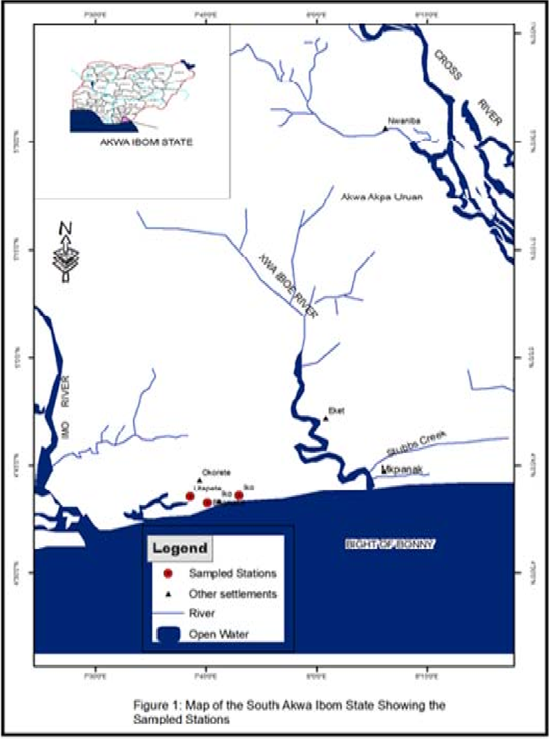
Fig. 1: Map of Iko River Estuary showing the Major Fishing Areas.
2.2 Sample Collection
A total of 40 specimens of Parapenaeopsis atlantica were collected monthly from September 2022 to August 2023 at Iko River Estuary. Specimens were obtained from the landings of artisanal fisherfolks, immediately after catch. Upon collection, shrimp samples were thoroughly rinsed with estuarine water to remove sediments and external contaminants. Samples were wrapped in labelled cellophane bags, stored in ice-cooled container and transported to the laboratory under cold chain conditions to prevent decomposition prior to analysis

2.3 Sample Preparation
In the laboratory, shrimps were carefully dissected using sterile stainless-steel instruments. Muscle tissues, being the edible portion, were excised, rinsed again with deionized water, and weighed using a digital balance. The tissues samples were then oven dried at 105ºC for 24-48 hours until a constant weight was achieved. Dried tissues were ground into a fine powder using a porcelain mortar and pestle, then stored in clean, airtight plastic containers for digestion and further analysis

2.4 Digestion Procedure
Approximately 1.0 g of powdered shrimp tissue was weighed into 50 mL conical flask. A mixture of 10mL concentrated nitric acid (HNO₃) and 2mL perchloric acid (HCIO₄) was added. The mixture was left to pre-digest overnight at room temperature to prevent violent reactions. The next day, the flask was placed on a hot plate at 120ºC and heated until the solution became clear, indicating complete digestion (typically 1-2 hours). After cooling, the digest was filtered using Whatman No.42 filter paper, and the filtrate was made up to 25mL with deionized water in a volumetric flask. The prepared samples were stored in acid-washed polyethylene bottles at 4ºC prior to metal analysis

2.5 Analysis of Heavy Metals
The concentration of selected heavy metals- cadmium (Cd), chromium (Cr), iron (Fe), magnesium (Mg), nickel (Ni), lead (Pb), zinc (Zn) and copper (Cu) in the digested shrimp tissues were quantify using a Perlin-Elmer Analyst 800 Atomic Absorption Spectrophotometer (AAS). The AAS was calibrated using standard solutions prepared from stock standards (1000 ppm) for each metal. Blank solutions and standard reference materials were included for quality control. Metal concentrations were expressed in mg/kg dry weight. The instrument detection limits (IDLs) and recovery rates were within acceptable analytical ranges (APHA. 2005).

2.6 Statistical Analysis
Data obtained from the metal concentration analysis were subjected to descriptive statistics (mean ± standard deviation). One-way analysis of variance (ANOVA). Was used to determine significant differences in heavy metal concentrations across sampling months and seasons (p<0.05). Pearson correlation coefficients were computed to assess relationships among metal concentrations, while hierarchical cluster analysis (HCA) was used to grouped metals based on concentration similarities and potential sources. All statistical analyses were performed using IBM SPSS statistic version 25.0 and PAST (Paleontological statistics) software version 4.0. Ecological risk assessments were carried out using WHO/FAO safety threshold values.

3.0 Results
3.1 Heavy Metals in Parapenaeopsis atlantica

3.1.1 Cadmium
The concentration of cadmium (Cd) in Parapenaeopsis atlantica varied between 0.19 – 0.26 mg / kg during the dry season and 0.00 – 0.07 mg / kg in the wet season. The mean cadmium (Cd) levels recorded were 0.02±0.02 mg / kg for the dry season and 0.03±0.02 mg / kg for the wet season, as presented in Table 1. Although, Cd concentrations were generally low in both seasons, levels appeared slightly higher during the wet season, with the peak value observed in May, 2023. Notably to detectable Cd was found in the studied tissues during July, as shown in Figure 3.

3.1.2 Chromium
The concentration of chromium (Cr) in the tissues of P. atlantica ranged from 0.01 – 0.02 mg / kg during the dry season and 0.01 – 0.04 mg / kg in the wet season. The mean Cr concentrations were identical in both seasons, with a value 0.02 ±0.00 mg / kg each as shown in Table 1. Chromium levels remained consistently low throughout the study period, with minimal seasonal variation, as illustrated in Figures 2 and 3.

3.1.3 Copper
The concentration of copper (Cu) recorded in the tissues of P. atlantica ranged from 0.18 – 1.19 mg / kg during the dry season and 0.70 – 1.83 mg / kg in the wet season. The mean copper concentrations were 0.36±0.02 mg / kg for the dry season and 1.24±0.02 mg / kg for the wet season, as detailed in Table 1. Copper levels exhibited a notable seasonal trend, with consistently uniform values across all months of the dry season, except for a deviation observed in January 2023 (Fig. 2). A marked increase in Cu concentration was evident during the wet season, with the highest value recorded in October 2022, while the lowest concentration was observed in May, 2023 as illustrated in Figure 3.

3.1.4 Iron
The concentration of iron (Fe) in P. atlantica ranged from 1.89 – 2.06 mg / kg during the dry season and 1.84– 2.01 mg / kg in the wet season. The mean Fe concentrations were 1.99±0.02 mg / kg for the dry season and 1.92±0.01 mg / kg for the wet season (Table 1). Iron levels remained consistently elevated across both seasons. In the dry season, the maximum was recorded in April 2023, while the lowest value was observed in November 2022 (Fig. 2). For the wet season, May 2023 exhibited the highest Fe concentration, whereas the lowest level was observed in September 2022 (Fig.3).

3.1.5 Magnesium
Magnesium (mg) concentration in the tissue of P. atlantica ranged from 0.17– 0.18 mg / kg during the dry season and 0.17 – 0.83 mg / kg in the wet season. The mean Mg values were 0.18±0.01 mg/kg for the dry season and 0.29±0.02 mg / kg for the wet season (Table 1). There was no observed variation in the concentration of magnesium in the tissue of P. atlantica during the dry season (Fig. 2). Similar results were recorded during the wet season, except during the month of May, 2023 where elevated concentration was noted (Fig. 3).

3.1.6 Nickel
Nickel (Ni) concentration ranged between 0.01– 0.13 mg / kg during the dry season and 0.01 – 0.20 mg / kg in the wet season. Mean values of Ni were 0.04±0.02 mg/kg for the dry season and 0.05±0.01 mg / kg for the wet season (Table 1). A slight deviation was observed in the concentration of nickel in the tissue of P. atlantica during the dry season. The highest concentration of Ni was noted in the month of March, 2023 with the least observed in the month of September, 2022 (Fig. 2). Similar trend was observed during the wet season with the highest concentration recorded in the month of August, 2023 and the least value noted in the month of October, 2022 (Fig.3).

3.1.7 Lead
Lead (Pb) concentration recorded in the tissues of P. atlantica for dry and wet season range between 0.02 – 0.28 mg / kg during the dry season and 0.02 – 0.23 mg / kg in the wet season. The mean Pb concentration were 0.14 ±0.03 mg/kg for the dry season and 0.07±0.02 mg / kg for the wet season (Table 1). Pb concentration was observed to be high in the month of November, 2022, February and April, 2023. However, a uniform concentration was noted for the months of December, 2022, January and March, 2023 (Fig. 2). Lead concentration was relatively low during the wet season except for the months of August and October, 2022 (Fig. 3).

3.1.8 Zinz
The concentration of zinc (Zn) ranged from 0.17 – 0.26 mg /kg during the dry season and 0.17– 0.25 mg / kg in the wet season. The mean zinc values recorded were 0.23±0.02 mg/kg for the dry season and 0.19±0.02 mg/kg for the wet season (Table 1). A close concentration range was observed for zinc contamination in the tissue of P. atlantica. Notably, during the dry season the concentration of zinc was relatively higher in the month of February, 2023 while the least zinc value was recorded in the month of November, 2022 (Fig.2). During the wet season, zinc concentration was relatively high in the month of July, 2023. The concentration range was relatively close in the other months as illustrated in Figure 3.

TABLE 1: Summary of Heavy Metal Concentrations (Range, Mean, Standard error) in Parapenaeopsis atlantica Tissues Across Wet and Dry Seasons in the Iko River Estuary (September, 2022 – August, 2023).

Heavy Metals | Units | Range (dry Season) | Range (Wet Season) | Mean ± S.E (Dry Season) | Mean ± S.E (Wet Season) | Maximum limit WHO/FEPA (mg/kg)
Cadmium | mg/kg | 0.19–0.26 | 0.00– 0.07 | 0.02 ± 0.02 | 0.03±0.02 | 0.5
Chromium | mg/kg | 0.01-0.02 | 0.01-0.04 | 0.02±0.00 | 0.02±0.00 | 0.5
Copper | mg/kg | 0.18-1.19 | 0.20-1.83 | 0.36±0.02 | 1.24±0.02 | 3.0
Iron | mg/kg | 1.89-2.06 | 1.84-2.01 | 1.99±0.02 | 1.92±0.01 | 0.5
Magnesium | mg/kg | 0.17-0.18 | 0.17-0.83 | 0.18±0.01 | 0.29±0.02 | 0.5
Nickel | mg/kg | 0.01-0.13 | 0.01-0.20 | 0.04±0.02 | 0.05±0.01 | 0.5
Lead | mg/kg | 0.02-0.28 | 0.02-0.23 | 0.14±0.03 | 0.07±0.02 | 2.0
Zinc | mg/kg | 0.17-0.26 | 0.17-0.25 | 0.23±0.02 | 0.19±0.02 | 30
Where: S.E = Standard Error, WHO = World Health Organisation.

Fig. 2: Mean Levels of Heavy Metals in P. atlantica Tissues (Mg/Kg) Collected in the Dry Season

Fig. 3: Mean Levels of Heavy Metals in P. atlantica Tissues (Mg/Kg) Collected in the Wet Season
3.2 Seasonal Mean Variation of Heavy Metals in Tissues of Parapenaeopsis atlantica From Iko River Estuary (September, 2022 – August, 2023).
The mean concentration of heavy metals in P. atlantica for both dry and wet seasons are shown in Table 2. Generally, higher levels of CD, Cr, Cu, Mg and Ni were recorded during the wet season compared to the dry season. However, these differences were not statistically significant (p>0.05), except for copper which showed a significant seasonal variation (p≤0.05). Conversely, the concentration of Fe, Pb and Zn were relatively higher in the dry season but the observed differences between seasons were not statistically significant (p>0.05).

TABLE 2: Seasonal Mean Variation of Heavy Metals in Tissues of Parapenaeopsis atlantica From Iko River Estuary (September, 2022 – August, 2023).
Heavy Metal | Dry | Wet | t-value
Cd | 0.022 | 0.028 | 0.598
Cr | 0.018 | 0.021 | 0.612
Cu | 0.356 | 1.237 | 2.430*
Fe | 1.998 | 1.922 | 1.799
Mg | 0.179 | 0.288 | 1.004
Ni | 0.041 | 0.051 | 0.272
Pb | 0.136 | 0.067 | 1.146
Zn | 0.230 | 0.194 | 1.969
t_{crit} = 2.281

3.3 Correlation Matrix and Hierarchical Cluster Analysis of Heavy Metals in Parapenaeopsis atlantica Tissues (Dry season)

Fig. 4 shows dry season correlation analysis for metal-metal relationship in tissue of P. atlantica. The following metals pairs showed strong positive correlation, Fe-Mg (r = 0.91, p<0.05), Fe-Cr (r = 0.85, p<0.05), Fe-Cd (r = 0.83, p<0.05); Cd-Mg (r = 0.96, p<0.001), Cd-Cr (r = 0.98, p<0.001) and Cr-Mg (r = 0.99, p<0.001). From, the cluster dendrogram, three cluster groups were delineated, cluster group 1 (Cd, Cr, Mg and Fe), group 2 (Zn and Ni) and group 3 (Cu and Pb) (Fig. 5).

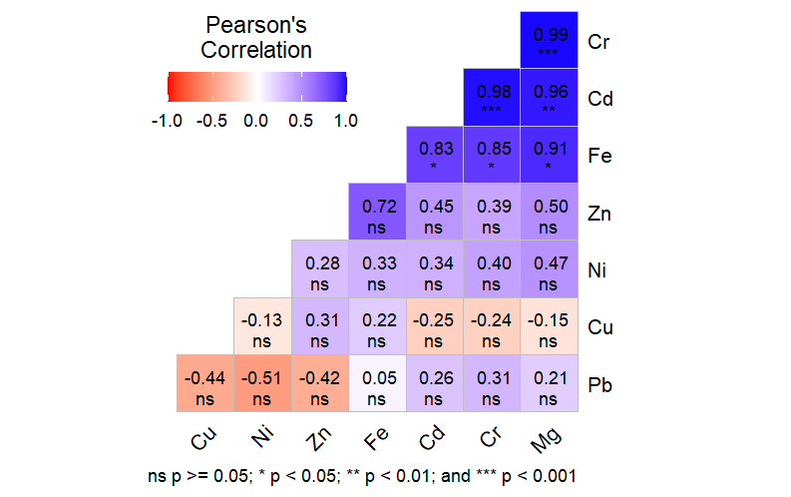
Fig. 4 Dry Season Correlation Analysis of Heavy Metals in Parapenaeopsis atlanticaTissues

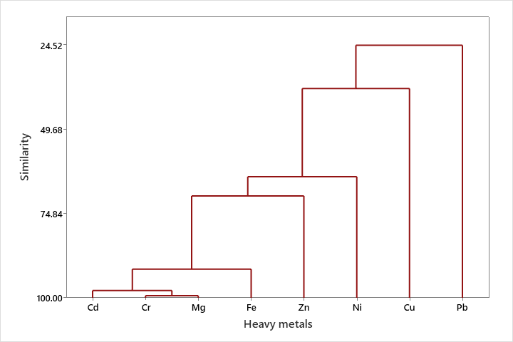
Fig 5: Hierarchical Cluster Analysis of Heavy Metals in Parapenaeopsis atlantica Tissues (Dry Season)

3.4 Correlation Matrix and Hierarchical Cluster Analysis based of Heavy Metals in Parapenaeopsis atlantica Tissues (Wet season)

The results of correlation analysis of heavy metal in tissue of P atlantica and cluster dendrogram showing concentration gradient and source apportionment during the wet season is presented in Fig. 6 and Fig. 7 respectively. During the wet season, significant negative and positive correlation was observed between the following metal pairs: Copper - Iron (r = -0.85, p<0.05), Chromium – Lead (r = 0.85, p<0.05) and Cadmium– Magnesium (r = 0.90, p<0.05). Cluster dendrogram which reflect source apportionment and concentration gradient delineated four bi-factor cluster groups (Cd, Mg), (Fe, Zn), (Cr, Pb) and (Cu and Ni).

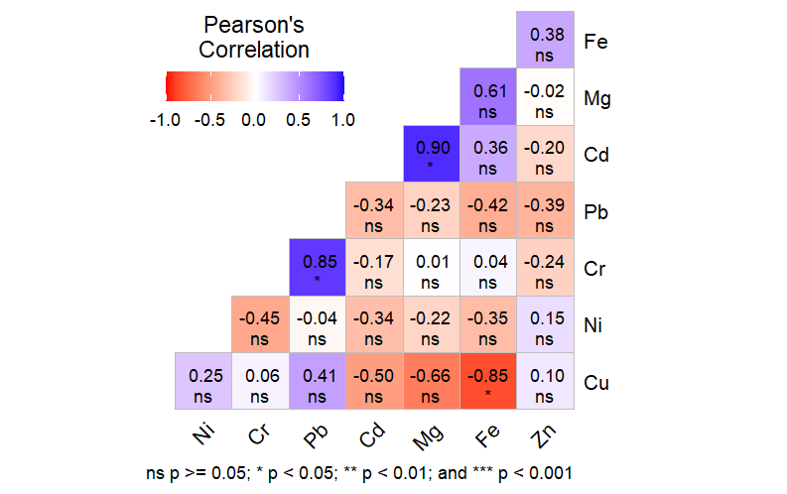
Fig. 6: Wet Season Correlation Analysis of Heavy Metals in Parapenaeopsis atlanticaTissues

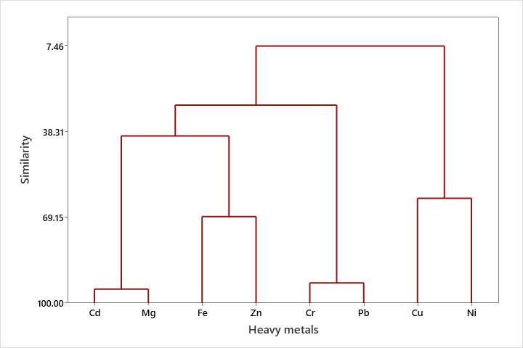
Fig 7: Hierarchical Cluster Analysis of Heavy Metals in Parapenaeopsis atlantica Tissues (Wet Season)

4.0 Discussion
The present study assessed the concentrations of selected heavy metals (Cd, Cr, Cu, Fe, Mg, Ni, Pb and Zn) in the tissues of Parapenaeopsis atlantica collected from the Iko River Estuary across dry and wet seasons. The results indicate varying degrees of bioaccumulation influenced by seasonal fluctuations and environmental inputs.
Cadmium (Cd) concentrations were slightly observed to be higher in the wet season, though statistically insignificant. This aligns with the findings of George et.al., (2023b) who reported low levels of cadmium in Tympanotonus fuscatus from Iko River Basin, attributing the presence of cadmium to agricultural runoff and urban effluents. However, values in this study were still below the FAO/WHO maximum permissible limit of 0.5 mg/kg, suggesting low current risk for human consumption, albeit with potential for accumulation over time.
Chromium levels were generally low across both seasons, showing no significant difference between dry and wet periods. These findings are consistent with George et.al., (2023a) who reported similarly low Cr concentrations in Ethmalosa fimbrata from Iko River Estuary. Chromium low detection in the tissues of the studied organisms may be linked to its relatively low bioavailability in estuarine systems or its affinity for sediment binding under oxidative conditions.
Copper concentrations were significantly higher in the wet season compared to the dry season with a significant seasonal difference observed. The elevated copper levels during the wet season may be attributed to increase surface Runoff from surrounding agricultural and urban areas as observed by Geroge et. al., (2023 a; b) in a related study. Copper is an essential trace element but can be toxic at elevated concentrations. The values in this study, however, remain within safe consumption limits as recommended by FAO/WHO.
Iron and zinc showed the highest concentrations among all metals analyzed, which is consistent with numerous studies. Inyang-Etoh and George, (2018) and George and Inyang-Etoh, (2018) reported similar trend of iron, copper and zinc dominance in tissues of T. fuscatus and C. Amnicola from Qua Iboe River Estuary. This assertion describes Fe and Zn as ubiquitous in aquatic environment due to their abundance in the earth crust and frequent input from corroding infrastructure, sediments and industrial discharges.
Lead levels remained relatively low showing no significant seasonal variation. Comparable Pb concentrations have been documented by Geroge et. al., (2023 a; b) in estuarine fishes from the Iko River Estuary. The low lead levels suggest limited contamination from petroleum activities or industrial discharge at the time of sampling, although chronic exposure risked cannot be entirely dismissed due to leads cumulative toxicity.
Nickel and Magnesium also showed slightly elevated values during the wet season, potentially resulting from increased leaching and runoff during rainfall. Nickel concentrations were consistent with earlier assertion reported by Geroge et. al., (2023 a; b) in a related study.
The concentration of metals in tissues of organisms depends on the amount of organic compound. Other factors that affect the abundance of metals in tissues of aquatic organisms include the trace metal content of the rock and parent material of soil formation around the study area. This assertion is consistent with the findings of (Yi, et.al. 2011, George, et. al., 2015, Ekpo, et. al., 2015, Inyang-Etoh and George, 2019, George, et. al., 2021a, George, et. al., 2021b). This study demonstrated evidence of bioaccumulation of heavy metals in the tissues of P. atlantica from Iko River Estuary. This agrees with the findings of Abiaobo et. al., (2017) and Abiaobo and Asuquo, (2020).
The results of the present findings agree favourably with the reports of Ekpechi and Okori, (2022) who reported low concentrations of heavy metals in tissue of P. atlantica from Ekpo Eyo Beach, Akpabuyo, South-East Nigeria. The authors noted that the elemental concentrations of all the metals studied were all below the Joint Food and Agriculture Organization / World Health Organization Expert Committee on Food additives (JECFA) recommended daily intake limits. In contrast, the results earlier reported by Fajana and Adeboyejo (2022) on heavy metals accumulations in the muscles of 5 demersal seafood sampled in Nigerian coastal waters affirmed that the concentration of zinc and iron recorded in the muscles of P. atlantica exceeded WHO/FAO permissible limit for daily intake limit. There was no significance variation observed in all the studied metals in both season exception of copper in the tissue of P. atlantica. This affirms earlier assertion by (George and Inyang-Etoh, 2018 b, George, et. al., 2021b).
The -higher metal concentrations observed during the wet season is typical of estuarine environment which is subject to increased freshwater influx, surface runoff and sediment resuspension. Statistical analyses (including Pearson correlation and hierarchical clustering) further revealed positive associations between certain metals (Cu- Ni; Fe-Zn), indicating possible common sources or similar geochemical behavior.
Despite the detected levels being within internationally accepted limits, the evidence of bioaccumulation over time especially for toxic metals like Cd, Pb, and Ni raises concern for long-term ecological and public health implications. Continuous exposure, even at low concentrations may disrupt physiological functions in aquatic organisms and pose carcinogenic or neurotoxic risks to higher trophic levels, including humans.

4.1 Summary, conclusion and recommendation
4.1.1 Summary and Conclusion
This study investigated the bioaccumulation and ecological risks associated with heavy metals in Parapenaeopsis atlantica harvested from the Iko River Estuary, Nigeria, over a twelve-month period spanning September 2022 to August 2023. A total of 40 shrimp samples were collected monthly from artisanal fisherfolks landings and analyzed for eight heavy metals (Cd, Cr, Cu, Fe, Mg, Ni, Pb, and Zn) using Perkin-Elmer Analyst 800 Atomic Absorption spectrophotometer after standard digestion procedures. The findings revealed seasonal variations in heavy metal concentrations, with Cd, Cr, Cu, Mg and Ni generally higher during the wet season, although only copper showed a statistically significant difference between seasons. Conversely, Fe, Pb and Zn concentrations were slightly elevated in the dry season, with no significant seasonal difference. Iron and zinc consistently exhibited higher mean values across all months, reflecting their natural abundance in the earth crust and possible anthropogenic enrichment. Correlation and hierarchical cluster analyses revealed strong positive associations among certain metals pairs and grouped metals based on their concentration and likely common sources. This suggest that both natural geogenic sources and human induced activities contribute to metal inputs into the estuarine ecosystem. Importantly, all heavy metal concentrations in shrimp tissues were within the permissible limits recommended by WHO/FAO, indicating that the shrimp are currently safe for human consumption. However, the presence and accumulation patterns of toxic metals like Cd, Cr and Pb, even at low concentrations, highlights the potential for long term bioaccumulation and ecological risks if pollution trend persists. Regular monitoring for heavy metals in water, sediment and biota within the Iko river estuary to track contamination trends and detect early warnings signs of bioaccumulation is recommended.

Disclaimer (Artificial intelligence)
Option 1:
Author(s) hereby declare that NO generative AI technologies such as Large Language Models (ChatGPT, COPILOT, etc.) and text-to-image generators have been used during the writing or editing of this manuscript.
Option 2:
Author(s) hereby declare that generative AI technologies such as Large Language Models, etc. have been used during the writing or editing of manuscripts. This explanation will include the name, version, model, and source of the generative AI technology and as well as all input prompts provided to the generative AI technology
Details of the AI usage are given below:
1.
2.
3.

5.0 References

Abiaobo, N. O. and Asuquo, I. E. (2020). Assessment of heavy metal concentrations in periwinkle (Tympanotonus fuscatus) samples from Uta ewa creek, Imo River estuary, South eastern Nigeria. Journal of Aquaculture & Marine Biology; 9(2):32-35.
Abiaobo, N. O., Akpan, I. I. and Umana, S. I. (2017). Assessment of Heavy Metals Concentration in Shell and Fin Fish from Iko River Estuary, Southeastern Nigeria. Journal of Agriculture and Ecology Research International.;12 (4):1–8.
Andem, A. B., Udofia U. U., Okorafor K. A. and George U. U. (2013). Bioaccumulation of some Heavy Metals and Total Hydrocarbon (THC) in the Tissues of Periwinkle (Tympanotonus fuscatus Var Radula) in the Intertidal Regions of Qua Iboe River Basin, Ibeno, Akwa Ibom State, Nigeria. Greener Journal of Biological Science, 3(7):253-259.
APHA (American Public Health Association). (2005). Standard methods of the examination of water and wastewater. (19th edition). American Public Health Association, Washington DC. 121-226.
Asuquo, A. P., Akpan, I. I., Abiaobo, N. O., George, U. U. (2023). Heavy Metals Assessment in Sediments of Qua Iboe River Estuary, South-South, Nigeria. Asian Journal of Research in Zoology; 6(4):27-34.
Asuquo, F. E., Ewa-Oboho, I., Asuquo, F. E. and Udo, P. J. (2004). Fish Species Used as Biomarker for Heavy Metal and Hydrocarbon Contamination for Cross River, Nigeria. The Environmentalist; 24:29-37.
Benson, N. U., Asuquo, F. E., Williams, A. B., Essien, J. P., Ekong, C., Akpabio, O. and Olajire, A. A. (2016). Source Evaluation and Trace Metal Contamination in Benthic Sediments from Equatorial Ecosystems Using Multivariate Statistical Techniques. PLoS ONE, 11(6): 1 – 19.
Effiong, Y. I., George, U. U., Mbong, E. O. (2021). Spatial and Seasonal Variations in Water Quality Parameters of a Humid Tropical River, Niger Delta, Nigeria. Researcher; 13(4):31-39.
Efiom E. and George, U. (2018). Source Evaluation and Trace Metal Contamination in Benthic Sediments from Imo River, South-East, Nigeria Using Multivariate Statistical Techniques. World Rural Observation, 10(2): 66 – 72.
Ekanim, M. P., Etim, I. N., Udofia, I. I. and George, U. U. (2016). Comparative Study of Heavy Metal Concentrations in Tissues and Shells of Tympanotonus fuscatus from Okoro Ete River, Eastern Obolo Local Government Area of Akwa Ibom State, Nigeria. International Journal of Technical Research and Applications, 4(4):58-62.
Ekpe, U. J., Ekanem, U., Akpan, E. R. (1995). Temporal changes in some water quality parameters in Iko and Uta Ewa River South-eastern Nigeria. Glob. J. Pure and Appl. Sci.; 1:63.
Ekpechi, D. C. and Okori, B. S. (2022). Seasonal Variation of Heavy Metals in Sediments, Water, Shiny Nose Fish, Shrimp, and Periwinkle in Esuk Ekpo Eyo Beach, Akpabuyo, South-East Nigeria. Journal of Environmental Treatment Techniques; 10(4):264-283.
Ekpo, E. A., George, U. U. and Edet, M. (2015). Impacts of Water Pollution with Heavy Metal on the Tissue of Egeria radiata (Bivalvia: Tellinacea: Donacidae) (Lammark, 1804) Obtained from Calabar River, Cross River State, Nigeria. Nature and Science, 13(8):36-39.
Ekwere, J, Akpan, E. B. and Ntekim, E. E. U. (1992). Geochemical studies of sediments in Qua Iboe estuary and associated Creek Southeastern Nigeria. Tropical Journal of Applied Sciences; 2:91-95. 29.
Etesin, U., Udoinyang, E. and Harry, T. (2013). Seasonal variation of physicochemical parameters of water and sediment from Iko River, Nigeria. Journal of Environment and Earth Science; 3(8):96-111.
Fajana, O. P. and Adeboyejo, A. (2020). Morphometric and Heavy Metals Accumulation in the Muscles of Five Demersal Seafoods Sampled in Nigerian Coastal Waters. Advance Journal of Graduate Research; 12(1):20-35.
George, I. E., Abiaobo, N. O., Akpan, I. I. and George, U. U. (2023 a). Assessment of Human Perturbations in Iko River Estuary using Bonga Shad as a Bio-indicator Organism. Nature and Science; 21(12): 30-40.
George, I. E., Abiaobo, N. O., Akpan, I. I. and George, U. U. (2023 b). Ecological Assessment of Heavy Metal Contamination of Tympanotonus fuscatus in Iko River Basin. Acta Biology Forum; 2(3):15-21.
George, U. U. and Efiom, Edak (2018). Physical and Chemical Variations in Water Quality of Imo River Owing to Human Perturbations in the System. Researcher, 10(6): 47 – 54.
George, U. and Effiom, E. (2017). Impacts of Coastal Activities on Benthic Sediments from Qua Iboe River Estuary, South-South, Nigeria using Multivariate Statistical Techniques. International Journal of Applied Research, 3(7): 39-50.
George, U. and Inyang-Etoh A. (2018 a). Parasitic Fauna of Landed Fishes from Qua Iboe River Estuary, South- South, Nigeria: It’s Application in Bio-monitoring Studies. New York Science Journal, 11(3): 54 – 60.
George, U. and Inyang-Etoh, A. (2018 b). Risk Index Evaluation of the Levels of Trace Metals in Callinectes amnicola Obtained from Qua Iboe River Estuary, South - South, Nigeria. Cancer Biology, 8(2): 73 – 78.
George, U. U. (2015). Environmental Risk Posed by Heavy Metal Concentration in the Tissue of Tympanotonus fuscatus from Calabar River, Nigeria. Cancer Biology, 5(4):76-79.
George, U. U. and Atakpa, E. O. (2015 b). Seasonal Variation in Physico-Chemical Characteristics of Cross River Estuary, South Eastern Nigeria. Nature and Science, 13(12):86-93
George, U. U., Akpan, E. R. and Akpan, M. M. (2020 a). Assessing the Impacts of Coastal Activities on the Water Quality of Qua Iboe River Estuary, South-South, Nigeria. New York Science Journal; 13(3):1-15.
George, U. U., Asuquo, F. E., Idung, J. U. and Andem, A. B. (2013). Bioaccumulation of Heavy Metal in three Fresh Water Fishes caught from Cross River System. European Journal of Experimental Biology, 3(3):576-582.
George, U. U., Atakpa, E. O. (2015 a). Impacts of Human Perturbations on the Physico-chemistry and Biological Parameters on the Water Quality of Cross River Estuary, South Eastern Nigeria. Report and Opinion, 7(11): 49-55.
George, U. U., Ekpo, E. A. and Edet, M. O. (2015). Levels of Heavy Metal Concentration in the Tissue of Crassostrea gigas Obtained from Imo River, South Eastern Nigeria. Academia Arena, 7(6):34-37.
George, U. U., Jonah, U. E., Nkpondion, N. N. and Akpan, M. M. (2020 b). Assessment of Water Quality and Benthic Macroinvertebrates Assemblage of Etim Ekpo River, Niger Delta, Nigeria. World Rural Observation;12(1):16 – 24.
George, U., Bate G. B., Otoh, A. (2021 a). Assessment of Trace Metal Concentrations in internal Organs of Tilapia zilli Caught from Orashi River, Niger Delta, Nigeria. Life Science Journal;18(7):9-16.
George, U., Inyang-Etoh, A. and Ikot, N. (2017). Biotic Index Assessment of Human Perturbations in Qua Iboe River Estuary using Macro-Benthic Invertebrate as Indicator Organisms. International Journal of Applied Research, 3(7): 51-59.
George, U., Inyang-Etoh, A., Bate, G. B. (2021 b). Monitoring and Evaluation of Trace Metal Concentrations in Tissues of Clarias gariepinus Caught from Orashi River, Niger Delta, Nigeria. Biomedicine and Nursing; 7(2):73-80.
Inyang-Etoh, A. and George, U. (2018). Health Risk Index Assessment of the Impacts of Coastal Activities on Tympanotonus fuscatus Obtained from Qua Iboe River Estuary, South - South, Nigeria. Cancer Biology, 8(2): 79 – 86.
Inyang-Etoh, A. and George, U. U. (2019). Trace Metal Concentrations in Tissues of Tilapia zilli Owing to Human Perturbations in Imo River. Cancer Biology, 9(4): 50-56.
Jonah, U. E., George, U. U. and Avoaja, D. A. (2019). Impacts of Anthropogenic Perturbation on Water Quality Characteristics of Ikpe Ikot Nkon River, Southern Nigeria. New York Science Journal; 12(9):70-77.
Jonah, U. E., George, U. U. and Avoaja, D. A. (2020). Impacts of Agrochemical on Water Quality and Macroinvertebrates Abundance and Distribution in Ikpe Ikot Nkon River, South-South, Nigeria. Researcher; 12(1):36-43.
NDDC (Niger Delta Development Commission). (2004). Biodiversity of the Niger Delta Environment. Niger Delta Development Commission master plan project final report. Niger Delta Development Commission;123-237.
NDES (Niger Delta Environmental Survey). (1999). Environmental and socio- economic characteristics (revised edition). Niger Delta Environmental Survey;1(1):1- 67.
Udotong, I. R., Eduok, S. I., Essien, J. P. and Ita, B. N. (2008). Density of hydrocarbon clastic bacteria and polycyclic aromatic hydrocarbon accumulation in Iko River mangrove ecosystem, Nigeria. Int. J. Environ, Earth Sci and Eng. 2008;2(8):1-7.
Ukpong, I. E. (1995). An ordination study of mangrove, swamp communities in West Africa,” Veg.;116:147-159.

Yi, Y., Yang, Z. and Zhang, S. (2011). Ecological Risk Assessment of Heavy Metals in Sediment and Human Health Assessment of Heavy Metals in Fishes from Yangtze River basin,” Environmental Pollution., 159: 2575 – 2585.

