**Cisplatin induced oxidative stress on chick embryos: Reversible effects of *Portulaca oleracea* L. extract on teratogenic deformities**

**Reviewer comments to authers:**

**Preparation of Portulaca oleracea L. extract you write** estimated the protein content**………… not found in results and discussion.**

**You write effect of different dose of** Cisplatin not found in research

Explain the sentence of blue highlight

Results

Can The effect of cisplatin appear after one day?

Growth abnormality teratological results not related to results in table

The results in table 1&2, PO showed negative results more than cisplatin

Where is group v in results in table 1

Statistical and results need revision

Figure 2 not present

**Reference:**

**Need Recent reference**

**Revise references**

**In general, the research designs and results need revise**

**What is composition of Po extract**

**Need revise of statistical results**

**Need more discussion**

**Need paraphrase and grammar modification**

**Abstract**

Cisplatin is an active cytotoxic agent that has proved to be successful antineoplastic agent in the treatment of various types of solid tumors. This study was conducted to study effect of cisplatin on morphological and biochemical changes in amniotic fluid and to determine whether *Portulaca oleracea* L. extract can modulate these alterations at the embryonic level against cisplatin toxicity by using chick embryo as animal model. The morphological changes are, change in volume of amniotic fluid, body weight and alterations of amniotic fluid (AF) biochemical parameters were studied after 24 hours of incubation by comparing cisplatin (100 µg) treated groups with their respective controls. It showed a significant dose versus time dependent reduction in volume of amniotic fluid as well as body weight of chick embryos, a dose-related increase in embryo lethality, gross morphological deformities were observed. There was a significant change in the biochemical levels of glucose, protein, urea, creatinine, uric acid, alkaline phosphatase, alanine and aspartate transaminases were observed with cisplatin treatment. *Portulaca oleracea* L.extract is also reported as an excellent source of the antioxidant vitamins such as α -tocopherol, ascorbic acid and β-carotene as well as glutathione and it reveals to test this extract as an embryo protective agent against cisplatin induced toxicity. Thus the changes in the gross morphological deformities and biochemical parameters in AF with cisplatin treatment were ameliorated by pretreatment of *Portulaca oleracea* L.extract (1mg and 3mg) by acting as a potent protective agent at embryonic level.

**Keyword**: Cisplatin, amniotic fluid, morphological changes, biochemical parameters and chick embryo.

**Introduction**

Cisplatin (CDDP, cis-diamminedichloroplatinum) is a planar platinum complex consisting of two chloride leaving groups in the cis-position around platinum and is one of the most effective anticancer drug administered to treat a variety of cancers such as ovarian, testicular, bladder, head and neck, and uterine cervix carcinomas (Thigpen *et al*., 1994). The efficacy of cisplatin is limited, however, by its dose-limiting nephrotoxicityand hepatotoxicity (Hesketh *et al*., 1990). Cisplatin induced toxicity is closely associated with an increase in lipid peroxidation in the affected tissues by causing generation of reactive oxygen metabolites and inhibits the activity of antioxidant enzymes.

Chick embryos are potential alternative model for chemical toxicity and carcinogenicity research. Hence chick embryo is considered as an exciting model lying on the border line between cell cultures and adult laboratory animals. Having extensive use of history by research scientists in many laboratories (Nusrat *et al*., 2017)as well as our previous findings, support the chick embryo as a convenient experimental model. The studies of toxicity and teratogenicity done in the chick embryo can often be directly applied to mammalian and human embryo inspite of some differences in morphology and physiology that is at cellular and organ levels.The uses of chick embryonic model for toxicological and pharmacological studies are promoted, as the mother does not influence the pharmacokinetics of the drug. Amniotic fluid studies are having a wide use in clinical diagnosis and management. The analysis of amniotic fluid is an index of fetal status in utero. (Hamilton *et al*., 1983).

*Portulaca oleracea* L.is a plantwhich is so prevalent around the World and has achieved almost identical recognition in each culture for its benefits. Scientifically, Po provides a rich plant source of nutritional benefits. It is one of the richest green plant sources of Omega-3 fatty acids. Pursulane is also reported as an excellent source of the antioxidant vitamins α -tocopherol, ascorbic acid and β-carotene as well as glutathione, and amino acids such as isoleucine, leucine, lysine, methionine, cysteine, phenylalanine, tyrosine, threonine, valineand also an excellent source of minerals. It has been reported to be rich in α-linolenic acid and beta carotene and has been reported to be a healthy food for patients with cardio vascular diseases. Po has shown other beneficial effects such as antibacterial, analgesic, anti inflammatory and wound healing activities. (Omara-Alwala *et al*., 1991)

Present study reports the use of amniotic fluid as an indicator for drug toxicity in developing fetus using chick model. We analyzed the embryo toxic effects (i.e Growth retardation, morphological changes and biochemical changes) after the single administration of different doses of cisplatin on 12th day old chick embryos and the possible protective efficacy of *Portulaca oleracea* L. extract against cisplatin induced embryo toxicity was studied.

**Materials and Methods**

Cisplatin was gifted by Prof. B. Nagarajan, Head, Department of Tumor Biochemistry and Microbiology, Cancer Institute, Adyar, Chennai, India. Acids, bases, solvents and salts used for the investigation were of analytical grade and were obtained from Qualigens and Merck, Mumbai, India.

**Maintenance of eggs**

Freshly laid Bobcock strain zero day old fertilized eggs were procured from Govt. Veterinary University, Tirupati and Balaji hatcheries, Chittoor, Chittoor District, Andhra Pradesh and were used for the study after the clearance from Institutional Animal Ethical Committee. Immediately after bringing the eggs to the laboratory, they were cleaned with distilled water and then alcohol. They were placed in an egg incubator maintained at 37°C with 65 per cent relative humidity. The day, the eggs were set was designated as ED 0. The humidity of the incubator is maintained by keeping the tray full of water inside. The eggs were injected with different doses of Cisplatin and *Portulaca oleracea* L. extract into the air sac of chick embryo.

**Preparation of Portulaca oleracea L. extract**

Aerial parts of *Portulaca oleracea* L. were collected in and around marshy places of Tirupati and Tirumala Hills. The plant was authenticated in the Department of Botany, Sri Venkateswara University, Tirupati, Chittoor District, Andhra Pradesh, India. Aerial parts were cleaned and dried under shade for 1 week and made into fine powder and plant material (100 gm) was kept in double-distilled water for 48 h. The aqueous extract was taken and concentrated in Buchi Rotavapour and the concentrated material was weighed (yield 2 gm) and stored at 4°Cin a refrigerator. The plant material was reconstituted with double-distilled water and estimated the protein content and used for experimental analysis.

**Experimental design**

The chick embryos were divided into 5 groups of six animals each. Group I received normal saline (served as control), Group II received only aqueous extract of *Portulaca oleracea* L. at a dose of 3mg/egg, Group III chick embryos received only cisplatin at a dose of 100μg/egg, Group IV and Group V chick embryos received pre-administration of aqueous extract of *Portulaca oleracea* L. at a dose of 1mg and 3mg 6 hours prior to the CDDP 100μg treatment. The protective role of *Portulaca oleracea* L. extract was assessed after 24 hours of treatment.

**Collection of chick embryo and amniotic fluid**

After 24 hours of treatment with CDDP and Po extract, 12th day old chick embryos were sacrificed by opening at air sac. Amniotic fluid and chick embryos were collected aseptically, stored in chilled cold saline at -20°C and used for evaluation of morphological and biochemical changes.

**Biochemical analysis**

Amniotic fluid was collected from the incubated eggs with the help of a sterile disposable syringe without contamination of blood and centrifuged at 3000 rpm for 10 minutes to remove cell debris. Clear supernatant was taken for the biochemical assays.

Protein content of amniotic fluid was estimated by the method of Lowry *et al.,*(1951), Glucose by the method of Sasaki and Matsui (Sasaki & Matsui 1972), Uric acid by the method of Caraway (1963), Cholesterol by the method of Zlatkis (Zlatkis *et al*., 1953) and Creatinine by the method of Broad and Sirota (Broad & Sirota 1948). Liver marker enzymes like alkaline phosphatase (ALP), alanine aminotransferase (ALT) and aspartate aminotransferase (AST) are measured by kit method.

**Statistical Methods**

Allthe results were expressed as mean ± standard error (SE) for six animals in each group and the difference between groups were considered significant when the P value determined by unpaid student’s ‘t’ test and less than 0.05 and 0.01 have been indicated as significant represented in astric mark in tables and figures respectively.

**Results**

The present investigation was undertaken to assess the embryotoxic effects of cisplatin and protective role of *Portulaca oleracea* L. extract and to specify the malformation anomalies and biochemical changes induced by cisplatin with a view to establish time and dose dependent effects. Cisplatin (50, 75 and 100μg) was administered through air-sac of the 12th day old chick embryo and changes in amniotic fluid volume and body weight were determined after 24 hours of treatment. Table 1 shows a significant decrease in volume of amniotic fluid and body weight of embryos when compared with their controls in the dose verses time.

**Terotological changes**

The main terotological changes noted were multiple and never single in any fetus. The morphological changes are hydrocephalous and hemorrhagic brain, thickening of neck, scanty feathers, displaced limbs and shortening of beak. Growth retardation was the main defect found with different doses of CDDP, Highest malformations in embryos were observed with higher concentration of CDDP (100μg) treatment (Figure.1). Pretreatment with Po extract (1mg and3mg) shows the lower rate of terotological changes (Figure.2).

**Amniotic fluid**

Administration of cisplatin to chick embryos revealed a significant alteration in the biochemical parameters of amniotic fluid (Table-2). Treatment with *Portulaca oleracea* L. extract afforded significantly promised protection against cisplatin induction.

Table 2 depicts the considerable alterations in glucose, protein, urea, creatinine, uric acid, levels were observed with CDDP treatment, where as with pre-treatment of Po extract showed a significant decrease in glucose, protein, urea, creatinine, uric acid, urea, creatinine, levels are observed in group IV (P<0.05) and V (P<0.01) compared to group III.

The enzymatic activity of alkaline phosphatase was elevated considerably with cisplatin treatment, where as the enzyme activity was markedly decrease in group IV and V (P <0.01) with Po treatment. AST and ALT enzyme activities were increased with cisplatin treatment, but significantly decreased in group IV and V (P<0.01) with Po pretreatment.

Ascorbic acid, cholesterol, levels are depleted with cisplatin treatment in group III animals, where as with pre-treatment of Po extract caused a significant increase in biochemical parameters of group IV and V animals compared to group III were observed. No significant variations were observed in *Portulaca oleracea* L. extract treated group II embryos when compared to group I controls.

**Discussion**

In the present study injection of cisplatin was made directly into the amniotic fluid surrounding the chick embryo. Cisplatin administration inhibits the development of the chick embryo *in vivo* and caused a number of developmental defects, which are related to the stage of development at the time of treatment.

The significant decrease in weight of chick embryo is due to the decreased energy supply as evidenced by the altered properties of macromolecules of yolk-sac are extra-embryonic vascular network which inturn reduce the nutrient transfer and hence responsible for affecting the embryonic growth when compared to controls. During chick embryo development, there is an antioxidant/prooxidant balance in tissues which is responsible for normal embryonic development and post-hatch chick viability. Alterations in amniotic fluid volume due to various teratogenic agents have been reported. A significant decrease in the volume of amniotic fluid is to be caused by less albumin entering the amniotic fluid via the sero-amniotic connection and conditions that retard the perforation of the sero-amniotic plate affect the fluctuations in volume of amniotic fluid. (Surai, 1999). (Table 1).

Internal hemorrhage and growth retardation represents the most frequent malformations with cisplatin treatment. In our findings the main reason for growth retardation may be due to altered properties of yolk sac or extra embryonic vascular network may reduce nutrients transfer to the embryo. In comparison to controls, growth retardation was less apparent at the later stages of embryonic development suggesting partial compensation of cell loss during the later stages of development.

**Protective efficacies of Po extract effect**

In the present study cisplatin at lower doses cannot cause any significant damage to embryos but higher doses found to be causing significant changes. Oxidative stress generated by cisplatin may be the causative reason for the above changes. Our results are also in agreement with previous observations in rats and mice.

The developmental abnormalities caused by CDDP resemble those of a series of abnormalities and related substance which interfere with purines and pyrimidine metabolism. The data suggests that drugs which interfere with DNA synthesis and cell division by limiting the nucleotides available for DNA synthesis produce a similar pattern of toxicity and developmental abnormalities in chick embryo.

**Amniotic fluid**

The glucose levels in amniotic fluid significantly elevated with CDDP treated groups when compared with control. The change in glucose levels is an indication of alterations in carbohydrate metabolism. CDDP showing toxic effects on carbohydrate metabolism and the increased levels of glucose in amniotic fluid may be due to changes in membrane permeability and diffusion of embryonic glucose into amniotic fluid. The elevated levels of glucose are brought back to near normal with pretreatment of *Portulaca oleracea* L. extract. The reason may be due to antioxidant supplementation through Po will act against oxidative stress caused by CDDP. (Table 2).

Increased levels of urea, uric acid and creatinine may be due to the stress caused by CDDP on kidneys. Uric acid, the metabolic end product of purine metabolism has been proven to be a selective antioxidant, capable of reacting with free radicals. Urea production is the end product of nitrogen metabolism. Wershana *et al.,*(2001) reported that an elevated level of creatinine is evidence of marked impairment of kidney function and its retention is thus an index of glomerular insufficiency. The elevated biochemical parameters are come down to near normal with pretreatment of Po extract. The elevated levels of proteins in amniotic fluid indicate the leakage of RBC cells into amniotic fluid.Elevated levels of protein, IP and potassium levels were come down to near normal with Po administration. The reason behind this may be due to Po administration protect the system from oxidative damage caused by CDDP. (Table 2).

The significant increases in the activities of enzymes in AF are due to the effect of cisplatin on normal hepatocytes which cause possible leakage of these enzymes to AF.The restoration activities of AST, ALT and ALP to near normal were observed with pretreatment of *Portulaca oleracea* L. extract. The reason behind this may be due to Po pretreatment protecting the hepatic cells against oxidative stress caused by CDDP. Our results are in agreement with Masthan *et al.,*(2007) who reported decreased activities of AST, ALT and ALP with pretreatment of *Baccopa monnera* L. in chick embryos. (Table 2).

**Conclusion**

Changes in the embryo lethality, gross morphological deformities and biochemical parameters in AF with cisplatin treatment contribute towards development of terotological changes in chick embryos and were ameliorated by pretreatment of *Portulaca oleracea* L.extract by acting as a potent protective agent during embryonic development.

**Abbreviations:** AF,amniotic fluid; ALP,alkaline phosphatase; ALT,alanine aminotransferase; AST,aspartate aminotransferase; CDDP, cis-diamminedichloroplatinum; ED,embryonic development; LD50,lethaldose; Po, *Portulaca oleracea*;

**References**

Broad., J, & Sirota, J.,H., (1948). Renal clearance of endogenous creatinine in man. *Journal of Clinical Investigation,* 27; 645.

Caraway, W.T., (1963). Uric acid in *Standard methods of clinical chemistry.* Vol. 4, edited by D Seligson, D (Academic Press, New York), 239.

Hamilton, J,W., Denison, M.S.m & Bloom, S.E., (1983). Development of basal and induced aryl hydrocarbon (Benzo α pyrene) hydroxylase activity in the chicken embryo in ovo. *Proceedings of the National Academy of Sciences*, 80 ; 3372.

Hesketh, M.A., Twaddell, T., & Finn, A, A. (1990). possible role for cisplatin (DDP) in the transient hepatic enzyme elevation noted after ondansetron administration. *Proceedings American Association of Clinical Oncology*, 9; 323.

Lowry, O.H., Rosebrough, N.J., Farr, A.L., & Randall, R.J., (1951). Protein measurement with folin-phenol reagent. *Journal of Biological Chemistry,* 193; 265.

Mastan, M., Prasad, U.V., & Parthasarathy, P.R., (2007). Protective effect of *Bacopa monniera* L. on cytarabine induced biochemical changes in chick embryo. *Indian Journal of Clinical Biochemistry*, 22; 122.

Nusrat Z., Nosheen K., Lubna A., & Jaweria F., (2017). Utilizing Chick Embryo in Ovo Model System to Study the Effects of Misoprostol on Early Embryogenesis - A Pilot Study. *Journal of Stem Cell Research and Therapy*, 2(1).

Omara-Alwala, T.R., Mebrahu, T., Prior, D.E, & Ezekwe, M.O., (1991). Omega three fatty acids in purslane (*Portulaca oleracea* L.) tissues. *Journal of the American Oil Chemists' Society,* 68; 198.

Sasaki, T., & Matsui, S., (1972). Effect of acetic acid concentration on the color reaction in the o-toluidine-boric acid method for blood glucose determination. *Japanese Journal of Clinical Pathology,* 1; 346.

Surai, P.F., (1999). Tissue-specific changes in the activities in the activities of antioxidant enzymes during the development of the chick embryo. *British Poultry Science,* 40; 397.

Thigpen, T., Vance, R., Puneky, L., & Khansurt, T, (1994). Chemotherapy in advanced ovarian carcinoma: current standard of care based on randomized trials. *Gynecologic Oncology Reports*, 55 ;597.

Wershana, K.Z., Kaabees, A.Y., & Shaban, W.M., (2001). The role of two antidotes in the prevention of acetaminophen-induced toxicity in male rabbits. *The Science*, 1;157.

Zlatkis, A., Zak, B., & Boyle, A.J., (1953). A new method for the direct determination of serum cholesterol. *Journal of Laboratory and Clinical Medicine*, 41; 486.

**Table 1: Weight and volume of amniotic fluid in 12th day old chick embryo after 24h of cisplatin treatment**

|  |  |  |  |  |  |
| --- | --- | --- | --- | --- | --- |
| **After 24 h cisplatin treatment** | | | | | |
|  | **Day of exposure**  **(12th day)** | **Group-I (Control)** | **Group II (Po-3mg)** | **Group III (CDDP-100μg)** | **Group IV (Po-1 mg+CDDP- 100μg)** |
| Weight of Embryo | After 24 hrs | 7.24±0.04 | 6.15±0.07* | 5.36±0.08** | 4.01±0.14** |
| Volume of amniotic fluid | After 24 hrs | 4.53±0.04 | 3.90±0.05* | 3.38±0.05** | 3.00±0.03** |

Values are average of six sets of separate experiments (Mean±SE)

Weight of embryo – Values are expressed as mg/egg weight

Amniotic fluid – Values are expressed as ml/embryo

Statistically significant alterations are expressed as * P < 0.05; ** P < 0.01; NS-Not Significant.

Comparisons are made between Group-II, III and IV with Group-I.

**Table 2: Pre-treatment of *Portulaca oleracea* L. extract on biochemical studies in amniotic fluid after 24 hrs cisplatin treatment**

|  |  |  |  |  |  |  |
| --- | --- | --- | --- | --- | --- | --- |
| **SNo.** | **Biochemical Parameters** | **Group I (Control)** | **Group II (Po-3mg)** | **Group III (CDDP-100μg)** | **Group IV (Po-1 mg+CDDP- 100μg)** | **Group V (Po-3 mg+CDDP-100μg)** |
| 1 | Glucose (mg/dL) | 31.76±0.21 | 34.76±0.27 | 47.98±0.06 | 43.85±0.11** | 35.33±0.33** |
| 2 | Protein (mg/dL) | 8.06±0.09 | 8.55±0.12 | 12.41±0.13 | 11.35±0.11** | 9.20±0.09** |
| 3 | Uric acid (mg/dL) | 14.01±0.13 | 14.06±0.08 | 18.25±0.13 | 17.23±0.13* | 14.06±0.08** |
| 4 | Urea (mg/dL) | 8.18±0.08 | 9.33±0.14 | 15.43±0.26 | 13.50±0.21* | 8.96±0.06** |
| 5 | Creatinine (mg/dL) | 0.53±0.03 | 0.76±0.03 | 1.26±0.04 | 1.03±0.03* | 0.70±0.02** |
| 6 | ALP (IU/L) | 4.90±0.19 | 5.08±0.06 | 9.26±0.13 | 8.05±0.12** | 5.46±0.10** |
| 7 | ALT (IU/L) | 8.73±0.14 | 9.73±0.15 | 16.60±0.15 | 15.01±0.06* | 11.05±0.10** |
| 8. | AST (IU/L) | 3.81±0.12 | 4.06±0.05 | 7.86±0.13 | 6.81±0.09* | 4.20±0.06** |

Values are average of six sets of separate experiments (Mean±SE)

Statistically significant alterations are expressed as * P < 0.05; ** P <0.01; NS-Not significant

Comparisons are made between Group-IV and V against Group-III.

There was no significant difference between Group-II and Group-I.

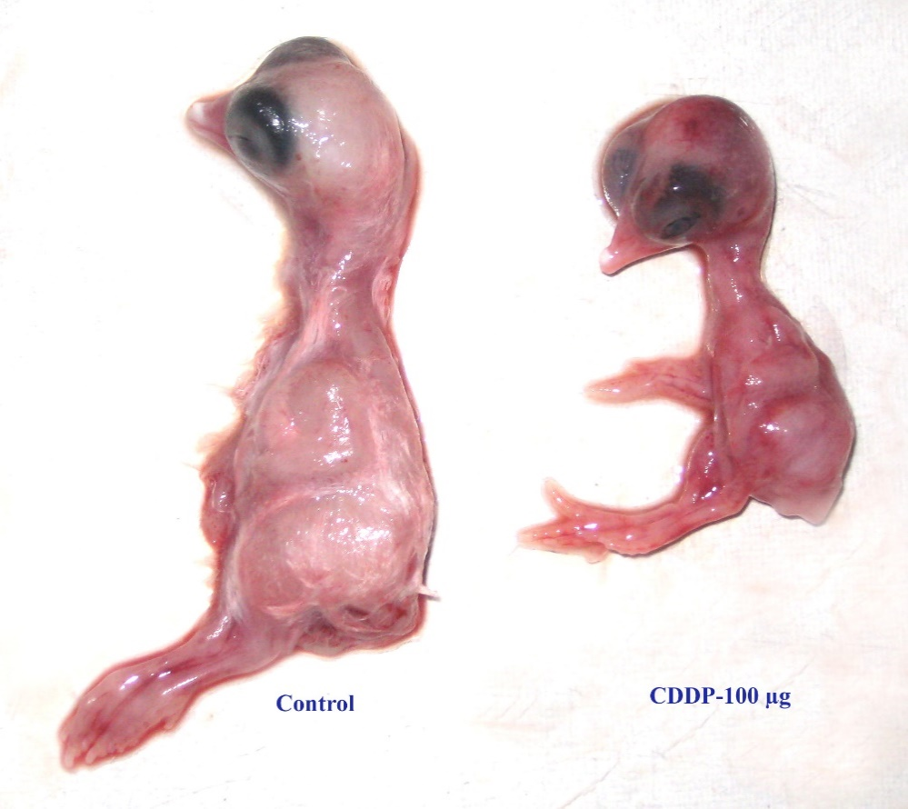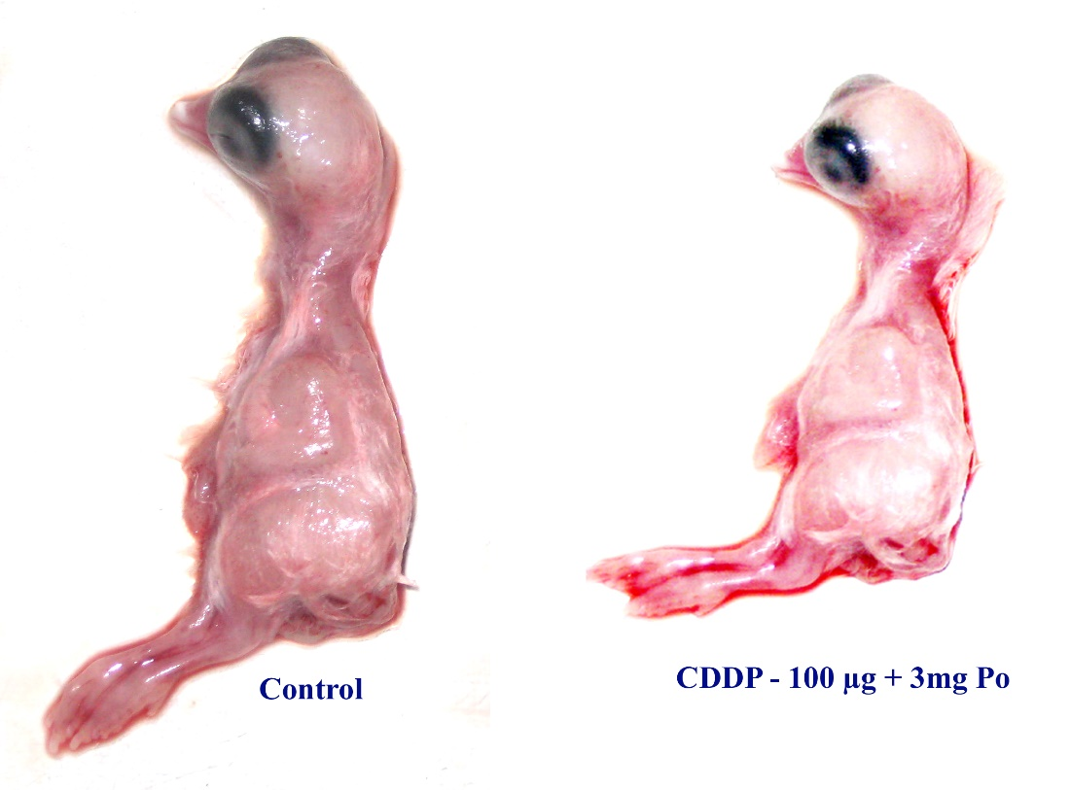

**Figure 1 : Effect of *Portulaca oleracea* L. extract on teratogenic deformities in Cisplatin induced chick embryos**