MAJOR SPECIES OF SOIL ISOPODS IN COASTAL AND AGRICULTURAL AREA OF ALAPPUZHA DISTRICT OF KERALA IN RELATION WITH PHYSICAL AND CHEMICAL FACTORS OF SOIL

ABSTRACT
The integrity of soil is crucial for the ongoing viability of the biosphere. The objective of the present investigation is to identify the predominant isopod species inhabiting the Coastal and Agricultural regions of the Alappuzha district in the state of Kerala, in relation to various soil parameters during 2022 to 2024. Through the analysis of soil samples collected from both Coastal and Agricultural environments, three distinct isopod species have been successfully isolated by using the Berlese-Tullgren funnel method. The identified species comprise Porcellio scaber, Philoscia muscorum, and Philoscia javanensis. The Important Value Index was employed to ascertain the dominant species within the studied ecosystems. Significant disparities were observed between the physical and chemical properties of the two distinct habitats, as well as across different seasonal contexts. The principal soil constituents affecting the isopod population were analysed utilizing Principal Component Analysis (PCA). Based on the findings of the PCA, it is evident that the overall isopod population is predominantly influenced by chemical constituents such as nitrogen, potassium, phosphorus, calcium, and magnesium, alongside physical parameters including temperature, moisture, pH, organic carbon, exchangeable acids, exchangeable bases, sand, silt, and clay.
Keywords: Isopods, Berlese funnel, Edaphic factors, Isopods, Important value index, Principal component Analysis

1.INTRODUCTION
Soil biodiversity is fundamentally significant in the preservation of ecosystem services that are indispensable for human welfare, encompassing nutrient cycling, water purification, and carbon sequestration. The intricate nature of soil ecosystems, which comprises a diverse spectrum of organisms ranging from microorganisms to larger fauna, is essential for the sustenance of agricultural productivity and the equilibrium of ecological systems (Wolters, 1997).
The soil ecosystem comprises macro and microorganisms, air, water, minerals, and organic materials. The mineral component of soil consists of three particle sizes sand, silt, and clay. Sandy soils lack productivity due to poor nutrient retention. Soil fertility is influenced by temperature and moisture. Soil organic carbon constitutes a significant carbon reservoir. Factors such as soil texture, climate, vegetation, and land use determine organic carbon levels in soil. Soil organic matter serves as the primary energy source for soil-dwelling microorganisms. Soil fertility is also affected by secondary minerals like calcium and magnesium, along with essential nutrients such as phosphorus, nitrogen, and potassium (Bini, B., 2015). The spatio-temporal fluctuations in the population density of the terrestrial isopod Philoscia muscorum in relation to soil edaphic variables in Thiruvananthapuram, Kerala and the complex interplay between isopod populations and their soil habitats, which is shaped by a multitude of factors, including urbanization, soil composition, and moisture content (Manjary and Sanal Kumar ,2021).
2. STUDY AREA
The coastal region of Kayamkulam and the agricultural region of Chengannur in the Alappuzha District have been selected for this investigation. The agricultural region of Chengannur, Alappuzha district, which lies between 9.3286° North latitude and 76.6166° East longitude, and the Kayamkulam coastline area, which is situated in the district between 9.1657° North latitude and 76.5005° East longitude.
3. MATERIALS AND METHODS
3.1 Sampling and Extracting Soil Isopods
To obtain samples, twenty sampling locations were randomly selected from each habitat. A soil auger was used to gather random soil samples of 5 × 5 cm² and 10 cm deep. Soil samples were collected and transferred to a polythene bag for transportation to the laboratory and properly labelled. Between 2022 and 2024, samples were collected monthly from the study locations throughout the monsoon, post monsoon and pre-monsoon seasons. Soil samples were placed in a 15 x 25 cm plastic tray, and hand-picked the large isopods. The remaining Isopods were extracted in a beaker containing 2 percentage of picric acid with the help of a Berlese Tullgren funnel. The extracted microarthropods were identified using the identification keys given by Kuhnelt in 1961. The isopods were preserved using 99.9% ethanol. The population density of isopod species is investigated from the extracted population from the sample. Major isopods in both habitats have been found by the Important Value Index (IVI) by calculating the Relative frequency (RF), Relative density (RD), and Relative area (RA) of each species (Ismail et al., 2021).
3.2 Soil Analysis
The soil edaphic variables that were examined from the soil samples were temperature, pH, exchangeable base, exchangeable acid, organic carbon matter in soil, moisture in soil, silt, sand and clay content. The soil's chemical makeup, including amounts of calcium, phosphorus, magnesium, nitrogen and potassium, was investigated. The soil's temperature was measured on-site using a soil thermometer. The soil's pH was measured using a soil pH meter. Exchangeable base and exchangeable acid were measured using Trivedy and Goel's technique (Trivedy et al.,1987). The value of organic matter in the soil was measured using the Walkley and Black technique (Walkley et al.,1934). The gravimetric technique was employed to quantify the moisture content present within the soil matrix. Soil samples underwent air drying followed by sieving, and various chemical parameters including phosphorus magnesium, nitrogen, potassium and calcium were meticulously analysed within these samples. The Kjeldahl distillation method was utilized to ascertain the nitrogen concentration, molybdate stannous chloride was employed to evaluate the phosphorus content, and flame photometry was applied to measure the potassium levels (APHA, 2012). The EDTA titration method as delineated by Jackson in 1958 was utilized to assess the concentrations of calcium and magnesium in the soil (Jackson M, 1958).
3.3 Data Analysis
Microsoft Excel was employed to generate descriptive statistical analyses. Utilizing the SPSS program version 21, a two-way analysis of variance (ANOVA) was executed to ascertain any statistically significant differences in the values of each parameter across various sites and seasons. Principal component analysis (PCA) was conducted using the PAST 4.03 software to examine the correlations between isopod populations, edaphic factors, and chemical variables.
4. RESULT AND DISCUSSION
4.1 Major Species
Three predominant isopod species have been isolated from coastal soil samples, alongside three distinct major isopod species identified from agricultural soil samples. The species identified comprise Philoscia muscorum, Porcellio scaber, and Philoscia javanensis. In the coastal region, the population density of all isopod species exhibits a pronounced peak during the post-monsoon period, while a diminished population peak is observed during the monsoon season (Figure 1.). The populations of P. muscorum and P. javanensis are comparatively more prevalent than that of P. scaber. Two-way ANOVA analysis indicates that there is a statistically significant variation in the population densities of all three species across different seasons (P<0.05), whereas no significant variation is noted among the samples (P>0.05). In the coastal environment, P. muscorum and P. javanensis demonstrate greater dominance, with Importance Value Index (IVI) scores of 310.19 and 271.3134, respectively. Conversely, P. scaber, with an IVI score of 258.4417, exhibits lesser dominance relative to the other species (Table 1).

Figure 1. Population density of different isopod species in different seasons in Coastal Area of Alappuzha District.

Figure 2. Population density of different isopod species in different seasons in Agricultural Area of Alappuzha District.
In the domain of agriculture, the population density of all Isopod species exhibits a pronounced peak during the post-monsoon period, while a marked decline in population density is observed during the monsoon season (Figure 2.). The application of two-way ANOVA indicates that there exists a statistically significant variation in population density among the three species across different seasons (P<0.05), whereas no significant variation is detected between the samples (P>0.05). Within the agricultural context, all three species demonstrate a pronounced dominance in population. Specifically, P. muscorum exhibits an Importance Value Index (IVI) of 303.165, P. javanensis possesses an IVI of 296.866, and P. scaber is recorded with an IVI of 299.969, thereby illustrating their dominance in the agricultural environment (Table 2.).
Table 1. Important Value Index (IVI) of different isopods in different seasons of Coastal Area, Kayamkulam, Alappuzha District
Species | Seasons | Monsoon
Species | Seasons | RD | RF | RA | IVI
Philoscia muscorum | Monsoon | 39.34192 | 30.30303 | 30.30303 | 99.94798
Philoscia muscorum | Post monsoon | 37.58389 | 33.33333 | 33.33333 | 104.2506
Philoscia muscorum | Pre monsoon | 39.32814 | 33.33333 | 33.33333 | 105.9948
Philoscia muscorum | Total IVI |  |  |  | 310.1934
Philoscia javanensis | Monsoon | 0.37196 | 33.33333 | 33.33333 | 67.03863
Philoscia javanensis | Post monsoon | 33.8255 | 33.33333 | 33.33333 | 100.4922
Philoscia javanensis | Pre monsoon | 37.11594 | 33.33333 | 33.33333 | 103.7826
Philoscia javanensis | Total IVI |  |  |  | 271.3134
Porcellio scaber | Monsoon | 0.234621 | 36.36364 | 36.36364 | 72.96189
Porcellio scaber | Post monsoon | 28.5906 | 33.33333 | 33.33333 | 95.25726
Porcellio scaber | Pre monsoon | 23.55592 | 33.33333 | 33.33333 | 90.22258
Porcellio scaber | Total IVI |  |  |  | 258.4417

Table 2. Important Value Index (IVI) of different isopods in different seasons of Agricultural Area, Chengannur, Alappuzha District
Species | Seasons | Monsoon
Species | Seasons | RD | RF | RA | IVI
Philoscia muscorum | Monsoon | 36.48184 | 33.33333 | 33.33333 | 103.1485
Philoscia muscorum | Post monsoon | 33.40611 | 33.33333 | 33.33333 | 100.0728
Philoscia muscorum | Pre monsoon | 33.27703 | 33.33333 | 33.33333 | 99.94369
Philoscia muscorum | Total IVI |  |  |  | 303.165
Philoscia javanensis | Monsoon | 31.12811 | 33.33333 | 33.33333 | 97.79477
Philoscia javanensis | Post monsoon | 34.82533 | 33.33333 | 33.33333 | 101.492
Philoscia javanensis | Pre monsoon | 30.91216 | 33.33333 | 33.33333 | 97.57882
Philoscia javanensis | Total IVI |  |  |  | 296.866
Porcellio scaber | Monsoon | 32.39006 | 33.33333 | 33.33333 | 99.05672
Porcellio scaber | Post monsoon | 31.76856 | 33.33333 | 33.33333 | 98.43522
Porcellio scaber | Pre monsoon | 35.81081 | 33.33333 | 33.33333 | 102.4775
Porcellio scaber | Total IVI |  |  |  | 299.969

4.2 Soil Analysis
Table 3. Mean ± SE of soil factors of Coastal Area- Kayamkulam, Alappuzha District.
Mean ± SE of soil factors of Coastal Area- Kayamkulam, Alappuzha District
Parameters | Monsoon | Post Monsoon | Pre Monsoon
Moisture % | 76.87 ± 2.92 | 65.93 ± 3.28 | 61.23 ± 2.66
Temperature | 22.54 ± 1.38 | 24.51 ± 0.32 | 25.64 ± 0.08
pH | 5.32 ± 0.10 | 4.26 ± 0.06 | 3.97 ± 0.08
O C % | 3.36 ± 0.51 | 4.39 ± 0.71 | 4.58 ± 0.27
EA % | 2.11 ± 0.15 | 2.749 ± 0.11 | 2.57 ± 0.10
EB% | 5.44 ± 0.14 | 10.47 ±1.10 | 4.95 ± 0.085
Sand % | 82.45 ± 1.46 | 65.53 ± 0.28 | 63.17 ± 5.63
Silt % | 7.27 ± 0.05 | 12.66 ± 0.06 | 10.57 ± 0.09
Clay % | 11.09 ± 0.10 | 14.00 ± 0.31 | 10.87 ± 0.19
N (ppm) | 2454.14 ± 5.34 | 4566.28 ± 9.97 | 3563.84 ± 2.44
P (ppm) | 4.25 ± 0.20 | 5.86 ± 0.21 | 4.34 ± 0.13
K (ppm) | 445.07 ± 2.275 | 197.29 ± 1.99 | 397.74 ± 1.63
Ca (ppm) | 453.90 ± 4.38 | 217.07 ± 2.24 | 491.16 ± 4.45
Mg (ppm) | 51.43 ± 1.28 | 44.77 ± 1.58 | 54.84 ± 1.94

Table 4. Mean ± SE of soil factors of Agricultural Area- Chengannur, Alappuzha District
Mean ± SE of soil factors of Agricultural Area-Chengannur, Alappuzha District
Parameters | Monsoon | Post Monsoon | Pre Monsoon
Moisture % | 86.29 ± 0.21 | 82.30 ± 0.10 | 77.64 ± 0.25
Temperature | 23.21 ± 0.11 | 25.14 ± 0.07 | 26.22 ± 0.12
pH | 5.53 ± 0.01 | 4.52 ± 0.02 | 4.09 ± 0.02
O C % | 4.17 ± 0.01 | 4.75 ± 0.02 | 5.39 ± 0.06
EA % | 63.14 ± 0.20 | 60.52 ± 0.13 | 66.24 ± 0.13
EB% | 12.26 ± 0.10 | 10.46 ± 0.01 | 9.48 ± 0.03
Sand % | 53.08 ± 0.17 | 55.48 ± 0.10 | 58.90 ± 0.06
Silt % | 20.16 ± 0.12 | 18.15 ± 0.06 | 17.06 ± 0.17
Clay % | 25.63 ± 0.06 | 24.06 ± 0.01 | 22.64 ± 0.14
N (ppm) | 2738.51 ± 3.74 | 2623.75 ± 1.63 | 2642.94 ± 9.37
P (ppm) | 7.56 ± 0.01 | 6.14 ± 0.01 | 7.99 ± 0.03
K (ppm) | 152.82 ± 0.36 | 172.09 ± 0.39 | 150.57 ± 0.31
Ca (ppm) | 1399.50 ± 0.44 | 1347.43 ± 0.96 | 1440.66 ± 1.03
Mg (ppm) | 67.067 ± 0.11 | 73.92 ± 0.21 | 71.92 ± 0.16

The findings pertaining to the edaphic and chemical properties of soil in Coastal and Agricultural regions are documented in Table 3 and Table 4, respectively. The mean soil moisture content observed in coastal regions was 76.87% during the monsoon season, 65.93% in the post-monsoon period, and 61.23% in the pre-monsoon phase. Conversely, the mean soil moisture content recorded in agricultural areas was 86.29% during the monsoon, 82.30% in the post-monsoon, and 77.64% in the pre-monsoon. The two-way ANOVA indicated statistically significant variations between locations (P<0.05) and temporal seasons (P<0.05). The mean soil temperature in coastal regions was found to be 22.54°C during the monsoon, 24.51°C in the post-monsoon, and 25.64°C in the pre-monsoon. In contrast, agricultural lands exhibited monsoon temperatures of 23.21°C, post-monsoon temperatures of 25.14°C, and pre-monsoon temperatures of 26.22°C. The two-way ANOVA further elucidated significant differences between locations (P<0.05) and seasonal variations (P<0.05). The mean pH level of the soil in coastal regions was recorded at 5.32 during the monsoon season, 4.26 in the post-monsoon phase, and 3.97 in the pre-monsoon period. Conversely, the agricultural land exhibited a pH level of 5.53 during the pre-monsoon, 4.52 in the post-monsoon, and 4.09 throughout the monsoon. The two-way ANOVA indicated that there were statistically significant differences across both sites (P<0.05) and seasons (P<0.05). In coastal regions, the average organic matter content of the soil was determined to be 3.36% during the monsoon season, 4.39% in the post-monsoon phase, and 4.58% throughout the pre-monsoon period. The mean organic carbon content in the agricultural sector was observed to be 4.17% during the monsoon, 4.75% in the post-monsoon, and 5.39% during the pre-monsoon. The two-way ANOVA analysis demonstrated significant variances between sites (P<0.05) and across seasons (P<0.05).
On average, the proportion of exchangeable acid present in coastal regions was recorded at 2.11% during the monsoon season, 2.74% in the post-monsoon period, and 2.57% in the pre-monsoon phase. The mean exchangeable acid concentration within the agricultural sector was observed to be 63.14% during the monsoon, 60.52% following the monsoon, and 66.24% preceding the monsoon. In terms of exchangeable base, coastal land exhibited an average percentage of 5.44% throughout the monsoon season, 10.47% during the post-monsoon interval, and 4.95% in the pre-monsoon timeframe. The mean value of exchangeable base within the agricultural landscape was determined to be 12.26% during the monsoon, 10.46% in the post-monsoon, and 9.48% prior to the monsoon. Coastal land demonstrated an average sand content percentage of 82.45% during the monsoon, 65.53% in the post-monsoon, and 63.17% during the pre-monsoon. Conversely, the average sand composition in the agricultural domain was found to be 53.08% during the monsoon, 55.48% in the post-monsoon, and 58.90% in the pre-monsoon. On average, the calculated proportion of silt content in soil of coastal area was 7.27% prior to the onset of the monsoon, 12.66% during the post-monsoon, and 10.57% amidst the monsoon season. In agricultural regions, the mean silt content is observed to be 20.16% during the monsoon, 18.15% in the post-monsoon period, and 17.06% preceding the monsoon. The average concentration of clay found within coastal soils was determined to be 11.09% during the monsoon season, 14.00% in the post-monsoon phase, and 10.87% prior to the monsoon. Conversely, the mean clay content in agricultural areas is reported to be 25.63% during the monsoon, 24.06% subsequent to the monsoon, and 22.64% before the commencement of the monsoon. Notable disparities were identified between different habitats (P<0.05) and across various seasons (P<0.05) concerning all examined edaphic parameters.
The chemical constituents, including nitrogen (N), phosphorus (P), potassium (K), calcium (Ca), and magnesium (Mg), were analysed within the designated study regions. The coastal ecosystem displayed an average nitrogen concentration of 2454.14 ppm during the monsoon season, 4566.28 ppm in the post-monsoon phase, and 3563.84 ppm throughout the pre-monsoon period. The agricultural ecosystem exhibited nitrogen levels of 2738.51 ppm during the monsoon, 2623.75 ppm in the post-monsoon, and 2642.94 ppm during the pre-monsoon. The nitrogen concentrations in both agricultural and coastal habitats exhibited significant variability across different habitats (P<0.05) as well as across seasonal changes (P<0.05). The average concentration of phosphorus in coastal regions was recorded at 4.25 ppm during the monsoon season, 5.86 ppm in the post-monsoon period, and 4.34 ppm prior to the monsoon. In agricultural ecosystems, phosphorus concentrations exhibited mean values of 7.56 ppm during the monsoon, 6.14 ppm in the post-monsoon, and 7.99 ppm in the pre-monsoon phase. The phosphorus concentrations in forest and plantation habitats demonstrated statistically significant differences both across habitats (P<0.05) and seasonal variations (P<0.05). An average potassium concentration of 445.07 ppm was observed during the monsoon, 197.29 ppm during the post-monsoon, and 397.74 ppm during the pre-monsoon in coastal environments. The mean potassium concentrations in agricultural habitats varied, measuring 152.82 ppm during the monsoon, 172.09 ppm in the post-monsoon, and 150.57 ppm during the pre-monsoon. The findings revealed a significant disparity between habitats (P<0.05) and across different seasons (P<0.05). The mean calcium concentration in the coastal region is quantified at 453.90 ppm throughout the monsoon season, 217.07 ppm during the post-monsoon phase, and 491.16 ppm in the pre-monsoon period. Conversely, the mean calcium concentrations within the agricultural sector are recorded at 1399.50 ppm prior to the onset of monsoon, 1347.43 ppm during the monsoon season, and 1440.66 ppm following the monsoon. Notably, significant fluctuations (P<0.05) are observed in the calcium concentrations among the two distinct habitats and across various seasonal intervals. The average magnesium concentration within the coastal region is determined to be 51.43 ppm during the monsoon season, 44.77 ppm in the post-monsoon phase, and 54.84 ppm prior to the monsoon. In the agricultural sector, the average magnesium levels are assessed at 67.067 ppm during the monsoon season, 73.92 ppm in the post-monsoon, and 71.92 ppm during the pre-monsoon. Significant disparities in magnesium concentrations are evident between coastal and agricultural habitats, as well as across the different seasons (P<0.05).
4.3 Principal Component Analysis
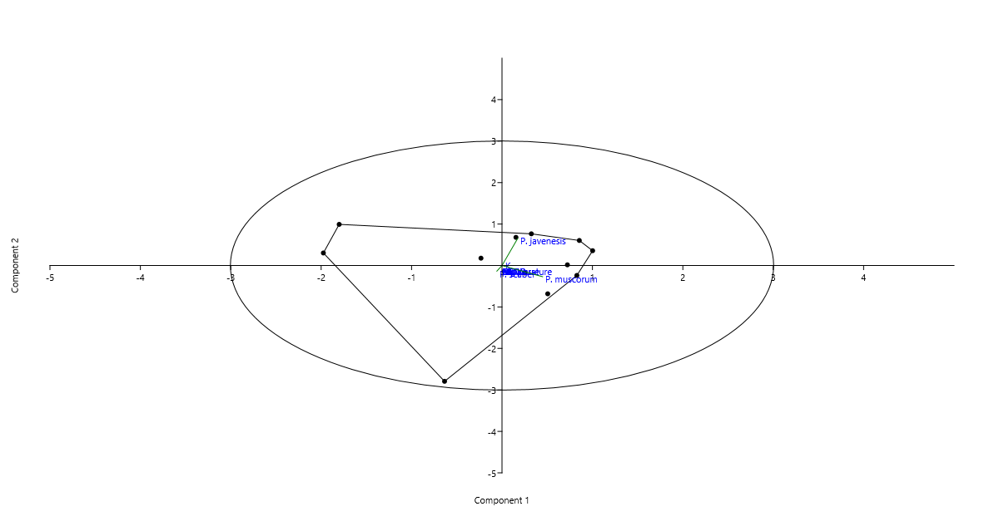
Figure 3. Principal Components Controlling the isopod population in Coastal area during monsoon season

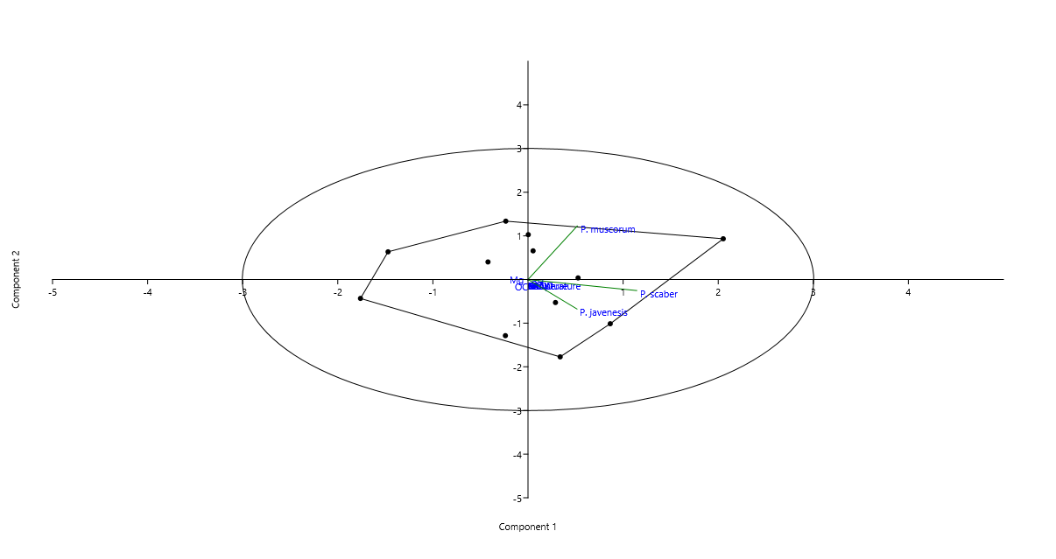Figure 4. Principal Components Controlling the isopod population in Coastal area during post monsoon season
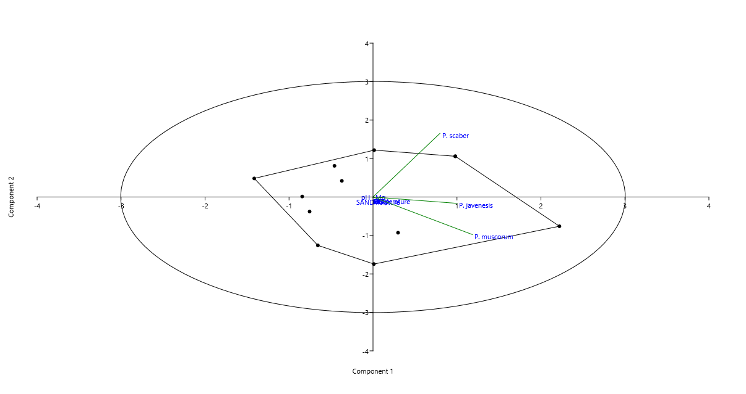
Figure 5. Principal Components Controlling the isopod population in Coastal area during pre-monsoon season

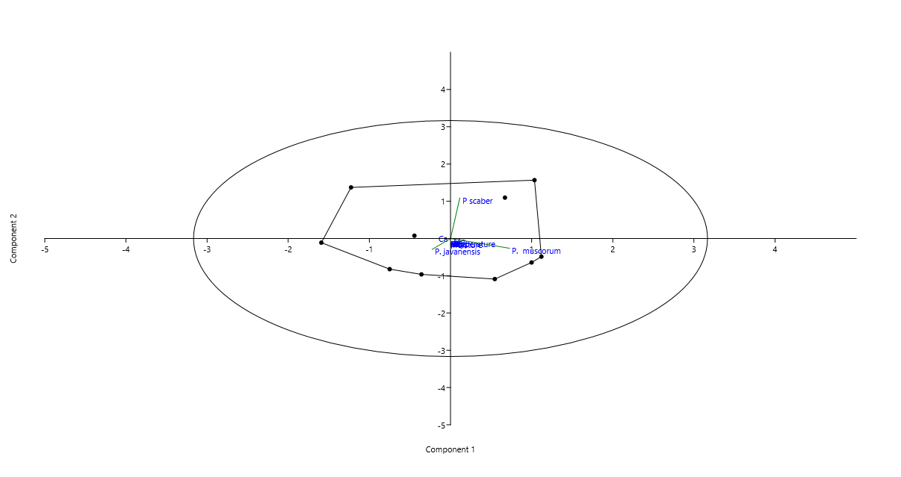
Figure 6. Principal Components Controlling the isopod population in Agricultural area during monsoon season
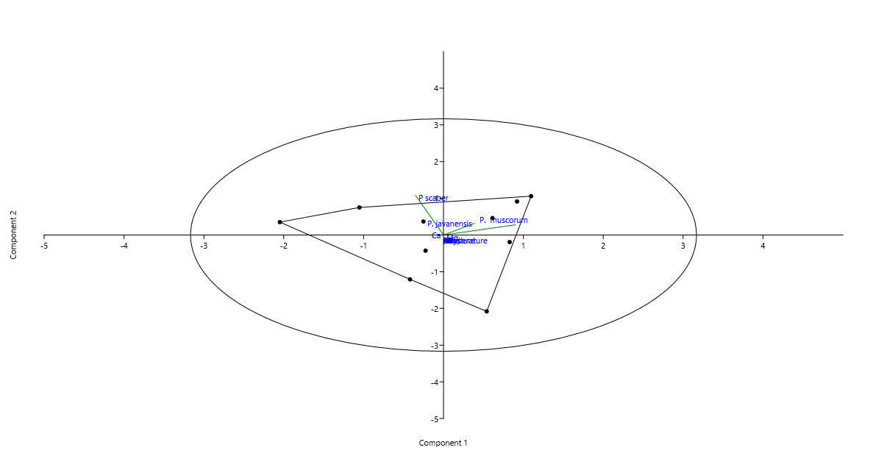

Figure 7. Principal Components Controlling the isopod population in Agricultural area during post monsoon season
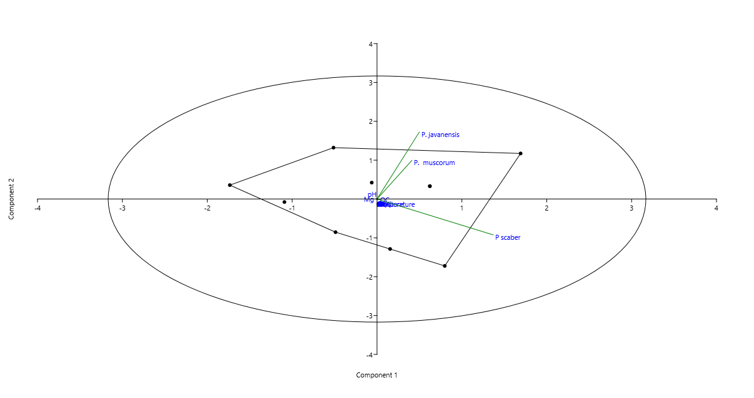

Figure 8. Principal Components Controlling the isopod population in Agricultural area during pre-monsoon season
Principal component analysis is conducted to evaluate the influence of edaphic and chemical parameters on the overall isopod population within the designated study area. The biplot elucidates that the total isopod population in the coastal region during the monsoon season (Figure 3.), the post-monsoon season (Figure 4.), and the pre-monsoon season (Figure 5.) is predominantly governed by physical factors such as organic carbon, exchangeable acid, exchangeable base, sand, as well as chemical factors including potassium and magnesium. During the post-monsoon season, the isopod population is positively influenced by moisture, temperature, pH, exchangeable base, and phosphorus.
In accordance with the principal component analysis, the total isopod population in agricultural environments is positively influenced by pH, exchangeable base, sand, silt, clay, and nitrogen, potassium, phosphorus, magnesium, and calcium during the monsoon period (Figure 6.). Throughout the post-monsoon period, the total isopod population is regulated by moisture, exchangeable acid, phosphorus, and calcium within the agricultural habitat (Figure 7.). In the pre-monsoon period, the total isopod population is influenced by temperature, organic carbon, sand, silt, nitrogen, potassium, calcium, and magnesium contents within the agricultural habitat (Figure 8). A multitude of determinants, encompassing moisture, organic carbon, exchangeable acids, clay content, exchangeable bases, nitrogen, phosphorus, calcium, and magnesium, significantly influence the spatial distribution of microarthropod populations (Bhavya, L. R. and Sanal Kumar M. G., 2021). An augmented level of phosphorus within the soil serves as an indicator of enhanced organic matter decomposition (Oladoye A. O,2015). Analysing the diversity and abundance of soil arthropods across various habitat types, considering diverse climatic and edaphic conditions, will facilitate an understanding of how abiotic factors govern both system stability and faunal functionalities (Pramanik et al., 2015). Soil moisture content and chemical characteristics are integral to the distribution of isopods, as they exhibit a preference for soils that are dense and capable of retaining moisture. The availability of specific nutrients (Calcium and Magnesium) along with soil pH also plays a critical role in shaping isopod populations, with distinct species demonstrating affinities for certain edaphic conditions (Kula et al., 2016). Isopods display diverse responses to climatic variables, whereby their distribution is intricately correlated with habitat attributes and the availability of moisture (Sfenthourakis S and Hornung, E, 2018). The distribution and population density of isopods are profoundly affected by climatic parameters, particularly humidity and temperature (Warburg, 1984). Soil temperature and moisture levels are essential determinants of microarthropod density. For example, elevated densities are frequently observed during the rainy season, attributable to enhanced soil moisture, which facilitates microarthropod activity (Acharya et al., 2020, Reddy, 1984).
The population density of all identified isopod species exhibits elevations during the post-monsoon season (Manjary S. and Sanalkumar M. G.,2021) The overall size of the microarthropod population demonstrated a significant positive correlation with both the temperature and moisture content of the soil at the time of sampling, among all factors considered (Bhattacharya and Raychaudhuri, 1981). For soil-dwelling organisms, calcium serves as a crucial nutritional component that is indispensable for plant sustenance and the stabilization of soil organic matter (Prietzel et al., 2021). The concentrations of organic matter and clay within the soil significantly influence its capacity for nutrient exchange (Bini et al., 2015). Temperature and soil moisture emerge as critical determinants in regulating the diversity and abundance of microarthropods (Ruby Angurana et al., 2022). The density of soil microarthropods is affected by numerous variables, including soil moisture, temperature, soil pH, and available food sources. Consequently, the proliferation of soil microarthropod populations is attributable to both seasonal fluctuations and edaphic conditions. The diversity of soil microarthropods is profoundly shaped by the physical properties and chemical properties of the soil (Abbas M. J. and Parwez, H, 2012).
5. Conclusion

In the coastal and agricultural regions, the post-monsoon period exhibited the highest density of isopod populations. The predominant species in the coastal environment comprise Philoscia muscorum, Philoscia javanensis, and Porcellio scaber. Conversely, in the agricultural zone, the dominant species include Philoscia muscorum, Philoscia javanensis, and Porcellio scaber. According to the results derived from the Principal Component Analysis (PCA), it is apparent that the overall isopod population is significantly affected by chemical constituents such as nitrogen, potassium, phosphorus, calcium, and magnesium, in conjunction with physical parameters including temperature, moisture, pH, organic carbon, exchangeable acids, exchangeable bases, sand, silt, and clay. The intrinsic characteristics of the soil must be preserved to ensure the survival of soil biota, which are critical components of the soil ecosystem.

References

- Wolters, V. (1997). The good, the bad and the ugly: Is there more to say about soil biodiversity in soil? In V. Wolters (Ed.), Ecosystems research report No. 24 (pp. 3–9). Luxembourg: Office for Official Publications of the European Communities.
- Bini, B., Sanal Kumar, M. G., & Vinod, P. (2015). Comparative study on the seasonal variations in the soil edaphic and chemical factors of agricultural and grassland habitats of central Travancore, Kerala. International Journal of Science and Research (IJSR), 4(1), 387–391.
- Manjary, S., & Sanalkumar, M. G. (2021). Spatio-temporal variations in population density of terrestrial isopod, Philoscia muscorum, with reference to soil edaphic factors at selected areas of Thiruvananthapuram district, Kerala. Uttar Pradesh Journal of Zoology, 42(8), 1–8.
- Kühnelt, W. (1955). In D. K. McE. Kevan (Ed.), Soil zoology (pp. 397–411).
- Ismail, Sulistiono, Hariyadi, S., & Madduppa, H. (2021). Diversity, density, and Importance Value Index of mangroves in the Segara Anakan lagoon and its surrounding area, Cilacap Regency, Indonesia. In IOP Conference Series: Earth and Environmental Science, 744(1), 012034. IOP Publishing.
- Trivedy, R. K., Goel, P. K., & Trisal, C. L. (1987). Practical methods in ecology and environmental science, Environmental Publications. (340 pp.).
- Walkley, A., & Black, I. A. (1934). An examination of the Degtjareff method for determining soil organic matter, and a proposed modification of the chromic acid titration method. Soil Science, 37(1), 29–38.
- American Public Health Association. (2012). Standard methods for the examination of water and wastewater (22nd ed.). American Public Health Association. 2013 pp.
- Jackson, M. 1958) Soil chemical analysis prentice Hall. Inc., Englewood Cliffs, NJ, 498 (, 183-204.
- Bhavya, L. R., & Sanal Kumar, M. G. (2021). Effect of soil edaphic and chemical factors on the population density of a terrestrial detritivore collembolan—Cyphoderus javanus in different places of Thiruvananthapuram district. Uttar Pradesh Journal of Zoology, 42(13), 22–31
- Oladoye, A. O. (2015). Physicochemical properties of soil under two different depths in a tropical forest of International Institute of Tropical Agriculture, Abeokuta, Ibadan, Nigeria. Journal of Research in Forestry, Wildlife and Environment, 7(1), 40–54.
- Pramanik, R., Sarkar, K., & Joy, V. C. (2001). Efficiency of detritivore soil arthropods in mobilizing nutrients from leaf litter. Tropical Ecology, 42(1), 51–58.
- Kula, E., & Lazorik, M. (2016). Centipedes, millipedes, terrestrial isopods and their relationships to physical and chemical properties of forest soils. Entomologica Fennica, 27(1), 33-51.
- Sfenthourakis, S., & Hornung, E. (2018). Isopod distribution and climate change. ZooKeys, (801), 25–61.
- Warburg, M. R., Linsenmair, K. E., & Bercovitz, K. (1984). The effect of climate on the distribution and abundance of isopods. Journal of Animal Ecology, 53(3), 753–761.
- Acharya, P., Samal, S., & Mishra, C. S. K. (2020). Microarthropod population dynamics in a subtropical deciduous forest of the Eastern-Ghat hill range in India in response to variation in edaphic factors. Tropical Ecology, 61(2), 230–241.
- Reddy, M. V. (1984). Seasonal fluctuation of different edaphic microarthropod population densities in relation to soil moisture and temperature in a pine, Pinus kesiya Royle plantation ecosystem. International Journal of Biometeorology, 28(1), 55–59.
- Prietzel, J., Klysubun, W., & Hurtarte, L. C. C. (2021). The fate of calcium in temperate forest soils: A Ca K-edge XANES study. Biogeochemistry, 152(2), 195–222.
- Ruby Angurana, Joydeep Dutta and Najitha Banu A (2022). Evaluation of the effects of edaphic factors on population diversity of soil arthropods: A case study of Punjab (India). International Journal of Entomology Research. 2021; 7(8). 80-86.
- Abbas, M. J., and Parwez, H. (2012). Impact of edaphic factors on the diversity of soil microarthropods in an agricultural ecosystem at Aligarh. Indian Journal of Fundamental and Applied Life Sciences, 2, 185–191.

