Original Research Article
Most neglected Babesia species lead to the clinical disease - A case report in a dog

Abstract
A one - year old mixed breed male dog with signs like fever, dullness, loss of appetite, and vomiting was presented at the Referral Veterinary Clinical Complex, Indian Veterinary Research Institute, Izatnagar. On clinical examination, it was found with ticks on the body, a pale mucous membrane, pyrexia (103.1), and dehydration. Haematological examination revealed decreased RBC and thrombocyte counts, and Giemsa’s stained blood smear manifeted Babesia vogeli organisms. The dog was treated with imidocarbdipropionate @6.5 mg/kg IM and doxycycline @ 6 mg/kg body weight IV in divided doses, along with supportive therapy against babesiosis, and showed progressive recovery within 2-3 days of treatment.
Keywords: Babesia vogeli, ticks, Babesiosis, Blood smear, Veterinary
Introduction:
Babesia Spp. are tick-borne protozoan parasites found worldwide and infect the red blood cells of various vertebrate hosts, including humans. Canine babesiosis is a frequent illness that can also be fatal too [1]. The most common Babesia species known to infect dogs are Babesia canis, B. vogeli, B. rossi, and B. gibsoni. Babesiosis is a disease spread by the bite of ticks [2].
Rhipicephalus sanguineus sensu lato, which is mostly prevalent in tropical and subtropical regions, is the vector that spreads B. vogeli [3]. In general, B. vogeli is thought to be very slightly harmful, producing subclinical or extremely mild illness [4,5]. Babesia vogeli infection can cause serious, potentially fatal symptoms in dogs who have had their spleen removed [2]. Clinical symptoms, hematological results, and the identification of intracellular parasites in blood smears are frequently used to diagnose the illness [6].
Case Presentation

In March 2025, the Indian Veterinary Research Institute, Izzatnagar's Referral Veterinary Clinical Complex, was notified of a dog exhibiting symptoms of despair, anorexia, and fever. The patient did not have a history of blood in the urine, but a clinical examination detected pyrexia (103.1°F), a pale mucous membrane, and ticks on the body.
The history did not clarify how vaccination and deworming came to be. The blood collected for haematology and smears made from peripheral blood were screened using an oil immersion compound binocular light microscope, fixed with methanol, and stained using the conventional Giemsa staining technique. The ticks were collected from the dog's body so that their morphology could be examined.
Hematological complications included thrombocytopenia, leukopenia, and anemia in the dog (Table 1). When the blood smear was examined for blood parasites using a binocular compound light microscope, many big, pear-shaped, paired organisms were found inside the erythrocytes at an acute angle in the center (Fig.1). Rhipicephalus sanguineus was determined to be the tick based on its morphology found on the dog's body (Fig 2a, 2b and 2c). In this instance, intramuscular injection of imidocarb dipropionate at a dosage of 6.6 mg/kg B.W. in divided doses was the recommended treatment of canine babesiosis. The antibiotic Doxycycline was suggested to be given orally for 7-10 days at a dose of 5-10 mg/kg body weight per day. The supplementary treatment comprises an IV infusion of 5 percent DNS afterward Ringer's lactate (RL) to restore lost fluid for 3 days; daily intravenous administration of pantoprazole at 0.5 mg/kg; and IV injections of vitamin B-complex at 2 ml once daily for 3 days.

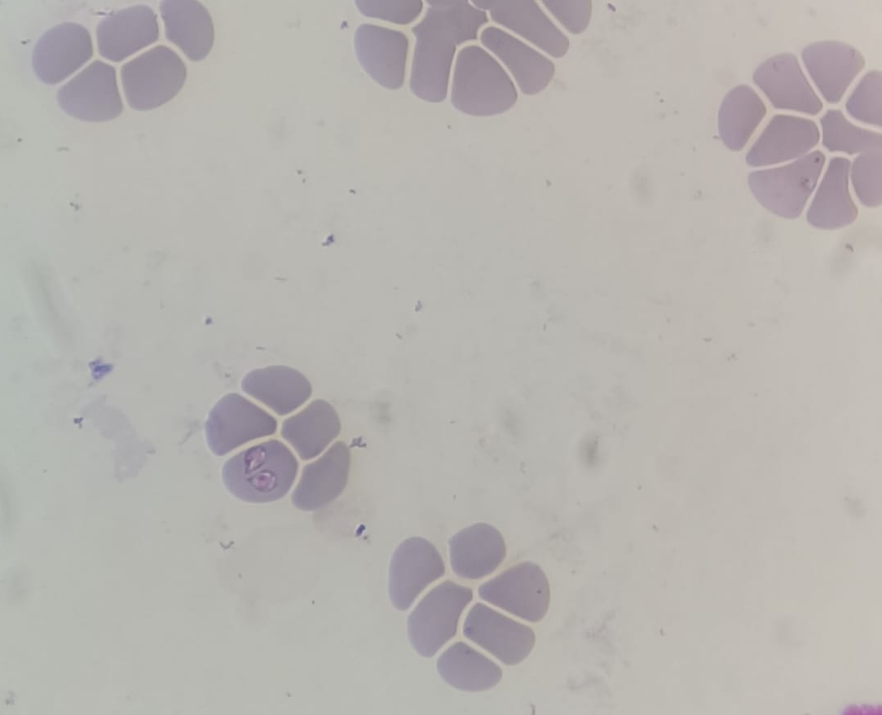

Fig 1: Pear-shaped large piroplasm stage in pair at acute angle inside RBC of dog

Table 1. Complete blood count of presented dog with their normal reference range
Tests | Results | Reference range | Units | Comments
WBC | 4 | 4.5-16.5 | 10³/µL | Leukopenia
RBC | 3.7 | 5.8-9.0 | 10⁶/µL | Anaemia
HGB | 8 | 13-20 | g/dL | Anaemia
HCT | 27 | 38-58 | % | Less
MCV | 73 | 60-75 | fL | -
MCH | 26 | 19-28 | Pg | -
MCHC | 32 | 30-37 | % | -
Platelets | 167 | 180-525 | 10³/µL | Thrombocytopenia

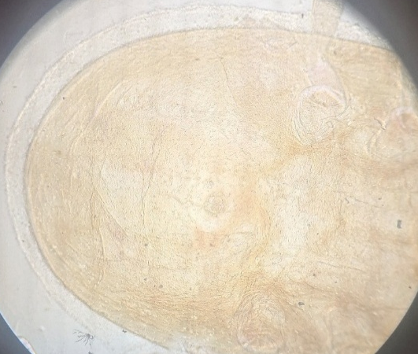
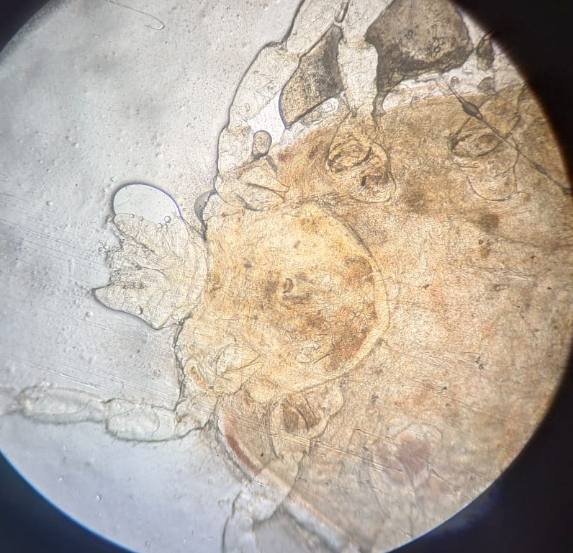

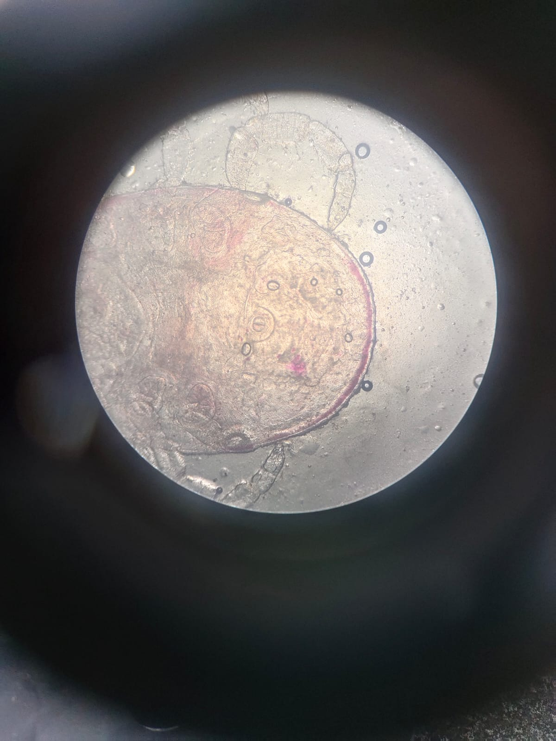
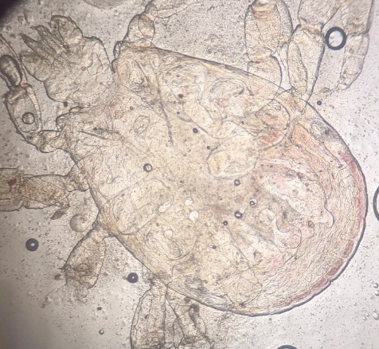

Fig 2a: Female tick first coxae deeply bifid and visible 1/3 scutum, 2b: posterior part of female without festoons 2c: male with festoons, hexagonal basis capitulum, bific first coxae and 2d: Metastriata (Anal groove present posterior to anal opening) in both male and female.(highlight the feature with arrows)

Discussion
Among the Babesia species detected in dogs, Babesia vogeli is one of the most significant infections. The study's findings supported the theory that males are more prone than females to contract B. vogeli [7]. We recognized the vector R. sanguineus, based on the characters, as Reichenow reported in his 1935 [8] research, and compared the huge size of the piroplasm to distinguish it from other Babesia Spp. or for a confirmatory diagnosis.(have u under went micrometry if so mention the range of piroplams)
Additionally, reports of naturally occurring infected dogs have raised the possibility that immunosuppressed canines may be more vulnerable to B. vogeli infections [4,9]. Low hemoglobin levels indicated anemia, which may result from hemoglobin loss brought on by RBC rupture in dogs [10].
When comparing a mild to moderate disease with B. vogeli to moderate disease with B. canis, the clinical symptoms of infection with other small and large Babesia species are often more severe.
Prior to and for a longer period than parasitemia, thrombocytopenia occurred. Some canines showed signs of profound but brief neutropenia [11].
Conclusion
Caution should be taken while analyzing the clinical manifestations, therapy, and prevention of canine babesiosis/piroplasmosis because the causal organism is commonly referred to as B. canis; however, it can be presumed that B. vogeli is associated and in my knowledge this is the first case in this region that lead to a disease condition.
Subsequently, there is a rise in the prevalence of vector-borne diseases in animals, which causes serious illnesses and losses in canines, along with other livestock. Modern infection control methods, like vaccination, natural predators, etc, are essential to prevent vector-borne parasite infections in animals. Epidemiological studies should be carried out to know the prevalence of Babesia vogeli along with other Babesia species and its potential health effects, so that control measures could be taken.

References
1. Selim, A., Megahed, A., Ben Said, M., Alanazi, A. D., & Sayed-Ahmed, M. Z. (2022). Molecular survey and phylogenetic analysis of Babesia vogeli in dogs. Scientific Reports, 12(1), 6988. https://doi.org/10.1038/s41598-022-11079-x
2. Wang, J., Zhang, J., Kelly, P., Zheng, X., Li, M., You, J., ... & Wang, C. (2018). First description of the pathogenicity of Babesia vogeli in experimentally infected dogs. Veterinary parasitology, 253, 1-7. https://doi.org/10.1016/j.vetpar.2018.02.028
3. Ćoralić, A., Gabrielli, S., Zahirović, A., Stojanović, N. M., Milardi, G. L., Jažić, A., ... & Otašević, S. (2018). First molecular detection of Babesia canis in dogs from Bosnia and Herzegovina. Ticks and tick-borne diseases, 9(2), 363-368. https://doi.org/10.1016/j.ttbdis.2017.11.013
4. Solano-Gallego, L., & Baneth, G. (2011). Babesiosis in dogs and cats—expanding parasitological and clinical spectra. Veterinary parasitology, 181(1), 48-60. https://doi.org/10.1016/j.vetpar.2011.04.023
5. Köster, L. S., Lobetti, R. G., & Kelly, P. (2015). Canine babesiosis: a perspective on clinical complications, biomarkers, and treatment. Veterinary Medicine: Research and Reports, 6, 119–128. https://doi.org/10.2147/VMRR.S60431
6. Mittal, M., Kundu, K., Chakravarti, S., Mohapatra, J. K., Singh, V. K., Kumar, B. R., ... & Kumar, A. (2019). Canine babesiosis among working dogs of organised kennels in India: A comprehensive haematological, biochemical, clinicopathological and molecular epidemiological multiregional study. Preventive veterinary medicine, 169, 104696. https://doi.org/10.1016/j.prevetmed.2019.104696
7. Daniel, L. N., Kujul, N. B., Kemza, S. Y., & Ibukunoluwa, M. R. (2016). Retrospective study of the risk factors associated with canine babesiosis diagnosed at veterinary clinic federal college of animal health and production technology, Vom, north central Nigeria, 1999–2006. Int. J. Sci. Appl. Res, 1(1), 86-93.
8. Reichenow, E. (1935). Uebertragungsweise und Entwicklung der Piroplasmen. Zbl Bakt I Orig, 135, 108-199.
9. Irwin, P. J. (2009). Canine babesiosis: from molecular taxonomy to control. Parasites & vectors, 2(Suppl 1), S4. https://doi.org/10.1186/1756-3305-2-S1-S4
10. Venkatesa kumar, E., Kumar, V., & Ramprabhu, R. (2018). Diagnosis and Management of Concurrent Ehrlichiosis and Babesiosis in a Dog. Intas Polivet, 19(2), 267-268.
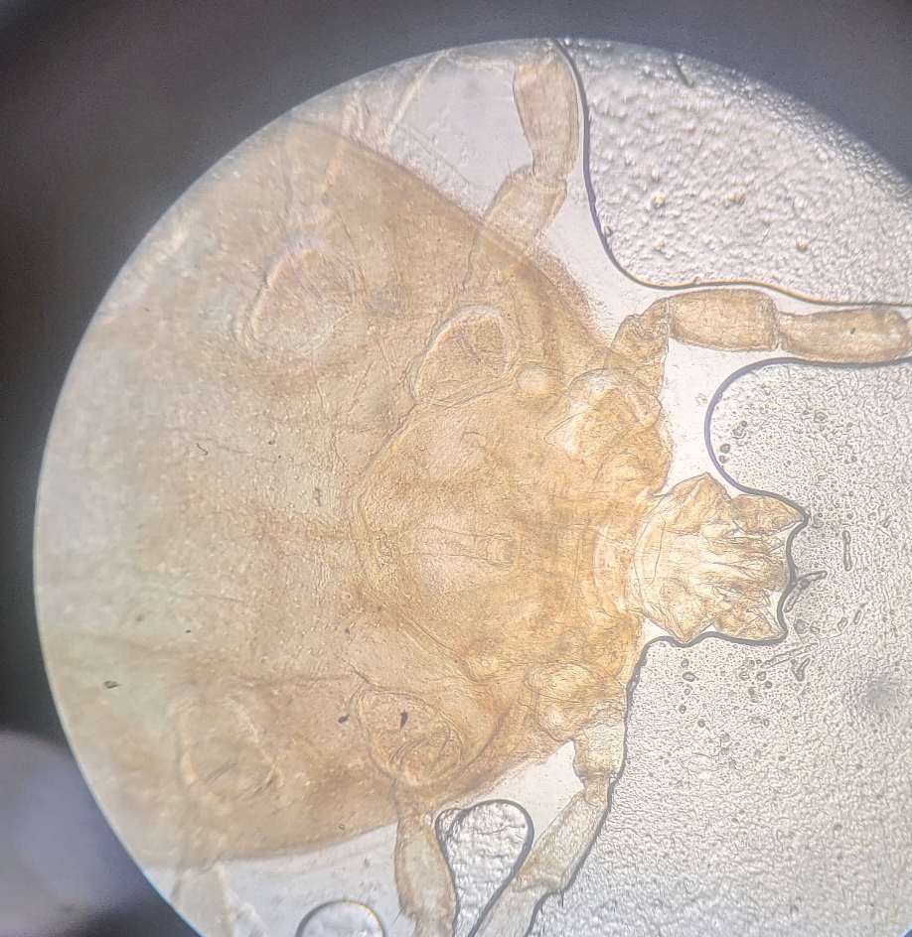
11. Meinkoth, J. H., Kocan, A. A., Loud, S. D., & Lorenz, M. D. (2002). Clinical and hematologic effects of experimental infection of dogs with recently identified Babesia gibsoni-like isolates from Oklahoma. Journal of the American Veterinary Medical Association, 220(2), 185-189. https://doi.org/10.2460/javma.2002.220.185

