Original Research Article
Effects of multi-strain probiotics and early life mineralization on iron-zinc homeostasis in neonatal piglets
Check the journal guideline carefully.
ABSTRACT
The present study was conducted to investigate the effect of multi-strain probiotics and multi mineral on iron-zinc homeostasis in neonatal piglets. Eight apparently healthy sows were selected and randomly divided into four equal groups (Control, MM, MSP and MM+MSP). The Blood samples were collected from anterior vena cava of piglets on day 0, 7, 14 and 21 post-farrowing. The zinc and iron concentration were measured using spectrophotometer. The results revealed that the mean Zn and Fe concentrations were markedly higher in MM group as compare to control, MSP and MM+ MSP groups on day 0. Moreover, that in MM group, Zn concentration on day 14 and 21 and Fe values on day 21 were significantly lower as compared to day 0. The mean concentration of iron on day 7 and Zn on day 7 and 21 were significantly higher as compared to day 0 in MSP group. In MM+ MSP group, mean concentration of Fe on day 14 and 21 and Zn value on day 14 were significantly lower as compared to day 0 and day 7. It is concluded that the supplementation of MSP has better effect on iron zinc homeostasis as compare to MM and MM+MSP supplementations.
Keywords: Multi-strain probiotics, multi-minerals, neonatal piglets.

- INTRODUCTION
Pig husbandry has a tremendous potential for a faster economic return because of some specific intrinsic traits including high fertility, superior feed conversion capacity, early maturity, and short generation interval (Byrne et al., 2022). Currently, one of the biggest obstacles to pig production being a profitable business is neonatal piglet mortality. Furthermore, inadequate mineralization is identified as a key factor for compromised health and elevated neonatal mortality. In hyper-prolific sows, this perinatal transfer of nutrients is not be optimal, although there is an active placental transfer of zinc (Zn) but limited for other trace minerals such as iron (Fe), copper (Cu), and selenium (Se) (Matte and Audet, 2020). Therefore, maintenance of adequate trace mineral levels in systemic circulation after birth is crucial to provide systemic protection against infection and stimulate intestinal growth and function (Cabrera et al., 2012). Among the microminerals, iron (Fe), copper (Cu), zinc (Zn), chromium (Cr), manganese (Mn) and selenium (Se) are essential trace minerals in pig nutrition. Incorporating these organic minerals into pig diets can yield notable benefits in terms of reproductive efficiency. Fe supplementation in the early life enhances pre-weaning survival because newborn piglets are susceptible to anemia since sow milk is a poor source of Fe. Zinc is a crucial trace mineral found in diet and feed. It is essential for the production of cell nucleic acids, cell division, immunological response, cognitive function, and blood coagulation. (Ciesinski et al., 2018). Zinc ions must enter cells in order for the intestinal barrier to function normally and for injured epithelium to heal. Moreover, intracellular zinc reduces inflammation of the gut mucosa (Ou et al., 2007).
For suckling piglets, the first seven days of birth are crucial for the colonization of their gut microbiota. Because of their unstable gut flora, newborn pigs are more prone to enteric and other infections, which increases their mortality rate. Earlier study has proved that single-strain probiotic supplements ameliorate the host’s iron status (Hoppe et al., 2015). Probiotics and Zn operate through distinct pathways, thus combining the two could have a beneficial combination effect. It has previously been documented that probiotics and Zn have synergistic effects on the host due to the Zn’s increased bioavailability (Tesan et al., 2011). The findings of some study also demonstrated that selenium-probiotics supplementation had a greater impact on IL-2 secretion and lymphocyte count than did probiotics (P) or selenium (Se) supplementation alone, indicating that SP is a more potent immune system booster for pigs than P or Se used alone. Based on these, the current study focused on invetigatingthe effect of multi-strain probiotics and multi mineral on iron- zinc homeostasis in neonatal piglets.
- MATERIAL AND METHODS
2.1. Multistrain probiotics preparation and procurement of multi-mineral injection
The probiotic strain: the mixture of MSP, consist of Limosilactobacillusreuteri MW 367846.1, Pediococcus pentasaceus MK611260.1, L. Reuteri KF 149014.1 and L. Johnsoni HM 772969, P. acidilactici KU837245.1 was obtained from Division of Animal Nutrition, ICAR-IVRI, Izzatnagar. Formerly isolatedabove-mentionedstrains were kept in 80% glycerol (1:1 v/v) stock at -80°C. Each probiotic was revived in lactobacillus-selective broth, also known as deManRogosa and Sharpe (MRS) broth (Himedia, Mumbai), and it is then cultured for 24 hours at 37°C. Three passages of the growing culture were required to obtain a colony count of 10⁹ CFU/ml of bacteria. One milliliter of the culture was diluted nine times in NSS (0.9%), dilution after dilution until it reached 10⁹ / CFU. One milliliter of the diluted culture was then added to sterile Petri-plates containing twenty milliliters of melted MRS agar, gently mixed, and incubated for twenty-four hours at 37°C. Cross streaking was done to check synergistic activity of all strains on MRS agar (Fig 1). Multi-minerals (MM) in injectable form (Stimvet™, Zinc 40 mg/ml, manganese 10 mg/ml, copper 15 mg/ml, selenium 5mg/ml) was procured from Wellcon Animal Health Private Limited, Agra, Uttar Pradesh.

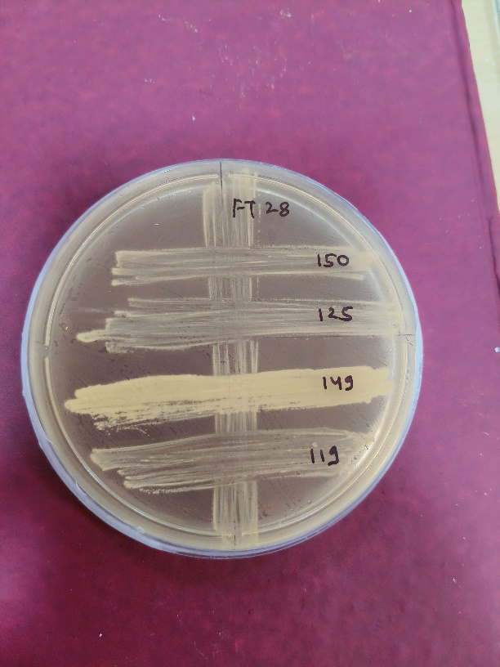
Fig 1: Cross streaking of all strains on MRS agar
2.2. Animals, experimental design and interventions
The present study was carried out in the Swine Production Farm (SPF) of the ICAR-Indian Veterinary Research Institute, Izzatnagar, Bareilly.The protocol of experiment was approved by Institute Animal Ethics Committee of ICAR-IVRI (approval no IAEC/L3). In the current investigation, eight sows with an average weight of 227.375±33.576 (SD) kg and ranging from first to third parity were enrolled and randomly divided into four groups (Control, MM, MSP and MM+MSP) equally (Fig 2).
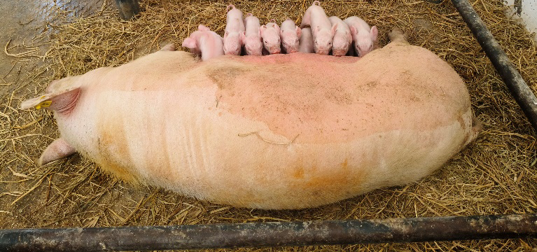
Fig 2: Apparently healthy piglets used for the experiment.
In control group, 17 piglets born from two sows received 1.0 mL of sterile normal saline (NSS) orally daily for seven days after birth whereas 22 piglets born from two sows in group MM were given 0.3 mL of multimineral (MM) injection (Zinc 40 mg/ml, manganese 10 mg/ ml, copper 15 mg/ml, selenium 5mg/ml) through intramuscular (IM) route on days 0 and 7 of birth (Fig 3); and fifteen piglets borne from two sows in MSP group received multi-strain probiotics in ratio 1:1:1:1:1 at a dose rate of 10⁹ colony forming unit (CFU) /piglet for 7 days from birth. In the MM+MSP group, twenty-three piglets born from two sows, received an oral dosage of MSP at the dose rate of 10⁹ CFU per piglet once a day, along with 0.3 mL of MM injection IM on day 0 and day 7 and MSP for first day 7 of birth.

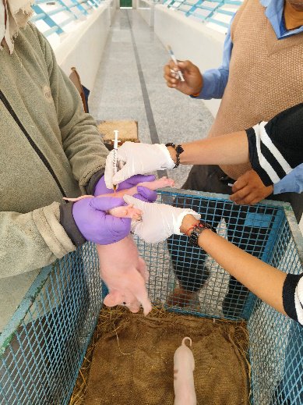
Fig 3: Administration of multimineral injections to the piglets.

2.3. Collection of blood sample
Approximately 2.0 mL of blood was collected in clot activator vacutainer for serum collection from anterior vena cava of piglet before initiation of supplementation (day 0) and thereafter on day 7, 14 and 21 days of the birth. Serum was collected for further testing.
2.4. Measurement of iron (Fe) and zinc (Zn) concentrations in serum
The spectrophotometer thermo-technique was used to measure the amounts of Zn and Fe in serum using commercially available kits for Zn and Fe (zinc kit and iron & TIBC kit, Coral Clinical Systems ltd. Uttarakhand, India), respectively. Zn and Fe concentrations were quantified as mg/dL and ìg/dL, respectively.
  - Statistical analysis
The data were analyzed using GraphPad Prism 6 Statistics Guide. The repeated measures ANOVA were applied. The multiple comparisons between groups, days and the interaction effects were done by using Turkey HSD test. The results were presented as the mean ± the standard error of the mean (SEM).
- RESULTS
The mean Zn and Fe concentrations were markedly higher in MM group as compare to control, MSP and MM+ MSP groups on day 0. No significant difference of Fe level was seen in control group in day 7 (p=0.996), day 14 (p=0.854) and day 21(p=0.999) from day 0 whereas there was significant decrease of Zn value on day 14 (p=0.006) and 21(p=0.001) in the control group. In MM group, the mean Zn concentration on day 14 (p=0.001) and 21 (p=0.013) and the mean Fe value on day 21 (p=0.028) as were significantly lower as compared to day 0. The mean Fe concentration on day 7 (p=<0.001) and the mean Zn concentration on day 7(p=0.012) and day 21(p=0.044) were significantly higher as compared to day 0 in MSP group. In MM+ MSP group, mean Fe concentration on day 14 (p=0.026) and 21 (p=0.015) and the mean Zn value on day 14 (p=0.003) were significantly lower as compared to day 0 and day 7. Here, the interaction between supplementations and days was significant for Zn (p <0.001) and Fe (p <0.001) (Fig 4 and Fig 5).

Fig 4. Changes of concentration of Iron (µg/dL) from day 0 to 21 of birth in control, multimineral (MM), multi strain probiotic (MSP) and MM+MSP groups

Fig 5. Changes of concentration of Zinc (µg/dL) from day 0 to 21 of birth in control, multimineral
(MM), multi strain probiotic (MSP) and MM+MSP groups

- DISCUSSION
In this study, a non-significant change of Fe from day 0 to 21 and a significant decrease in Zn value on day 14 and 21 in the control group might be due to inadequate transfer of minerals to the foetus during the latter part of gestation (Mahan et al., 2009). In an earlier study, it was reported that the limited prenatal transfer of some micronutrients (Cu, Fe and Se) was not compensated by the postnatal transfer (Mahan and Vallet, 1997). Supplementation strategies are well known for these two trace elements with parenteral administrations of Fe to piglets (Matte and Audet, 2020). In MM group, the decreased Zn concentration on day 14 and 21 might be due to difference in bioavailability of Zn in injectable form. Although, the MM used in this study is of inorganic form however, earlier work has shown that the type of ligand influences the stability of a given complex or chelate but the position of the amino acids in a peptide sequence also has a significant impact (Sun et al., 2020). The process of complexing or chelating elements such as Cu, Fe or Zn, for instance, typically involves reacting inorganic mineral salts with a suitable bonding group, such as a peptide or amino acid, after which the mineral becomes part of a biologically stable structure (Byrne and Murphy, 2022). Whereas, a significantly lower Fe level on day 21 as compared to day 0 might be due to the interaction of Mn with several other dietary nutrients such as Zn and Fe by competing with Fe in absorption sites (Watson et al., 1973) or reducing tissue concentrations of Fe and Zn (Miller et al., 1989).
Earlier study has proved that single-strain probiotic supplements ameliorate the host’s iron status (Hoppe et al., 2015). Oral multispecies probiotic supplementation effect on iron turnover remains unexplored. In this study, the multispecies probiotic supplementation significantly increased mean Fe concentration on day 7 and the mean Zn concentration on day 7 and day 21 as compared to day 0 in suckling piglets. Dietary Fe absorption is only possible in the form of Fe²⁺ ion and takes place in the duodenum and small intestine. In the intestinal mucosa, iron is bound with apoferritin, and then stored in the liver as ferritin. Whereas in blood Fe is bound to transferin, which is responsible for blood iron transportation (Silva and Faustino., 2015). Skrypnik, et al. (2019) found significantly higher duodenal Fe levels in rats that received multispecies probiotics compared to the controls, which indicate higher Fe absorption in duodenum. Here, significantly increased mean Fe concentration on day 7 could be due to ability of probiotics to make increased Fe bioavailability. Previous investigations have also confirmed the relationship between probiotics and increased Fe bioavailability (El-Sayed et al., 2022). Earlier investigators evaluated the association between probiotic intake and Zn status in healthy children (Ballini et al., 2019). However, the results of these studies are inconsistent. For examples, two studies in children have showed no significant change in Zn status after probiotic supplementation (Ballini et al., 2019). While, another randomized double-blind trial evaluated the effect of a synbiotic containing L. plantarum, L. acidophilus, B. infantis, B. lacti, prebiotic FOS, lactose free, gluten free, 4.5 × 10⁹ CFU and showed that Zn levels increased by 1.7% in the treated group as compared to a decrease of about 3.5% in the placebo group (Ballini et al., 2019). Beyond the differences in type, dose, and duration of interventions from the studies evaluating the influence of probiotics on Zn status, the combined intake of probiotics and Zn appears to be an important factor. Animal model studies suggested that the efficacy of probiotics may be increased by the combination of probiotics and Zn. Likewise, earlier study on rat model has shown that the combination of probiotics and Zn can improve Zn bioavailability in rat model (Tesan et al., 2011). Therefore, co-supplementation of Zn and probiotics may amplify Zn absorption (Surono et al., 2014). In the current study, mean Fe concentration on day 14 and 21 and the mean Zn value on day 14 were significantly lower as compared to day 0 in suckling piglets that received both MSP and MM. Although no reports are available on the effects of combined supplementation with MSP and MM on Fe and Zn, the contrast finding of this study might be due to antagonistic actions between MM and MSP.
- CONCLUSION
Pig husbandry is gaining momentum in India in recent past owing to its promising outcomes. Like in dairy and poultry sectors, there are many inclement factors which destabilises the piggery farming and piglet mortality is one such factor. Out of many facets which drive piglet mortality, poor absorbance of iron and other microelements is one such factor. In this study, we tried to investigate the effect of multi-strain probiotics and multi mineral on iron- zinc homeostasis in neonatal piglets which revealed that the supplementation of MSP has better effect on iron zinc homeostasis as compare to MM and MM+MSP supplementation. Further studies including a greater number of animals and geographical regions is needed in this aspect to explore more.
DISCLAIMER (ARTIFICIL INTELLIGENCE)
Authors hereby declare that NO generative AI technologies such as Large Language Models (ChatGPT, COPILOT, etc) and text-to-image generators have been used during writing or editing this manuscript.

REFERENCES
Ballini, A., Gnoni, A., De Vito, D., Dipalma, G., Cantore, S., Gargiulo Isacco, C., Saini, R., Santacroce, L., Topi, S., Scarano, A., Scacco, S. & Inchingolo, F. (2019). Effect of probiotics on the occurrence of nutrition absorption capacities in healthy children: a randomized double-blinded placebo-controlled pilot study. European Review for Medical and Pharmacological Sciences, 23(19): 8645–8657.
Byrne, L. & Murphy, R. A. (2022). Relative Bioavailability of Trace Minerals in Production Animal Nutrition: Animal Health Research Reviews, 12(15):1981.
Cabrera, R.A., Lin, X., Campbell, J.M., Moeser, A.J. & Odle, J. (2012). Influence of birth order, birth weight, colostrum and serum immunoglobulin G on neonatal piglet survival. Journal of Animal Science and Biotechnology, 3(1):1-10.
Ciesinski, L., Guenther, S., Pieper, R., Kalisch, M., Bednorz, C. & Wieler, L. H. (2018). High dietary zinc feeding promotes persistence of multi-resistant E. coli in the swine gut. PLoS One,13(1): e0191660.
El-Sayed, E.M. & Ibrahim, K.S. (2022). Ameliorating effects of probiotics on alterations in iron homeostasis and inflammation in COVID-19. Molecular Biology Reports, 49: 5153– 5163.
Hoppe, M., Önning, G., Berggren, A. & Hulthén, L. (2015). Probiotic strain Lactobacillus plantarum 299v increases iron absorption from an iron-supplemented fruit drink: a double-isotope cross-over single-blind study in women of reproductive age. British Journal of Nutrition, 114:1195–1202.
Mahan, D. C., Watts, M. R. & St-Pierre, N. (2009). Macro- and micromineral composition of fetal pigs and their accretion rates during fetal development. Journal of Animal Science, 87(9): 2823–2832.
Mahan, D.C. & Vallet, J.L. (1997). Vitamin and mineral transfer during fetal development and the early postnatal period in pigs. Journal of Animal Science, 75: 2731-2738.
Matte, J.J. & Audet, I. (2020). Maternal perinatal transfer of vitamins and trace elements to piglets. Animal, 14(1): 31-38.
Miller, W.J., Amos, H.E., Gentry, R.P., Blackmon, D.M., Durrance, R.M., Crowe, C.T., Fielding, A.S. & Neathery, M.W. (1989). Long-term feeding of high zinc sulfate diets to lactating and gestating dairy cows. Journal of Dairy Science, 72: 1499–1508.
Ou, D., Li, D., Cao, Y., Li, X., Yin, J., Qiao, S. & Wu, G. (2007). Dietary supplementation with zinc oxide decreases expression of the stem cell factor in the small intestine of weanling pigs. The Journal of Nutritional Biochemistry, 18(12): 820-826.
Silva, B. & Faustino, P. (2015). An overview of molecular basis of iron metabolism regulation and the associated pathologies. BBA Molecular Basis of Disease, 1852:1347– 1359.
Skrypnik, K., Bogdañski, P., Schmidt, M., & Suliburska, J. (2019). The effect of multispecies probiotic supplementation on iron status in rats. Biological Trace Element Research, 192, 234- 243.
Sun, X., Sarteshnizi, R.A., Boachie, R.T., Okagu, O.D., Abioye, R.O., Pfeilsticker Neves, R., Ohanenye, I.C. & Udenigwe, C.C. (2020). Peptide–mineral complexes: understanding their chemical interactions, bioavailability, and potential application in mitigating micronutrient deficiency. Foods. 9: 1402.
Surono, I.S., Martono, P.D., Kameo, S., Suradji, E.W. & Koyama, H. (2014). Effect of probiotic L. plantarum IS-10506 and Zn supplementation on humoral immune response and Zn status of Indonesian pre-school children. The Journal of Trace Elements in Medicine and Biology, 28(4): 465-469.
Tesan, F.C., Hernández, F., Torti, H.E., Massot, F., Huarte, M., Rubín de Celis, E., Barreiro Arcos, M.L., Weill, R., Cremaschi, G.A., Boccio, J. & Salgueiro, M.J. (2011). Glycine-stabilized Zn gluconate has similar bioavailability than Zn sulfate in a Zn fortified probiotic food. The Open Nutraceuticals Journal, 4:136-143.
Watson, L.T., Ammerman, C.B., Feaster, J.P. & Roessler, C.E. 1973. Influence of manganese intake on metabolism of manganese and other minerals in sheep. Journal of Animal Science, 36: 131–136.

