Ichthyofaunal Diversity of Bhojtal Lake (Upper Lake) in Bhopal, M.P with relation to water quality

Abstract: Such a diverse collection of fish, representing 33 species from 9 orders and 13 families, has been recorded in the Upper Lake (Bhojtal), Bhopal. The Cypriniformes came out on top with 45% species richness, followed by Siluriformes forming 28%, and then the remaining smaller proportions of orders like Beloniformes, Synbranchiformes, and Perciformes. Seasonal variations in species richness reveal an increase in diversity during winter, which coincides with environmental parameters favorable for aquatic species life. Biodiversity indices, such as the Shannon-Wiener Index (H′) and Simpson's Index (1-D), reveal the maximum values during the winter season (H′ = 3.384; 1-D = 0.9636), Seasonal changes are also reflected in the monsoon and the values are significantly low there (H′ = 3.046; 1-D = 0.945). These are parameters essential to understand temporal variability. Various physicochemical parameters present seasonal variations, air temperature ranged between 20–35°C, water temperature between 18–31°C, pH between 5.7–7.8, total alkalinity between 92 and 145 mg/L, dissolved oxygen between 5.7 and 7.5 mg/L, free CO₂ between 3 and 10 mg/L, and total hardness between 155 and 234 mg/L, these however are majorly shaped up by subtropical climatic conditions as well as runoff characteristics of Central India. Most of the fish species were classified under the Least Concern (LC) category on the IUCN red data list, however, sighting of Near Threatened (NT) and Vulnerable (VU) species indicates the emerging threats that need continuous conservation inputs. Essentially, the study strongly endorses the vital need for regular monitoring and habitat management to make sure of the long-term sustainability of Upper Lake's aquatic biodiversity.
Keywords: Abundant, Diversity indices, Wetland, Hydrological cycles, Upper Lake.
- Introduction:
The Upper Lake and lower Lake are the two lakes that make up Bhoj Wetland. While the Lower Lake is eutrophic and the Upper Lake is shallow, heavily stratified and oligotrophic (Kodarkar et. al., 2006). The Bhojtal Lake covers 31KM² and has catchment area of 361 KM² mostly rural with some urbanized area. The Bhojtal Lake popularly called Upper Lake or Bada Talab has a wide variety of fish. According the studies there were between 40-53 different species of fish present in the lake, dominated by Cyprinifoemes including Labeo rohita, Catla catla, Cirrhinus mrigala (Sahadevan and Shrivastava, 2002). 53 fish species were identified by Qureshi (1983). Tamot and Awasthi (2010) investigated biodiversity and conservation of indigenous fish species in the Upper Lake, highlighting the need for continuous monitoring and management to maintain ecological balance and sustainability. There has been little consideration of spatial alterations in fish diversity and community structure in relation to changes in habitat and the development of methods for assessing ecological integrity in river systems (Das et al., 2013).
However, because of pollution and ecological harm brought on by the expanding population and human activity in the surrounding area, the water quality in the Upper Lake has steadily declined. The introduction of untreated sewage and other anthropogenic activities caused these water bodies to be under tremendous tress (Mishra et. al., 2001).
- Material & Methodology:
  - Study area
The current investigation was carried out at the Bhojtal Lake (also known as Upper Lake) in Madhya Pradesh, Bhopal located at Latitude 23º10’-23º20’N and Longitude 77º15’-77º25’E. The city Bhopal depends significantly on this ancient lake, one of the largest and oldest artificial reservoirs in central India, for its potable water. The Bhoj Wetland was named after Raja Bhoj, because he constructed an earthen embankment across the Kolans River in the eleventh century due to its ecological significance, the Upper Lake and its downstream neighbour, the Lower Lake, were designated as wetlands of national importance by India's Government of India Ministry of Environment and Forests in 1998. Later on, the site was officially designated as a Ramsar site in 2002. For the three main stations were selected from the lake, these are Site1-Karbala (23°15'38.7"N 77°22'46.0"E), Site2-Khanugaon (23°15'26.7"N 77°22'00.6"E), Site3-Van Vihar (23°14'34.2"N 77°22'50.7"E).
  - Physico-chemical Parameters
For the water quality parameters water samples were collected from sampling station in the morning between 7am-11am of each month during February -December, 2023. During the study air temperature, water temperature, pH, DO, CO_{2,} total alkalinity and total hardness were recorded. Temperature was recorded through thermometer and other parameters were analyzed by following method as given in “WORK BOOK ON LIMNOLOGY” by A. D. Adoni (1985).
  - Collection and Identification of Fish
During this present study the fish samples were collected from the study area with the help of local fishermen, using several mesh size of nets (Gill nets) & hooks & line residing on the banks of the water body for 24 hrs. After collection of samples, species identified by taxonomic key that of V. G. Jhingran (1988) & Jayaram (1994). Those species are not be able to identify, were bring to the laboratory in Department of Aquaculture, SAGE University, Bhopal preserved with 10% alcohol for farther identification.
  - Data Analysis:
The Shannon-Weiner (1949) index was used here to calculate the diversity of species in different habitats. The formula of Shannon-Weiner (H) is as follows:
$H`=\sum_{i=1}^{S}{pi(ln⁡(pi}))$
Margalef’s richness (D_{mg}) (1968) index was used here to determine the species richness. If ‘S’ is the number of species recorded & ‘N’ is the total number of individuals in the sample.
The index calculation is as following formula:
$Dmg=\left(s˗1\right)/lnN$
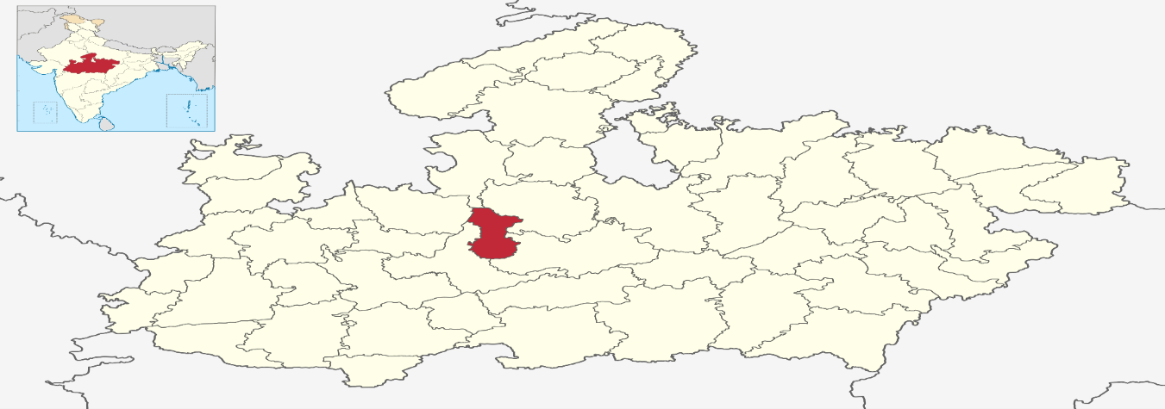
Madhya Pradesh
INDIA
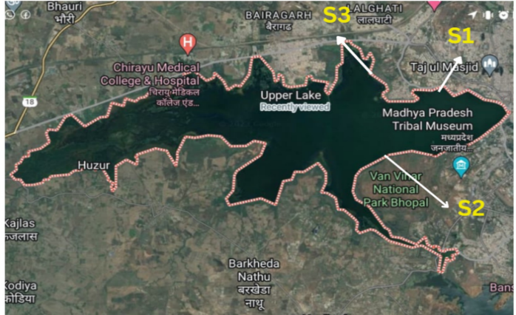
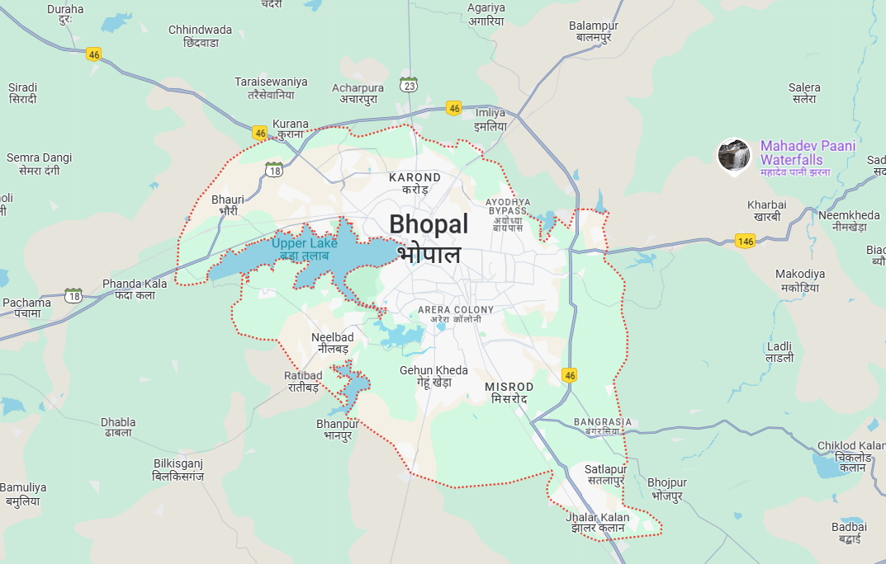
Fig.1: Location Map of the study station

- Result & Discussion:
  - Diversity of fishes in Bhojtal Lake (Upper Lake)
Within the ambit of the study, 33 different species of fishes belonging to 9 orders and 13 families were identified from some sites of Upper Lake. Diversified is the order Cypriniformes with two families and thirteen species, followed by the order Siluriformes with three families and eight species. Conversely, the order Osteoglossiformes has one family and three species and the orders Cichliformes, Osteoglossiformes, Beloniformes, Synbranchiformes, and Perciformes each have one family and one species (Table-1.). Species richness in Upper Lake is given higher by Cypriniformes (45%). What follows is 28% from Siluriformes, with Beloniformes, Synbranchiformes, and Perciformes sharing about 3% each (Fig. 1). Species diversity peaks in winter, with all the ideal conditions of adequate water and food supply present. In terms of conservation, most species were in the category of Least Concern (LC) by the IUCN Red List, indicating their populations are considered at least relatively stable. However, the presence of Near Threatened (NT) species such as Cyprinus cachius, Puntius sarana, and Channa marulius, and Vulnerable (VU) species like Labeo calbasu, Labeo bata, Mystus aor, and Hypophthalmichthys molitrix points to possible threats to these species and compounds the importance of continued monitoring and management of the habitat to secure long-term sustainability.
Table-1. List of fish species reported in Bhojtal Lake.
Order | Family | Vernacular Name | Name Of The Species | Availability Status | IUCN Status
Cypriniformes | Cyprinidae | Rohu | Labeo rohita | ++ | LC
Cypriniformes | Cyprinidae | Catla | Labeo catla | ++ | LC
Cypriniformes | Cyprinidae | Chela | Cyprinus cachius | +++ | NT
Cypriniformes | Cyprinidae | Common Carp | Cyprinus carpio | +++ | LC
Cypriniformes | Cyprinidae | Kalot | Labeo calbasu | ++ | VU
Cypriniformes | Cyprinidae | Grass Carp | Ctenopharyngodon idella | ++ | LC
Cypriniformes | Cyprinidae | Puntius | Puntius ticto | ++ | LC
Cypriniformes | Cyprinidae | Puntius | Puntius saphore | ++ | LC
Cypriniformes | Cyprinidae | Puntius | Puntius sarana | +++ | NT
Cypriniformes | Cyprinidae | Bata | Labeo bata | + | VU
Cypriniformes | Cyprinidae | Mrigal | Cirrhinus mrigala | + | LC
Cypriniformes | Cyprinidae | Moila | Rasbora daniconius | ++ | LC
Cypriniformes | Cyprinidae | Moila | Rasbora rasbora | ++ | LC
Cypriniformes | Xenocyprididae | Big head Carp | Hypophthalmichthys nobilis | + | LC
Cypriniformes | Xenocyprididae | Silver Carp | Hypophthalmichthys molitrix | + | VU
Siluriformes | Siluridae |  | Wallago attu | + | LC
Siluriformes | Siluridae | Singhi | Heteropneustes fossilis | + | LC
Siluriformes | Siluridae | Pabda | Ompok bimaculatus | + | LC
Siluriformes | Bagridae | Singara | Mystus singhala | ++ | NT
Siluriformes | Bagridae |  | Mystus aor | ++ | VU
Siluriformes | Bagridae | Tangra | Mystus vittatus | +++ | LC
Siluriformes | Bagridae |  | Mystus bleekeri | ++ | LC
Siluriformes | Pangasidae | Pangus | Pangasius pangasius | + | LC
Ophiocephaliformes | Ophiocehalidae | Samhal | Channa marulius | + | NT
Ophiocephaliformes | Ophiocehalidae | Mathia | Channa gachua | + | LC
Ophiocephaliformes | Ophiocehalidae | Samhal | Channa straitus | + | LC
Cichliformes | Cichlidae | Tilapia | Orechromis mossambicus | + | LC
Osteoglossiformes | Notopteridae | Patola | Notopterus notopterus | ++ | LC
Beloniformes | Belonidae | Suja | Xenontedon cancila | + | LC
Synbranchiformes | Mastacembelidae | Baam | Mastacembelus armatus | + | LC
Perciformes | Chandidea | Khasua | Parambassis ranga | ++ | LC
Perciformes | Chandidea | Khasua | Parambassis nama | ++ | LC
Clupiformes | Clupeidae | Baruti | Gudusia chpra | +++ | LC
+ Rare, ++ Average, +++ Abundant, LC Least Concern, VU Vulnerable, NT Near threaten,

Fig.2. Showing overall percentage composition of taxonomic order in upper lake

  - Analysis of Biodiversity Indices: Seasonal analysis of biodiversity indices, such as the Shannon-Wiener Index (H′), Simpson's Index (1-D), Dominance Index (D), and Evenness (e^H/S), revealed substantial temporal variations in the community structure over the study period. Maximum diversity was found in winter highest Shannon-Wiener values (H′ = 3.384) and Simpson's Index (1-D = 0.9636 and lowest dominance (D = 0.03635) while monsoon showed the least biodiversity lowest Shannon-Wiener index (H′ = 3.046) and Simpson's index (1-D = 0.945) and the highest dominance (D = 0.055).

Table-2. Presents the seasonal variation in biodiversity indices
Biodiversity indices | Summer | Monsoon | Winter
Dominance_D | 0.04 | 0.055 | 0.03635
Simpson_1-D | 0.96 | 0.945 | 0.9636
Shannon_H | 3.306 | 3.046 | 3.384
Evenness_e^H/S | 0.8803 | 0.876 | 0.8936

Fig.3.Showing the seasonal variation in biodiversity indices of Bhojtal Lake

  - Water Quality Parameters:
During the study the Air Temperature ranged from 20°C to 35°C, attaining its peak in summer (June 2023) and lowest in winter (December 2023). Fluctuations-indicative of central India's subtropical climate-shed their effects on evaporation, stratification, and aquatic life. The water temperature ranged between 18°C and 31°C, presenting minima during winters and maxima during summers (June 2023). Higher temperatures in summers stress the aquatic life because dissolved oxygen is less soluble in warm water. pH ranged from 5.7 to 7.8, lowest at S2 in monsoon (August 2024), and highest at S1 in summer (June 2023). Seasonal and monsoon variations were connected with organic matter input and runoff. Total Alkalinity (TA) range between 92 to 145 mg/L was observed, with the highest values during monsoon and the lowest in summer. High alkalinity during the monsoon period was due to runoff from carbonate-rich soils, assisting the aquatic ecosystem in maintaining stability. Dissolved Oxygen (DO) ranges from 5.7 to 7.5 mg/L, with the minimum during the monsoon and the maximum in winter. Winter gave some cooler temperatures and consequently lowered microbial activities, increasing oxygen levels, important for aquatic life. The free CO₂ ranged between 3 and 10 mg/L, with the lowest levels in winter and the highest in summer. Higher concentration of CO₂ may result in acidification of water affecting the buffering system, which in turn is harmful to organisms depending on calcium carbonate. Total Hardness (TH) varied from 155 to 234 mg/L, with the maximum in monsoon and the minimum in summer. Seasonal variations indicate geological and anthropogenic inputs into the lake.

Table-3.: Showing variation in water quality parameters of Bhojtal Lake during study period.
Season/ Sites |  | AT | WT | pH | CO₂ | TA | DO | TH
Summer | S1 | 30  ±0.578 | 28  ±1.528 | 7.8  ±0.361 | 9  ±2 | 110  ±0.578 | 6.5  ±0.231 | 180  ±2.887
Summer | S2 | 29  ±0.578 | 27  ±2.646 | 7.6  ±0.265 | 7  ±1.528 | 105  ±0.578 | 6.8  ±0.252 | 171  ±3.215
Summer | S3 | 32  ±0.578 | 29  ±1.528 | 7.5  ±0.174 | 5  ±1 | 92  ±0.578 | 7  ±0.265 | 155  ±5
Monsoon | S1 | 26  ±0.289 | 25  ±0.289 | 6.6  ±0.352 | 7  ±1 | 145  ±0.289 | 5.8  ±0.513 | 218  ±8.660
Monsoon | S2 | 25  ±0.764 | 23  ±0.252 | 6.9  ±0.462 | 4  ±0.578 | 137  ±0.764 | 6  ±0.530 | 195  ±3.606
Monsoon | S3 | 27  ±0.578 | 25  ±0.347 | 6.8  ±0.1 | 4  ±1 | 130  ±0.578 | 6.2  ±0.520 | 180  ±10.214
Winter | S1 | 22  ±1 | 20  ±3.560 | 7.1  ±0.231 | 5  ±0.578 | 128  ±1 | 7  ±0.174 | 210  ±13.229
Winter | S2 | 20  ±2.646 | 18  ±3.512 | 7.2  ±0.289 | 3  ±0.578 | 122  ±2.646 | 7.2  ±0.379 | 185  ±12.289
Winter | S3 | 21  ±1 | 19  ±3.717 | 7.2  ±0.4 | 3  ±0.578 | 113  ±1 | 7.5  ±0.173 | 165  ±13.229

- Conclusion:
This study further stressed the ecological richness of the system by revealing a rich Ichthyofaunal diversity with 33 species from 9 orders and 13 families. Order Cypriniformes was dominant with 45% species richness, followed by 28% Siluriformes. Most of the species are Least Concern (LC), but species which are Near Threatened (NT) or Vulnerable (VU) call for conservation efforts. Seasonal trends in environmental parameters revealed dynamic interrelations with the region's climatic and hydrological cycles in which air temperature ranged between 20 and 35°C, water temperature between 18 and 31°C, pH 5.7-7.8, total alkalinity 92-145 mg/L, dissolved oxygen 5.7-7.5 mg/L, free CO2 3-10 mg/L, and total hardness 155-234 mg/L. The winter season was most suitable for aquatic life and had the highest values of biodiversity indices—Shannon-Wiener (H′ = 3.384) and Simpson's (1-D = 0.9636), along with the lowest dominance (D = 0.03635).
The cyclical variations exhibited stress the fragile balance between natural climatic influences and anthropogenic impacts on this crucial aquatic ecosystem. Monitoring and sustainable management of the Upper Lake are, thus, needed for the long-term conservation of its rich biodiversity and ecological functions.

Reference:
Adoni A. D. (1985) work book on limnology, Indian MAB committee, Department of Environment, Govt of India, Pratibha Publishers Sagar, 216.
Bhattacharjya, B.K., Bhaumik, U., and Sharma, A.P., (2017) Fish habitat and fisheries of Brahmaputra River in Assam, India. Aquatic Ecosystem Health & Management 20(1- 2), 102-115.
Cardinale B. J., Duffy J. E., Gonzalez A., Hooper D. U., Perrings C., Venail P., Narwani A., Georgina M. M., Tilman D., David A. W., Ann P. K., Gretchen C. D., Michel L., James B. G., Anne L., Srivastava D. S. & Naeem S.., 2012. Biodiversity loss and its impact on humanity (vol 486, pg 59)
Darwall W. R. T., Vie j. c., 2005. Identifying important sites for conservation of freshwater biodiversity: extending the species-based approach, Fisheries Ecology and Management, Volume 12, Issue 5.
Das, M. K., Sharma, A. P., Vass, K. K., Tyagi, R. K., Suresh, V. R., Naskar, M. & Akolkar, A.B., (2013) Fish diversity, community structure and ecological integrity of the tropical River Ganges, India, Aquatic Ecosystem Health & Management, 16:4, 395-407
Das, M. K., Sharma, A. P., Vass, K. K., Tyagi, R. K., Suresh, V. R., Naskar, M., & Akolkar, A. B. (2013). Fish diversity, community structure and ecological integrity of the tropical River
Das, B. K., Boruah, P. & Kar, D. (2017) Icthyofaunal Diversity of Siang River in Arunachal Pradesh, India, Volume 70, pages 52–60
Dhote, S., Varughese, B. & Misra, S.M. (2001) Impact of idol immersion on water quality of twin lakes of Bhopal. 21. 998-1005.
Hussain, S., Ali, H. And Manohar, S., (2017) Ichthyofaunal diversity of a freshwater lake: a case study of Upper Lake Bhopal (M.P.), journal of international academic research for multidisciplinary, ISSN: 2320-5083, Volume 5, Issue 2
Joshi, K. D., Alam, A., Jha, D. N., Srivastava, S. K. And Kumar, V., (2016). Fish diversity, composition and invasion of exotic fishes in river Yamuna under altered water quality conditions, Indian Journal of Animal Sciences 86 (8): 957–963.
Jayaram, K.C. (1999) the freshwater fishes of the Indian region. Delhi: Narendra Publishing House.
Jayaram, K.C. (2010) The Freshwater Fishes of the Indian Region. 2nd Edition, Narendra Publishing House, Delhi, 616 p.
Kodarkar, M. S., and Mukerjee, A., 2006. Bhoj Wetland, Experience and Lesion Learning Brief, Madhya Pradesh Lake Conservation Authority, Bhopal, India, pp.1-2.
Mishra, S.M., 2007. Conservation and Management of Bhoj Wetland of Bhopal, India, In World Lake Vision Action Report (ILEC), pp. 168 - 180.
Mishra, S.M., Pani, S., Bajpai, A. & Bajpai, A. K. 2001. Assessment of Trophic Status by Using Nygaard Index with Special Reference to Bhoj Wetland, Poll Res. 20 (2): 1-7.
Qureshi, T.A. and Qureshi, N.A. (1983) Indian Fishes Publishers Brij Brothers, Sultania Road Bhopal (M.P.). 5-209.
Sahadevan, M., Vyas, V. and Shrivastava, P., 2000. Biodiversity of Aquatic Vegetation in Upper Lake of Bhopal. In conservation of Aquatic Resources, S.N. Dwivedi Ed. pp. 135-142
Tamot, P. and Awasthi, A., 2012. Ichthyo-Faunal Study and Limnology of a Protected (Kerwan) Reservoir, Bhopal, India; J. Exp. Zool. India; ISSN 0972-0030 Vol. 15, No. 1, pp. 275-278
Tamot, P. and Awasthi, A., 2010. Biodiversity and conservation of indigenous fish species of Upper Lake, Bhopal, Proc. Nat. Sem. Int. – livelihood. 378-388
Wetzel, R.G. (2001): Limnology Lakes and Rivers ecosystems. San Diego Academic press, 1006 pp.
Sahadevan, M., Vyas, V. and Shrivastava, P. 2000. Biodiversity of Aquatic Vegetation in Upper Lake of Bhopal. In conservation of
Aquatic Resources, S.N. Dwivedi Ed. pp. 135-142
Sahadevan, M., Vyas, V. and Shrivastava, P. 2000. Biodiversity of Aquatic Vegetation in Upper Lake of Bhopal. In conservation of
Aquatic Resources, S.N. Dwivedi Ed. pp. 135-142
Sahadevan, M., Vyas, V. and Shrivastava, P. 2000. Biodiversity of Aquatic Vegetation in Upper Lake of Bhopal. In conservation of
Aquatic Resources, S.N. Dwivedi Ed. pp. 135-142
Sahadevan, M., Vyas, V. and Shrivastava, P. 2000. Biodiversity of Aquatic Vegetation in Upper Lake of Bhopal. In conservation of
Aquatic Resources, S.N. Dwivedi Ed. pp. 135-142
Qureshi, T. A., & Qurashi, N. A. (1983): Indian Fishes publishers Brij Brother, Sultania Road
Bhopal (M.P.) 5-209.
Qureshi, T. A., & Qurashi, N. A. (1983): Indian Fishes publishers Brij Brother, Sultania Road
Bhopal (M.P.) 5-209.

