STUDIES ON THE INCIDENCE AND MANAGEMENT OF THRIPS, SCIRTOTHRIPS DORSALIS IN RABI GROUNDNUT
ABSTRACT
In the 2021-22 rabi season, thrips incidence on groundnut was monitored weekly from 15 days after sowing (DAS) to harvest, revealing initial damage of 14.90%, which peaked at 97.05% by the 6th standard week (SW). Correlation analysis showed a significant positive association between thrips population and foliar damage (r =0.84), with further correlations in the 1-lag week (r =0.85) and 2-lag week (r =0.92). Environmental factors also impacted thrips incidence, with maximum temperature showing a strong positive correlation (r=0.71) and evening relative humidity negatively correlating (r=-0.65). Three management modules were evaluated: the Chemical module, utilizing Cyantraniliprole, achieved the lowest damage at 33.04%, while the Eco-friendly module averaged 43.72%, promoting beneficial natural enemies such as coccinellids and spiders. In contrast, the Untreated Control suffered the highest damage at 74.05%. These findings highlight the effectiveness of integrated pest management strategies in controlling thrips populations while considering environmental sustainability.
INTRODUCTION
Groundnut (Arachis hypogea L.), commonly known as peanut, is a vital legume crop in the Fabaceae family, valued for its underground pods and high nutritional content. The name Arachis hypogea derives from Greek, meaning "legume" and "below ground." Originating from South America, groundnut ranks as the fourth-largest source of edible oil and third-largest source of vegetable protein worldwide. It is rich in essential nutrients, including proteins (25-28%), oils (43-45%), and vitamins such as B, E, and K, making it crucial for human consumption, animal feed, and industrial applications. Globally, groundnut is cultivated on 29.93 million hectares, producing 55.30 million tonnes with a productivity of 1851 kg/ha (FAO, 2021). India is a major producer, with 6.09 million hectares under cultivation, yielding 10.21 million tonnes annually. Andhra Pradesh plays a key role, with 8.69 lakh hectares cultivated, yielding 7.74 million tonnes, though yields are constrained by rainfed farming and pest infestations (Directorate of Economics and Statistics, 2021).
Among the pests that affect groundnut, sucking pests like thrips (Scirtothrips dorsalis, Frankliniella schultzei, Thrips palmi) are particularly damaging. Thrips feed by rasping leaf surfaces and sucking sap, stunting plant growth and distorting leaves. They are also vectors for viral diseases, such as bud necrosis, which caused significant losses in Andhra Pradesh Anantapur district (Rao et al., 2003). Given the growing threat of thrips, effective management strategies are critical. Weather parameters such as temperature, humidity, and rainfall influence thrips populations, necessitating Integrated Pest Management (IPM) strategies. This study aims to compare eco-friendly and chemical control methods to develop sustainable, cost-effective pest management practices, ensuring stable groundnut production and contributing to food security.
MATERIAL AND METHODS
Two field experiments were conducted during the 2021-22 rabi season at S.V. Agricultural College, Tirupati (13°37’35’’ N, 79°21’52’’ E), to examine the incidence of thrips, Scirtothrips dorsalis in groundnut under varying climatic conditions and to evaluate the efficacy of different pest management approaches. In the first experiment, a randomized complete block design with three replications was used to monitor S. dorsalis populations and damage symptoms on the Dharani groundnut variety. Sown at 80 kg/ha with a 22.5 x 10 cm spacing, the crop was monitored weekly throughout the season (7:00–9:00 a.m.) from seedling emergence to harvest, with standard agronomic practices excluding insecticides. Thrips populations were counted on five leaves per plant (two upper, two middle, one lower) from five randomly selected plants per plot following Bhatt and Karnatak (2018). Damage indicators, such as scratches, mottling, pale spots, and leaflet elongation, were recorded. Data on natural predators like coccinellid beetles and spiders were also collected from each square meter, with life stages (grub, pupa, and adult) noted. Weekly meteorological data on temperature, humidity, and rainfall were gathered to analyse the climatic impact on thrips populations.
The second experiment assessed three Integrated Pest Management (IPM) modules against thrips on 100 m² plots with 3m gap between treatments. Module I (Ecofriendly Management) included biological controls, using 6 rows of Bajra as a border crop, and yellow and blue sticky traps (20 per acre) for monitoring. Neem formulation (1500 ppm-3ml/litre) was applied at 15-20 DAS, followed by Beauveria bassiana (5g/litre) at 30-35 DAS and Spinosad (0.3 ml/litre) at 45-50 DAS. Module II (Chemical Management) utilized synthetic pesticides, starting with seed treatment using Imidacloprid 17.8 SL (2 ml/kg), followed by foliar sprays of Thiamethoxam 25 WG (0.2g/litre) at 15-20 DAS, Diafenthiuron 47.8 SC (1ml/litre) at 30-35 DAS, and Cyantraniliprole 10.26 OD (1.2 ml/litre) at 45-50 DAS. Module III served as an untreated control. Observations from five 1m² marked areas per module were recorded at 15, 45, 75, and 105 DAS, with leaf damage assessment based on five randomly selected plants per square meter, multiplying leaves by four for total leaflet counts. Damage symptoms (scratches, mottling, pale spots, and elongation) were used to compare module efficacy, correlating results with pest incidence across modules. The simple correlation coefficient of pooled pest population with weather parameters viz., maximum temperature (Tmax), minimum temperature (Tmin), morning relative humidity (RHm), evening relative humidity (RHe), rainfall (RF), and sunshine hours (SSH) was calculated for the current, 1-lag, and 2-lag weeks using R software. Results of second experiment were analyzed by two-way ANOVA, and means were separated by Duncan’s Multiple Range Test (Duncan, 1955).
RESULTS AND DISCUSSION
During the 2021–22 rabi season, thrips incidence on groundnut was recorded weekly from the 52nd standard week (SW) of 2021 (15 DAS) to the 12th SW of 2022. Initial thrips damage was observed at 14.90%, with 1.32 thrips per plant in the 52nd SW of 2021, increasing to 23.88% and 1.84 thrips per plant in the following week, with symptoms such as white spots and scratches on leaves. Thrips damage continued to rise, reaching 40.50% with 2.96 thrips per plant by the 1st SW of January 2022. This trend persisted with damage at 51.93% and 72.24% in the 2nd and 3rd SWs, with populations of 3.36 and 3.56 per plant, respectively. By the 6th SW, the damage peaked at 97.05%, with a thrips population of 6.44 per plant. From the 7th to the 10th SW, foliar damage stayed high, between 98.11% and 98.96%, although the population declined from 5.88 to 4.44 thrips per plant. At the harvest stage of crop, in the 11th and 12th SW, damage reached 99%, with populations of 3.28 to 3.68 per plant. Thrips activity peaked from flowering to pod-filling stages and declined afterward, aligning with findings from Naresh et al. (2018) and Kumbhar et al. (2021) on peak thrips incidence during post-flowering.
Correlation analysis indicated a significant positive association between thrips population and foliar damage (r = 0.84). Foliar damage was positively correlated with maximum temperature (Tmax; r = 0.71) and negatively with evening relative humidity (RH(e); r = -0.65) in the current week (Fig.1a). In the 1-lag week, correlations between thrips population and foliar damage (r = 0.85) and foliar damage with Tmax (r = 0.73) were also positive. In the 2-lag week, thrips population showed positive correlations with foliar damage (r = 0.92), Tmax (r = 0.65), and sunshine hours (r = 0.62), with foliar damage also correlating positively with Tmax (r = 0.81) (Fig.1b, c). These results align with previous studies by Naresh et al. (2018) and Kumbhar et al. (2021), who reported positive associations between thrips incidence and Tmax. Additionally, Vijayalakshmi et al. (2017) and Kandakoor et al. (2012) observed nonsignificant positive correlations between thrips population and minimum temperature, with negative associations with RH and rainfall, similar to Nandagopal et al. (2008) and Nigude et al. (2018), underscoring the environmental influence on thrips infestations.
In this study, three management modules were tested for their effectiveness in reducing thrips damage on rabi groundnut, with observations made every 10 days from crop emergence until harvest. The modules included a Chemical module, an Eco-friendly module, and an Untreated Control (Table 1). Thrips damage began at 15 DAS across all modules, with the Chemical module showing the lowest initial damage at 4.21%, followed by the Eco-friendly module at 9.25%, while the Control had the highest at 14.55%. At 45 DAS, damage was consistently lower in the Chemical module (31.35%), followed by the Eco-friendly module (35.38%), with the Control at 75.20%. The Chemical module, with Cyantraniliprole application, provided the best control, reaching an average foliar damage of only 33.04% compared to 43.72% in the Eco-friendly module and 74.05% in the Control. The Chemical modules superior performance is attributed to the targeted use of insecticides, which effectively managed pest populations. However, the Eco-friendly module, employing Spinosad and other natural components, supported a higher population of beneficial natural enemies like coccinellid predators and spiders, particularly from 45 to 75 DAS when pest activity was high (Fig 2). These predators, often seen preying on leafhoppers, contributed to pest suppression, demonstrating the module’s integrated pest management approaches success. This aligns with findings by Karuppuchamy (2016) and Jasrotia et al. (2020), who observed that integrated pest management (IPM) practices, including border crops and natural treatments, effectively reduce pest populations. While the Chemical module achieved the lowest pest damage, the Eco-friendly module fostered natural enemy populations, creating a balanced approach to pest control. This pattern is consistent with studies by Dhathri et al. (2021) and Dwivedi and Devi (2018), indicating that eco-friendly measures can enhance natural enemies activity, thus providing sustainable pest control solutions without adverse environmental impacts.
Table. 1 Percent foliar damage by thrips recorded from modules
Module | 15 DAS | 45 DAS | 75 DAS | 105 DAS | F value
Eco-Friendly Module | 9.25±0.77 ^{Bd} | 35.38±0.72^{Bc} | 55.378±0.68^{Bb} | 66.03±0.98^{Ba} | 41.55
Chemical Module | 4.21±0.65^{Cd} | 31.354±0.72^{Cc} | 40.228±0.68^{Cb} | 51.04± 0.59^{Ca} | 32.42
Untreated Control | 14.55±0.78^{Ad} | 75.208±1.01^{Ac} | 95.568±0.78^{Ab} | 99.422±0.22^{Aa} | 8.68
F value | 49.09 | 14.10 | 211.64 | 4.94 | -
Lowercase letters indicate significant differences over time (DAS), and uppercase letters indicate significant differences across management modules. *DAS = Days After Sowing.
Finally, the study elucidated the seasonal incidence of S. dorsalis on groundnut in the Tirupati district, Andhra Pradesh, revealing their peak infestation periods and associations with weather factors such as temperature and humidity. The research identified critical stages of thrips damage and demonstrated the effectiveness of three distinct management modules in reducing infestation levels. While the Chemical module yielded the lowest foliar damage through targeted insecticide application, the Eco-friendly module fostered a higher population of beneficial natural enemies, enhancing overall pest suppression. This dual approach highlights the importance of integrating chemical and eco-friendly practices for sustainable pest management in groundnut cultivation.

REFERENCES
Bhatt, B. Karnatak., & A. K., 2018. Population dynamics of sucking pests and their predators on okra agroecosystem. Journal of Entomology and Zoology Studies, 6(2), 1289- 1291.
Dhatri, K. S., Chalam, M. S. V., Rajesh, A., Murthy, B. R., & Venkateswarlu, N. C., 2021. Bio-efficacy of newer insecticides against sucking insect pest complex of groundnut (Arachis hypogea L.). The Pharma Innovation Journal, 10(7), 621-627.
Directorate of Economics and Statistics. 2021, https://des.ap.gov.in/
Duncan, D. B., 1955. Duncan new multiple range test. Biometrics. 11, 1-42.
Dwivedi, S. A., & Devi, S. S., 2018. Ecofriendly Sustainable management of Sap feeder pests in Groundnut. International Journal of Chemical Studies 8(6), 195-199.
FAOSTAT. 2020-2021. Food and Agriculture Organisation of the United Nations. World Agricultural Production, Rome, Italy. http://faostat.fao.org/.
Jasrotia, P., Jadon, K. S., Singh, S. K., Nataraja, M. V., Harish, G., Dutta. R., Padvi & R. D., Savaliya, S. D., 2020. Development and validation of IPM modules against major sucking insect-pests of groundnut. Legume Research-An International Journal, 43(4), 592-597.
Jayanthi, M., Singh, K. M., & Singh, R. N., 1993, Population build up of insect pests on MH 4 variety of groundnut influenced by abiotic factors. Indian Journal of Entomology, 55(2), 109-123.
Jena, B. C., & Kuila, B., 1996. Jassid infestation in groundnut and its chemical control. Indian Journal of Entomology, 58, 378- 381.
Kandakoor, B., Khan, K. H., Gowda, B. G., Chakravarthy, A. K., Kumar, C. T. A., Venkataravana, P. 2012. The incidence and abundance of sucking insect pests on groundnut. Current Biotica, 6(3), 342-348.
Karuppuchamy, P. 2016. Ecologically Sustainable Pest Management for Thrips and Aphids in Groundnut. Madras Agricultural Journal, 103(4-6), 141- 145.
Kumbhar, N. B., Mutkule, D. S., Fand, D. N., Gore, S. H., Ghodke, S. S., Biradar, J. M., 2021. Studies on the population dynamics of different insect pest of groundnut. The Pharma Innovation Journal, 10(12), 1958-1964
Nandagopal, V., Prasad, T. V., Gedia. M. V., & Makwana A. D., 2008. Influence of weather parameters on the population dynamics of Sesbania thrips (Caliothrips indicus Bagnall) in groundnut in saurashtra region. Journal of Agrometeorology, 10(2), 175-177.
Naresh, T., Rao, A. R., Krishna, T. M., Devaki, K., Ahammed, S. K., & Sumathi, P., 2018. Seasonal incidence and effect of abiotic factors on population dynamics of thrips on groundnut (Arachis hypogaea L.) during rabi season. Journal of Pharmacognosy and Physochemistry, 7(2), 1600- 1604.
Nigude, V. K., Patil, S., Bagade, A. S., & Mohite, P. B., 2018. Seasonal incidence of sucking pests of groundnut (Arachis hypogaea L.). Journal of Current Microbiology and Applied sciences, 7 (1), 566-569.
Rao, R. D. V. J. P., Reddy, D. V. R., Nigam, S. N., Reddy, A. S., Waliyar, F., Reddy, T. Y., Subramanyam, K., Sudheer, N. J., Naik, K. S. S., Bandyopadhyay, A., Desai, S., Ghewande, M. P., Basu. M. S., & Somasekhar. 2003. Peanut Stem Necrosis: A New Disease of Groundnut in India. Information Bulletin No.67. Technical Report. International Crops Research Institute for the Semi-Arid Tropics, Patancheru, Telangana, India.
Vijayalakshmi, G., Ganapathy, N., & Kennedy, J. S., 2017. Influence of weather parameters on seasonal incidence of thrips and Groundnut bud necrosis virus (GBNV) in groundnut (Arachis hypogea L.). Journal of Entomology and Zoology, 5(3), 107-110.

a | 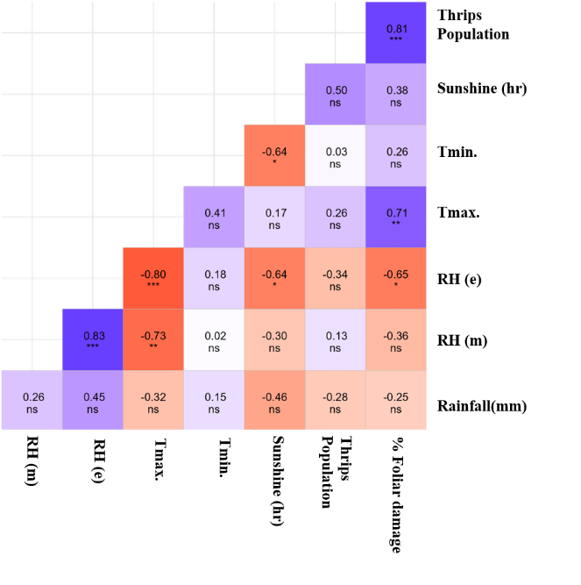
b | 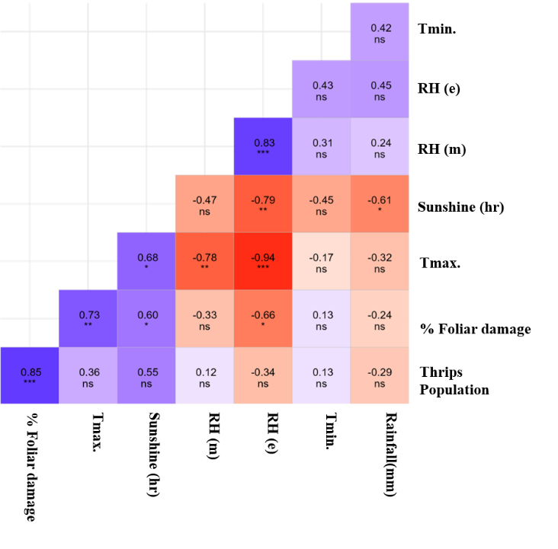
c | 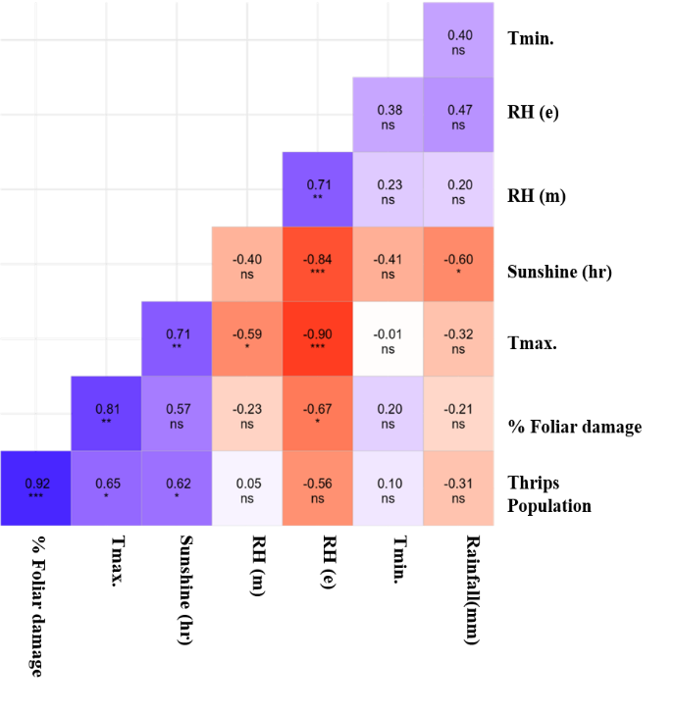
Fig. 1: Pearson correlation between environmental factors and (a) thrips population and foliar damage percentage for the current week, (b) 1-week lag, and (c) 2-week lag.
a | 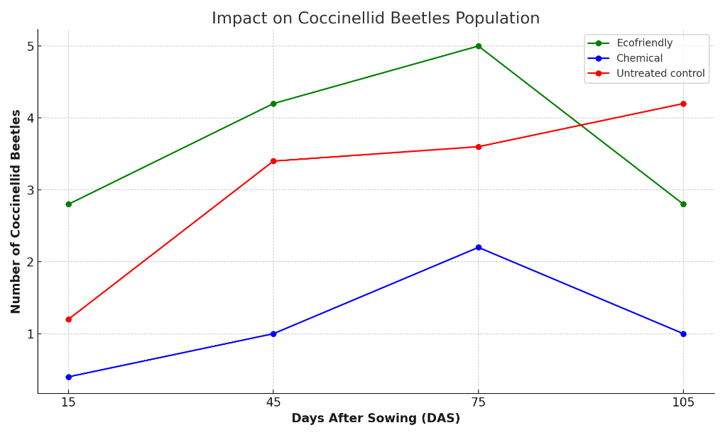
b | 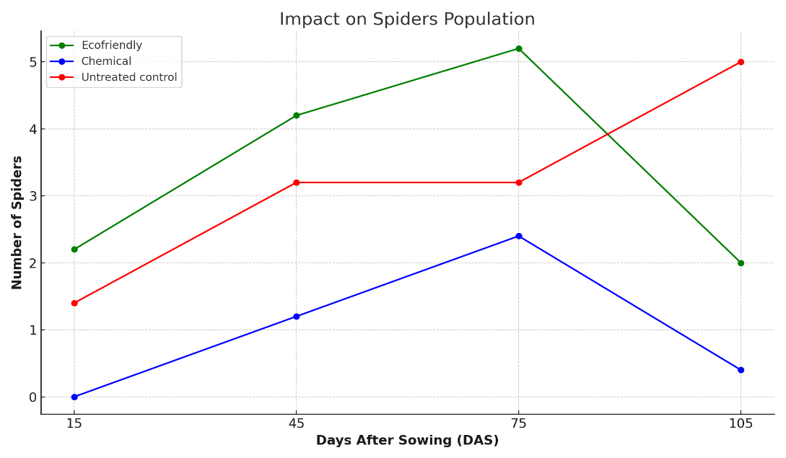
c | 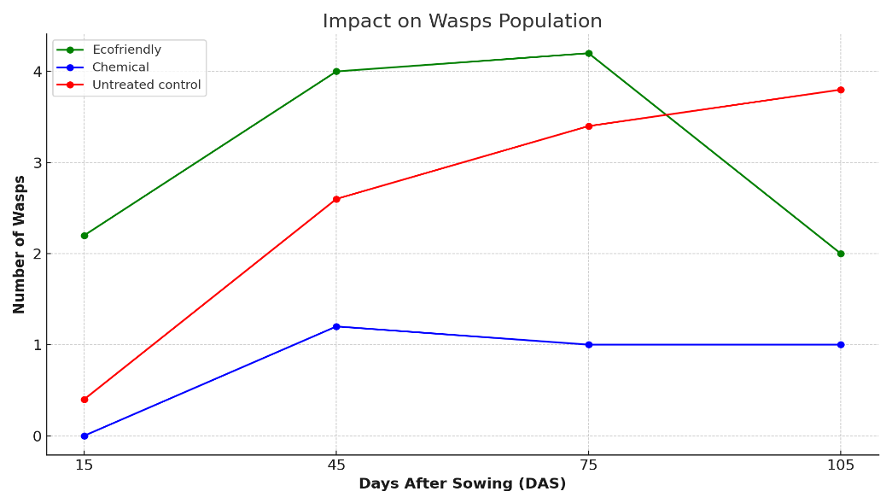
Fig. 2: Natural enemies recorded in the crop period across different management modules: (a) Coccinellid predators (grubs and adults), (b) Spiders, (c) Wasps

