**Effect of pre-pubertal exposure to perflourooctanoic acid on developmental landmarks in F1 generation rats: protective role of resveratrol**

**Abstract**

In the present study, healthy male Wistar strain albino rats at prepubertal age (23 days old; body weight 35g to 38g) were randomly divided into 4 groups of ten rats each. Rats in group I, did not receive any treatment while rats in groups II, III, IV received (via oral route, gavage) resveratrol (RES: 20mg/kg/day), perfluorooctanoic acid (PFOA: 20mg/kg/day) and combination of PFOA +RES from day 23 to 56 and maintained up to 90 days. After completion of experimental period, rats from control and treated groups were cohabited with virgin female rats. Pregnant rats were maintained separately and after gestation period, all the rats were allowed to deliver pups. During their weaning period and after completion of weaning period, developmental landmarks in F1 generation pups were investigated to assess the parental mediated development toxicity. No significant changes in crown rump length, anogenital distance, lower and upper incisor eruption, fur development, pinna unfolding, eye slit opening and eye opening of pups delivered to female cohabited with control and experimental rats. Interestingly we noticed a significant change in delay of testicular descent age in PFOA exposed rats over controls, while RES supplementation reduced testicular decent age in rats exposed to both PFOA and RES. Based on the results, we postulate that the steroidogenic effects of RES could be associated with reduced testicular decent age in F1 rats following PFOA mediated parental developmental toxicity.

**Introduction:**

It has been shown that the environmental pollutants as well as pharmaceutical compounds are playing a major role in the depletion of the male reproductive system resulting in male infertility. These environmental effluents and pharmaceutical compounds or toxicants impede with the endocrine hormones which regulate the male reproduction. Such chemicals are known as endocrine disruptors. EDs disturb the biological functions by blocking the endogenous hormone synthesis, binding the endogenous receptors by mimicking property. Obstructing the transport of endocrine hormones (Svechnikov et al., 2010a; b; Boas et al., 2012; Bode and Dong, 2015; Sifakis et al., 2017; Schug et al., 2016; Haraux et al., 2016; Warembourg et al., 2018; Oliveire et al., 2019, Schwartz et al., 2019). Perfluorooctanoic acid (PFOA) is an eight-carbon chain man-made chemical and is one of the popular PFCS and is widely used in the manufacturing of products like Teflon®, Gore-Tex® and aqueous firefighting foams. PFOA is used in industries as surfactant, non-stick utensils, and other cookware like fry pans and as greaseproof in pop-corn microwave bags. There are two processes for the chemical synthesis of PFOA: electrochemical fluorination which synthesizes branched PFOA and telomerization, which results in linear PFOA (Sinclair et al., 2007). PFOA is one of the chemicals that belong to persistent of organic pollutants (POPs) member (Sharma et al., 2014) and its estimated half-life fate in humans was found to be approximately four years (Olsen et al., 2007). Experiments of PFOA on rats show that the renal elimination time of the chemical was less in female rats (3-4 h) compared to male rats (6-8 days) (Lau et al., 2005). Published reports have shown that people living in the industrialized areas were detected with the accumulation of PFOA at a concentration of 4 ng/ml in their serum (Lau et al., 2005). According to ASTDR (2018), EPA (2016) and IARC (2017), PFOA has been categorized as a carcinogen. The first nationwide bio-monitoring survey on PFAS in Indians revealed that PFOA was one of the predominating PFAS (Ruan et al., 2019).

Antioxidant therapy has been shown in numerous studies to improve testicular function when exposed to a wide range of substances, including pharmaceuticals and environmental toxins with endocrine disruptive properties (Asadi et al., 2017). Resveratrol (RES) is one of the antioxidants present in peanuts, fruits like blueberry, blackberry, grapes, and red wine. The higher quantities of RES are present in roots of an herb, *Polygonum cuspidatum* (Japan), leaves and roots of *Veratrum grandiflorum* and *V. formosanum* (China) are widely used in traditional medicine. It is widely used against the reproductive disorders such as cryptorchidism, dyszoospermia, enhancing testosterone production, penile erection triggering, improving spermatogenesis in males (Juan et al., 2005; Rolando et al., 2020; Revel et al., 2003; Uguralp et al., 2005; Shin et al., 2008). The role of RES in the protection of male reproductive health against chemical induced oxidative toxicity is well noticed. RES supplementation restored testicular dysfunction against a range of oxidative stress-induced environmental pollutants such as 2,5- HSD, glyphosate, Benzo(a)pyrene, acrylamide, CdCl2, 2,3,7,8-tetrachlorodibenzo-p-dioxin (TCDD), and Di (2-ethylhexyl) phthalate and also physical stress, chronic unpredictable mild stress (Fahim et al., 2019).

Previously, we have shown that the antioxidant properties of resveratrol (RES) on male reproduction and fertility efficacy in adult rats following prepurbertal exposure to perfluorooctanoic acid (PFOA) was demonstrated. Further, we have shown that RES supplementation also restored steroidogenic properties in PFOA-exposed rats compared to controls. Transcriptomic profiling of the testes and epididymides revealed 98 and 611 altered genes, respectively associated with disruption of apoptosis and glutathione pathways in the testis, while glutathione and bile secretion pathways in epididymis of PFOA-exposed rats. These events might lead to male infertility in PFOA-exposed rats. Surprisingly, restoration of selected reproductive indicators was observed in RES plus PFOA-exposed rats compared to rats exposed to PFOA alone. Further, we postulated that RES with its steroidogenic, antiapoptotic, and antioxidant effects, restored PFOA-induced fertility potential in rats (Pavani et al., 2023).

Despite of a strong correlation between environmental PFOA exposures and increased incidence of deteriorated sperm quality and density in experimental animals and humans, studies on the effect of PFOA on paternal mediated developmental toxicity is not well addressed. The present study was extension to our previous studies (Pavani et al., 2025) wherein we investigated the probable effect of RES on developmental landmarks of F1 generation pups delivered to females cohabited with PFOA exposed rats during their prepubertal period.

**Material and Methods**

Wistar strain albino rats were selected as animal models in the current study. The animals were purchased from authorized vendor (Bengaluru, Karnataka). All the animals were transported in an air-conditioned vehicle without causing any stress to the animals. After their arrival, rats were acclimatized to the laboratory conditions over a period of seven to eight days. All the rats were maintained in the standard polypropylene rat cages covered with paddy husk as the bedding material and the laboratory conditions were: temperature of 22 to 25°C, 12-hour light and 12-dark cycle, and relative humidity of 50 ± 5°C. During the acclimatization period, the food and tap water was provided *ad libitum*. Required chemicals Perfluorooctanoic acid (PFOA) was purchased from Sigma Aldrich Company. (CASno. 335-67-1; purity:95 %; obtained from Sigma chemicals Co, St. Louis, USA). Resveratrol (RES; CAS No. 501-36-0; purity:>99 %) was obtained from TCI Chemicals (India) Pvt. Ltd.).

**Experimental design:**

In the present study prepubertal rats (23 days old, body weight: 35g to 38g) were selected and divided into 4 groups each with ten rats.

Group I: rats in this group did not receive any treatment

Group II: rats in this group received RES (20 mg/Kg/day; orally via gavage)

Group III: rats in this group were exposed to PFOA (20 mg/Kg/day; orally via gavage)

Group IV: rats in this group received both RES and PFOA at selected doses as mentioned in group II and III (orally via gavage)

The test chemicals were given from 23rd day to 56th day and maintained up to 90th day. To study the sexual behavior parameters, after the treatment was completed, the male rats were cohabited with female rats at proestrus stage in 1:1 ratio. The next day morning, presents of sperm in vaginal smear was determined. Vaginal smear was determined by using Pasteur pipette containing physiological saline (0.9% NaCl) and microscopically examined for the presents of smear. Presents of sperm in the vaginal smear is considered as the gestation day 1 or day 1 of pregnancy. These females were separated and maintained in separate cages until delivery of the pups and the body weights and developmental landmarks were determined after the birth until 21st day of pups.

**Evaluation of pups**

**1. Birth weight of pups**

Birth weights were known on the parturition day. Pups body weight was predisposed by intrauterine growth restriction, litter size and length of gestation.

**2. Body weight of pups**

The pups body weight was measured on postnatal days (PND) 1,7,14, and 21.

**3. Crown-rump length**

With the help of Vernier calliper, pups crown rump was determined on PND 1, from the head top to the tail base. This was achieved by positioning every pup side by side on horizontal surface. Millimetres were the units used to determine the crown-rump.

**4. Anogenital distance (AGD)**

The distance present in between the genital tubercle and the anus is called as AGD. In males the anogenital distance is more when compared to females. In due response to testosterone, the males anogenital length is increased (Fisher et al., 2004). Vernier callipers was used to determine the AGD of pups on PND 1. The units for AGD were millimetres.

**5. Developmental landmarks**

Developmental landmarks such as pinna unfolding, teeth eruption, eye slit formation (pups are born with eyelids closed), fur development, and testis descent were the developmental landmarks chosen and determined in pups.

**6.** **Testicular descent**

The site of the testis was located at lower part of the kidney at the time of delivery. Consequently, the male gonad (testis) was migrated from the lower part of the kidney to scrotum. The male pups were examined for testicular descent and the time required to descent testis to scrotum was recorded.

**RESULTS**

**Body weight of pups**

No significant change was observed in the body weight of F1 generation pups (Postnatal day, PND :1 and 21) delivered to females cohabited with control, RES treated, PFOA exposed and PFOA and res treated rats (Table 1).

**Physical developmental land marks**

No significant difference was observed in the developmental landmarks which included crown rump length, anogenital distance, lower and upper incisor eruption, fur development, pinna unfolding, eye slit opening, and also eye opening of pups delivered to females cohabited with control and experimental rats (Table 1; Fig. 1).

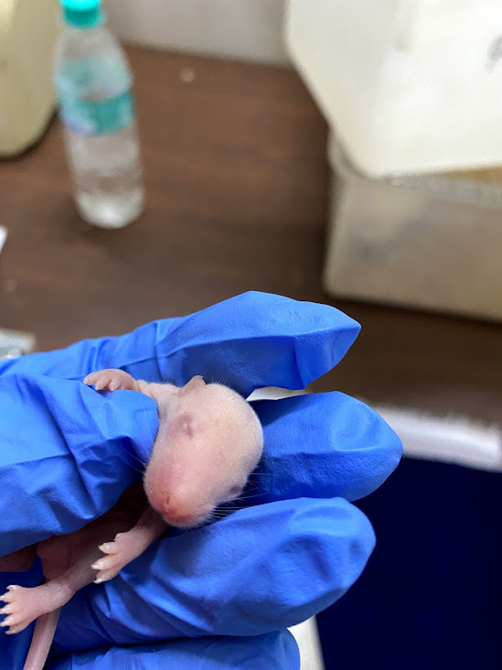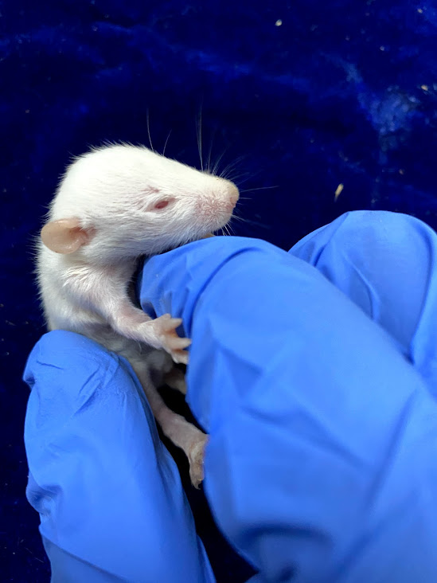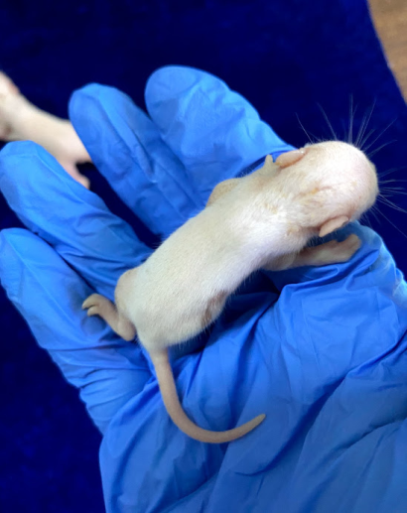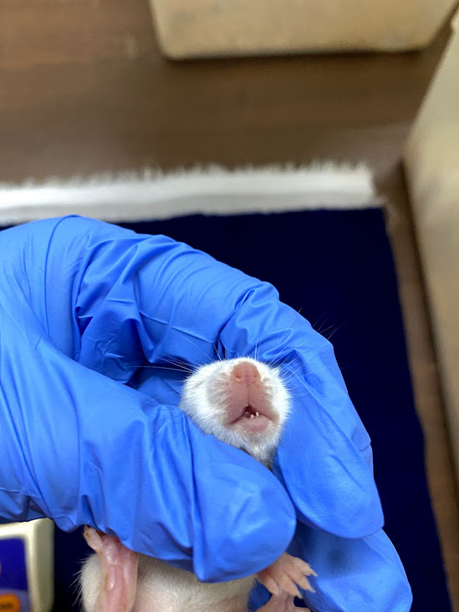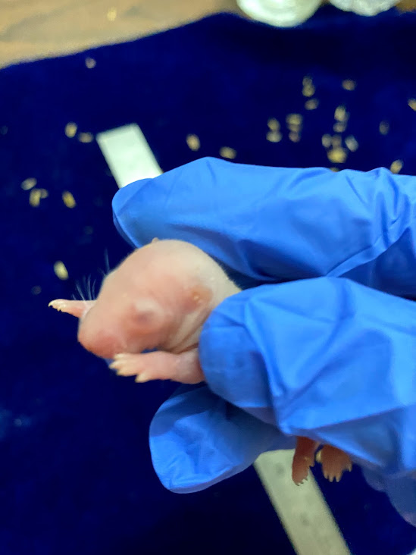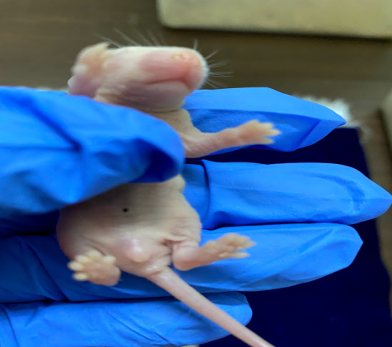

**A**

**B**

**C**

**D**

**E**

**F**

**Figure: 1:** Selected developmental landmarks in pups

A. Pinna unfolding; B. Teeth formation; C. Eye slit formation

D. Eye opening; E. Fur development; F. Anogenital distance

Testicular decent is an important factor wherein testicles are properly placed in the Scrotal sacs. Hence difference in the testicular decent time or age could be one of the valuable developmental landmark to assess the developmental toxicity. Significant difference in the testicular decent age of the F1 pups was noticed. There was a significant increase (24.66%; p<0.001) in the testicular decent age of F1 generation rats which were exposed to PFOA alone. There was a significant decrease (-20.25%; p<0.001) in the testicular decent age of F1 generation pups of PFOA plus RES supplemented rats. On the other hand, there was no significant difference between the untreated i.e. the control group and the RES alone supplemented group (Table 1).

Table 1:Changes in the body weights and developmental landmarks of pups delivered to females cohabited with control and experimental rats

|  |  |  |  |  |
| --- | --- | --- | --- | --- |
|  | Control |  | PFOA exposed |  |
| Parameter | **Untreated** | **RES** | **untreated** | **RES** |
| No. of pups | 10 | 10 | 10 | 10 |
| Body weight of pups (g) on  PND 1 | 4.81a ± 0.53 | 4.92a ± 0.48  (2.286) | 4.84a ± 0.51  (0.623) | 4.89a ± 0.49  (-0.609); **(1.03)** |
| Body weight of pups (g) on  PND 21 | 30.28a ± 1.71 | 29.48a ± 1.68  (-2.642) | 30.09a ± 1.59  (-0.627) | 30.07a ± 1.74  (2.001); **(-0.066)** |
| Crown rump length (cm) | 4.7a ± 1.08 | 4.9a ± 1.10  (4.255) | 4.6a ± 1.21  (-2.127) | 4.8a ± 1.09  (-2.040); **(4.347)** |
| Anogenital distance (cm) | 0.42a ± 0.06 | 0.43a ± 0.07  (2.380) | 0.41a ± 0.06  (-2.380) | 0.42a ± 0.05  (-2.325); **(2.439)** |
| Fur development (days) | 5.91a ± 0.28 | 6.02a ± 0.31  (1.861) | 6.18a ± 0.29  (4.568) | 6.07a ± 0.33  (0.830); **(-1.779)** |
| Eye slit formation (days) | 8.52a ± 0.82 | 9.01a ± 0.68  (5.751) | 8.71a ± 0.71  (2.230) | 8.89a ± 0.53  (-1.331); **(2.0665)** |
| Eye opening (days) | 12.91a ± 0.42 | 12.48a ± 0.61  (-3.330) | 12.68a ± 0.71  (-1.781) | 12.83a ± 0.81  (2.804); (1.1829) |
| Pinna unfolding (days) | 5.51a ± 0.71 | 5.61a ± 0.62  (1.814) | 5.81a ± 0.71  (5.444) | 5.69a ± 0.68  (1.426); **(-2.065)** |
| Lower incisor eruption (days) | 2.98a ± 0.45 | 3.02a ± 0.51  (1.342) | 3.12a ± 0.84  (4.697) | 3.09a ± 0.76  (2.317); **(-0.961)** |
| Upper incisor eruption (days) | 6.01a ± 0.21 | 5.98a ± 0.29  (-0.499) | 6.11a ± 0.38  (1.663) | 6.07a ± 0.41  (1.505); **(-0.654)** |
| Testicular descent (days) | 24.08a ± 1.38 | 23.91a ± 1.41  (-0.705) | 30.02b ± 1.32  (24.66) | 23.94a ± 1.48  (0.125); **(-20.25)** |

Values are expressed as mean ± S.D. of 15 individual male pups

Values in the parentheses are percent change from that of control. Whereas, values in the parentheses (bold) are percent change from that of PFOA exposed rats.

Mean values with same alphabets in a row did not differ significantly from each other at p< 0.05.

**Discussion.**

To assess the paternal mediated toxicity in pups delivered to females cohabited with males exposed to PFOA, developmental milestones was evaluated in this study. Prepubertal exposure to PFOA did not affect developmental landmarks such as eye opening, fur development, crown rump length, pinna unfolding eye slit formation, and anogenital distance in F1 pups as compared to their respective controls. Further, an increase in the age of testicular descent in F1 pups of PFOA exposed males as compared to controls could reflect improper testosterone levels in F1 male pups. This is because; the subsequent inguinoscrotal phase of testicular descent is primarily driven by testosterone (Achermann and Hughes, 2016). Earlier PFOA-induced maternal mediated developmental toxicity in experimental models. Gestational studies have shown that PFOA/PFCS show dose dependent developmental effects of in mice/rats including birth weights, survival rate and growth aspects at postnatal period (Tarapore and Outang, 2021). Studies of Song et al. (2018) indicated that the embryonic exposure to PFOA deteriorate postnatal survival rate associated with maternal mediated reproductive toxicity in mice. Further, it has been shown that gestational exposure to PFOA exhibit increased incidence of meiotic division defects in F1 generation female offspring (Zhou et al., 2022). One of the important findings of this study indicates that the supplementation of RES to PFOA exposed rats reduced the age of testicular descent in F1 generation pups delivered to females cohabited with RES + PFOA treated rats. In our previous study we have shown that the RES supplementation ameliorated testosterone levels associated with elevated levels of sperm quality and density and fertility efficacy in PFOA exposed rats (Pavani et al., 2025). These results could be attributed to the positive effect of RES at the level of testicular germ cells, Leydig cells and Sertoli cells in PFOA exposed rats supplemented with RES.

**Conclusion**

The present study demonstrated PFOA-mediated paternal mediated developmental toxicity in F1 pups as evidenced by delay in testicular descent. Our findings also suggested that the steroidogenic effects of RES could be associated with improved testosterone levels in PFOA + RES treated rats which eventually reduced the delay in testicular descent in F1 pups. Further, studies were aimed to elucidate the biochemical and molecular mechanisms underlying fertility potential in F1 male pups delivered to females cohabited with PFOA exposed rats.

**References**

AchermannIeuan, J. C., and Hughes, A., (2016). Disorders of sex development. Williams Textbook of Endocrinology (Thirteenth Edition). 893-963.

Asadi, A., Arazi, H., Ramirez-Campillo, R., Moran, J., Izquierdo, M., (2017). Influence of maturation stage on agility performance gains after plyometric training: a systematic review and meta-analysis. Strength cond. res. 31(9):2609-2617.

Agency for Toxic Substances and Disease Registry (ATSDR). 2018. Toxicological Profile for Perfluoroalkyls. U.S. Department of Health and Human Services, Public Health Service

Boas, M., Feldt-Rasmussen, U., Main, K.M., (2012). Thyroid effects of endocrine disruptingchemicals. Mol. Cell. Endocrinol. 355:240-248.

Bode, A. M., and Dong, Z., (2015). Toxic phytochemicals and their potential risks for humancancer. Cancer Prev. Res. (Phila). 8:1–8.

Chen, X., Zeng, Z., Huang, Z., Chen, D., He, J., Chen, H., Yu, B., Yu, J., Luo, J., Luo, Y., Zheng, P., (2021). Effects of dietary resveratrol supplementation on immunity, antioxidative capacity and intestinal barrier functiom in weaning piglets. Anim. Biotechnol. 32(2): 240-245.

Dolinsky, V. W., Soltys, C. L. M., Rogan, K. J., Chan, A. Y. M., Nagendran, J., Wang, S., Dyck, J. R. B., (2015). Resveratrol prevents pathological but not physiological cardiac hypertrophy. J. Mol. Med. 93, 413-425.

U.S. Environmental Protection Agency (EPA). (2016). Drinking Water Health Advisory for Perfluorooctanoic Acid (PFOA).

Fahim, A. T., El-Fattah, A. A. A., Sadik, N. A. H., Ali, B. M., (2019). Resveratrol and dimethyl fumarate ameliorate testicular dysfunction caused by chronic unpredictable mild stress-induced depression in rats. Arch. Biochem. Biophys. 665, 152-165.

Gal, R., Deres, L., Toth, K., Halmosi, R., Habon, T., (2021). The Effect of Resveratrol on the Cardiovascular System from Molecular Mechanisms to Clinical Results. Int. J. Mol. Sci. 22, 10152.

Haraux, E., Braun, K., Buisson, P., Stéphan-Blanchard, E., Devauchelle, C., Ricard, J., Boudailliez, B., Tourneux, P., Gouron, R., Chardon, K., (2016). Maternal exposure to domestic hair cosmetics and occupational endocrine disruptors is associated with a higher risk of hypospadias in the offspring. Int. J. Environ. Res. Public Health. 14:27.

Holthoff, J. H., Woodling, K. A., Doerge, D. R., Burns, S. T., Hinson, J. A., Mayeux, P. R., (2010). Resveratrol, a dietary polyphenolic phytoalexin, is a functional scavenger of peroxynitrinte. Biochem. Pharmacol. 80(8):1260-1265.

Hosoda, R., Hamada, H., Uesugi, D., Iwahara, N., Nojima, I., Horio, Y., Kuno, A., (2021). Different antioxidative and antiapoptotic effects of piceatannol and resveratrol. J. Pharmacol. Exp. Ther. 376(3):385-396.

IARC (2017). Perfluorooctanoic acid. IARC Monographs on the Evaluation of Carcinogenic Risks to Humans, 110, 1-774.

Juan, M. E., Gonzalez-pons, E., Munuera, T., Ballester, J., Rodriguez-gil, J. E., Planas, J. M., (2005). Trans-Resveratrol, a natural antioxidant from grapes, increases sperm output in healthy rats. J. Nutr. 135:757-760.

Kolasa-Wołosiuk, A., Tarnowski, M., Baranowska-Bosiacka, I., Chlubek, D., Wiszniewska, B., (2019). Antioxidant enzyme expression of mRNA and protein in the epididymis of finasteride-treated male rat offspring during postnatal development. AMS, 15(3):797-810.

Koushki, M., Amiri-Dashatan, N., Ahmadi, N., Abbaszadeh, H. A., Rezaei-Tavirani, M., (2018). Resveratrol: A miraculous natural compound for diseases treatment. 6(8): 2473-2490.

Lau, C., strynar, M. J., Linstrom, A. B., Hanson, R. G., Thibodeaux, J. R., Barton, H. A., (2005). Pharmacokinetic evaluation of perfluorooctanoic acid in the mouse. Toxicol. Sci. 84(1):1096-6080.

Liu, D. Y., & Baker, H. W. G., (2000). Defective sperm-Zona pellucid interaction: a major cause of failure of fertilization in clinical invitro fertilization. Hum. Reprod. 15(3):702-708.

Lu, H., Zhang, H., Gao, J., Li, Z., Bao, S., Chen, X., Wang, Y., Ge, R., (2019). Effect of perflurooctanoic acid on stem leydig cell function in the rat. Environ. Poll. 250:206-215.

Moore, K., Hughes, C. F., Ward, M., Hoey, L., Mc Nulty, H., (2018). Proc Nutr Soc. 10:1-2.

Novakovic, R., Rajkovic, J., Gostimirovic, M., Gojkovic-Bukarica, L., Radunovic, N., (2022). Resveratrol and reproductive health. Life 12(2):294

Oliveira, K. J., Chiamolera, M. I., Giannocco, G., CabanelasPazos-Moura, C., Carvalho, T. M. O., (2019). Thyroid function disruptors: from nature to chemicals. J. Mol. Endocrinol. 62: R1–R19.

Olsen, G. W., Burris, J. M., Ehresman, D. J., Froehlich, J. W., Seacat, A. M., Butenhoff, J. L., Zobel, L. R., (2007). Halflife of serum elimination of perfluorooctanesulfonate, perfluorohexanesulfonate, and perfluorooctanoate in retired fluorochemical production workers. Environ. Healt. Persp. 115(9):1298-305.

Pasquariello, R., Verdile, N., Brevini, T. A. L, Gandolfi, F., Boiti, C., Zerani, M., Maranesi, M., (2020). The role of resveratrol in mammalian reproduction. Molecules. 25(19): 4554.

Pavani, R., Venkaiah, K., Prakasam, P. G., Dirisala, V. R., Krishna, P. G., Kishori, B., & Sainath, S. B. (2025). Protective Effects of Resveratrol Against Perfluorooctanoic Acid-Induced Testicular and Epididymal Toxicity in Adult Rats Exposed During Their Prepubertal Period. Toxics, 13(2), 111.

Revel, A., Raanani, H., Younglai, E., Xu, J., Rogers, I., Han, R., Savouret, J. F., Casper, R. F., (2003). Resveratrol, a natural aryl hydrocarbon receptor antagonist, protects lung from DNA damage and apoptosis caused by benzo[a]pyrene. J. Appl. Toxicol. 23:255-261.

Rolando, P., Verdile, N., Brevini, T. A. L., Gandolfi, F., Boiti, C., Zerani, M., Maranesi, M., (2020). The role of resveratrol in mammalian reproduction. Molecules. 25(25):4554.

Ruan, Y., Lalwani, D., Kwok, K. Y., Yamazaki, E., Taniyasu, S., Kumar, N. J. I., Lam, P. K. S., Yamashita, N., (2019). Assessing exposure to legacy and emerging per and polyfluoroalkyl substances via hair- the first nationwide survey in India. Chemosphere. 229, 366-373.

Schug, T. T., Johnson, A. F., Birnbaum, L. S., Colborn, T., Guillette, L. J., Crews, D. P., Collins, T., Soto, A. M., vom Saal, F. S., McLachlan, J. A., Sonnenschein, C., Heindel, J. J., (2016). Minireview: Endocrine Disruptors: Past Lessons and Future Directions. Mol. Endocrinol. 30:833–847.

Schwartz, C. L., Christiansen, S., Vinggaard, A. M., Axelstad, M., Hass, U., Svingen, T., (2019). Anogenital distance as a toxicological or clinical marker for fetal androgen action and risk for reproductive disorders. Arch. Toxicol. 93:253–272.

Seo, Y., Park, J., Choi, W., Son, D. J., Kim, Y. S., Kim, M. K., Yoon, B. E., Pyee, J., Hong, J. T., Go, Y. M., Park, H., (2019). Antiatherogenic effect of resveratrol attributed to decreased expression of ICAM-1 (Intercellular adhesion molecule-1). ATVB. 39(4):675-684.

Sharma, P., Sharma, A., Jasuja, N. D., Joshi, S. C., (2014). Organophosphorous compounds and oxidative stress: a review. Toxicol. Environ. Chem. 96(5):681-698.

Shin, S., Jeon, J. H., Park, D., Jang, M-J., Choi, J. H., Choi, B-H., Joo, S. S., Nahm, S. S., Kim, J-C., Kim, Y., (2008). trans-resveratrol relaxes the corpus cavernosum ex vivo and enhances testosterone levels and sperm quality in vivo. Arch Pharm Res. 31, 1, 83–87, 2008.

Shin, S., Jeon, J. H., Park, D., Jang, M. J., Choi, J. H., Choi, B. H., Soo, S., (2008). Trans –resveratrol relaxes the corpus cavernosum ex vivo and enhances testosterone levels and sperm quality in vivo. Arch. Pharm. Res. 31:83-87.

Sifakis, S., Androutsopoulos, V. P., Tsatsakis, A. M., Spandidos, D. A., (2017). Human exposure to endocrine disrupting chemicals: effects on the male and female reproductive systems. Environ. Toxicol. And Pharmacol. 51:56-70.

Sinclair, E., Kim, S. K., Akinleye, H. B., Kannan, K., (2007). Quantitation of gas-phase perfluoroalkyl surfactants and fluorotelomer alcohols released from nonstick cookware and microwave popcorn bags. Environ. Sci. Technol., 41: 1180-1185.

Song, P., Li, D., Wang, X., Zhong, X., (2018). Effect of perfluorooctanoic acid exposure during pregnancy on the reproductive and development of male offspring mice. Andrology, 50:8.

Svechnikov, K., Izzo, G., Landreh, L., Weisser, J., Soder, O., (2010). Endocrine disruptors and leydig cell function. J. Biomed. Biotech. 684504:10.

Svechnikov, K., Landreh, L., Weisser, J., Izzo, G., Colon, E., Svechnikova, I., Soder, O., (2010b). Origin, development and regulation of human Leydig cells. Horm. Res. Paediatr. 73:93-101.

Tarapore, P., & Ouyang, B., (2021). Perfluoroalkyl Chemicals and Male Reproductive Health: Do PFOA and PFOS Increase Risk for Male Infertility? Int J Environ Res Public Health. 18(7): 3794.

Uguralp, S., Usta, U., Mizrak, B., (2005). Resveratrol may reduce apoptosis of rat testicular germ cells after experimental testicular torsion. Eur. J. pediatr. Surg. 15(5):333-336.

Warembourg, C., Botton, J., Lelong, N., Rouget, F., Khoshnood, B., Le Gléau, F., Monfort, C., Labat, L., Pierre, F., Heude, B., Slama, R., Multigner, L., Charles, M. A., Cordier, S., Garlantézec, R., (2018). Prenatal exposure to glycol ethers and cryptorchidism and hypospadias: a nested case–control study. Occup. Environ. Med. 75:59–65.

Zhou, Y. T., Li, R., Li, S. H., Ma, X., Liu, L., Niu, D., Duan, X., (2022). Perfluorooctanoic acid (PFOA) exposure affects early embryonic development and offspring oocyte quality via Inducing mitochondrial dysfunction. Environ. int. 167, 107413.