Life Table Parameters of The Tobacco Caterpillar, Spodoptera litura (Fab.) on Ornamental Roses

.
ABSTRACT

A life table study of Spodoptera litura (Fabricius) on roses was conducted to assess various population growth parameters. Present research work was carried at farmers field, garden and laboratory of Department of Zoology, Dayanand Girls P. G. College, Kanpur in C. R. D. and R. B. D. Design in three replications. The Life Table serves as an important analytical framework for examining pupa population dynamics. It offers a comprehensive overview of survival patterns, developmental stages, and life expectancy.The Life table also consolidates essential demographic data for a cohort, detailing the number of individuals dying at each stage (dx) and those surviving (lx). Additionally, it records the mortality rate (qx), where ‘x’ denotes the age interval, along with the corresponding age structure (lx). The findings showed 10% mortality during the egg stage. Maximum duration for egg, larval, and pupal stages was recorded 3, 19, and 10 days, respectively. It was found that out of 100 eggs only 65 individuals survived adult emergence. The highest female progeny contribution (mx = 335.15) occurred on the 41st day of pivotal age. The net reproductive rate (Ro) was 643.34 females, with a mean generation time (Tc) of 40.91 days. The intrinsic rate of increase (rm) was 0.1581 females/female/day, and the finite rate of increase (λ) was 1.17 females/female/day, corresponding to a weekly multiplication rate (λ⁷) of 3. 00. At stable age distribution, the percentage contributions of Spodoptera litura on roses eggs, larvae, pupae, and adults were 49.74%, 48. 02%, 1.94%, and 0.31%, respectively.

Keywords: Roses, Tobacco caterpillars, Net reproductive rate, innate capacity for increase, life cycle, population dynamics

1. INTRODUCTION
Rose is the most preferred flower in the international market. India holds significant potential for the export of cut flowers. The rose, often regarded as the world’s favorite and the undisputed queen of flowers, is truly one of nature’s most beautiful creations. It plays a vital role in the perfume and pharmaceutical industries. Additionally, a large quantity of roses is used for decorative purposes. The growing demand for both cut and loose flowers has made floriculture an important commercial sector in Indian agriculture. India ranks first globally, contributing 46.54% of the total area under cut rose cultivation. The tobacco caterpillar, Spodoptera litura (Fabricius), is a significant agricultural pest affecting over 290 plant species across 99 families. This nocturnal moth exhibits high mobility, with females laying eggs on a diverse range of host plants, facilitating the pest's survival across various environmental conditions. Outbreaks of S. litura are often triggered by factors such as insecticide resistance, favorable weather conditions, cyclonic weather, and heavy rainfall following prolonged dry spells (Thanki et al., 2003, Arya, 2018).
An ecological study life table is a vital analytical tool that offers comprehensive insights into the population dynamics of a species. The life table is a record of survival and reproductive rate in the population calculated by age, size, and developmental stages like egg incubation period of egg hatching, Juvenile stage, adult stage etc. It is an essential tool for understanding patterns and causes of mortality, predicting future growth, and decline of the population and managing the population of endangered species (Arya, 2018a). The Life table has been calculated with two methods: cohort and static. Survival and reproduction of all members can be followed by the cohort life table birth and death also can be checked by this method. Living individuals’ numbers in a population of each age and the outcome of their reproduction are recorded in a static Table. Survivorship and fecundity are the basic parameters for any life table. We can calculate age-specific rates of survival, mortality, fecundity, survivorship curve, life expectancy, generation time, net reproductive rate etc. can be calculated according to goal (Bharathi et al. 2007). Arya and Dubey (2013) reported that entomopathogenic fungi play a vital role in managing insect pests of ornamental plants by infecting and killing them naturally. They offer an eco-friendly alternative to chemical pesticides, helping maintain aesthetic value and plant health while preserving beneficial insects and preventing environmental contamination in ornamental horticulture.

2. Material and Methods

2.1. Survival of various life stages of Spodoptera litura:
Ten pairs of emerging adults, raised in a research laboratory, were included for oviposition in wooden frames measuring 45×45×60 centimetres to evaluate life and fertility tables. Healthy, recently harvested rose flowers were available for oviposition, and cotton buds coated in a 10% honey solution were supplied as sustenance for the adult. Following egg-laying, the female moth collected a batch of one hundred eggs per batch using a camel hairbrush and arranged them into ten batches of ten plastic containers measuring 8. 0×4.5 cm. Following hatching, each larva was housed in a separate rose flower, with daily access to fresh food and leaves. Every day, observations were made regarding fecundity, freshly emerging adults, pupae development, hatching, and larval period data. Observed that age-specific mortality rate in the eggs, larvae, pupae, and adult stages of development.

2.2. Life Table of Age-specific fecundity for Spodoptera litura:
The adult moths that emerged on the same day were caged for oviposition; they were changed daily, and the number of eggs laid on the following days was counted in order to assess the age-specific fecundity. Until every female moth perished, age-specific fecundity observations were kept going. The number of eggs that each female produced was divided by two to determine the total number of female births (mx), as the sex ratio has been reported as

2.3. Age-specific life table’s preparation:
This study used the life fecundity table analysis provided by (Howe 1953).
x = Pivotal age (in days)
Lx= Female survival at age “x”
mx= At age “x”age schedule for female births
Ro= Net reproductive rate
rm= For increase in number the innate capacity
Tc= Generation’s mean duration

2.4. Net reproductive rate (Ro),
The life table values of ‘x’, ‘lx’ and ‘mx’ were estimated by the observed data. The net reproductive rate (Ro) is 'lxmx'. The rate of multiplication of population generation measured in terms of adult females produced per generation is ‘Ro’. The calculation provided indicated how many times a population would multiply in a generation.
Ro = ∑lx. mx

2.5. The mean duration of generation:
The applicable value of generation time (Tc), the mean age of the mother in a cohort at the birth of female offspring was calculated by the given formula:
$$Tc= \frac{Σx. lx. mx}{Ro}$$

2.6. Innate capacity for increase in number (rm)
Survived total number of individuals, and female offspring in mean number birth rate was observed at each age interval. From observed data the arbitrary value of ‘rm’ was derived by the given formula:

$$rm=\log_{e}ro$$
Where -
e = 2.71828
Tc = Mean generation time
A subsequent period, known as the intrinsic rate (rm), was computed from the arbitrary “rm”by choosing trial values that differed in the second decimal places on either side of it and building the relationship. (Atwal and Bains, 1974)
e^{7-rmx. lxmx} = e⁷ = 1097
For every trial of “rm, “tables were set up independently by each host with the assistance of “x”and “lxmx. “When the data of, e-7-rmx. lxmx. from the two trials are plotted against the corresponding arbitrary 'rm, ' a straight line is produced. A vertical line drawn from the specified value of, e-7-rmx. lxmx, intersected the straight line.
The true “rm”value, accurate to four decimal places, was provided by the intersecting points. The provided formula was used to calculate the exact generation time (T).
$$T=\frac{\log_{e}ro}{rm}$$

2.7. The finite rate of natural increase (λ),
The formula for calculating the finite rate of increase in the number of females per female per day was λ = antiloge^{rm}
The population's weekly multiplication was computed using the provided data. The (Ro)² formula was also utilized to calculate the fictitious F₂ females.

2.8. Stable age distribution:
Using the knowledge of “rm, “the stable distribution (percent distribution of various age groups) of Spodoptera litura on roses was estimated, along with the age-specific mortality of the immature and mature stages. The Atwal and Bains (1974) approach was used to create the stable age distribution table.
$$lx= \frac{lx+(1x+1)}{2}$$
Using the provided formula, the “LX”(live table age distribution) was computed from the “lx”table.
The distribution of percentages for each age group was computed by multiplying Lx by e-rm(x+1). formula by combining the percentages for each stage- egg, larval, pupal, and adult in one group.

2.9. Life expectancy of Spodoptera litura:
We calculated this pest’s life expectancy by applying columns x, lx, dx, 100qx, Lx, Tx, and ex.
Where -
x = pivotal age (days)
lx = number of survivors out of 100 at the start of the age interval
dx = Number dying during ‘x’
$$100 qx= \frac{dx.100}{lx}$$
Mortality rate per hundred alive at the beginning of the age interval
$$lx= \frac{lx +(lx+l)}{2}$$
Alive between Xander x+1
Tx= Number of individuals’ life days beyond ‘x’
$$ex= \frac{tx}{lx} ×2$$
Expectations of further life

3. Results and Discussion

3.1. Life Table statistics of Spodoptera litura on roses:
Tobacco caterpillar is a major pest damaging more than 250 species of plants. Spodoptera litura moths are active at night and lay eggs on a white range of host plants to increase their chances of surviving in various environments. It can withstand adverse weather conditions like severe rainfall, cyclonic storms, and high temperature. The life Table is a valuable analytical tool for studying pupa dynamics. It provides an inclusive account of description of survivability, development and life expectancy (Dar 2003; Dhabi 2009). The Life Table summarises vital statistics for a cohort, including the number of deaths (dx), and the survivors (lx). The rate of death (qx) where ‘x’ represents age and the age structures (lx).
A life Table analysis can estimate the impact of certain mortality variables on insect populations. Life Tables based on laboratory data obtained under control conditions demonstrate a population's maximum growth potential. Using different life Tables can create an oracular model that can be tested against natural population fluctuations (Cardona et al., 2007; Bruno 2009 and Ashok et al.2020). The study was carried out to determine age-specific survival rate, reproduction, and population variations of Spodoptera litura on roses data were summarized in Table 1, 2, 3, 4 and 5.

3.2. Survival of various life stages of Spodoptera litura:
sTo study the survival of Spodoptera litura on roses, 100 eggs were collected in 10 replications. Life stages observed in Spodoptera litura were 3, 18 and 10 days for egg, larval and pupal stages, respectively. Revealed that 10 eggs, 8 eggs hatched into larvae, 7 larvae formed pupa in 4 replications. Out of 100 eggs, 85 eggs hatched successfully into larvae, and 77 larvae successfully formed pupa. Out of 85 larvae, a total of 65 adults successfully emerged from 77 larvae (Plate 1, 2, 3, 4 and 5). Arya (2016) reported that environment play an active role in incubation period of egg. The mortality rate was 15 per cent, the larval and pupal phases 23 and 35 per cent, respectively (Cardona 2003; Maghodia and Koshiya, 2008). Table 1 revealed that 65 individuals successfully emerged as adults from 100 eggs.

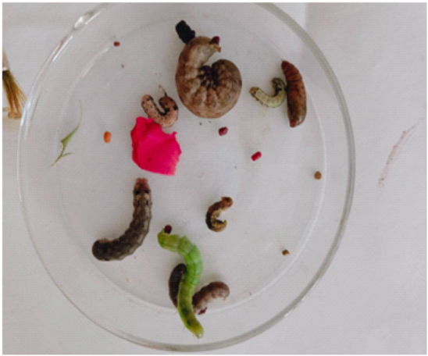  Plate No.1  Different instars of Tobacco caterpillar (Spodoptera litura) | 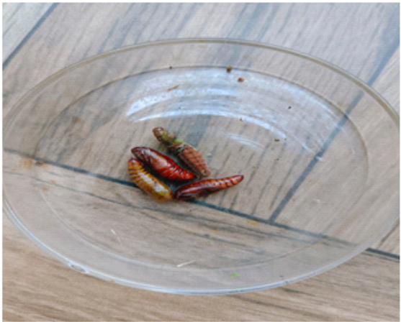  Plate No.2  Pupal stage of Tobacco caterpillars (Spodoptera litura)
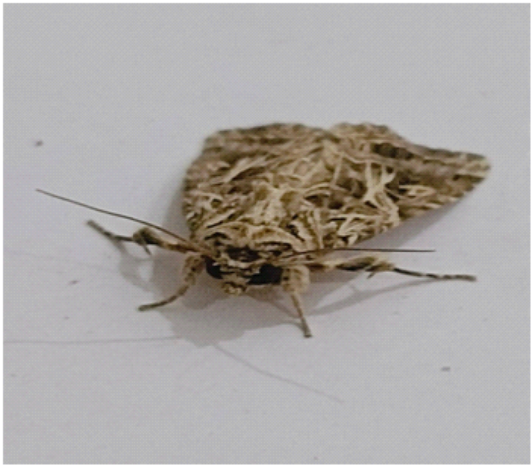  Plate No.3  Adult moth of Tobacco caterpillar (Spodoptera litura) | 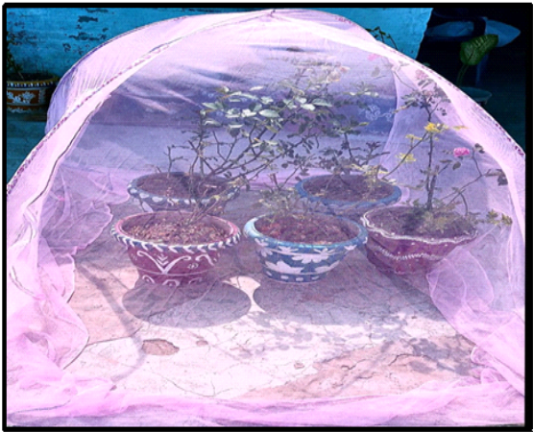  Plate No.4  Mating process of Tobacco caterpillar on rose plants (Spodoptera litura)
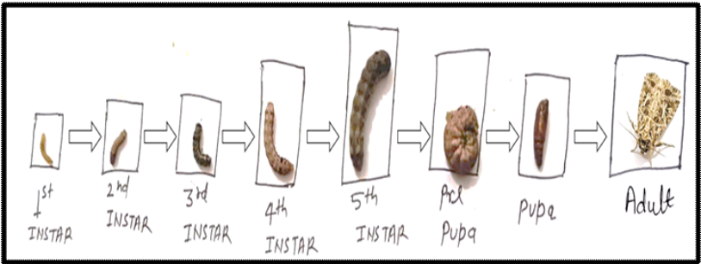
Plate No.5
Various life stages of Tobacco caterpillar (Spodoptera litura)

3.3. Life Table and age-specific fecundity of Spodoptera litura:
Life Table for calculating age-specific fecundity to assess the females (lx) and age schedule for birth at age x(mx). Table -2 showed the age-specific fecundity data Spodoptera litura oviposition period ranged between 35 to 37th days of pivotal age. The first-time Female deposited a clutch of eggs on the 38th, 39th, and 40th day (mx=36.50, 118.15, 224. 05) which continued until up to the 44th day (mx=46.10) with lx values being 0.65 to 0.32, respectively. The first female death toll was recorded on the 39th day of crucial age, 5th day following the appearance of adult females (lx=0.61) and the mortality rate subsequently increased showed a slow fall in the lx values after the 39th day of pivotal age (Greenberg et al.2001; Gedia et al., 2008a). The female revealed the highest mean offspring production per day (mx=335.15) on the 41st day of pivotal age but decreased to (mx=46.10) on the 44th day. The net reproductive rate (Ro) for lx. mx. and x. lx. mx. was 26316.23, Which was used to calculate the average generation length.

3.4. The mean duration of a generation, innate capacity and finite rate of increase in number of Spodoptera litura
The net reproductive rate (Ro) which represents the ratio of female births in a particular generation was 643.34. The mean generation time (Tc) was observed at 40.91 days given in Table- 3. Spodoptera litura has a natural growth in number (rm) was 0.1581 and a finite rate of increase(λ)1.17 females per female. The population can be multiplied weekly (3. 00) times (Gedia et al., 2008b; Kavitha et al.2011 and Patil, et al.2015) Doubling time was recorded at 4.38 days. The potential fecundity value was recorded at 1181.19. In the hypothetical F2 generation female population was 413886.36, with a possible fecundity of 1181.19 eggs per female. Present finding revealed close conformity with the results of Arya (2019).
Table 1: Survival of Spodoptera litura at various developmental stages on roses
Replication | No. of eggs | Egg stage  (0 - 3 days) | Larval stages (4 - 23 days) | Pupal stages (24 - 34 days)
1 | 10 | 7 | 6 | 5
2 | 10 | 8 | 7 | 6
3 | 10 | 9 | 9 | 8
4 | 10 | 8 | 7 | 6
5 | 10 | 10 | 10 | 8
6 | 10 | 9 | 7 | 6
7 | 10 | 8 | 8 | 8
8 | 10 | 9 | 7 | 5
9 | 10 | 10 | 10 | 8
10 | 10 | 7 | 6 | 5
Total | 100 | 85 | 77 | 65
Cumulative mortality (%) | - | 15 | 23 | 35

Fig. 1. Survival of Spodoptera litura at various developmental stages on roses

Table 2: Lifecycle and age-specific fecundity of Spodoptera litura on roses
Pivotal age expressed in days (x) | Survival at different age intervals (lx) | Age schedule for birth at age x (mx) | lx. mx | x. lx. mx
0-34s | 65. 00 | - | - | Immature
35 | 0.65 | - | 0.65 | 22.75
36 | 0.65 | - | 0.65 | 23.40
37 | 0.65 | - | 0.65 | 24. 05
38 | 0.65 | 36.50 | 23.73 | 901.74
39 | 0.61 | 118.15 | 72. 07 | 2810.73
40 | 0.60 | 224. 05 | 134.43 | 5377.20
41 | 0.58 | 335.15 | 194.39 | 7969.99
42 | 0.51 | 293.12 | 149.49 | 6278.58
43 | s0.41 | 128.12 | 52.53 | 2258.79
44 | 0.32 | 46.10 | 14.75 | 649. 00
45 | 0.20 | 0. 00 | 0. 00 | 0. 00
 | ∑lx |  | R₀=∑lx. mx | ∑x. lx. mx
 | 70.83 | 1181.19 | 643.34 | 26316.23

Table 3: Mean length of generation, innate capacity for increase in number and finite rate of increase in number of Spodoptera litura on roses
Population growth statistics | Formula | Calculated value
Net reproductive rate | R_{o}= ∑lx. mx | 643.34
Mean length of generation (days) | Tc= ∑x. lx. mx / Ro | 40.91
Innate capacity for increase in number (females/female/day) | rm= Log_{e} R_{o} / T_{c} | 0.1581
Finite rate of increase in number (females/female/day) | λ=antilog e^{rm} | 1.17
Arbitary 'rm' (rc) | - | 0.16 or 0.17
Weekly multiplication of population | (λ)⁷ | 3. 00
Doubling time (DT) (Days) | = log_{e}2/rm | 4.38
Potential fecundity (Pf) | ∑ mx | 1181.19
Hypothetical F₂ females | (R0)² | 413886.3556

3.5. Age-specific distribution of Spodoptera litura on roses:
The study found that the Spodoptera litura developmental stage of roses showed a negative impact on the age schedule of natality and mortality rate (mx and lx) (Table 4). The study found that adults made up only 0.31 percent of the stable age population, while eggs, larvae and pupae accounted for 49.74, 48. 02 and 1.94 percent, respectively. Similar results were found by Patil et al. (2015) and Arya and Dubey (2017). The study found that the immature stage provided the highest Table age distribution among the population (Tuan, et al.2013; Shekhawat et al. 2018).

Table 4: Age-specific distribution of Spodoptera litura on roses
Pivotal age  (in days) x | lx | X+1 | rm*  (x+1) | exp  (rm*x+1) | Lx(exp  (rm*x+1) | % contribution
0 | 1. 00 | 1 | 0.1581 | 0.8538 | 0.853800 | 15.5197 | Eggs  49.74
1 | 1. 00 | 2 | 0.3162 | 0.7289 | 0.728900 | 13.2493 | Eggs  49.74
2 | 1. 00 | 3 | 0.4743 | 0.6223 | 0.622300 | 11.3117 | Eggs  49.74
3 | 1. 00 | 4 | 0.6324 | 0.5313 | 0.531300 | 9.6575 | Eggs  49.74
4 | 1. 00 | 5 | 0.7904 | 0.4536 | 0.453600 | 8.2452 | Larvae  48. 02
5 | 1. 00 | 6 | 0.9485 | 0.3873 | 0.387300 | 7. 0400 | Larvae  48. 02
6 | 0.90 | 7 | 1.1066 | 0.3307 | 0.297630 | 5.4101 | Larvae  48. 02
7 | 0.90 | 8 | 1.2647 | 0.2823 | 0.254070 | 4.6183 | Larvae  48. 02
8 | 0.89 | 9 | 1.4228 | 0.2410 | 0.214490 | 3.8988 | Larvae  48. 02
9 | 0.88 | 10 | 1.5809 | 0.2058 | 0.181104 | 3.2920 | Larvae  48. 02
10 | 0.87 | 11 | 1.7390 | 0.1757 | 0.152859 | 2.7785 | Larvae  48. 02
11 | 0.87 | 12 | 1.8971 | 0.1500 | 0.130500 | 2.3721 | Larvae  48. 02
12 | 0.85 | 13 | 2. 0551 | 0.1281 | 0.108885 | 1.9792 | Larvae  48. 02
13 | 0.84 | 14 | 2.2132 | 0.1093 | 0. 091812 | 1.6689 | Larvae  48. 02
14 | 0.83 | 15 | 2.3713 | 0. 0934 | 0. 077522 | 1.4091 | Larvae  48. 02
15 | 0.82 | 16 | 2.5294 | 0. 0797 | 0. 065354 | 1.1880 | Larvae  48. 02
16 | 0.81 | 17 | 2.6875 | 0. 0681 | 0. 055161 | 1. 0027 | Larvae  48. 02
17 | 0.81 | 18 | 2.8456 | 0. 0581 | 0. 047061 | 0.8554 | Larvae  48. 02
18 | 0.80 | 19 | 3. 0037 | 0. 0496 | 0. 039680 | 0.7213 | Larvae  48. 02
19 | 0.79 | 20 | 3.1618 | 0. 0424 | 0. 033496 | 0.6089 | Larvae  48. 02
20 | 0.77 | 21 | 3.3198 | 0. 0362 | 0. 027874 | 0.5067 | Larvae  48. 02
21 | 0.75 | 22 | 3.4779 | 0. 0309 | 0. 023175 | 0.4213 | Larvae  48. 02
22 | 0.73 | 23 | 3.6360 | 0. 0264 | 0. 019272 | 0.3503 | Pupae  1.94
23 | 0.73 | 24 | 3.7941 | 0. 0225 | 0. 016425 | 0.2986 | Pupae  1.94
24 | 0.73 | 25 | 3.9522 | 0. 0192 | 0. 014016 | 0.2548 | Pupae  1.94
25 | 0.72 | 26 | 4.1103 | 0. 0164 | 0. 011808 | 0.2146 | Pupae  1.94
26 | 0.72 | 27 | 4.2684 | 0. 0140 | 0. 010080 | 0.1832 | Pupae  1.94
27 | 0.71 | 28 | 4.4265 | 0. 0120 | 0. 008520 | 0.1549 | Pupae  1.94
28 | 0.71 | 29 | 4.5845 | 0. 0102 | 0. 007242 | 0.1316 | Pupae  1.94
29 | 0.71 | 30 | 4.7426 | 0. 0087 | 0. 006177 | 0.1123 | Pupae  1.94
30 | 0.70 | 31 | 4.9007 | 0. 0074 | 0. 005180 | 0. 0942 | Pupae  1.94
31 | 0.69 | 32 | 5. 0588 | 0. 0064 | 0. 004416 | 0. 0803 | Pupae  1.94
32 | 0.66 | 33 | 5.2169 | 0. 0054 | 0. 003564 | 0. 0648 | Pupae  1.94
33 | 0.66 | 34 | 5.3750 | 0. 0046 | 0. 003036 | 0. 0552 | Adult  0.31
34 | 0.65 | 35 | 5.5331 | 0. 0040 | 0. 002600 | 0. 0473 | Adult  0.31
35 | 0.65 | 36 | 5.6912 | 0. 0034 | 0. 002210 | 0. 0402 | Adult  0.31
36 | 0.65 | 37 | 5.8492 | 0. 0029 | 0. 001885 | 0. 0343 | Adult  0.31
37 | 0.65 | 38 | 6. 0073 | 0. 0025 | 0. 001625 | 0. 0295 | Adult  0.31
38 | 0.65 | 39 | 6.1654 | 0. 0021 | 0. 001365 | 0. 0248 | Adult  0.31
39 | 0.61 | 40 | 6.3235 | 0. 0018 | 0. 001098 | 0. 0200 | Adult  0.31
40 | 0.60 | 41 | 6.4816 | 0. 0015 | 0. 000900 | 0. 0164 | Adult  0.31
41 | 0.58 | 42 | 6.6397 | 0. 0013 | 0. 000754 | 0. 0137 | Adult  0.31
42 | 0.51 | 43 | 6.7978 | 0. 0011 | 0. 000561 | 0. 0102 | Adult  0.31
43 | 0.40 | 44 | 6.9559 | 0. 0010 | 0. 000400 | 0. 0073 | Adult  0.31
44 | 0.32 | 45 | 7.1139 | 0. 0008 | 0. 000256 | 0. 0047 | Adult  0.31
45 | 0.20 | 46 | 7.2720 | 0. 0007 | 0. 000140 | 0. 0025 | Adult  0.31
Total | 34.32 | 1081 | 170.8927 | 5.8348 | 5.501403 | 100. 0 | 100

3.6. The life expectancy of Spodoptera litura
Table 5 summarised that the life expectancy (ex) of Spodoptera litura declined with time. Newly deposited eggs recorded a life expectancy of 12.90 days. The death rate (dx) gradually increased, resulted in a decrease in the lx values. The mortality rate found highest between 40-45 days of pivotal age. After 1 day, the expectation of survival decreased.

Table 5: Life Table for computing life expectancy of Spodoptera litura on roses
Pivotal age (Days) (x) | Number Surviving to the beginning of the age interval | Number dying during 'x' | Mortality rate per hundred alive at beginning of the age interval (dx.100) (100 qx) | Alive between age ‘x’ and ‘x+1’ (Lx) | No. of the individual’s life days beyond ‘x’ (Tx) | Expectation of further (ex)
0 - 5 | 100 | 10 | 10. 00 | 96. 00 | 644. 00 | 12.88
05-10 | 92 | 3 | 3.26 | 88.50 | 548. 00 | 11.91
10-15 | 85 | 5 | 5.88 | 82. 00 | 459.50 | 10.81
15-20 | 79 | 2 | 2.53 | 77.50 | 377.50 | 9.56
20-25 | 76 | 3 | 3.94 | 73. 00 | 300. 00 | 7.89
25-30 | 70 | 5 | 7.14 | 67.50 | 227. 00 | 6.49
30-35 | 65 | 4 | 6.15 | 63. 00 | 159.50 | 4.91
35-40 | 61 | 1 | 1.64 | 54.50 | 96.50 | 3.16
40-45 | 48 | 36 | 75. 00 | 33. 00 | 42. 00 | 1.75
45-50 | 18 | 17 | 94.44 | 9. 00 | 9. 00 | 1. 00

4. Conclusion

Various life stages of Spodoptera litura (Fab.) roses produced 100 eggs in 10 replications. The maximum duration of various life stages of Spodoptera litura was perceived to be 3, 18 and 10 days for egg, larval and pupal stages, respectively. Total developmental period out of 100 eggs, a total of 65 adults successfully emerged. It was found that Age-specific distribution of adults contributed only 0.31 per cent to the population of stable age, whereas eggs, larvae and pupae presented 49.74, 48. 02 and 1.94 per cent, respectively. The life expectancy of newly hatched eggs of Spodoptera litura was seen at 12.90 days. Death rate (dx) increased gradually which showed a decrease in the lx values and the impermanence rate was relatively greatest at the age 40-45 days of pivotal age.

References

- Arya, S. (2016) Response of Abiotic Factors on Population of Oriental Fruit Fly (B. Dorsalis) In Guava Varieties. Academic Social Research.2 (4), 73-76
- Arya, S. (2018) Biometrical Studies of Floribunda Roses. International Journal of Biological Sciences.9 (1), 162-165. DOI: https://doi.org/10.5281/zenodo.15669147
- Arya, S. (2018a) Insect Pest and Diseases of Roses: Symptoms and Control Measures. Academic Social Research.4 (1), 312-319. DOI: 10.5281/zenodo.15697980
- Arya, S. (2019) Population Dynamics of Citrus butterfly Papillio demoleus on Citrus crop. Remarking an Analisation.4 (2), 111-117. DOI: https://doi.org/10.5281/zenodo.15697804
- Arya, S. and Dubey, R. K. (2017) A Scientific Study and Analysis of Incidence and Intensity of Bark Eating Catapillar (Inderbela Spp.) In Guava (P. Guajava) Tree. International Journal of Innovative Research in Science, Engineering and Technology.6 (5), 10032-10034
- Arya, S., and Dubey, R. K. (2013) Bio efficacy of entomopathogenic fungi against oriental fruit fly (dacus dorsalis H.) infesting guava in riverbed area of ganga. International Journal of Innovative Research in Science, Engineering and Technology.2 (11), 7066-7068
- Ashok K., Kennedy J. S., Geethalakshmi V., Jeyakumar P., Sathiah N. and Balasubramani V. (2020) Life Table study of fall armyworm Spodoptera frugiperda (JE Smith) on maize Indian Journal of Entomology 82(3), 574–579. Doi: 10.3390/insects14040329
- Atwal A. S. and Bains S. S. (1974) Applied Animal Ecology, Kalyani Publishers, Ludhiana, pp.11-35.
- Bharathi J. L., Srieedhar U., Kishore B., Prasad J. V. and Prasad Rao J. A. V. (2007) Life table studies of Spodoptera litura on different types of tobacco, “Tobacco Res.33:36-42.
- Bruno F., Conti D., Bueno V., Sampaio M. V. and Sidney L. (2009) Reproduction and fertility life table of three aphid species (Macrosiphini) at different temperatures. Revista Brasileira de Entomologia 54(4), 654-660.
- Cardona J., Rajendran G., Cannayane I. and Chandrika M. (2003). Life table for Meloidogyne Incognita on brinjal. International Journal of Nematology 13 (2), 204-208.

- Cardona, E. V., Ligat, C. S. and Subang, M. P. (2007). Life history of common cutworm, Spodoptera litura Fabricius (Noctuidae: Lepidoptera) in Benguet. BSU Res. J.56: 73-84.
- Dar, M. H., Rizvi, P. Q., and Naqvi, N. A. (2003) Age and stage specific life tables of Spodoptera litura Fabricius on mungbean and urdbean. Indian Journal of Pulses Research, 16(1), 39- 41.
- Dhabi M. R., Mehta, D. M., Patel, C. C. and Korat, D. M., (2009). Life table of diamondback moth, Plutellaxylostella (Linnaeus) on cabbage (Brassica oleraceae var. capitata L.). Karnataka J. Agric. Sci., 22(2), 319-321.
- Gedia M. V., Vyas H. J., Acharya M. F. and Patel P. V., (2008b). Life table, rate of increase and stable age distribution of Spodoptera litura (Fabricius) on cotton. Ann. Pl. Prot. Sci., 16(1), 62-65.
- Gedia M. V., Vyasv H. J., Acharya M. F. and Patel P. V., (2008a). Studies on life fecundity tables of Spodoptera litura (Fabricius) on groundnut. Ann. Pl. Prot. Sci., 16(1), 74-77.
- Greenberg S. M., Sappington T. W., Legaspi B. C., Liu T. X. and Sitamau M. (2001). Feeding and life history of Spodoptera exigua (Lepidoptera: Noctuidae) On different host plants. Annals of the Entomological Society of America 94(4), 566-575.
- Howe, R. W. (1953) The rapid determination of intrinsic rate of increase of an insect population Ann. Appl. Biol.40:134-135. Doi: 10.1111/j.1744-7348.1953.tb02372.x
- Kavitha P. G., Jonathan E. I. and Nakkeeran S. (2011) Life cycle, Histopathology and yield loss Caused by Root knot nematode Meloidogyne Incognita on Noni. Madras Agric. J., 98 (10-12), 386-389.
- Maghodia, A. B. and Koshiya, D. J., (2008). Life fecundity studies (for females) of Spodoptera litura Fabricius on different hosts. Crop Res., 35(3), 132-136.
- Patil, R. A., Ghetiya, L. V., Jat, B. L. and Shitap, M. S., (2015). Life table evaluation of Spodoptera litura (Fabricius) on bidi tobacco, Nicotiana tabacum. The Ecoscan, 9: 25-30.
- Shekhawat S. S. Ansari M. S. and Basri R. (2018) Effect of Host Plants on Life Table Parameters of Spodoptera litura. Int. J. Pure App. Biosci. SPI: 6 (2), 324-332.
- Thanki K. V, Patel G. S. and Patel J. R. (2003) Population dynamics of Spodoptera litura on Castor Ricinus Communis. Indian journal of Entomology 65(3), 347-350.
- Tuan, S. J., Lee, C. C. and Chi, H. (2013) The development and life cycle of Meloidogyne Incognita in sweet potato (Ipomoea batatas) TIS 4400-2. IOSR Journal of Agric. and Veterinary Science.7(9), 49-53.

