***Original Research Article***

**CELLULASE PRODUCTION FROM *BACILLUS SUBTILIS* CAS PG2 USING LIGNOCELLULOSIC WASTES- A STATISTICAL APPROACH**

**ABSTRACT**

The cellulase producing bacterium *Bacillus subtilis* CAS PG2 was isolated from fish gut and identified through 18S rRNA gene sequences. Optimization of medium components and culture conditions for celluase production were optimized by response surface methodology utilizing lignocellulosic waste as a substrate. Plackett-Burman tool was used to determine the ideal medium ingredients and culture conditions for increased protease production. Utilizing central composite design, the optimal medium components for achieving maximum cellulase production (1124.29 U/mL) were determined as follows: rice bran (7.50 g/L), peptone (5.00 g/L), KH2PO4 (0.75 g/L), and NaCl (7.50 g/L). Thus, the cellulase from fish gut-associated *Bacillus subtilis* CAS PG2 that uses lignocellulosic biomass could be quite valuable in developing industrial value added products.

**KEYWORDS:** *Bacillus subtilis*. Cellulosic wastes. Cellulase. Lignocellulosic wastes

**1. INTRODUCTION**

The most prevalent renewable biopolymer for numerous industries, including the manufacturing of paper and pulp (Buchert et al., 1996), animal feed, textiles, and detergents (Sukumaran et al., 2005; Aygan and Arikan, 2008), is cellulose biomass. They are used lignocellulosic material-based for manufacturing of bioethanol (Wang et al., 2009). The efficient use of cellulosic biomasses is hindered by the microcrystalline structure of cellulose (Lai et al., 2016; Yang et al., 2014). Although traditional heat, acid, and alkali treatment techniques produce good results, they also cause secondary contamination (Agbor et al., 2011). Alternatively, the utilization of microbial cellulases has been proposed as a highly efficient approach for cellulose biodegradation (Fang et al., 2012; Li et al., 20212). Lignocellulosic materials, comprising predominantly cellulose (40–60%), hemicellulose (20–40%), and lignin (15–30%), along with smaller yet substantial fractions (Dekker, 1983; Annamalai et al., 2012), are widely employed. Ethanol production from lignocellulosic biomass stands as a pivotal technology for sustainable transportation fuels (Sukumaran et al., 2009). However, the enzymatic saccharification of cellulosic materials for fermentable sugar production faces notable challenges due to the low productivity and high cost of cellulases.

Microorganisms produce cellulases during their growth on cellulosic materials, catalyzing the hydrolysis of the cellulose's β-1,4-glycosidic linkage (Lee and Koo, 2001). Various types of cellulase, including endoglucanase (1,4-D-glucan-4-glucanohydrolase; EC 3.2.1.4), exocellobiohydrolase (1,4-D-glucan glucohydrolase; EC 3.2.1.74), and glucosidase (D-glucoside glucohydrolase; EC 3.2.1.21), are necessary for the complete enzymatic degradation of cellulosic materials. The enzymatic breakdown of cellulosic materials can be achieved through a complex reaction involving these different enzymes. Extensive global research has been undertaken to discover new microorganisms that produce cellulolytic enzymes with higher specific activity and improved efficiency (Johnvesly et al., 2002). Moreover, enzymes produced by marine microbes, owing to their diverse habitats, can offer several advantages over conventional enzymes (Rasmussnen and Morrissey, 2007). Therefore, the goal of the current work was to statistically optimize the media components for cellulase synthesis using agro industrial wastes by the response surface approach. Further research was done on the *Bacillus subtilis* cellulase for the enzymatic saccharification of cellulosic biomass.

**2. MATERIALS AND METHOD**

**2.1. Isolation and Molecular Identification of Cellulase Producer**

Nutrient agar (Himedia, India) media was used to isolate probiotics strains from live and healthy common carp (50 –100g; 5 pieces) of both sexes were collected from Manakkudi Estuary, Kanyakumari District, Tamil Nadu, India by standard spread plate method. Isolates were plated on carboxymethyl-cellulose (CMC) agar plates for cellulase production screening. The strain CAS PG2 with potential was identified based on morphological and biochemical characteristics (Garrity et al., 2001). This identification was subsequently confirmed through molecular characterization via 16S rRNA gene sequencing. Initially, bacterial genomic DNA was isolated using the phenol-chloroform technique (Marmur, 1961), followed by PCR amplification of the 16S rRNA gene using primers 8F and 1492R   
(5′-GAGTTTGATCCTGGCTCAG-3′). PCR cycling conditions comprised 35 cycles of initial denaturation at 95°C for 5 min, followed by denaturation at 95°C for 1 min, annealing at 55°C for 1 min, extension at 72°C for 1.5 min, and final extension at 72°C for 5 min. Sequencing of the 16S rRNA gene was performed using an automated DNA sequencer (MegaBACE; GE Healthcare Lifesciences, Little Chalfont, UK), and homology was analyzed against sequences in GenBank using the CLUSTAL X program (Saitou and Nei, 1987).

**2.2 Statistical optimization of cellulase production**

**2.2.1 Plackett - Burman design**

The Plackett-Burman design offers an efficient method to screen significant media components among numerous process variables necessary for enhanced cellulase production by screening 'n' variables in 'n + 1' experiments. Each factor is assessed at two levels: -1 for a low level and +1 for a high level. In the present study, nine variables were selected, including Paper Industry Waste (PIW), Tamarind Kernel Powder (TKP), Palm Jaggery (PJ), Rice Bran (RB), peptone, casaminoacid, MgSO4, KCl, and Sodium chloride (Table 1). These variables were evaluated across 12 experimental trials, as detailed in Table 2. The design was executed in a single block, and the sequence of experiments was fully randomized. The design was constructed using MINITAB, version 16 (PA, USA).

**2.2.2. Central composite design**

The next step in medium optimization is to figure out the ideal concentrations of key factors that affect cellulase production. Rice bran, peptone, MgSO4, and NaCl were found to be the most important factors at Plackett-Burman design time. The statistical programme Minitab, version 16 (Minitab Inc., State College, PA, USA) was used to create a total of 31 experiments, with the centre values of all variables being coded as zero. Table 3 provides the whole experimental plan, together with their values and the matching experimental and projected response values (Y). Analysis of Variance was applied to the cellulase production data received from the RSM (ANOVA). The following second order polynomial equation was used to fit the experimental RSM data using the response surface regression method:

Y= *β0* + ∑ *βiX*i+ ∑ *βiiXi2*+ ∑ *βijXiXj*

where *Y* is the predicted response**,** *Xi*and*Xj* are independent factors, *β*0 is the intercept, *βi* is the linear coefficient, *βii* is the quadratic coefficient, and *βij* is the interaction coefficient. The statistical software package MINITAB, version 16 (PA, USA) was used to analyze the experimental data.

**2.3. Cellulase activity**

The cellulase activity was assessed by combining 100 μl of the enzyme mixture with 100 μl of 1% (w/v) CMC in 50 mM Tris-HCl buffer (pH 9) at 50°C for 20 minutes. To halt the reaction, the DNS (3,5-dinitrosalicylic acid) reagent was added. The mixture was then boiled for 10 minutes, cooled on ice, and the amount of liberated reducing sugars was measured at 550 nm. The quantity of enzyme required to release 1 mol of glucose per minute was used to define 1 unit of cellulase activity.

**3. RESULTS AND DISCUSSION**

**3.1 Isolation and identification of cellulose producing bacteria**

A cellulase-producing strain, designated as CAS PG2, was isolated from fish obtained from the Kanyakumari coast in Tamil Nadu, India. Based on its morphological, physiological, and biochemical characteristics, the strain CAS PG2 was identified as belonging to the Bacillus genus. It is a Gram-positive bacterium capable of forming endospores. Notably, it lacks oxidase activity but exhibits catalase activity. Furthermore, the strain CAS PG2 demonstrates the ability to thrive in both aerobic and anaerobic conditions. Based on the evolutionary distance and the constructed phylogenetic tree (Fig. 1), we confirmed the identity of the strain as *Bacillus subtilis* and designated it as *Bacillus subtilis* CAS PG2 (GenBank ID: PP503338.1).

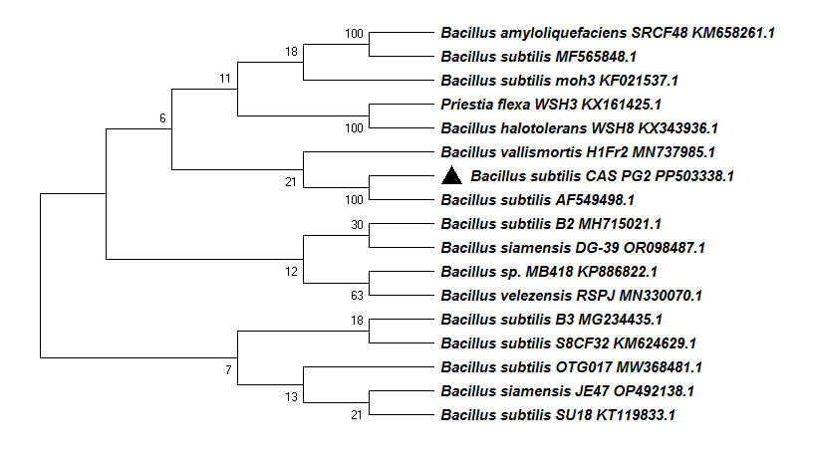

**Fig. 1. Neighbor-joining phylogenetic tree analysis of partial 16S rRNA gene sequences of *Bacillus subtilis* CAS PG2 PP503338.1 and related microorganisms. Percentage bootstrap values, based on 1,000 replications. Scale bar (0.05) indicates the number of substitutions per nucleotide position.**

**3.2 Screening of significant variables using Plackett- Burman design**

Nine different variables were examined in the Plackett-Burman design to ascertain their effects on cellulase production. In terms of the total variables, RB, peptone, KH2PO4, and NaCl showed positive effects and significant p values (<0.05) in cellulase production, whereas PIW, TKP, PJ, casaminoacid, and MgSO4 showed negative effects (Table 1). The results of the Plackett-Burman design experiment demonstrated a variation in cellulase production ranging from 323.22 to 782.01 U/mL (Table 2). This variability underscores the importance of media optimization in achieving higher productivity. Subsequently, a central composite design was employed to investigate the optimal concentrations of the four variables, namely RB, peptone, KH2PO4, and NaCl, as well as their interactions.

**Table 1. Experimental variables at different levels used for the production of alkaline cellulase by *Bacillus subtilis* using Plackett–Burman design.**

|  |  |  |  |  |  |  |  |
| --- | --- | --- | --- | --- | --- | --- | --- |
| Serial No | Variables | Levels | | Effect | Coefficient | t-value | p-value |
| -1 | +1 |
|  |  |  |  |  |  |  |  |
| Constant |  |  |  |  | 556.99 | 135.58 | 0.000 |
| X1 | PIW (g/l) | 1 | 5 | 11.56 | 5.78 | 1.41 | 0.295 |
| X2 | TKP (g/l) | 1 | 5 | 16.02 | 8.01 | 1.95 | 0.191 |
| X3 | RB (g/l) | 1 | 5 | 103.66 | 51.83 | 12.62 | 0.006* |
| X4 | PJ (g/l) | 1 | 5 | -52.98 | -26.49 | -6.45 | 0.023 |
| X5 | Peptone (g/l) | 1 | 3 | 40.95 | -20.47 | -4.98 | 0.038* |
| X6 | Casamino (g/l)  acid | 0.1 | 1 | -26.60 | 13.30 | 3.24 | 0.084 |
| X7 | KCl (g/l) | 0.1 | 0.5 | -9.62 | -4.81 | -1.17 | 0.362 |
| X8 | MgSO4 (g/l) | 0.1 | 0.5 | 91.07 | 45.53 | 11.08 | 0.008* |
| X9 | NaCl (%) | 1 | 5 | 186.20 | 93.10 | 22.66 | 0.002* |

**Table 2 Plackett-Burman design matrix for 9 variables with coded values along with the predicted and observedcellulase levels**

|  |  |  |  |  |  |  |  |  |  |  |  |
| --- | --- | --- | --- | --- | --- | --- | --- | --- | --- | --- | --- |
| Runs | X1 | X2 | X3 | X4 | X5 | X6 | X7 | X8 | X9 | Cellulase yield (U/mL) | |
| Observed | Predict |
|  |  |  |  |  |  |  |  |  |  |  |  |
| 1 | +1 | -1 | +1 | +1 | -1 | +1 | -1 | -1 | -1 | 482.02 | 480.05 |
| 2 | -1 | +1 | +1 | +1 | -1 | +1 | +1 | -1 | +1 | 659.12 | 661.09 |
| 3 | -1 | -1 | +1 | +1 | +1 | -1 | +1 | +1 | -1 | 474.42 | 482.39 |
| 4 | -1 | -1 | -1 | +1 | +1 | +1 | -1 | +1 | +1 | 609.13 | 601.15 |
| 5 | +1 | +1 | -1 | +1 | -1 | -1 | -1 | +1 | +1 | 635.10 | 643.07 |
| 6 | -1 | +1 | +1 | -1 | +1 | -1 | -1 | -1 | +1 | 658.12 | 656.15 |
| 7 | +1 | -1 | -1 | -1 | +1 | +1 | +1 | -1 | +1 | 557.03 | 565.00 |
| 8 | +1 | +1 | -1 | +1 | +1 | -1 | +1 | -1 | -1 | 323.22 | 315.24 |
| 9 | -1 | +1 | -1 | -1 | -1 | +1 | +1 | +1 | -1 | 517.25 | 515.28 |
| 10 | +1 | -1 | +1 | -1 | -1 | -1 | +1 | +1 | +1 | 782.01 | 774.08 |
| 11 | +1 | +1 | +1 | -1 | +1 | +1 | -1 | +1 | -1 | 597.20 | 599.17 |
| 12 | -1 | -1 | -1 | -1 | -1 | -1 | -1 | -1 | -1 | 389.25 | 391.22 |

**3.3 Response surface methodology**

The challenge of optimizing cellulase production parameters for the advancement of commercially viable production technology has been presented by traditional optimization techniques, which call for changing a single variable optimization strategy and have some drawbacks, including time consumption, the need for additional experimental data sets, and the absence of interdependencies between variables (Annamalai et al., 2014). A cellulase production technique may be developed with the use of effective experimental designs. Numerous fermentation processes have successfully used statistical optimization techniques like response surface methodology to optimize several variables, with positive results (Hao et al., 2006).

For fitting a second-order response surface in the current investigation, a central composite design with four factors and six levels-including five replicates at the centre point-was used. Table 3 displayed the design matrix together with the associated experimental data.

**Table 3. Central composite design for the experimental conditions and the corresponding responses to cellulase production.**

|  |  |  |  |  |  |  |  |  |  |
| --- | --- | --- | --- | --- | --- | --- | --- | --- | --- |
| Trials | Coded variable level | | | | | | | Cellulae yield (U/mL) | |
| X3  (g/L) | | X5  (g/L) | X8  (g/L) | | X9  (%) | | Observed | Predict |
| 1 | 6.25 | 4 | | | 0.625 | | 6.25 | 734.45 | 738.39 |
| 2 | 8.75 | 4 | | | 0.625 | | 6.25 | 747.32 | 745.37 |
| 3 | 6.25 | 6 | | | 0.625 | | 6.25 | 720.76 | 703.53 |
| 4 | 8.75 | 6 | | | 0.625 | | 6.25 | 687.62 | 695.65 |
| 5 | 6.25 | 4 | | | 0.875 | | 6.25 | 671.35 | 703.83 |
| 6 | 8.75 | 4 | | | 0.875 | | 6.25 | 681.38 | 688.05 |
| 7 | 6.25 | 6 | | | 0.875 | | 6.25 | 694.21 | 680.78 |
| 8 | 8.75 | 6 | | | 0.875 | | 6.25 | 671.65 | 650.14 |
| 9 | 6.25 | 4 | | | 0.625 | | 8.75 | 730.42 | 711.70 |
| 10 | 8.75 | 4 | | | 0.625 | | 8.75 | 741.38 | 746.26 |
| 11 | 6.25 | 6 | | | 0.625 | | 8.75 | 710.18 | 694.95 |
| 12 | 8.75 | 6 | | | 0.625 | | 8.75 | 787.38 | 714.66 |
| 13 | 6.25 | 4 | | | 0.875 | | 8.75 | 758.46 | 741.87 |
| 14 | 8.75 | 4 | | | 0.875 | | 8.75 | 776.67 | 753.67 |
| 15 | 6.25 | 6 | | | 0.875 | | 8.75 | 775.22 | 736.94 |
| 16 | 8.75 | 6 | | | 0.875 | | 8.75 | 746.37 | 733.88 |
| 17 | 5.00 | 5 | | | 0.750 | | 7.50 | 492.38 | 509.51 |
| 18 | 10.00 | 5 | | | 0.750 | | 7.50 | 481.77 | 513.43 |
| 19 | 7.50 | 3 | | | 0.750 | | 7.50 | 736.21 | 717.96 |
| 20 | 7.50 | 7 | | | 0.750 | | 7.50 | 596.26 | 663.30 |
| 21 | 7.50 | 5 | | | 0.500 | | 7.50 | 547.43 | 577.55 |
| 22 | 7.50 | 5 | | | 1.000 | | 7.50 | 543.54 | 562.22 |
| 23 | 7.50 | 5 | | | 0.750 | | 5.00 | 1082.30 | 1059.41 |
| 24 | 7.50 | 5 | | | 0.750 | | 10.00 | 1044.77 | 1116.46 |
| 25 | 7.50 | 5 | | | 0.750 | | 7.50 | 1024.62 | 1110.08 |
| 26 | 7.50 | 5 | | | 0.750 | | 7.50 | 1124.13 | 1110.08 |
| 27 | 7.50 | 5 | | | 0.750 | | 7.50 | 1124.31 | 1110.08 |
| 28 | 7.50 | 5 | | | 0.750 | | 7.50 | 1124.62 | 1110.08 |
| 29 | 7.50 | 5 | | | 0.750 | | 7.50 | 1123.52 | 1110.08 |
| 30 | 7.50 | 5 | | | 0.750 | | 7.50 | 1124.69 | 1110.08 |
| 31 | 7.50 | 5 | | | 0.750 | | 7.50 | 1124.69 | 1110.08 |

The second-order polynomial equation contains the mathematical model for the synthesis of cellulase with the independent process variables X3, X5, X8, and X9.

Y= -11500.6+ 1471.25X3 +1027.22X5 +12474.7X8 - 40.71X9 - 96.99X32 - 106.63X52 -8756.43X82 - 4.67X92 - 3.42X3X5 - 40.81X3X8 + 4.05

X3X9 + 38.1135X5X8 - 3.17X5X9 + 100.77X8X9

where Y is the predicted cellulase yield, X3 is RB, X5 is peptone, X8 is KH2PO 4 and X9 is initial NaCl. F-test and ANOVA were used to analyze the statistical significance. The model appears to be well-fitted based on the high F-value and non-significant lack of fit. Additionally, substantial P-values (0.000) indicated that the observed experimental data fit the model well, and the model's fit was verified by calculating the coefficient (R2), which had a multiple correlation coefficient of 98.50%. The modified R2 was about 98.15%, while the projected R2 was about 98.31% (Table 4). Regression equations are typically illustrated using three-dimensional response surface plots to show the link between responses and experimental levels for each variable (Fig.2).

**Table 4. Analysis of variance (ANOVA) for the parameters of response surface methodology fitted to quadratic polynomial model for optimization of cellulase production.**

|  |  |  |  |  |  |
| --- | --- | --- | --- | --- | --- |
| Source | DF | SS | MS | F-value | P-value |
| Regression | 14 | 1266200 | 90443 | 45.21 | 0.000 |
| Linear | 4 | 9738 | 2434 | 1.22 | 0.342 |
| Square | 4 | 1250305 | 312576 | 156.25 | 0.000 |
| Interaction | 6 | 6157 | 1026 | 0.51 | 0.090 |
| Residual Error | 16 | 32008 | 2001 |  |  |
| Lack-of-Fit | 10 | 23485 | 2349 | 1.65 | 0.278 |
| Pure Error | 6 | 8523 | 1420 |  |  |
| Total | 30 | 1298208 |  |  |  |

R2 = 99.53%, R2 (adj) = 99.12%, R2 (pred) = 99.35%, SS, sum of squares; DF, degrees of freedom; MS, mean square.

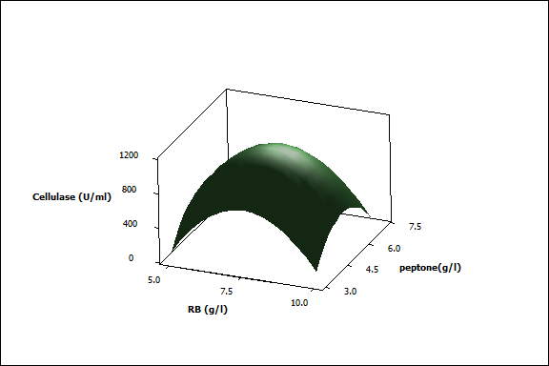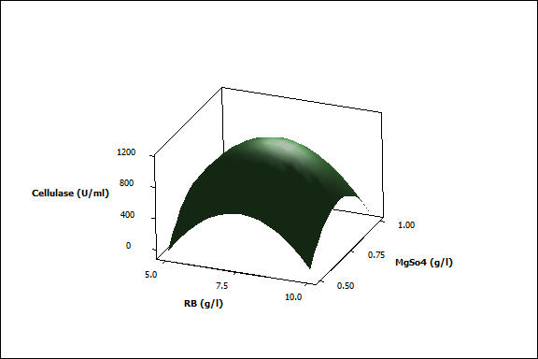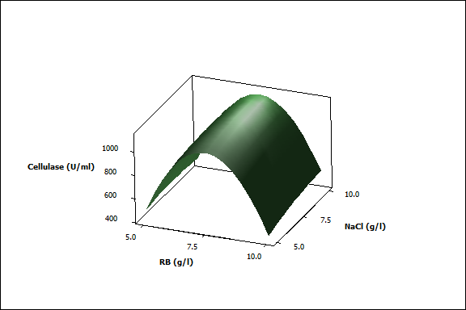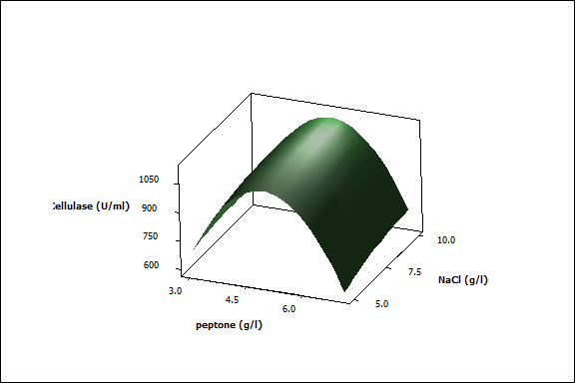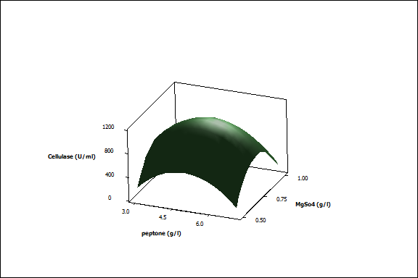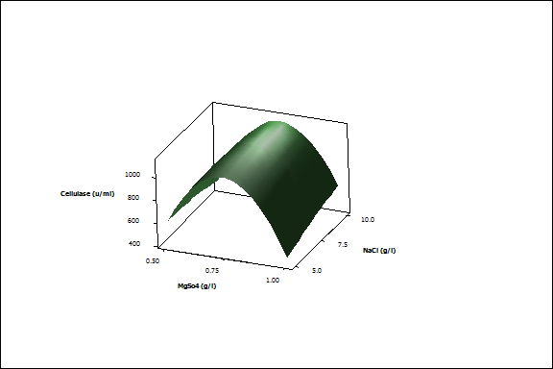

**A**

**C**

**B**

**F**

**E**

**D**

**Fig. 2. Three-dimensional response surface plots for cellulase production showing interactive effects of (A) RB and Peptone, (B)RBand NaCl, (C)peptone and MgSO4, (D)RB and MgSO4 (E)Peptone andNaCl (F)MgSO4 andNaCl concentrations.**

The model's results demonstrated that the highest levels of RB, peptone, KH2PO4, and NaCl could be produced, with respective values of 7.50 (g/L), 5.0 (g/L), 0.75 (g/L), and 7.50 (%). The average cellulase yield under these indicated conditions was   
1101.05 U/mL, which was in line with the expected value of 1124.29 U/mL. By using this optimization technique, the production of cellulase was increased from 323.22 U/mL to   
1124.29 U/mL. However, *B. halodurans* CAS 1 and *B. subtilis* A-53 used rice bran as a potential carbon source for maximal cell growth and cellulase synthesis (Lee et al., 2010, Annamalai et al., 2013). Similarly, Jo et al. (2008) and Mayende et al. (2006) observed that the best carbon source for the synthesis of cellulase by   
*B. amyloliquefaciens* DL-3 and *Bacillus* sp. CH 43 and HR was lignocellulosic wastes such rice hulls and rice bran. The candidate strain *Bacillus subtilis*, however, produced more cellulase than other marine bacteria such *Achromobacterxylosoxidans* (64.8 U/ml) (Mahalakshmi et a., 2016) and *B. subtilis* A-53 (89.6 U/ml) (Lee et al., 2010).

**4. CONCLUSIONS**

In the present study, based on the statistical optimization, maximum cellulase production (1124.29 U/mL) was obtained when the media provided with rice bran, KH2PO4 and NaCl were set at 7.50(g/l), 5.0(g/l), 0.75(g/l) and 7.50(%) respectively. Additionally, The results of using bacterial cellulase to saccharify various agricultural resources suggested that the strain might be further researched and taken into consideration for biomass saccharification and related industrial applications. According to the current study, *B. subtilis*, a estuarine fish associated bacterium that produces cellulase, is the best choice for the enzymatic saccharification of cellulosic wastes to yield reducing sugars for the subsequent manufacture of ethanol.

**ETHICS APPROVAL**

This article does not contain any studies with human participants.

**REFERENCES**

Agbor, V.B., Cicek, N., Sparling, R., Berlin, A., & Levin, D.B. (2011). Biomass pretreatment: fundamentals toward application. Biotechnology Advances, 29: 675–685

Annamalai, N., Rajeswari, M.V., & Balasubramanian, T. (2014). Enzymatic saccharification of pretreated rice straw by cellulase produced from *Bacillus carboniphilus* CAS 3 utilizing lignocellulosic wastes through statistical optimization. Biomass & Bioenergy, 68: 151-160

Annamalai, N., Rajeswari, M.V., Elayaraja, S., Thavasi, R., Vijayalakshmi, S., & Balasubramanian, T. (2012). Purification ­and Characterization of Thermostable Alkaline Cellulase from Marine Bacterium *Bacillus licheniformis* AU01 by Utilizing Cellulosic Wastes. Waste Biomass Valorization, 305–310

Aygan, A., & Arikan, B.A. (2008). New halo-alkaliphilic, thermostable endoglucanase from moderately halophilic *Bacillus* sp. C14 isolated from Van soda lake. International Journal of Agriculture and Biology, 10: 369–374

Buchert, J., Surnakki, A., Tenkanen, M., & Viikari, L. (1996). Enzymatic characterization of pulp. In: Jeffries TW, Viikari L (eds) Enzymes for pulp and paper processing. ACS Symp. Ser**655:** 38–48

Dekker, R.F.H. (1983). Bioconversion of hemicellulose: aspects of hemicellulase production by *Trichoderma reesei* QM9414 and enzymic saccharification of hemicellulose. Biotechnology and Bioengineering, 1-45

Fang, G.R., Li, J.J., Cheng, X., & Cui, Z.J. (2012). Performance and spatial succession of a full-scale anaerobic plant treating high-concentration cassava bioethanol wastewater. World Journal of Microbiology and Biotechnology, 22: 1148–1154

Garrity, G.M., Boone, D.R., & Castenholz R,W. (2001). Bergey’s manual of systematic bacteriology, 2nd edn. Springer, New York

Hao, X.C., Yu, X.B., &Yan, Z.L., (2006). Optimization of the medium for the production of cellulase by the mutant *Trichoderma reesei* WX- 112 using response surface methodology. Food Technology and Biotechnology, 44: 89–94

Johnvesly, B., VirupakshiS, Patil, G.N., Ramalingam, N., & Naik, G.R., (2002). Cellulase-free thermostable alkaline xylanase from thermophillic and alkalophillic *Bacillus* sp. JB-99.   
Journal of Microbiology and Biotechnology, 12: 153–156

Lai, D., Deng, L., Li, J., Liao, B., Guo, Q.X., Fu, Y. (2011). Hydrolysis of cellulose into glucose by magnetic solid acid. Chem Sus Chem, 4: 55–58

Lee, B.H., Kim, B.K., Lee, Y.J., Chung, C.H., & Lee, J.W. (2010). Industrial scale of optimization for the production of carboxymethylcellulase from rice bran by a marine bacterium, *Bacillus subtilis* subsp. subtilis A-53. Enzyme and Microbial Technology. 46: 38-42

Lee, S.M., & Koo, Y.M. (2001). Pilot-scale production of cellulose using Trichoderma reesei Rut C-30 in fed-batch mode. Journal of Microbiology and Biotechnology, 11: 229–233.

Li, P.P., Wang, X.J., & Cui, Z.J. (2012) .Survival and performance of two cellulose-degrading microbial systems inoculated into wheat strawamended soil. Journal of Microbiology and Biotechnology. 22: 126–132

Marmur, J. (1961). A procedure for the isolation of deoxyribonucleic acid from microorganisms. Journal of Molecular Biology, 3: 208–218

Rasmussnen, R.S., & Morrissey, M.T. (2007). Marine biotechnology for production of food ingredients. Advances in Food and Nutrition Research, 52: 237–292

Saitou, N., & Nei., M. (1987). The neighbor-joining method: a new method for reconstructing phylogenetic trees. Molecular Biology and Evolution, 4: 406–425

Sukumaran, K.R., Singhania, R.R., & Pandey, A. (2005). Microbial cellulases production, applications and challenge. Journal of Scientific & Industrial Research, 64: 834–844

Wang, C.Y., Hsieh, Y.R., NgCC, Chan, H., Lin, H.T., Zeng, W.S., & Shyu, Y.T. (2009). Purification and characterization of a novel halostable cellulase from *Salinivibrio* sp. strain NTU-05. Enzyme and Microbial Technology, 44: 373–379

Yang, W., Meng, F., Peng, J., Han, P., Fang, F., & Ma., L. (2014). Isolation and identification of a cellulolytic bacterium from the Tibetan pig’s intestine and investigation of its cellulase production. Electronic Journal of Biotechnology, 17: 262–267 .