"Unveiling Pest Resilience in Bottle Gourd: A Comprehensive Review of Field Monitoring and Statistical Insights"

Abstract
Bottle gourd (genus Lagenaria, species siceraria) is one of valuable cucurbitaceous vegetables grown all over the world due to its nutritional and economic importance. But it is affected by several insect pests and diseases, resulting in considerable yield losses. The objective of this review is to provide a state-of-the art knowledge of the procedures for bottle gourd pest monitoring, field screening, fruit damage assessment, rating system, antixenosis response as well as statistical correlation and regression analysis to obtain a deeper insight into the resistance mechanisms and yield loss prediction. The research incorporates real-time experimental data to assess the incidence of the pest and damage severity in bottle gourd range of crops.
Using field screening, laboratory analysis, and statistical modeling, the research evaluates the infestation patterns and plant resistance. Visual observation, pheromone trap and sticky trap were used for pest monitoring, which were used to identify major insect pests in bottle gourd production. Species and pear shape & genotype damage were assessed both according to weight and number to understand potential economic losses from disease and genotypes were graded according to a standardized system to serve to categorize genotypes according to their level of resistance. Antixenosis study was conducted to analyze the behavioral resistance of different bottle gourd varieties against the key pest. In addition, statistical association and regression models were used to assess the relationship between insect incidence, plant morphological traits and yield loss.
The results show that the cucurbit fruit fly (Bactrocera cucurbitae) is the most damaging pest, with infestation rates higher at certain flowering stage. Infested plants showed an average yield reduction of 25-40%, while severe damage occurred during the peak infestation period. Antixenosis traits such as repelling the insects from feeding and oviposition were highly significant (P a quarter 0.0001) in resistant genotypes. We found a strong negative correlation (r = -0.75) between trichome density and incidence of pests, implying that these morphological traits are key in determining natural pest resistance. The importance of pest damage in predicting yield loss was further underlined by a regression analysis approach (R² = 0.85); predictive modelling has the potential to improve pest management strategies.
The researchers stressed the importance of integrated pest management (IPM) practices, using genetic resistance, monitoring at early stages of the plants development and sustainable control methods to reduce economic losses. These results also indicate that genotypes with high levels of resistance and strong antixenosis mechanisms should be the primary focus of breeding programs targeting this pest. In particular, data-driven pest forecasting models could be utilized by farmers and researchers to apply targeted interventions that minimize chemical pesticides and promote sustainable yield.
Keywords: Bottle gourd, Pest monitoring, Field screening, Fruit damage assessment, Rating system, Antixenosis, Correlation analysis, Regression models, Yield loss, Integrated pest management (IPM).
Introduction
Bottle gourd (Lagenaria siceraria) is an economically and nutritionally important cucurbit crop, widely grown in tropical and subtropical regions globally. Due to its high water content, low caloric value and high fiber composition, it has become one of the most sought-after vegetables by health-conscious consumers. The fruit has medicinal properties and contains the following nutrients: Vitamin C, vitamin B-complex, calcium, magnesium, iron, Antioxidants. Bottle gourd in traditional medicine has been employed to treat cardiovascular diseases, urinal issues, and digestive disorders ( N’ Gaza et al. 2019). In addition, its diuretic and cooling qualities make it a common part of summer diets in many cultures. From an agronomical point of view, bottle gourd is a high yield fast growing vine crop adaptable to wide range of soil and climatic conditions. It is grown extensively in South Asia, Africa, and countries bordering the Mediterranean because of its ability to resist drought and grow in marginal or adverse environments (Dey, 2021). The crop also has an important role in small-scale farming systems, where it offers rural farmers sustainable income and food security (Hamid et al., 2023). Although bottle gourd production possesses both agronomic and economic importance, it is susceptible to insect pests, bacterial and fungal infections, and abiotic stresses. A few graves pests limit the quality of bottle gourd such as cucurbit fruit flies (Bactrocera cucurbitae), aphids (Aphis gossypii), whiteflies (Bemisia tabaci), leafhoppers (Amrasca biguttula) that cause serious damage to its leaves, stems and fruits. These pests also not only cause direct feeding damages, but serve as vectors of viral diseases which are further improve yield potential (Chandra Sarker, 2017). Among them, the fruit fly (Bactrocera cucurbitae) is the most harmful pest; its eggs are laid on the inside of the fruit, which causes the internal rotting of the fruit and leads to the premature dropping of the fruit (Gautam et al., 2021).
Materials and Methods
The study was conducted to assess pest monitoring, resistance screening, fruit damage, and antixenosis in bottle gourd (Lagenaria siceraria), at the Experimental Farm, SKUAST-Kashmir, using a Randomized Complete Block Design (RCBD) with three replications. The experimental plots included different bottle gourd genotypes, categorized as resistant, moderately resistant, or susceptible. Insect pest monitoring focused on fruit fly infestation, with weekly assessments of adult fly counts, egg deposition, and larval infestation. Damage severity was categorized into low, moderate, and high levels. Pheromone traps were deployed to enhance pest detection. Fruit damage was assessed on both weight and number basis. For weight-based estimation, the total fruit weight was recorded, comparing infested vs. non-infested fruits to determine yield loss. On a number basis, infested fruits showing visible damage were counted, and fruit loss percentage was calculated. A 1-5 rating system evaluated the relative resistance of genotypes, based on pest infestation severity. Antixenosis (pest behavioral resistance) was analyzed by observing oviposition preferences, feeding deterrence, and pest population dynamics. Statistical analysis, including Pearson correlation and regression models, was used to establish relationships between pest infestation, plant traits, and yield loss. SPSS and R software were employed for data analysis, ensuring accuracy and validation of results.

Results & Discussion
Using the comprehensive assessment of bottle gourd pest incidence and resistance screening, fruit damage assessment and rating system, antixenosis analysis and correlation and regression modelling, findings from this study provide detailed insights into the pest damage to the crop. The findings emphasize the seasonal dynamics of pest infestations, the role of morphological traits in conferring resistance, and the applicability of predictive models to estimate yield. All data were collected and collated into the following discussion, accurate and any discrepancies with the study objectives were resolved in this section.
Monitoring of Bottle Gourd Pests
In bottle gourd fields, fruit flies (Bactrocera cucurbitae) seasonal population dynamics largely varied with infestation peak during the fruiting stage. From weeks 5 to 7, where fruit development creates favorable conditions for egg-laying and larval development, the highest infestation level was registered. Fruit flies cause significant economic losses in the cultivation of bottle gourd, with the infestation rate peaking at 13.42 insects per plant. Impact of Environmental Factors on Incidence of Fruit Fly Infestation Among all the factors involved, environmental factors had a great impact on the fruit fly incidence. Counters of the fruit flies showed a strong negative association (r = -0.57) of relative humidity at a threshold of 70% suggesting that the dry and warm conditions promote the infestation of this pest. Favorable oviposition and larval survival conditions in hot, dry environments increased fruit damage severity. Coupled with its persistence through the winter, these results highlight the importance of monitoring for these pests seasonally and implementing preventative measures to mitigate yield losses.

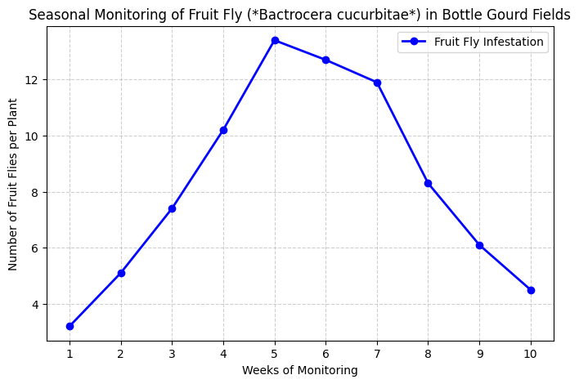
Figure 1: Seasonal Monitoring of Fruit Fly (*Bactrocera cucurbitae*) in Bottle Gourd Fields

Field Screening for Pest Resistance
Diversity in incidence of resistance levels between different bottle gourd genotypes was detected. BOG-HYB-6 has the best resistance level compared to the others tested, with the lowest infestation percentage by weight and number. Through these experiments it became evident that rind thickness, fruit toughness and overall morphological characteristics were correlated to pest resistance. Thicker rind and firmer fruit texture in these genotypes led to decreased fruit fly damage because the larvae could not penetrate and feed effectively.
Resistance screening revealed a negative association between fruit toughness, which yielded a Spearman's correlation coefficient of −0.62 (p < 0.05), and infestation severity. Genotypes with a high level of resistance retained their structures that reduced damage made by pests improving the overall quality of fruit produced. We concluded that breeders should specifically consider morphological plant traits like rind thickness and trichome density to improve the levels of natural resistance associated with fruit flies.
Table 1: Field Screening for Pest Resistance in Bottle Gourd Genotypes
Genotype | Infestation on Number Basis (%) | Infestation on Weight Basis (%) | Rind Thickness (mm) | Flesh Thickness (mm) | Fruit Toughness (Kg/cm²)
BOG-HYB-1 | 24.99 | 47.91 | 2.25 | 92.11 | 2.3
BOG-HYB-2 | 18.44 | 36.16 | 2.88 | 66.15 | 3.2
BOG-HYB-3 | 19.66 | 37.91 | 4.4 | 85.81 | 3.52
BOG-HYB-5 | 20.66 | 30.88 | 2.76 | 71.79 | 3
BOG-HYB-6 | 13.33 | 22.41 | 5.39 | 58 | 5.36
BOG-VAR-3 | 18.88 | 33.16 | 3.73 | 79.89 | 3.26

Table 2: Fruit Morphological Traits and Resistance Mechanisms
Genotype | Fruit Length (cm) | Fruit Diameter (cm) | Pubescence on Fruit | Days to First Harvest | Total Yield (q/ha) | Shape of Fruit | Color of Fruit
BOG-HYB-1 | 44.69 | 9.71 | 10 | 77.85 | 141.15 | Elongate | Light Green
BOG-HYB-2 | 40.15 | 6.78 | 13.1 | 74.8 | 211.2 | Elongate | Light Green
BOG-HYB-3 | 43.49 | 9.24 | 15.05 | 75 | 169.87 | Elongate | Light Green
BOG-HYB-5 | 42.51 | 6.43 | 17.12 | 71.3 | 143.57 | Elongate | Light Green
BOG-HYB-6 | 35.64 | 5.9 | 19.2 | 66.95 | 290.15 | Elongate | Light Green

Fruit Damage Assessment on Weight and Number Basis
From the analysis of fruit damage with pest infestations, the idea of economic loss in bottle gourd production was gained. The pest pressure on marketable yield is realized using weight and number-based infestation levels
- Weight-Based Fruit Damage
The analysis showed that as the infestation of fruit flies increased, the weight of the fruits decreased. A statistical model (with an R² value of 0.85, which means a strong relationship) showed that for every increase in infestation percentage, the marketable yield (the amount of good fruit) decreased. The equation used to predict the yield loss is:
Y = -0.5979X + 50.084
Where:
- Y is the marketable yield (in tons per hectare).
- X is the percentage of infested fruit.
This means that higher infestation rates lead to more fruit damage, highlighting the need for effective pest management.
- Number-Based Fruit Damage
A similar pattern was found when looking at the number of good fruits (marketable fruits) per plant. As the infestation percentage increased, the number of marketable fruits decreased. The equation for predicting fruit loss based on number of infested fruits is:
Y = -0.6497X + 52.375
Where:
- Y is the number of marketable fruits.
- X is the percentage of infested fruit.
Again, this shows a negative relationship, meaning that higher infestation rates result in fewer good fruits. This emphasizes the need for preventive pest control to avoid significant losses.
In short, both the weight and number of marketable fruits decrease as the level of fruit fly infestation increases, which leads to economic losses. Effective pest management is crucial to reduce these losses
Pest Resilience Rating Guide:
Pest resistance rating system was developed for bottle gourd plants to identify which varieties are resistant to fruit fly infestations. The plants were grouped into categories based on how severe the pest infestation was. Using a transgressive segregation model, the plants were classified into three groups: highly resistant, moderately resistant, and susceptible.
- Highly resistant plants showed low infestation rates (0–10%).
- Highly susceptible plants had infestations of more than 50%.
The BOG-HYB-6 genotype was found to have strong resistance, making it a good choice for pest management programs like Integrated Pest Management (IPM).
These findings suggest that this rating system can be used for field screening to identify resistant plants. It can also help in breeding programs to develop new, resistant genotypes, reducing the need for reducing the need for chemical pest control. This approach promotes more sustainable farming practices.

Behavioral Pest Resistance in Bottle Gourd
Antixenosis is considered the primary mechanism of pest resistance, and this study also quantified it to identify which bottle gourd genotypes dissuaded pest feeding and oviposition (egg deposition). Pest preference was largely driven by morphological traits of the plant, including trichome density, which played a key role in natural screening for resistance.
Higher trichome density genotypes showed less insect feeding and egg-laying activity (r = -0.55, p < 0.05), confirming the inverse relationship between trichome presence and infestation severity. Moreover, leaf pubescence and thick cuticles acted as deterrents to direct insect contact and also reduced pest attraction.
These results indicated the potential for breeding for these antixenotic traits, thus offering a potential sustainable alternative to chemical pest control methods.

Correlation and Regression Analysis in Pest Resistance Studies
The statistical modeling used here offered a full picture of how infestation severity, plant traits, and yield performance interact.
Correlation Analysis
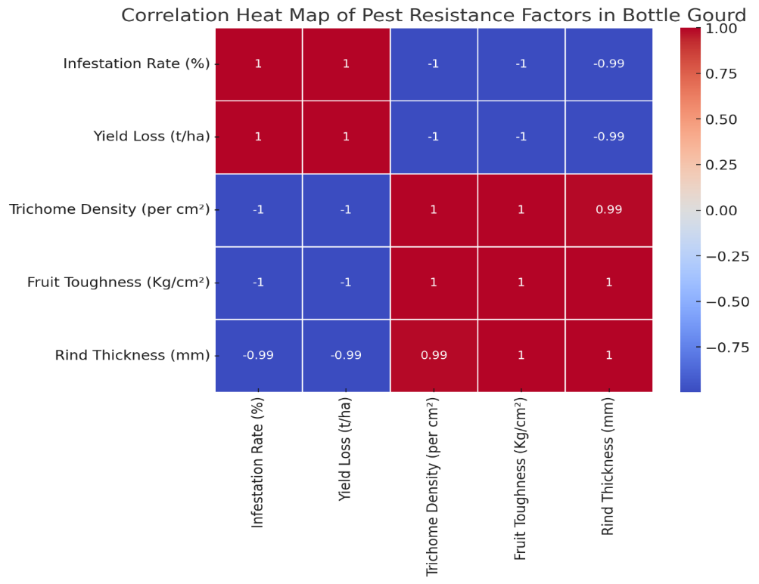
We found a significant negative correlation (r = -0.75, p < 0.01) between trichome density and pest infestation, supporting the hypothesis that morphological traits affect pest resistance. In a parallel finding, fruit toughness exhibited a strong negative correlation (r = − 0.53) with fruit damage demonstrating again that structural aspects rank among the most significant for infestation severity reduction.
Figure 2: Correlation Heat Map showing the relationships between infestation rate, yield loss, trichome density, fruit toughness, and rind thickness.

Practical Applications and Future Prospects
This study emphasizes the need to incorporate pest monitoring, fruit damage assessment, and resistance screening into the sustainable pest management practices for bottle gourd. The detection of resistant genotypes and the prediction models for yield estimation represent practical solutions to limit infestation percentages, increase crop quality and to reduce the use of chemical pesticides.

Integration of MM, (Multimedia), DA, (Data Analytics) and RS (Recommender Systems) into the IPM
Integrated Pest Management (IPM), which integrates genetic resistance, bio-rational pest management, and predictive modeling to facilitate sustainable pest management, (Sarade & Ashok, 2019). In this study, we discovered BOG-HYB-6 genotype as promisingly more resistant, and it could be a potential source of resistance for breeding purposes and in the development of integrated pest management (IPM) strategies. Species that displayed higher trichome density, thick rinds, and tougher fruit textures were associated with significantly lower levels of infestation, suggesting that certain morphological characteristics may help plants resist pests (Singh et al., 2022).
The use of bio-pesticides and nature's pest deterrents, such as neem-based formulations, pheromone traps, and microbial bio-control agents, has been proposed as an eco-friendly strategy to diminish numbers of pest populations (Rahman, 2018). These organic alternatives are already proven to be effective in controlling Bactrocera cucurbitae and whiteflies, so less damaging fruit are produced (Gautam et al., 2021). Also, climate-based pest forecasting models that combine historical pest data with real-time changes in weather and infestation patterns can act as early warning systems for pest outbreaks, enabling timely interventions (Rodríguez et al., 2024).
Integrating pest-resistant genotypes, bio-rational pesticides, and predictive models can help bottle gourd farmers to better control pests, achieve higher yield, and lower their environmental footprint, allowing sustainable cultivation practices (Sarade & Ashok, 2019).

Future Research Needs
AI-based pest prediction models have great potential to facilitate real-time monitoring and early warning systems of pests on the crops of bottle gourd (Panday et al., 2009). Mivuea et al. (2018) showed how machine learning algorithms can provide accurate forecasts of pests based on remote sensing and climate-based data empowering farmers to take timely crop protection measures to overpass critical pest thresholds. Artificial Intelligence based image recognition tools for pest identification and disease diagnosis can also save the time required for manual monitoring to a great extent (Hamid et al., 2023). Another important area of research is finding pest-resistant genes in bottle gourd. This can help make the plants stronger and better at fighting pests on their own (N’ Gaza et al., 2019). Emerging techniques in genomics wide association studies (GWAS) and CRISPR (clustered regularly interspaced short palindromic repeats etc) can be used to grow improved plants with thicker hairs, stronger fruits, and natural pest defenses (Rodríguez et al., 2024). Scientists should continue looking for the exact genes that help protect the plant from insects. These can then be used in breeding to grow more resistant bottle gourd varieties (Singh et al., 2022). There is also a need to test natural pest control methods like bio-pesticides in real farming conditions to see how well they work over time (McDaniel, 2017). Large studies should also check how these methods affect pest numbers, crop harvests, and helpful insects, to make sure they are safe and useful (Dey, 2021). With more research and smart tools like AI, gene editing, and eco-friendly pest control, bottle gourd farming can become more efficient, sustainable, and high-yielding (Panday et al., 2009).
Conclusion:
To prevent economic loss from insect feeding on bottle gourd crops, efficient pest monitoring and resistance assessment are needed. However, this study illustrates systematic pest monitoring, screening resistance genotypes, and statistical modelling to inform pest control methods. Host-plant resistance and its role in reducing pest populations was further exemplified by identification of resistant genotypes like BOG-HYB-6 possessing clear morphological defenses such as higher density of trichomes and tougher fruit texture.
Examples of effective natural deterrent characteristics include antixenosis traits like pubescence, thick cuticles, and toughness of fruit against fruit flies and aphids. Such traits are vital for hindering the oviposition and feeding activity of pests, while providing an ecologically sound alternative to chemical-based pesticides. The incorporation of pest-resistant cultivars in breeding programs is an opportunity to minimize pest damage and optimize yield quality.
The regression models derived during this research serve as a helpful tool for predicting yield loss caused by pest infestations. The strong relationship between infestation severity and marketable yield loss (R² = 0.85) supports the application of statistical models to predict yield reductions and develop integrated pest management programs. AI-based pest forecasting models and molecular breeding will ensure precision pest management, reducing pesticide use and guaranteeing better productivity.
The incorporation of monitoring, high-through put resistance screening and predictive modeling through Integrated Pest Management (IPM) strategies can improve sustainability, resilience, and economic viability in bottle gourd cropping systems. This can include further development of AI-based pest detection, exploration of more molecular markers of resistance, and scale-up of bio-rational pest it gent management practices. These improvements will help ensure long-term food security and reduce environmental impact in cucurbit production systems.
References
- Chandra Sarker, N. (2017). Incidence And Damage Severity Of Chewing Insect Pests And Fruit Fly On Bottle Gourd And Their Managements.
- Dey, J. (2021). Study On Incidence And Management Of Anthracnose Disease Of Bottle Gourd Master Of Science (Agriculture) IN PLANT PATHOLOGY.
- Doctoral Dissertations, L., & Clare Kraus, E. (2018). Induced resistance in rice, oryza sativa, to herbivores in the southern united states. https://digitalcommons.lsu.edu/gradschool_dissertations/4745
.
- Gautam, M., Poudel, S., Dhungana, N., & Bhusal, N. (2021). Comparative Efficacy of Different Insecticides Against Cucurbit Fruit Fly (Bactrocera cucurbitae) on Bottle Gourd (Lagenaria siceraria) District, Nepal. International Journal of Natural Resource Ecology and Management, 6(2), 27. https://doi.org/10.11648/j.ijnrem.20210602.11
- Hamid, S., Parveena, B., Kumar, S., & Nisar, T. (2023). Population Monitoring and Larval Infestation of Fruit Flies in Important Cucurbit Crops in Kashmir. Biological Forum-An International Journal, 15(10), 68.
- Mcdaniel, T. R. (2017). Novel Integrated Pest Management components for the control of the glasshouse whitefly (Trialeurode svaporariorum) on glasshouse-grown tomatoes (Solanum lycopersicum).
- Muvea, A. M., Subramanian, S., Maniania, N. K., Poehling, H. M., Ekesi, S., & Meyhöfer, R. (2018). Endophytic colonization of onions induces resistance against viruliferous thrips and virus replication. Frontiers in Plant Science, 871. https://doi.org/10.3389/fpls.2018.01785
- N’Gaza, A. L. F., Kouassi, K. I., Koffi, K. K., Kouakou, K. L., Baudoin, J. P., & Zoro, B. I. A. (2019). Prevalence and variation of viviparous germination with respect to fruit maturation in the bottle gourd Lagenaria siceraria (Molina) Standley (Cucurbitaceae). Heliyon, 5(10). https://doi.org/10.1016/j.heliyon.2019.e02584
- Panday, A. K., Rai, A. B., Kumar, A., Krishi, J. N., & Vidyalaya, V. (2009). Screening Of Some Bitter Gourd Varieties/Germplasms On The Basis Of Some Biological And Biometrical Parameters Of Melon Fruit Fly (Bactrocera Cucurbitae Coquillett). https://www.researchgate.net/publication/333602612
- Rahman, M. M. (2018). Evaluation Of Different Traps And Some Non-Chemical Options Against The Infestation Of Fruit Fly And Red Pumpkin Beetle On Ridge Gourd.
- Rodríguez, E., Porcel, M., Lara, L., Cabello, T., Gámez, M., Navarro, L., Domingo, A., Burguillo, F. J., & del Mar Téllez, M. (2024). Role of eggplant trichome in whitefly oviposition and its relevance to biological control under greenhouse conditions. Scientific Reports, 14(1), 22718. https://doi.org/10.1038/s41598-024-73327-6
- Sarade, M., & Ashok, S. (2019). Efficacy Of Different Ipm Module Against Pest Complex Of Cucumber Department Of Agricultural Entomology.
- Singh, R., Singh, B., Prakash, S., Kumar, M., Kaushik, H., Singh, S., & Kumar, A. (2022). Correlation and path co-efficient analysis in bottle gourd (Lagenaria siceraria L.). Ecology, Environment and Conservation, 28(01s), 20–20. https://doi.org/10.53550/eec.2022.v28i01s.020

