Short Research Article
Development of a computer model to estimate the shear strength of steel fiber-reinforced concrete beams

ABSTRACT
The study presents a highly efficient computational model for estimating the shear strength of steel fiber-reinforced concrete beams using Artificial Neural Networks (ANN). This approach was developed after it was found that previous reference studies relied solely on empirical and statistical models to achieve this estimation. These models account for key variables, including beam dimensions, shear span, characteristic concrete compressive strength (f′c), properties of the steel fibers used, and aggregate diameters in the concrete mix.

Keywords: Steel fibers, Regression analysis, Artificial neural network

Introduction:
Reference studies have shown that research efforts have developed semi-empirical equations for calculating the shear resistance of concrete beams. However, these equations suffer from computational complexities and their dependence on specific experimental conditions.
With the advancement in artificial intelligence (AI) techniques, the use of Artificial Neural Networks (ANNs) has become a viable means to address these challenges. This research falls under this concept, aiming to develop a computational model for predicting shear strength with sufficient accuracy, leveraging the capabilities of ANNs to analyze somewhat complex data. In this context, researcher (Hadi) conducted a study discussing the applications of neural networks in the field of structural engineering, particularly in design based on application results. The study revealed that Artificial Neural Networks are highly suitable for use in this field due to the accuracy of their results, ease of use and application, as well as their high flexibility in dealing with various problems [1].
In the same vein, researcher (Mansour) et al. conducted a study applying Artificial Neural Networks to predict the ultimate shear resistance of reinforced concrete beams with longitudinal and transverse reinforcement [8-10]. They created an ANN model using /671/ cases of reinforced concrete beams collected from previous studies. The model was structured using nine input parameters, including: longitudinal and transverse reinforcement ratios, beam cross-section dimensions (length-width), shear span-to-effective depth ratio, yield strength of longitudinal and transverse reinforcement bars, and concrete compressive strength, as shown in Figure (1)
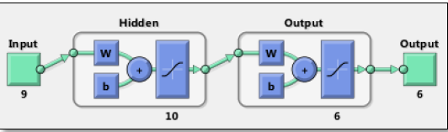
Figure (1) The Artificial Neural Network (ANN) Model
The study concluded that the selected Artificial Neural Network (ANN) model demonstrated highly accurate prediction of ultimate shear stress through the input parameters considered, when compared with experimental results and international design codes [5].
Researcher Andres Winston C. Oreta et al. conducted a study applying Artificial Neural Networks to simulate the size effect on shear strength in concrete beams without transverse reinforcement. They created an ANN model using /155/ cases of reinforced concrete beams collected from previous studies. The model was structured using five input parameters: characteristic concrete compressive strength, beam width, effective depth, shear span-to-effective depth ratio, and longitudinal reinforcement ratio, as shown in Figure (2).
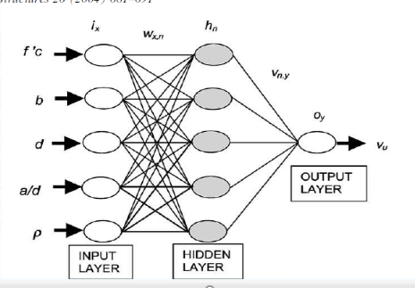
Figure (2) Artificial Neural Network (ANN) Model
The study demonstrated that the model provides good predictive results compared to numerical and theoretical results, as well as design equations in international codes. It successfully simulates the size effect on ultimate shear stress at diagonal tension failure [4].
Research Problem and Objective:
"International codes adopt concrete compressive strength as the basis for estimating other mechanical properties, which must be experimentally verified from the execution concrete mix. These codes do not account for potential variations in failure patterns or fracture mechanics of tested specimens due to factors such as aggregate interlock and particle sizes – particularly when steel fibers are added. This research addresses this gap by developing a rapid, accurate computational method to predict shear strength in steel fiber-reinforced concrete (SFRC), moving beyond traditional experimental approaches while incorporating concrete constituent properties for precise beam design.
The study aims to develop an Artificial Neural Network (ANN) model for predicting shear strength in steel fiber-reinforced concrete beams. This leverages experimental data from prior studies to train and test the model, with shear strength (V<sub>u</sub>) as the target output.
ANN Model Design:
The neural network model was constructed using /105/ experimental cases compiled from reference studies. The model outputs shear strength (Vu) and employs /11/ input parameters: beam width, beam height, shear span length, fiber shape factor, fiber tensile strength, shear span-to-effective depth ratio, fiber volume fraction, longitudinal reinforcement ratio, maximum aggregate size, characteristic concrete compressive strength, and effective depth. MATLAB's NFTOOL toolbox facilitated model development through iterative testing. The finalized architecture features:
- Input layer: 11 nodes
- Hidden layer: 18 neurons (feedforward)
- Output layer: 1 neuron
- Correlation coefficient: R = 0.98306"
Network Training:
"Following architecture optimization via trial-and-error, the network was trained using NFTOOL's approximation and fitting functions. Training performance was evaluated by Mean Squared Error (MSE). For each architecture configuration, training-validation-testing cycles were executed. Table (1) details the network development process in MATLAB, showing correlation coefficients (R) for training, validation, and testing phases. The conventional 70%-15%-15% data partitioning ratio was maintained without modification."
Research Problem and Objective:
International codes adopt concrete compressive strength as the basis for estimating its other mechanical properties. This strength must be experimentally achieved from the execution concrete mix, without considering potential variations in failure patterns or the fracture mechanics of tested specimens due to influencing factors. These specifically include aggregate interlock and diameters, in addition to the properties of added steel fibers (if any). Therefore, the significance of this research lies in its pursuit to extrapolate the shear strength of steel fiber-reinforced concrete (SFRC) mixes through a sufficiently fast and accurate computational means, instead of traditional experimental and calculation methods. This approach takes into account the properties of concrete components to achieve adequate precision in designing fiber-reinforced beams.
This research aims to develop an Artificial Neural Network (ANN) model to predict the shear strength in reinforced and steel fiber-reinforced concrete beams. It leverages actual data collected from reference studies of previous research, using this data to train and test the model, where the required output is the shear strength.
ANN Model Design:
The neural network model was developed based on scientific data collected from reference studies in this field. A total of 105 cases were used. The required output of this model was the shear strength (Vᵤ), while the number of input parameters was 11. These include:
- Beam width (*b*),
- Beam height (*h*),
- Beam span (*a*),
- Fiber shape factor (*l/d*),
- Tensile strength of the used fibers (fᵧ),
- Shear span to effective depth ratio (*a/d*),
- Fiber volume fraction (Vf),
- Longitudinal reinforcement ratio (ρ),
- Maximum aggregate size (da),
- Characteristic concrete strength (f'c),
- Effective depth (*d*).
The NFTOOL toolbox in MATLAB was utilized to build the mathematical model and determine the network specifications through several trials. The adopted network consists of:
- An input layer containing 11 input elements.
- A feedforward hidden layer containing 18 neurons.
- An output layer containing one neuron.
- A correlation coefficient value R = 0.98306.
ANN Training:
After building the network described above through several trials, it was trained using the NFTOOL fitting and approximation tool. The training error (Mean Squared Error - MSE) was adopted. For each network architecture, training, validation, and testing were performed. Table (1) below illustrates the network construction processes using MATLAB via trial and error, showing the correlation coefficient (R) values for the (Training, Validation, Testing) phases. This uses the program's default data percentage split (70%, 15%, 15%), which we did not need to change.
Table (1): Network Training Results
Neurons | R Training | R Validation | R Test | Overall R | Cause of Stop
1 | 0.93745 | 0.89373 | 0.92648 | 0.93242 | Validation Stop
5 | 0.97598 | 0.96637 | 0.95415 | 0.96522 | Validation Stop
7 | 0.99028 | 0.9639 | 0.9442 | 0.97298 | Validation Stop
9 | 0.99264 | 0.96514 | 0.9691 | 0.98222 | Validation Stop
10 | 0.99141 | 0.95133 | 0.96791 | 0.98168 | Validation Stop
12 | 0.99182 | 0.92692 | 0.96435 | 0.95493 | Validation Stop
15 | 0.99265 | 0.93695 | 0.98592 | 0.98235 | Minimum gradiant reached
18 | 0.99002 | 0.98914 | 0.96006 | 0.98306 | Validation Stop
22 | 0.98273 | 0.94531 | 0.95809 | 0.96977 | Minimum gradiant reached
25 | 0.99394 | 0.96533 | 0.94164 | 0.95882 | Validation Stop
30 | 0.99126 | 0.97459 | 0.9256 | 0.97068 | Minimum gradiant reached
"Based on the training results shown in the previous table, it was observed that the final optimal neural network yields the highest values for the correlation coefficient R with an acceptable minimal error. This network has an architecture comprising:
- 11 units in the input layer,
- One hidden layer containing 18 neurons,
- One output layer.
According to NFTOOL, the activation function for the hidden layer is the hyperbolic tangent sigmoid function (TANSIG), while the activation function for the output layer is the pure linear function (PURELIN), as illustrated in Figure (3)."
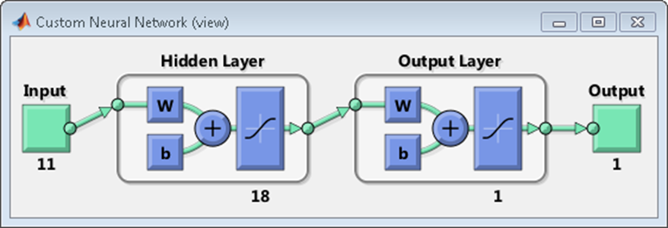
Figure (3): Representation of the Neural Network
Figure (4) shows the training results of the designed and trained neural network. It illustrates the correlation coefficient R between the actual shear strength values in steel fiber-reinforced concrete beams and the predicted values generated by the network: 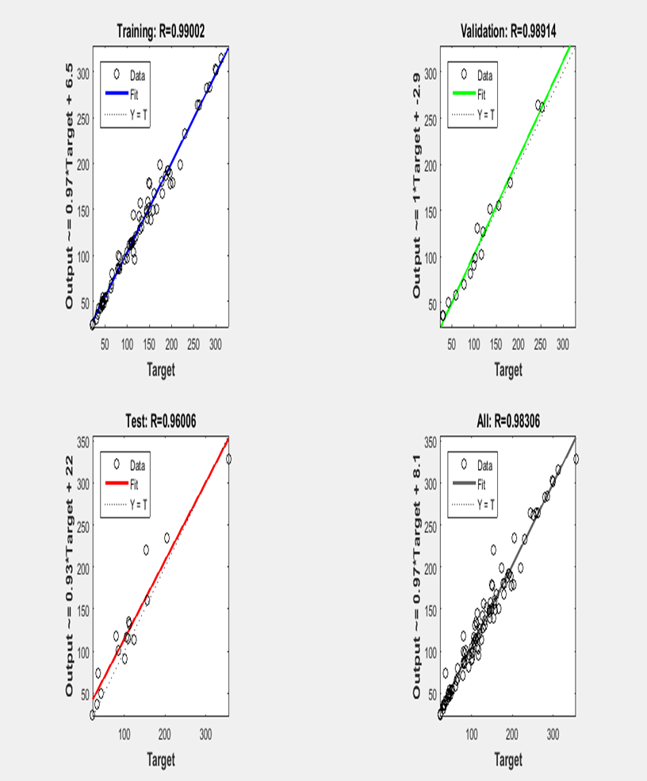
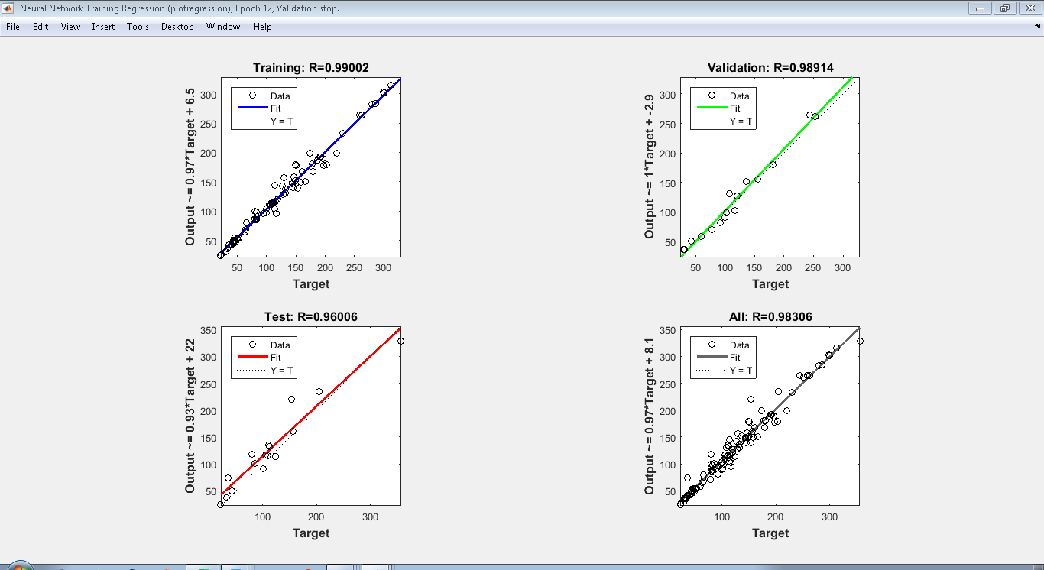
Figure (4): Neural Network Training Results
Where:
- X-axis: Actual Outputs (True Values)
- Y-axis: Predicted Outputs (Network-Generated Values)
- O: Input Data Points
- FIT: Convergence Curve
- R: Correlation Coefficient
- Dotted Line: Ideal/Best-Fit Line
To assess the strength of the relationship, note the correlation coefficient values:
- Training Phase: R = 0.99002
- Validation Phase: R = 0.98914
- Testing Phase: R = 0.96006
These values are excellent and very close to 1, indicating a strong correlation (closer to 1 signifies a stronger relationship).
Figure (5) shows the neural network’s performance. The lowest Mean Squared Error (MSE) was 119.2382 at 6 iterations, which is considered acceptable relative to the actual shear strength values of the input steel fiber-reinforced concrete beams
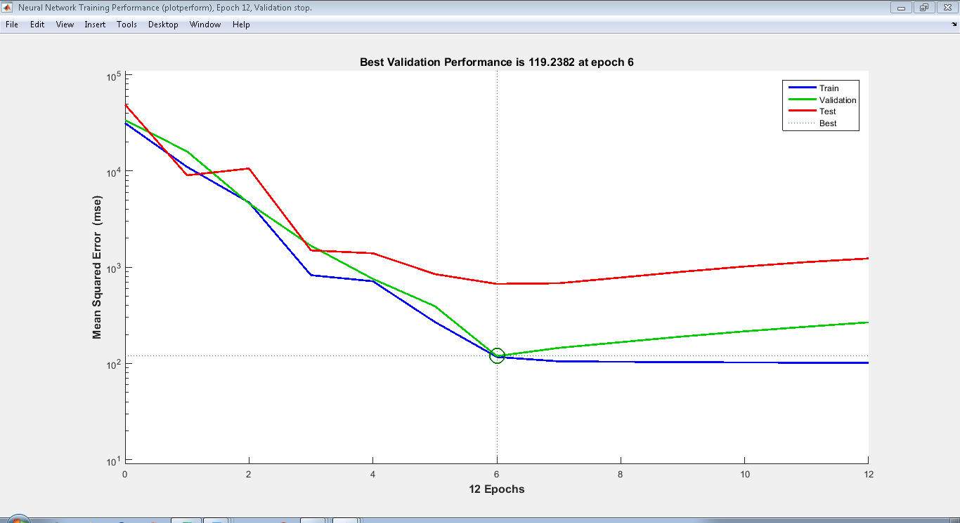
Figure (5): Neural Network Performance
Figure (6) shows that the error function gradient (Gradient) = 74.5174 at Epoch = 12. The initial value of the µ parameter (mu), which updates the weights based on error changes, was MU = 1. The bottom value indicates the number of effective parameters (weights and biases) involved in network training: Validation Checks = 6.
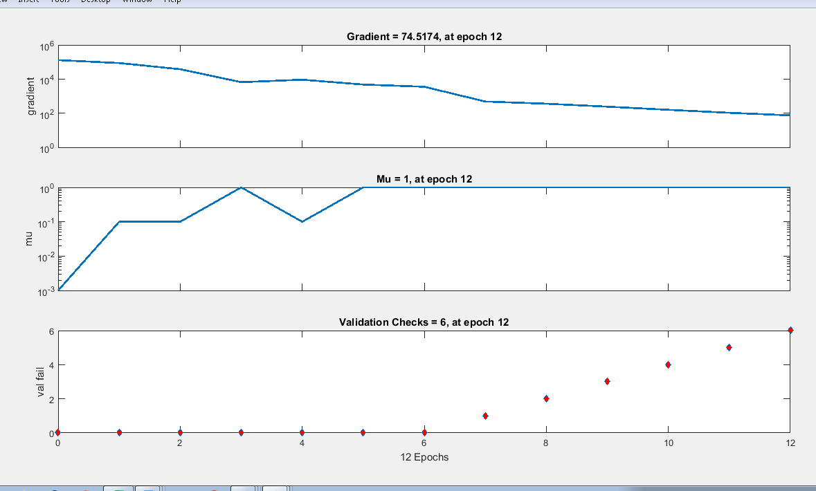
Figure (6): Number of Effective Parameters
Results of testing the designed and trained neural network for the research objective:
The network was supplied with a set of new, previously unseen input cases (15 verification cases). The network generated predictions, enabling a comparison between the network-calculated output values and the actual output values (true shear strength values of these beams) collected from published research, as shown in Table (2) below:
م | Bw | h | d | L span | p | a/d | da | f′c | Vf % | Lf/df | Ften
1 | 85 | 150 | 130 | 1160 | 0.0205 | 3.02 | 9.6 | 30.6 | 0.5 | 133 | 2000
2 | 152 | 455 | 381 | 2136 | 0.0196 | 3.44 | 10 | 38.1 | 1 | 55 | 1100
3 | 152 | 455 | 381 | 2136 | 0.0263 | 3.44 | 10 | 49.2 | 1 | 80 | 1100
4 | 205 | 685 | 610 | 3558 | 0.0152 | 3.5 | 10 | 29.6 | 0.75 | 80 | 1100
5 | 152 | 254 | 221 | 2100 | 0.0239 | 2.5 | 10 | 34 | 0.5 | 60 | 1130
6 | 152 | 254 | 221 | 2100 | 0.0239 | 3.5 | 10 | 34 | 0.5 | 60 | 1130
7 | 150 | 225 | 197 | 1603.2 | 0.0136 | 2.8 | 20 | 29.1 | 0.5 | 60 | 1260
8 | 300 | 700 | 570 | 5000 | 0.0287 | 2.98 | 18 | 60.2 | 0.75 | 86 | 2200
9 | 140 | 375 | 340 | 1910 | 0.0167 | 2.5 | 19 | 36 | 1 | 60 | 1100
10 | 120 | 200 | 167.5 | 720 | 0.0132 | 1.43 | 13 | 23.9 | 1.5 | 60 | 1100
11 | 200 | 300 | 260 | 1800 | 0.0355 | 3.46 | 14 | 46.4 | 0.25 | 65 | 1100
12 | 200 | 300 | 260 | 1800 | 0.0355 | 3.46 | 14 | 43.2 | 0.5 | 65 | 1100
13 | 152.4 | 304.8 | 282.6 | 1524 | 0.0199 | 2.5 | 9.6 | 33.2 | 1 | 100 | 1100
14 | 125 | 250 | 222 | 1200 | 0.0145 | 1.8 | 10 | 30 | 0.5 | 80 | 1225
15 | 120 | 300 | 266 | 1100 | 0.0126 | 1.13 | 20 | 31.9 | 0.6 | 50 | 834
Table (2): Input Values from Laboratory Experiments in Published Literature
Where:
- Bw: Beam width (mm)
- h: Beam height (mm)
- d: Effective depth (mm)
- L span: Beam span (mm)
- ρ: Longitudinal reinforcement ratio (%)
- a/d: Shear span-to-effective depth ratio
- d<sub>max</sub>: Maximum aggregate size (mm)
- f'<sub>c</sub>: Characteristic concrete strength (MPa)
- V<sub>f</sub>: Fiber volume fraction (%)
- L<sub>f</sub>/d<sub>f</sub>: Fiber shape factor
- F<sub>ten</sub>: Fiber tensile stress (MPa)
After testing and verifying the results in Table (3), the error percentage between actual and predicted values ranged between [0.667% – 1.139%]. These values indicate acceptably small errors, with the maximum relative error not exceeding 5% (in Experiment 1). This prediction error margin is remarkably small relative to shear strength magnitudes.

Table (3): Network Test Results with New Inputs
Project Number | True Value | Calculated Value | Absolute Error | Relative Error %
1 | 22 | 23.13995 | 1.139951 | 5%
2 | 174 | 171.3338 | 2.666224 | 2%
3 | 220 | 225.2934 | 5.293442 | 2%
4 | 228 | 220.8137 | 7.186261 | 3%
5 | 65 | 65.66746 | 0.667457 | 1%
6 | 50 | 50.94313 | 0.943132 | 2%
7 | 53 | 51.5004 | 1.4996 | 3%
8 | 522 | 510.2391 | 11.76088 | 2%
9 | 155 | 149.0939 | 5.906148 | 4%
10 | 85 | 81.58872 | 3.41128 | 4%
11 | 111 | 113.9154 | 2.915394 | 3%
12 | 121 | 124.1903 | 3.190339 | 3%
13 | 146 | 147.5876 | 1.587604 | 1%
14 | 79 | 80.0195 | 1.019498 | 1%
15 | 146 | 147.0814 | 1.081355 | 1%
Figure (7): Verification Phase Test Sample Results
Figure (7) shows the test sample results during the verification phase, displaying both the true shear strength and the neural network-predicted shear strength for each case."

Figure (7): Comparison of Neural Network-Predicted Shear Strength vs. True Shear Strength
The relative error between the true shear strength and the neural network-predicted shear strength was calculated for each test sample using the formula:
(Predicted Shear Strength – True Shear Strength) / True Shear Strength
The maximum percentage error reached 5%, as shown in Figure (8) below:


Figure (8): Error Percentage in Estimating the Shear Strength Under Study
Conclusions and Recommendations:
- The developed model can predict shear strength with acceptable accuracy, achieving a correlation coefficient (R) of 0.99 during training and 0.960 during testing. The relative error ranged between 1% to 5%.
- Increasing the training sample size will improve the model's performance.
- It is recommended to apply these results to verify the design of steel fiber-reinforced concrete beams.

References
[1]. An-Najjar H.M., " Prediction of Ultimate Shear Strength of Reinforced Concrete Deep Beams Using Artificial Neural Networks", M.Sc. Thesis, Department of Civil / StructuralEngineering, Islamic University, Gaza, 2005.
[2] Tully S.H., "A Neural Network Approach for Predicting the Structural Behavior of
Concrete Slabs", M.Sc. Thesis, Faculty of Engineering and Applied Science, University
of Newfoundland, Canada, 1997.
[3] Nandy S., "Assessing External Reinforcement on Reinforced Concrete Beams Using
Neural Networks", M.Sc. Thesis, Department of Civil Engineering, University of
Florida, 2001.
[4] Oreta A.W. C., "Simulating Size Effect on Shear Strength of R.C. Beams Without
Stirrups Using Neural Networks", Engineering Structures, Vol. 26, 2004, pp. 681-691.
[5]. Mansour M. Y., Dicleli M., Lee J.Y., and Zhang J., "Predicting the Shear Strength ofReinforced Concrete Beams using Artificial Neural Networks", Engineering StructuresVol. 26, 2004, pp. 781-799.
[6] Yousif S. T., "Artificial Neural Networks Modeling of Elasto_Plastic Plates", Ph.D.
Thesis, Department of Civil Engineering, University of Mosul, Iraq, 2007.
[7] Yousif, S. T. and Abdullah, S. “Artificial neural networks model for predicting
compressive strength of concrete.", Tikrit Journal of Eng. Sciences, Vol.16, No.3,
September 2009, pp.55 - 63.

8. Yaseen, Z. M., Tran, M. T., Kim, S., Bakhshpoori, T., & Deo, R. C. (2018). Shear strength prediction of steel fiber reinforced concrete beam using hybrid intelligence models: a new approach. Engineering Structures, 177, 244-255.

9. Araújo, D. L., Carmo, L. C., Nunes, F. G., & Toledo Filho, R. D. (2010). Computational modeling of steel fiber reinforced concrete beams subjected to shear. Revista IBRACON de Estruturas e Materiais, 3, 68-94.

10. Kara, I. F. (2013). Empirical modeling of shear strength of steel fiber reinforced concrete beams by gene expression programming. Neural Computing and Applications, 23, 823-834.

