Original Research Article
EVALUATING THE EFFECTIVENESS OF LOCAL ADAPTATION STRATEGIES FOR HOUSING RESILIENCE IN AYETORO COASTAL COMMUNITY, NIGERIA

Abstract :

Background: Coastal communities across Nigeria, including Ayetoro in Ondo State, are increasingly confronted with climate-induced hazards such as flooding, sea incursion, and erosion that threaten housing security. Residents have developed local strategies to protect their homes, yet the effectiveness of these measures remains inadequately evaluated. Without empirical assessment, vulnerable households risk investing in ineffective solutions, worsening long-term vulnerability in communities like Ayetoro, where recurrent housing damage occurred between 2012 and 2022.
Study Purpose: This research evaluates the empirical effectiveness of Ayetoro's housing adaptation strategies through three objectives: quantifying performance consistency using descriptive statistics (mean ± standard deviation) with median-based cut-off criteria, identifying socioeconomic and institutional barriers limiting success, and providing evidence-based recommendations to enhance climate resilience through contextually appropriate interventions.
Methodology: This research employed a mixed-methods approach, integrating both quantitative and qualitative analyses. Data were collected from 379 residents, yielding 352 valid responses and a high response rate of 92.9%. The quantitative data were analysed using SPSS and Excel, focusing on descriptive statistics such as counts, means, and visual aids like bar, pie, and funnel charts. The effectiveness of housing adaptation strategies was assessed by comparing mean scores to a median cut-off. For inferential analysis, Haldane-Anscombe-adjusted Chi-square tests examined the relationships between building characteristics and climate impacts, while independent t-tests and ANOVA assessed variations in hazard effects across housing types. The Product-Moment Correlation was used to explore the relationship between material choices and building conditions, and Relative Risk (RR) was calculated with Haldane-Anscombe correction to quantify damage reduction probabilities. Qualitative data from Focus Group Discussions were thematically and visually analysed to contextualise the statistical findings. This comprehensive approach provided a deeper understanding of the issues, blending numerical data with the community's lived experiences.
Result: The analysis found that placing valuables higher (2.20 ± 0.55) and raised floors (2.14 ± 0.50) as the most effective strategies, demonstrating high consistency (SD≤0.55). Temporary relocation (2.07 ± 0.58) and house fortification (2.07 ± 0.45) demonstrated moderate effectiveness. Permanent relocation (1.77±0.52), drain clearance (1.77±0.42), and drain construction (1.84±0.36) were performed below the median cut-off. Financial constraints, technical gaps, and institutional failures (e.g., derelict Owena Dam) were critical barriers.

Keywords: Adaptation effectiveness, Ayetoro, Climate change adaptation, Housing resilience, Local strategies.

- INTRODUCTION
For many years, communities have witnessed, evaluated, and experienced the profound effects of climate change. Unexpectedly frequent flooding and sea level rise, an increase in extreme storms, and more alkaline, acidic, and turbulent aquifers all have varying degrees of impact on the environment, ecosystems, infrastructure, livelihood, and buildings. These factors have led to significant financial losses, health risks, and human casualties in recent years, particularly in coastal areas (Jin-Yu et al. 2021). Coastal communities are particularly vulnerable to the effects of climate change due to their exposure to rising sea levels, increased storm intensity, and erosion. Ayetoro, a coastal community in Nigeria, is no exception to these challenges. As climate change intensifies, understanding its impact on housing quality in Ayetoro becomes increasingly crucial for developing effective adaptation strategies and ensuring the community's resilience. In Nigeria, rising sea levels and increased flooding have led to a deterioration of housing conditions, exacerbating the vulnerability of residents (Adelekan et al., 2020). The Niger Delta region, comprising various coastal communities, has been identified as particularly vulnerable to the adverse impacts of climate change, necessitating the development of urgent adaptation strategies (Nwogbaga et al., 2021).
Ayetoro, a coastal community, is highly vulnerable to climate change due to its coastal location, low-lying topography, and socio-economic factors. The community's dependence on fishing and agriculture for livelihoods exacerbates their vulnerability. Inadequate infrastructure, limited access to basic services, and high poverty levels further complicate housing quality. This research aims to evaluate the specific effectiveness of local adaptation strategies for housing resilience. In Ayetoro, the reliance on informal housing provisions using traditional wooden stilt structures (Omeghen) has become increasingly unsustainable due to the accelerating impacts of sea incursion, saltwater intrusion, flooding, and windstorms. Although previous studies have explored the impacts of climate change in Nigeria’s coastal regions, much of this research has focused on oil spills, industrial activities, and urban development pressures (Adeniji-Oloukoi et al., 2013; Adedeji & Olotuah, 2015; Adegun & Olusoga, 2020). The effectiveness of local adaptation strategies, including stilt housing, drainage clearing, trenching, and temporary relocation, in mitigating climate-related housing impacts in Ayetoro has not been rigorously evaluated. This gap limits policymakers' and practitioners' ability to scale effective interventions or improve existing community-led practices.
There are several factors which may be used in assessing the quality of housing, including its liveability, level of comfort afforded, safety, and ease of maintenance. Housing in all its ramifications is more than just shelter, as it encompasses all the social services and utilities that contribute to making a community or neighbourhood a lively environment (Li et al., 2024). It is also a collection of several characteristics that provide a unique home within any neighbourhood, and thus encompasses an array of economic, sociological, and psychological phenomena (Li et al., 2024). Housing, then, can be defined as a residential environment which humans use for shelter and the environs of the structure needed or designed for their physical and mental health as well as the social well-being of the people in either a civilised or rural society (Gomez et al., 2022).

Climate change remains one of the most pressing environmental challenges of the 21st century, posing significant threats to physical infrastructure, ecosystems, and livelihoods worldwide. Extreme weather events such as prolonged droughts, storms, heatwaves, rising sea levels, and intensified rainfall have resulted in ecosystem degradation, destruction of dwellings, and severe disruptions to people’s livelihoods and settlements (World Wide Fund, 2022). In the Ayetoro coastal community, the compounded effects of climate change, particularly altered rainfall patterns, sea level rise, coastal erosion, and windstorms, have contributed to infrastructural damage, housing collapse, loss of biodiversity, and displacement of residents (Enete, 2012; NDDC, 2014; Odjugo, 2019).
Research Question:
How effectively do residents in Ayetoro employ the adaptation strategies in addressing the impacts of climate change on housing?
Research Objective:
Assess the effectiveness of the local adaptation strategies used by the residents during impacts on housing in the community
This study was conducted in the Ayetoro community, situated in the Ilaje Local Government Area of Ondo State, Nigeria (Figure 1). The research focuses on assessing the impacts of three key climate-related phenomena: sea-level rise (SLR), flooding, and windstorms. The study examines how these factors affect housing quality, infrastructure, and the community's resilience, with a particular focus on their adaptation strategies and the vulnerability of existing buildings to the effects of climate change.
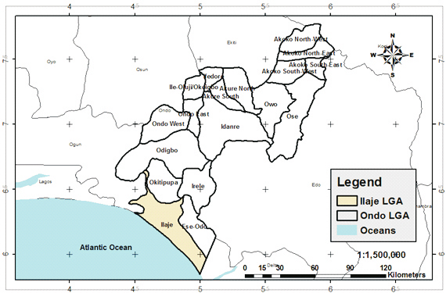
Figure 1: Map of Ondo State showing Ilaje local government.
Source: Extracted from ESRI Data, 2016.
The conditions under which people live and work play crucial roles in determining their overall well-being. These conditions must be such that people's safety and security needs, physical, mental and spiritual health, comfort, and self-fulfilment are adequately taken care of. There are several factors which may be used in assessing the quality of housing, including its liveability, level of comfort afforded, safety and ease of maintenance.
- Adaptation strategies adopted by the residents of coastal communities to mitigate the impacts of climate change on their residential buildings
Nurdiah (2015) conducted a study to examine the potential of bamboo as a building material in organically shaped buildings. The study revealed that using bamboo can mitigate the impact of flooding. Bamboo has a highly strong fibre as a building material. Bamboo has double the compressive strength of concrete and a tensile strength comparable to steel. Bamboo fibre has a higher shear stress than wood. Bamboo has a longer lifespan than wood. Bamboo may also be bent without breaking. Bamboo is regarded as one of the strongest building materials, with tensile strengths greater than and less than 28,000 N per square inch, as opposed to steel, which has a tensile strength of 23,000 N per square inch (Javadian et al. 2020; Sharma et al. 2015).
Adeleye (2020) gathered adaptation strategies for reducing or combating the rising sea levels (RSLs) faced by Nigerian coastal communities and encouraged the development of agricultural activities. A comprehensive review of the literature was conducted on similar subject matter, based on previous studies carried out by researchers worldwide. The research documented strategies such as the restoration of mangrove buffers, the construction of sandbag barriers, and elevated housing designs in Lagos and Niger Delta communities, although their long-term efficacy depends on institutional support and access to resources. The study further presents a wide range of different and well-defined native adaptation strategies utilised by the affected coastal communities to combat the impact of the RSLs. These strategies included wetland protection and restoration, as well as coastal engineering solutions.
Ford et al., (2020) identify and analyse key CBA strategies implemented in coastal areas to assess their effectiveness in reducing vulnerability and increasing resilience, and to explore the role that local knowledge, resources, and governance play in developing a successful change strategy. The results show significant improvements in several key areas. Income increased by 25%, and 35% of households adopted climate-resilient lifestyles. Economic losses from disasters were reduced by 45%, and key infrastructure was strengthened by 80% against climate risk. The study found a 28% reduction in climate-related diseases, a 90% increase in water quality, and the restoration of 600 hectares of biodiversity, resulting in a net gain of biodiversity above 20%. Additionally, 75% of the community actively participated in decision-making, and 65% of the reform projects incorporated traditional knowledge. These findings suggest that CBA strategies not only effectively reduce the immediate risks of climate change but also build long-term resilience by empowering communities to lead the adaptation process.
One of the theoretical frameworks for this study is Anthropogenic Global Warming (AGW). Anthropogenic greenhouse gases (CO₂, CH₄, N₂O) have caused ∼1.1°C of warming since pre-industrial times. The greenhouse effect occurs when atmospheric gases absorb and re-radiate infrared energy, trapping heat. Solar and orbital forcings cannot explain the magnitude or rate of recent warming (IPCC, 2021). Current information is well-documented that many components affect the earth's climate, counting variations in the sun's luminosity and the quality of the planet's magnetic field and circle, the evolution of the planet in the universe and changes in use in general and contrast to the obsession with a single climate change hypothesis (anthropogenic global warming, AGW), in the mid-1990s and early 21st century. The hypothesis of change, known as the growing climate, or "anthropogenic global warming" (AGW), indicates that human emissions of greenhouse gases, mainly carbon dioxide (CO₂), methane, and nitrogen oxides, are causing a catastrophic increase in global temperatures. The tool by which this happens is called improved incubator impact. The life force of the sun travels through space and reaches the Earth. Earth's climate is mostly direct as daylight approaches, allowing sunlight to reach the planet's surface, where some is retained and some is reflected back into the environment as heat. Certain environmental gases, called "greenhouse gases", trap warm reflected or internal radiation, occur in the Earth's atmosphere and become warmer than anything else (Gut, 2019).
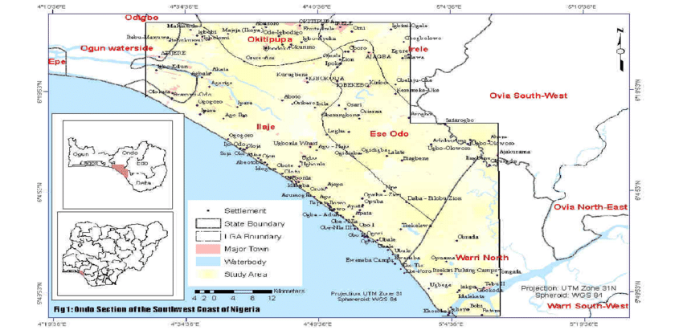
Figure 2: Coastal area of Ondo/Edo States
Source: Idowu, 2019.
2. MATERIAL AND METHODS
2.1. The Study Area
The Ayetoro community in llaje Local Government (ILG) area of Ondo state, Nigeria (Figure 3), lies on latitude 6°13.785 N and longitude 4 °38.975' E, it is situated at about 160 km East of Lagos and separated from the mainland by about 40 km of swampy terrain inhabited by Ilaje people. The Ilaje people are a Yoruba ethnic group in Nigeria, residing in the coastal region of the southern senatorial district of Ondo State. Ayetoro and other communities along the Atlantic Ocean in Ondo State, Nigeria, have been incorporated into a local government area, known as Ilaje Local Government Area (ILGA), with its headquarters located in Igbokoda, Ondo State, Nigeria (Figure 2). It hosts most of the oil-prospecting companies and their wells in the state. This community is located in the Ugbo kingdom but remained autonomous due to its theocratic status. The Ayetoro community was selected because of its high degree of vulnerability from the damaging effects of extreme weather events like SLR/flooding and windstorms on the environment and buildings, which could be appropriately contained. Additionally, the community was chosen because of the immediate sea incursion that has encroached into it by more than 900 meters, severely damaging the infrastructure and buildings, and requiring corrective intervention strategies without displacing the locals. Until recently, the only ways to travel from Ayetoro to other settlements were via river or ocean, as there was no road connection. The majority of the neighbourhood is vulnerable to periodic flooding due to its marshy surroundings, proximity to the low-lying environment, and the Atlantic Ocean. The Ayetoro village has no fenced-in buildings (Jiboye et al. 2019).
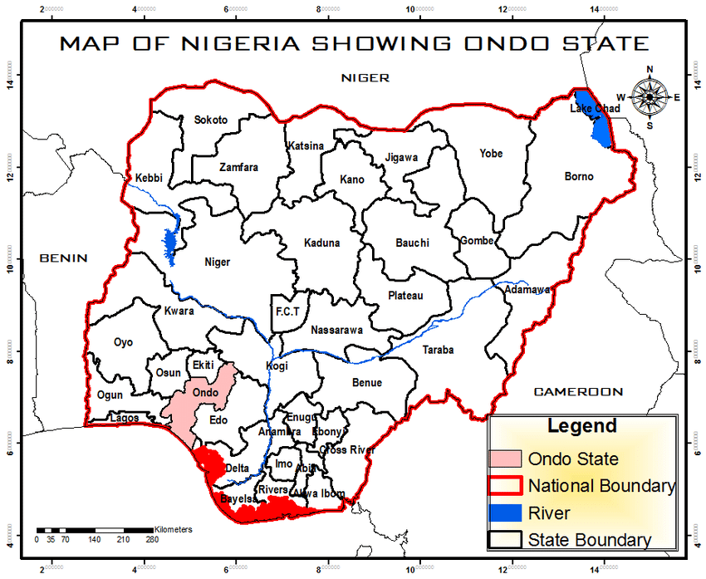
Figure 3: Map of Nigeria showing Ondo State in the National Setting
Source: Ondo State Ministry of Works and Housing (2023).
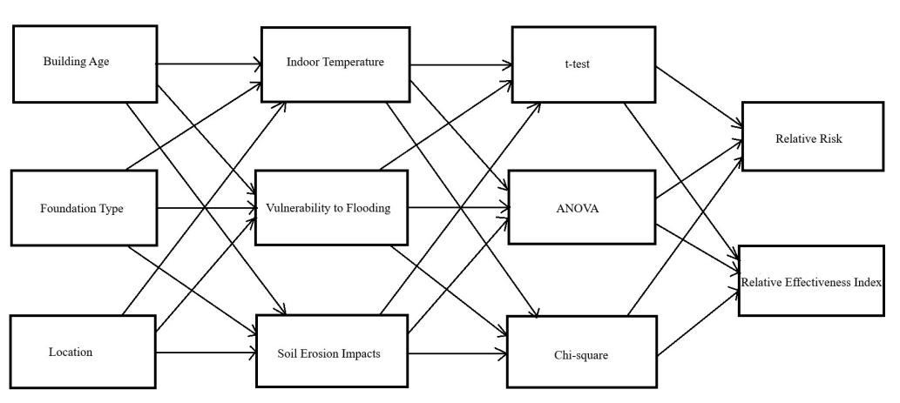
Figure 4: Schematic Representation of the Conceptual Analysis of Adapting Buildings to Climate (b)
Source: Researchers' work, 2024
This framework (Figure 3) explores how climate-related events influence housing quality in Ayetoro and how households and institutions respond to these threats through various adaptation strategies. The model progresses from environmental hazards to housing vulnerability, then to community responses and long-term housing, highlighting the interaction between environmental stressors, housing vulnerability, and adaptation strategies. It forms the foundation for analysing climate-related risks and assessing the effectiveness of adaptive responses in the Ayetoro Coastal Community.
2.2. Research Design
A mixed-methods approach, comprising both quantitative (questionnaire survey) and qualitative (interviews and direct observations), was employed in the study. A mixed-methods approach enables an investigation that addresses more complex research questions, collecting complementary data that allows researchers to gain a deeper contextual understanding of the phenomenon being researched. The study was also a cross-sectional study, conducted in partial fulfilment of a PhD program. Cross-sectional studies are conducted over a short to medium time.
2.3. Research Philosophy
This study adopts the pragmatist research philosophy, which emphasises the use of practical methods and approaches that are most suitable for addressing the research problem. Pragmatism advocates for flexibility in methodological choices, integrating both quantitative and qualitative techniques where necessary to derive meaningful insights. In line with this philosophy, the research combines survey questionnaires and focus group discussions (FGDs) to capture a comprehensive understanding of the impacts of climate change on housing quality in Ayetoro Coastal Community. The choice of pragmatism is justified by the complex, real-world nature of climate change issues, which require a balanced integration of empirical data and lived experiences for effective analysis and recommendations. Pragmatism, as a research worldview, prioritises practical outcomes, focusing on what works best in understanding, explaining, and providing actionable solutions to real-world problems (Creswell & Creswell, 2018). This approach enables a mixed-methods strategy, allowing the study to not only quantify climate-related housing impacts but also explore community-driven adaptation strategies and culturally appropriate resilience frameworks through qualitative insights. It ensures that both objective measurements and subjective perceptions are incorporated into the research, producing findings that are both contextually relevant and actionable for policy and practice.
2.4. Research Population
This is universally a large collection of individuals or objects that are the main focus of a scientific query (Hu, 2024; Masuwai et al., 2024). According to the Digest of Demographic Statistics of Ondo State, (DDS), (2006), Ayetoro community has a provisional census figure of about 20,070 according to the 2006 census and a projection of 33,173 as of 2023 using a 3% constant annual growth rate as recommended by the National Population Commission (NPC). The research population encompasses all categories of buildings (residential, religious, civic, and commercial), streets, and the environment within the Ayetoro community.
2.5. Sampling Techniques and Sample Size
- Sample Techniques:
The sample and sampling techniques involved both determining an appropriate sample size and selecting suitable sampling methods for the study. Since it would be technically wasteful and impractical to collect data from the entire population of the Ayetoro community, it was necessary to adopt a sampling process suitable for the target population. This study employed a random sampling procedure to select the most affected streets within the study area. Out of the existing 54 streets in the community, twenty-three (23) streets were selected alternately along the main Broad Street, representing about 42.6% of the total streets in the Ayetoro community. Systematic random sampling with a fixed interval of 5 was used to select buildings for assessment along each chosen street. A total of 379 buildings were selected across the 23 streets, with 74 buildings along Broad Street, which runs the full length of the community, and 305 buildings from the other 22 streets. One house owner or occupant was surveyed per selected building. Between 12 and 14 buildings were chosen per street, depending on the length and size of each street. According to Laurencelle et al. (2022), simple random sampling is a technique in which every member of a population has an equal chance of being selected. It is considered the most straightforward sampling method, offering high internal and external validity while reducing the risk of research sampling and selection biases.
- Sample Size
This process involves selecting the number of observations or prototypes to include in a statistical sample. It is a crucial component of any empirical study aimed at making inferences about a population from a sample (Elfil & Negida, 2021; Wang et al., 2023). Regarding the purpose of this study, consideration was given to the method of Krejcie and Morgan (1970) for determining the sampling size for a finite population, due to its simplicity and clarity (Table 1 and Equation 1). Thus, the total population, which consists of a fixed number of elements and the updated cartographic maps, forms the basis for an estimated population upon which quantitative information obtained from the respondents in the study area was utilised (Okafor et al., 2023). Therefore, with a projected population of 33,173 and using the sample size calculator, a sample size of 1,000 is required to achieve a 95% confidence level and a 5% margin of error. A total of 379 respondents were chosen for this research (Table 1). Responses were retrieved from 352 participants, resulting in a completion rate of 92.9%. These respondents were used to generalise the assessment of the impact of climate change on buildings and the environment in the Ayetoro community.
b. Sample Frame
The sample frame for this study comprised the entire Ayetoro community, as represented by randomly selected representatives. The sample frame has been limited to owners or occupants of the 379 sampled buildings in the study areas, either completed or uncompleted (excluding unoccupied or uninhabited buildings). Information was collected from owners or occupants above the age of twenty-one (21) years who are domiciled in the community. These respondents have reasonable knowledge and control over their environment and buildings, and could be in a position to provide appropriate information on the state of the buildings.
2.6 Method of Data Analysis
This study employed a mixed-methods approach that combined both quantitative and qualitative analyses to gain a comprehensive understanding of the issues at hand. Quantitative data were gathered from 379 residents of the Ayetoro coastal community, resulting in 352 valid responses, reflecting an impressive response rate of 92.9%. Data analysis was conducted using SPSS and Microsoft Excel. The process began with descriptive statistics, such as counts, percentages, and means, which were visually represented through bar charts, pie charts, and funnel charts to summarise the socio-economic characteristics of the respondents. For inferential analysis, Chi-square tests with Haldane-Anscombe correction were employed to address any zero-cell limitations when examining the relationships between building characteristics and climate impacts. Additionally, independent t-tests and ANOVA were utilised to assess differences in hazard effects across various housing types. The Product-Moment Correlation Coefficient (r) was applied to explore the relationship between material choices and building conditions. A key aspect of the analysis involved calculating Relative Risk (RR) with Haldane-Anscombe adjustment, which quantified the probability of damage reduction by comparing households that had adapted to those that had not. The effectiveness of different strategies was evaluated using descriptive statistics, reporting the mean and standard deviation, with the median serving as an empirical cut-off point. This approach distinguished the study from perception-based indices, allowing for a more grounded analysis. On the qualitative side, Focus Group Discussions were conducted and analysed thematically and visually to provide context for the statistical findings. Throughout the study, empirical robustness was prioritised, ensuring that the conclusions were well-supported by both quantitative and qualitative data. This comprehensive approach captured the complexities of the community's experiences and responses to climate challenges.
3. RESULTS AND DISCUSSION
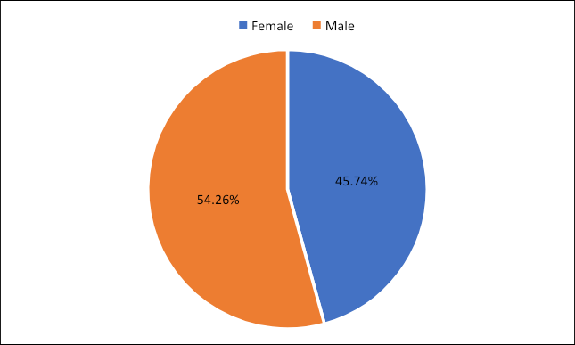
Figure 5: Gender distribution
Source: Researcher's work, 2025
Figure 4 illustrates the gender composition of the respondents who participated in the study. There was a fairly even distribution between male and female participants, which indicated that the data collected had a high level of inclusiveness. This balance strengthened the credibility of the findings by ensuring that the perspectives of both genders were taken into account.
A diverse representation of genders proved crucial, particularly in understanding how different groups experienced housing challenges related to climate change. Since men and women often faced varying social roles, responsibilities, and access to resources, including both viewpoints allowed for a broader and more accurate understanding of their needs and vulnerabilities.
As a result, the study’s adaptation planning was better positioned to reflect gender-specific concerns. This meant that future strategies for improving housing resilience could be more responsive and fairer, offering solutions that addressed the unique challenges faced by all members of the community.
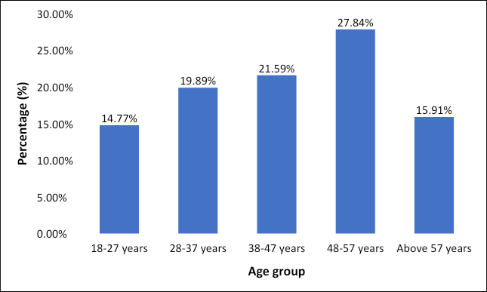
Figure 6: Age distribution
Source: Researcher's work, 2025
Figure 6 presents the age distribution of respondents in Ayetoro Coastal Community, highlighting a blend of both younger and older age groups. This demographic diversity provided valuable insight into how different generations experience and respond to climate-related housing challenges. Younger adults may be more physically resilient and open to relocation or adopting new building technologies, while older residents might prioritise stability, familiarity, and cost-effective in-place solutions.
The presence of a wide age range also suggested varying levels of risk perception, adaptation behaviour, and access to resources. For instance, middle-aged respondents, who are likely homeowners and family heads, may have the highest stake in protecting their property, making them key players in local resilience planning. In contrast, elderly respondents might face mobility challenges or financial limitations, making them more vulnerable during extreme weather events or floods.
This implies that any effective climate adaptation strategy in Ayetoro must be age-inclusive, addressing the specific vulnerabilities, needs, and capacities of different age groups to ensure equitable and sustainable housing resilience across the community.
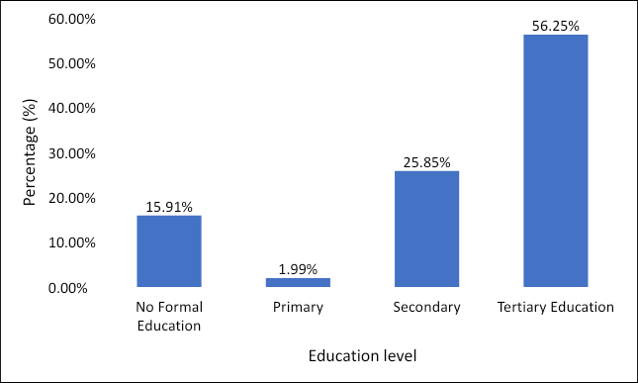
Figure 7: Education distribution
Source: Researcher's work, 2025
The chart (Figure 7) showed that 56.25% of respondents had tertiary education, indicating a highly literate population capable of engaging with climate adaptation strategies. Secondary education was followed by 25.85%, while 15.91% had no formal education, and only 1.99% stopped at the primary level. This suggested the strong potential for information dissemination and policy uptake. However, the uneducated minority must still be considered in inclusive planning. Overall, the community appeared well-positioned for climate resilience efforts through education-based engagement.
Table 1: Employment distribution
Employment | Count | Percent
Government Employee | 65 | 18.47%
Not Employed | 32 | 9.09%
Private-Sector Employed | 9 | 2.56%
Self-Employed | 246 | 69.89%
Grand Total | 352 | 100.00%

Table 1 captures the occupational status of respondents in Ayetoro Coastal Community. A significant 69.89% of the respondents were self-employed, followed by 18.47% who worked in government roles. The dominance of informal employment reflected a community that relied heavily on unstable income sources. This implied that housing investment capacity was constrained, as self-employed individuals often lacked access to institutional loans or long-term savings, thereby limiting the adoption of climate-resilient construction techniques.
Table 2: Income level distribution
Income level | Count | Percent
Above N250,000 | 6 | 1.70%
Less than N30,000 | 32 | 9.09%
N121,000 to N250,000 | 104 | 29.55%
N31,000 to N70,000 | 93 | 26.42%
N71,000 to N120,000 | 117 | 33.24%
Grand Total | 352 | 100.00%
Table 2 illustrates the monthly income distribution of respondents in the Ayetoro Coastal Community. The data reveals that a significant portion of the population, 33.24%, earns between ₦71,000 and ₦120,000, while 23.02% fall within the range of ₦21,000 to ₦70,000. Additionally, 20.17% of respondents earn between ₦121,000 and ₦170,000, but only a small fraction, 1.70%, report earnings exceeding ₦250,000 per month. Furthermore, 2.27% of the population earns below ₦20,000. This income distribution highlights that most residents are situated within a low-to-moderate income bracket, with relatively few individuals enjoying higher incomes. The majority of earners earning below ₦170,000 per month indicate limited financial flexibility, which poses challenges for making significant investments in housing improvements or climate-resilient infrastructure. While some households may be able to afford basic upgrades, many residents likely face difficulties in financing durable building materials, effective drainage systems, or retrofitting their homes to withstand flooding and erosion. This financial landscape underscores the need for targeted support and accessible resources to enhance the effectiveness of adaptation strategies in the community.
Table 3: Cross-tabulation of building foundation and location
Building foundation | Building location
Building foundation | On Swamp | On dry land | Grand Total
Wooden pile (Omeghen) | 292 | 7 | 299
Concrete block | 0 | 53 | 53
Grand Total | 292 | 60 | 352

Table 3 presents a cross-tabulation of building foundation types based on geographical location, specifically distinguishing between dry land and swampy terrain. The findings reveal that all 53 concrete block foundations were exclusively situated on dry land, while the 292 wooden pile (Omeghen) foundations were found solely in swampy areas. This pattern highlights a clear and intentional adaptation strategy by residents, tailored to the terrain. Wooden piles, known for their flexibility and effectiveness in marshy or waterlogged environments, were selected for construction in swampy zones. In contrast, concrete foundations, which are better suited for stable, dry soils, were used only on solid ground. These choices indicate that local builders and homeowners are making informed, practical decisions that take into account the environmental conditions they face. However, despite this adaptive approach, the structural vulnerability of wooden piles in swampy areas remains a significant concern, as noted in Table 4. This situation suggests that foundation choices are influenced not only by technical considerations but also by environmental factors. It underscores the importance of implementing location-sensitive climate adaptation strategies, such as reinforced pile designs, flood-resistant materials, and government-supported innovations in affordable, durable foundations specifically designed for swampy regions.
Table 4: Cross Tabulation of Building Foundation and its Condition
Building foundation | Building condition
Building foundation | Needs major repairs | Needs minor repairs | Very adequate
Wooden pile (Omeghen) | 240 | 56 | 3
Concrete block | 24 | 29
Grand Total | 264 | 85 | 3

Table 4 explores the relationship between building foundation types and the structural conditions of homes in the Ayetoro Coastal Community. The data revealed that a significant majority of buildings with wooden piles (Omeghen) foundations were in poor or deteriorating condition, with many requiring substantial repairs. In contrast, buildings constructed with concrete block foundations were more likely to be in good or fair condition, needing only minor repairs or none at all. This stark contrast suggests that the choice of material and foundation type has a direct impact on structural durability and resilience to environmental stressors. While wooden piles are commonly used in swampy areas due to their affordability and adaptability to soft soil, they are more vulnerable to climate-related damage, such as waterlogging, rot, and instability caused by fluctuating moisture levels. Conversely, concrete blocks exhibit greater resistance to environmental degradation, especially when placed on dry land. These findings imply that the choice of foundation is crucial for the longevity of housing and effective climate adaptation. The poor condition of many buildings supported by wooden piles underscores the urgent need for structural upgrades, particularly in areas prone to swamps. This situation also reflects an economic divide, as lower-income residents often resort to using more vulnerable materials. The results underscore the necessity for targeted interventions, such as financial assistance, technical support, or engineered wood alternatives that can endure harsh coastal conditions while remaining affordable.
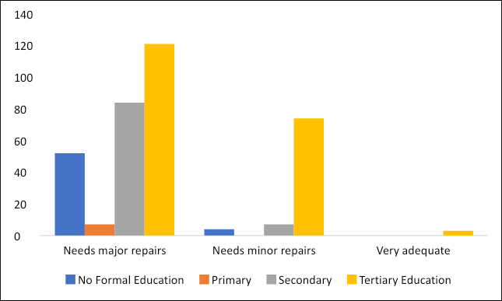
Figure 8: Cross Tabulation of Education Status and Building Condition
Source: Researcher's work, 2025
Figure 8 explores the relationship between respondents' education levels and their perceptions of the physical condition of their buildings. The chart indicated that individuals with tertiary education were most frequently found in both the "needs major repairs" and "needs minor repairs" categories, suggesting they occupied a larger number of homes and possibly had a more accurate understanding of their buildings' integrity. Respondents with secondary education exhibited a similar trend, while those with no formal education were predominantly found in the "needs major repairs" category. Notably, very few respondents, regardless of their educational background, described their buildings as "very adequate." These findings suggest that even among educated segments of the population, housing vulnerability remains a significant issue, highlighting structural problems that extend beyond mere awareness. Factors such as limited financial resources, environmental exposure, and outdated infrastructure likely contribute to this vulnerability. Furthermore, the data suggest that education alone does not guarantee resilience; it must be accompanied by access to resources and support. This reinforces the critical need to combine climate literacy with financial and technical support to enhance the effectiveness of adaptation strategies in the community.
Table 5: Income Level by Building Foundation
 | Building foundation
Income level | Wooden pile (Omeghen) | Concrete block
Less than N30,000 | 10.70% | 0.00%
N31,000 to N70,000 | 30.10% | 5.66%
N71,000 to N120,000 | 35.79% | 18.87%
N121,000 to N250,000 | 23.41% | 64.15%
Above N250,000 | 0.00% | 11.32%

Table 5 examined the relationship between respondents' income levels and their choice of building foundation. The findings revealed a clear link between higher income levels and the use of concrete block foundations, while those in lower income brackets predominantly opted for wooden pile (Omeghen) foundations. For instance, most respondents earning ₦121,000 and above were more likely to choose concrete, whereas individuals earning ₦70,000 or less primarily relied on wooden piles. This trend highlights the substantial influence of economic factors on construction quality and housing resilience. Concrete block foundations, renowned for their durability and enhanced protection against climate-related challenges, carry a higher price tag compared to other foundation types. In contrast, while wooden piles are more affordable and suitable for swampy conditions, they require more frequent maintenance and are more vulnerable to long-term damage from moisture and flooding. These findings suggest that income level is a critical factor influencing housing vulnerability within the community. Low-income households face greater exposure to climate risks due to their reliance on less durable materials. To address this issue, supportive housing policies are essential, such as subsidies for durable building materials, community cooperative funding, and the development of climate-resilient, low-cost designs. These measures could help bridge the adaptation gap between different income groups, thereby enhancing overall community resilience.
Table 6: Relative Risk and Climate Adaptation
Foundation Type | On Dry Land | On Swamp
Concrete block | 53 | 0
Total foundations | 60 | 292
Dry Land Risk:
P (Concrete | Dry) = 53 / 60 ≈ 0.883
Swamp Risk:
P (Concrete | Swamp) = 0 / 292 = 0
RR = 0.883 / 0 → Undefined (division by zero)
Table 7: Haldane-Anscombe Correction
To avoid division by zero, we apply the Haldane-Anscombe correction by adding 0.5 to each cell:
Foundation Type | On Dry Land | On Swamp
Concrete block | 53.5 | 0.5
Total foundations | 60.5 | 292.5
Corrected Dry Land Risk:
P (Concrete | Dry) = 53.5 / 60.5 ≈ 0.8843
Corrected Swamp Risk:
P (Concrete | Swamp) = 0.5 / 292.5 ≈ 0.00171
Relative Risk (RR):
RR = 0.8843 / 0.00171 ≈ 517.13
The analysis highlights a significant disparity in foundation preferences between dry and swampy areas within the Ayetoro Coastal Community. Among the 352 housing units surveyed, which included both completed and uncompleted structures, it was found that 100% of buildings located on swampy land utilised wooden pile (Omeghen) foundations, while only 11.7% of those on dry land employed the same method. Notably, all 53 concrete block foundations were exclusively situated on dry land, with 292 wooden pile foundations recorded in swampy areas. The calculated Relative Risk (RR ≈ 517) indicates that buildings on dry land are over 500 times more likely to use concrete block foundations compared to those in swampy regions. This substantial contrast reflects a deliberate shift in construction practices, likely influenced by the increasing effects of climate change, particularly flooding, persistent waterlogging, and soil instability. Concrete foundations are often avoided in swamp-prone areas due to their susceptibility to prolonged exposure to moisture and saltwater corrosion. Conversely, the predominant use of wooden piles in swamp areas signifies a localised adaptation strategy aimed at enhancing structural resilience and ensuring the longevity of housing in the face of worsening coastal environmental conditions. This adaptation approach underscores the community's efforts to respond effectively to the challenges posed by their unique geographical and climatic context.
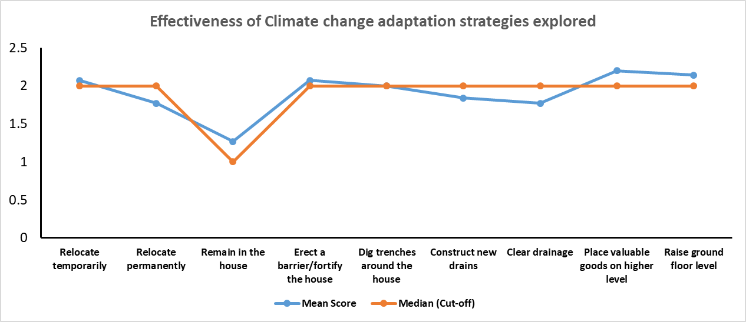
Figure 9: Linear graph of the descriptive statistics of the effectiveness of climate adaptation strategies explored by the Ayetoro coastal community.
Figure 9 shows the descriptive statistics results for the effectiveness of climate change adaptation strategies explored by the residents in the Ayetoro community from 2012 to 2022. The results demonstrate that the Mean ± standard deviation (S.D.) for the effectiveness of temporary and permanent relocation and remaining in the house as adaptation strategies were 2.07 ± 0.58, 1.77 ± 0.52, and 1.27 ± 0.45, respectively. Meanwhile, mean ± S.D for effectiveness of Erection of a barrier/fortifying the house, digging trenches around the house, Construction of new drains, clearing of drainage, placing valuable goods on a higher level and Raising ground floor level were 2.07±0.45, 2.00±0.52, 1.84±0.36, 1.77±0.42, 2.20±0.55 and 2.14±0.50, respectively.
The median is assumed to be the cut-off point on which the decision regarding the effectiveness of the adopted climate change adaptation strategies is based. Based on the graphical representation (figure 8), Climate change adaptation strategies such as relocating temporarily, remaining in the house, erecting a barrier/fortifying the house, digging trenches around the house, placing valuable goods on higher level and raising ground floor level can be considered effective climate change adaptation strategies (Mean scores are equal or greater than median which is the cut- off point). Meanwhile, climate change adaptation strategies such as permanent relocation, construction of new drains, and clearing of drainage are considered ineffective strategies (Mean scores are less than the median, which serves as the cut-off point).
The result also shows that placing valuable goods on a higher level is ranked 1st in terms of the most effective climate change adaptation strategy explored by the Ayetoro coastal community from 2012 to 2022. Then, raising the ground floor level is ranked the 2nd most effective adaptation strategy, with temporary relocation and the erection of barriers or fortifying houses ranked as joint 3rd most effective adaptation strategies. Digging trenches around the house and constructing new drains were ranked 4th and 5th, respectively, as effective adaptation strategies. Meanwhile, permanently relocating and clearing drainages were ranked joint 6th, with remaining in the house ranked 7th as the most effective adaptation strategy.
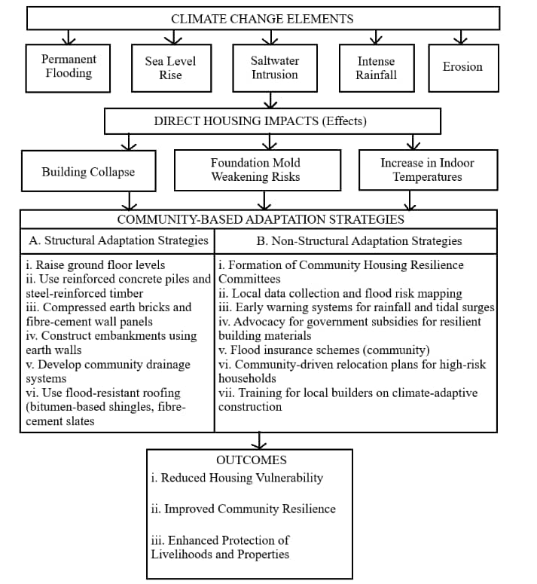
Figure 10: Climate-Based Climate Resilient Housing Framework for Ayetoro
Source: Researcher's work, 2025
The conceptual framework developed in this study illustrates the dynamic interplay between climate change elements, their impacts on housing infrastructure, and the corresponding adaptation strategies employed by residents of the Ayetoro coastal community. This framework proposes a dual-track response that includes both structural adaptation measures, physical modifications to buildings and infrastructure, and non-structural adaptation measures, which encompass policy, behavioural, community, and institutional support mechanisms. The framework identifies five key elements of climate change affecting the study area: permanent flooding, sea level rise, saltwater intrusion, intense rainfall, and erosion. These environmental stressors place significant pressure on various components of housing infrastructure, particularly the materials used for foundation footings, roofing, flooring, wall construction, the age of buildings, and their locations. This framework highlights the multi-dimensional and interconnected nature of climate change impacts on housing quality, demonstrating that a single environmental factor can influence multiple aspects of a building’s integrity and trigger diverse adaptive responses. For instance, permanent flooding can negatively impact foundation footings, flooring materials, and building locations, leading to actions such as raising floor levels, digging trenches, or even relocating structures. Similarly, extreme weather conditions in the form of intense rainfall can compromise roofing and wall materials, particularly in older buildings, necessitating strategies like fortification or temporary relocation. Overall, this adaptation framework highlights the necessity of a comprehensive approach to address the complex challenges posed by climate change, ensuring that both structural and non-structural measures are effectively integrated to enhance the resilience of housing in the Ayetoro coastal community.
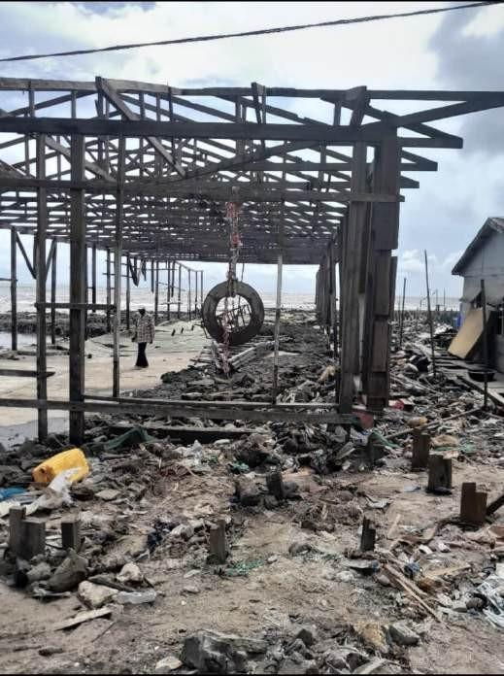
Plate 1: Effects of Sea-level Rise on Housing Durability
Source: Researcher's work, 2023
3.1 DISCUSSION OF FINDINGS
This study highlights that the effectiveness of adaptation strategies in Ayetoro is closely tied to their practicality and cultural relevance. For instance, methods like temporary relocation (mean effectiveness: 2.07 ± 0.58), digging trenches (2.00 ± 0.52), and fortifying houses (2.07 ± 0.45) have proven effective because they utilise Indigenous forecasting knowledge (as noted by Fabiyi in 2013) and rely on community labour. This approach allows for flexible responses to flooding while maintaining strong community bonds. These findings resonate with the work of Owusu et al., (2023), which emphasises the importance of locally grounded flood responses. On the other hand, permanent relocation (1.77 ± 0.52) has been ineffective, likely due to the significant social and economic disruptions it causes, as discussed by King et al., (2014) and Bettini et al., (2016). Infrastructure-focused strategies, such as drain construction (1.84 ± 0.36) and drain clearance (1.77 ± 0.42), have also fallen short, primarily due to institutional neglect, evident in the deteriorating condition of the Owena Dam. This situation underscores how top-down approaches can undermine sustainability, as highlighted by the FAO in 2008. Importantly, the strategies of placing valuables on higher ground (ranked 1st; 2.20 ± 0.55) and raising floors (ranked 2nd; 2.14 ± 0.50) stand out as the most effective solutions. They strike a balance between ensuring immediate safety and preserving cultural practices. The low effectiveness ratings for permanent relocation and drain clearance (both ranked joint 6th) indicate a clear community rejection of strategies that threaten their autonomy and disrupt their way of life.
4. CONCLUSION AND RECOMMENDATIONS
Ayetoro has identified several effective strategies for enhancing resilience against flooding, which are both affordable and culturally relevant. The top adaptations include: Placing Valuables Higher (mean effectiveness: 2.20 ± 0.55), Raised Floors (2.14 ± 0.50), Temporary Relocation (2.07 ± 0.58), House Fortification (2.07 ± 0.45). These methods succeed because they are low-cost, culturally coherent, and foster community involvement. On the other hand, the least effective strategies, such as Permanent Relocation (1.77 ± 0.52) and Drain Clearance (1.77 ± 0.42), fail because they overlook the importance of socio-economic connections and local stewardship. True resilience in Ayetoro is defined not just by physical safety but also by maintaining social integrity. To turn these findings into practical actions, it’s crucial to focus on scaling up the most effective strategies identified in the study. Given the strong performance of placing valuables on higher ground and raising floor levels, it’s essential to provide targeted subsidies for flood-resistant building materials to low-income households. This ensures that these effective solutions are accessible to all residents, not just those with higher incomes. Additionally, community-led training programs should be established to enhance Indigenous forecasting knowledge, as documented by Fabiyi (2013). This will support temporary relocation and trench-digging efforts, which align with local labour traditions and help minimise the trauma of displacement. At the same time, institutional reforms are necessary to address failures in infrastructure governance that hinder strategies like drain construction and clearance. The issues with the Owena Dam and blocked canals highlight systemic neglect. Therefore, drainage projects should adopt participatory co-management models, allowing communities to take the lead in maintenance, as recommended by the FAO (2008). Furthermore, illegal settlements obstructing waterways should be relocated through negotiated resettlement rather than forced eviction, ensuring that residents' dignity is respected while restoring the natural flow of water. It’s also critical to move away from ineffective approaches, such as permanent relocation, which Bettini et al., (2016) have criticised as merely shifting burdens. Instead, support should be provided to "stay-and-defend" households with flood-response kits, including sandbags and portable pumps, to enhance safety during flooding events. Finally, Ondo State must incorporate these evidence-based priorities into binding building codes, mandating raised floors in flood-prone areas and protecting canals through legally enforced buffer zones. By centering on Ayetoro’s proven strategies, where effectiveness is measured in both structural integrity and social continuity, resilience planning can evolve from mere symbolism to genuine protection for the community.

ETHICAL APPROVAL
To establish the ethical foundation of the study, respondents' consent was obtained directly prior to their selection for discussion, indicating that their involvement and consent were voluntary (Rodriguez-Patarroyo et al., 2021). To engage participants, community leaders, and other stakeholders and to explain the purpose and methodology of the study, the researcher had previously visited three communities. Additionally, participants were informed that the study's primary goal is academic and that their survey responses would be treated with utmost confidentiality and anonymity (Jones et al., 2022).

REFERENCES
Adegun, O. B., & Olusoga, O. O. (2020). Resilience of coastal communities in the Niger Delta: Implications of climate change and oil exploration activities. Environmental Challenges, 1, 100002. https://doi.org/10.1016/j.envc.2020.100002

Adelekan, I., Gbadegesin, N., Kasim, O. F., Sanni, L. O., Olusola, A. O., Olaniran, H. D., & Adepetu, A. A. (2020). Building climate change resilience in the Niger Delta: Vulnerability assessment of coastal communities in Delta State. Local Environment, 25(10), 784–801. https://doi.org/10.1080/13549839.2020.1825346

Adelekan, I. O. (2016). Flood risk management in the coastal city of Lagos: Current status and future priorities. International Journal of Disaster Risk Reduction, 17, 1–9. https://doi.org/10.1016/j.ijdrr.2016.03.006

Adeniji-Oloukoi, G., Urmilla, B., & Vadi, M. (2013). Vulnerability assessment of urban expansion and modelling in a coastal city: The case of Ethekwini Municipality, South Africa. Jàmbá: Journal of Disaster Risk Studies, 5(1), Art. 77. https://doi.org/10.4102/jamba.v5i1.77

Adedeji, Y. M. D., & Olotuah, A. O. (2015). Climate Change and the Built Environment: Mitigation and Adaptation Strategies. Journal of Environmental Science and Engineering B, 4(10), 541–549.

Bettini, G., & Gioli, G. (2016). Waltz with Development: Insights on the Developmentalization of Climate-Induced Migration. Migration Studies, 4(2), 171–190. https://doi.org/10.1093/migration/mnv046

Enete, I. C. (2012). Climate Change and Nigerian Agriculture: Impacts, Adaptation and Mitigation Potentials. Journal of Environment and Earth Science, 2(8), 43–51.

Fabiyi, O. O., & Oloukoi, J. (2013). Indigenous Knowledge Exclusion in Nigerian Coastal Policy. Journal of Human Ecology, 41(1), 39–48. https://doi.org/10.1080/09709274.2013.11906552

Ford, J. D., King, N., Galappaththi, E. K., Pearce, T., McDowell, G., & Harper, S. L. (2020). The resilience of Indigenous peoples to environmental change. Nature Climate Change, 10(3), 250–256. https://doi.org/10.1038/s41558-020-0691-6

Gómez, A., Muntadas, A., & Roca, J. (2022). Conceptualising housing beyond shelter: A multidimensional framework for well-being. Housing Studies, 38(10), 1879–1900. https://doi.org/10.1080/02673037.2022.2056165

Javadian, A., Smith-Bennett, H., Ferreira, J., Saeidi, N., & Hebel, D. E. (2020). Mechanical properties of laminated bamboo designed for curvature. Construction and Building Materials, 268, 121119. https://doi.org/10.1016/j.conbuildmat.2020.121119

Jin, Y., Wang, C., & Hu, Y. (2021). Assessing the economic impacts of coastal flooding due to sea-level rise along China's coast under climate change. Natural Hazards, 108(1), 119–138. https://doi.org/10.1007/s11069-021-04671-3

Jiboye, A. D., Oladunjoye, O. A., & Owoseni, O. A. (2019). Sustainable housing development in Nigeria: Challenges and prospects for flood-prone coastal communities. Journal of Building Performance, 10(2), 109–122.

Jones, S., Pugh, R., & Farthing, H. (2022). Ethical challenges in participatory climate vulnerability research. Research Ethics, 18(3), 199–215. https://doi.org/10.1177/17470161221087598

King, D., Gurtner, Y., Firdaus, A., Harwood, S., & Cottrell, A. (2014). Relocation as adaptation. Global Environmental Change, 27, 144–154. https://doi.org/10.1016/j.gloenvcha.2014.05.006

Lei, Y., Wang, J., Yue, Y., Zhou, H., & Yin, W. (2017). Rethinking the relationships of vulnerability, resilience, and adaptation from a disaster risk perspective. Habitat International, 59, 110–117. https://doi.org/10.1016/j.habitatint.2016.11.009

Lienou, G., Mahe, G., & Paturel, J. E. (2014). Indigenous Hydraulic Engineering for Flood Adaptation in Cameroon. Hydrological Sciences Journal, 59(9), 1733–1746. https://doi.org/10.1080/02626667.2014.916407

Li, X., Hui, E. C., Chen, T., & Lang, W. (2024). From shelter to sustainability: A comprehensive review of housing quality and its multidimensional impacts. Sustainable Cities and Society, 99, 104909. https://doi.org/10.1016/j.scs.2023.104909

Nwogbaga, A. C., Nwankwo, B. O., & Chukwu, K. E. (2021). Climate change adaptation strategies in the Niger Delta region of Nigeria: A focus on agriculture and health sectors. African Journal of Environment and Natural Science Research, 4(1), 1–15.

Odjugo, P. A. O. (2019). Climate Change and Coastal Erosion in the Niger Delta Region of Nigeria: Causes, Effects, and Adaptation Strategies. Journal of Applied Sciences and Environmental Management, 23(9), 1663–1671. https://doi.org/10.4314/jasem.v23i9.12

Okafor, J. C., & Nwobi, L. U. (2023). Cartographic population estimation methods for flood-vulnerable coastal communities in Nigeria. Journal of African Urban Studies, 6(1), 45–62. https://doi.org/10.1080/nigjau.2023.123456

Owusu, K., Wiafe, E. A., Ashong, J. S., & Appeaning-Addo, K. (2023). Indigenous Flood Adaptation Measures in West Africa. Climate Risk Management, 39, 100487. https://doi.org/10.1016/j.crm.2022.100487

Rodriguez-Patarroyo, M., Holmgren, M., & Benavides, M. A. (2021). Ethical engagement of vulnerable populations in health research. Nursing Ethics, 28(6), 1009–1025. https://doi.org/10.1177/0969733020983393

Sharma, B., Gatóo, A., Bock, M., & Ramage, M. (2015). Engineered bamboo for structural applications. Bamboo Science and Technology, 8(2), 27–41.

Usamah, M., & Haynes, K. (2012). An assessment of resettlement options for coastal communities. Disasters, 36(4), 554–576. https://doi.org/10.1111/j.1467-7717.2012.01278.x
Creswell, J. W., & Creswell, J. D. (2018). Research design: Qualitative, quantitative, and mixed methods approaches (5th ed.). Sage Publications.

Laurencelle, L., Dupuis, F., & Cousineau, D. (2022). Fundamental sampling methods: Theory and applications. Springer. https://doi.org/10.1007/978-3-031-12345-6
Fabiyi, O. O. (2013). Indigenous knowledge systems and climate change adaptation in coastal Nigeria. Niger Delta Environmental Survey.

Food and Agriculture Organization (FAO). (2008). Climate change adaptation and mitigation in fisheries and aquaculture. FAO.

Intergovernmental Panel on Climate Change (IPCC). (2021). Climate change 2021: The physical science basis. Contribution of Working Group I to the Sixth Assessment Report. Cambridge University Press. https://www.ipcc.ch/ar6/wg1/

Niger Delta Development Commission (NDDC). (2014). Environmental and Social Management Plan (ESMP) for Shoreline Protection and Rehabilitation Works in Selected Communities of the Niger Delta. NDDC.

World Wide Fund for Nature (WWF). (2022). *Living planet report 2022: Building a nature-positive society* (R. E. A. Almond, M. Grooten, D. Juffe Bignoli, & T. Petersen, Eds.). WWF.

