Bioaccumulation and Ecological Risk Assessment of Heavy Metals in Parapenaeopsis atlantica from the
Iko River Estuary, Nigeria.

Abstracts

Bioaccumulation and ecological risk assessment of heavy in Parapenaeopsis atlantica from the Iko River Estuary, Nigeria was conducted for one year between September, 2022 – August, 2023 with aim of understanding the risks associated with consuming P. atlantica obtained from the Estuary. 40 samples of P. atlantica were bought from landings of artisanal fisherfolks at Iko River Estuary on a monthly basis for a period of 12 months. Shrimps’ samples were thoroughly washed with the sea water, placed in a labeled cellophane bag and preserved in ice cooled box. Samples were later transported to the laboratory prior to laboratory analysis. In the laboratory standard analytical procedure were adhered to in the preparation of samples prior to heavy metal determination using Perkin-Elmer Analysts 800 Atomic Absorption Spectrophotometer (AAS). The concentration of heavy metals in tissue of P. atlantica studied for (Cd, Cr, Cu, Fe, Mg, Ni, Pb and Zn) did not show any significant variation exception of copper. However, throughout the study duration the values of iron and zinc were observed to be generally higher than all the studied metals which was attributed to their abundance in the earth crust. Correlation analysis showed strong positive relationship between metal pairs in both season and hierarchical cluster dendrogram delineated the metals into cluster groups based on concentration gradient and source of contamination. Based on the results of findings, the concentration of heavy metal in the tissue of the P. atlantica fell within the WHO/FAO recommended threshold limit for safe consumption of P. atlantica. However, the result also shows evidence of bioaccumulation if the trend persists unchecked. Therefore, constant monitoring of heavy metal levels in tissues of edible aquatic organisms to prevent health related issues to man as the final consumer of this seafood’s is highly recommended.

Keywords: Bioaccumulation, Ecological Risk, Parapenaeopsis atlantica, Heavy Metals, Iko River

1.0 Introduction

Heavy metal pollution in aquatic ecosystems is a growing environmental concern due to its potential impact on biodiversity, food safety, and human health. Coastal estuaries, such as the Iko River Estuary in Southeastern Nigeria, receive significant anthropogenic inputs from industrial, agricultural, and domestic sources, leading to the accumulation of toxic metals in aquatic organisms (George, et al., 2023 a; b). Among these organisms, shrimps are of particular interest due to their ecological role in food webs and their economic importance as a seafood resource.
Shrimps, including Parapenaeopsis atlantica, are filter feeders and benthic organisms that readily accumulate heavy metals from sediments and water. The bioaccumulation of metals such as lead (Pb), cadmium (Cd), mercury (Hg), and arsenic (As) in shrimps raises concerns about potential toxic effects on aquatic life and human consumers (George, et. al., 2013; Andem, et. al., 2013; George, et. al., 2015). Studies have shown that chronic exposure to these metals can cause oxidative stress, enzyme inhibition, and reproductive impairments in crustaceans (Ekpo, et. al., 2015; George, 2015).
Previous research on heavy metal contamination in Nigerian aquatic environments has highlighted the presence of elevated metal levels in sediments, water, and biota. (Ekanim, et. al., 2016; George and Effiom, 2017; George and Inyang-Etoh, 2018 b; Inyang-Etoh and George, 2018; Effiom and George, 2018; Asuquo, et.al., 2023). However, specific studies on P. atlantica in the Iko River Estuary remain scarce, despite its ecological and commercial significance.
In the aquatic ecosystem, sources of heavy metal contamination can be broadly classified into natural and anthropogenic origins. While natural weathering of rocks and soil erosion contribute trace amounts of metals to aquatic systems, human-induced pollution is the predominant cause of heavy metal accumulation in estuaries (George, et. al., 2021 a; b; Jonah, et. al., 2019; George, et. al., 2020 a). The use of phosphate fertilizers and pesticides in nearby farmlands introduces Cd, Zn, and Cu into the estuary through surface runoff from agricultural farmlands especially during the rainy season (George and Atakpa, 2015 a, b; Jonah, et al., 2020, George, et. al., 2020 b; Effiong, et. al., 2021).
The estuary receives discharge from petrochemical industries, oil refineries, and illegal crude oil bunkering. Oil spills and produced water from offshore drilling operations contain toxic metals such as Pb, Ni, and Hg, which enter the water column and sediments (Benson, et al., 2016; Asuquo, et. al., 2004). Wastewater discharge from nearby settlements carries metals from household products, pharmaceuticals, and electronic waste into the aquatic system (George, et. al., 2017; George and Inyang-Etoh, 2018 a; George and Effiom, 2018).
This study aims to assess the concentrations of heavy metals in P. atlantica from the Iko River Estuary. The findings will provide valuable insights into environmental pollution in the region and inform regulatory policies for seafood safety and aquatic ecosystem management.

2.0 Materials and Methods
2.1 The Study Area
Iko River estuary is in Eastern Obolo Local Government Area, Akwa Ibom State, in the Niger Delta region, Nigeria. The area lies within latitude 4°0’30’ N and longitude 7°40’ E (Fig. 1) (Ekpe et. al, 1995; Udotong et. al. 2008; Etesin et. al. 2013). The river has a shallow depth ranging from 1.0 m to 7.0 m at flood and ebb tide. Iko River takes its rise from Qua Iboe River catchments and drains directly into the Atlantic Ocean at the Bight of Bony (Ekpe et. al, 1995). The adjoining Creeks, channels and tributaries from the Iko River estuary are significant in the provision of suitable breeding sites for the diverse aquatic resources that abound in the area. Human activities in the area include fishing by artisan fisher’s folks as well as petroleum exploration and production activities (NDES, 2000; NDDC, 2004). The shoreline of Iko River estuary is fringed with mangrove and nipa vegetations, tidal mudflat and pneumatophores of Avicenia exposed during low tide. The macrophytes are composed of the native red mangrove; Rhizophora racemosa, R. harrizonii, R. Mangle, black mangrove (Avicenia africana) and Laguncularia racemosa and the exotic nipa palm (Nypa fruticans) (Ekwere et. al. 1992; Ukpong, 1995). The study area lies within the tropical rainforest zone and has two major seasons: the wet season (April to October) and the dry season (November to March). The main occupation of the inhabitants includes large scale fishing employing the use of fishing vessels, small scale fishing by artisanal fishers employing the use of fishing boats, farming activities involving the use of agrochemicals, boat construction as well as timber logging of mangrove vegetation as fuel wood.
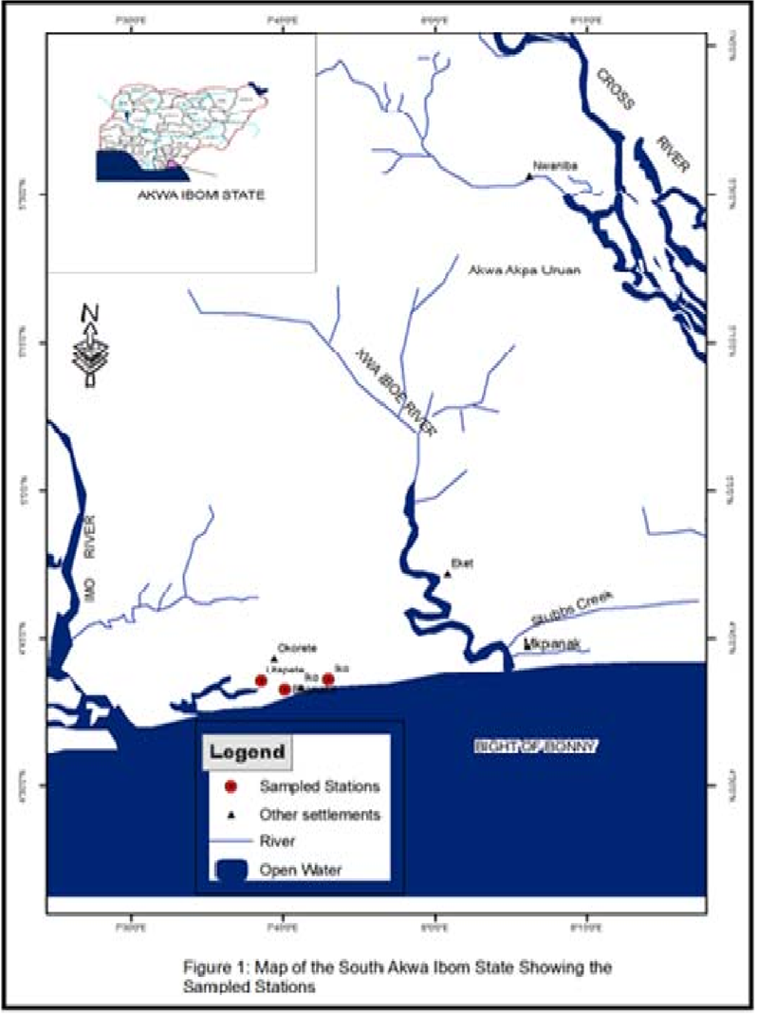
Fig. 1: Map of Iko River Estuary showing the Major Fishing Areas.
2.2 Sample Regime / Collection
Samples of Bonga fish (Ethmalosa fimbriata) were bought from landings of artisanal fisherfolks in the Iko River estuary on a monthly basis between September, 2022 and August 2023. The samples were then washed thoroughly with the sea water, placed in a labeled cellophane bag and preserved in ice cooled box. The samples were later transported to the zoology Unit laboratory department, of Biological Sciences Akwa Ibom State University and stored in the freezer at - 4ºC prior to laboratory analysis.
2.3 Sample Preparation
Fish samples were removed from the freezer and allowed to thaw at room temperature, the flesh of the fish was taken using stainless steel surgical knife. The samples were then oven dried at 65º C until they attained constant weight.

2.4 Digestion Procedure
Dry tissue samples weighing 0.50g were digested with 5.0 ml of concentrated nitric acid (HNO₃), 2.0 ml of hydrogen peroxide (H₂O₂), and 1.0 ml distilled water was added. The vessel was sealed and placed into the rotor 8 for the microwave digestion. The digested samples were transferred to the 50.0 ml auto-sampler polypropylene vials and distilled water was added to a final total volume of 20.0 ml.

2.5 Analysis of Heavy Metals
The concentration of heavy metals in fish samples were analyzed using Perkin-Elmer Analysts 800 Atomic Absorption Spectrophotometer (AAS) equipped which Winlab 32TM for AA version 6.5 software, which features all the tools needed to analyze samples, report and archive data and ensure regulatory compliance. It also features a solid-state detector which is highly efficient at low wavelengths. The Analyst 800 uses a transversely heated stabilized temperature platform system to ensure the minimum influence of matrix interference possible and provides the lowest detection limits available (APHA, 2005)

2.6 Statistical Analysis
MS Excel was used for graphical representation of spatial variations among metal pairs and Statistical package for Social Sciences (SPSS) version 20 was employed to compute Mean, variance and standard error in the data. Paired sample t-test was used to compare seasons. The probability level was set at p = 0.05. Correlation analysis and Hierarchical cluster analysis was employed using R-software to test for metal association and source of contamination.

3.0 Results
3.1 Heavy Metals in Parapenaeopsis atlantica
Summary of the data obtained on seasonal range values, seasonal mean and standard error on heavy metals in Parapenaeopsis atlantica studied between September, 2022 to August, 2023 is presented in table 1.
3.1.1 Cadmium
The concentration of cadmium obtained for both seasons ranged between 0.19 – 0.26 mg / kg and 0.00 – 0.07 mg / kg respectively. The mean cadmium values recorded for dry and wet season were 0.02 mg / kg ± and 0.03 mg / kg ± (Table 3). Cadmium concentration recorded in the tissue of P. atlantica were relatively low during the dry season (Fig. 2). During the wet season the concentration of cadmium was observed to be high in the month of May, 2023 while in the month of July, 2023 no trace of cadmium was noted in the tissue of P. atlantica (Fig. 3)
3.1.2 Chromium
The range of chromium values obtained for dry and wet season were 0.01 – 0.02 mg / kg and 0.01 – 0.04 mg / kg respectively. The mean chromium values recorded for dry and wet season were 0.02 mg / kg ± and 0.02 mg / kg ± respectively (Table 1). The values recorded for chromium during the study duration in the tissues of P. atlantica were relatively low for both season (Fig. 2 and Fig. 3).

3.1.3 Copper
The concentration range for copper recorded in the tissues of P. atlantica for dry and wet season range between 0.18 – 1.19 mg / kg and 0.70 – 1.83 mg / kg respectively. The seasonal mean copper values recorded for dry and wet season were 0.36 mg / kg ± and 1.24 mg / kg ± respectively (Table 1). The concentration of copper in the tissue of P. atlantica showed an interesting pattern with a uniform concentration recorded for all the months in the dry season exception of January, 2023 (Fig. 2). The concentration of copper was relatively higher during the wet season when compared to the dry season as observed in the bar chats. The highest concentration was recorded in the month of October, 2022 with the least recorded in May, 2023 (Fig. 3).

3.1.4 Iron
The range concentration of iron in the tissue of P. atlantica noted for dry and wet season were 1.89 – 2.06 mg / kg and 1.84– 2.01 mg / kg respectively. The mean values recorded for dry and wet season were 1.99 ± mg / kg and 1.92 ± 0.03 mg / kg respectively (Table 1). The concentration of iron was observed to be relatively high in both seasons. For the dry season, the highest concentration was observed in the month of April 2023 and the least was recorded in the month of November, 2022 (Fig. 2). It was observed during the wet season that the concentration of iron was high in the month of May, 2023 in the tissue of P. atlantica while the least concentration was noted in the month of September, 2022 (Fig.3).

3.1.5 Magnesium
Magnesium concentration in the tissue of P. atlantica for dry and wet season was in the range of 0.17– 0.18 mg / kg and 0.17 – 0.83 mg / kg respectively. The mean magnesium values recorded for dry and wet season were 0.18 ± mg/kg and 0.29 ± mg / kg respectively (Table 1). There was no observed variation in the concentration of magnesium in the tissue of P. atlantica during the dry season (Fig. 2). Similar results were recorded during the wet season, exception of May, 2023 where elevated concentration was noted (Fig. 3).

3.1.6 Nickel
Nickel concentration for dry and wet season range between 0.01– 0.13 mg / kg and 0.01 – 0.20 mg / kg respectively. Mean values for dry and wet season were 0.04 ± mg/kg and 0.05 ± mg / kg respectively (Table 1). A slight variation was observed in the concentration of nickel in the tissue of P. atlantica. The highest concentration was noted in the month of March, 2023 with the least being the month of September, 2022 (Fig. 2). Similar trend was observed during the wet season with the highest concentration recorded in the month of August, 2023 and the least value noted in the month of October, 2022 (Fig.3).

3.1.7 Lead
Lead concentration recorded in the tissues of P. atlantica for dry and wet season range between 0.02 – 0.28 mg / kg and 0.02 – 0.23 mg / kg respectively. The mean concentration of lead for dry and wet season were 0.14 ± mg/kg and 0.07 ± mg / kg respectively (Table 1). The concentration of lead was observed to be high in the month of November, 2022, February and April, 2023. However, a uniform concentration was noted for the months of December, 2022, January and March, 2023 (Fig. 2). Lead concentration was relatively low during the wet season exception for the months of August and October, 2022 (Fig. 3).

3.1.8 Zinz
Zinc values range from 0.17 – 0.26 mg /kg and 0.17– 0.25 mg / kg for dry and wet season respectively. The mean zinc values recorded for dry and wet season were 0.23 ± mg/kg and 0.19 ± mg/kg respectively (Table 1). A close concentration range was observed for zinc contamination in the tissue of P. atlantica. However, during the dry season the concentration of zinc was noted to be higher in the month of February, 2023 while the least zinc value was observed in the month of November, 2022 (Fig.2). During the wet season, zinc concentration was relatively high in the month of July, 2023. The concentration range was relatively close in the other months as observed in the chat (Fig. 3).
4.6 Mean Seasonal variation of Dry and Wet values of Heavy Metal measured in Tissue of Parapenaeopsis atlantica Caught from Iko River Estuary (September, 2022 – August, 2023).

TABLE 1: Seasonal range, mean variation, standard error of Heavy Metal measured in Tissue of Parapenaeopsis atlantica Caught from Iko River Estuary for wet and dry season (September, 2022 – August, 2023).

Heavy Metals | Units | Range (dry Season) | Range (Wet Season) | Mean ± S.E (Dry Season) | Mean ± S.E (Wet Season) | Maximum limit WHO/FEPA (mg/kg)
Cadmium | mg/kg | 0.19–0.26 | 0.00– 0.07 | 0.02 ± | 0.03± | 0.5
Chromium | mg/kg | 0.01-0.02 | 0.01-0.04 | 0.02± | 0.02± | 0.5
Copper | mg/kg | 0.18-1.19 | 0.20-1.83 | 0.36± | 1.24± | 3.0
Iron | mg/kg | 1.89-2.06 | 1.84-2.01 | 1.99± | 1.92± | 0.5
Magnesium | mg/kg | 0.17-0.18 | 0.17-0.83 | 0.18± | 0.29± | 0.5
Nickel | mg/kg | 0.01-0.13 | 0.01-0.20 | 0.04± | 0.05± | 0.5
Lead | mg/kg | 0.02-0.28 | 0.02-0.23 | 0.14± | 0.07± | 2.0
Zinc | mg/kg | 0.17-0.26 | 0.17-0.25 | 0.23± | 0.19± | 30
Where: S.E = Standard Error, WHO = World Health Organisation.

Fig. 2: Mean Heavy Metal Concentration (Mg/Kg) in the Tissue of Shrimps (Dry Season)

Fig. 3: Mean Heavy Metal Concentration (Mg/Kg) in the Tissue of Shrimps (Wet Season)
3.2 Mean Seasonal variation of Dry and Wet values of Heavy Metal measured in Tissue of Parapenaeopsis atlantica Caught from Iko River Estuary (September, 2022 – August, 2023).
Mean dry and wet season concentration of heavy metal in the tissue of P. atlantica is presented in Table 2. The mean concentration of cadmium, chromium, copper, magnesium and nickel were observed to be higher in the wet season than the dry season but with no significant difference at p = 0.05 exception of copper that showed significant at p = 0.05. The concentration of iron, lead and zinc were relatively higher during the dry season than the wet season but no significant difference was observed at p = 0.05.

TABLE 2:Mean Seasonal variation of Dry and Wet values of Heavy Metal measured in Tissue of Shrimp Caught from Iko River Estuary (September, 2022 – August, 2023).
Heavy Metal | Dry | Wet | t-value
Cd | 0.022 | 0.028 | 0.598
Cr | 0.018 | 0.021 | 0.612
Cu | 0.356 | 1.237 | 2.430*
Fe | 1.998 | 1.922 | 1.799
Mg | 0.179 | 0.288 | 1.004
Ni | 0.041 | 0.051 | 0.272
Pb | 0.136 | 0.067 | 1.146
Zn | 0.230 | 0.194 | 1.969
t_{crit} = 2.281

3.3 Correlation and hierarchical cluster dendrogram based on heavy metals in Tissue of Parapenaeopsis atlantica (dry season)

Fig. 4 shows dry season correlation analysis for metal-metal relationship in tissue of P. atlantica. The following metals pairs showed strong positive correlation, Fe-Mg (r = 0.91, p<0.05), Fe-Cr (r = 0.85, p<0.05), Fe-Cd (r = 0.83, p<0.05); Cd-Mg (r = 0.96, p<0.001), Cd-Cr (r = 0.98, p<0.001) and Cr-Mg (r = 0.99, p<0.001). From, the cluster dendrogram, three cluster groups were delineated, cluster group 1 (Cd, Cr, Mg and Fe), group 2 (Zn and Ni) and group 3 (Cu and Pb) (Fig. 5).

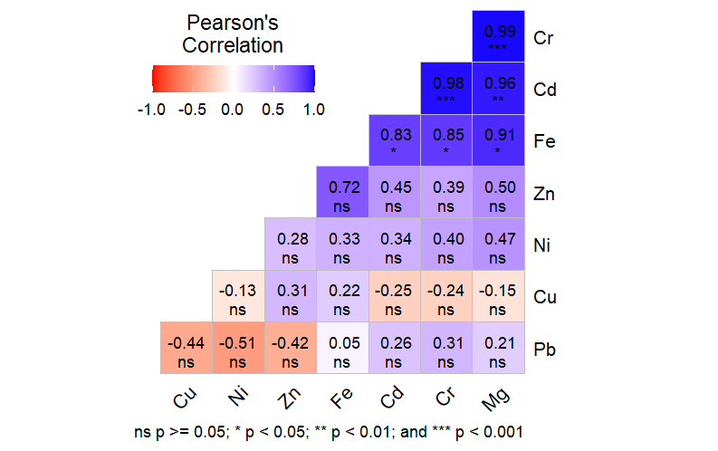
Fig. 4 Dry season Heavy metal correlation in the flesh of Parapenaeopsis atlantica

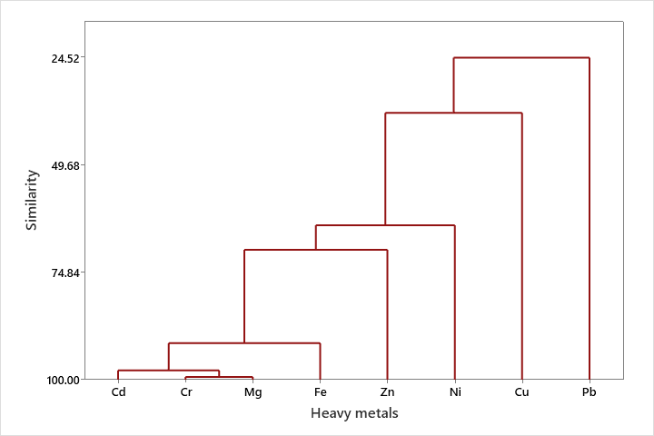
Fig 5: Hierarchical Cluster Dendrogram based on Heavy Metals in Tissue of Parapenaeopsis atlantica (Dry)

3.4 Correlation and hierarchical cluster dendrogram based on heavy metals in Tissue of Parapenaeopsis atlantica (wet season)

The results of correlation analysis of heavy metal in tissue of P atlantica and cluster dendrogram showing concentration gradient and source apportionment during the wet season is presented in Fig. 6 and Fig. 7 respectively. During the wet season, significant negative and positive correlation was observed between the following metal pairs: Copper - Iron (r = -0.85, p<0.05), Chromium – Lead (r = 0.85, p<0.05) and Cadmium– Magnesium (r = 0.90, p<0.05). Cluster dendrogram which reflect source apportionment and concentration gradient delineated four bi-factor cluster groups (Cd, Mg), (Fe, Zn), (Cr, Pb) and (Cu and Ni).

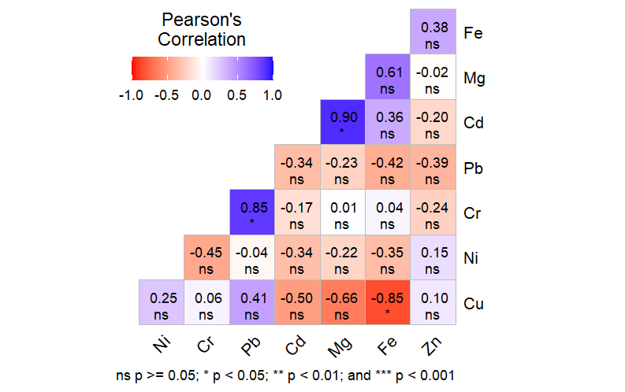
Fig. 6: Wet season Heavy metal correlation in the flesh of Parapenaeopsis atlantica

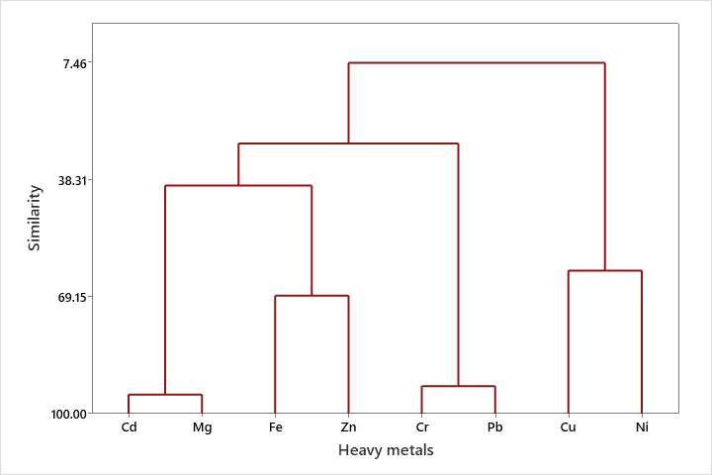
Fig 7: Hierarchical Cluster Dendrogram based on Heavy Metals in Tissue of Parapenaeopsis atlantica (Wet)

4.0 Discussion
Pollution of aquatic ecosystems via heavy metals is an important environmental concerned as heavy metals pose serious threats to human health when transfer through bio-accumulated organism like P. atlantica via the food chain. This assertion agrees with the findings of (Omoregie et al., 2002). However, the consumption of P. atlantica in the Niger Delta region of Nigeria is considered very common owing to the fact that it’s less expensive and easily affordable mostly by the inhabitants of riverine communities and other rural dwellers (Inyang-Etoh and George (2018).
The mean values of trace metal concentrations in the tissues of the studied organism obtained from Iko River Estuary, Eastern Obolo showed a remarkable pattern. This follows the trend: Fe > Cu > Zn > Mg > Pb >Ni > Cd > Cr for dry season. The pattern for the wet season deviated slightly following the trend: Fe > Cu > Mg > Zn > Pb >Ni > Cd > Cr. However, the observed accumulation of heavy metals such as Iron (Fe), Copper (Cu), Zinc (Zn), Magnesium (Mg), Lead (Pb), Nickel (Ni), Cadmium (Cd), and Chromium (Cr) in the test organisms could be from the sediment and were relatively low in all the metals and did not exceed the WHO permissible limit during the study duration. Inyang-Etoh and George, (2018) and George and Inyang-Etoh, (2018) reported similar trend of iron, copper and zinc dominance in tissues of T. fuscatus and C. Amnicola from Qua Iboe River Estuary. Certain factors may have influenced the differential uptake of metals in the test organisms. Generally, elemental concentrations of trace metals in tissues of organism depends not only on anthropogenic and lithogenic sources but also on the textural characteristics such as organic matter, mineralogical composition, nature of the sediment and depositional environment of the sediments (Pourang, et.al. 2005). Fine sediments (mud) dominate Iko River Estuary (IRE) and trace metals are believed to be more associated with smaller grain size particles. This assertion was supported by (Saeed and Shaker, 2008) who stated that the concentration of metals in sediment depends on the amount of organic compound and its particle size. Other factors that affect the abundance of metals in tissues of aquatic organisms include the trace metal content of the rock and parent material of soil formation around the study area. This assertion is consistent with the findings of (Yi, et.al. 2011, George, et. al., 2015, Ekpo, et. al., 2015, Inyang-Etoh and George, 2019, George, et. al., 2021a, George, et. al., 2012b). This study demonstrated evidence of bioaccumulation of heavy metals in the tissues of P. atlantica from Iko River Estuary. This agrees with the findings of Abiaobo et. al., (2017) and Abiaobo and Asuquo, (2020).
The results of the present findings agree favourably with the reports of Ekpechi and Okori, (2022) who reported low concentrations of heavy metals in tissue of P. atlantica from Ekpo Eyo Beach, Akpabuyo, South-East Nigeria. The authors noted that the elemental concentrations of all the metals studied were all below the Joint Food and Agriculture Organization / World Health Organization Expert Committee on Food additives (JECFA) recommended daily intake limits. In contrast, the results earlier reported by Fajana and Adeboyejo (2022) on heavy metals accumulations in the muscles of 5 demersal seafood sampled in Nigerian coastal waters affirmed that the concentration of zinc and iron recorded in the muscles of P. atlantica exceeded WHO/FAO permissible limit for daily intake limit.
There was no significance variation observed in all the studied metals in both season exception of copper in the tissue of P. atlantica. This affirms earlier assertion by (George and Inyang-Etoh, 2018 b, George, et. al., 2021b). Significant positive correlation between metals pairs were observed for Fe-Mg, Fe-Cr, Fe-Cd, Cd-Mg, Cd-Cr and Cr-Mg for dry season. Also, during the wet season significant positive correlation was recorded for Cr-Pb, Cd-Mg and a negative correlation was also observed for Cu-Fe. The positive relationship between metals pairs portends that increase in one parameter mandates a corresponding increase in another parameter while the negative correlation observed portrays an inverse relationship between metal pairs.
Five cluster group dendrogram was established during the dry season for P. atlantica, 2 mono-factor groups and three bi-factors groups while 4 bi-factor cluster groups were delineated during the wet season.

4.1 Summary, conclusion and recommendation
4.1.1 Summary and Conclusion
The elemental concentrations of heavy metals observed in the tissues of Parapenaeopsis atlantica during the study were within permissible limit as recommended by WHO/FAO. The trend in heavy metals observed in studied species during the study duration recorded iron and zinc as the most dominant metals which was attributed to its abundance in the earth crust. Dendrograms resulting from hierarchical cluster analysis indicated multiple cluster groups based on concentration gradient and similar sources of contaminants. The high concentrations of iron and zinc in the study organisms calls for concern as this may result in deleterious health effects to consumers of these aquatic species overtime. P. atlantica is a common commercial aquatic species consumed in Nigeria, notably the Niger Delta Region by most rural dwellers and riverine communities owing to their cheap source. However, this study emphasizes the essence of constant monitoring of heavy metal levels in tissues of edible aquatic organisms to prevent health related issues to man as the final consumer of this seafood’s via transfer through the food chain.

5.0 References

Abiaobo, N. O. and Asuquo, I. E. (2020). Assessment of heavy metal concentrations in periwinkle (Tympanotonus fuscatus) samples from Uta ewa creek, Imo River estuary, South eastern Nigeria. Journal of Aquaculture & Marine Biology; 9(2):32-35.
Abiaobo, N. O., Akpan, I. I. and Umana, S. I. (2017). Assessment of Heavy Metals Concentration in Shell and Fin Fish from Iko River Estuary, Southeastern Nigeria. Journal of Agriculture and Ecology Research International.;12 (4):1–8.
Andem, A. B., Udofia U. U., Okorafor K. A. and George U. U. (2013). Bioaccumulation of some Heavy Metals and Total Hydrocarbon (THC) in the Tissues of Periwinkle (Tympanotonus fuscatus Var Radula) in the Intertidal Regions of Qua Iboe River Basin, Ibeno, Akwa Ibom State, Nigeria. Greener Journal of Biological Science, 3(7):253-259.
APHA (American Public Health Association). (2005). Standard methods of the examination of water and wastewater. (19th edition). American Public Health Association, Washington DC. 121-226.
Asuquo, A. P., Akpan, I. I., Abiaobo, N. O., George, U. U. (2023). Heavy Metals Assessment in Sediments of Qua Iboe River Estuary, South-South, Nigeria. Asian Journal of Research in Zoology; 6(4):27-34.
Asuquo, F. E., Ewa-Oboho, I., Asuquo, F. E. and Udo, P. J. (2004). Fish Species Used as Biomarker for Heavy Metal and Hydrocarbon Contamination for Cross River, Nigeria. The Environmentalist; 24:29-37.
Benson, N. U., Asuquo, F. E., Williams, A. B., Essien, J. P., Ekong, C., Akpabio, O. and Olajire, A. A. (2016). Source Evaluation and Trace Metal Contamination in Benthic Sediments from Equatorial Ecosystems Using Multivariate Statistical Techniques. PLoS ONE, 11(6): 1 – 19.
Effiong, Y. I., George, U. U., Mbong, E. O. (2021). Spatial and Seasonal Variations in Water Quality Parameters of a Humid Tropical River, Niger Delta, Nigeria. Researcher; 13(4):31-39.
Efiom E. and George, U. (2018). Source Evaluation and Trace Metal Contamination in Benthic Sediments from Imo River, South-East, Nigeria Using Multivariate Statistical Techniques. World Rural Observation, 10(2): 66 – 72.
Ekanim, M. P., Etim, I. N., Udofia, I. I. and George, U. U. (2016). Comparative Study of Heavy Metal Concentrations in Tissues and Shells of Tympanotonus fuscatus from Okoro Ete River, Eastern Obolo Local Government Area of Akwa Ibom State, Nigeria. International Journal of Technical Research and Applications, 4(4):58-62.
Ekpe, U. J., Ekanem, U., Akpan, E. R. (1995). Temporal changes in some water quality parameters in Iko and Uta Ewa River South-eastern Nigeria. Glob. J. Pure and Appl. Sci.; 1:63.
Ekpechi, D. C. and Okori, B. S. (2022). Seasonal Variation of Heavy Metals in Sediments, Water, Shiny Nose Fish, Shrimp, and Periwinkle in Esuk Ekpo Eyo Beach, Akpabuyo, South-East Nigeria. Journal of Environmental Treatment Techniques; 10(4):264-283.
Ekpo, E. A., George, U. U. and Edet, M. (2015). Impacts of Water Pollution with Heavy Metal on the Tissue of Egeria radiata (Bivalvia: Tellinacea: Donacidae) (Lammark, 1804) Obtained from Calabar River, Cross River State, Nigeria. Nature and Science, 13(8):36-39.
Ekwere, J, Akpan, E. B. and Ntekim, E. E. U. (1992). Geochemical studies of sediments in Qua Iboe estuary and associated Creek Southeastern Nigeria. Tropical Journal of Applied Sciences; 2:91-95. 29.
Etesin, U., Udoinyang, E. and Harry, T. (2013). Seasonal variation of physicochemical parameters of water and sediment from Iko River, Nigeria. Journal of Environment and Earth Science; 3(8):96-111.
Fajana, O. P. and Adeboyejo, A. (2020). Morphometric and Heavy Metals Accumulation in the Muscles of Five Demersal Seafoods Sampled in Nigerian Coastal Waters. Advance Journal of Graduate Research; 12(1):20-35.
George, I. E., Abiaobo, N. O., Akpan, I. I. and George, U. U. (2023 a). Assessment of Human Perturbations in Iko River Estuary using Bonga Shad as a Bio-indicator Organism. Nature and Science; 21(12): 30-40.
George, I. E., Abiaobo, N. O., Akpan, I. I. and George, U. U. (2023 b). Ecological Assessment of Heavy Metal Contamination of Tympanotonus fuscatus in Iko River Basin. Acta Biology Forum; 2(3):15-21.
George, U. U. and Efiom, Edak (2018). Physical and Chemical Variations in Water Quality of Imo River Owing to Human Perturbations in the System. Researcher, 10(6): 47 – 54.
George, U. and Effiom, E. (2017). Impacts of Coastal Activities on Benthic Sediments from Qua Iboe River Estuary, South-South, Nigeria using Multivariate Statistical Techniques. International Journal of Applied Research, 3(7): 39-50.
George, U. and Inyang-Etoh A. (2018). Parasitic Fauna of Landed Fishes from Qua Iboe River Estuary, South- South, Nigeria: It’s Application in Bio-monitoring Studies. New York Science Journal, 11(3): 54 – 60.
George, U. and Inyang-Etoh, A. (2018 b). Risk Index Evaluation of the Levels of Trace Metals in Callinectes amnicola Obtained from Qua Iboe River Estuary, South - South, Nigeria. Cancer Biology, 8(2): 73 – 78.
George, U. U. (2015). Environmental Risk Posed by Heavy Metal Concentration in the Tissue of Tympanotonus fuscatus from Calabar River, Nigeria. Cancer Biology, 5(4):76-79.
George, U. U. and Atakpa, E. O. (2015 b). Seasonal Variation in Physico-Chemical Characteristics of Cross River Estuary, South Eastern Nigeria. Nature and Science, 13(12):86-93
George, U. U., Akpan, E. R. and Akpan, M. M. (2020 a). Assessing the Impacts of Coastal Activities on the Water Quality of Qua Iboe River Estuary, South-South, Nigeria. New York Science Journal; 13(3):1-15.
George, U. U., Asuquo, F. E., Idung, J. U. and Andem, A. B. (2013). Bioaccumulation of Heavy Metal in three Fresh Water Fishes caught from Cross River System. European Journal of Experimental Biology, 3(3):576-582.
George, U. U., Atakpa, E. O. (2015 a). Impacts of Human Perturbations on the Physico-chemistry and Biological Parameters on the Water Quality of Cross River Estuary, South Eastern Nigeria. Report and Opinion, 7(11): 49-55.
George, U. U., Ekpo, E. A. and Edet, M. O. (2015). Levels of Heavy Metal Concentration in the Tissue of Crassostrea gigas Obtained from Imo River, South Eastern Nigeria. Academia Arena, 7(6):34-37.
George, U. U., Jonah, U. E., Nkpondion, N. N. and Akpan, M. M. (2020 b). Assessment of Water Quality and Benthic Macroinvertebrates Assemblage of Etim Ekpo River, Niger Delta, Nigeria. World Rural Observation;12(1):16 – 24.
George, U., Bate G. B., Otoh, A. (2021 a). Assessment of Trace Metal Concentrations in internal Organs of Tilapia zilli Caught from Orashi River, Niger Delta, Nigeria. Life Science Journal;18(7):9-16.
George, U., Inyang-Etoh, A. and Ikot, N. (2017). Biotic Index Assessment of Human Perturbations in Qua Iboe River Estuary using Macro-Benthic Invertebrate as Indicator Organisms. International Journal of Applied Research, 3(7): 51-59.
George, U., Inyang-Etoh, A., Bate, G. B. (2021 b). Monitoring and Evaluation of Trace Metal Concentrations in Tissues of Clarias gariepinus Caught from Orashi River, Niger Delta, Nigeria. Biomedicine and Nursing; 7(2):73-80.
Inyang-Etoh, A. and George, U. (2018). Health Risk Index Assessment of the Impacts of Coastal Activities on Tympanotonus fuscatus Obtained from Qua Iboe River Estuary, South - South, Nigeria. Cancer Biology, 8(2): 79 – 86.
Inyang-Etoh, A. and George, U. U. (2019). Trace Metal Concentrations in Tissues of Tilapia zilli Owing to Human Perturbations in Imo River. Cancer Biology, 9(4): 50-56.
Jonah, U. E., George, U. U. and Avoaja, D. A. (2019). Impacts of Anthropogenic Perturbation on Water Quality Characteristics of Ikpe Ikot Nkon River, Southern Nigeria. New York Science Journal; 12(9):70-77.
Inyang-Etoh, A. and George, U. U. (2019). Trace Metal Concentrations in Tissues of Tilapia zilli Owing to Human Perturbations in Imo River. Cancer Biology, 9(4): 50-56.
Jonah, U. E., George, U. U. and Avoaja, D. A. (2020). Impacts of Agrochemical on Water Quality and Macroinvertebrates Abundance and Distribution in Ikpe Ikot Nkon River, South-South, Nigeria. Researcher; 12(1):36-43.
NDDC (Niger Delta Development Commission). (2004). Biodiversity of the Niger Delta Environment. Niger Delta Development Commission master plan project final report. Niger Delta Development Commission;123-237.
NDES (Niger Delta Environmental Survey). (1999). Environmental and socio- economic characteristics (revised edition). Niger Delta Environmental Survey;1(1):1- 67.
Omoregie, E. Okoronkwo, M. O. Eziashi, A. C. and Zoakah, A. I. (2002). Metal concentrations in water column, benthic macroinvertebrates and tilapia from Delimi river, Nigeria. Journal of Aquatic Sciences 17(1): 55 – 59.
Pourang, N., Nikouyan, A. and Dennis, J. (2005). Trace Element Concentration of Fish, Surficial Sediment and Water from Northern part of the Persian Gulf,” Environmental Monitoring Assessment, 109: 293 – 216.
Saeed, S. M. and Shaker, I. M. (2008). Assessment of Heavy Metal Pollution in Water and Sediment and their Effect on Oreochromis niloticus in North Delta Lake,” Egyptian International symposium on Tilapia in Aquaculture.
Udotong, I. R., Eduok, S. I., Essien, J. P. and Ita, B. N. (2008). Density of hydrocarbon clastic bacteria and polycyclic aromatic hydrocarbon accumulation in Iko River mangrove ecosystem, Nigeria. Int. J. Environ, Earth Sci and Eng. 2008;2(8):1-7.
Ukpong, I. E. (1995). An ordination study of mangrove, swamp communities in West Africa,” Veg.;116:147-159.

Yi, Y., Yang, Z. and Zhang, S. (2011). Ecological Risk Assessment of Heavy Metals in Sediment and Human Health Assessment of Heavy Metals in Fishes from Yangtze River basin,” Environmental Pollution., 159: 2575 – 2585.

