Original Research Article
Impact of Human-Elephant Conflict: A case study from Northern West Bengal, India.

ABSTRACT:
Human-wildlife conflict (HWC) refers to the conflict between human and wildlife mostly in the edges of protected areas resulting in negative impact on both sides. Elephants are one such animal responsible for HWC in many Asian countries. Northern part of West Bengal encounters large number of instances of Human-elephant conflict (HEC). The present case study was conducted between January 2024 to February 2025, to estimate the impact of HEC on humans in Chauhaddi village of Jalpaiguri District in the Northern West Bengal. Primary data was collected through regular field survey, household questionnaire survey and key informants survey. Results revealed a massive damage of different types of agricultural crops in field during the study period. We also documented instances of house damage and damage of stored food grains by the elephants. Short term measures like use of noise and light or construction of physical barriers and long term managements like maintenance of wildlife corridors, proper restoration of elephant habitat and awareness among locals can help in mitigating HEC in long term. In a nutshell, HEC results in massive loss of crop and property in North Bengal and proper mitigation measures are necessary to address this problem.
KEYWORDS: Chauhaddhi, Crop damage, Elephant raids, Human-Elephant Conflict, North Bengal.

1. INTRODUCTION
Human-wildlife conflict (HWC) is commonly described as friction between wild animal and humans (Monney et al., 2010). HWC takes place “when the needs and behaviour of wildlife impact negatively on the goals of humans or when the goals of human negatively impact the needs of wildlife” (Deshmukh & Jaybhaye, 2024). HWC is one of the major challenges in sustainable development. This is particularly applicable when ecologically and economically important wildlife impact human livelihood (Braczkowski et al., 2023). HWC includes incidents like crop and property damage, livestock and human injury and fatalities and harm or death of wild animals (Gandiwa et al., 2013; Mc Guinness & Taylor, 2014; Bharti et al. 2025).HWC involves a diverse array of animals, ranging from large herbivores (like elephants) to smaller carnivorous species (Woodroffe et al., 2005; Paudel et al. 2024).These animals contribute to HWC in various ways: herbivores typically cause crop and property damage and occasional human injuries, while carnivores are more often responsible for livestock depredation and attacks on humans (Jenks et al., 2013).
Among HWC, Human -Elephant conflict (HEC) is a significant one in many Asian countries (Rathnayake et al. 2022) including India. IUCN has listed the Asian Elephant (Elephas maximus) as ‘endangered’ animal. However, loss of habitat, HEC and illegal killing serves as major threats to the survival of elephants (Lenin & Sukumar, 2011). HEC results in adverse effect on the local peoples in form of damage of crop and property and sometimes loss of lives (Kamdar et al., 2022). Understanding HEC and knowledge about the spatial-temporal pattern of HEC can help in planning the mitigation measures in the affected areas (Naha et al., 2019). Mitigating HEC is crucial for the conservation of elephants as well as social justice (Kamdar et al., 2022)
According to the last estimates by Government of India, about 27000 (AISEPE, 2017) elephants spread across an area of about 109,500 sq Km in 23 states (Lenin & Sukumar, 2011). In such areas HEC are common resulting in damage of crop, property and lives. The government needs to spend substantial amount of fund for controlling such damages and paying ex-gratia/compensation (Bist, 2002).
In India, more than 50% of the elephant population occurs in small groups within fragmented landscape with extensive overlap with the humans (Naha et al., 2019). Dooars located in the northern part of West Bengal is one such fragmented landscape with about 500 elephants spread over an area of 2000 sq Kms (All India Synchronized Elephant Population Estimation. 2017).A large number of cases of HEC are reported from North Bengal every year and majority of such cases occurs outside the protected areas (Chowdhury et al., 1998).

Although in most of the cases the Human Animal Conflict or HEC are typically portrayed from the animal centric perspective focusing on the population decline and death of wildlife, there has been significant rise in human casualties and property and crop damage. The present study was conducted in Chauhaddi village of Dhupguri block, Jalpaiguri district, which suffers frequent elephant raids. However data on impact of HEC on humans from this area is missing. This study is an initiative to bridge this research gap. Here we have estimated the crop and property damage in the area due to elephant raids between January 2024 and February 2025. We have also documented the frequency and time of elephant raids in the study area and also mentioned some of the probable mitigation measures.

2. STUDY AREA AND METHODOLOGY
2.1 Study area
The study was conducted in a specific area in Northern West Bengal where there is frequent incidence of Human-Elephant conflicts. The area selected for the present study was Chauhaddi village in Dhupguri block of Jalpaiguri district of West Bengal (Fig. 1). The geographical co-ordinates of the study area is 26.6422 °N Latitude and 88.8959 °E longitude. This area lies in close proximity to a number of forested areas like Gorumara national park and Chapramari wild life sanctuary. Chauhaddi has a population of about 2205 (as per 2011 census) and 491 household. The percentage of male and females are respectively 47.8% and 52.2% , with a total literacy rate of 58.7%. Chauhaddi has a total area of 230.7 hectares. Dhupguri, located 15 kms from Chauhaddi is the nearest town.
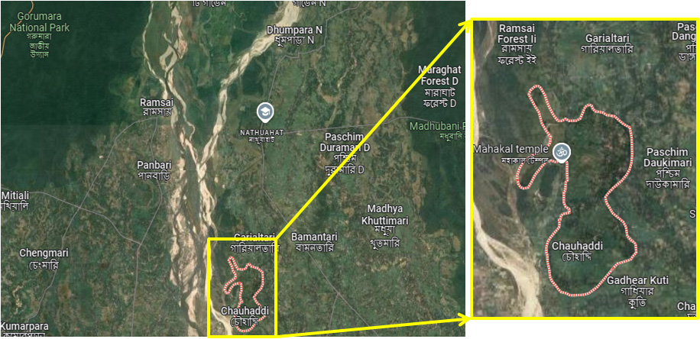
Fig1: Study area (Chauhuddi village) outlined in red line. Right panel is zoomed image of the Chauhuddi Village.(Source: Google maps)
2.2 Data collection and field visits

Regular field visits were conducted in the study area throughout the study period to gather information regarding HEC in the area. We obtained verbal approval from the local community heads/ village headmen for conducting the study. Field survey was usually done on the next day of the elephant raids after getting information from the local villagers. The portion of crop field trampled by elephants or the portion from where crop was eaten by elephants or both was considered as damaged area. Only the damaged area of the crop field was roughly measured using a tape. In some instances few villagers acted as volunteers to provide the information regarding the area of the damaged crop field when we could not visit. Primary data were also collected through Household survey and Key Informant Interviews and sample size were determined following Subedi et al. (Subedi et al. 2020). Household Survey was conducted using semi-structured questionnaires. 64 households (more than 10% of the total households), the affected farmers or their family member, witnesses of Elephant raids, conflict victim and few key informants were included in the survey. A person was interviewed only after his/her verbal consent. Information regarding the area of damaged crop field, property and stored grain damage were also collected from the form submitted by the villagers for compensation.

2.3 Data Analysis and Statistics

The data was analyzed through descriptive statistics represented through graphs and figures. Student’s t test was performed as unpaired, two tailed set of arrays to evaluate the significance of difference between the times of elephant raids. The results are presented as p values, where p < 0.01 was considered statistically significant. Chi squre test was performed to analyze if there is any crop preference for the elephants for raiding. The graphs and statistical analysis were done using MS-Excel and SPSS 9.0 for windows.

3. RESULTS:
3.1 Number and time of raids by elephants
The instances of elephant raids in the study site were documented over the entire 14 months of study period. Result reveals that there were a total of 161 cases of elephant raids in the area. The mean number of elephant raids was 11.4 per month during the study time. The month wise instances have been presented graphically in Fig.2. Our data revealed maximum cases of elephant raids on February 2025 and a minimum number of cases in April 2024. We also documented a visual increase in the number of raids from September 2024 to February 2025 (Fig.2).
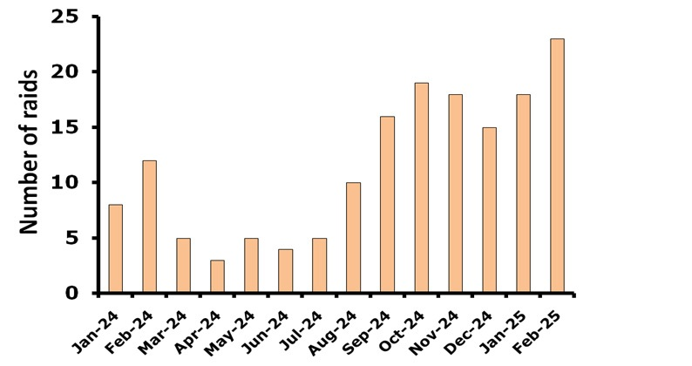
Fig 2: Graphical representation of number of elephant raids, monthly from January 2024 to February 2025 in the study site.
We also investigated the time at which the elephants raid the human habitat. All the incidents were found to occur between 6PM to 6 AM. Within this span of time, maximum (42%) raids occurred between 12AM to 3AM whereas only 5% cases occurred between 6PM to 9PM (Table 1 & Fig. 3A). Similarly, when the time of raid was compared with respect to mean percentage of elephant raids monthly, it was also found that maximum raids occurred between 12 AM to 3 AM. Result revealed significantly less percentage of raids between 6 PM to 9 PM and 3AM to 6 AM compared to percentage of raids between 12 AM to 3 AM. Interestingly, there was no significant difference in the percentage of raids between 12 AM to 3 AM and 9 PM to 12 AM (Fig. 3B). Therefore, the result indicates that the maximum elephant raids in the study area occurred during 9 PM to 3AM.
Table. 1: Total number of elephant raids at different time intervals between January 2024 and February 2025
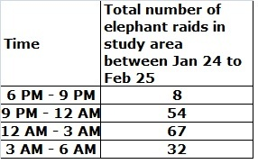
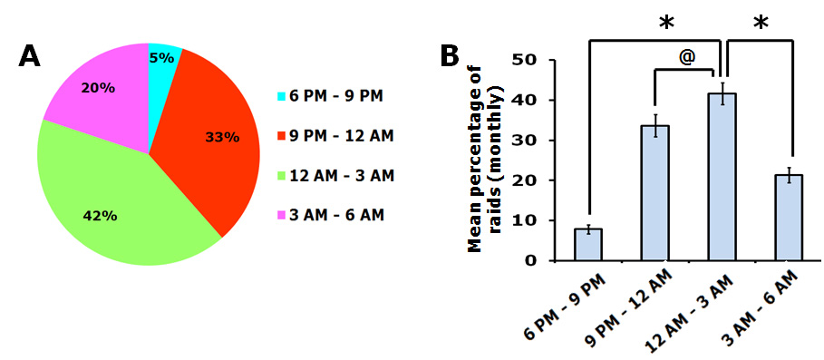
Fig. 3: A. Graphical representation of percentage of total number of elephant raids between 6 PM to 9 PM, 9 PM to 12 AM, 12 AM to 3AM and 3AM to 6AM during the study period. B. Graphical representation of mean percentage of elephant raids (monhly) at different times between January 2024 and February 2025. Data represented as mean ± SEM. Ascetics indicates statistically significant difference between the indicated class (*p<0.01). @ indicates absence of any significant difference between the indicated classes.

3.2 Amount of crop field damaged
The elephant raids in the study area resulted in massive damage of crop in fields. The different crops and area of cultivated field that were damaged were documented in the present study. Result shows that fields of 17 different types of crops were damaged. The crops were Potato, Paddy, Cabbage, Cucumber, Tomato, Pointed gourd, Radish, Eggplant, Cauliflower, Garlic, Beans, Mustard, Jute, Lady finger, Gourd, Banana and onion. It was documented that the maximum damaged area was that of the Paddy field which was 28% of the total area of the damaged agricultural field, followed by cabbage and potato fields (Fig.4). The least affected crop field in the study area was Banana and onion.

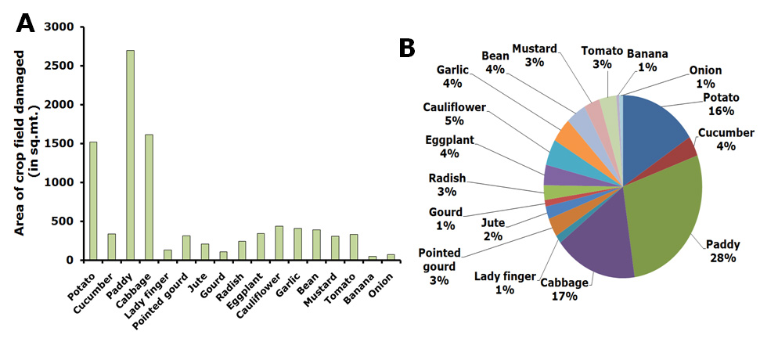
Fig 4:A. Graphical representation ofthe area of cropfields damaged (17 different crops are shown). B. Graphical representation of the percentage of different types of crops damaged in field in the study area.

Next we investigated the month wise damage of each crop in field due to the elephant raids (Table 2). Our results show that, maximum damage of paddy fields occurred during October 2024 to December 2024, potato occurred during December 2024 and January 2025 and maximum damage of cabbage occurred during October 2024 (Fig. 5A). Results also revealed that Jute and gourd fields were maximally damaged during August 2024 and September 2024 respectively (Fig. 5 B). Maximum damage of Radish and eggplant occurred in October 2024 and that of cauliflower occurred in November 2024. Tomato fields and pointed gourd fields were maximally affected during February 2024 and January 2025 respectively (Fig. 5C).
Chi square test was performed to check if there is any association between the number of raids by elephants and the type of crop. Under df=16, for a significance level of 0.01 the critical value is 32.00. Our calculated chi square value was 86.57, which is much more than the critical value. This implies that the number of raids were not independent of the type of crop or in other words,
the elephants shows preference to specific crop for raids.

Table.2: Estimates of area of crop field damaged month wise (in Sq. mt.)
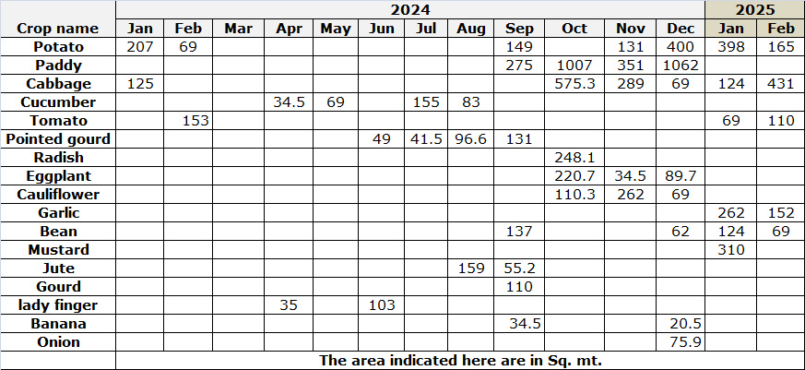
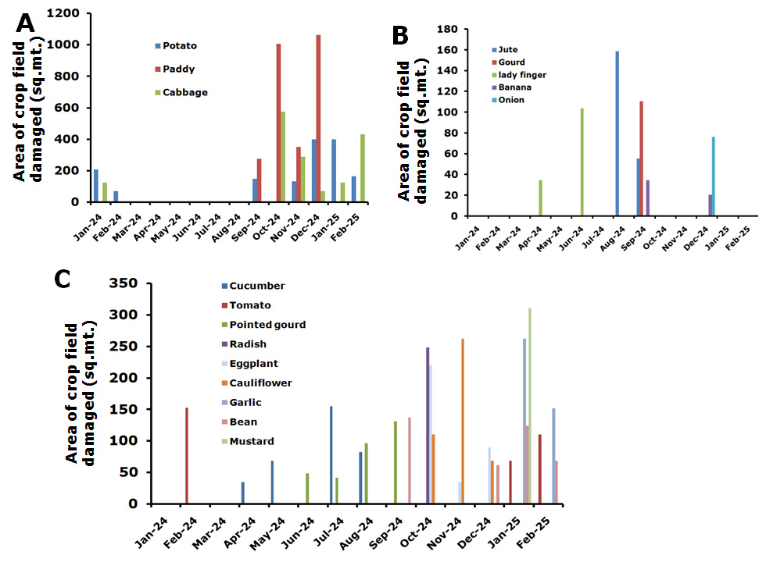
Fig 5:Graphical representation of area of crop field damaged month wise by the elephants from January 2024 to February 2025. A. Graphical representation of potato, paddy and cabbage fields damaged month wise. B. Graphical representation of Jute, gourd, lady finger, banana and onion fields damaged month wise. C. Graphical representation of Cucumber, Tomato, Pointed gourd, Radish, Eggplant, Cauliflower, Garlic, Beans and mustard fields damaged month wise.

3.3 Instances of house damage and damage of stored grains
Apart from the crop field damage, the elephants also cause house damage and damage of the store food grains whenever they enter human habitat. In the study area a large number of instances of house damage and damage of stored food grain was documented (Fig. 6). A total of 63 cases of house damage and 46 cases of damage of stored food grain was documented in the study area within the 14 month of study time. Maximum instances were documented between September 2024 and January 2025.

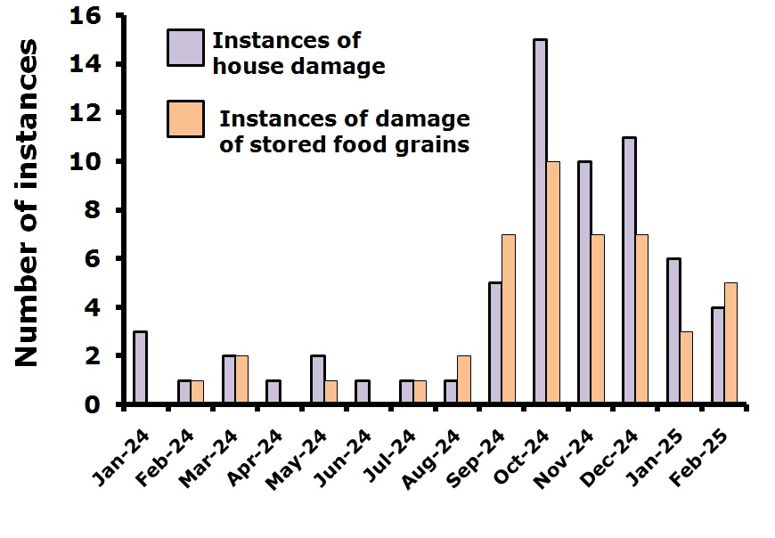
Fig 6: Graphical representation of the number of instances of house damage and instances of damage of stored grains in the study area by the elephants during the study period.

4. DISCUSSION:
As per the government records the total number of human deaths due to HEC in India is within 390-420 during 2013-2016 (Ministry of Environment, Forest and Climate Change, Elephant Menace Report, 2017). Of the entire elephant population in the country North Bengal houses about 1.8% of the elephants. However this small percentage of elephant population is responsible for about 12% of human casualties of the entire country resulting from HEC (Naha et al., 2019), implying the magnitude of problem. Reports also suggests that elephants come in this area from neighboring states like Assam resulting in seasonal usage of this area (Sukumar et al., 2003).This place also has a high human population (about 500-700 per sq Km) as per census2011. This results in frequent HEC in his area.

Studies have reported an increase of about 44% of area under human settlement and a slight increment of forest area between 2008 to 2018.Establishment of Teesta barrage in 1980 near Siliguri has disrupted the traditional migratory routes of elephant from east to west causing habitat fragmentation (Sukumar, 1989).

The present study focuses on the HEC in a particular area of North Bengal, West Bengal, India. Result revealed massive loss of crops in field due to elephant raids (Fig. 4 A). A study from Africa had reported that the elephants cause damage in same area every year indicating a spatial pattern and repetitive behavior (Naughton-Treves , 1998). Thus the areas raid by elephant this year is likely to be raid every year with a higher frequency. Clustering of crop damage location indicates the long term memory of elephants (Sitati et al., 2003).This may be a reason why we found an increased number of raids in our study area in January and February 2025 compared to January and February 2024.
Previous reports suggests that in spite of availability of resources in protected areas, the elephant, during the crop harvesting season raids the adjacent areas for the accessibility of abundant food (Stewart-Cox &Ritthirat, 2007). This study also found that most of the raids were done during the harvesting time of the respective crops.

Reports suggest that majority of elephant raids occur after dark in night (Naha et al., 2019). Telemetry data also indicates that elephants are nocturnal here (Sukumar et. al., 2003). These reports corroborate well with the present finding where we have found that most of the elephant raids occurred after evening and maximum during night. In previous reports (Mukherjee, 2016) as well as in the present study, the local peoples have informed that the elephants regularly damage households to seek stored grains including locally brewed alcohol .

It is important to note that the protected areas in this region are about 10-20 Sq Km, whereas report indicates that a herd of elephant need habitat patch of 250-300 sq km for sustenance (Desai & Riddle, 2015).
One possible way to address this is the proper maintenance of the wildlife corridors for the free movement of animals. Anthropogenic activities in this areas needs to be controlled, specially construction of walls, railway tracts and roads.

It was found in this study that most of the crops grown in the study area and subjected to elephant raids are palatable crops. Growing comparatively unpalatable crops like ginger, chillies etc could be a short term measure to control elephant raids on crop field.

Elephants prefer to live in large areas and confining them in small fragmented forested area will only intensify the problem resulting in more human elephant conflict and damage of crop and property.

Traditional methods such as using noise, lights, building physical barriers like fences and elephant-proof trenches and cultivating crops that are not preferred by elephants near forest boundaries can offer short-term relief from HEC. However, for sustainable and long-term management, it is important to focus on maintaining and protecting wildlife/ elephant corridors, restoring elephant habitats and planting food sources preferred by elephants inside the protected areas. Active participation and awareness among local communities are also essential. Efforts to mitigate HEC should be a collaborative initiative involving the Government, non-governmental organizations and local residents.

CONCLUSION
The conservation initiatives have resulted in an increase in the wildlife population in protected areas of north Bengal (Chakraborty 2015; Mukherjee et al. 2019)). Simultaneously the increase in human population and increase of land use around the protected areas are resulting in frequent human wildlife conflict including HEC. Even though most of the reports highlight the losses of the wildlife, the damage and losses suffered by the humans also needs to be addressed. Massive damage of property and crop resulting from HEC in Chauhuddi area of North Bengal were observed. Such incidents will increase the chances of retaliatory effects among locals, which may pose challenge to conserve wildlife in nature. Initiatives such use of light and noise, construction of physical barriers, maintenance of wildlife/elephant corridors, habitat restoration could mitigate such conflicts.

DISCLAIMER (ARTIFICIAL INTELLIGENCE)

Author(s) hereby declaresthat NO generative AI technologies such as Large Language Models (ChatGPT, COPILOT, etc) and text-to-image generators have been used during writing or editing of this manuscript.

Author’s contributions
This work was carried out in collaboration between both authors. Both authors read and approved the final manuscript

REFERENCE

All India Synchronized Elephant Population Estimation. (2017). Ministry of Environment, Forest and Climate Change, Report. 2017.

Bharti, S., Kumar, G., Kapoor, G. (2025). Navigating Human-wildlife Conflict: Key Species, Impacts, Mitigation and Challenges in Himachal Pradesh, India. Asian Journal of Research in Zoology, 8(1), 33-49.

Bist. S.S.(2002). An Overview of Elephant Conservation in India. Indian Forester. 128.

Braczkowski, A.R., O’Bryan, C.J., Lessmann, C., Rondinini, C., Crysell, A.P., Gilbert, S., Stringer, M., Gibson, L., & Biggs, D. (2023). The unequal burden of human-wildlife conflict. Communication Biology, 6, 182.

Chakraborty, S. (2015). Human Animal Conflicts in Northern West Bengal: Losses on both sides. International Journal of pure and applied Bioscience, 3(3), 35-44.
Chowdhury, S., Khalid, M.A., Roy, M., Singh, A.K., & Singh, R.R.(1998). Management of elephant populations in West Bengal for mitigating man-elephant conflicts. Wildlife Institute of India, Dehradun, India, Report.

Desai, A.A., & Riddle, H.S. (2015). Human-Elephant Conflicts in Asia, US Fish and Wildlife Service, Asian Elephant Support, Report.

Deshmukh, S. N., & Jaybhaye, R.G.(2024). Assessment of Human-wildlife Conflict: A Case Study from Kothale Village in the Kalsubai-Harishchandragad Wildlife Sanctuary (KHWS), Maharashtra, India. Asian Journal of Environment & Ecology, 23(12), 187–198.

Gandiwa, E., Heitkönig, I. M., Lokhorst, A. M., Prins, H. H., & Leeuwis, C. (2013). CAMPFIRE and human-wildlife conflicts in local communities bordering northern Gonarezhou National Park, Zimbabwe. Ecology and Society, 18(4).

Jenks, K.E., Songsasen, N., Kanchanasaka, B., Bhumpakphan, N., Wanghongsa, S., &Leimgruber, P. (2013). Community attitudes toward protectedareas in Thailand. Natural History Bulletin of the Siam Society, 59(2), 65-76.

Kamdar, A., Baishya, H.K., Nagendra, H., Ratnam, J., Smith, D., & Sekar, N. (2022). Human–elephant conflict mitigation as a public good: what determines fence maintenance? Ecology and Society, 27(3),24

Lenin, J., & Sukumar, R. (2011). Action Plan for the mitigation of human-elephant conflict in India. Asian Nature Conservation Foundation, Report.

Elephant Menace Report. (2017). Ministry of Environment.Forest and Climate Change.

Mc Guinness, S., & Taylor, D. (2014). Farmers’ perceptions and actions to decrease crop raiding by forest-dwelling primates around a Rwandan forest fragment. Human Dimensions of Wildlife, 19(2), 179-190.

Monney, K. A., Dakwa, K. B., & Wiafe, E. D. (2010). Assessment of crop raiding situation by elephants (Loxodonta africana cyclotis) in farms around Kakum conservation area, Ghana. International Journal of Biodiversity and Conservation, 2(9), 243-249.

Mukherjee, N. (2016). A Brief Appraisal of Human Wildlife Conflict in Jalpaiguri andAlipurduar Districts of West Bengal. International Journal of Scientific and Research
Publications, 6(8), 131–136.

Mukherjee, T., Sharma, L.K., Thakur, M., Saha, G.K., Chandra, K. (2019). Changing landscape configuration demands ecological planning: Retrospect and prospect for megaherbivores of North Bengal. Plos One,14(12), e0225398.

Naha, D., Sathyakumar, S., Dash, S., Chettri, A., &Rawat, G.S. (2019). Assessment and prediction of spatial patterns of human-elephant conflicts in changing land cover scenarios of a humandominated landscape in North Bengal. PLoS One, 14(2), e0210580

Naughton-Treves L. (1998). Predicting patterns of crop damage by wildlife around Kibale National Park, Uganda. Conservation Biology, 12.

Paudel, P., Rai, M., Gurung, S., & Raut N.(2024) Status of Human-Wildlife Conflict and mitigation measures adopted bylocals in ShivapuriNagarjun National Park, Kathmandu Nepal. Nepal Journal of Environment Science, 12(2), 47-58.

Rathnayake, C.W., Jones, S., Soto-Berelov, M., & Wallace, L. (2022) Human–elephant conflict and land cover change in Sri Lanka. Applied geography. (143), 102685.
Sitati, N.W., Walpole, M.J., Smith, R.J., & Williams, L. N. (2003). Predicting spatial aspects of human-elephant conflict. Journal of Applied Ecology,40.

Stewart-Cox, B., & Ritthirat, J. (Eds.) (2007). Mitigating human-elephant conflict in Asia: a new initiative in Thailand. In: Walpole M and Linkie M Mitigating Human Elephant Conflict: Case Studies from Africa and Asia. Fauna and Flora International, Cambridge, UK.

Subedi, P., Joshi, R., Poudel, B., & Lamichhane, S. (2020). Status of Human-Wildlife conflict and Assessment of Crop Damage by Wild Animals in Buffer Zone Area of Banke National Park, Nepal. Asian Journal of Conservation Biology, 9(2), 196-206

Sukumar, R. (1989). The Asian Elephant: ecology and management. Oxford University Press, Cambridge, UK.

Sukumar, R., Venkataraman, A., Cheeran, J.V., & Mujumdar, P.P. (2003). Study of elephants in Buxa Tiger Reserve and adjoining areas in northern West Bengal and preparation of conservation action plan. Centre for Ecological Sciences, Indian Institute of Science, Bangalore.
Woodroffe, R., Thirgood, S., & Rabinowitz, A. (Eds.).(2005). People and wildlife, conflict or co-existence? (Vol.9). Cambridge University Press.

