Review Article
Advances and Limitation of Yellow Sticky Traps in Integrated Pest Management

Abstract
Yellow Sticky Traps (YSTs) serve as essential instruments in integrated pest management (IPM) strategies, effectively aiding in the monitoring and control of flying insect pests within agricultural and greenhouse environments. These traps take advantage of the powerful visual appeal that numerous insects possess for the color yellow, which mimics floral cues and reflects light at wavelengths that are particularly noticeable to insect photo-receptors. YSTs play a crucial role in spotting early infestations, pinpointing pest hotspots, and evaluating the relative abundance and movement of pests like whiteflies, thrips, aphids, and leaf miners. The incorporation of pheromones, kairomones, and UV-reflective coatings has significantly boosted their effectiveness. While YSTs offer affordability, environmental benefits, and user-friendliness, they also have drawbacks, such as the potential to capture non-target species and their restriction to the flying stages of pests. The implementation of high trap densities for mass trapping has proven effective in diminishing pest populations in controlled environments. Their involvement in decision-making and sustainable pest management is continually progressing alongside innovations in lure technology and trap design. This paper emphasizes the evolving significance of YSTs as both monitoring and management tools in sustainable pest control systems. However, challenges such as trap saturation, species misidentification, limited integration with automated technologies, and environmental sensitivity remain areas for further research and innovation.

Keywords: Agriculture, Integrated Pest Management, pest monitoring, visual attraction, sustainable pest management.

Introduction
Insect traps serve the purpose of monitoring or managing insect populations through the capture and elimination of individual insects. Typically, they employ food, pheromones, chemical attractants, and visual lures as bait. They are positioned in a way that ensures safety for both people and animals, while also preventing any residues from contaminating food or feed. Sticky traps are designed as enclosed structures or straightforward flat panels that ensnare insects using a sticky adhesive material. They often find themselves lured into traps. Pests can inadvertently find their way into traps that do not contain bait while they are exploring or wandering, which is why these traps are also called as "blunder" traps. Sticky traps are most
commonly employed in the surveillance of pests, both indoors and in agricultural settings. These traps serve as effective measures to deter various insect pests from exploiting this behavior. Using colored traps serves as a perfect example of this approach. For many years, scientists have examined yellow sticky traps (YSTs), which play a role in pest management strategies for numerous crops, such as whiteflies, thrips and fungus gnats. They have become a crucial component of integrated pest management strategies for various greenhouse pests (Steiner et al., 1999; Park et al., 2011).
Adult whiteflies, including those found in greenhouses, such as Trialeurodes vaporariorum (Westwood) and Bemisia tabaci (Gennadius), can be detected early, hotspots can be identified, relative abundance can be estimated, and dispersal activity can be tracked using YSTs (Gillespie and Quiring, 1992; Heinz et al., 1992; Naranjo et al., 1995). Additionally, YSTs can reduce adult populations on their own or in conjunction with other control methods as trap crops (Moreau, 2010; Moreau and Isman, 2011) or biological control (Yano, 1987; Gu et al., 2008). A straightforward technique for determining the relative sizes of insect populations is to use sticky traps. Because sticky traps are used to gather and fix insects inside the trap area, they are also more effective than extensive unit area sampling at detecting early pest infestations (Southwood, 1978). Despite these seeming benefits of employing sticky traps, greenhouse pest management methods are typically implemented with minimal consideration for the pest population levels at the time of application. To optimize the effectiveness of control measures and reduce their impact on non-target species, precise and timely techniques for assessing the numbers of pest and beneficial arthropods are required.

Early use of yellow sticky traps
Sticky traps have been used in a variety of ways to capture insects for periods. The idea goes back to neolithic times, when humans employed natural bonds like tree resins and seamen to capture bugs. Beforehand societies, similar as the Egyptians and Greeks, employed sticky composites to cover crops against pest infestation. In the nineteenth century, growers and scientists experimented with several sticky composites to manage agrarian nonentity pests. Originally, these traps were created using natural cements and attached directly to trees or other shells. In the 1920s and 1930s, experimenters created more complex sticky traps with petroleum- grounded bonds. The use of colors to attract insects was delved, and it was discovered that particular tinges were more effective in soliciting specific insect species. The marketable manufacture of yellow sticky traps began in the 1960s and 1970s. They were generally used in glasshouses, vineyards, and open- field husbandry to cover and control nonentity populations without counting too much on insecticides. While the early use of sticky substances relied heavily on natural materials, these primitive traps had laid the foundation for more systematic approaches to pest control. The shift from traditional methods to modern pest surveillance marked a turning point in agricultural entomology. With increasing awareness of the environmental and health impacts of synthetic pesticides during the mid-20th century, there was a growing demand for safer, non-chemical alternatives. This led to the refinement of sticky trap design, the standardization of color-based attraction principles, and the incorporation of traps into scientifically driven Integrated Pest Management (IPM) programs. As agricultural systems became more complex, so too did the role of sticky traps—from rudimentary pest deterrents to essential tools in pest monitoring, forecasting, and control. From the 1980s to the present, advancements in tenacious compositions have made traps more robust and rainfall- resistant. The use of yellow sticky traps in IPM systems has come a global standard (Kogan, 1998). A century agone, Lloyd (1921) reported that the greenhouse whiteflies, Trialeurodes vaporariorum, prefer yellow coloured traps that are opaque. Yellow sticky traps employed for monitoring, decision timber, and mass prisoner of flying agrarian pests as part of IPM ( Böckmann et al., 2015; Samson and Kirk, 2013). Also, the attraction of insects to yellow sticky traps is not merely a result of general phototaxis, but, it is deeply rooted in insect visual ecology, particularly the sensitivity of specific opsin-based photoreceptors such as long-wavelength-sensitive (LWS) opsins which enable many pests, including whiteflies and aphids, to detect wavelengths of yellow colour (around 550–600 nm) with high precision.

Current uses and innovations
YSTs are presently used in Agriculture to cover and control pests in crops similar as tomatoes, cucumbers, and citrus), Greenhouses (to descry early infestations), Urban Pest Control (to manage houseflies and fungus gnats), and scientific exploration (to study insect geste and population dynamics). Pheromones, UV-reflective coatings, and biodegradable accoutrements have all been employed in ultramodern traps to increase effectiveness and sustainability. YSTs are effective because many flying insects are visually attracted to the color yellow due to their light-seeking behaviour and sensitivity to specific wavelengths.

The attraction of colour
Nonentity pests use colours to detect host plants (Prokopy & Owens, 1983). yellow colour sticky traps, which have a high reflectance in the long- surge area from green to red (about 500- 640 nm) and a low reflectance in the short- surge region from UV to blue (about 300- 500 nm), are especially appealing to splint- feeding insects including aphids, canvases , thrips, and whiteflies. Insects that visit flowers or fruit are generally drawn to the color of their host (Kirk, 1984). For instance, Drosophila suzukii, deposits its eggs in berry fruit and gets attracted to red (Kirkpatrick et al., 2017).
The western flower thrips (WFT), Frankliniella occidentalis, frequently prefers blue traps (440- 460nm) in greenhouse grown crops. The applicable trap color can be determined by the enmeshing purpose (Sampson et al., 2021). nevertheless, recent exploration has shown that nonentity vulnerability to different wavelengths and degrees of reflectance appears to vary depending on nonentity species and coitus (Domingue et al., 2016; Van der Kooi et al., 2021). Shi et al., in 2020 revealed that manly individualities in the Cicadellidae family are more attracted to yellow sticky traps than females. Another study penned by Goretti et al., in 2011 set up that female chironomids are more attracted to white light than males. Other trap characteristics that might impact trap catch include background, edge length, form, position, and face texture (Vernon and Gillespie, 1995). Relative attraction can be told by ambient light conditions or boosted by LEDs. The optimum trap colour will be determined by the function of the trap and yellow sticky traps are an excellent choice for covering a variety of pest species from a single trap.
Other trap hues, such as blue for thrips and capsids or red for SWD, are more suited when a grower is looking for traps that will catch a specific species. Sometimes less appealing trap colours are chosen to reduce the number of non-target insects caught, such as predators and pollinators. Black sticky traps (Russell IPM) are used with a species-specific scent to catch the marmorated stink bug, Halyomorpha halys. This ensures that just the intended pests are captured, making them easier to identify and count. Sticky traps are available in a variety of adhesive kinds, which impacts the species collected.
The strongest adhesive comes with a peel- off silicon paper which is essential to catch bigger species like marmorated stink bug. Traps with clinging 'wet' adhesive are also available, which keep excellent catch rates for minor pest species like whiteflies while enabling bigger species to escape. These help the by- catch of bigger bloodsuckers and pollinators, like lacewings and sundries. likewise, yellow sticky traps are generally used for wharf coleopteran, hemipteran, and hymenopteran insects because utmost insects are more visible against a yellow colour background than against darker trap colors (Kelber et al., 2003; Idris et al., 2012; Carrillo- Arámbula et al., 2022).

Reliability of yellow sticky traps
Binns et al., (2000) on whitefly management said reliability assumes that the results are not impactes by the person collecting the data, or by exogenous, uncontrolled variables such as weather or possible diurnal behaviour of the pest. Because YSTs rely on the characteristic responses of whiteflies, many physiological behaviours, environmental conditions as well as intra- and interspecific biotic interactions occurring in the greenhouse that can affect the number of whiteflies trapped. In addition, characteristics of the trap and its placement in the greenhouse, or misuse can influence trap catches (Webb et al., 1985; Gillespie and Quiring, 1992). Some of these factors can be manipulated for enhancing the capture efficiency of the traps. Others, however, are subjected to the ecology and management of the crop, and thus, they either cannot be manipulated, or only to a limited extent. Despite, the degree of influence of such factors on the pest’s tendency of getting trapped can be studied and taken into account when interpreting trap catches. Some factors must be taken as such, without the possibility of manipulating them, as it is difficult to calculate how they affect pest behaviour at a given time, or their practical importance is small or masked by the influence of other, more important factors.

Enhancing trap efficiency
Hartstack et al., (1971) said that trap efficiency is defined as the percentage of insects caught with respect to those insects entering the effective radius of the trap; effective radius, in turn, is the maximum distance from which a trap attracts insects. The characteristics of the trap such as size, shape and colour, can be adjusted, but may be, in practice, restricted to those YSTs already available in the market. Park et al., (2011) suggested small-sized traps should be used whenever possible so as to reduce the time allocated for the insect counts as long as there is a good correlation between trap and direct counts. Semiochemicals such as pheromones, kairomones, and their counterparts, which are utilized to seek partners and plant hosts, influence insect behaviour. These can be used in sticky traps to boost trap capture. The fragrances can be applied as separate lures or encapsulated for prolonged release and mixed into the glue in the sticky traps. In greenhouse strawberry experiments, adding the aggregation pheromone, neryl (S)-methyl butanoate, the kairomone analogue, methyl isonicotinate and a mixture of floral scents (Thripnok, Russell IPM) to yellow sticky traps increased trap efficiency by 50-300% (Sampson et al, 2021). The best possible attractant will be determined by the crop and insect species present. For instance, kairomones and their equivalents attract a variety of flower-inhabiting thrips species, unlike the western flower thrips aggregation pheromone, which is very unique to WFT as conducted by Sampson et al in 2021. Their research also showed that a variety of lures are offered for different pest species. Addition of fruit volatile lure (SWD lure, Russell IPM) to red sticky traps boosted trap capture of SWD by 46 times making the trap-lure combination a useful and sensitive monitoring tool in raspberry cultivation (Sampson et al, 2021). Other attractants, such as 3-Hexen-1-ol, and Linalool, have been found to attract the glasshouse whitefly. However, few have been found effective in the field (Schlaeger et al., 2018). Several commercially available thrips attractants have been found to be effective against WFT (Kirk et al., 2021). Also the assessment of odour- enhanced traps are needed to be included for the response of natural enemies such as Encarsia formosa since several predators and parasitoids strongly rely on odour cues.

Monitoring and decision making
Recognizing when a crop is vulnerable and identifying the pest populations responsible for damage is essential for assessing the need for intervention; therefore, the initial step toward enhanced management is to initiate monitoring. Growers want a consistent baseline to evaluate daily and annual fluctuations in pest and beneficial insect populations, rather than relying on traps with the highest captures. Yellow traps are predominantly utilized due to their ability to attract a variety of animals. It is advantageous since most insects are more discernible against a yellow background than against darker trap colors. Sticky traps are often positioned vertically just above the crop canopy at a density of around one trap per 200 m². They should be incrementally elevated as the crop develops to preserve a consistent height over the plants. The trap capture of whiteflies, for instance, and their parasitoid, Encarsia formosa, demonstrated a strong correlation with corresponding populations in tomato crops within 170 m² plots as studied by Böckmann et al., in 2015. To monitor pests such as fungus gnats (Bradysia spp.), traps to be positioned horizontally next to the growing medium. Adults emerge from the substrate and have limited flight capabilities, resulting in reduced abundance in the upper regions of tall vegetation.
Case study
A study conducted by Lu et al., in 2012 in assessing YSTs as effective methods in controlling sweet potato whitefly Bemisia tabaci either in the greenhouse or field. The study showed that YSTs had very different impacts on the dynamics of adult whiteflies in greenhouse and field (Figure 1A, Figure 2A, Figure 3A) as well as had very different impacts on the dynmaics of immature whiteflies (Fighure 1B, Figure 2B, Figure 3B). The results showed that in the greenhouse, YSTs significantly reduced the increase of adult as well as the immature whitefly densities (Figure 1A1, Figure 2A1, Figure 3A1, Figure 1B1, Figure 2B1 and Figure 3B1). In the field, yellow sticky traps did not have obvious impact on adult dynamics (Figures 1A2, 2A2, 3A2). The dynamics of whitefly adults in control fields and fields with traps were very similar. In the field the impact of yellow sticky traps on immature whitefly dynamics was not obvious (Figures 1B2, 2B2, 3B2). Their study showed that YSTs can significantly suppress the population increase of adult and immature whiteflies in the greenhouse. But in the field, traps could not significantly prevent the increase of a whitefly population. They also stated the reasons that explains why YSTs in greenhouses effectively reduced the population of whiteflies. The primary reason was that as YSTs can capture a greater number of adult whiteflies and reduced the adults on host plants, few number of eggs were laid on host plant leaves and few larvae could be seen on the leaves. Next, the grenhouse in which they conducted the experiment was covered with plastic film and nylon mesh, which reduced the migration of adult whiteflies between other greenhouses, and between greenhouse and field. They also stated the factors that led to the failure of YSTs to control whitefly populations. One of the failure factor was that although the traps captured many whitefly adults and reduced the number of adults on host plants in field, many adults from nearby fields could have entered the experimental fields and got trapped. As a result, some adults were trapped by YSTs in the experimental field while others landed on the plants within the experiemental fields.

Fig 1 :

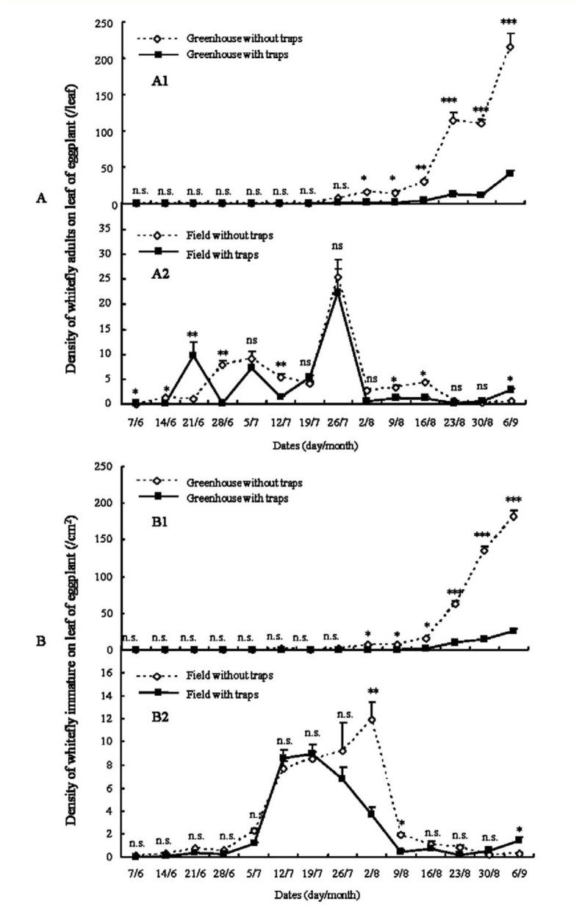
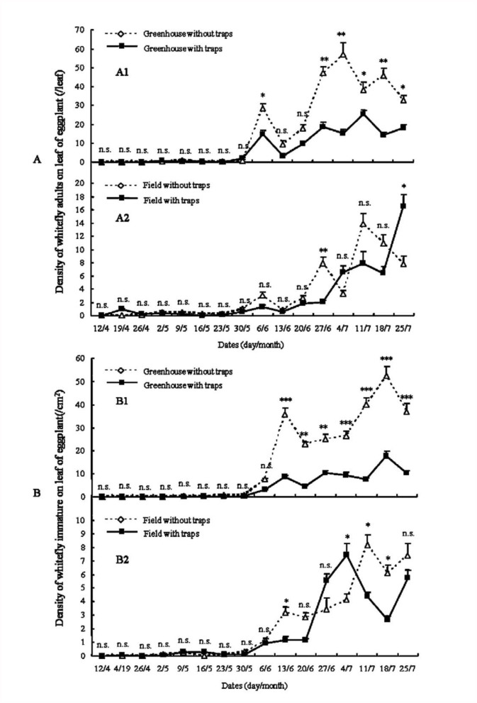

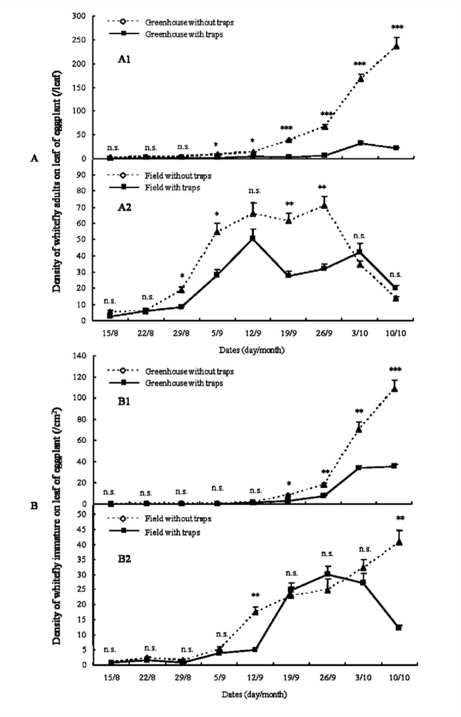
Source: Lu, Y., Bei, Y., & Zhang, J. (2012). Are yellow sticky traps an effective method for control of sweetpotato whitefly, Bemisia tabaci, in the greenhouse or field?. Journal of insect science, 12(1), 113.

Mass trapping of insect pests
The number of pests trapped will be proportional to the trap's area. When the density of sticky traps per area increases, they capture enough pests to lower the insect population in the crop. The number of traps necessary will vary according to the bug type and crop. Yellow sticky traps can only attract whiteflies from a short distance of 50 cm². Growers typically employ one trap per 2 m² in pest hotspots to minimize whitefly populations. In glasshouse aubergines, Lu et al., (2012) reported a considerable decline of the silver leaf whitefly, Bemisia tabaci, using one trap per 5m² although this trap density did not provide control in outdoor crops where pest pressure was higher. Yellow roller traps are used to minimize the amount of adult whiteflies in protected crops. Despite the usage of sticky traps to collect dangerous pest bug species, non-targeted insects such as pollinators and predators have been neglected. Mass trapping of beneficial or non-targeted insects using sticky traps might have detrimental consequences, such as reducing their numbers and increasing pest populations (Mondor, 1995).
Challenges faced by the use of yellow sticky traps

Trap Saturation:
- Reduced Capture Efficiency: Once saturated, additional insects are less likely to stick, leading to underestimation of pest populations.
- Frequent Maintenance Required: Traps must be replaced or cleaned regularly. This increases labor costs and reducing convenience in large-scale operations.
- Visual Obstruction: Identification and counting of individual species becomes difficult when insects overlap each other.
- Selective Bias: Highly attractive species may dominate the trap surface, which restricts the presence of less abundant but potentially important pests.

2. Integration with Remote Sensing and Automated Monitoring:
- Lack of Standardization: Current YSTs are not universally designed for compatibility with automated systems or sensors.
- Image Analysis Complexity: Insect overlap, shadows, and varying trap backgrounds will complicate the AI-based insect recognition.
- Connectivity Issues: Remote farms or greenhouses might lack stable internet or network access for real-time data transmission.
- Cost Constraints: Advanced monitoring systems can be expensive,which limits their adoption by small or resource-limited farmers.
- Power Requirements: Many monitoring devices need constant power supply, making them less practical for field conditions without solar or long-life battery solutions.
- Data Overload and Interpretation: High-frequency data collection can result in large datasets which requires proper analysis tools and trained personnel.

3. Additional Emerging Challenges:
i. Environmental Factors: Rain, wind, and dust can reduce the stickiness of traps or affect sensor reliability.
ii. Non-target Insects: Beneficial insects might also get trapped, reducing ecosystem services like pollination and natural pest control.
iii. Need for Calibration: Automated systems need frequent calibration to ensure accuracy across different light conditions and insect types.
iv. Legal and Privacy Concerns: Use of camera-equipped drones or sensors in agricultural fields might raise concerns related to privacy and data ownership.

Conclusion
Yellow Sticky Traps (YSTs) have emerged as one of the most practical and versatile tools in the management of insect pests, particularly in greenhouse and field crop systems. Their widespread adoption stems from their simplicity, cost- effectiveness, and eco-friendly nature. By capitalizing on the natural visual preferences of many pest species, particularly their attraction to the color yellow, YSTs allow for efficient monitoring of pest populations such as whiteflies, thrips, and aphids. These traps provide essential data on pest abundance, distribution, and activity, thereby supporting timely and informed decisions regarding pest control interventions. However, despite their many advantages, YSTs are not without limitations. Their non- selective nature can lead to the capture of beneficial insects such as pollinators and natural enemies, which may disrupt ecological balance in cropping systems. In conclusion, while Yellow Sticky Traps alone may not provide complete control in the face of severe infestations, they are an essential component of IPM strategies. Their use contributes to sustainable agriculture by reducing reliance on chemical pesticides and supporting early pest detection and monitoring.
Disclaimer (Artificial intelligence)
Author(s) hereby declares that NO generative AI technologies such as Large Language Models (ChatGPT, COPILOT, etc.) and text-to-image generators have been used during the writing or editing of this manuscript.

References

Binns, M. R., Nyrop, J. P., van der Werf, W., & Werf, W. (2000). Sampling and monitoring in crop protection: the theoretical basis for developing practical decision guides. Cabi.
Böckmann, E., Hommes, M., & Meyhöfer, R. (2015). Yellow traps reloaded: what is the benefit for decision making in practice?. Journal of Pest Science, 88, 439- 449.
Carrillo-Arámbula, L., Infante, F., Cavalleri, A., Gómez, J., Ortiz, J. A., Fanson, B. G., & González, F. J. (2022). Colored sticky traps for monitoring phytophagous thrips (Thysanoptera) in mango agroecosystems, and their impact on beneficial insects. Plos one, 17(11)
Domingue, M. J., Lelito, J. P., Myrick, A. J., Csóka, G., Szöcs, L., Imrei, Z., Baker,Gillespie, D. R., & Quiring, D. J. (1992). Flight behavior of the greenhouse whitefly,Trialeurodes vaporariorum (Westwood)(Homoptera: Aleyrodidae), in relation to yellow sticky traps1. The Canadian Entomologist, 124(5), 907-916.
Hartstack Jr, A. W., Hollingsworth, J. P., Ridgway, R. L., & Hunt, H. H. (1971). Determination of trap spacings required to control an insect population. Journal of Economic Entomology, 64(5), 1090-1100.
Heinz, K. M., Parrella, M. P., & Newman, J. P. (1992). Time-efficient use of yellow sticky traps in monitoring insect populations. Journal of Economic Entomology, 85(6), 2263-2269.
Idris, A. B., Khalid, S. A. N., & Roff, M. M. (2012). Effectiveness of sticky trap designs and colours in trapping alate whitefly, Bemisia tabaci (Gennadius) (Hemiptera: Aleyrodidae). Pertanika Journal of Tropical Agricultural Science, 35(1), 127-134.
Kelber, A., Vorobyev, M., & Osorio, D. (2003). Animal colour vision-behavioural tests and physiological concepts. Biological reviews of the Cambridge Philosophical Society, 78: 81–118.
Kirk, W. D., De Kogel, W. J., Koschier, E. H., & Teulon, D. A. (2021). Semiochemicals for thrips and their use in pest management. Annual Review of Entomology, 66(1), 101-119.
Kirkpatrick, D. M., McGhee, P. S., Gut, L. J., & Miller, J. R. (2017). Improving monitoring tools for spotted wing drosophila, D rosophila suzukii. Entomologia experimentalis et applicata, 164(2), 87-93.
Kogan, M. (1998). Integrated pest management: Historical perspectives and contemporary developments. Annual review of entomology, 43(1), 243-270.
Lu, Y., Bei, Y., & Zhang, J. (2012). Are yellow sticky traps an effective method for control of sweetpotato whitefly, Bemisia tabaci, in the greenhouse or field. Journal of insect science, 12(1), 113.
Moreau, T. (2010). Manipulating whitefly behaviour using plant resistance, reduced-risk sprays, trap crops and yellow sticky traps for improved control for wweet pepper greenhouse crops, Pp. 114.
British Columbia). Moreau, T. L., & Isman, M. B. (2011). Trapping whiteflies. A comparison of greenhouse whitefly (Trialeurodes vaporariorum) responses to trap crops and yellow sticky traps, Pest Management Science, 67(4):408-413.
Naranjo, S. E., & Flint, H. M. (1995). Spatial distribution of adult Bemisia tabaci (Homoptera: Aleyrodidae) in cotton and development and validation of fixed- precision sampling plans for estimating population density. Environmental Entomology, 24(2), 261-270.
Sampson, C., Turner, R., & Ali, A. (2021). Monitoring and trapping with sticky traps, what’s new? International Pest Control, 63(3): 166.
Schlaeger, S., Pickett, J. A., & Birkett, M. A. (2018). Prospects for management of whitefly using plant semiochemicals, compared with related pests. Pest management science, 74(11), 2405-2411.
Shi, L., He, H., Yang, G., Huang, H., Vasseur, L. & You. M. (2020). Are Yellow Sticky Cards and Light Traps Effective on Tea Green Leafhoppers and Their Predators in Chinese Tea Plantations? Insects,12(1):14.
Steiner, M. Y., Spohr, L. J., Barchia, I., & Goodwin, S. (1999). Rapid estimation of numbers of whiteflies (Hemiptera: Aleurodidae) and thrips (Thysanoptera: Thripidae) on sticky traps. Australian Journal of Entomology, 38(4), 367-372.
T. C. (2016). Differences in spectral selectivity between stages of visually guided mating approaches in a buprestid beetle. Journal of Experimental Biology, 219(18), 2837-2843.
Van der Kooi, C.J., Stavenga, D.G., Arikawa, K., Belušič, G. & Kelber, A. (2021). Evolution of insect color vision: from spectral sensitivity to visual ecology. Annual Review of Entomology, 66: 435-461.
Vernon, R. S., & Gillespie, D. R. (1995). Influence of trap shape, size, and background color on captures of Frankliniella occidentalls (Thysanoptera: Thripidae) in a Cucwnber Greenhouse. Journal of Economic Entomology, 88(2), 288-293.
Webb, R. E., Smith, F. F., Affeldt, H., Thimijan, R. W., Dudley, R. F., & Webb, H. F. (1985). Trapping greenhouse whitefly with coloured surfaces: variables affecting efficacy. Crop Protection, 4(3), 381-393.
yellow sticky traps. Pest management science, 67(4), 408-413.

