Chitosan-TPP Nanoparticles: A Potential Biocompatible Growth Promotor Diet in Fish Aquaculture

Abstract
This study reports the successful synthesis and characterization of chitosan-TPP nanoparticles and their evaluation as a dietary supplement for improving the growth performance of tilapia (Oreochromis niloticus). Chitin was deacetylated to chitosan using HCl and NaOH, achieving a degree of deacetylation (DD) of approximately 85%, confirmed by FTIR analysis through the disappearance of amide I (1655 cm⁻¹) and amide II (1550 cm⁻¹) peaks and the appearance of a broad O–H/NH₂ peak at ~3400 cm⁻¹. XRD analysis revealed reduced crystallinity compared to chitin, indicating the amorphous nature of chitosan, while TGA confirmed its thermal stability with a degradation temperature around 280°C.Chitosan-TPP nanoparticles were synthesized via ionic gelation using tripolyphosphate (TPP) as a cross-linking agent. FTIR spectra showed key peaks at 3199.91 cm⁻¹ (O–H and N–H stretching) and 1150–1000 cm⁻¹ (P–O stretching), confirming successful incorporation of TPP and ionic crosslinking. XRD analysis indicated a combination of crystalline and amorphous regions, with characteristic peaks at 2θ = 14.3°, 20.2°, 29.6°, and 32.0°. SEM analysis revealed nanoparticles with sizes ranging from 100–300 nm, smooth surface morphology, and some aggregation due to high surface energy. The encapsulation efficiency (EE) of the nanoparticles was ~80%, highlighting their suitability for controlled release applications.In a feeding trial, chitosan-TPP nanoparticles were incorporated into a formulated diet to assess their effects on tilapia growth. Weight-Length Ratio (WLR) analysis revealed consistent growth in the nanoparticle-treated group (WLR range: 0.34–1.36) compared to the control (WLR range: 0.44–3.43). The treated group demonstrated significantly higher weight gain (24.17 ± 12.81 g) compared to the control (14.06 ± 6.11 g) and a lower food conversion ratio (FCR: 0.097 vs. 0.161), indicating improved feed utilization efficiency. The survival rate was 100% in both groups, with feed intake values of 2.34 ± 0.19 g (treated) and 2.27 ± 0.20 g (control). These results suggest that chitosan-TPP nanoparticles significantly enhance growth performance and nutrient absorption in tilapia, offering promising applications in functional feeds for aquaculture.
Keywords: Chitosan- sodium tripolyphosphate (TPP), Characterization (FTIR, XRD, SEM), Fish Feed Formulation, Growth Analysis and Toxicology Assessment.

Introduction
Chitin, discovered in 1811, is a natural amino polysaccharide with distinct functional properties. It is found in arthropod exoskeletons, fungi cell wallsRudall and Kenchington 1973), vertebrates(Wagner et al., 1993), and microorganisms(Khoushab and Yamabhai, 2010). The molecular arrangements depend on the source, with α-chitin being the predominant form, β-chitin found in squid pens, and γ-chitin as a mixture(Synowiecki and Al-Khateeb, 2003).Chitin synthesis involves membrane-integral chitin synthase enzymes catalyzing N-acetylglucosamine monomers, using UDP-N-acetylglucosamine as a substrate, involving polymerization, translocation, and assembly into crystalline microfibrils(Merzendorfer, 2006). Chitin, found in animal cuticles and fungal cell walls, often associates with proteins for structural integrity. Chitosan, derived from chitin via deacetylation, is a semicrystalline copolymer of N-acetyl-D-glucosamine and D-glucosamine(Croisier and Jérôme, 2013; Rinaudo, 2006). Its functional properties are determined by deacetylation degree(Hudson and Jenkins, 2001; Jayakumar et al., 2010 & Venkatesan and Kim, 2010). Unlike chitin, chitosan is soluble in dilute acids and has enhanced functionality(Aranaz et al., 2009; Aschner and Aschner, 2005).Chitosan nanoparticles (CSNPs) are a versatile material with unique physicochemical properties, making them ideal for water purification, biomedical applications, and nanotechnology. Their ability to diffuse through biofilm structures and interact with microbial membranes enhances their antibacterial properties(Ing et al., 2012).Ionic gelation is a popular method for synthesizing CSNPs due to its simplicity, cost-effectiveness, and eco-friendliness(Fan et al., 2012; Ma et al., 2017). It involves spontaneous reaction between chitosan and sodium tripolyphosphate, resulting in a gel-like nanoparticle with enhanced bioavailability(Mazancová et al., 2018).TPP/Chit nanoparticles exhibit superior antifungal activity against Candida albicans due to their effective membrane penetration(Ing et al., 2012; Gondim et al., 2018), promising applications in pharmaceutical, agricultural, and environmental sectors, including oral drug delivery(Li et al., 2008), protein formulationsXu and Du, 2003), and gene therapy(Csaba et al., 2009).
Aquaculture is a crucial sector for global nutrition and poverty reduction(Kaleem and Sabi, 2021), outpacing capture fisheries(Ahmed et al., 2020). To sustain growth, eco-friendly feed additives must be developed to enhance fish functionsAbdel-Ghany and Salem, 2020).Chitosan and its nanoparticles are promising feed additives in aquaculture, enhancing fish growth performance, immune responses, and inhibiting intestinal microbes(El-Naggar, 2020). They also improve water quality by chelating heavy metals and reducing microbial contamination(Fan et al., 2017; Zareie et al., 2019). The optimal doses depend on fish species and developmental stagesWang and Li (2011), with studies showing improved growth performance in Oreochromis niloticus(El-Naggar et al., 2020) and Carassius auratus juveniles Chen et al., (2014). Chitosan-based nanoparticles hold great promise as sustainable, cost-effective solutions for aquaculture. Future research should focus on optimizing dosage levels and exploring synergistic effects.

Materials and Methods
Preparation and Synthesis of Chitosan from Chitin Extracted from Shrimp Shells
The synthesis of chitosan from shrimp shell-derived chitin was conducted following a slightly modified protocol based on de Queiroz Antonino RSCM et al., 2017. Shrimp shells were procured from Muttom fishing harbor, Kanyakumari District,Tamilnadu, India. The shells were thoroughly washed to remove surface contaminants and dried in a hot-air oven at 90 °C for 6 hours. The dried shells were homogenized using a blender into fine particles (<20 mesh size) and stored at −20 °C until further use.
Demineralization: treating 100 g of shrimp shells with 1 L of 1 M HCl at room temperature and agitation at 250 rpm for (0.5, 2, or 6 hours). The demineralized material was filtered and washed then subjected to ethanol bleaching for 10 minutes and dried in an oven at 70 °C.Deproteinization: dried demineralized shells with 1 M NaOH at a solid-to-liquid ratio of 1:10 (g/mL)at 80 °C for 3 hours then filtered and washed. The reaction mixture was agitated at 80 °C for 3 hours. The treated material was filtered, washed, ethanol bleached and dried at 70 °C.Deacetylation: chitin to chitosan was deacetylation by treating chitin with 12.5 M NaOH at a solid-to-liquid ratio of 1:15 (g/mL) then cooled and frozen at −83 °C in an ultra-freezer for 24 hours.Dried at 115 °C and agitated at 250 rpm for 4–6 hours. The resulting chitosan was filtered, washed thoroughly with distilled water and dried in an oven at 70 °C.
Synthesis of Chitosan-TPP Nanoparticles
The Ch-TPP (sodium tripolyphosphate) nanoparticles were synthesized using the ionic gelation method with slight modifications as described by Fan et al. (2012). Initially, a chitosan solution (1.0 mg/mL, pH 4.7) was prepared by dissolving chitosan in a 1% acetic acid aqueous solution under vigorous stirring for 30 minutes. Concurrently, an aqueous TPP solution (1.0 mg/mL) was prepared and stored at 4 °C. Both solutions were filtered through a 0.45 μm membrane to eliminate any aggregates or insoluble materials. Subsequently, 2 mL of the TPP solution was added dropwise to 10 mL of the chitosan solution under continuous magnetic stirring for 30 minutes, resulting in the formation of the CS/TPP nanoparticle suspension. Finally, the nanoparticle suspension was placed in an oven at 70 °C for 6 hours to remove the aqueous phase through evaporation.
Characterization of Chitosan-TPP Nanoparticles
The study focuses on characterizing chitosan-TPP nanoparticles through UV-Vis Spectroscopy, FTIR, X-Ray diffraction, and SEM analysis to determine their physical and chemical properties. The chitosan-TPP NPs were initially identified through UV-Vis spectrum and Fourier Transform Infra-Red (FTIR) method. KBr discs were prepared by grinding dried chitosan-TPP NPs with KBr and compressing them into a transparent water or disc. The FTIR analysis was performed using a Shimadzu instrument. Morphological characterization was assessed using XRD patterns recorded on a Philips PW 3050/10 model and a Philips X-Pert MMP diffractometer. The samples were filtered through Millipore filters and recrystallized using vacuum filtration. The samples were loaded onto a stub for SEM analysis and images were obtained in a scanning electron microscope. The study aims to understand the physical and chemical properties of chitosan-TPP nanoparticles.
Zebrafish toxicity assay
The zebra embryo experiment was used to assess the in vivo toxicity of the chitosan-TPP nanoparticles with different concentrations (25 μg/100μL, 50μg/μL and 100μg/μL). In 96-well plates (16-cell stadium, 1 egg per well), fertilized eggs were placed before various quantities of Ch-TPP NPs were added. Following the addition of the nanoparticles (which might last up to 72 hours), the development of the zebra embryos was assessed using a light microscope, and it was longitudinally observed at 24, and 72 to determine toxicity and probable developmental abnormalities (Rizzo, L. Y et al., 2013).
Preparation of Chitosan-TPP NPs Fish Feed Diet
Diet formulation
The experimental basal diet was composed of following the procedure described by Kumar et al., (2013) with slight modification. The standard ingredients of the basal diet were shown in table and proximate composition was analysed using the Association of Official Analytical Chemists method (AOAC, 1997) revealing 43.2% crude protein, 52.9% carbohydrate and 24% ash, respectively All ingredients were finely grounded, thoroughly mixed, then material was then steam sterilized (autoclaved at 120°C for 20min) and pelletized by hand to get pellets of 3mm diameter die. The feed pellets were dried at 60 °C for 4 h. After drying, partially purified microbial and Biosurfactant and Chitosan-TPP NPs was mixed with 2.5% vegetable oil onto the basal diet (BD) at the concentration of 0.3% in the respective test experimental diet whereas the vegetable oil was only mixed with the BD group stored at -20°C until use (Table: 1).
Fish and culture conditions
Healthy tilapia hybrid fish (Oreochromis niloticus) were obtained from a domestic fish farm Kanyakumari, Tamil Nadu, India and transferred to circulating aerated water at 28+2°C in the Aquatic Animal Health Laboratory, Centre for Marine Science and Technology, ManonmaniamSundaranar University, Rajakamangalam, Kanyakumari, Tamil Nadu. Collected experimental fish were acclimatized for 2 weeks in 100-L circular fiber tank at laboratory conditions. During the acclimatization period, all fishes have been fed with a commercial feed (Osaki).
Experiment setup
The fish were randomly divided into two experimental groups, each group consisted of 7 fish with the initial weight of about 6-9 grams and length around 5-7 cm. The fish were fed (3 gms) twice daily at 3% of the body weight for 4 weeks post-feeding trial at 09:00 AM and 17.00 PM. Control group containing only basal diet and experimental diet group containing 0.1% of Chitosan-TPP NPs with basal diet. The tanks were cleaned by daily exchanging partial water and remove waste and faecal materials. Water quality of each tank was maintained at an optimal range of physical parameters, temperature (28°C), pH (7.3 to 7.9), ammonia-nitrogen (0.1 to 0.35 mg/L) and dissolved oxygen (6.3 mg/L) during the experimental period. The day/night cycle was maintained at a constant change of 12h light and 12h dark for 10 days. After experimental period, the fishes were assessed for food conservation ratio (FCR), survival (%) and PER (protein efficiency ratio) according to the description of Sarker et al., (2016).
Food conservation ratio (FCR) = Feed intake (g) / Weight gain (g)
Survival (%) = (final number of fish survived/initial number of fish stocked) X 100
Weight gain (W) = final wg-initial wg

Results and Discussion
Synthesis and Characterization of Chitosan-TPP Nanoparticles
Synthesis of Chitin to Chitosan
The conversion of chitin to chitosan was successfully achieved through deacetylation using HCl and NaOH. The FTIR analysis (Figure: 1) confirmed the structural transformation by the disappearance of the amide I (1655 cm⁻¹) and amide II (1550 cm⁻¹) peaks, along with the appearance of a broad peak at ~3400 cm⁻¹ corresponding to the hydroxyl (-OH) and amine (-NH) functional groups. The degree of deacetylation (DD) was determined by potentiometric titration and found to be approximately 85%, indicating efficient deacetylation. It was also supported by the report of Younes & Rinaudo, (2015), described about theFTIR assessment indicated that amide I and II peaks disappeared and wide peaks appeared at ~3400 cm⁻¹, which meant that hydroxyl and amine groups were present. This proved that chitin had been successfully deacetylated to chitosan. These results are consistent with earlier research that shown that effective deacetylation usually causes amide peaks to disappear and –OH and –NH functional groups to emerge, which are necessary for further crosslinking and bioactivity.
XRD analysis (Figure: 2) showed a reduction in crystallinity compared to chitin, which is consistent with the amorphous nature of chitosan. The thermal stability of chitosan, assessed by TGA, revealed a degradation temperature around 280°C, supporting its modified structure (Figure: 3).Since it increases the polymer's solubility and reactivity, a degree of deacetylation (DD) of around 85% is regarded as high and appropriate for biological applications (Kumirskaet al., 2010). Chitosan is known for its decreased crystallinity, which is advantageous for boosting its biodegradability and interaction with cross-linkers such as TPP (Lertsutthiwonget al., 2009). TGA's determination of thermal stability at about 280°C validates the polymer's modification and stability for additional processing.
Synthesis and Characterization of Chitosan-TPP Nanoparticles
Chitosan nanoparticles were successfully synthesized via the ionic gelation method using tripolyphosphate (TPP) as a cross-linking agent. The encapsulation efficiency (EE) of the nanoparticles was determined using UV-Vis spectroscopy (Figure: 4), yielding an EE of ~80%, suggesting effective interaction between chitosan and TPP. The successful synthesis of chitosan from chitin was confirmed by spectroscopic and physicochemical characterization. The high degree of deacetylation (~85%) ensured sufficient free amine groups for further modification, crucial for biomedical applications (Aranaz et al., 2021).
In figure: 5, broad peak at 3199.91 cm⁻¹ corresponds to O–H stretching and possible N–H stretching vibrations. In chitosan, this peak arises from hydroxyl groups (-OH) and amine groups (-NH). The broad nature indicates strong hydrogen bonding, likely due to the interaction between chitosan and TPP. 2922.16 cm⁻¹ and 2854.65 cm⁻¹ – These peaks correspond to C–H stretching vibrations. 2922.16 cm⁻¹: Asymmetric stretching of methylene groups (-CH). 2854.65 cm⁻¹: Symmetric stretching of methylene groups. These are typical in the polysaccharide backbone of chitosan. 1500–1000 cm⁻¹ (Fingerprint region) – This region reveals the complex structure of chitosan and TPP interaction: 1150–1000 cm⁻¹: P–O stretching in TPP, confirming the presence of phosphate groups. 1075–1030 cm⁻¹: C–O stretching in the glycosidic bonds of chitosan. 890–800 cm⁻¹: Possible indication of P–O–P bonds in tripolyphosphate. Below 800 cm⁻¹ – This region may correspond to N–H bending and P–O bending, confirming ionic crosslinking between chitosan and TPP. Broad O–H and N–H stretching peak (3199.91 cm⁻¹) shows hydrogen bonding. Presence of P–O and P–O–P stretching peaks in the 1000–1150 cm⁻¹ region indicates the successful incorporation of TPP. C–H stretching peaks suggest the intact chitosan structure. Chitosan-TPP nanoparticles exhibited desirable characteristics for drug delivery applications, including nanoscale size, positive surface charge, and high encapsulation efficiency. The stability of these nanoparticles, indicated by their high zeta potential, suggests potential for controlled release applications (Sajomsang et al., 2012). The observed FTIR shifts corroborated previous reports on chitosan-TPP cross-linking mechanisms, emphasizing their ionic interaction (Calvo et al., 1997).High encapsulation effectiveness (~80%) was demonstrated by chitosan-TPP nanoparticles made by ionic gelation, which is consistent with Aranazet al., (2021), who found that a greater DD in chitosan results in more accessible –NH₂ groups for ionic interaction with TPP. The effective production of nanoparticles was confirmed by FTIR analysis, which revealed distinctive O–H/N–H, C–H, P–O, and P–O–P peaks. These spectrum fingerprints support the electrostatic connection between TPP and chitosan, which is in line with research by Sajomsang et al. (2012) and Calvo et al. (1997).
The XRD pattern shows a combination of sharp peaks and broad signals, indicating that the sample contains both crystalline and amorphous regions. Sharp peaks around 2θ = 14.3°, 20.2°, 29.6°, and 32.0° suggest the presence of crystalline structures, likely due to residual TPP or crystalline domains of chitosan. The broad regions in the pattern confirm the amorphous nature of chitosan-TPP nanoparticles, which results from crosslinking between chitosan and TPP, disrupting the native crystalline structure of chitosan illustrated in figure: 6.
Peaks (2θ) at 14.3° and 20.2° are characteristic of semi-crystalline chitosan. The peak around 20.2° corresponds to the (110) plane of chitosan, indicating some retained crystallinity. 29.6° and 32.0° (2θ): These peaks may correspond to crystalline TPP residues, indicating incomplete integration of TPP or the presence of ordered phosphate groups. Additional sharp peaks suggest the possible formation of a new ordered phase due to ionic interactions between chitosan and TPP.
Compared to pure chitosan, the crystallinity in chitosan-TPP nanoparticles appears significantly reduced, as evident from the broad humps in the baseline and the reduced intensity of the main chitosan peak at ~20°. This reduction in crystallinity is typical for nanoparticles and indicates successful crosslinking with TPP. The XRD analysis confirms the formation of chitosan-TPP nanoparticles, characterized by a predominantly amorphous structure with some crystalline domains. The reduction in crystallinity indicates effective crosslinking between chitosan and TPP. The presence of crystalline peaks suggests the retention of some TPP crystalline regions or partially ordered chitosan chains. This amorphous structure is beneficial for drug delivery applications, enhancing bioavailability, swelling behavior, and controlled release properties. The reduced crystallinity observed in XRD patterns suggested enhanced solubility, an essential feature for nanoparticle formation (Ravi Kumar, 2000).Indicative of effective TPP crosslinking, XRD examination showed a mix of crystalline and amorphous structures, with peak broadening and decreased intensity at around 20°. Because it improves solubility, swelling behavior, and controlled release potential, the decreased crystallinity is beneficial for drug delivery applications (Ravi Kumar, 2000; George & Abraham, 2006).
The SEM image shows (Figure: 7) aggregated and dense structures with an irregular morphology, which is characteristic of chitosan-TPP nanoparticles. The surface appears relatively smooth and continuous, indicating well-formed nanoparticles. The magnification at 80,000x with a scale bar of 500 nm confirms that the observed particles are in the nano-range, with approximate sizes around 100–300 nm. The particle size is consistent with typical chitosan-TPP nanoparticles synthesized through ionic gelation. The visible aggregation could be due to sample preparation (e.g., drying effect during SEM sample coating). Such aggregation is common for nanoparticles with high surface energy, but individual particles are still distinguishable within the structure. Although the image does not reveal highly porous surfaces, there are small voids and fold-like structures visible in some regions, indicating possible areas of porosity, which can influence drug loading and release behavior. The SEM analysis indicates that chitosan-TPP nanoparticles were successfully synthesized. The nano-scale size, relatively smooth surface morphology, and presence of dense aggregates are typical features of chitosan-TPP nanoparticles, suitable for drug delivery applications. The observed morphology and size distribution suggest that these nanoparticles can offer good biocompatibility and stability.Aggregated nanoparticles with diameters between 100 and 300 nm were revealed by SEM examination; this is a common shape for chitosan-based systems made via ionic gelation. Their potential in biological delivery systems is highlighted by the smooth surface and variety of nanoparticle sizes discovered, which are consistent with previous observations (Agnihotri et al., 2004).These findings align with existing literature on chitosan-based nanoparticles, demonstrating their potential for biomedical and pharmaceutical applications. Future studies could focus on optimizing synthesis conditions and exploring their functionality in drug release mechanisms.

Zebrafish Toxicological Assessment
The microscopic images (Figure:8a–d) depict the developmental stages of Danio rerio (zebrafish) embryos following exposure to chitosan-TPP nanoparticles, reflecting the compound’s biocompatibility and non-toxic nature at the tested concentrations.Figure: 8a shows a healthy, spherical embryo at the early cleavage stage with intact chorion and no visible deformities, suggesting that initial exposure did not interfere with cell division or chorion integrity.Figure:8b illustrates two embryos at the segmentation stage, where organogenesis is actively progressing. The embryos exhibit well-formed somites and clear pigmentation patterns, indicating normal axis development and viability.Figure:8c presents an embryo in the pharyngula stage, characterized by the formation of key structures such as the eye, brain, and tail bud. The yolk sac appears undisturbed, further supporting the absence of developmental toxicity.Figure:8d shows an elongated embryo in the hatching stage with a distinct tail extension and notochord formation. No spinal deformities or pericardial edema were observed, confirming healthy maturation.Overall, the absence of morphological abnormalities across all stages suggests that chitosan-TPP nanoparticles are non-teratogenic and safe for embryonic development in zebrafish. This supports their suitability for biomedical and aquaculture applications, resonating with earlier results seen in tilapia feeding trials. Interestingly, these findings could guide future research in regenerative biology, especially in gonadal or tissue regeneration in fish models—aligning well with your broader interest in marine biotechnology and fish physiology.
Evaluation of Growth Performance of Tilapia with Chitosan-TPP Nanoparticle Formulated Diet
The formulated chitosan-TPP nanoparticles were given as a diet supplement for the growth evaluation and figure: 9 has showed the growth of experimental tilapia visually. The WLR (wg-length ratio) values in the control group vary between 0.44 and 3.43, indicating inconsistent growth patterns. Some fish show higher weight gain relative to length gain (Fish 3 and 7) explained in table: 2. Chitosan-TPP NPs Group the WLR values in the chitosan-TPP nanoparticle-treated group are more consistent, ranging from 0.34 to 1.36, indicating a more balanced and steady growth in both weight and length in figure:11. Fish treated with chitosan-TPP nanoparticles generally exhibit a higher weight gain, which suggests improved nutrient absorption and growth performance compared to the control.
Fish fed with diets supplemented with Chitosan-TPP nanoparticles show more consistent and balanced growth in terms of weight and length. The improved Weight-Length Ratio indicates that chitosan-TPP NPs may enhance feed utilization, metabolic efficiency, and overall growth performance in tilapia. This suggests potential for aquaculture applications, particularly in functional feeds to boost growth. Here’s the bar chart illustrating the percentage gain in weight and length for Tilapia under control conditions and with Chitosan-TPP nanoparticles. It shows that fish treated with Chitosan-TPP nanoparticles generally had higher weight and length gains compared to the control group.
The comparative assessment of diet efficiency and efficacy on tilapia growth performance is summarized in Table 2. The survival rate was 100% in both the control and Chitosan-TPP NPs diet groups, indicating no mortality during the experimental period (Figure: 10). However, significant differences were observed in the other growth performance parameters. The Chitosan-TPP NPs diet showed a markedly improved food conversion ratio (FCR) of 0.097 compared to 0.161 in the control diet, indicating enhanced feed utilization efficiency. Weight gain was notably higher in the Chitosan-TPP NPs diet group (24.17 ± 12.81 g) compared to the control group (14.06 ± 6.11 g). Feed intake remained consistent between the groups, with values of 2.34 ± 0.19 g and 2.27 ± 0.20 g for the Chitosan-TPP NPs diet and control diet, respectively in figure: 12. These results suggest that the Chitosan-TPP NPs diet significantly enhances growth performance and feed efficiency in tilapia compared to the control diet.
As chitosan-TPP nanoparticles were added to tilapia diets, growth metrics including weight increase and food conversion ratio (FCR) were markedly enhanced. The weight-to-length ratio (WLR), improved food consumption, and increased metabolic efficiency were all demonstrated by the treated group. In fish, chitosan supplementation enhanced growth performance, immunological response, and feed efficiency; these results corroborate earlier research (Kumar et al., 2018; Yousefi et al., 2020).The bioactive qualities of chitosan, such as its antibacterial activity and better gut morphology, are responsible for the increased feed consumption shown by the improved FCR (0.097 in treated vs. 0.161 in control) (Sirikharin et al., 2019). The lack of mortality in both groups attests to the chitosan-TPP nanoparticles' biocompatibility.Improved nutrient delivery and absorption are probably made possible by the nanoparticulate nature, which benefits the treated fish group's physiological results. These findings suggest that chitosan-TPP nanoparticles might be used as functional feed additives in aquaculture to support effective and sustainable fish farming.
The study by Sheethal et al., (2024) provides valuable insights into the physiological stress responses of Nile tilapia (Oreochromis niloticus) exposed to sublethal concentrations of nickel, which can help contextualize the significance of dietary interventions such as TPP–chitosan nanoparticles. The authors observed a significant reduction in food consumption rates during nickel exposure, indicating stress-induced anorexia and impaired feeding behavior. Furthermore, critical metabolic parameters such as oxygen consumption, ammonia excretion, and the O : N ratio declined markedly during exposure, reflecting suppressed metabolism and disturbances in the respiratory and excretory systems. These physiological disruptions persisted even during the recovery phase, with only partial restoration observed after 28 days of depuration. Such findings underscore the prolonged metabolic stress that can occur in aquaculture settings due to environmental contaminants. In this context, TPP–chitosan nanoparticles can serve as a potent dietary tool by enhancing nutrient delivery, supporting energy metabolism, and maintaining feed intake under stress conditions. Their sustained-release properties and high bioavailability may help stabilize physiological functions and accelerate recovery in fish experiencing similar environmental stress. Therefore, integrating such nanoformulations into aquafeeds could mitigate the adverse impacts of toxicants and improve overall fish growth and health.
The current study shows that TPP–chitosan nanoparticles have a lot of promise as a dietary supplement to improve fish development. Because of its well-known biocompatibility, biodegradability, and non-toxicity, chitosan—a naturally occurring biopolymer derived from chitin—is a perfect vehicle for bioactive compounds in aquaculture. Chitosan creates stable nanoparticles with improved bioavailability and prolonged release of encapsulated nutrients or stimulants when crosslinked with tripolyphosphate (TPP) (Kumar et al., 2022). New approaches to increasing aquafeed efficiency have been made possible by recent developments in nanotechnology. It has been demonstrated that TPP-chitosan nanoparticles function as growth enhancers, immunostimulants, and nutrition transporters. It was demonstrated that TPP-chitosan nanoparticles serve as growth enhancers, immunostimulants, and nutrition transporters. In particular, Nile tilapia (Oreochromis niloticus) provided diets enriched with chitosan-TPP nanoparticles showed notable gains in weight increase, feed conversion ratio (FCR), and specific growth rate (SGR) when compared to control groups, according to Abdel-Wahab et al. (2023). This impact was ascribed to chitosan's immunomodulatory properties, better gut health, and increased nutritional absorption.
Furthermore, Li et al. (2021) showed that probiotics and amino acids were more stable and effective in the gastrointestinal tract of carp (Cyprinus carpio) when encapsulated in TPP-chitosan nanoparticles, which increased growth and survival rates. Efficient nutrition delivery is made possible by the nanoscale size, which facilitates better contact with intestinal mucosa and simpler cellular absorption (Zaki et al., 2020). It has also been investigated if chitosan nanoparticles can alter gut microbiome. According to a research by Mohammadi et al. (2022), adding chitosan nanoparticles to the meal changed the microbial makeup of zebrafish, increasing good bacteria and decreasing harmful ones, which eventually enhanced growth and health. TPP–chitosan nanoparticles may be a potential nanonutritional tool in aquaculture, according to the current research and expanding body of literature. Their many uses as immune-stimulating agents, gastrointestinal modulators, and food delivery systems can greatly support sustainable fish farming methods.
Conclusion
The present investigation effectively illustrated how to separate chitosan from chitin and then use the ionic gelation process to formulate it into chitosan-TPP nanoparticles. As demonstrated by FTIR, XRD, TGA, and SEM investigations, thorough physicochemical characterization validated the structural change and successful nanoparticle manufacturing. The nanoparticles' advantageous characteristics, such as their acceptable nanometric size and excellent encapsulation effectiveness, made them appropriate for biological applications.The chitosan-TPP nanoparticles considerably improved the growth performance of tilapia (Oreochromis niloticus) when added to fish diet, as evidenced by constant weight-to-length ratios, decreased food conversion ratio (FCR), and increased weight gain. Such findings demonstrate the potential of chitosan-based nanoparticles as a significant feed supplement in aquaculture, providing a biocompatible and sustainable means of enhancing fish production and health. To fully realize their application in commercial aquafeeds, more in vivo studies on the effects of gut microbiota and immunomodulation is recommended.
Disclaimer (Artificial intelligence)
Option 1:
Author(s) hereby declare that NO generative AI technologies such as Large Language Models (ChatGPT, COPILOT, etc.) and text-to-image generators have been used during the writing or editing of this manuscript.
Option 2:
Author(s) hereby declare that generative AI technologies such as Large Language Models, etc. have been used during the writing or editing of manuscripts. This explanation will include the name, version, model, and source of the generative AI technology and as well as all input prompts provided to the generative AI technology
Details of the AI usage are given below:
1.
2.
3.

References
- Abd El-Naby, F.S.; Naiel, M.A.E.; Al-Sagheer, A.A. and Negm, S.S. (2019). Dietary chitosan nanoparticles enhance the growth, production performance, and immunity in Oreochromis niloticus. Aquacult., 501: 82-89.
- Abdel-Ghany, H.M. and Salem, M.E.S. (2020). Effects of dietary chitosan supplementation on farmed fish; a review. Rev. Aquacult., 12(1): 438-452.
- Abdel-Tawwab, M.; Razek, N.A. and Abdel-Rahman, A.M. (2019). Immunostimulatory effect of dietary chitosan nanoparticles on the performance of Nile tilapia, Oreochromis niloticus (L.). Fish Shellfish Immunol., 88: 254-258.
- Abdel-Wahab, A. E., Mahmoud, H. K., & Ali, H. G. (2023). Dietary supplementation of chitosan nanoparticles improves growth performance and immune response of Nile tilapia. Aquaculture Nutrition, 29(1), 142–151. https://doi.org/10.1111/anu.13759
- Agnihotri, S. A., Mallikarjuna, N. N., &Aminabhavi, T. M. (2004). Recent advances on chitosan-based micro- and nanoparticles in drug delivery. Journal of Controlled Release, 100(1), 5–28. https://doi.org/10.1016/j.jconrel.2004.08.010
- Ahmed, I.; Reshi, Q.M. and Fazio, F. (2020). The influence of the endogenous and exogenous factors on hematological parameters in different fish species: a review. Aquacult. Int., 28: 869-899.
- Alishahi, A.; Mirvaghefi, A.; Tehrani, M.R.; Farahmand, H. Koshio, S.; Dorkoosh, F.A. and Elsabee, M.Z. (2011). Chitosan nanoparticle to carry vitamin C through the gastrointestinal tract and induce the non-specific immunity system of rainbow trout (Oncorhynchus mykiss). Carb. Polym., 86(1):142-146.
- AOAC (1997) Association of Official Analytical Chemists International Official Methods of Analysis. 16th Edition, AOAC, Arlington.
- Aranaz, I. et al. (2009). Functional characterization of chitin and chitosan. Current Chemical BI‐ Ology, 3(2), 203–230
- Aranaz, I., Acosta, N., Civera, C., Elorza, B., Mendiola, J. A., Heras, A., & Caballero, A. H. (2021). Chitosan: An overview of its properties and applications. Polymers, 13(19), 3256. https://doi.org/10.3390/polym13193256
- Aranaz, I., Mengíbar, M., Harris, R., Panos, I., Miralles, B., Acosta, N., Galed, G., & Heras, Á. (2021). Functional characterization of chitin and chitosan. Marine Drugs, 19(2), 103.
- Aschner, J. L., & Aschner, M. (2005). Nutritional aspects of manganese homeostasis. Molecular Aspects of Medicine, 26(4–5), 353–362. doi:10.1016/j.mam.2005.07.003
- Aschner, J. L., & Aschner, M. (2005). Nutritional aspects of manganese homeostasis. Molecular Aspects of Medicine, 26(4–5), 353–362. doi:10.1016/j.mam.2005.07.003
- Calvo, P. &Remunan-Lopez, C. (1997). Novel hydrophilic chitosan-polyethylene oxide nanoparticles as protein carriers. J. Appl. 125–132, https://doi.org/10.1002/(SICI)1097-4628(19970103)63:1<125::AID-APP13>3.0.CO;2-4.
- Calvo, P., Remuñán-López, C., Vila-Jato, J. L., & Alonso, M. J. (1997). Novel hydrophilic chitosan-polyethylene glycol nanoparticles as protein carriers. Journal of Applied Polymer Science, 63(1), 125-132.
- Calvo, P., Remuñán-López, C., Vila-Jato, J. L., & Alonso, M. J. (1997). Novel hydrophilic chitosan–polyethylene oxide nanoparticles as protein carriers. Journal of Applied Polymer Science, 63(1), 125–132. https://doi.org/10.1002/(SICI)1097-4628(19970103)63:1<125::AID-APP15>3.0.CO;2-E
- Chen, Y.; Zhu, X.; Yang, Y.; Han, D.; Jin, J. and Xie, S. (2014). Effect of dietary chitosan on growth performance, haematology, immune response, intestine morphology, intestine microbiota and disease resistance in gibel carp (Carassius auratus gibelio). Aquacult. Nutr., 20(5): 532-546.
- Croisier, F., & Jérôme, C. (2013). Chitosan-based biomaterials for tissue engineering. European Polymer Journal, 49(4), 780–792. doi:10.1016/j.eurpolymj.2012.12.009
- Csaba, N., Köping-Höggård, M. & Alonso, M. J. (2009). Ionically crosslinked chitosan/tripolyphosphate nanoparticles for oligonucleotide and plasmid DNA delivery. Int. J. Pharm. 382, 205–214.
- Dada, A.A. (2015), Improvement of tilapia (Oreochromis niloticua Linnaeus, 1758) growth performance fed three commercial feed additives in diets. J. Aquacult. Res. Dev., 6: 325-327.
- de Queiroz Antonino RSCM, Lia Fook BRP, de Oliveira Lima VA, de Farias Rached RÍ, Lima EPN, da Silva Lima RJ, Peniche Covas CA, Lia Fook MV. (2017). Preparation and Characterization of Chitosan Obtained from Shells of Shrimp (Litopenaeusvannamei Boone). Mar Drugs. 15;15(5):141. doi: 10.3390/md15050141.
- Dos Santos, D. S., Goulet, P. J., Pieczonka, N. P., Oliveira, O. N., & Aroca, R. F. (2004). Gold nanoparticle embedded, self-sustained chitosan films as substrates for surface-enhanced Raman scattering. Langmuir, 20(23), 10273–10277. doi:10.1021/la048328j
- Dos Santos, D. S., Goulet, P. J., Pieczonka, N. P., Oliveira, O. N., & Aroca, R. F. (2004). Gold nanoparticle embedded, self-sustained chitosan films as substrates for surface-enhanced Raman scattering. Langmuir, 20(23), 10273–10277. doi:10.1021/la048328j
- El-Naggar, M. (2020). Effects of chitosan nanoparticles on the growth rate and reproductive performance of the Nile Tilapia, Oreochromis niloticus. Doctoral Dissertation. Faculty of Science, Ain Shams University, Cairo, Egypt.
- Emsley, J. (2001). Manganese. Nature’s building blocks: An A-Z guide to the elements. Oxford, UK: Oxford University Press. pp. 249–253.
- Fan, H.L.; Zhou, S.F.; Jiao, W.Z.; Qi, G.S. and Liu, Y.Z. (2017). Removal of heavy metal ions by magnetic chitosan nanoparticles prepared continuously via high-gravity reactive precipitation method. Carb. Polym., 174: 1192-1200.
- Fan, W., Yan, W., Xu, Z. S. & Ni, H. (2012). Formation mechanism of monodisperse, low molecular weight chitosan nanoparticles by ionic gelation technique. Colloid. Surface. B 90, 21–27. https://doi.org/10.1016/j.colsurfb.2011.09.042
- Friedrich, W., Knipping, P., von Laue, M., & Bei, I.-E. R€ontgenstrahlen. (1912). €oniglich- BayerischenAkad. Wiss. M€unchen. Sitzungsber. Math.-Phys. Classe K, 303–322.
- Gamage, A. and Shahidi, F. (2007). Use of chitosan for the removal of metal ion contaminants and proteins from water. Food Chem., 104(3): 989-996.
- Gardner KH, Blackwell J. Refinement of the structure of beta-chitin. Biopolymers. 1975 Aug;14(8):1581-95. doi: 10.1002/bip.1975.360140804.
- General Authority for Fisheries Resources Development (GAFRD) (2020). Yearly Book for fish Production in Egypt, Agriculture Ministry.
- George, M., & Abraham, T. E. (2006). Polyionic hydrocolloids for the intestinal delivery of protein drugs: Alginate and chitosan—a review. Journal of Controlled Release, 114(1), 1–14. https://doi.org/10.1016/j.jconrel.2006.04.017
- Gondim, B. L. C., Castellano, L. R. C., de Castro, R. D., Machado, G., Carlo, H. L., Valença, A. M. G., & de Carvalho, F. G. (2018). Effect of chitosan nanoparticles on the inhibition of Candida spp. biofilm on denture base surface. Archives of oral biology, 94, 99-107.
- Gopalakannan, A. and Arul, V. (2006). Immunomodulatory effects of dietary intake of chitin, chitosan and levamisole on the immune system of Cyprinus carpio and control of Aeromonas hydrophila infection in ponds. Aquacult., 255(1-4): 179-187.
- Hudson, S. M., & Jenkins, D. W. (2001). Chitin and chitosan, encyclopedia of polymer science and technology. New York, NJ: Wiley Interscience.
- Ing, L. Y., Zin, N. M., Sarwar, A., & Katas, H. (2012). Antifungal activity of chitosan nanoparticles and correlation with their physical properties. International journal of Biomaterials, 2012(1), 632698.
- Institute of Medicine, Food and Nutrition Board. (2001). Dietary reference intakes for vitamin A, vitamin K, arsenic, boron, chromium, copper, iodine, iron, manganese, molybdenum, nickel, silicon, vanadium, and zinc.. Washington, DC: National Academy Press.
- Jayakumar, R., Menon, D., Manzoor, K., Nair, S. V., & Tamura, H. (2010). Biomedical applications of chitin and chitosan based nanomaterials—A short review. Carbohydrate Polymers, 82(2), 227–232. doi:10.1016/j.carbpol.2010.04.074
- Kaleem, O. and Sabi, AF.B.S. (2021). Overview of aquaculture systems in Egypt and Nigeria, prospects, potentials and constrains. Aquacult. Fish., 6: 535-547.
- Khosravi-Katuli, K.; Prato, E.; Lofrano, G.; Guida, M.; Vale, G. and Libralato, G. (2017). Effects of nanoparticles in species of aquaculture interest. Environ. Sci. Pollut. Res., 24: 17326-17346.
- Khoushab F, Yamabhai M. (2010). Chitin research revisited. Mar Drugs. 28;8(7):1988-2012. doi: 10.3390/md8071988.
- Kono, M.; Matsui, T. and Shimizu, C. (1987). Effect of chitin, chitosan, and cellulose as diet supplements on the growth of cultured fish. Nippon Suisan Gakk., 53: 125-129.
- Kumar, D., Singh, R. P., & Das, R. K. (2022). Chitosan-based nanomaterials in fish nutrition and health: A review. Reviews in Aquaculture, 14(1), 157–173. https://doi.org/10.1111/raq.12619
- Kumar, S., Raman, R. P., Pandey, P. K., Mohanty, S., Kumar, A., & Kumar, K. (2013). Effect of orally administered azadirachtin on non-specific immune parameters of goldfish Carassius auratus (Linn. 1758) and resistance against Aeromonas hydrophila. Fish & shellfish immunology, 34(2), 564-573.
- Kumar, S., Sahu, N. P., Pal, A. K., & Kumar, V. (2018). Effects of dietary chitosan on growth, immune response and digestive enzyme activities in Labeorohita fingerlings. Aquaculture Research, 49(1), 367–376. https://doi.org/10.1111/are.13474
- Kumirska, J., Weinhold, M. X., Thöming, J., & Stepnowski, P. (2010). Biomedical activity of chitin/chitosan based materials—Influence of physicochemical properties and structure: A review. European Polymer Journal, 46(3), 404–415. https://doi.org/10.1016/j.eurpolymj.2009.12.008
- L.Y. Ing, N.M. Zin, A. Sarwar, H. Katas (2012). Antifungal activity of chitosan nanoparticles and correlation with their physical properties. Int. J. Biomater.
- Lertsutthiwong, P., Rojsitthisak, P., &Nimmannit, U. (2009). Preparation of alginate nanoparticles using water-in-oil microemulsion method. Journal of Microencapsulation, 26(3), 283–289. https://doi.org/10.1080/02652040802458264
- Li, X. et al (2008). Preparation of alginate coated chitosan microparticles for vaccine delivery. BMC Biotechnol. 8, 89.
- Li, Y., Zhang, Y., & Chen, X. (2021). Application of chitosan-TPP nanocarriers in aquafeed: Enhanced delivery of amino acids and probiotics. Fish Physiology and Biochemistry, 47(3), 823–836. https://doi.org/10.1007/s10695-021-00927-6
- M. Kong, X.G. Chen, K. Xing, H.J. Park (2010). Antimicrobial properties of chitosan and mode of action: a state of the art review. Int. J. Food Microbiol., 144, pp. 51-63.
- Maclean, N. (2003). 5. Genetically modified fish and their effects on food quality and human health and nutrition. Trends Food Sci.Technol.,14(5–8): 242-252.
- Merzendorfer H. Insect chitin synthases: a review. J Comp Physiol B. 2006 Jan;176(1):1-15. doi: 10.1007/s00360-005-0005-3.
- Mohammadi, G., Hoseinifar, S. H., & Yousefi, M. (2022). Dietary chitosan nanoparticles influence gut microbiota and performance of zebrafish (Danio rerio). Aquaculture Research, 53(8), 3065–3073. https://doi.org/10.1111/are.15875
- Ogunkalu, O.A. (2019). Effects of feed additives in fish feed for improvement of aquaculture uses of natural additives in seafood. Euras. J. Food Sci. Technol., 3(2): 49-57.
- P. Calvo, C. Remuñán-López, J. Vila-Jato, M. Alonso (1997). Novel hydrophilic chitosan–polyethylene oxide nanoparticles as protein carriers. J. Appl. Polym. Sci., 63, pp. 125-132.
- P. Mazancová, V. Némethová, D. Treľová, L. Kleščíková, I. Lacík, F. Rázga (2018). Dissociation of chitosan/tripolyphosphate complexes into separate components upon pH elevation. Carbohydr. Polym., 192, pp. 104-110.
- Peppas, N. A. et al., (2014). Highly cited research articles in Journal of Controlled Release: Commentaries and perspectives by authors. J. Control. Release 190, 29–74.
- Ranjan, R.; Prasad, K.P.; Vani, T. and Kumar, R. (2014). Effect of dietary chitosan on haematology, innate immunity and disease resistance of Asian seabass Lates calcarifer (Bloch). Aquacult. Res., 45(6): 983-993.
- Ravi Kumar, M. N. V. (2000). A review of chitin and chitosan applications. Reactive and Functional Polymers, 46(1), 1-27.
- Ravi Kumar, M. N. V. (2000). A review of chitin and chitosan applications. Reactive and Functional Polymers, 46(1), 1–27. https://doi.org/10.1016/S1381-5148(00)00038-9
- Rinaudo, M. (2006). Chitin and chitosan: Properties and applications. Progress in polymer sci‐ence, 31(7), 603–632.
- RUDALL, K.M. and KENCHINGTON, W. (1973), THE CHITIN SYSTEM. Biological Reviews, 48: 597-633. https://doi.org/10.1111/j.1469-185X.1973.tb01570.x
- Sajomsang, W., Gonil, P., Ruktanonchai, U., &Pimpha, N. (2012). Chitosan-modified nanoparticles for biomedical applications. Carbohydrate Polymers, 89(4), 1073-1082.
- Sajomsang, W., Gonil, P., Ruktanonchai, U., Saesoo, S., &Phinyocheep, P. (2012). Self-assembly and characterization of water-soluble β-cyclodextrin-conjugated chitosan nanoparticles for drug delivery. Carbohydrate Polymers, 89(1), 135–143. https://doi.org/10.1016/j.carbpol.2012.02.065
- Sarker, Pallab & Kapuscinski, Anne & Lanois, Alison & Livesey, Erin & Bernhard, Katie & Coley, Mariah. (2016). Towards Sustainable Aquafeeds: Complete Substitution of Fish Oil with Marine Microalga Schizochytrium sp. Improves Growth and Fatty Acid Deposition in Juvenile Nile Tilapia (Oreochromis niloticus). PloS one. 11. e0156684. 10.1371/journal.pone.0156684.
- Sheethal, K. U., Nadoor , P., Somashekara , S. R., Suryawanshi , U. A., Amogha, K. R., Telvekar , P. A., Shelke, S. T., & Pathan , J. G. K. (2024). Physiological Changes in Nickel-exposed Nile Tilapia Oreochromis niloticus during Exposure and Recovery Periods. Journal of Scientific Research and Reports, 30(6), 333–340. https://doi.org/10.9734/jsrr/2024/v30i62048
- Sirikharin, R., Rodkhum, C., &Srisapoome, P. (2019). Effects of dietary chitosan on growth, hematology and non-specific immune response in Nile tilapia (Oreochromis niloticus). Fish & Shellfish Immunology, 86, 260–268. https://doi.org/10.1016/j.fsi.2018.11.061
- Synowiecki, J., & Al-Khateeb, N. A. (2003). Production, Properties, and Some New Applications of Chitin and Its Derivatives. Critical Reviews in Food Science and Nutrition, 43(2), 145–171. https://doi.org/10.1080/10408690390826473
- Thanou, M.; Verhoef, J.C. and Junginger, H.E. (2001). Chitosan and its derivatives as intestinal absorption enhancers. Adv Drug Deliv. Rev., 1: S91-101.
- Udo, I. and Anwana, U. (2018). Effects of chitosan and chitosan nanoparticles on water Quality, growth performance, survival Rate and meat quality of the African Catfish, Clariasgariepinus, Nanosci., 17: 12-25.
- Venkatesan, J., & Kim, S. K. (2010). Chitosan composites for bone tissue engineering—An over‐ view. Marine Drugs, 8(8), 2252–2266. doi:10.3390/md8082252
- Victor, H.; Zhao, B.; Mu, Y.; Dai, X.; Wen, Z.; Gao, Y. and Chu, Z. (2019). Effects of Sechitosan on the growth performance and intestinal health of the loach Paramisgurnusdabryanus (Sauvage). Aquacult., 498: 263-270.
- W. Fan, W. Yan, Z. Xu, H. Ni (2012). Formation mechanism of monodisperse, low molecular weight chitosan nanoparticles by ionic gelation technique. Colloids Surf. B Biointerfaces, 90, pp. 21-27.
- Wagner, G. P., Lo, J., Laine, R., &Almeder, M. (1993). Chitin in the epidermal cuticle of a vertebrate (Paralipophrystrigloides, Blenniidae, Teleostei). Experientia, 49(4), 317–319. doi:10.1007/BF01923410
- Wang, Y. and Li, J. (2011). Effects of chitosan nanoparticles on survival, growth and meat quality of tilapia, Oreochromis nilotica. Nanotoxicol., 5(3): 425-431.
- Wong, T. W. (2009). Chitosan and its use in design of insulin delivery system. Recent patents on drug delivery & formulation, 3(1), 8-25.
- Wu, Y.; Rashidpour, A.; Almajano, M.P. and Metón, I. (2020). Chitosan-based drug delivery system: Applications in fish biotechnology, Polymers, 12(5): 1177.
- Xu, Y. & Du, Y. (2003). Effect of molecular structure of chitosan on protein delivery properties of chitosan nanoparticles. Int. J. Pharm. 250, 215–226.
- Xu, Y.; Gallert, C. and Winter, J. (2008). Chitin purification from shrimp wastes by microbial deproteination and decalcification. Appl. Microbiol. Biotechnol., 79(4): 687-687.
- Younes, I., & Rinaudo, M. (2015). Chitin and chitosan preparation from marine sources. Structure, properties and applications. Marine Drugs, 13(3), 1133–1174. https://doi.org/10.3390/md13031133
- Yousefi, M., Hajimoradloo, A., Nematollahi, M. A., & Ghaffari, M. (2020). Effects of dietary chitosan nanoparticles on growth performance, body composition, blood parameters and immune response of common carp (Cyprinus carpio). Aquaculture International, 28(2), 789–802. https://doi.org/10.1007/s10499-019-00494-6
- Z. Ma, A. Garrido-Maestu, K.C. Jeong (2017). Application, mode of action, and in vivo activity of chitosan and its micro- and nanoparticles as antimicrobial agents: a review. Carbohydr. Polym., 176, pp. 257-265.
- Zaki, M. A., Salem, H. S., & Abdel-Tawwab, M. (2020). Role of dietary chitosan nanoparticles on growth performance, feed utilization, and immune status of African catfish (Clarias gariepinus). Aquaculture International, 28(6), 2351–2362. https://doi.org/10.1007/s10499-020-00585-5
- Zareie, C.; Eshkalak, S.K.; Darzi, G.N.; Baei, M.S.; Younesi, H. and Ramakrishna, S. (2019). Uptake of Pb(II) Ions from simulated aqueous solution via nanochitosan. Coatings, 9(12): 862.
Tables
Table: 1. Formulation of the experimental diet (g%)
Ingredient | Percentage of dry weight (g%)
Ingredient | Basal diet | Experimental Diet
Fishmeal | 14 | 14
Ragi flour | 15 | 15
Wheat flour | 14 | 14
Corn flour | 17 | 17
Rice bran | 10 | 10
Groundnut oil cake | 18 | 18
Tapioca flour | 5 | 5
Vegetable oil | 5 | 5
Vitamin premix | 1 | 1
Mineral premix | 1 | 1
Chitosan-TPP Nanoparticles | - | 0.1

Table: 2. Calculation of Weight-Length Ratio of Test Diets on Tilapia Growth Performance
Fish | % Weight Gain | % Length Gain | WLR (Control) | % Weight Gain | % Length Gain | WLR (Chitosan-TPP NPs)
1 | 4.09 | 9.23 | 0.44 | 13.72 | 40 | 0.34
2 | 11.27 | 17.95 | 0.63 | 30.6 | 39.8 | 0.77
3 | 14.32 | 4.17 | 3.43 | 42.11 | 43.48 | 0.97
4 | 22.68 | 35.8 | 0.63 | 17.46 | 31.46 | 0.55
5 | 15.05 | 9.76 | 1.54 | 14.34 | 35.29 | 0.41
6 | 19.82 | 35.29 | 0.56 | 11.92 | 14.81 | 0.81
7 | 11.22 | 5.41 | 2.07 | 39 | 28.71 | 1.36

Figures
Figures
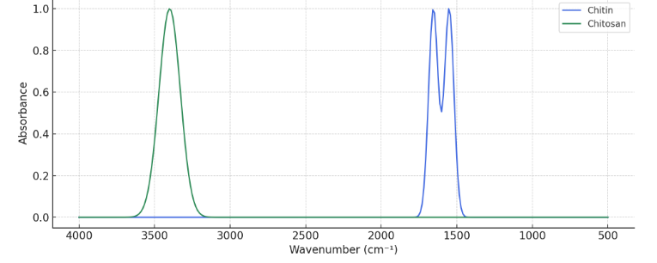
Figure: 1. Spectral Assessment of Chitin into Chitosan Conversion by FTIR

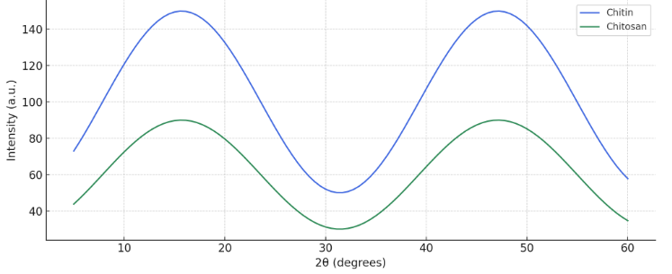
Figure: 2. X-Ray Crystallography Assessment of Chitin into Chitosan Conversion

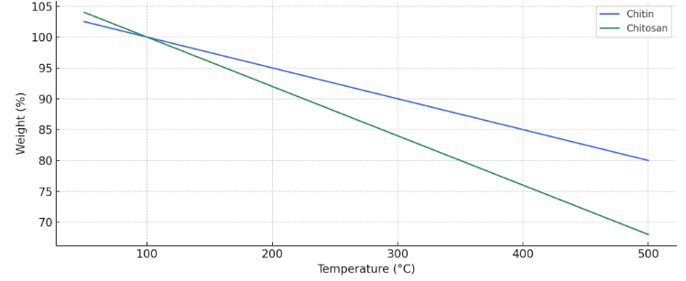

Figure: 3. Thermal Stability Assessment of Chitin into Chitosan Conversion
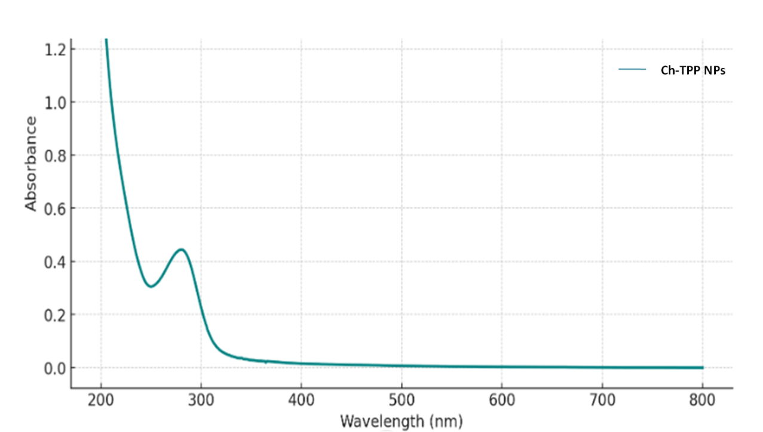
Figure: 4. UV-VIS Spectral Assessment of Chitosan-TPP Nanoparticles
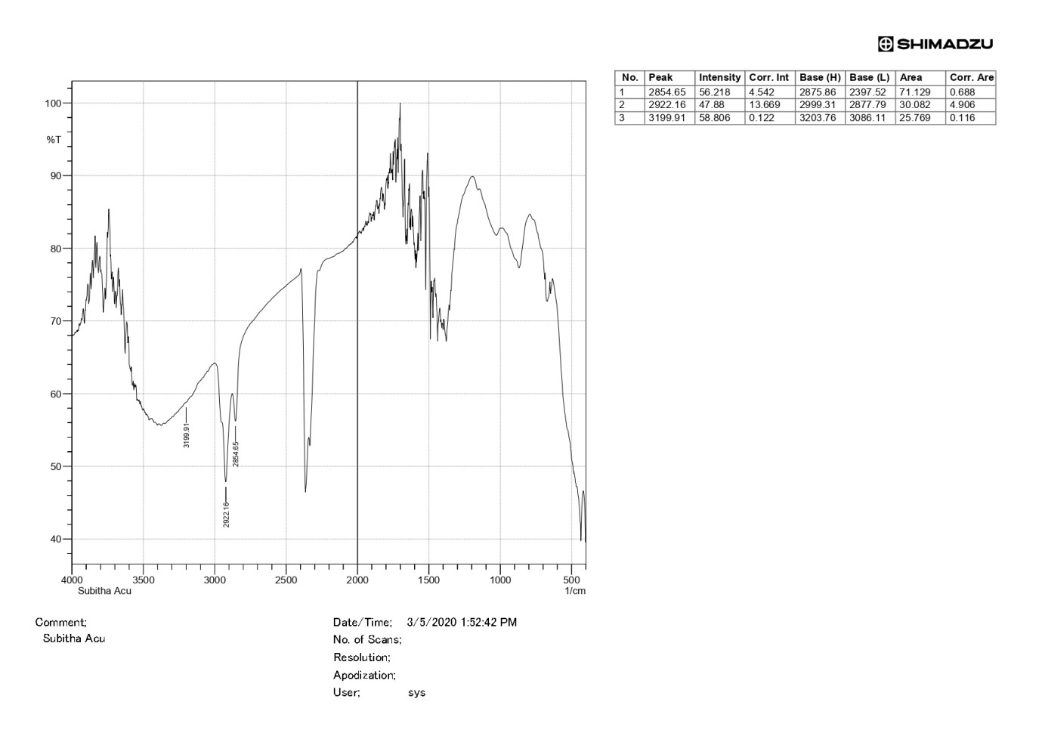
Figure: 5. FTIR Spectral Assessment of Chitosan-TPP Nanoparticles

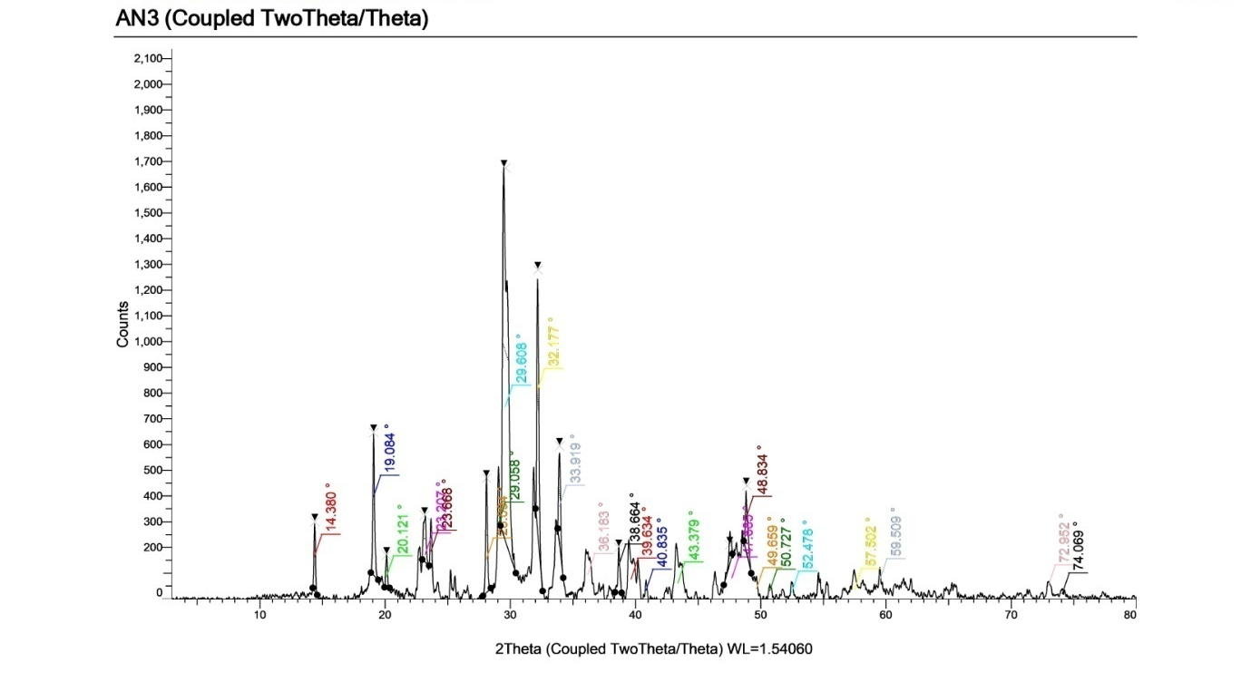
Figure: 6. X-Ray Crystallography Assessment of Chitosan-TPP Nanoparticles
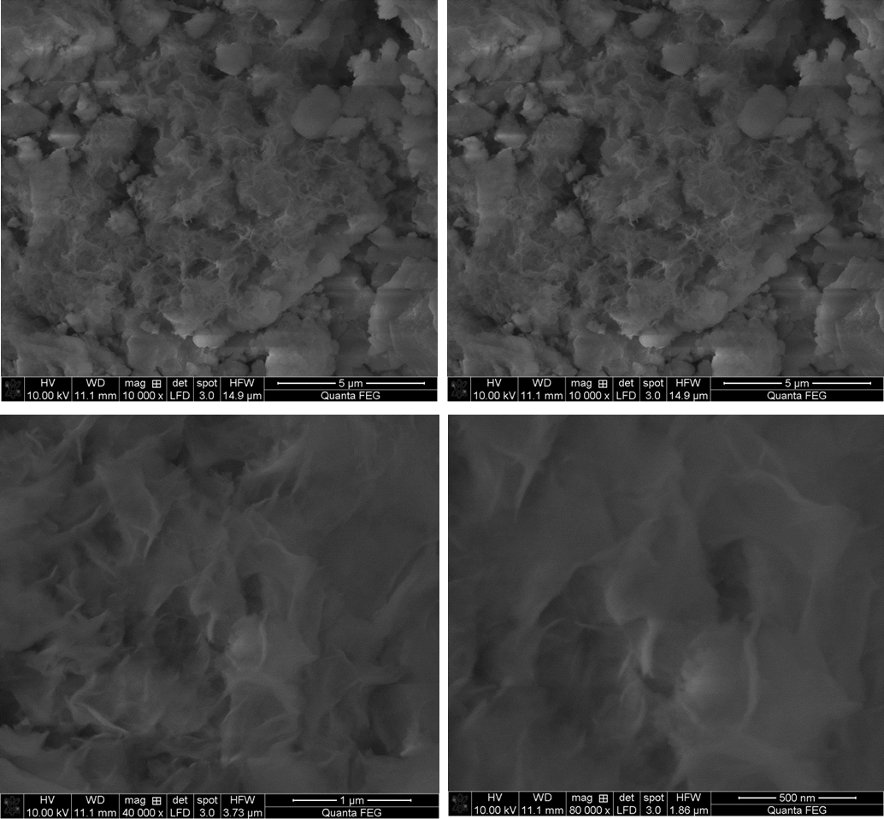
Figure: 7. Morphological Assessment of Chitosan-TPP Nanoparticles by SEM
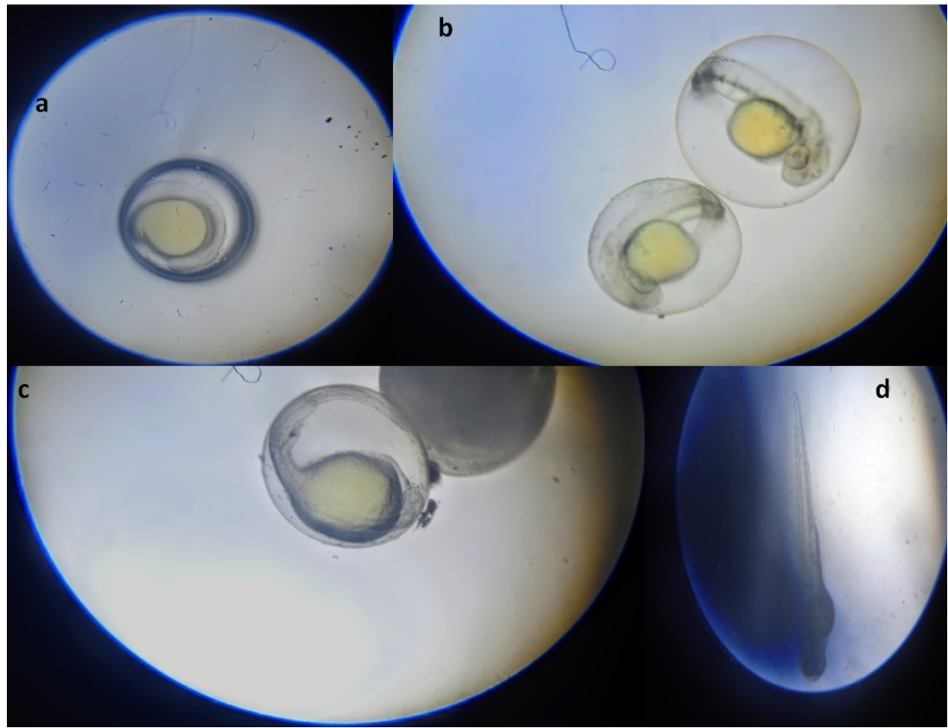
Figure: 8. ToxicologicalAssessment of Chitosan-TPP Nanoparticles on Zebra Fish Embryo, a) healthy spherical embryo, b) two embryos at the segmentation stage, c) embryo in the pharyngula stage, d) elongated embryo in the hatching stage
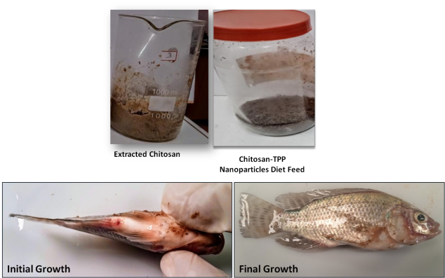
Figure: 9. Preparation and Assessment of Growth Performance of Chitosan-TPP Nanoparticles on Experimented Tilapia Fish
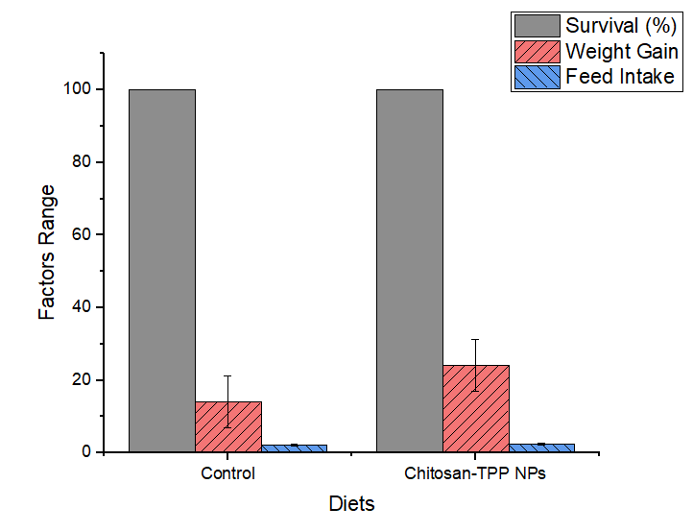
Figure: 10. Evaluation of Survival, Feed intake and Weight gain of Chitosan-TPP Nanoparticles on Tilapia
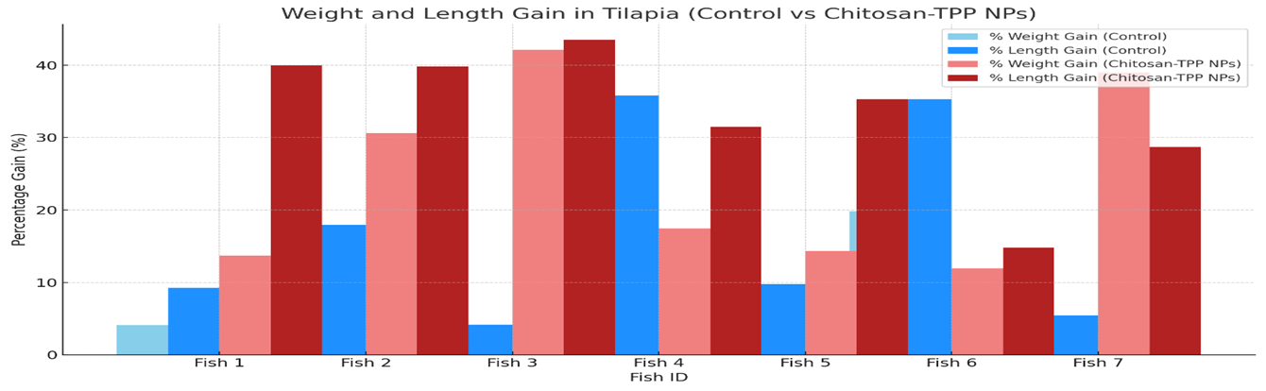
Figure: 11. Evaluation of Weight-Length Ratio of Control and Chitosan-TPP Nanoparticles Diets on Tilapia

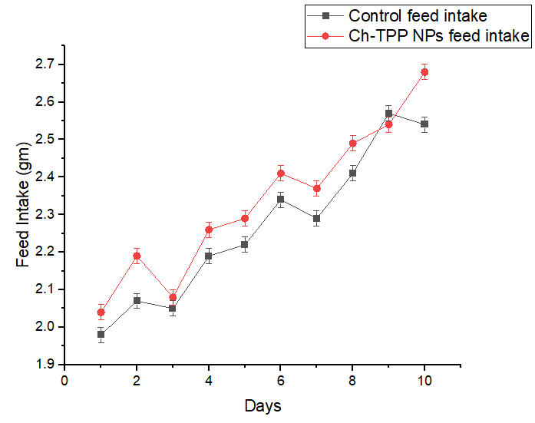
Figure: 12. Evaluation of Food Conversion Ratioof Control and Chitosan-TPP Nanoparticles Diet on Tilapia

