**Seroprevalence of ovine sarcocystosis by indirect fluorescent antibody technique**

**1. Abstract**

*Sarcocystis* spp. is a prevalent parasite found in livestock raising significant concerns for public health due to the potential risks associated with the consumption of undercooked or raw meat. *Sarcocystis* species have been identified in various animals worldwide yet our study marks the first investigation of *Sarcocystis* infection in slaughtered sheep in and around Hyderabad, Telangana. The prevalence of ovine sarcocystosis was investigated by immuno fluorescent antibody technique standardized in our laboratory. Purified bradyzoites collected from microcysts of *Sarcocystis* spp. were used to prepare antigenic slides. The sera sample collected from a sheep prior to slaughter whose muscle sample were found positive for the bradyzoites of *Sarcocystis* spp. by Pepsin HCl acid muscle digestion was used as known positive serum. A blood sample from a newborn lamb was used as a negative reference serum in all the tests. The prepared antigen slides reacted well with positive serum emitting bright yellowish-green fluorescence whereas negative serum with reddish fluorescence or polar fluorescence or no fluorescence. The seroprevalence of ovine sarcocystosis, determined by the laboratory-standardized IFAT, was 58% (145 out of 250) of tested sheep sera. The prevalence varied with age, with a lower infection rate (47%) observed in the 1-2 years age group and an increasing rate (65.3%) in those older than two years. Significant difference (p<0.05) in infection was noticed between sheep older than 2 years and 1-2 year. No significant difference (p>0.05) in infection was noticed between male (56%) and female (59.3%) animals.

**Keywords:** OvineSarcocystosis, Seroprevalence, IFAT, parasite

**2. Introduction**

Sarcocystosis is a protozoan infection affecting animals and humans by various *Sarcocystis* spp*.* (Dubey, 1989). *Sarcocystis* spp*.* are obligatory, heteroxenous parasites and exhibits a digenetic life cycle, characterized by its utilization of carnivores as definitive host and herbivores as intermediate host. This genus now has 189 species recognized all around the world (Abdullah, 2021). Sarcocystosis in domestic animals is common in India (Jyothisree *et al*. 2017) and has been observed in cattle, buffaloes, sheep, goats, horses, and pigs from diverse regions of the nation. sheep serve as intermediate host for six distinct species of *Sarcocystis*, *viz.,* *S. tenella, S. arieticanis, S. gigantea, S. medusiformis, S. mihoensis,* and *S. microps*. *Sarcocystis tene*lla and *S. arieticanis* which are pathogenic and produce microscopic cysts that are transferred by canids whereas *S. gigantea* and *S. medusiformis* which are non-pathogenic but form macroscopic cysts that are visible to the naked eye and are spread by felids. Anaemia, weight loss, and impaired weight growth are common in infected animals. When the central nervous system is affected, hind limb paralysis, ataxia, paresis, myopathy, and mortality are all possible (Buxton 1998). Infection in pregnant sheep can causes abortions and foetal deaths. Decrease in animal products including meat and wool as well as infertility are further economic losses. The condemnation of carcasses is thought to result in annual economic losses of 20 million euros in Spain (Rahdar *et al*.,2017). Whole or partial carcasses at slaughterhouses are also condemned. Sarcocystis infection poses a risk to food safety and public health in addition to causing financial losses in the animal husbandry industry (Dong *et al*., 2018). The type of parasite present and the quantity of oocysts consumed determine how severe the symptoms are in animals. During slaughter, the meat having macrosarcocysts can be viewed with naked eye and can be removed but the microsarcocysts which are pathogenic are not visible. Therefore, to avoid consumption of such infected meat (unsafe) we decided to standardize a serological test to diagnose the infection during ante-mortem examination. Telangana is number one in sheep population in India as per 20th national livestock census conducted in 2019 and accordingly mutton consumption. Dasmabai *et* *al*. (2017) and Rashmitha *et* *al*. (2019) studied the seroprevalence of bovine sarcocystosis in Telangana state but the studies on ovine sarcocystosis are scant. Hence, it is proposed to standardize an economical, easy to perform serological test in live animal during ante-mortem examination to minimize economic loss and any possibility of zoonotic infections.

**3. Materials and methods**

**3.1 Collection of samples:**

Organ samples *viz.,* oesophagus, heart of sheep slaughtered at different slaughter houses in Hyderabad were collected. After collection, the samples were kept in sterile plastic zip-lock covers on ice at 4 °C and brought to the Department of Veterinary Parasitology, College of Veterinary Science, Rajendranagar, Hyderabad for further processing.

**3.2 Separation of bradyzoites from muscle:**

Suspected oesophageal and heart muscle (20 g) sample was chopped into small pieces and incubated in 50 ml of pepsin HCl solution (2.6 g pepsin, 5 g NaCl, 7 ml 1 M HCl, and 993 ml distilled water) for 20 minutes at 40 °C. According to the procedure outlined by Motamedi *et al*. (2010). The suspension obtained after incubation was filtered through five layers of prewetted muslin cloth centrifuged at 2000 rpm for 5 min, and sediment was suspended in 0.5 ml of distilled water. A drop of this solution was then examined for the presence of bradyzoites under a light microscope. The bradyzoites of *Sarcocystis* spp. obtained by pepsin HCl acid muscle digestion technique (Dasmabai *et* *al*., 2017) were resuspended in PBS (pH 7.4) and purified by filtering through five layers of prewetted muslin cloth. Such purified bradyzoites were stored at 4 ºC in a refrigerator for further use.

**3.3 Standardization of indirect fluorescent antibody technique:**

Antigen slides were prepared, as per the procedure outlined in the USHDEW manual by Palmer (1976). The pure bradyzoite preparation of *Sarcocystis* spp. were resuspended in a known quantity of PBS (pH 7.4) so as to contain 6-8 bradyzoites per high power field. Approximately, 10-15μl of the bradyzoite suspension was directly charged and sucked in immediately with the help of a micropipette. This facilitated making a thin smear on the opposite side of 5 mm diameter area circles (10 No.) each made previously using a glass marking diamond pencil on the underside of a clean, grease-free glass slide. Once the spots had dried-up, the slides were placed in a coupling jar containing chilled acetone and incubated at 4 °C overnight. The antigen coated slides were then air-dried, wrapped in aluminium foil and stored at -20°C for future use in IFAT.

**3.4 Immuno conjugate:**

Rabbit anti-goat IgG fluorescent isothiocyanate (FITC) for use in IFAT was obtained from Bangalore Genei Pvt. Ltd., India and used at 1:40 dilution in all reactions.

**3.5 Reference sera:**

The sera sample collected from a sheep prior to slaughter whose muscle sample were found positive for the bradyzoites of *Sarcocystis* spp. by Pepsin HCl acid muscle digestion and squash technique during post slaughter examination was used as known positive serum. A blood sample from a newborn lamb was used as a negative reference serum in all the tests.

**Standardization of IFAT:**

Antigen slides previously preserved at -20°C were thawed at room temperature for 5 min. rinsed with distilled water and air-dried. The circles on the slides were marked with wax pencil to prevent capillary movement of well contents. Double dilutions of positive and negative reference sera starting from neat and 1:8, respectively were loaded in antigen wells. Slides were incubated at 37°C for 30 min in a humid chamber. Such slides were once rinsed with distilled water, followed by three washes in PBS (pH 7.6) each for five min in a coplin jar with a final rinse in distilled water, and air-dried. Ten microlitres of rabbit anti-Goat IgG FITC (Bangalore Genei) diluted to 1:40 in 1% Evans blue (PBS pH 7.6) were loaded in each well and incubated, followed by washing and air drying, as before. The slides were then immediately examined after mounting in a drop of buffered glycerol under 60x magnification of a fluorescent microscope (Nikon 80i). Positivity and negativity were determined as per the guidelines described.

The results were analyzed by Chi square test as per the method described in Snedecor and Cochran (1977).

**4. Results and Discussion**

The prepared antigen slides reacted well with positive serum at 1:40 dilution emitting bright yellowish-green fluorescence whereas negative serum with reddish fluorescence or polar fluorescence or no fluorescence. The results indicated that this method effectively detected *Sarcocystis* infection. Whereas the known positive anti-*Sarcocystis* serum did not cross reacted with *Toxoplasma gondii* (tachyzoite) antigenic slide already available in our laboratory. Out of the 250 sheep sera tested, 145 showed the presence of antibodies to sarcocystosis in sheep highlighting the higher rate of infection among the sheep.

The prevalence of infection varied depending on age groups. Out of 250 sheep sera examined 47/100 were found positive indicating 47% of infection in the sheep of 1-2 years age group whereas 98/150 of sheep were positive indicating 65.3% of infection among sheep older than 2 years, which was significantly (p<0.01) higher than 1-2 years age group of sheep.

The laboratory standardized IFAT was also applied to detect the sex wise incidence of ovine sarcocystosis. Out of 250 sheep sera examined 56/100 of male and 89/150 female sheep were positive indicating 56% and 59.3% of infections, respectively. As such no significant difference (p>0.01) was observed in the incidence of sarcocystosis between male and female sheep in our present investigation.

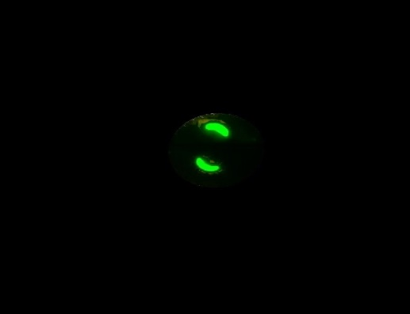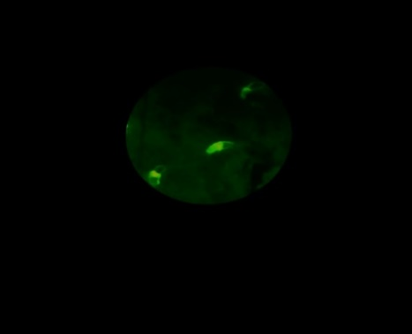

**Fig 2 Photomicrograph of bradyzoites of *Sarcocystis spp.* showing polar/half** **fluorescence indicating no immunoreactivity with negative ovine serum in IFAT (60X)**

**Fig.1 Photomicrograph of bradyzoites showing bright yellowish green fluorescence with *Sarcocystis* spp. positive ovine serum in IFAT (60X)**

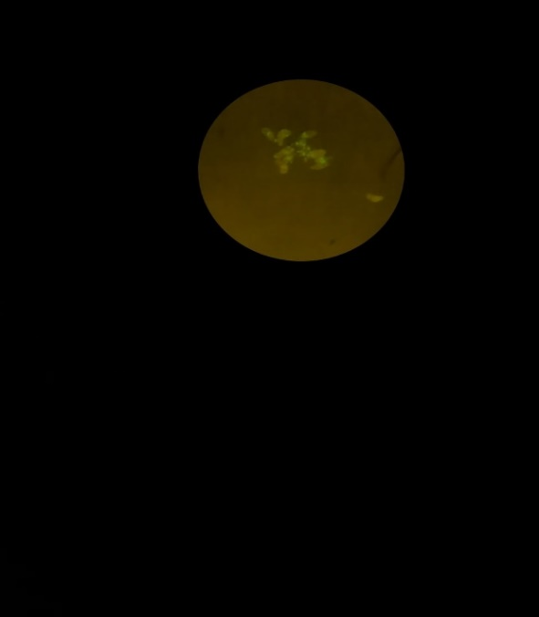

**Fig 3 Photomicrograph of bradyzoites of *Sarcocystis* spp. showing reddish** **Fluorescence indicating no immunoreactivity with negative ovine serum in IFAT (60X)**

**3**

**Fig 4 Pie diagram showing age wise prevalence of ovine sarcocystosis**

Out of 250 samples screened 145 were found positive indicating 58% of infection. Conversely Adel *et al*. (2017) reported an infestation rate of 64.8% in Egyptian water buffalo using IFAT. Dasmabai *et al*. (2017) recorded a prevalence of 79.46% for Sarcocystosis by IFAT in cattle and buffaloes. Ferreira *et al*. (2023) used IFAT to detect antibodies against *Sarcocystis* spp. in cattle and found antibodies in 96% of serum samples at a 1:25 dilution and 80% at a 1:200 dilution. The findings revealed that the laboratory-standardized IFAT was the most effective in diagnosing Sarcocystosis in the highest percentage (58%) among the tested animals.

The rate of infection increased with age *i.e.,* > 2 years of age sheep had 65.3% infection followed by 47% positivity in 1-2 years of age group. The difference may be due to older sheep having more time of exposure resulting in more accumulation of the parasite that causes the disease, leading to a higher likelihood of infection over a period of time. Additionally, the proportionately reduced immunity with increasing age might have made the sheep more susceptible to sarcocystosis. The results were in accordance with Beyazit *et al*. (2007) and Mirzaei *et al*. (2016). In contrary to this Hajimohammadi *et al*. (2014) reported that, there was no discernible relationship between the infection and the animal sex.

There was no significant difference in the rate of infection between male (56%) and female sheep (59.3%). These results were in-accordance with Hajimohammadi *et al*. (2014). Conversely Oryan *et al*. (1996) reported that females had a higher prevalence of infection (61.07%) than males (38.93%). The difference be because, the disease is primarily caused by ingestion of contaminated food or water rather than being influenced by the animal's gender. Both male and female animals have similar chances of exposure to the parasite resulting in similar infection levels.

**Conclusion**

Even though many molecular techniques are available, this study findings indicate that the immunofluorescence antibody technique (IFAT) method stands out as the most suitable, expeditious, and consistently replicable technique for the diagnosis of sarcocystosis in a significant population of live animals. IFAT can be done in live animal while traditional techniques cannot detect sarcocystosis in live animal. IFAT provides accurate and reliable results at a relatively low cost making it an appealing choice for diagnostics due to its efficacy and accuracy.

This is especially relevant in regions like Telangana, where there is a significant sheep population and a high consumption of mutton. This research reveals the occurrence of *Sarcocystis* spp. in sheep within and near Hyderabad. Consequently, it is advisable to ensure thorough cooking of meat to mitigate potential health risks for consumers.

**Acknowledgement**

The authors are thankful to college of Veterinary science, PVNRTVU, Rajendranagar, Hyderabad for providing necessary facilities for research work.

**Disclaimer (Artificial intelligence)**

Author(s) hereby declared that NO generative AI technologies such as Large Language Models (ChatGPT, COPILOT, etc.) and text-to-image generators have been used during the writing or editing of this manuscript.

**Competing Interests**

**“**Authors have declared that no competing interests exists”.

**References**

1. Dubey J P, Speer C A and Fayer R. 1989. Sarcocystosis of Animals and Man. CRC Press Inc, Boca Raton, Florida.
2. Abdullah S H. 2021. Investigation of *Sarcocystis* spp. in slaughtered cattle and sheep by peptic digestion and histological examination in Sulaimani Province, Iraq. *Veterinary World* **14**(2): 468.
3. JyothiSree C, Venu R, Samatha V, Malakondaiah P, and Rayulu V C. 2017. Prevalence and microscopic studies of *Sarcocystis* infection in naturally infected water buffaloes (*Bubalus bubalis*) of Andhra Pradesh. *Journal of Parasitic Diseases* **41**: 476-482.
4. Buxton D. 1998. Protozoan infections (*Toxoplasma gondii, Neospora caninum and Sarcocystis* spp.) in sheep and goats: recent advances. *Veterinary Research* **29**(3-4): 289-310.
5. Rahdar M and Kardooni T. 2017. Molecular identification of *Sarcocystis* spp. in sheep and cattle by PCR-RFLP from southwest of Iran. *Jundishapur Journal of Microbiology* **10**(8).
6. Dong H, Su R, Wang Y, Tong Z, Zhang L, Yang Y and Hu J.2018. *Sarcocystis* species in wild and domestic sheep (*Ovis ammon* and *Ovis aries*) from China. *BMC Veterinary Research* **14**: 377.
7. Dasmabai B, Udaya kumar M and Rayulu V C. 2017. Diagnosis of bovine sarcocystosis by immune flourescent antibody technique. *Journal of Parasitic Diseases* **41** (3): 795-798.
8. Rashmitha P, Udaya Kumar M, Murthy G S S and Reddy Y N. 2019. Serodiagnosis of bovine sarcocystosis by Dot-ELISA. *Indian Journal of Animal Research* **54** (6): 734-738.
9. Motamedi G R, Dalimi, A., Aghaeipour K and Nouri A. 2010. Ultrastructural and molecular studies on fat and thin macrocysts of *Sarcocystis* spp. isolated from naturally infected goats. Archives of Razi Institute, **65**: 91-97.
10. Palmer Dan F .1976. USDHEW (U.S. Department of Health, Education and Welfare) Manual. A procedural guide for the performance of the serology of toxoplasmosis. Centre for Disease Control, Atlanta.
11. Snedecor G W and Cochran W G. 1977. Statistical methods applied to experiments in agriculture and biology 5th ed Ames, Iowa: Iowa State University Press, 251.
12. Adel Aziz A R Zakaib Ali F A and Salman D. 2017. Evaluation of IFAT reliability in diagnosing Sarcocystis*spp.* in Egyptian water buffalo (*Bubalus bubalis*). *Journal of Veterinary Medicine and Allied Sciences* **1**(2): 64-71.
13. Ferreira M S, Fernandes F, Braunig P, Guerra R R, Sangioni L A and Vogel F S. 2023. *Sarcocystis* spp. detection in cattle using different diagnostic methods. *Pesquisa Veterinaria Brasileira* **43**: e07206.
14. Beyazit A, Yazicioglu O and Karaer Z. 2007. The prevalence of ovine *Sarcocystis* species in Izmir province. *Ankara Universitesi Veteriner Fakultesi Dergisi* **54**(2): 111-116.
15. Mirzaei M and Rezaei H. 2016. The role of sheep in the epidemiology of *Sarcocystis* spp. in Tabriz area northwest of Iran. *Journal of Parasitic Diseases* **40**: 285-288.
16. Hajimohammadi B, Zohourtabar A, Fattahi A, Omidpanah A, Rayati T, Ghasemi A and Sazmand A. 2014. Occurrence and distribution of *Sarcocystis* parasite isolated from sheep in Yazd Province, Iran. *Journal of Community Health Research* **3**(3): 204-209.
17. Oryan A, Moghaddar N and Gaur S N S. 1996. The distribution pattern of *Sarcocystis* species, their transmission and pathogenesis in sheep in Fars Province of Iran. *Veterinary Research Communications* **20**: 243-253.