THE STUDY OF INDIGENOUS ORNAMENTAL FISH DIVERSITY FROM WETLAND OF MANJHAUL, BEGUSARAI BIHAR

ABSTRACT:
The present study work goals to reveal the status of indigenous ornamental fish diversity of Kanwar wetland of Manjhaul subdivision of Begusarai district in Bihar. A collection of fishes was made from period of January 2023 to December 2023. In this investigation work different types of local fishing equipment’s like jhang, Aanta, Aarsi, Bari, Kanra etc were used by fishermen. Many types of nets of different mesh size as Bag net, Scoop net, Cast net and Gill net were used to caught the fishes. In this study 48 type of fishes were informed out of which 26 fish species belongs to ornamental potential. They belong to 7 order, 13 families, 15 genera and 26 species. Cypriniformes was the most abundant fish order represented by 5 families, 6 genera and 9 species. Out of 26 fish species it was observed that 18 fish species have high ornamental potential and 8 are of both ornamental as well as nutritional value. The study work shows moderate piscine diversity.
Keywords: Wetland, Indigenous, ornamental fish, diversity, cyprinids.
1. INTRODUCTION
Fishes are one of the most significant and diversified groups which are correlated with the advantage of Individuals. India is one of the mega biodiversity nations in the world and possesses 9th position as far as fresh water mega biodiversity. Goswami T.K. and Goswai M.M. (2006). Indian rivers preserve a rich variety of fish species, which supports to the commercial fisheries Biligrami,K.S. (1988). ornamental fisheries are a rising sector having strength to increase economy of rural communities, poor’s and downtrodden. Ornamental fishes are the most popular pets in the world. The fishes have socio economic, nutritional and aesthetic value and important for upkeep of environment. ornamental fishes play an important role in the world trade in fish and fishery products, which is valued about us $ 9.0 billion (FAO, 2000) in which India's share is about 1%. The information about their pattern, arrangement, behaviours, population diversity, captive breeding is insufficient. Due to pollution, population development and climate change, the freshwater habitat has recently become one of the most fragile habitats in the world Pacheco et al., (2021). Water quality and biodiversity in freshwater ecosystems have been greatly impacted by human activities such as land use changes, excessive sediment extraction and chemical inputs (Mohd Azam et al., (2021). Many pioneers work on ornamental fish diversity including mills et al., (1990), Talwar et al., (1991), Madhu et al., (1996), Mahapatra et al., (1998), swain et al., (2002), Das et al., (2006), Mahapatra et al., (2006).
Many comprehensive and precious work done in the field of ornamental fisheries. Many of the workers made their important contribution includes those by AIfred and Ramakrishnan stated about fish diversity of Kanwar lake wetland ecosystem. Anon (1997) studied management action plan for Kanwar wetland. Bakalial et al., (2011) stated about ornamental fishes of hill stream channels of Subansiri drainage of northeast. Chandra et al., (2021) noticed a gradual increase in air breathing fish species recorded by CIFRI. Cristopher (1999) discussed about ornamental fish trade and conservation efforts. Das et al., (2010) stated about studies of loaches an ornamental fish of wetland of north Bihar and its export potential. Das et al., (2015) worked on status of ornamental fish diversity in jhang wetland in Kusheshwar asthan, Darbhanga and reported 35 fish species among them Perciformes was the dominant order. Ghosh et al., (2003) stated about ornamental fish farming and aqua business in India. Jayaram K.C., (2006) worked on cat fishes of India. His research work focusses on taxonomy, ecology and conservation of cat fishes. Kumar et al., (2014) described about status, conservation and management of wetlands of Begusarai Bihar. Munshi et al, (1988) described about systematics of freshwater fishes of India. Monticini p (2010) described about ornamental fish trade its production and commerce. Pandey and Mandal, (2017) stated about present status challenges and scope of ornamental fish trade in India. Raut et al., (2020) recorded 50 species of fish in the flood plain lakes of North Bihar, out of them 28 identified as potential ornamental fishes. Swain et al., (2010) described about present scenario of ornamental fish farming. Tlusty (2002) described the benefits of aqua culture production of ornamental fish and risks about this.
2. METHODOLOGY
A collection of fishes was made by using different types of nets as Drag net, Gill net, Cast net and other fishing gears as hooks and Lines, Traps, Arsis, Bari, Birti, kanra and Sahat was used by the experienced fishermen. Collected fishes were preserved in 10% formalin solution. Identification was done by using standard books like “The fishes of India.” (Francis Day 1878) and Fish and Fisheries of India Jhingran (1991). Taxonomic references used were Shrestha,1981; P.Talwar & A. Jhingran,1991) and(Jayaram,2010) to species level. Statistical data was performed by Shannon-Wiener diversity index (1963).
The Study Area:
Kanwar lake is Asia's largest freshwater ox-bow lake. It is a protected area and winter capital of migratory birds. In 1989 under provision of Indian wildlife protection Act 1972 Kanwar is identified as bird sanctuary. It was declared first Ramsar site of Bihar and 39th Ramsar site of India in 2020. It lies between latitude 25015’N, and 25045’N and longitude 85045’E and 86036’E in North part of Bihar. Kanwar lake is located 22 km north west of Begusarai town. It is in Manjhaul sub-division of Begusarai district. Kanwar wetland convers 2620 hectares area of Indo-Gangetic Plains. A depression is made between Burhi Gandak and palaea channel of Bagmati that forms this ox-bow lake. During monsoon it connects 17 related water bodies and spread to area approx. 6700 hectares but shrinks to 600 ha after monsoon. Directory of Asian wetlands refers Kanwar lake extend to be around 7400 ha (Scott 1989). Area under inundation reported to be shrunk to 6043 ha (Ghosh et al., 2004).
The Kanwar lake has been classified as wetland type 19 due to presence of habitat (Scott, 1989)
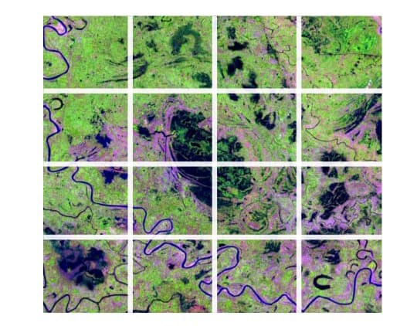
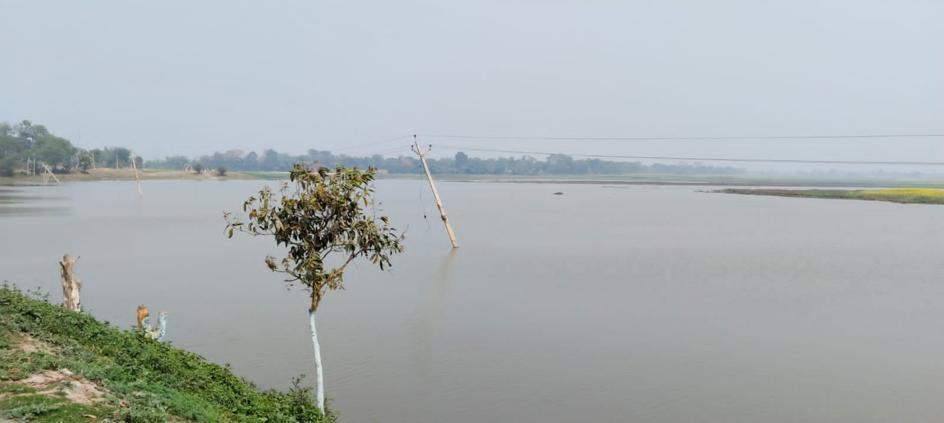
Picture 1: Map of Kanwar Lake Picture 2: Study Area Kanwar Lake

3. RESULTS AND DISCUSSION:
The result of this study work confirms presence of 48 species of fishes during investigation period January 2023 to December 2023 out of which 26 species of fishes belongs to ornamental potential. They belong to 07 order 13 families, 15
genera and 26 species. These 7 orders were Cypriniformes, Channiformes, Mastacembeliformes, Perciformes, Beloniformes, Symbranchiformes and Clupeiformes. Order Cypriniformes shows highest diversity accounting for 35% of

the total fish species collected from the kanwar lake. It was followed by Perciformes with 6 species (23%), Channiformes (15%) with 4 species, and Mastacembeliformes (11%) with 3 species. Clupeiformes (7%) with 2 species .The rest 2 orders with 01 species each constituted (4%) of the total fish documented in the Kanwar lake.
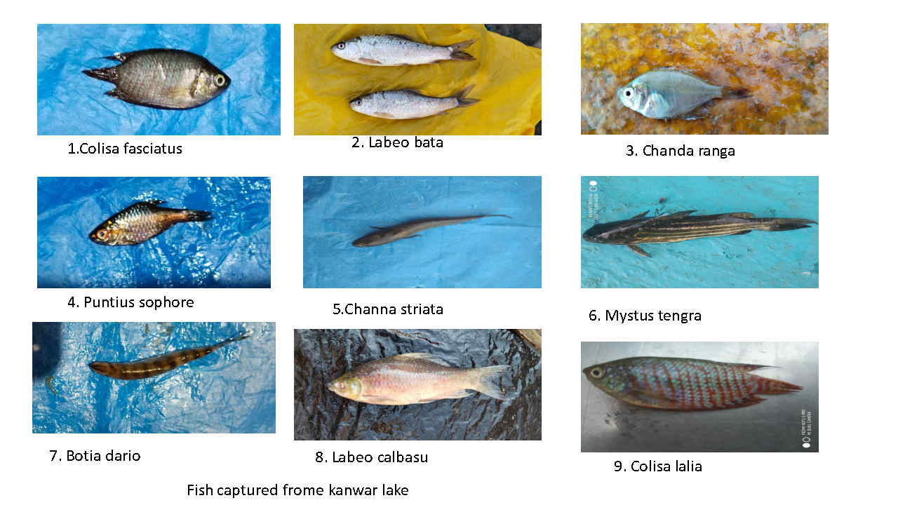
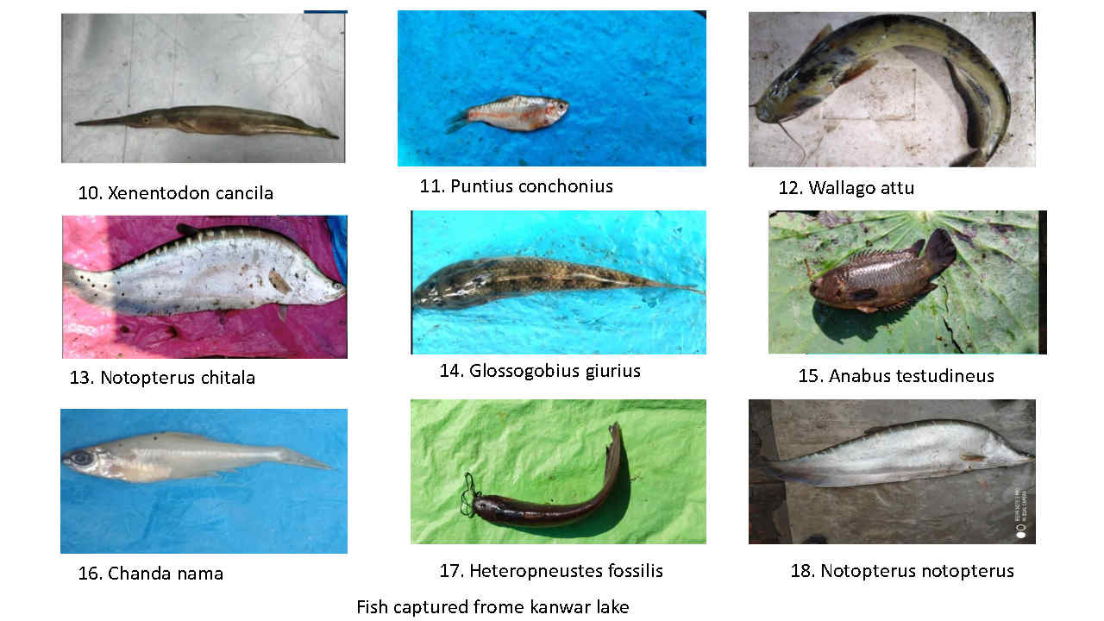
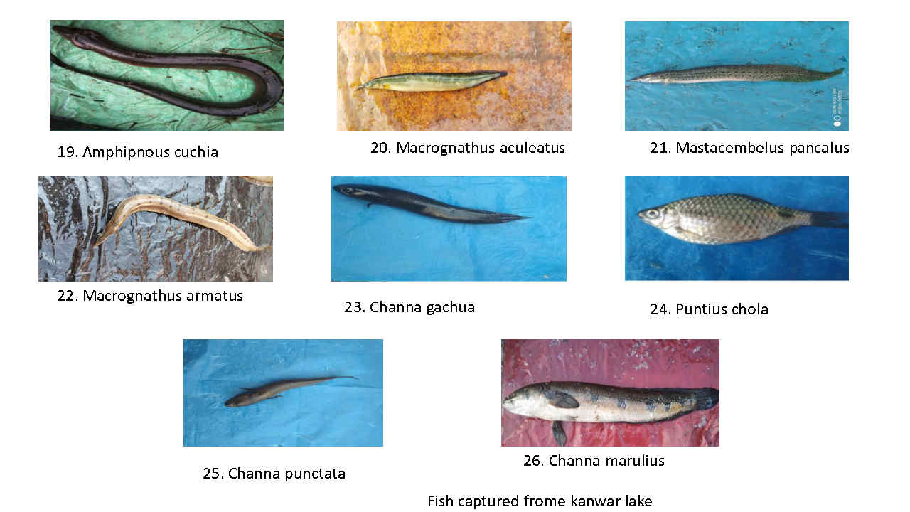
Plate 1. 26 species collected from the Kanwar lake.
In a survey work by Sinha Archana and Jamal Akhtar (2015), 79 species of ornamental fishes were reported from Bihar. Anon (2004) reported more than 41 species of commercially valuable fishes from the Kanwar lake. These species match with the present findings assessment of CIFRI (2007, 2011) reported presence of 54 species from river Gandak out of which 50 species reported in Kanwar (Vass et al., 2010, Srivastava, 2013). Out of them 26 species mainly belong to Cypriniformes, Siluriformes, Beloniformes, Channiformes, Perciformes, Symbranchiformes and Mastacembeliformes. Presence of 35 fish species recorded throughout the year and extra 15 species when river connects to wetland in rainy season (Sinha and Jha 1997), ZSI 2002, Tiwary et al., (2009). A gradual increase in air breathing fish species as Clarias Batrachus, Heteropneustes fossilis Anabas testudineus was recorded by CIFRI, Chandra et al., (2021). In mahalaya and kochalaya region of Kanwar lake presence of wallago attu was confirmed by local fishermen. Fresh water shining barb variety has been released for ornamental fish culture swain et al., (2016).

Table 1: List of collected fish species with their common name and local name.

Ornamental fishes of Kanwar Lake.
Order | Family | Scientific Name | Common Name | Local Name
Cypriniformes | Cyprindae | Puntius sphore | Spotfin Swamp barb | Pothia
 |  | Puntius chola | Swamp barb | Sidhari
 |  | Puntius conchonius | Rosy barb | Lal Pothi
 |  | Labeo calbasu | Calbasu | Basari
 |  | Labeo bata | Bata | Bata
 | Cobitidae | Botia dario | Necktic loach | Baghi
 | Siluridae | Wallago attu | Fresh Water Shark | Boari
 | Heteropneustidae | Heteropneustes fossilis | Stinging Cat fish Singhi
 | Bagridae | Mystus Tengara | Tiger Zebra Catfish | Tengara
Channiformes | Channidae | Channa punctatus | Spotted Snake head | Garai
 |  | Channa marulius | Giant snake head | Shaura
 |  | Channa gachua | Pigmy snake head | Chenga
 |  | Channa striatus | Kobra snake head | Shaura
Mastacembe- | Mastaem- | Mastacembelus Pancalus | Spiny eel | Katgaichi
liformes | belidae
 |  | Mastacembelus armatus | Long eel | Bami
 |  | Mastacembelus aculeatus | peacock eel | Pataya
Perciformes | Gobiidae | Glossogobius giuris | Tank goby | Bulla
 | Centropomidae | Chanda nama | Elongated glass perchlet Chanari
 |  | Chanda ranga | Glass fish | Chana
 | Anabantidae | Anabas testudineus | Climbing perch | Kawai
 |  | Colisa Fasciatus | Giant gourami | Khesra
 |  | Colisa lalia | Dwarf gourami | Khalisa
Beloniformes | Belontiidae | Xenentodon cancila | Fresh water gar fish | Kauwa Machhli
Symbranchiformes | Symbranchidae | Amphipnous cuchia | Mud eel | Anhawa
 |  | Notopterus notopterus | L Knife fish | Bhuna
Clupeiformes | Notopteridae | Notopterus chitala | Clown feather back | Chitala

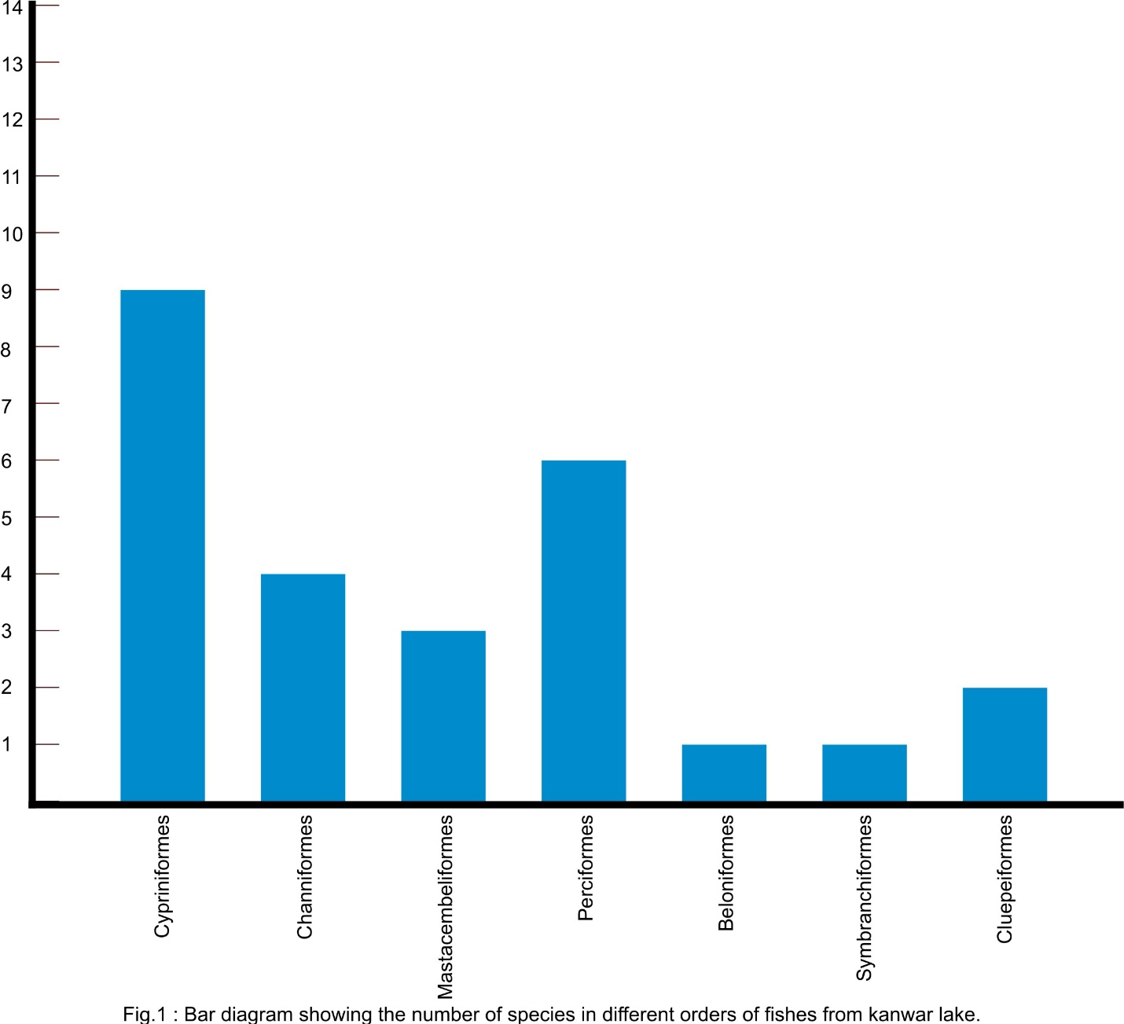
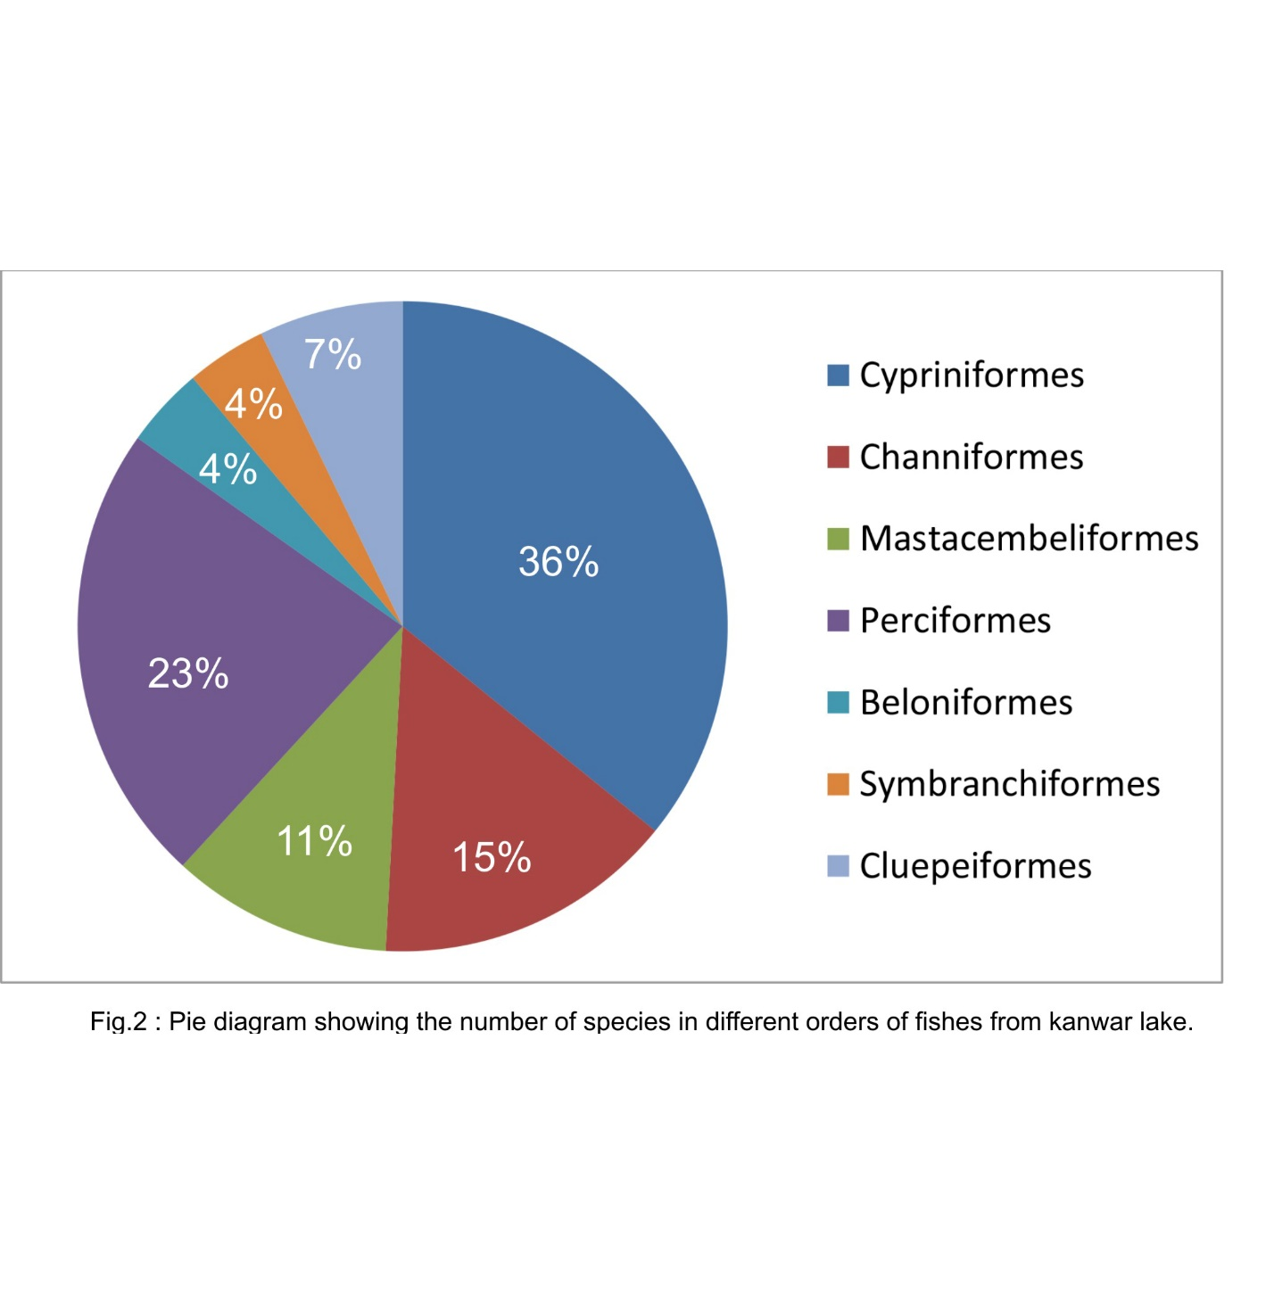4. CONCLUSION
The increasement of the fisheries sector by adding ornamental fish culture and its trade could be a big support to local people and fishermen. Present study work provides important insights into the ichthyodiversity of the Kanwar lake. This investigation work may add skeletal information about diversity and ornamental potential of fishes.

DISCLAIMER
Author hereby announce that no generative AI technologies as large language models (COPILOT, Chat GPT etc.) and text-to-image generator have been used during writing.

5. REFERENCES:
1. Alfred J.R.B and Ramakrishnan (2002), Kabar lake wetland an - overview. Fauna of Kabar lake (Bihar) wetland ecosystem series, 4 (zoological survey of India Kolkata) PP. I - 14.
2. Anon: Management action plan for Kanwar lake (2004-2005,2008-2009), Department of Environment & Forest, Govt. of Bihar.
3. Anna mercy, (2007) Gopalakrishnan & Lakra, Ornamental fishes of the western ghats of India pp: 2:35 P.
4. Bhumika, U, Shaha S.K. and Mitra A, (2000) the fifth Indian fisheries science congress, Abstract 21-23 sept. PP 133.
5. Bakalial B. S. Borah and Hazarika (2011) ornamental fishes from hill stream channels of subansiri drainage. Books on rivers and streams of northeast India PP 14 3 - 150.
6. Chandra et al., (2021), Faunal diversity in Ramsar Wetlands of India PP. 1-292.
7. Cristopher Andrews (1999) the ornamental fish trade and fish conservation. journal of fish biology 37, PP 53-59.
8. Dayal R. and Kapoor D; (2000), survey on existing data base for endangered fish species of peninsular India. PP 192 - 193.
9. Das J.P.L. Kolay S.R. and Rahmatullah (2015) worked on status of ornamental fish diversity in jhang - A wetland of Kusheshwarsthan chaur 2 (4): 142-146.
10. Ghosh et al., (2003), ornamental fish farming successful small-scale aqua business in India. Aquaculture Asia 8 (3): 14-16
11. Jayaram K.C. (2006), catfishes of India, Narendra Publishing House Delhi - 110006 XI plates + 383P
12. Kanwar Jheel: An integrated management action plan (2016) for conservation and wise use. Wetland International south Asia February 147 P
13. Khan M.A. An account of fishes of Uttar Pradesh plains (2000) 98 (part I) 101-121
14. Munshi, J.S. Dutta & Srivastava (1988). National history of fishes and systematics of freshwater fishes of India. Narendra Publishing house New Delhi 403 PP.
15. Mishra K.S. (1959) an aid to the identification of the common commercial fishes of India and Pakistan Res Indian mus 57 (1-4): 320
16. Monticini, P (2010) The ornamental fish trade production and commerce of ornamental fish FAO, 102, 7.
17. Nelson, J. S., Grade, T. C., & Wilson, M. V. H. (2016), Fishes of the world, John Wiley & Sons.
18. Pandey, P.K. and Mandal, S.C. (2017) Present Status Challenges and scope of ornamental fish trade in India, conference Aqua Aquaria India.
19. Raja, K., Anand, P., Padmavathy, S., Stephan, J., Kumar, S., (2019) present and future market trends of Indian ornamental fish sector 7 (2): 06-15
20. Raut et al., (2020), potential and opportunity for ornamental fishes in North Bihar. Research Today 2 (7): 677-679.
21. Swain et al., (2010), ornamental fish farming present scenario. In: ornamental fish farming Indian council of Agricultural Research, New Delhi. PP 54-62.
22. Tlusty, M. (2001). The benefits and risks of aqua cultural production for the aquarium trade. Aquaculture 205: 203 - 215.
23. Tejaswini et. Al., (2014) The ornamental fish species in the river Bhima Maharashtra India Issue-2 Volume - II PP 167-174.

