***Original Research Article***

**Biodiversity of Host plants for *Laccifer lacca* in Gondia district, Maharashtra, India**

**ABSTRACT:**

Lac is mainly produced in India, Thailand, and Indonesia, parts of China, Vietnam and Cambodia. In India Bihar and Maharashtra are the major Lac producing state. Present study was carried out to enhance the production of Lac and multiplication of insect diversity in ecological system as if due to anthropogenic activity and increase in farm lands continuously forest cover has been detrioted by cutting down major host plants of lac insect too, destruction its habitat. Our study promotes and encourage lac culture to increase entrepreneur ship of among women and farmers community of rural agro depended area of district with conservation and identification of host plants *Laccifer lacca.*

**Keywords***: Laccifer lacca,* Conservation, Rural Farming, Host Plants

**Introduction:**

Lac is natural resin produced by Lac insect *Laccifer lacca* from its cuticle dermal glands in form of body case as protective covering of commercial importance in global commodity.

Lac insect belongs to Coccoidea with miniature body structure (Kondo *et al.,* 2005., Chamberlin JC 1923., Carter HJ 1861., Kumar *et al*. 2002; Mohanta *et al.* 2012).). Female being viviparous, give rise to birth of n number of young crawlers in the form nymphs from female brood lac reaching up to fourth instar stage having sexual differentiation in Pupal stage. Adults emerges out from pupal stage and grows enormously based upon sexes. Lac as by product can be used in makeover of dyes , paints , wood polish , cosmetics, varnishes and products of textile industries in the form of dyes The lifecycle of lac insect involves egg, nymphs and adult. Nymphs are potent crawlers living in colonial and sparsely spreading stage (Roonwal *et al* 1958, Ramani *et al*., 2007). Lac nymphs are active sap feeder of host plants sap specific to their feeding preferences, being commercially important it is important to cultivate the host plants for more production of lac as byproduct( Anderson J. 1971., Mishra *et al* 1923., Sharma *et al*., 2006., Singh *et al*., 2009, Sharma and Ramani, 1999).According to Kapur, 1962; Varshney and Teotia, 1968; Varshney, 1968; Sharma *et al*., 1997 around the world nearly 400 lac host plants are reported, of which In India nearly 114 species were cultivated and some are naturally grown in vegetation in different geographical region of India such Bihar, Maharashtra, Madhya Pradesh, Arunachal Pradesh, Assam like states (Avasia D.N. 1909). There are several taxonomist who reported some of new species of host plants among them Varshney (1986, Roonwal, 1962, Mohanta *et al*., 2012) reported some major host plants such as Palas, Ber, Kusum as major host plants used traditionally.

Maharashtra state is well knowns for its diversity in term of flora and fauna found throughout the forest areas. In Maharashtra state only limited District are well known producers of lac among them Gondia ,Bhandara and Gadchiroli district are tribal occupied harboring major lac producing farmers since age old times as traditional farming business. Lac production flourishes due to its climate adaptability.

**Material and Methods:**

**Survey and Study Sites:**

On weekly basis regular survey were undertaken to study the lac cultivable areas by direct interaction with local traders and farmer growing lac. During survey different village were noted down with their geo coordinates using GeoCam application and photographs were taken using Sony DSLR Camera With 55-300 mm Zoom lens and macro lens to record photographic evidence. Among observed host plants their tagging were done by using water resistant labels to check the colonial multiplication by observing live colonial lac encrustation and nymphal crawl through visual observation and binocular Celestron 10 x 50 . The observations of different parameters of host plants, their intensity and location were recorded under the study. The lac insect and host plants were observed for the presence of lac insects, their strain, growth, stage, intensity and colour variation documented for further laboratory records.

**Observation:**

Observation were done using Line Transect Methods in and around farmer filed areas , border line of forest patches due to incidence of wild animal and human conflicts in reported areas , and rural patch of farmers and undisturbed land habitats. During observation host plants such as *Butea monosperma* found in abundance followed by *Ziziphus mauritiana*, with bigger and robust trees like *Ficus religosa*, *Albizia saman*, *Ficus bengalensis*, *Ficus racemose*, *Ficus amphissimna* and in dense forest patches host trees such as *Pithocilobium dulce*, *Albizzia lebbek* as wilder species .We also recorded vernacular names of host plants were lac cultivation were practiced by local peoples to create awareness.

**Result & Discussion:**

Our result indicate based upon survey maximum production of lac was done.in Gondia District in villages such as Goregoan, Chopa, Sadak Arjuni, Amgoan, Kawarabandh, Salekasa and adjoining border areas of Gondia district village such as Dasgoan connecting Madhya Pradesh .We find major cultivation and naturally grown trees of *Butea monosperma* (Palash) naturally found in Bunds of Paddy field and forest corridor area , where farmers where doing regular pruning before onset of lac rearing and spreading of culture. As per Yogi *et al*., 2018 he reported maximum production of stick lac nearly 1100 quintals annual turnover from Gondia district alone, contributing major part of total lac produce in state.

Table 1 .depicts major village which were actively involved from Gondia District in lac production. During interaction with farmer community we found nowadays farmer were moving towards nearby cities for more professional job by dropping the village farming lifestyle as if due to less commercial value of lac. As if they growing and producing lac only by traditional methods and stick lac after scrapping sold to local vendor at cheap rate rather unknowing if final commercial value would be more after post processing .Thus its need of hours to create awareness among them true potential of lac production and cultivation of its economic value . Our Data significantly emphasis on more and more cultivation of host plants such as *Butea monosperma* (Palas) with higher productivity and its local conservation by villager community. Among host plants major cultivation and mainentence of lac population was found in *Ziziphus mauritiana, Butea monosperma, Ficus religosa, Ficus citrifolia.*

Kumar *et al.* (2007) conducted a survey evaluating the relative performance of *K. lacca* with respect to productivity parameters on 7 host plants. Our results suggest were found to show variation from the earlier works done by different researchers in comparison to host specificity might be attributed to the different species of lac insect used for inoculation, the climatic difference and the time of inoculation as well as harvesting of the lac insect. Thus it is important to conserve host plants as if day by day human anthropogenic activity in cutting down of trees usually such host trees we majorly observed on rural and highway road banking, for construction of road theses important host plants were cut down first without knowing its economic importance.

**Conclusion:**

India being largest producer of lac in world. It has shown wide fluctuation in yield of production as if conservation measure need to be taken to have more production of lac in future too. Apart from Anthropogenic activity and land acquistation, movement from farmers to rural farming to city for job creates havoc in Lac industry as if major operation ned to perform manually from rearing to spreading of brood lac to host plant. Even during our work we find there is an attack of natural predator and parasites on brood lac hammering production and reduces yield. Thus our present research more focus on conservation strategies for rural enterneuprenur lac cultivation and to attract more farmers back in farm field for lac cultivation.

**Table .1: Showing cultivation of Lac Host plants in different village of Gondia District with geocordinates**

|  |  |  |  |  |  |  |
| --- | --- | --- | --- | --- | --- | --- |
| **S.**  **No.** | **District** | **Section Block** | **Village**  **Under**  **Survey** | **GPS Coordinate** | | **Host plant** |
| 1 | Gondia | Gondia | Murdara | E 080° 00' 58.5'' | N 21° 00' 58.5'' | *Butea monosperma* |
| 2 | Gondia | Gondia | Bhagwatola | E 080° 09' 35.4'' | N 22° 28' 8.08'' | *Butea monosperma* |
| 3 | Gondia | Gondia | Dhapewara | E 080° 04' 38.4'' | N 21° 32' 45.4'' | *Butea monosperma* |
| 4 | Gondia | Tirora | Bhuratola | E 079° 56' 30.7'' | N 21° 26' 7.68'' | *Butea monosperma* |
| 5 | Gondia | Gondia | Satona | E 080° 14' 6.45'' | N 21° 36' 7.76'' | *Butea monosperma* |
| 6 | Gondia | Goregoan | Tumsar | E 080° 17' 9.82'' | N 21° 15' 9.85'' | *Butea monosperma* |
| 7 | Gondia | Goregoan | Mohadi | E 080° 15' 57.4'' | N 21° 17' 05.8'' | *Butea monosperma* |
| 8 | Gondia | Goregoan | Chopa | E 080° 17' 01.3'' | N 21° 17' 50.9'' | *Butea monosperma* |
| 9 | Gondia | Goregoan | Nonegawn | E 080° 16' 8.72'' | N 21° 20' 53.6'' | *Butea monosperma* |
| 10 | Gondia | Salekasa | Kawarabandh | E 080° 26' 54.6'' | N 21° 15' 9.3'' | *Butea monosperma* |
| 11 | Gondia | Salekasa | Sitepar | E 080° 29' 8.01'' | N 21° 16' 48.2'' | *Butea monosperma* |
| 12 | Gondia | Salekasa | Pandarwani | E 080° 28' 6.56'' | N 21° 11' 16.0'' | *Butea monosperma* |
| 13 | Gondia | Salekasa | Sakritola | E 080° 25' 01.6'' | N 21° 15' 7.62'' | *Butea monosperma* |
| 14 | Gondia | Amgoan | Zaliya | E 080° 19' 7.37'' | N 21° 17' 7.37''ֹ | *Butea monosperma* |
| 15 | Gondia | Amgoan | Surkudi | E 080° 17' 8.06'' | N 21° 20' 05.2'' | *Butea monosperma* |
| 16 | Gondia | Amgoan | Lanji | E 080° 17' 8.06'' | N 21° 20' 05.2'' | *Ficus amphissimma* |
| 17 | Gondia | Amgoan | Kawarabandh | E 080° 24' 8.25'' | N 21° 21' 28.7'' | *Butea monosperma* |
| 18 | Gondia | Amgoan | Dhobitola | E 080° 17' 4.69 | N 21° 18 58.5' | *Butea monosperma* |
| 19 | Gondia | Deori | Fukimeta | E 080° 25' 23.2'' | N 21° 07' 14.3'' | *Butea monosperma* |
| 20 | Gondia | Amgoan | Amgaon | E 080° 22' 8.57'' | N 21° 22' 12.1'' | *Butea monosperma* |
| 21 | Gondia | Deori | Halvitola | E 080° 23'.38.2'' | N 21° 13' 02.1'' | *Butea monosperma* |
| 22 | Gondia | Deori | Halvitola | E 080° 23'.38.2'' | N 21° 13' 02.1'' | *Ziziphus mauritiana* |
| 23 | Gondia | Deori | Badegawn | E 080° 22' 9.22'' | N 21° 08' 9.34'' | *Butea monosperma* |
| 24 | Gondia | Deori | Mulla | E 080° 02' 06.7'' | N 21° 09' 725'' | *Butea monosperma* |

**Fig.1 Map showing Gondia District with villages of prime importance having major lac cultivars (Courtesy: Google Map)**

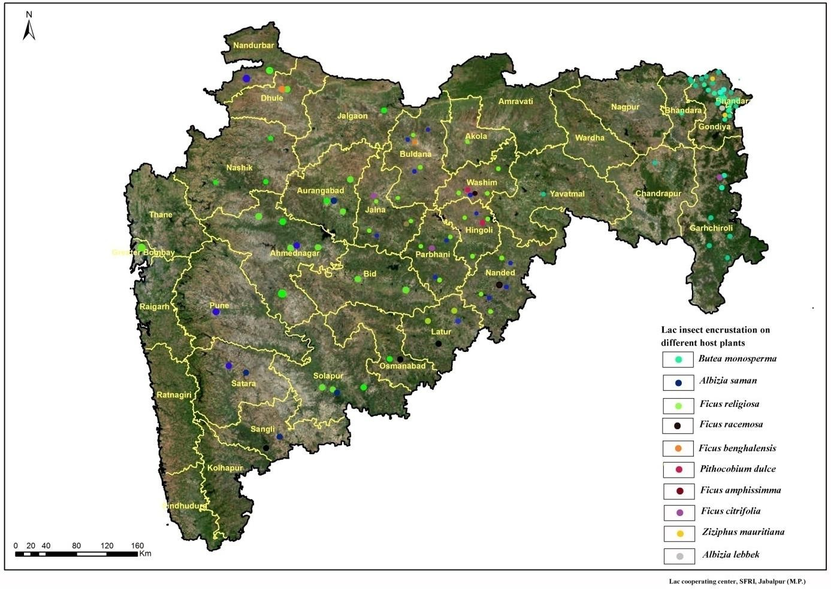

**Fig 2. Lac encrustation on different host plants A. *Butea monosperma*.** **B. *Ziziphus mauritiana***

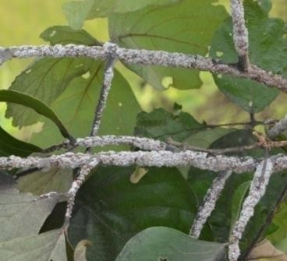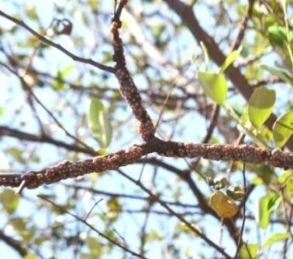

B

A

Disclaimer (Artificial intelligence)

Option 1:

Author(s) hereby declare that NO generative AI technologies such as Large Language Models (ChatGPT, COPILOT, etc.) and text-to-image generators have been used during the writing or editing of this manuscript.

I hereby declare that No generative AI technologies such Large Language Models (ChatGPT,COPILOt etc and text to image generator have been used during the writing or editing of this manuscript.

Option 2:

Author(s) hereby declare that generative AI technologies such as Large Language Models, etc. have been used during the writing or editing of manuscripts. This explanation will include the name, version, model, and source of the generative AI technology and as well as all input prompts provided to the generative AI technology

Details of the AI usage are given below:

1.

2.

3.

References

Anderson J. (1971).Monograph on *Cocci ceriferi* (fide) Agric .Ledger **9**:181-387.

Avasia DN. (1909) Lac and Lac Cultivation from practical experience of the same. *Indian Forest .Pamph*.Calcutta **4**:10pp

Carter HJ.,(1861). Natural history of the lac insect (Coccus lacca) .*Ann.Mag.Nat.Hist.* London 3 (7) :1-10 363-364.

Chouhan NS. A colour mutant in the Indian lac Insect. India Journal of Entomology. 1967; **29**:216-217.

Kapur AP.*(1958) The Lac Insect. In: A Monograph on Lac, Mukhopadhyay, B. and M.S. Muthana (Eds.). Indian Lac Research Institute, Ranchi, India, 1962, 59-89.

Khan WA (2021). *Ficus palmata* a nutraceutical under took advantage of the product. Int. J Agric. Nutr.;**3** (2):14-18.DOI: 10.33545/26646064.2021.v3.i2a.67.

Kondo T, Gullan PJ .,(2005). A new lac insect from Colombia, with revised key to lac insect genera and to species of *Austrotachardiella* Chamberlin (Hemiptera: Coccoidea: Kerriidae).Neotropical Entomology **34** No.3 Londrina .

Kumar KK (2002) Scope of lac cultivation in employment and income generation. In: Kumar

KK, Ramani R, Sharma KK (eds) Recent Advances in Lac Culture. ICAR-IINRG, Ranchi,

pp 254–262

Meena SC, Sharma KK, Swami H, Rana BS, Lekha, Lahot VD (2020). Survey record of lac insect *Kerria lacca* and its host plants in western plains of India. India Journal of Agricultural Science 90 (01):220-5, January 2020/Short Communication.; **90** (01):220-5.

Mohansundaram A, Sharma K, Lahot VD, Thamilarasi K, Ghosh J, Ramani R.( 2018) Occurrence of lac insects and their host plants in Tamil Nadu and Kerela. Indian Journal of Entomology. **80** (04):1351-1358.

Mohanta J, Dey DG, Mohanty N. Performance of lac insect, *Kerria lacca* Kerr in conventional and non- conventional cultivation around Similipal Biosphere Reserve, Odisha, India. Bioscan, 2012**; 7**: 237-240.

Pal G, Jaiswal AK, Bhattacharya A. Lac statics at a glance 2010 (Technical bulletin No. 01/2011) Indian Institute of Natural Resins and Gums, Ranchi. 2011, 1- 24.

Pal G. (2009) Impact of scientific lac cultivation training on lac economy- A study in Jharkhand. Agricultural Economics Research Review.; **22**:139-143.

Ramani R, Baboo B, Goswami DN (2007). Lac- an Introduction, Indian Lac Research Institute, Ranchi,.

Roonwal ML, Raizada MB, Chatterjee RN, Singh B. Descriptive account of the host plants of the lac insect, *Laccifer lacca* (Kerr) and the allied plant in the India region (Part 1-2) (1958). India Cess Committee, Ranchi,.

Roonwal ML (1962). Lac Hosts. In: A Monograph on Lac, Mukhopadhyay, B. and M.S. Muthana (Eds.). Indian Lac Research Institute, Ranchi, India, 14-58.

Sharma KK, Jaiswal AK and Kumar KK. (2006). Role of lac culture in biodiversity conservation: Issues at stake and conservation strategy. *Current Science*.; **91** :894-898

Sharma KK, Ramani R, Mishra YD. (1997) An additional list of the host plants of lac insects, Kerria spp. (Tachardidae: Hemiptera). Journal of Non-Timber Forest Products. **4** (3/4):151-155.

Sharma KK, Ramani R. An update on synoptic catalogue of lac insects (Homoptera: Tachardiidae) (1999). *Journal of Bombay Natural History Society*. **96**:438-443.

Singh JP, Jaiswal AK, Monobrullah MD and Bhattacharya A. (2009) Response of sime selected insecticides on neuropteran predator (*Chrysopa lacciperda*) of lac insect (*Kerria lacca*). Indian Journal of Agricultural Science. **79** (9):727-731.

Varshney RK (1968). Further data on host-plants of lac insects (Tachardidae: Homoptera). Journal of Bombay Natural History Society. 1967; **65**:249-251.

Varshney RK, Ganguli G. Advances in the taxonomy of lac insects. Patna University Journal*.* **23**(4):55-63.

Varshney RK, Teotia TPS (1968). A supplementary list of host plants of insects, *Jour. Bombay Nat. Hist. Soc*. ; **64**(3):488-511.

Yogi RK, Bhattacharya A, Jaiswal AK, Kumar A. (2014) Lac, Plant Resins and Gums Statistics 2014: At a glance. ICAR-Indian Institute of Natural Resins and Gums, Ranchi (Jharkhand), India Bulletin (Technical) No. 07/2015, 1-68p.

Yogi RK, Kumar Alok, Singh AK. Lac, Plant Resins and Gums Statics 2016: At a glance. ICAR-Indian Institute of Natural Resins and Gums, Ranchi (Jharkhand), India Bulletin (Technical) No. 19/2018, 2018, 1-80p.