**A preliminary checklist of Butterfly fauna from Bongaigaon district of Assam, India.**

**Abstract**

Butterflies are an excellent biological indication of the health of the environment and the quality of their habitat. Bongaigaon district is situated in the north bank of mighty river Brahmaputra in western part of Assam, India. The area are mostly plain with traces of lofty green hills, moist deciduous forests, natural wetlands, rivers, etc, all combine to give it a impressive grandeur and is famous for endangered and endemic primate Golden Langur (*Trachypithecus geei*). The diverse flora and fauna in the forests of the district makes it an important location for conservation and research on the region’s biodiversity. Therefore a preliminary study was undertaken to observe the butterfly diversity with species richness based on observation and sighting records from January to December, 2024 in three (03) forest areas of Bongaigaon district, Assam, India. Transect counting method was used to track the population trend of butterflies for one year. A checklist has been created based on research on the diversity of butterflies in the study area. During the study period, 46 butterfly species from 5 families in the order Lepidoptera were identified. With 19 species, the family Nymphalidae was the most prevalent among them, followed by the families Lycaenidae (11), Papilionidae (6), Pieridae (6), and Hesperiidae (4). As not a single study was carried out on the current population, distribution, diversity and occurrence with habitat variability of the particular area , the study will promote and throw light for future studies. Additionally, it will highlight specific forest regions in the Bongaigaon district as a resource of biodiversity conservation practices.

Key words: Butterfly diversity, transect counting, Lepidoptera, Bongaigaon.

**1.0 Introduction**

Among the insect group of the order Lepidoptera, butterflies—also referred to as the "living jewels"—are regarded as the most delicate and attractive species [1]. Butterflies serve as ecological marker of an ecosystem as they are extremely sensitive to disturbances and changes in their habitat. Hence, they are regarded as an umbrella species in the study of conservation ecology [2] [3]. It is important to note butterfly diversity indirectly reflects plant variety because both caterpillars and adult butterflies are extremely reliant on certain host plants. In India, more than 1300 species of butterflies are found belong to six families [4]. They are Nymphalidae, Papilionidae, Lycaenidae, Pieridae, Hesperiidae and Riodinidae. According to Das *et al.,* [5] more than two-thirds of the species were found in India's northeastern states. The eight states that make up northeastern India—Assam, Arunachal Pradesh, Manipur, Meghalaya, Mizoram, Nagaland, Sikkim, and Tripura—are among the most biodiverse regions in the world and are home to a diverse array of butterflies [6]. Butterfly distribution, diversity, and abundance are best served by a wide range of flowering plants, as well as appropriate habitats, topography, and temperatures. Approximately 962 species and subspecies of butterflies from five taxonomic groups can be found in northeastern India alone [1], [4]**.**  The primary source of food for butterflies is plants; certain plant species give caterpillars trophic resources, while others give adults nectar. The vegetation is crucial to the survival of butterflies because it provides certain structural components that help identify the ideal microclimates in which they lay their eggs, develop into larvae, caterpillars, and pupae. Because of their strong reliance on plants, they may be negatively impacted by changes in the environment and vegetation structure, which could result in their migration or local extinction [7]. Some reports of butterflies in certain areas of Norteastern India have also been reported by various workers [1], [4], [7], [8], [9], [10], [11], [12]. As they interact with plants as herbivores and pollinators, butterflies play a significant role in ecosystems [13]. A very few studies had been made on butterfly diversity of Assam as well as Bongaigaon district. Hence an attempt was made to study the butterfly diversity, distribution and their relative abundance on the study area. The area was mostly plain with traces of lofty green hills, moist deciduous forests, natural wetlands, rivers, etc all combine to give it an impressive grandeur and is famous for endangered and endemic primate Golden Langur (*Trachypithecus geei*). The diverse flora and fauna in the forests of the district makes it an important location for conservation and research on the region’s biodiversity.

**2.0 Materials and Methods**

**2.1 Study Area**

According to estimated forest statistics of Assam, 2005, Bongaigaon district's forest cover were expected to be 56,596 hectares, or 22.6% of its total geographical area. The district is located within the Aie valley of the Brahmaputra river basin. It is situated in India's Northeastern Himalayan sub-region, with latitudes 26°28' - 26°54' North and longitudes 89°-90°96'East. The following are the three main forest regions in the district where the study was carried out:

Area 1: Kakoijana reserve Forest, Bongaigaon.

Area 2: Shankarghola, North salmara Sub-division, Bongaigaon.

Area 3: Khagarpur pahar, North Salmara Sub-division, Bongaigaon.

The map of Bongaigaon district along with study sites were represented in **Fig. 1**.

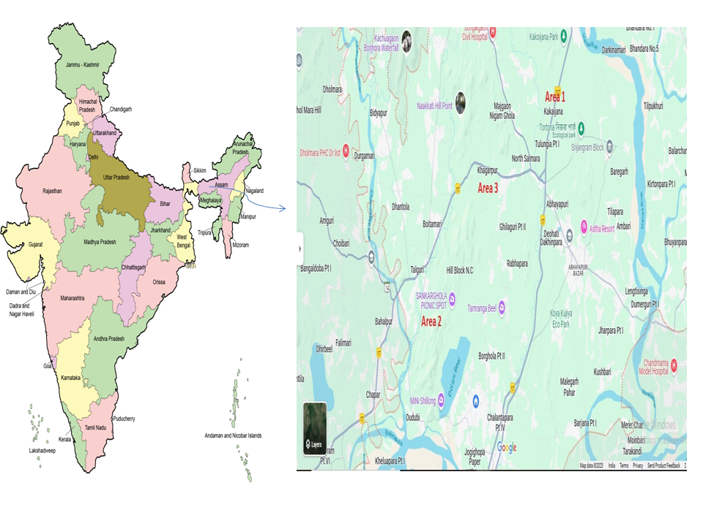

**Fig 1.** Map of Bongaigaon district, Assam showing study locations (Area 1, Area 2, Area 3)

**2.2 Methodology**

The findings presented here were based on survey carried out from January to December, 2024 at three (03) forest areas of Bongaigaon district of Assam. The observations were taken between 0700 and 1000 hours, when butterfly activities were at its highest. Using the transect counting method [14], [15], [16], [17], field notes, photos (taken with a Canon EOS600D DSLR), and observations of butterflies and their population trends were tracked for a year. Identification of butterfly species were done by using photographs, field guides and available literatures [18], [19]. Early mornings, particularly after rain showers, were the best times to observe and take pictures because this is when nectar sources and flowering plants attracted the most butterflies. Based on the abundance in the Bongaigaon district, the observed butterflies were divided into five groups: Very Common (more than 25 sightings) is represented by VC, Common (16–25 sightings) by C, Uncommon (9–15 sightings) by UC, Rare (5-8 sightings) by R, and Very Rare (less than 5 sightings) by VR.

**3.0 Result and Discussions**

A total of 46 butterfly species belonging to 5 families of order Lepidoptera were recorded during the study period. Among them family Nymphalidae, represented by 19 species was the most dominant species followed by family Lycaenidae (11 species), Papilionidae (6 species), Pieridae (6 species) and Hesperiidae (4 species) being the least. Among these five families the four butterfly species *Eurema hecabe*, *Catopsillia Pomona*, *Lampides boeticus* and *Phalanta alcippe* were catagorized into Very Common catgory based on their observation and their sighting were more than 25. Similarly, three species *Leptotes plinius*, *Heliophorus* *epicles*, *Melantitis leda* were catagorized into Common i.e their sighting were between 16 to 25 and twelve species *Odontoptilum angulatum*, *Papilio demoleus*, *Graphium sarpendon*, *Cepora nadina*, *Castalius rosimon*, *Curetis thetis*, *Danaus genutia*, *Elymnias hypermnestra*, *Junonia almanac*, *Ypthima baldus*, *Polyura athamus*, *Cyrestis thyodamas* were Uncommon (9-15 sightings). Where as Ninteen species *Udaspes folus, Pseudocoladenia dan*, *Graphium antiphates*, *Papilo clytia*, *Papilo helenus*, *Graphium doson*, *Delias descombesi*, *Delias pasithoe*, *Lonura atymnus*, *Spindasis lohita*, *Rapala pheretima*, *Spalgis epius*, *Symbrenthia lilaea*, *Tirumala limniace*, *Euploea midamus*, *Junonia atlites*, *Athyma nefte*, *Pantoporia hordonia*, *Charaxes bernardus* were rare (5-8 sightings) and eight species *Spialia galba*, *Ixias pyrene*, *Zemeros flegyas*, *Spindasis syama*, *Hypolymnas bolina*, *Vagrans egista*, *Stibochiona nicea*, *Cethosia cyane* were catagorised into Very rare category based on sightings in the study areas. With 178 members, the family Nymphalidae was the largest contributor, followed by the Lycaenidae (119 members), Pieridae (101 members), Papilionidae (45 members), and Hesperidae (33 members). Since the majority of the species in the Nymphalidae are naturally polyphagous, they always had a strong position in the tropical region. Outsized host plant richness is indicated by a large percentage of nymphalid species [16]. The checklist of butterflies with their abundances recorded in the 3 forest areas of Bongaigaon and the photograph of few butterfly species were listed in **Table. 1** and **Image. 1** respectively*.* Percentage of occurrence of butterfly species under different families were graphically depicted in **Fig.2.** Similarly, Aruna *et al.,*[20] also observed occurrence of Nymphalidae family were dominant than others and Hesperiidae being the least in Ranga Reddy district of Telangana, India. Again, Gogoi *et al.,* [12] also recorded presence of butterfly species more in numbers under Nymphalidae family and lesser in Pieridae, which might be due to ecology of that particular study area as it lies in between Eastern Himalaya and Indo-Burma region. On the contrary we had observed Hesperidae being the least in numbers and Pieridae being the second most dominant family in our study area. On the other hand, Saikia *et al.,* [1] also recorded similar records of highest occurrence of Nymphalidae family and least occurrence of Hesperiidae. Again, Common emigrant (*Catopsillia Pomona* Fabricius) was very common and highest species recorded under family Pieridae with a total number of 40 during the study period; whereas Bishaya *et al.,* [7] recorded Psyche under Pieridae as the most dominant butterfly species in their study; although the dominant families were Nymphalidae in both the studies.

|  |  |  |  |  |  |  |
| --- | --- | --- | --- | --- | --- | --- |
| **Table.1.** Butterflies and their abundance in the three forest areas of Bongaigaon district, Assam, are listed. | | | | | | |
| Common Name | Scientific name | A 1 | A 2 | A 3 | T | RA |
| Family: Hesperiidae | | | | | | |
| 1. Chestnut angle | *Odontoptilum angulatum* Felder | 3 | 5 | 7 | 15 | UC |
| 1. Grass demon | *Udaspes folus* Cramer | 4 | 2 | - | 6 | R |
| 1. Indian skipper | *Spialia galba* Fabricius | - | 1 | 3 | 4 | VR |
| 1. Fulvous pied flat | *Pseudocoladenia dan* Fabricius | - | 3 | 5 | 8 | R |
| Family: Papilionidae | | | | | | |
| 1. Fivebar swordtail | *Graphium antiphates* Cramer | - | 4 | 3 | 7 | R |
| 1. Common lime | *Papilio demoleus* Linn. | 3 | 5 | 2 | 10 | UC |
| 1. Common mime | *Papilo clytia* Linn. | - | 5 | 3 | 8 | R |
| 1. Common blue bottle | *Graphium sarpendon* Linn. | 2 | 3 | 4 | 9 | UC |
| 1. Red Helen | *Papilo helenus* Linn. | 1 | 3 | 2 | 6 | R |
| 1. Common jay | *Graphium doson* Felder & Felder | - | 3 | 2 | 5 | R |
| Family: Pieridae | | | | | | |
| 1. Common grass yellow | *Eurema hecabe* Linn. | 8 | 14 | 12 | 34 | VC |
| 1. Common emigrant | *Catopsillia Pomona* Fabricius | 5 | 20 | 15 | 40 | VC |
| 1. Yellow orange tip | *Ixias pyrene* Linn. | - | 1 | 2 | 3 | VR |
| 1. Lesser gull | *Cepora nadina* Lucas | 2 | 5 | 4 | 11 | UC |
| 1. Red spot jezebel | *Delias descombesi* Boisduval | 2 | 3 | 2 | 7 | R |
| 1. Red base Jezebel | *Delias pasithoe* Linn. | 3 | 2 | 1 | 6 | R |
| Family: Lycaenidae | | | | | | |
| 1. Yamfly | *Lonura atymnus* Stoll | 2 | 1 | 2 | 5 | R |
| 1. Common Peirrot | *Castalius rosimon* Fabricius | 3 | 4 | 6 | 13 | UC |
| 1. Zebra blue | *Leptotes plinius* Fabricius | - | 10 | 12 | 22 | C |
| 1. Punchinello | *Zemeros flegyas* Cramer | - | - | 3 | 3 | VR |
| 1. Pea blue | *Lampides boeticus* Linn. | 3 | 15 | 10 | 28 | VC |
| 1. Long banded silverline | *Spindasis lohita* Horsfield | - | - | 5 | 5 | R |
| 1. Purple sapphire | *Heliophorus epicles* Godart | 2 | 5 | 10 | 17 | C |
| 1. Indian Sunbeam | *Curetis thetis* Drury | - | 6 | 4 | 10 | UC |
| 1. Copper flash | *Rapala pheretima* Hewitson | - | 3 | 5 | 8 | R |
| 1. Club Silverline | *Spindasis syama* Moore | - | - | 2 | 2 | VR |
| 1. Apefly | *Spalgis epius* Westwood | - | 2 | 4 | 6 | R |
| Family: Nymphalidae | | | | | | |
| 1. Common tiger | *Danaus genutia* Cramer | 2 | 3 | 5 | 10 | UC |
| 1. Common jester | *Symbrenthia lilaea* Hewitson | - | 2 | 6 | 8 | R |
| 1. Common palmfly | *Elymnias hypermnestra* Linn. | - | 5 | 8 | 13 | UC |
| 1. Peacock pansy | *Junonia almanac* Linn. | 1 | 3 | 5 | 9 | UC |
| 1. Blue tiger | *Tirumala limniace* Cramer | 3 | 1 | 2 | 6 | R |
| 1. Blue spotted crow | *Euploea midamus* Linn. | - | 5 | - | 5 | R |
| 1. Grey pansy | *Junonia atlites* Linn. | 7 | 4 | 5 | 16 | C |
| 1. Great eggfly | *Hypolymnas bolina* Linn. | - | 2 | 1 | 3 | VR |
| 1. Common five ring | *Ypthima baldus* Fabricius | 6 | 2 | 2 | 10 | UC |
| 1. Colour sergent | *Athyma nefte* Westwood | - | 3 | 4 | 7 | R |
| 1. Leopard lacewing | *Cethosia cyane* Drury | - | - | 2 | 2 | VR |
| 1. Small leopard | *Phalanta alcippe* Stoll | 2 | 10 | 14 | 26 | VC |
| 1. Common lascar | *Pantoporia hordonia* Stoll | - | 2 | 4 | 6 | R |
| 1. Common evening brown | *Melantitis leda* Linn. | 10 | 5 | 3 | 18 | C |
| 1. Popinjay | *Stibochiona nicea* Gray | - | - | 2 | 2 | VR |
| 1. Tawny rajah | *Charaxes bernardus* Fabricius | - | 5 | 2 | 7 | R |
| 1. Common map | *Cyrestis thyodamas* Doyere | 3 | 4 | 6 | 13 | UC |
| 1. Vagrant | *Vagrans egista* Cramer | - | 4 | - | 4 | VR |
| 1. Common nawab | *Polyura athamus* C. & R. Felder | 1 | 8 | 4 | 13 | UC |

|  |
| --- |
| * Area 1-A1, Area 2-A2, Area 3-A3, T- Total, RA- Relative abundance |

**Fig. 2.** Percentage of occurence of butterfly species under different families

***Image.1****.* Photographs of few butterflies captured during the study period:

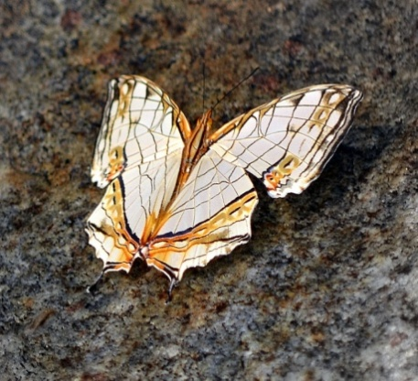 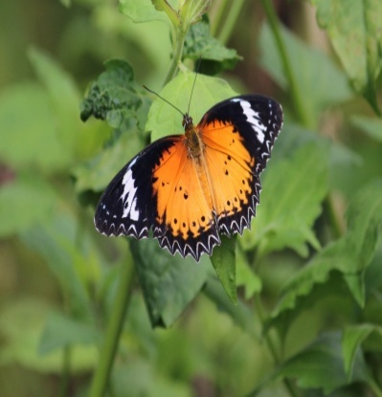 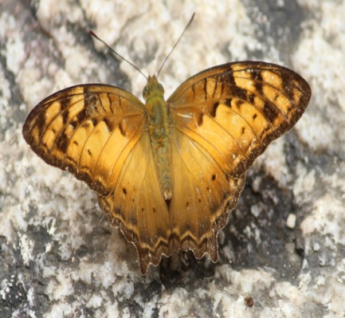 *Cyrestis thyodamas Cethosia cyane*  *Vagrans egista*

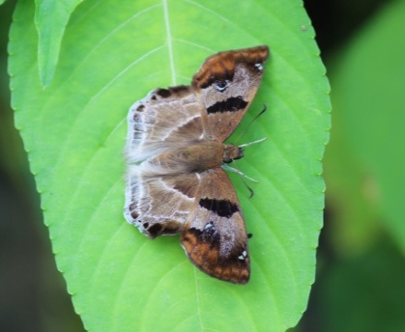 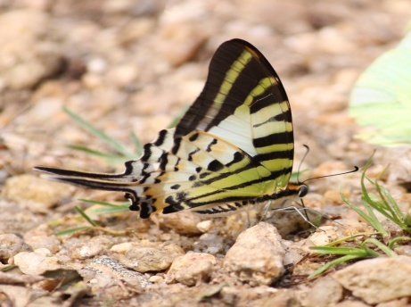 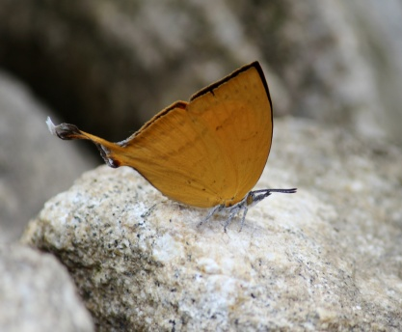

*Odontoptilum angulatum Graphium antiphates Lonura atymnus*

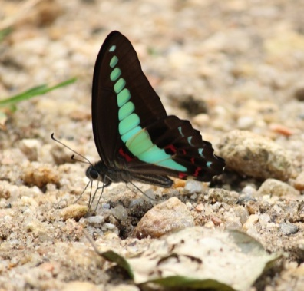 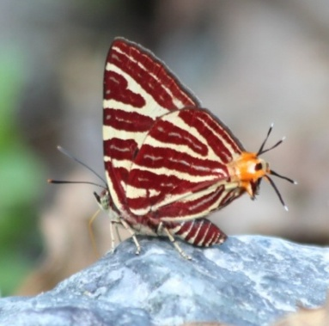 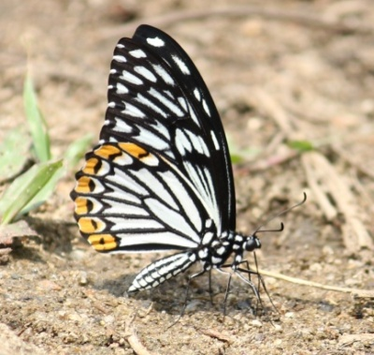

*Graphium sarpendon Spindasis syama Papilo clytia*

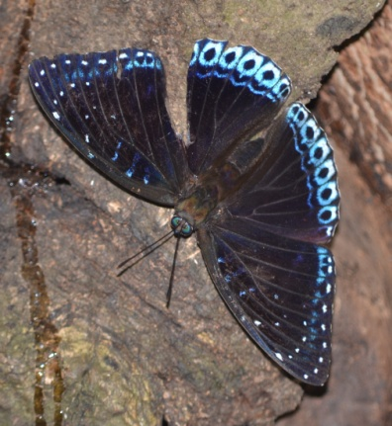 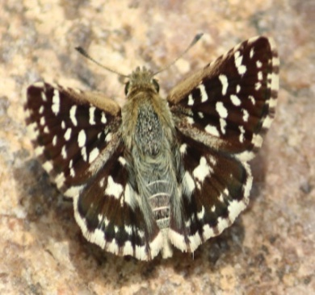 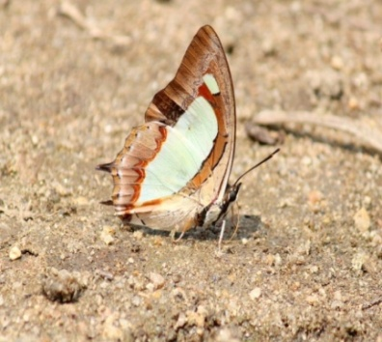

*Stibochiona nicea Spialia galba Polyura athamus*

**4.0 Conclusion**

The study offers preliminary checklist on butterfly species of Bongaigaon district of Assam. Hence it is very tricky to state whether the butterfly diversity in the locale is escalating or declining. Therefore, it is recommended that the region be examined through continuous monitoring and comparison each year. As the district was undergoing urbanization and upgrading, many new infrastructures were getting established leading to deforestation and cutting of trees that provided shelter for butterflies, in turn increasing pollution, soil erosion etc along with other issues. All these phenomenon ultimately destroy the natural ecosystem. The presence of 46 species was a crucial indicator of robust biodiversity in spite of anthropogenic activities. In order to achieve sustainable development, biodiversity must be conserved and species diversity must be further studied.

**Acknowledgement**

Authors gratefully acknowledge Dept. of Applied Biology, USTM for supporting to carry out this work. Authors were also thankful to the local guides those involved during the study period.

**Disclaimer (Artificial intelligence)**

Author(s) hereby declare that NO generative AI technologies such as Large Language Models (ChatGPT, COPILOT, etc.) and text-to-image generators have been used during the writing or editing of this manuscript.

**References**

[1] C. Saikia, M. K. Singh, and M. Gogoi, “A Study on Butterfly Diversity of Tingkhong College Campus, Dibrugarh, Assam, India,” *Asian J. Biol. Life Sci.*, vol. 13, no. 2, pp. 561–565, 2024, doi: 10.5530/ajbls.2024.13.69.

[2] C. J. Betrus, E. Fleishman, and R. B. Blair, “Cross-taxonomic potential and spatial transferability of an umbrella species index,” *J. Environ. Manage.*, vol. 74, no. 1, pp. 79–87, 2005, doi: https://doi.org/10.1016/j.jenvman.2004.08.010.

[3] J. Béguinot, “Least-biased Estimations of True Species Richness of Butterfly Fauna in Sub-urban Sites around Jhansi (India) and the Range of Inter-annual Variation of Species Richness,” *Asian J. Environ. Ecol.*, vol. 2, no. 1, pp. 1–12, Mar. 2017, doi: 10.9734/AJEE/2017/32040.

[4] U. Dutta, S. Dey, and D. Moran, “A study on the diversity of butterflies in selected landscapes of the Indian Institute of Technology, Guwahati campus, Assam, India,” *J. Threat. taxa*, vol. 17, no. 2, pp. 26515–26529, 2025, doi: 10.11609/jott.8254.17.2.26515-26529.

[5] G. N. Das, Z. F. Fric, S. Panthee, J. S. Irungbam, and M. Konvicka, “Geography of Indian Butterflies: Patterns Revealed by Checklists of Federal States,” *Insects*, vol. 14, no. 6, p. 549, 2023, doi: 10.3390/insects14060549.

[6] A. Bora and L. R. Meitei, “Diversity of butterflies (Order: Lepidoptera) in Assam University campus and its vicinity, Cachar District, Assam, India.,” *J. Biodivers. Environ. Sci.*, vol. 5, no. 3, pp. 328–339, 2014, [Online]. Available: https://innspub.net/diversity-of-butterflies-order-lepidoptera-in-assam-university-campus-and-its-vicinity-cachar-district-assam-india/

[7] P. Bishaya, K. Saikia, and R. Gogoi, “Butterfly diversity in Cotton University Campus, Guwahati,Assam, India,” *Uttar Pradesh J. Zool.*, vol. 42, no. 24, pp. 396–403, 2021, [Online]. Available: https://mbimph.com/index.php/UPJOZ/article/view/2714.

[8] M. Bhuyan, P. R. Bhattacharya, and P. B. Kanjilal, “Butterflies of the Regional research laboratory campus, jorhat,Assam.,” *Zoos’ print J.*, vol. 20, no. 6, pp. 1910–1911, 2005, [Online]. Available: https://zoosprint.org/index.php/zpj/article/view/6716

[9] Doherty.W, “Notes on Assam Butterfly.,” *J. Asiat. Soc. Bengal*, vol. 58, pp. 118–138, 1889, [Online]. Available: https://archive.org/details/biostor-278152

[10] D. Saharia, “A collection of butterflies of Assam agriculture college, Jorhat, Assam.,” *J. Assam Agric. Coll.*, pp. 87–90, 1967.

[11] S. Modak, A. Das, and R. Ahmed, “A Preliminary Study on Butterfly Diversity in Garbhanga Reserve Forest , Basistha, Assam, India,” vol. 7, no. 0976, pp. 16–24, 2018.

[12] R. Gogoi, A. Chetry, and A. Bhuyan, “Diversity and species richness of butterfly in soraipung range of Dehing Patkai National Park, Assam, India,” *J. Basic Appl. Zool.*, vol. 84, no. 1, 2023, doi: 10.1186/s41936-023-00327-9.

[13] A. D. Tiple, A. M. Khurad, and R. L. H. Dennis, “Factors influencing nectar plant resource visits by butterflies on a university campus: implications for conservation,” *Nota Lepid.*, vol. 28, no. 3/4, pp. 213–224, 2006, [Online]. Available: https://www.zobodat.at/pdf/Nota-lepidopterologica_28_0213-0224.pdf

[14] K. Barhaum, D. Anderson, and C. ZI, “Estimation of density from line transacts sampling of biological population,” 1980. [Online]. Available: http://the-eis.com/elibrary/sites/default/files/downloads/literature/Estimation of density from line transect sampling of biological populations_1980.pdf

[15] C. Zhang *et al.*, “Applicability of butterfly transect counts to estimate species richness in different parts of the palaearctic region,” *Ecol. Indic.*, vol. 95, pp. 735–740, 2018, doi: https://doi.org/10.1016/j.ecolind.2018.08.027.

[16] F. Barkmann, P. Huemer, U. Tappeiner, E. Tasser, and J. Rüdisser, “Standardized butterfly surveys: comparing transect counts and area-time counts in insect monitoring,” *Biodivers. Conserv.*, vol. 32, no. 3, pp. 987–1004, 2023, doi: 10.1007/s10531-022-02534-2.

[17] E. Pollard, “A Method for assessing changes in abundance of butterflies.,” *Biol. Conserv.*, vol. 12, pp. 116–134, 1977.

[18] I. Kehimkar, *The Book of Indian Butterflies.* BNHS and Oxford University press, Mumbai, India, 2008.

[19] I. Kehimkar, *Butterflies of India*. BNHS, Mumbai, 2016. [Online]. Available: https://www.researchgate.net/publication/329702173_BUTTERFLIES_OF_INDIA_-_BNHS_FIELD_GUIDES

[20] I. Aruna Sri, V. Sunitha, B. Naresh, Y. V. B. Charan, K. Swamy, and V. V. Rao, “Status and diversity of butterfly and moth fauna at Dandumailaram I & II and Hafeezpur Urban Conservation Block Cluster in Ranga Reddy district, Telangana, India.,” *Indian J. Plant Prot.*, vol. 52, no. 4, pp. 189–194, 2024, [Online]. Available: https://epubs.icar.org.in/index.php/IJPP/article/view/166473